NAME…………………………………………….ADMISSION NUMBER………………………

AGRICULTURE
TIME: 2 HOURS
KENYA CERTIFICATE OF SECONDARY EDUCATION (K.C.S.E.)
AGRICULTURE
TIME 2HOURS
INSTRUCTIONS TO CANDIDATES.
- Write your name and admission number in the spaces provided.
- Answer all questions in the spaces provided.
- This question paper consists of three sections A, B and C.
- Answer all the questions in sections A.B and C.
- Answers should be written in the spaces provided.
For Examiner’s use only
Section | Question | Maximum score | Candidate,s score
A | 1-16 | 30
B | 17-24 | 30
C | 25 | 20
C | 26 | 20
C | Total score | 100

This paper consists of 12 printed pages.
Candidates should check the question paper to ascertain that all the pages are printed as indicated and no questions are missing.

SECTION A(30MKS
1. List any four types of records a farmer should keep.(2marks)

2. Give two conditions in agricultural production under which opportunity cost is zero
(1 mark)

3 Give four reasons-for keeping livestock health records on the farm. (2 marks)

4. State 4 reasons for primary cultivation.(2marks)

5. Distinguish between soil structure and soil texture (1mark)

6. State one function for each of the following:

(a) shovel; (1 mark)

(b) strip cup. (1 mark)

7 Differentiate between olericulture and pomoculture (2mks)

8 State four conditions under which shifting cultivation is practiced. 2mks

9 State 3 reasons why agriculture is important in Kenya’s economy (3mks)

10 Name the exotic cattle with
i) Highest butter fat content ………………………………………(1marks)

ii) Lowest butter fat content …………………………………(1mark)

11. State two characteristics of goats that make them adaptable to arid areas of Kenya.(1mark)

12 Give four ways by which soil loses its fertility (2marks)

13 State four characteristics that make a crop suitable for green manuring. (2marks)

14 State four ways in which burning of vegetation may lead to loss of soil fertility.
(2 marks)

15. What is the function of each of the following ingredients in the preparation of compost manure?
(a) Wood ash (1 mark)

(b) Top soil (1 mark)

16 Give 4 reasons why water treatment is important. (2marks)

SECTION B (30MARKS

17. The diagram below illustrates a final seedbed after a tertiary operation done during land preparation. Study it carefully and answer the questions that follow.
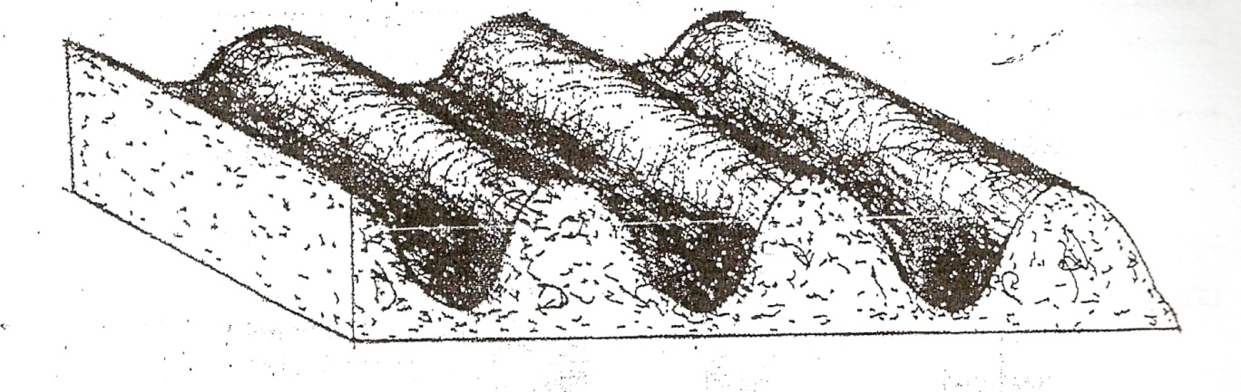
(a) Name the tertiary operation carried out on the seedbed (1mark)

b) Give two advantages of planting crops on a final seedbed illustrated above
(2 marks)

18 a) List two aspects of light that influence crop growth.(2marks)

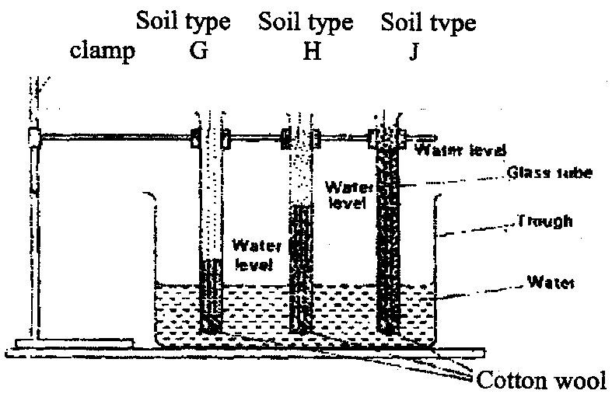
b The diagram below shows an experiment set up using soil types G , H and J and observations made after 24 hours. Study the diagram and answer the questions that follow.

- What is the experiment represented above designed to study? (1mark)

ii) Name the soil types G and J (1mark)

iii) What is the characteristic texture of soil types G and J?(2marks)

iv) State how a farmer would improve the structure of soil type G.(1mark)

19 Study the diagrams of workshop tools shown below
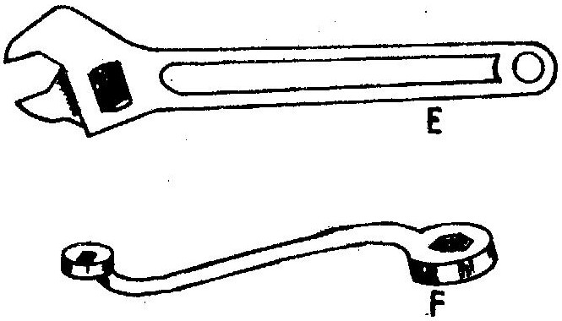

(i) Identify the tools labeled E and F (1 mark)
E __________________

F __________________
(ii) What functional advantage does tool E have over tool F? (1 mark)

20. The diagram below illustrates the general shape of a cattle breed. Study it carefully and answer the questions that follow.
HEAD
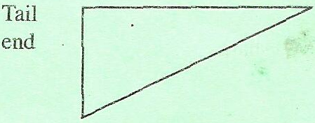

(a) Identify the type of breed illustrated by the above shape (1mark)

(b) Give an example of a breed in (a) above. ( 1 mark)

(c) State four physical characteristics of the type of breed identified in (a) above.
(2 marks)

21. The diagrams labeled A_{1,} A₂, A_{3,} and B below illustrate materials and methods of vegetative propagation. Study them and answer the questions that follow.

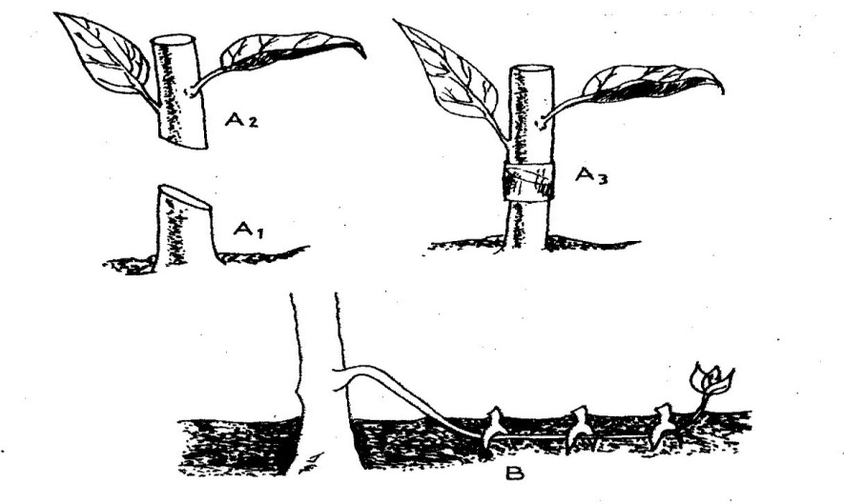

(a) Name the parts labeled A₁, and A₂ (2 marks)

(b) Name the methods of propagation illustrated in diagrams A₃ and B (2 marks)

22.The diagrams labeled D and E below are illustrations of coffee established using two different formative pruning systems. Study them and answer the questions that follow.

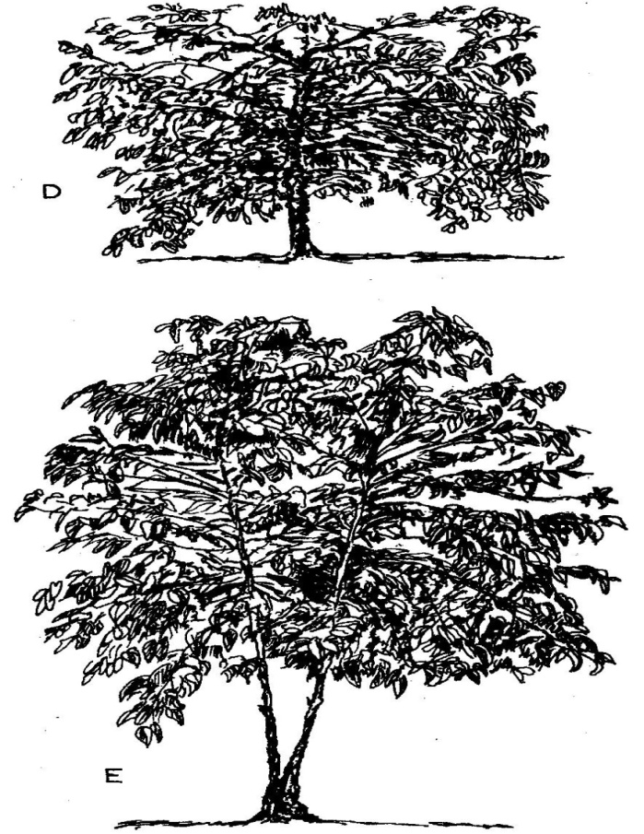

(a) Name the system of pruning illustrated in diagram D above (1 mark)

(b)State 2 disadavantages of the pruning system labelled E (2 marks)

23 (a) The diagrams below represent two ways in which a crop was pruned. Study them carefully and answer the questions that follow.
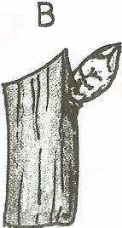
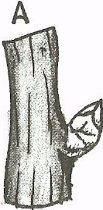

(i) Which diagram represents the correct way of pruning? (1 mark)

(ii) Give a reason for your answer in (i) above. (1 mark)

(b) State two ways in which pruning assists in controlling crop diseases. (1 mark)

24. Below are diagrams showing different types of internal parasites. Study them carefully and answer the questions that follow:-
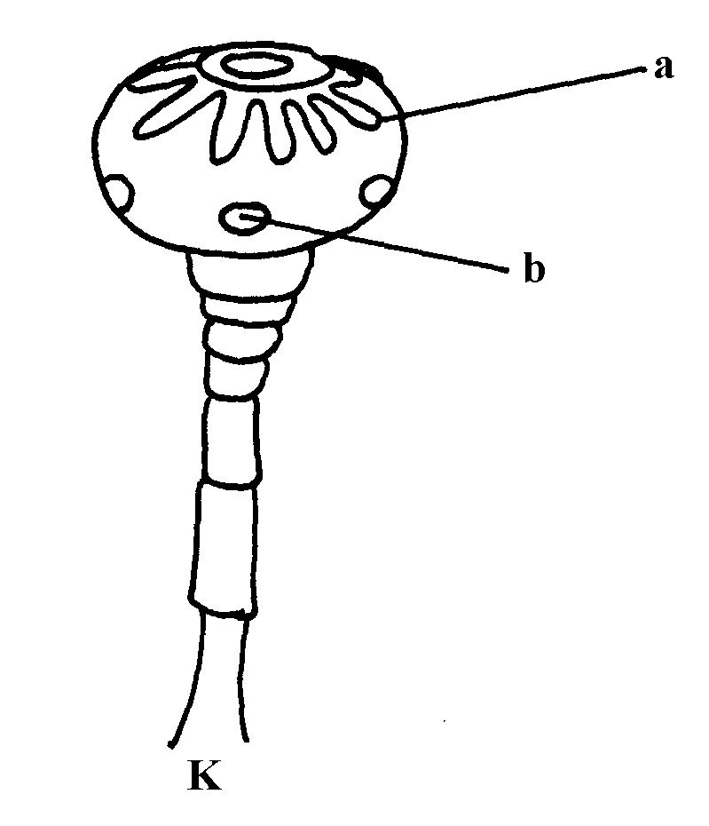
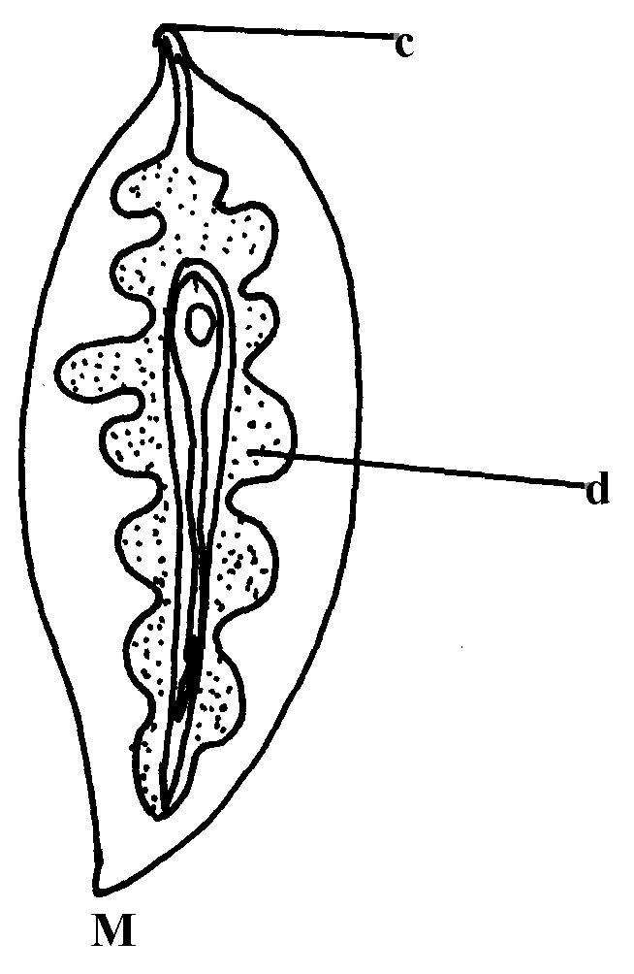

a) Identify the parasites K & M (1mark)

b) Name the organs where each parasites is found (2marks)

c) Give the intermediate host of parasite M (1mark)

SECTION C (40 MARKS
25. a) State and explain five factors which may influence the spacing of crops (10 marks)

b) State and explain five advantages of crop rotation (10marks)

26 (a) Describe ten signs of ill –health in livestock (10 marks)

b).Explain measures used to control livestock diseases. (10 marks)

