NAME …………………………………………………………………………ADM NO………………….CLASS……………..
CHEMISTRY FORM 1
END OF TERM III
Answer All the questions in the spaces.
1. What is chemistry (1 mark)
2. State any importance of studying chemistry (1 mark)

3. a) Name three illegal drugs (3 marks)

b) State three ways of preventing drug abuse. (3 marks)

4. Complete the following table (8mks)
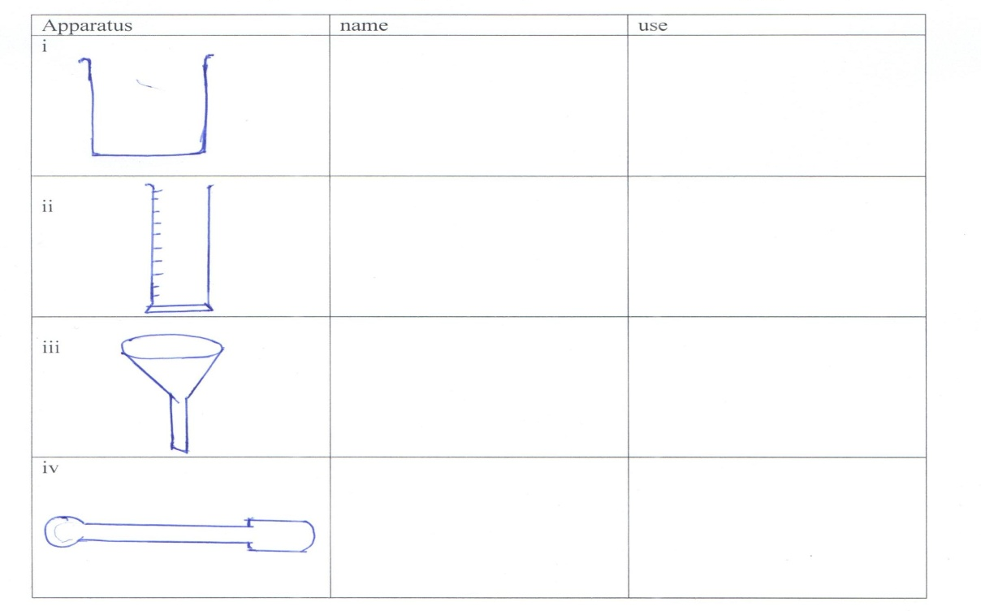

5. State four laboratory safety rules (4mks)

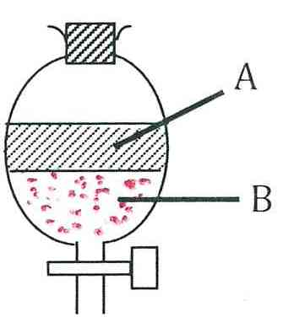
6. (a)The apparatus below were used to separate a mixture of liquid A and B.

State two properties of liquids that make it possible to separate using such apparatus. (2 marks)

(b) Give the name of the above apparatus. (1 mark)

7. Describe how you can separate a mixture of sand and common salt (3 marks)

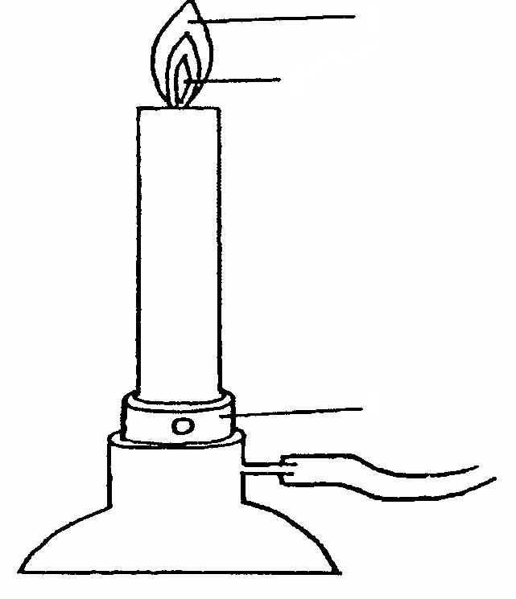8. The diagram below shows a Bunsen burner when in use
C
B
A

- Name the regions labelled B and C. (2 marks)
B………………………………………………………………………………….
C………………………………..............................................................................
- What is the function of the part labeled A? (1 mark)
9. State three differences between physical and chemical change. (3 marks)

10. i. Differentiate between weak and strong alkali (2 marks)

ii. The following is a list of pH values of some substance:
Substance | M | N | V | X | Z
pH | 10.6 | 7.2 | 13.2 | 5.9 | 1.5

Identify:
a) Strong acid (1 mark)
b) Weak base (1 mark)
11. Name the method or process that can be used to separate each of the following mixture
- Water and motor oil (1 mark)
ii . Iron filings and sulphur powder . (1 mark)
- Iodine and sand (1 mark)
iv. Water and ethanol (1 mark)
12. Write the chemical symbols of the following elements (5 marks)
- Calcium …………………………………………..
- Sodium…………………………………………….
- Barium……………………………………………..
- Lead…………………………………………………
- Copper……………………………………………….
13. The diagram below represents the apparatus used to prepare and collect oxygen.
Hydrogen
Peroxide

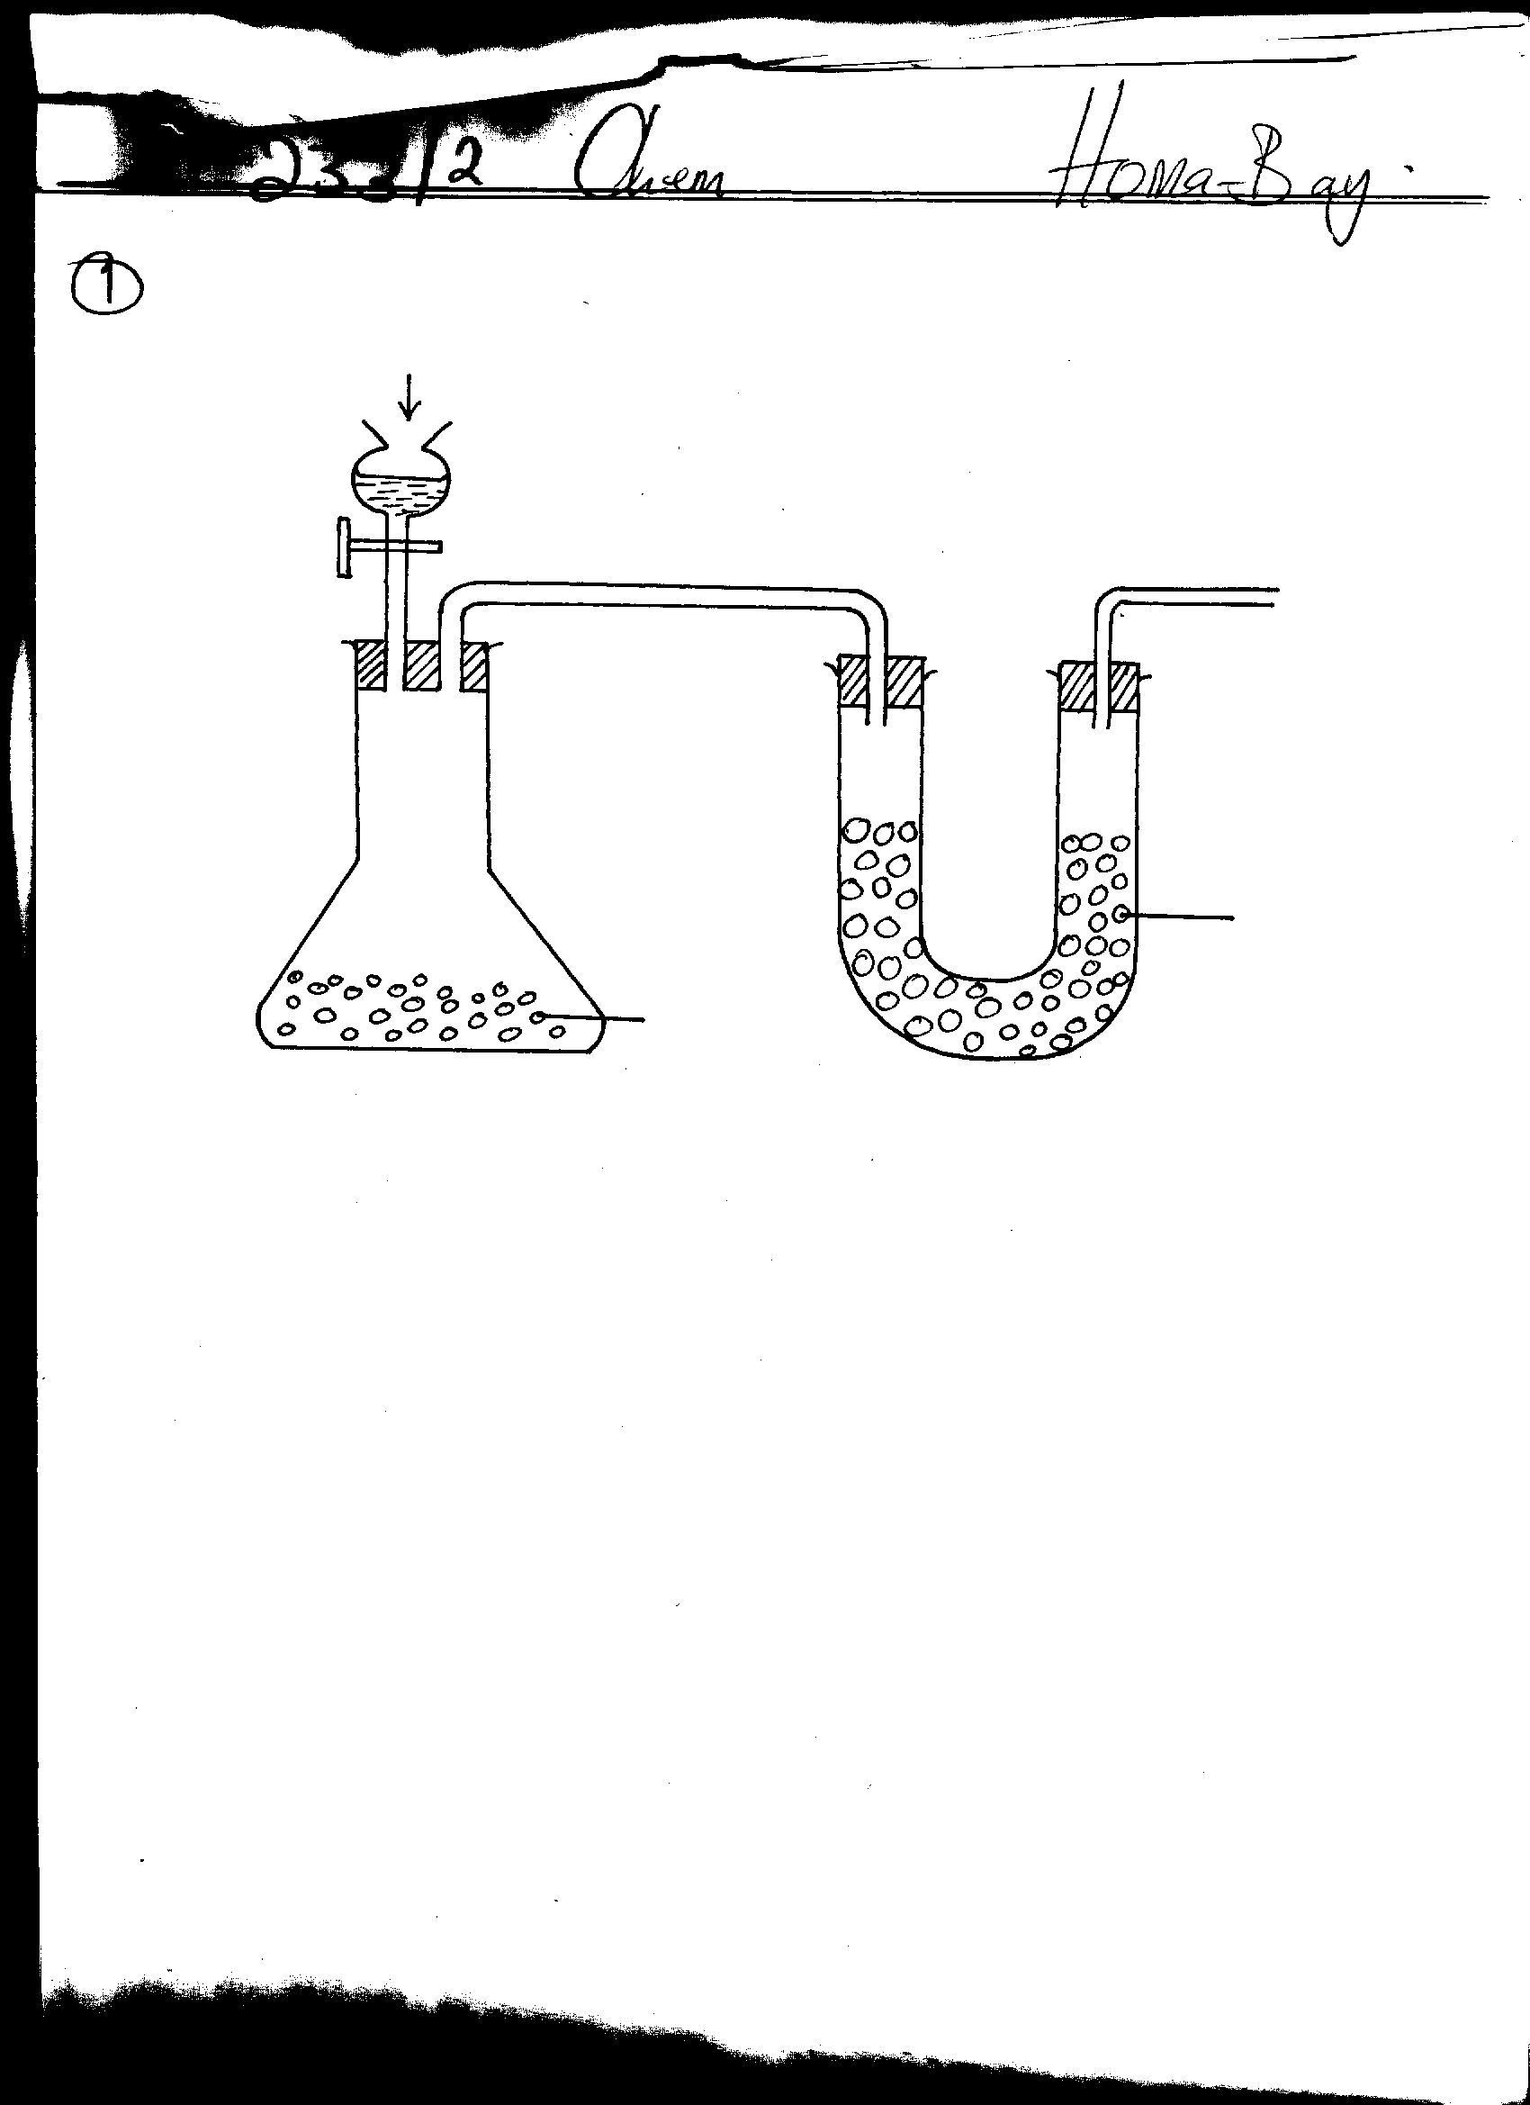

Solid Q
Solid P

- Complete the diagram to show how oxygen gas is collected.(2 marks)
- Name solid P (1 marks)
P
iii. Write the word equation to show the reaction that produces oxygen gas.(1 mark)

- State three physical properties of oxygen. (3 marks)

v. State two uses of oxygen gas. (2 marks)

14.(i) What is a flame? (1mk)

(ii). The following diagrams represent the two types of flames produced by a bunsen burner.

(a) (b)

(a). Identify the flames (a) and (b). (2mks)

(b). Which type of the flames identified above is preferred for heating? Give a reason for your answer. (2mks)

(c). give four differences between the flames (a) and (b) above. (4mks)
Flame (a) | Flame (b)
(d)(i). Give two reasons why flames (a) and (b) in 4(ii) above differ. (2mks)

15. A form one student wanted to separate and obtain iodine and sodium chloride (common table salt) from a mixture of the two. He set the experiment set up shown below.
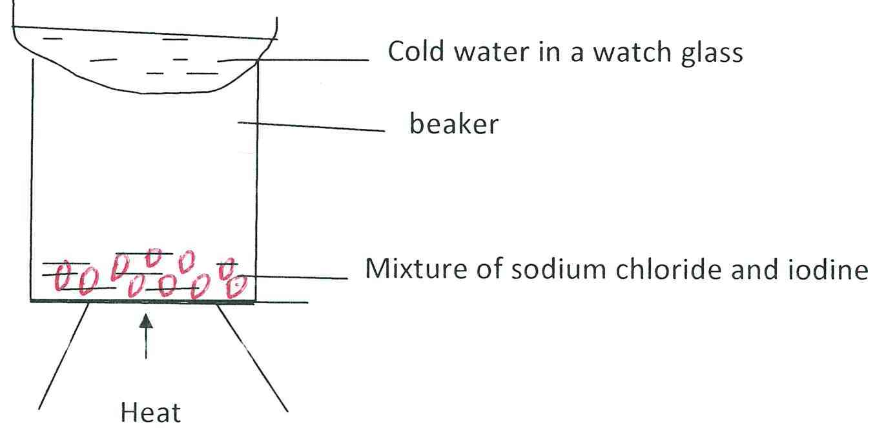

(a). the mixture was heated for some time and left to cool. On cooling, shiny black crystals and white crystals were observed on the surface of the watch glass and in the beaker respectively. Name:
I. Shiny black crystals

II. White crystals. (2mks)

(b). What was the purpose of the cold water in the watch glass? (1mks)

(c). What property of iodine makes it be collected on the watch glass as shown? (1mk)

(d). Explain why it is possible to separate a mixture of iodine and sodium chloride.(1mk)

16. The curves below represent the variation of temperature with time when pure and impure samples of a solid were heated separately.

A
B

Temperature

(a). Which curve represents the variation in temperature for pure solid? Explain. (2mks)

(b)State the effect of an impurity on the melting and boiling points of a pure substance.(2mks)

(c) Name two gases used with oxygen in welding. (2mks)
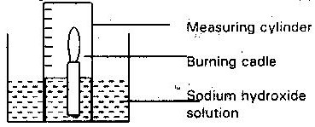
17. A candle was burnt using the apparatus shown below. The initial volume of measuring cylinder was 90cm³. The apparatus was allowed to cool and the volume of air in the measuring cylinder had dropped to 70cm^{3.}

a) Why was the volume recorded when the air was cooled? (1mk)

b) What was the purpose of sodium Hydroxide? (1mk)

c) Use the results given to calculate the percentage of oxygen in air. (2mks)

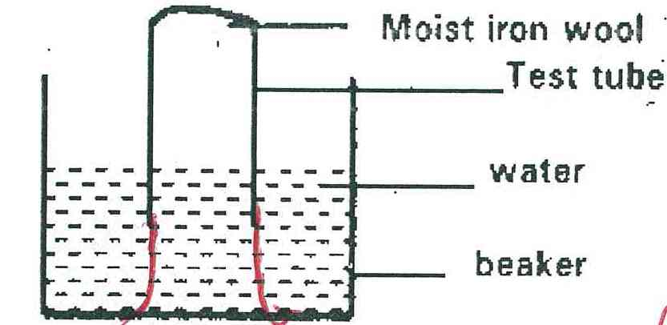
18. The set up below was used to study some properties of air

State and explain two observation that would be made a t the end of the experiment. (3mks)

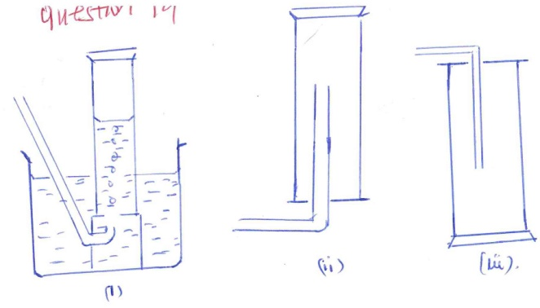
19. The diagram below represents three methods for collecting gases in the laboratory

a) Name the methods shown in the diagram (3mks)

b) State with reasons the most suitable methods for collecting each of the following gases.
i) Oxygen (1mk)
ii) Hydrogen (1mk)

iii) Carbon (IV) Oxide (1mk)

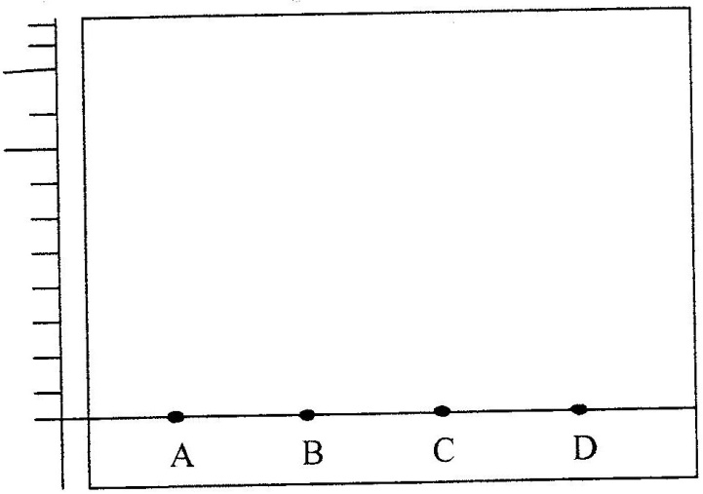
20 a) The diagram below shows spots of pure substance A,B, and C on a chromatography paper. Spot D is that of a mixture

After development, A, B and C were found to have moved 8cm, 3cm and 6 cm respectively.
D has separated into two spots which had moved 6cm and 8 cm
(i) On the diagram
I Label the baseline (origin) (1 mark)

II Show the positions of all the spots after development (3 marks)

(ii) Identify the substances present in the mixture D (2 marks)

(b) Describe how solid ammonium chloride can be separated from a solid mixture of ammonium chloride and anhydrous calcium chloride (2 marks)

(c) The table shows liquids that are miscible and those that are immiscible

Liquid | L₃ | L₄
L₁ | Miscible | Miscible
L₂ | Miscible | Immiscible
Use the information given to answer the questions that follow
(i) Name the method that can be used to separate L1 and L3 from a mixture of two (1 mark)

(ii) Describe how a mixture of L₂ and L4 can be separated (2 marks)

