CHEMISTRY FORM 1
END OF TERMIII
TIME:
MARKING SCHEME
- Branch of science that deals with study of composition, properties and reactions of matter

2. – Forms foundation for professional training. (1 mk for any one)
-- Provides man with knowledge necessary for manufacture of basic necessities
-- Enables man to understand and deal with environmental factors affecting him
3a) Heroin
Cocaine
Mandrax
Morphine
Bang
b) Proper use of all medicinal drugs
Never use any illegal drug
Stay away from those who use or sell drugs
Involving in any other useful work

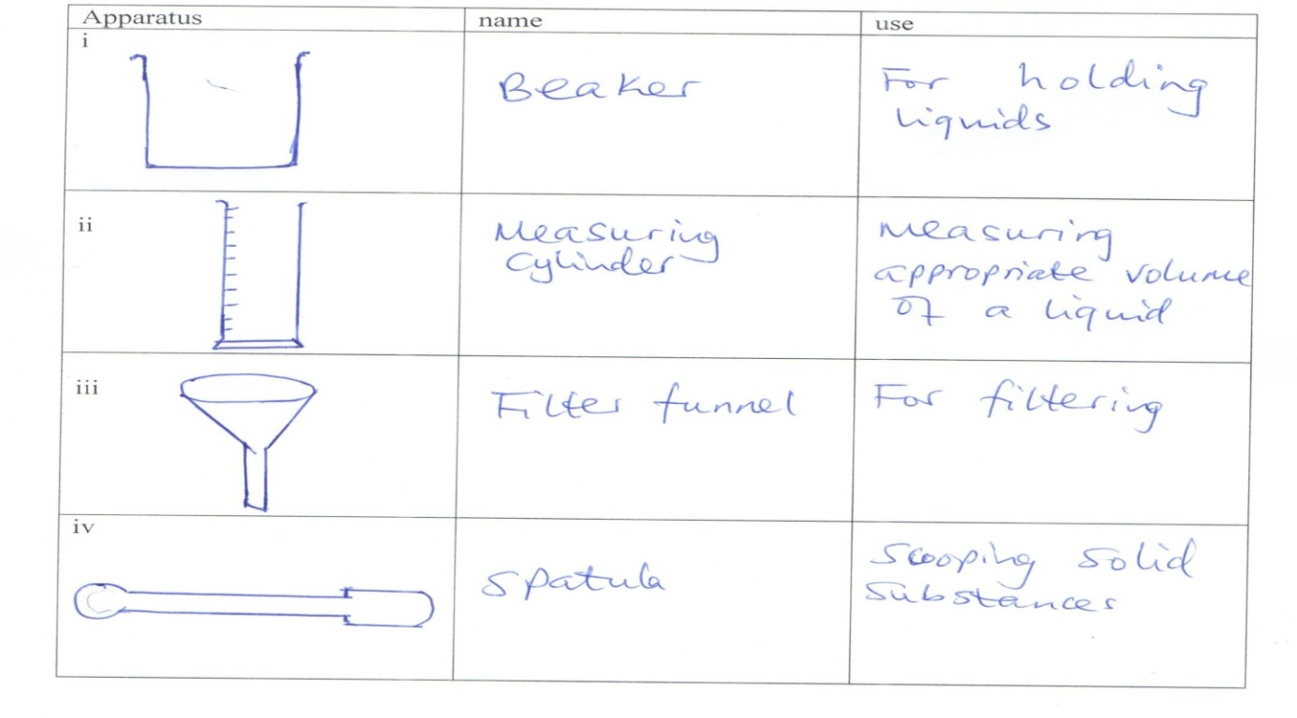
4

- Pestle
- Crushing

(1 mk for name 1mk for use.
5. laboratory safety rules
-no running in the lab
-no performing un authorized practical
-no smelling gases directly
-no eating in the laboratory
6. (a) The apparatus below were used to separate a mixture of liquid A and B.
B
A

State two properties of liquids that make it possible to separate using such apparatus. (2 marks)
- Immiscible
- Different densities
(b) Give the name of the above apparatus. (1 mark)
- Separating funnel

7. - Add water to the mixture and stir, √¹ common salts dissolves while sand insoluble.
- Filter√¹ to obtain sand as residue and common salts as filtrate. 1
- Evaporate the filtrate t o obtain crystals√¹ of common salts.
NB: Steps must be systematic, otherwise penalize fully.

8. i. B - unburnt gas/colourless region 1
C - Pale blue region 1
ii. Closing and opening of air holes 1

9. Physical Chemical
- No new substance is formed -New substance is formed
- No energy is either given out or absorbed - Energy is usually given out or absorbed
- Mass of the substance does not change - Mass of the substance changes
- Change is usually reversible - Change is usually irreversible
10. i. Weak alkali is the one that does not ionize completely in solution / has less OH⁻ ions while strong alkali is the one that undergoes complete ionization / has many OH- ions √
ii. a) Z,
b) M
11.i. Decantation/use of separating funnel
ii. Use of a magnet
iii. Sublimation
iv. Fractional distillation
12. i. Ca
ii. Na
iii. Ba
iv. Pb
v. Cu
13. i. P – Manganese (IV) oxide
Q – Anhydrous calcium chloride /calcium oxide
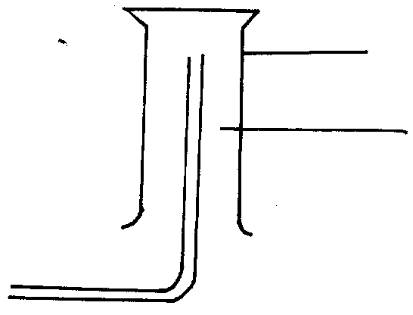
ii.
Gas jar
Oxygen

iii. Hydrogen peroxide → Water + Oxygen

iv. Extraction of O₂ from air.
- Colourless
- Odourless
- Slightly soluble in water

v. – Used in hospitals by patients with breathing difficulties
- Used when mixed with helium in deep sea divers & mountain climbers
- Burn fuels that propel rockets
- mixed with acetylene used for welding
- remove impurities during steel making
- remove impurities during
14. (i). Aflame is a mass of burning gases.
(ii)(a) a- non-luminous flame
b-luminous flame.
(b). a- non-luminous flame. Produces much heat.
(c).
(a) non luminous flame | (b) luminous flame
Has three zones | Has four zones
Produces much heat and less light | Produces much light and less heat
Short and steady | Large and wavy
Roaring noisy flame | Quiet flame
Produces soot | No soot
(d)(i). a-non-luminous flame is produced when the air hole is open while the luminous flame (b) is produced when the air hole is closed.
(ii)(a).non luminous flame.
15(a) shiny-black crystals are iodine crystals
-white crystals are sodium chloride solid
(b). To cool and condense the iodine vapour to form iodine solid.
(c) . iodine sublimes when heated .
(d). iodine sublimes while sodium chloride does not.
16. (a). curve B. pure substances have sharp melting and boiling points.
(b). Impurities lower the melting points but raises the boiling points. Of substances.
(c).-Hydrogen; acetylene/ ethyne.
17. (a) To allow all oxygen to be used up and also to allow the gas to contract/
cater for any expansion of gases
(b) To absorb carbon (IV) oxide which was produced by the burning candle
(c) % of oxygen 90 – 70 x 100 = 22.2%
90
18 -Iron will be covered by a reddish brown substance/coating/rust
-Water in test tube rise and water in a beaker drops
Explanation:
Iron Combines with oxygen in a presence of moisture to form hydrated Iron (III) oxide / rust water rises up to occupy the space which was occupied by oxygen in the tube.

(19) .a. Upward delivery/ downward displacement of air.
b. Downward delivery/upward displacement of air.
(ii). Method (b). carbon (iv) oxide is denser than air.
19 (a) (i) Over water
(ii) Upward delivery/ downward displacement of air
(iii) Downward delivery/ upward displacement of air
(b) (i) Over water : it is slightly soluble in water
(ii) Upward delivery: It is less dense than air
(iii) Downward delivery: it is denser than air

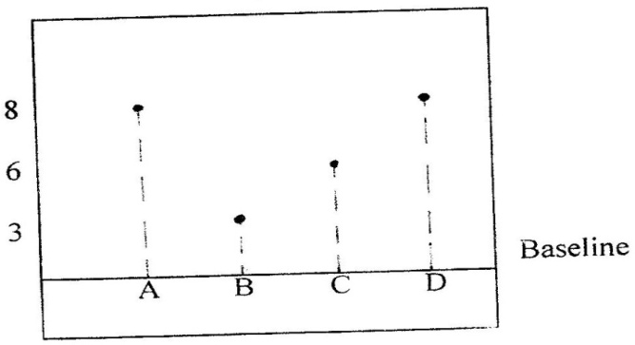
20
a) (i)

(ii) A and C
b) Since NH₄CL sublimes but CaCl₂ does not ; sublimation process would do .Heat the mixture. Ammonium chloride sublimates into vapour and condenses on the cooler part of the heating tube. Calcium chloride will remain on the bottom of the heating tube.
c) i) Fractional distillation
ii) Separating funnel method
Since the tow liquids are immiscible, pour both the liquids in a separating funnel and allow settling, the denser liquid will settle down and the less dense will form a second layer on top. Open the tape and run out the liquid in the bottom layer leaving the liquid in the second layer in the funnel.

