FORM TWO TERM III CHEMISTRY
MARKING SCHEME

1. X – 2.8.3 (1 mk)
Y – 2.6 (1 mk)
(b) X₂Y₃ (1 mk)

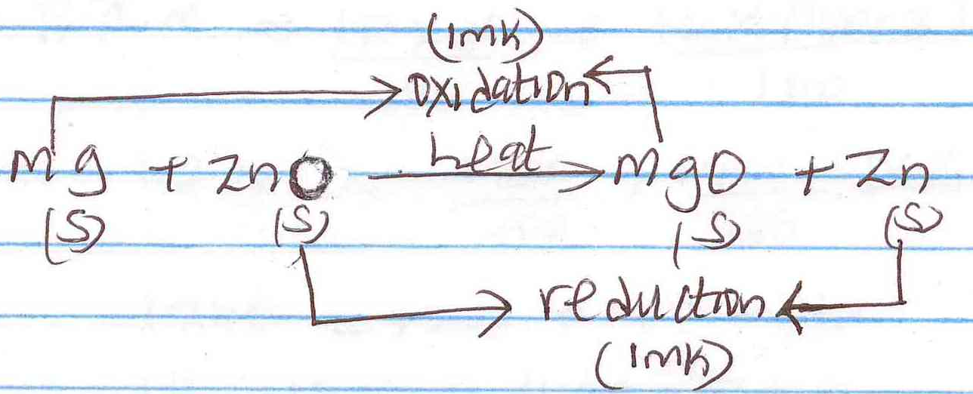
2. (a)

(b) Reducing agent – Mg (1 mk)

3. Deliquescent salts absorbs water from the atmosphere and form a solution. (1 mk) while efflorescent salt loose water of crystallization to the atmosphere. (1 mk)

4. (a) B (1 mk)
(b) A and C (1 mk for each)

5. (i) Solvent extraction (1 mk)
(ii) Fractional distillation (1 mk)
(iii) Crystallisation / Evaporation (1 mk)

6. (a) Group – V (1 mk)
Period – 3 (1 mk)
(b) A non metal (1 mk)

7. Let the relative abundance of isotope $\begin{matrix}12 \\ 6\end{matrix}C$ be X. relative abundance of isotope $\begin{matrix}14 \\ 6\end{matrix}C$ will be (100 – x)
R.A.M = $\frac{12×X}{100}+\frac{14×\left(100-X\right)}{100}$
12.4 = $\frac{12X}{100}+\frac{1400}{100}$=14x (1 mk)
1240 = 12x + 1400 – 14x
14x – 12x = 1400 – 1240
2x = 160
X = 80 (1 mk)
Relative abundance of $\begin{matrix}12 \\ 6\end{matrix}C$ is 80% (1/2 mk)
Relative abundance of $\begin{matrix}14 \\ 6\end{matrix}C$ is (100 – 80) = 20% (1/2 mk)
(accept correct ratio)

8. (i) (a) Downward delivery (upward displacement of air) (1 mk)
(b) Upward delivery (Downward displacement of air) (1 mk)

(ii) It is less dense than air. (1 mk)
(iii) Hydrogen/Ammonia (1 mk for any)

9. (i) The mass increases (1 mk) since copper combines with oxygen forming copper(ii)oxide. (1/2 mk)
(ii) The mass decreases (1 mk) since copper(ii)nitrate decomposes forming copper(ii)oxide, Nitrogen(iv)oxide, Oxygen. (1/2 mk)

10. Y – Hydrogen bonding (1 mk)
Z – Covalent bonding (1 mk)

11.
Element | Sulphates | Phosphates | Nitrates
R | RSO₄ | R₃(PO₄)₂ | R(NO₃)₂
B | B₂(SO₄)₃ | BPO₄ | B(NO₃)₃
Q | Q₂SO₄ | Q₃PO₄ | QNO₃
(1/2 mk for each)
12. (a) (i) Zn(NO₃)₂ (1 mk)
(ii) Nitrogen(iv)oxide or NO2 (1 MK)
heat
(b) 2Zn(NO₃)_{2(s)} 2ZnO_{(s)} + 4NO_{2 (g)} + O_{2(g)} (1 mk)

13. (a) Dative bond or coordinate bond (1 mk)
(b) Blue litmus paper turns to red (1 mk) while red remains red since aluminium chloride dissolves in water forming an acidic solution (1 mk)

14. (i) Mobile ions (1 mk)
(ii) Mobile ions (1 mk)
(iii) Delocalised electrons (1 mk)

15. (a) 9 + 10 = 19 (1 mk)
(b) A (1 mk)
(c) C and E (1 mk)

16. (a) (i) Dilute sulphuric (vi) acid or H2SO4(aq) (1 mk)
(ii) anhydrous copper(ii)sulphate (1 mk)
(b) CuO_{(s)} + H₂SO_{4(aq)} CuSO_{4(aq)} + H₂O_{(l)}

17.
- Its light (low density)
- Its not easily corroded
- It’s a good conductor of electricity

(2 mks for any two)

18. (a) M – Diamond (1/2 mk)
N – Graphite (1/2 mk)
(b) (i) N (1/2 mk) – it has delocalised electrons. (1/2 mk)
(ii) M (1/2 mk) – it is hard since it contains giant atomic structure. (1/2 mk)

19. (a) – Salty water
- Acidic conditions
- High temperature
(2 mks for any two)

(b) – Electroplating
- Galvanising
- Oiling and greasing
- Coating with plastic
(1 mk for any one)

20. (i) X, Y, Q, R (2 mks for any two)
(ii) Z (1 mk)
(iii) X (1 mk)

21. (a) (i) I – Bee hive shelf (1 mk)
II – Sodium peroxide (1 mk)
(ii) it is insoluble in water. (1 mk)
(iii) The gas would be mixed with air which was in the apparatus. (1 mk)
(iv) 2Na₂O₂(_{s)} + 2H₂O_{(l)} 4NaOH_{(aq)} + O_{2(g)} (1 mk)

(b) Oxide (1 mk)
(c) – Cutting and welding of metals
- In hospitals by patients with breathing problems
- In deep sea diving
- In mountain climbing
(2 mks for any two)

22. (i) Zinc Sulphate or ZnSO₄ (1 mk)
(ii) Sodium nitrate or NaNO₃ (1 mk)
(iii) Potassium Chloride or KCl (1 mk)

23. (i) B (1 mk)
(ii) C (1 mk)
(iii) E (1 mk)
(b) N – 2.5
H – 1
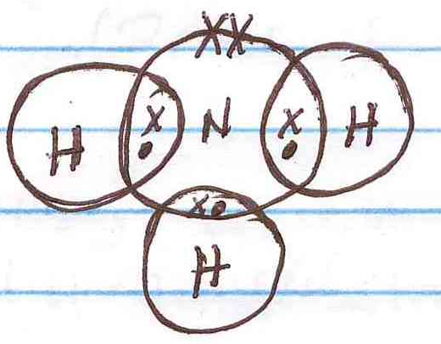
(2 mks)

24. Ammonia solution neutralized methanoic acid found in the nettle plant since it is an alkali. (1 mk)

25. (a) R Q P S (1 ½ MK)
Increasing reactivity
(1 mk only if the first and last letters are correct and others wrong)
(b) Its inert unlike hydrogen (1 mk)

26. (a) Heat (1 mk)
(b) Chlorine gas is poisonous (1 mk)
(c) 2Fe_{(s)} + 3Cl_{2(g)} 2FeCl_{3(s)} (1 mk)
(d) Anhydrous Calcium Chloride (1 mk). It stops moisture (1 mk) from entering the reaction flask where it would react with solid X which is deliquescent.
(e) FeI2 (1 mk)
(f) – Steerilise drinking water.
- Manufacture bleaching agents
- Manufacture P.V.C
- Manufacture hydrochloric acid.
- Manufacture insecticides and antiseptics.
(2 mks for any two)

(II) (i) A hissing sound is produced.
- A ball like substance is formed.
- The ball like substance darts around the water surface.
- The solution formed turns red litmus paper to blue.
(2 mks for any two)
(ii) 2Na_{(s)} + 2H₂O_{(l)} 2NaOH_{(aq}) + H_{2(g)} (1 mk)

27. (a) B A C (1 mk)
Increasing reactivity
(b) C (1 mk)
(c) Silver (Ag) or mercury (Hg) (1 mk for any)
heat
(II) (a) 2NaHCO_{3(s)} NaCO_{3(s)} + CO₂ + H₂O_{(g)} (1 mk)
heat
(b) CuCO_{3(s)} CuO_{(s)} + CO2(_{g)} (1 mk)

28. (a) Particles acquire kinetic energy (1 mk) causing the temperature to rise.
(b) XY (1 mk)
(c) Heat is used to break the intermolecular (1 mk) forces between water molecules.
(d) Testing whether the boiling point is 100⁰C.

