MARKING SCHEME PAPER 2 CHEMISTRY 233/2 FORM 3
END OF TERM 3

1. (a) E and H (1 mk)
They have seven electrons in their outermost energy level hence require one to have octet configuration. (1 mk)

(b) Giant atomic structure (1 mk) makes atoms of element C and oxygen gas will bonded by covalent bond. (1 mk)
(c) E is more reactive than H. (1 mk). They react by (1 mk) gaining. E has high electron affinity (candidates to bring the essence of atomic radius or repulsion due to atomic radius.

(d) Y_{(s)} + Cl_{2(g)} YCl_{2(s)} (1 mk)
Mole ration 1:1
No. of moles 0.0540 $\frac{1.21}{24}=0.0540$ (1 mk)
0.0540 = 1.3g
1 mole = x
X = $\frac{1.3}{0.0540}$
= 24g (1 mk)
(e) Alkaline earth metal (1 mk)
(g)
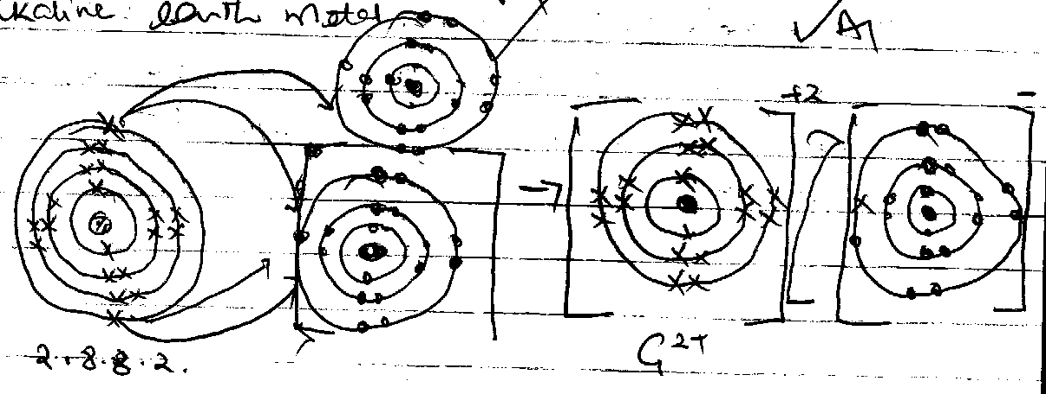

2. (a) (i) Thistle should be dipped inside acids otherwise gas would escape in air (1/2 mk)
(ii) Hydrogen should be collected by upward delivery because is less denser than air. (1/2 mk)
(iii) Delivery tube should not be touching the solid, no gas would be collected.

(b) Conc Sulphuric (vi) acid or H₂SO_{4(l)} (1mk)
(c) Zinc granules or Magnesium (1 mk)
(d) CuSO_{4(s)} or Copper(ii)Sulphate crystals. (1 mk)
(e) (i) Reducing agent (1 mk)
(ii) H_{2(g)} + Pb_{(s)} Pb_{(s)} + H₂O_{(l)} (1 mk)
(iii) Copper(ii)oxide or CuO_{(s)} (1 mk)

3.
- Chromatography (1 mk)
- – The chromatogram must have different solubility rate. (1 mk)
- The dyes must have different adsorption on the filter paper. (1 mk)
- – It is the furthest distance reached by the solvent on the adsorbent material (or filter paper). (1 mk)
- It is indicated as H on the diagram. (1 mk)
- Red, blue and green. (1 mk) (if only two are correct)
- B (1/2 mk) – It remains on the baseline (1/2 mk)
- Dye A and C (1/2 mk). They have only one chromatogram. (1/2 mk)
- – Detecting and identifying poisonous substances present in food substances. (1 mk)
- Separation of dyes into pure colours. (1 mk)

4. (a) Solvay process (1 mk)
(b) A – Ammonia gas
B – Ammonium Chloride
C – Sodium hydrogen carbonate
D – Calcium Oxide
Gas X – Carbon (iv) oxide (5 mks)
(c) Process Q – Filtration
R – Thermal decomposition (NaHCO₃)
S – Thermal decomposition of (CaCO₃) (3 mks)
(d) Step 4
2NaHCO_{3(s)} Na₂CO_{3(s)} + H₂O + CO_{2(s)} (1 mk)
Step 7
Ca(OH)_{2(s)} + 2NH₄Cl_{(s)} CaCl_{2(aq)} + 2H₂O_{(l)} + 2NH_{3(g)} (1 mk)
(e) Ammonia gas
- Carbon(iv)oxide gas
(f) Manufacture of glass.
(ii) Softening of hard water. (Any two correct) (2 mks)

5. (a) T = Alkene (1 mk)
P = Alkane (1 mk)
(b) C₂H_{4(g)} + 3O_{2(g)} 2CO_{2(g)} + 2H₂O_{(l)} (1 mk)
(c) Process W – Polymerisation (1 mk)
Q – Dehydration (1 mk)
(d) Step I – Hydrogenation (1 mk)
(iii) Additional reaction (1 mk)
(vi) Substitution reaction (1 mk)
(e) Conc Sulphuric (vi)acid (1 mk)
Soda lime (1 mk)
(f) CH₃CH₂COONa_{(s)} + NaOH _{(aq)} CH₃CH_{3(s)} + Na₂CO_{3(s)} (1 mk)

6. (a) 2Pb(NO₃)_{2(s)} 2PbO_{(s)} + 4NO_{2(g)} + O_{2(g)} (1 mk)
(b) Gas = Oxygen (1 mk)
(c) On cooling is yellow (1/2 mk)
On heating is Reddish brown (1/2 mk)
(d) Magnesium ribbon continues to burn (1 mk), forming white fume. Burning magnesium is exothermic, therefore decompose nitrogen(iv)oxide to nitrogen and oxygen. Oxygen produced support burning. (1 mk)
(ii) 4Mg_{(s)} + 2NO_{2(g)} 4MgO + N_{2(g)}
(e) Reaction should be carried in a fume chamber on open space, since the gas is poisonous. (1 mk)
(f) Cu(NO3)2 contains water of crystallisation or it is hydrated (1 mk)
(g) Nitrogen (iv) oxide easily liquedify. (1 mk)
(h) Manufacture of Nitric(v)acid. (1 mk)

7. (a) Graham’s law of diffusion state that under the same conditions of temperature and pressure, the rate of diffusion of a gas is inversely proportional, the square root of its density. (1 mk)
(b) $\frac{{RSO}_{2}}{RG}=\sqrt{\frac{{R.M.M}_{G}}{{R.M.M}_{{SO}_{2}}}}$ S = 32, 2O = $\frac{32}{64}$
$\frac{25}{26.26}= \sqrt{\frac{{R.M.M}_{G}}{{64}_{2}}}$ (1 MK)
${\left(\frac{25.00}{26.26}\right)}^{2}=\frac{{R.M.M}_{G}}{64}$
64 X ${\left(\frac{25.00}{26.26}\right)}^{2}= {R.M.M}_{G}$(1 MK)
64 X 0.9063
= 58 (1mk)

Temperature ⁰C | 0 | 20 | 40 | 60 | 80
Volume of the gas out | 140 | 150 | 160 | 170 | 180

