NAME…………………………….. INDEX NO……………….. SCHOOL…………......... CANDIDATE’S SIGN……………..….... DATE……………….………………………

232/2
PHYSICS
PAPER 2
(THEORY)
TIME: 2 HOURS
JULY/AUGUST

EXCEL EXAMINATION - 2018
Kenya Certificate of Secondary Education
PHYSICS
PAPER 2
(THEORY)
2 HOURS

INSTRUCTIONS TO THE CANDIDATES:
- Write your name, index number, class and admission number in the spaces provided above.
- Sign and write the date of examination in the spaces provided above.
- This paper consist of TWO sections; A and B.
- Answer ALL the questions in section A and B in the spaces provided.
- ALL working MUST be clearly shown.
- Mathematical tables, electronic calculators and slide rules may be used.
- Take acceleration due to gravity = 10m/s².

For Examiner’s Use Only
Section | Question | Maximum Score | Candidate’s Score
A | 1-13 | 25
B | 14 | 11
B | 15 | 09
B | 16 | 12
B | 17 | 14
B | 18 | 09
 | TOTAL | 80

SECTION A: 25 MARKS; ANSWER ALL QUESTIONS IN THIS SECTION
- The figure below represents an object O placed in front of a plane mirror M.

E

O .
M
Using rays, locate the position of the image as observed by the eye E. (2mks)
- The figure below shows a negatively charged rod brought slowly near the cap of a positively charged leaf electroscope.

+ + + + + + + +
-__

+

State what is observed and explain your observation (3mks)

- State how local action can be minimized in a simple cell. (1mk)

- Differentiate between a magnet and a magnetic material in terms of domains’ theory (2mks)

- The figure below shows an object placed in front of a concave mirror. By use of correct ray diagrams, locate the position of the image (2mks)

C F

- A conductor carrying current is placed in the magnetic field and moves in the direction shown.

P O Q

Indicate on the diagram the polarities of P and Q. (1mk)

- Distinguish between mechanical waves and electromagnetic waves. (1mk)

- Critical angle of a material is given to be 24.4⁰. calculate the speed of light in the material given the speed of light in vacuum is 3.0x10⁸ m/s. (3mks)

- State two reasons why prisms are preferred in optical instruments rather than plane mirrors. (2mks)

- Below is an incomplete electromagnetic spectrum.

Radio wave | A | Infrared | visible | ultraviolet | B | Gamma

- State one use of radiation A (1mk)

- How are waves B produced (2mks)

- The following is part of radioactive decay series.
Pa
234
b
Th
a
90
U
238
92
α β

Determine the values of a and b. (2mks)

- State one cause of power loss during transmission of electricity (1mk)

- Distinguish between n-type semi conductor and p-type semi conductor. (2mks)

SECTION B: 55 MARKS; ANSWER ALL QUESTIONS IN THIS SECTION

- a) state Lenz’s law (1mk)

b) The figure below shows a coil of wire next to a magnet. A voltmeter is connected to the coil of the wire.
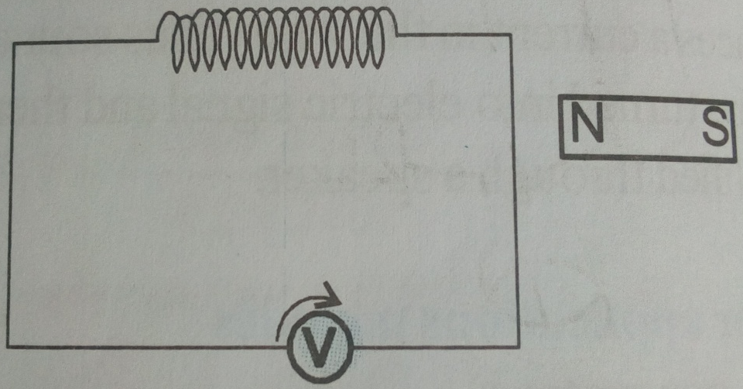

Describe two ways of inducing e.m.f in the coil of the wire (2mks)

c) A transformer is designed to supply current 5A at a potential difference of 50V to a motor from an a.c supply of 240V. if the efficiency of the transformer is 80%, calculate;
i) The power supplied to the transformer (3mks)

ii) The current in the primary coil (2mks)
d) Give 3 structural features in a transformer design which help in achieving high efficiency (3mks)

- a) State what is meant by the term photoelectric effect (1mk)

b) The figure below shows a graph of stopping potential against frequency

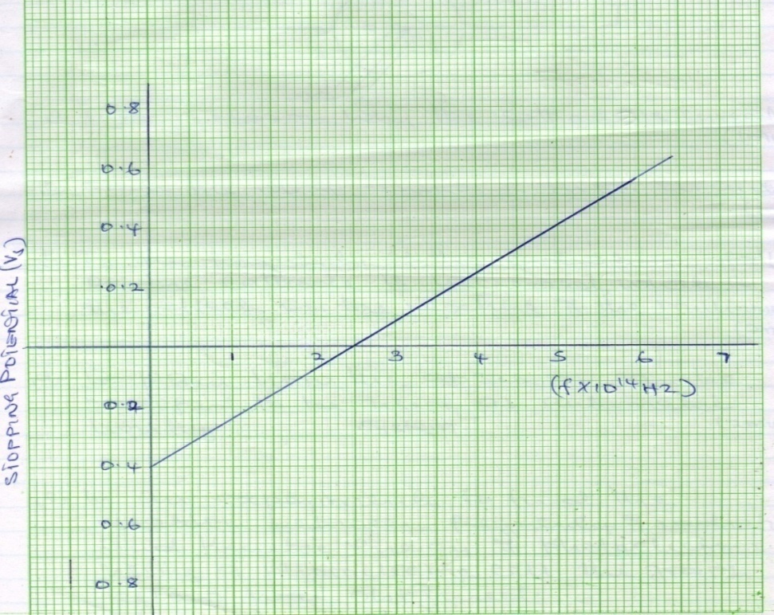

From the graph, determine;
- threshold frequency (1mk)

- the plank’s constant (3mks)

- The work function of the metal in joules. (3mks)

c) Give the energy conversion which occurs in a photocell (1mk)

- . a) The figure below shows the main features of a CRO.
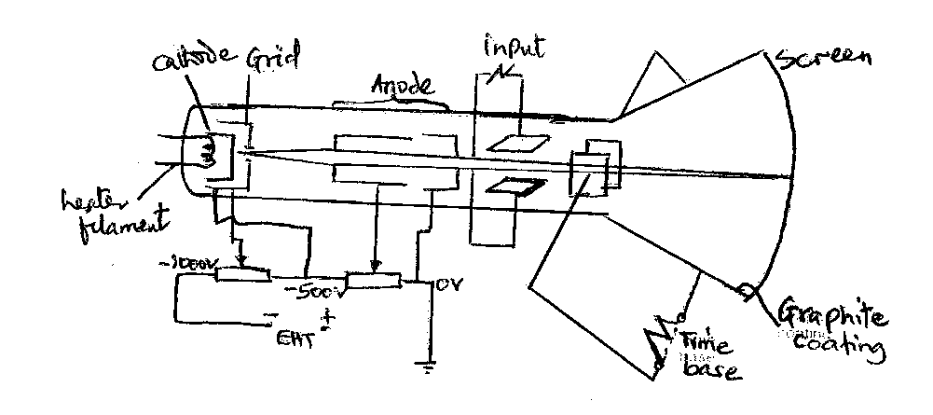
- describe how the electrons are produced (2mks)

- state and explain the function of the grid (1mk)

- State what would be observed on the screen if an a.c voltage is connected across the y plate. (1mk)

- Give the reason why it is possible to have a wider screen in the TV set than the CRO. (2mks)

b) State two advantages of using a CRO as a voltmeter (2mks)

c) Given that in the figure below, the time base control is set as 1ms/div and the y gain as 50V/div.

O

Determine the following;
- the frequency of the ac signal (2mks)

- the peak voltage of the input signal (2mks)

- a) The figure below shows the structure and circuit of x-ray tube.

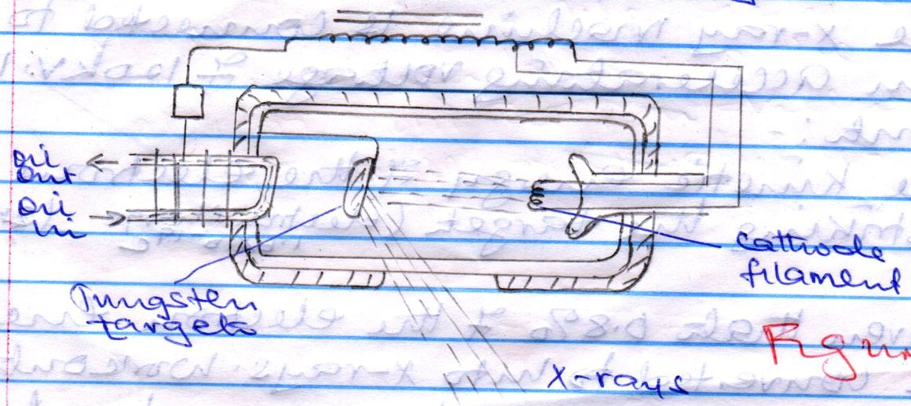

- explain how the electrons are produced by the cathode filament (2mks)

- explain how the electrons reach the target at the desired speed (1mk)

- Target is made of tungsten. Give a reason why tungsten is preferred (1mk)

- A lot of heat is produced in this machine. Briefly explain how heat loss is enhanced (1mk)

- Give a reason why the target must rotate while in use (1mk)

- The tube must be evacuated. Give a reason for evacuation. (1mk)

- State a reason for surrounding the machine with lead shield. (1mk)

b) The x-ray machine is connected to an accelerating voltage of 120kV. Work out;

i) The kinetic energy of electrons striking the target (e=1.6x10⁻¹⁹C ) (3mks)

ii) Given that 0.8% of electron energy is converted to x-ray, work out the minimum wavelength of the x-rays produced. (take h=6.63x10⁻³⁴, c= 3.0x10⁸m/s) (3mks)

- a) State how increasing the distance of separation affect the capacitance of the parallel plate capacitor (1mk)

b) A 5F capacitor is charged to a potential difference of 200V and isolated. It is then connected to 10F capacitor. Find;
i. the resultant potential difference across combination (3mks)

ii) Energy stored before connection (2mks)

- total energy of the capacitors after the connection (2mks)

c) State one application of the capacitors (1mk)

