232
FORM TWO PHYSICS HANDBOOK
[With well drawn diagrams, solved examples and questions for exercise]
(2015 Edition)
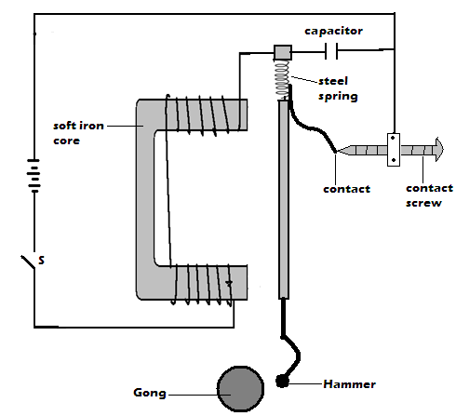


LABO ATOMS
Table of Contents
 | ACKNOWLEDGEMENT | Page 2
 | BRIEF PERSONAL PROFILE | Page 2
 | GUIDELINES IN MY LIFE | Page 2
Chapter 1 | MAGNETISM | Page 3
Chapter 2 | MEASUREMENT II | Page 9
Chapter 3 | TURNING EFFECT OF A FORCE | Page 15
Chapter 4 | EQUILIBRIUM AND CENTRE OF GRAVITY | Page 18
Chapter 5 | SOUND | Page 21
Chapter 6 | HOOKE’S LAW | Page 25
Chapter 7 | MAGNETIC EFFECT OF AN ELECTRIC CURRENT | Page 30
Chapter 8 | WAVES I | Page 36
Chapter 9 | FLUID FLOW | Page 40
Chapter 10 | REFLECTION AT CURVED SURFACES | Page 45

Acknowledgement
First and foremost I thank the Almighty God for the gift of life, energy, knowledge and skills to pursue this work.
I am very grateful to the entire Nyabururu Girls’ High school fraternity for generously supporting me all round as I worked on this material. I must specifically appreciate the H.O.D Physics Nyabururu Girls’ Mr. Albert O. Onditi for the support and encouragement.
The support by Matongo Secondary School Science department members, Mr. Onyancha and Mr. Misati of Physics, Mr. Ondieki of Chem, Madam Abigael, Priscilla and Jael of Chem/Bio must be appreciated.
The care and best wishes I received from my mother Joyce Mokeira and my siblings deserve special attention. They were a great source of encouragement.
Lines that influence activities in my life
- God is always there to assist provided you ask for Him.
- At its best, Physics eliminates complexity by revealing underlying simplicity.
- There is no method of changing your fate except through hard work.
- Cohesion with immediate neighbours and determination always betters your immediate environment.
Brief Personal Profile
Chweya, N. E. is a Physics/Chemistry teacher. He is a First Class Honors B.Ed graduate from Moi University (Chepkoilel). He also has profound knowledge in computer applications and graphics.
 | Chapter One $MAGNETISM$
 | Properties of magnets  - Magnetic poles  - Magnetic poles refer to the ends of a magnet where the power of attraction or repulsion is greatest.  - The force of attraction of a magnet is greatest at its poles. The force reduces away from poles. This is why when a bar magnet is dipped in iron fillings, the fillings cling mainly around the ends of the magnet.  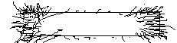  - Directional property of a magnet  - If a magnet is suspended by a thread and is free to rotate it rotates and finally rests in the in the North-south direction. This is called the directional property of a magnet.  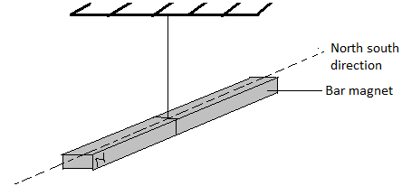  - Magnetic and non- magnetic materials  - Magnetic materials are those that can be attracted by magnets e.g. Iron, Nickel, Cobalt, Iron alloy like steel, Nickel alloy etc.  - Non-magnetic materials are those that cannot be attracted by a magnet e.g. Copper, Brass, Aluminium, Glass, wood, Graphite  - Ferromagnetic materials are magnetic materials that are strongly attracted by magnet e.g. soft iron  - The Basic Law of Magnetism  It states that like poles of magnets repel while unlike poles attract. |  | 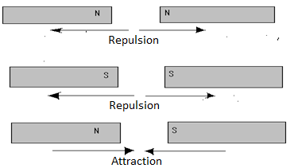  - Repulsion is the only sure test for polarity of magnet. This is because repulsion can only occur between like poles of magnets. Attraction is not sure test because it can occur between unlike poles of magnets or between a magnet and unmagnified magnetic material.
Exercise
- Describe how you would verify the basic law of magnetism given two bar magnets and a piece of thread
Solution
Procedure
Suspend one bar magnet. Bring the north pole of another magnet towards the north pole of the suspended magnet and observe what happens.
Bring the same pole towards the south pole of the suspended magnet.
Observations and conclusion
A north pole attracts a south pole and repels a north pole while a south pole repels a south pole. Hence, like poles repel while unlike poles attract.
Magnetic field patterns
Magnetic field
- The space around a magnet where the magnetic influence (magnetic force of attraction and repulsion) is felt
- The field is stronger near the poles of the magnet and is weaker farther away from the poles.
 | Magnetic field lines  - These are lines of force which represent a magnetic field. These lines form a magnetic field patterns.  Direction of magnetic field  - The direction of magnetic field at a point is the direction to which a free north pole would move if placed at that point in the field.  Characteristics/ properties of magnetic field lines  - Magnetic field lines start from the North Pole and end at the South Pole.    - They repel each other sideways and form closed paths as shown above.  - They do not intersect each other.  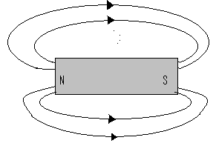  - They are closer together where the field is stronger.  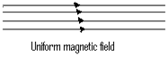  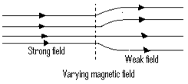  - Consider two bar magnets with opposite poles adjacent.  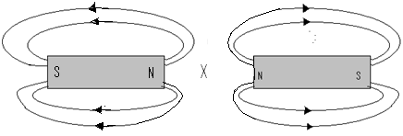 |  | - Point x is called neutral point. The resultant magnetic field at the neutral point is zero.  - Magnetic field lines get concentrated along the soft iron.  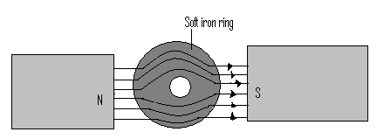  - The soft iron ring concentrates the magnetic field lines thus preventing them from pausing through region P. This is called magnetic shielding and region P is therefore said to be shielded by the ring from magnetic fields.  Practical application of magnetic shielding  - The soft iron rods and rings are used in magnetic shielding where some electrical measuring instruments and watches are shielded and protected from stray magnetic fields.  Exercise  - Describe how you would shield a magnetic material from a magnetic field. State one application of magnetic shielding.  - Explain the meaning of the following  - Magnetic field  - Magnetic lines of force  - The diagram below the magnetic field patterns between two magnets P and Q  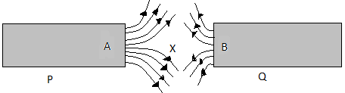  - Identify poles A and B  - State which of the two magnets P and Q is stranger. Explain.
 | - Sketch the magnetic field patterns for the arrangement below.  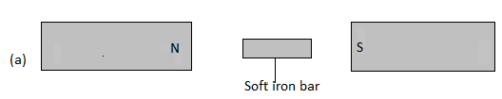  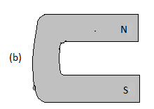  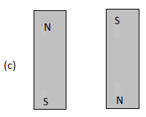  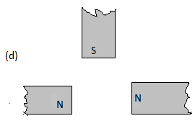  The Domain Theory of Magnetism  - Magnets consist of small magnetic groups referred to as magnetic domains. Domains have a common magnetic axis. Domains comprise smaller sub – atomic magnets (molecular magnets) called dipoles. The dipoles in a particular domain point towards a common direction.  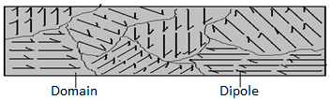 |  | Magnetization  - Magnetization is the process of making a magnet from magnetic material. During this process, dipoles get aligned. In a partially magnetized material most but not all domains are aligned in one direction.  - When a material is fully magnetized all the domains are aligned in one direction. At this state the material is said to be magnetically saturated.  - There are four common methods of magnetization; these are:  - Induction  - Stroking  - Hammering in north-south direction  - Electrical method using direct current.  - Electrical method  - Direct current is used.  - The magnetic material to be magnetized is placed inside the solenoid connected in series with the battery. The switch is closed and current is passed through the solenoid for some time.  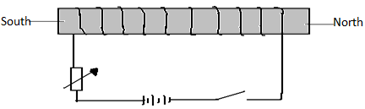  - The polarities of the magnet depend on the direction of the electric current.  - The poles of the magnet can be identified using the right hand grip rule for current carrying coil which states that: If a coil carrying a current is grasped in the right hand such that the fingers point in the direction of current in the coil, then the thumb points in the direction of North Pole.  Notes:  - Allowing the current to flow for a long time does not increase the extent of magnetic saturation. It only causes overheating of the solenoid which adversely affects magnetism.  - A solenoid is a coil with many turns of insulated copper wire.
 | Exercise  - In an experiment to magnetized two substance X and Y using current two curves wave obtained as shown below.  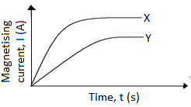  Explain the difference between X and Y  - The graph in the figure below show the relationship between the attractive force of an electromagnetic and the magnetizing current  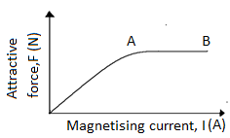  Explain the shape of the curve at point AB using the domain theory.  - Hammering (mechanical method)  - This method makes the use of the earth’s magnetic field. A steel bar to be magnetized is placed in the north-south position and the upper end is hammered. The end pointing northward becomes a north pole and the one pointing southward the South Pole.  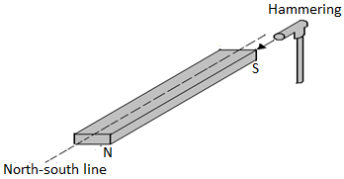  - Induction  - In this method, a magnet induces magnetism in a magnetic material in contact with it. The end of the material in contact with the magnet attains a polarity opposite to the pole of the magnet. |  | 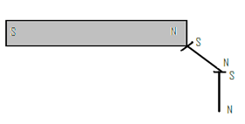  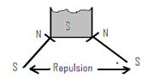  - Stroking method  - In this method a magnetic material bar is repeatedly stroked using one end of a strong magnet. Stroking aligns domains and therefore the magnetic material becomes a magnet. There are two types of stoking:  - Single stroke method  - In this method the magnetic material is stroked with one pole of the magnet from one end to another, lifting it away as shown. The stroking is repeated several times while keeping the inclination of the magnet the same.  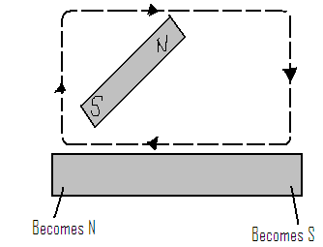  - The end of the magnetic material bar where the magnet finishes stroking acquires an opposite polarity to that of the stroking magnet.  Disadvantages of single stroke method  - It produces magnets in which one pole is nearer the end of the magnetized material than the other.  - N/B This disadvantage can be avoided by use of double stroke method.
 | b) Double stroke method  - In this method, the magnetic material bar is stroked from the centre repeatedly in opposite directions, using opposite polarities of two bar magnets as shown in (a) below or like poles as in (b) below.  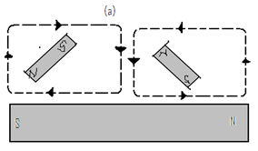  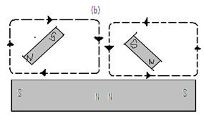  Exercise  With the aid of a diagram explain how you would magnetized a steel bar so as to obtain a south pole at marked end of the bar by  - Using a permanent magnet  - Using an electric current  Which of the above method produce stranger magnet? Give a reason.  Demagnetization  - This is the process by which a magnet losses magnetism. In this process domains reverse their direction and get misaligned (disoriented)  - A magnet can undergo self-demagnetization if poorly stored or the process can be influenced externally by giving the dipoles enough energy to overcome the forces holding them in a particular direction. |  | Demagnetization can be hastened by any of the following methods;  - Heating  - Hammering in east-west position  - Dropping on a hard surface  - Electrical method using alternating current.  - Hammering  - Hammering a magnet placed in the east- west direction or dropping it evidently on the hard surface floor several times makes it lose most of the magnetism.  - Heating  - Heating a magnet until red hot and cooling it suddenly when resting in the east- west direction makes it lose its magnetism.  - Electrical method  - Placing a magnet in a solenoid placed in east west direction and passing an alternating current demagnetizes it. This is because alternating current reverses many times per second, disorienting the magnetic dipoles.  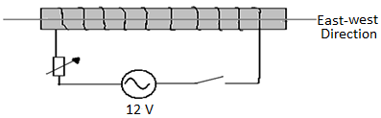  Hard and soft magnetic material  Soft magnetic material  - These are those magnetic materials magnetized easily but do not retain their magnetism for long. Examples: iron, alloy of iron and nickel.  Applications of soft magnetic materials  - Making electromagnets  - Making transformer cores  - Used for magnetic shielding  Hard magnetic materials  - These are magnetic materials that are difficult to magnetize but once magnetized they retain their magnetism for a long time. Example – steel.  Application of hard magnetic materials: Used in making permanent magnets
 | Storing magnets  - Bar magnets are stored in pairs with soft iron keepers placed across their ends to prevent self-demagnetization. Unlike poles of the magnets are placed close to each other.  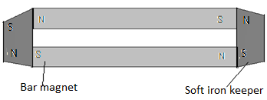  - The magnets magnetize soft iron keepers through induction. The aligned dipoles form a closed loop or chain round the magnets and the keepers, with no free poles.  Uses of magnets  - Used in hospitals for removing pieces of iron from the eyes of patients.  - Used to industries as stirrers, lifting iron scrap metals.  - Weather stations for resetting six’s minimum and maximum thermometer.  - Navigation for showing direction as in compass needles  - Magnetic tapes used in audio and video recorders. |  | - State the polarities of ends X and Y.  - With the aid of a diagram explain how bar magnets are stored so as to minimize self demagnetization  - Describe a simple experiment to show the existence of magnetic poles  - Name two properties of a magnet  - What are ferromagnetic materials?  - Using the domain theory of magnetism, explain why  - The stray of a magnet cannot be measured beyond a certain point.  - The temperature increase weaker or destroy the magnetism of a magnet.  - The graphs below are for two magnetic materials.  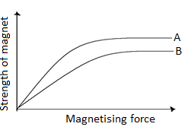  - Which material is easier to magnetize?  - Which material forms a stronger magnet?  - State one application of each.  - Two similar razor blades are placed one on a wooden block and the other on a soft iron block as shown below.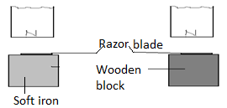  It was observed that the razor blade on the wooden block was attracted to the magnet while the other on the soft iron was not. Explain.
 | Revision Questions
- Why is soft iron used as magnet keeper?
- Describe how you would shield a magnetic material from a magnetic field. State one application of magnetic shielding
- Use the domain theory to explain a difference between magnetic and non- magnetic materials.
- A coil of insulated wire is wound around a u-shaped soft iron care XY and connected to a battery as shown in the figure below.
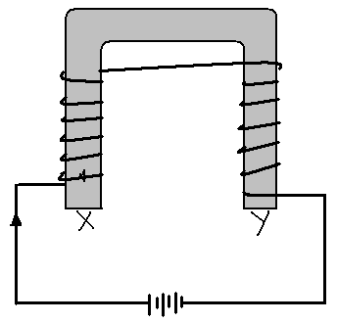
 | Chapter Two $MEASUREMENT II$
 | Specific objectives  By the end of this topic, the leaner should be able to:  - Measure length using vernier calipers and micrometer screw gauge  - Express quantities in correct number of decimal places and correct number of significant figures.  - Express measurements in standard form  - Estimate the diameter of a molecule of oil  - Solve numerical problems in measurement. | Content  - Measurement of length using vernier calipers and micrometer screw gauge  - Decimal places, significant figures and standard form  - Estimation of the diameter of the molecule of oil (relate to the size of the HIV virus, mention effects of oil spills on health and environment.)  - Problems in measurements.
 | Vernier Calipers  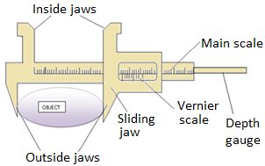  - The Vernier calipers has two scales. The main scale is contained on the steel frame and is graduated in centimeters but also has millimeters divisions. The Vernier scale is contained on the sliding jaw and has 10 equal divisions.  - The length of Vernier scale is 0.9cm implying that each division of the vernier scale is 0.09cm.  - The difference between the main scale division and the Vernier scale division is called the least count. This is the accuracy of the Vernier calipers i.e.$\left(0.9-0.09\right)cm=0.01cm$  - Vernier calipers has inside jaws used to measure internal diameters and outside jaws used to measure external diameters. | Using Vernier Calipers  - Place the object whose diameter (length) is to measured between the outside jaws.  - Close the jaws till they just grip the object.  - Record the reading of the main scale, opposite and to the left of the zero mark of the vernier scale.  - Read the vernier scale mark that coincides exactly with a main scale mark and multiply it with the least count (accuracy) of the Vernier calipers. This is the Vernier scale reading.  - The sum of the vernier scale reading and the main scale reading gives the diameter (length) of the object.  Vernier calipers reading = vernier scale reading +main scale reading  Example  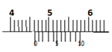  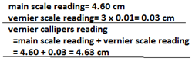
 | Exercise  - Describe how you would measure the internal diameter of 100cm³ beaker using vernier calipers.  - Write down the vernier calipers reading in diagram (a) (b) and (c) showed below.  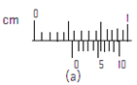  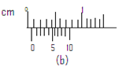  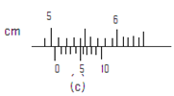  Zero Error of the Vernier Calipers  - Vernier calipers is said to have a zero error if the zero marks of the main scale and vernier scale do not coincide when the jaws of the calipers are closed without an object.  - There are two types of errors:  - Positive Error  - Occurs when the zero mark of the main scale is to the left of the zero mark of the vernier scale.  Example  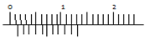  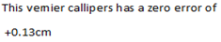  Correction of the Positive Error  - The positive error is corrected by subtracting the zero error from the reading obtained. | - Negative Error  - Occurs when the zero mark of the main scale is to the right of the zero mark of the vernier scale  Example  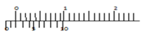  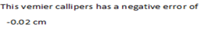  Correction of the Negative Error  - The negative error is corrected by adding zero error to the reading obtained.  Exercise  The figure below shows a vernier calipers  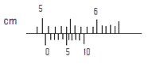  State the correct reading of scale if the instrument has a zero error of – 0.02cm.  Micrometer Screw Gauge  - It is used to measure very small lengths such as the diameter of a thin wire.  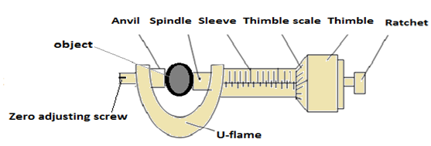
 | - The micrometer screw gauge consist of a thimble which carries a circular rotating scale known as thimble scale and a spindle which moves forward and backwards when the thimble is rotated.  - The sleeve has a linear scale in millimeters and half millimeter called sleeve scale and the thimble has a circular scale of 50 or 100 equal divisions.  - The ratchet at the end of the thimble prevents the user from exerting more pressure on an object when the micrometer screw gauge is in use.  - The distance moved by the spindle in one complete rotation of the thimble is called the pitch of the micrometer. A spindle moves forward or backwards by 0.5mm per a complete rotation of the thimble with 50 divisions.  - Therefore each division of thimble scale represents a spindle travel of  $$\frac{0.5mm}{50}=0.01mm$$  - This means that if the thimble rotates through one division, the spindle moves forward or forward by 0.01mm. This is the least count (accuracy) of the micrometer screw gauge.  - Least count of the screw gauge is defined as the distance moved by the spindle when the thimble rotates through one division.  Using a micrometer screw gauge  - Place the object whose diameter/length is to be measured between the anvil and the spindle.  - Close the micrometer using ratchet until the object is held gently between the anvil and the spindle. Note that the ratchet should slip only once when the grip is firm enough to give accurate reading.  - Read the sleeve scale and record it as:  Sleeve scale reading = --------------mm  E.g. consider the screw gauge below:  - Read the thimble scale and multiply it by the least count of the screw gauge (0.01mm) and record it as:  Thimble scale reading= ……x 0.01=………….mm  - Micrometer reading = sleeve scale reading + thimble scale reading  Examples  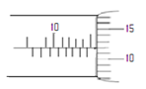 | 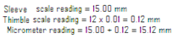  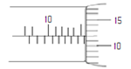  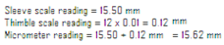  The zero error of the micrometer screw gauge  - It occurs if the zero mark of the thimble scale does not coincide with the horizontal (centre) line of the sleeve scale when the micrometer is closed without an object.  Positive error of micrometer screw gauge  - Occurs when the zero mark of the thimble scale is below the horizontal line.  Example  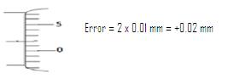  - The positive error is corrected by subtraction of the error from the reading given by the micrometer screw gauge.  Negative error  - It occurs when the zero mark of the thimble scale is above the horizontal line of the sleeve scale.  Example  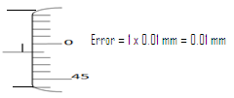  - The negative error is corrected by adding the error to the reading obtained by the screw gauge
 | Significant Figures  - Significant figures refer to the number of digits used to specify the accuracy of a value.  Note:  - The digits 1-9 are all significant when they appear in a number.  - The first digit from the left of a number is the first significant figures  - The number of significant figures is determined by counting the number of digits from the first significant figure on the left.  - Zero may be significant or not depending on the position of the digit  - If zero occurs between non- zero digits it is significant e.g. 1004(4sf), 15607(5sf), 180.45(5sf)  - When zero occurs at the left end of a number it is not significant e.g. 0.00546(3sf), 0.0002(1sf)  - If the zero occurs at the right hand end of an integer it may or may not be significant. E.g. 60000.It can be correct to 1 significant figure therefore the zeros are not significant. If all the zeros are counted (ended) then it will be correct to 6 significant figures.  - If the zero occurs at the right hand end after the decimal point, it is always significant e.g. 2.000(4sf), 3.0(2sf)  Exercise  Write down the number of significant figures in each of the following  - 40000  - 609  - 0.000675  - 5237.8  - 0.0000600  - 0.002304  Standard Form  - This is a way of writing a number especially a very large or very small number in which only one integer appears before the decimal point.  - A positive number is said to be in standard form when written as AX10^{n}, where A is such that 1≤A <10 and the index n is an integer e.g.3567= 3.567x 10³  - If the number lies between zero and 1 then the index n becomes a negative e.g.0.0003567=3.567x10⁻⁴ | Exercise  Express the following in cm giving the answers in standard form  - 0.1mm  - 125 mm  - 3.8m  - 0.015m  - 7.8 km  Decimal places  - Refer to number of digits to the right of the decimal point and this determines the accuracy of the number e.g. 6.0345 (4d.p)  Exercise  Find the volume of a cube whose side is 2.22 cm. Express your answer correct to 3 d.p  Standard Prefixes Used With SI Units  - The table below shows multiples and sub- multiples used with SI units, their prefixes and symbol for the prefixes.
  Sub-multiple/ multiple | prefix | Symbol for prefix
  10⁻¹ | deci | d
  10⁻² | centi | c
  10⁻³ | milli | m
  10⁻⁶ | micro | µ
  10⁻⁹ | nano | n
  10⁻¹² | pico | p
  10⁻¹⁵ | femto | f
  10⁻¹⁸ | atto | a
  10¹ | deca | da
  10² | hecto | h
  10³ | kilo | k
  10⁶ | mega | M
  10⁹ | giga | G
  10¹² | tera | T
  10¹⁵ | peta | P
  10¹⁸ | exa | E
 | The Oil Drop Experiment  - This is an experiment used in the estimation of diameter/ size /thickness of a molecule.  - In this experiment, a tray is filled with water to the brim, and lycopodium powder is lightly sprinkled on the water surface.  - An oil drop is carefully placed at the centre of the tray and allowed to spread on the surface of water until it is one molecule thick. This forms a patch whose diameter is measured  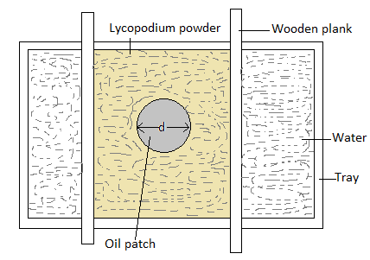  - Thickness of oil molecule is estimated as d  volume of oil drop = volume of oil patch  $$\frac{4}{3}πr^{3}=π(\frac{d}{2})^{2}×thickness, t, of oil patch (or molecule)$$  Functions of lycopodium powder  - It breaks surface tension  - it clearly shows the extent of spread of the oil drop  Function of beams:  - Used to estimate diameter of the spread oil patch  Assumptions made in oil drop experiment  - The oil drop is perfectly spherical  - The oil patch is perfectly cylindrical  - The oil patch is one molecule thick. | Possible Sources of Error in the Experiment  - Error in measuring the diameter ( or volume) of oil drop  - Error in measuring diameter of oil patch  Exercise  - In an experiment to estimate the size of an oil molecule, the diameter of the patch was measured to be 200mm for an oil drop of radius 0.25mm. Determine the diameter of the molecule of the oil  - In an experiment to estimate the diameter of oil molecule 100 drops of oil are released from burette and level of oil in burette changes from 0.5cm³ to 20.5 cm^{3.} One of the drops is placed on water and spreads over a circular patch of diameter 20 cm.  - Determine:  - The volume of the oil drop  - The area of the patch covered by the oil  - The diameter of the oil molecule  - State:  - Assumptions made in this experiment  - Two possible sources of errors in this experiment
Revision Questions
- What are the zero errors of the micrometer screw gauges shown in the figures below?(the micrometers are closed).if the micrometers were used to measure the diameter of a wire whose diameter is 1.00 mm, what would be the reading on each?
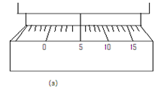
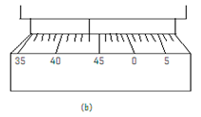
- Compare and contrast the scales of two micrometer screw gauges with a pitch of 0.5mm and 1.0mm.
- What are the two limitations of the micrometer screw gauge?
- List down the advantages and disadvantages of the micrometer screw gauge over the vernier calipers
- Sketch a micrometer screw gauge scale reading:
- O.23 mm
- 5.05 mm
- (a)What are the zero errors of the vernier calipers in figures (a) and (b) below?
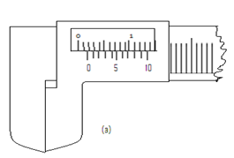
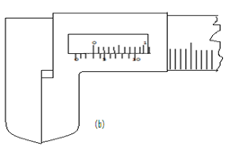
(b) If the correct diameter of an object is 4.01 cm, what would be the readings of both calipers for this diameter?
( c) The calipers in figure (a) was used to measure the diameter of a cylindrical object and recorded 4.55 cm while the one in figure (b) was used to measure the diameter of a sphere and recorded 5.05cm. Calculate correct volumes of these objects in m³. (Take π = 3.142)
 | Chapter Three $TURNING EFFECT OF A FORCE$
 | Moment of a Force  - Basically, moment of a force refers to the turning effect of the force.  - It is defined as the product of the force and the perpendicular distance between the point of support (pivot or fulcrum) and the line of action of the force.  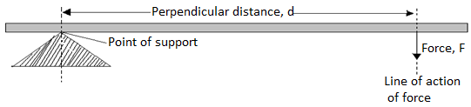  $$Moment of a force=force×perpendicular distance$$  - SI unit of moment of a force is the newton meter (Nm)  Factors Affecting Moment of a Force  - Amount of force – moment of force is directly proportional to the amount of force applied.  - Perpendicular distance between line of action of force and point of support – moment is directly proportional the distance 90⁰.  Examples of Activities in Which Force Produces a Turning Effect  - Opening and closing a door  - Closing a lid of a container e.g.( geometrical instrument box)  - A pair of scissors or garden shears in use  - Children playing on “ see saw”  - A wheelbarrow being used to lift heavy loads  - A screwdriver being used to tighten or loosen a screw.  - Beam balance in use.  Examples  Find the moment of the force about the pivot in the figures below  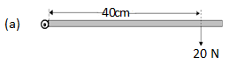 | $$Moment of a force=force ×perpendicular distance$$  $$∴moment of force about pivot=20N×0.4 m$$  $$=8 Nm$$  The Principle of Moments (the Law of the Lever)  - Consider a meter rule balanced (at equilibrium) on a pivot at its centre by weights W₁, W₂, W₃ and W₄ as shown below.  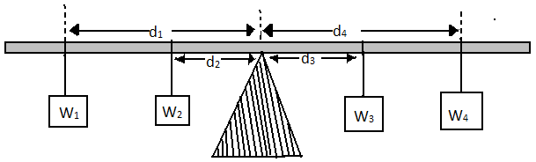  - The forces W₁ and W₂tend to make the rule turn in the anticlockwise direction about the pivot. Therefore, the moments due to these weights are referred to as an anticlockwise moments.  - Similarly, the forces W₃ and W₄ tend to make the rule turn in a clockwise direction and therefore, their moments about the pivot are clockwise moments.  Sum of clockwise moment =W₃d₃ + W₄d₄  Sum of anticlockwise moment =W₁d₁ + W₂d₂  At equilibrium (balance), Sum of clockwise moment = Sum of anticlockwise moment  W₃d₃ + W₄d₄ = W₁d₁ + W₂d₂  - This can be summarized by the principle of moments which states “for a system in equilibrium the sum of clockwise moments about a point must be equal to the sum of anti clockwise moments about the same point”.  N/B: A body is said to be at equilibrium when it is balanced under the action of a number of forces.
 | Examples  - State the law of the lever ( as above)  - A uniform meter rule pivoted at its centre is balanced by a force of 4.8N at 20cm mark and some other two forces, F and 2.0N on the 66cm and 90cm marks respectively. Calculate the force F.  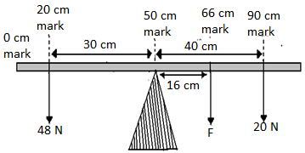  At equilibrium (balance),  Sum of clockwise moment = Sum of anticlockwise moment  $$F ×0.16+2.0×0.40=4.8×0.30$$  $$0.16F+0.80=1.44$$  $$0.16F=0.64$$  $$F=\frac{0.64}{0.16}$$  $$F=4.0 N$$  - A boy of mass 40kg sits at a point 2.0m from the pivot of a seen saw. Find the weight of a girl who can balance the see-saw by sitting at a distance of 3.2m from the pivot. (Take g =10nkg)  solution  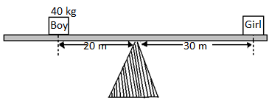  At equilibrium (balance),  Sum of clockwise moment = Sum of anticlockwise moment  $$W_{g}×3.2m=\left(40kg×10\frac{N}{kg}\right)×2.0m$$  $$3.2W_{g}=800$$  $$W_{g}=\frac{800}{3.2}$$  $$w_{g}=250 N$$ | Exercise  A half meter rule is suspended vertically from a pivot at the 0 cm mark. It is maintained in the vertical position by four horizontal forces acting in the directions shown in the figure below  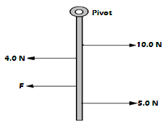  The 10.0 N force acts through the 15 cm mark, 4.0 N force through the 20 cm mark and 5.0 N force through the 40 cm mark. Calculate F which acts through the 30 cm mark.  Parallel forces  - Consider a uniform rod below balanced by the forces F₁, F₂, F₃, F₄, F₅ and R which is the normal reaction on pivot.  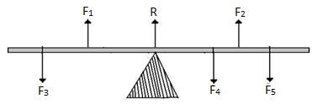  - The forces F₁, F₂, F₃, F₄, F₅ and R are parallel.  - For parallel forces:  - The sum of forces acting on one side of the system is equal to the sum of forces acting on opposite direction i.e. the algebraic sum of parallel forces is zero.  - The sum of clockwise moments is equal to the sum of anticlockwise moments i.e. the algebraic sum of the moments of parallel forces is zero.  Exercise  A uniform metal rod of length 80cm and mass 3.2kg is supported horizontally by two vertical spring’s balances C and D balance C is also from one end while balance D is 30cm from the other end. Find the reading on each balance.
 | Anti – parallel forces (Couples)  - Anti – parallel forces or a couple refers to equal, parallel but opposite forces.  - The total moment of anti-parallel forces is the product of one of the forces and the perpendicular distance between the forces.  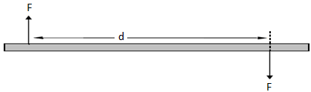  Example  Two vertical equal and opposite forces act on a meter rule at 20 cm and 90 cm marks respectively. If each of the forces has a magnitude of 4.0 N, calculate their moment on the meter rule about the 40 cm mark.  solution  Total moment  = one of the force, F X perpendicular distance between the forces, d  $$=4.0N×\left(0.9-0.2\right)m$$  $$=4.0 N ×0.7$$  $$=2.8 Nm$$  Examples of couples  - Forces applied on a wheel spanner when tightening or loosening a nut  - Forces applied when opening a water tap  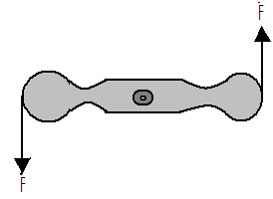 | - Forces applied on the steering wheel of a car when going round a bend  - Forces applied on bicycle handle  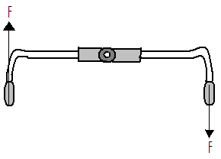  Revision Exercise  - Explain why the handle of a door is placed as far as possible from the hinges.  - Explain why it is easier to loosen a tight nut using a spanner with a long handle than the one with a short handle.  - The figure below shows a uniform bar in equilibrium under the influence of two forces  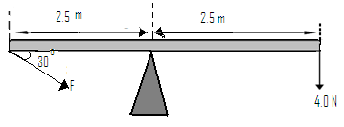
 | Chapter Four $EQUILIBRIUM AND CENTRE OF GRAVITY$
 | Centre of Gravity  - Centre of gravity (COG) of a body is the point of application of the resultant force due to earth’s attraction. It is the point where the whole weight of the body appears to act from. The resultant force is the weight $(W=mg)$of the body.  Centre of Gravity of Regular Shapes  - The centre of gravity of a uniform body (body with weight evenly distributed) lies at the body’s geometrical centre. For example, a uniform meter rule balances at the 50 cm mark when suspended.  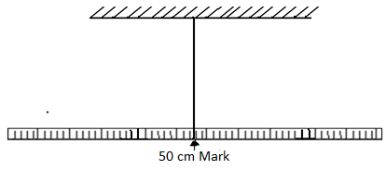  - The centre of gravity of regular shapes can also be determined by construction e.g.  - For square and rectangular plates, diagonals are constructed. The point of intersection is the centre of gravity.  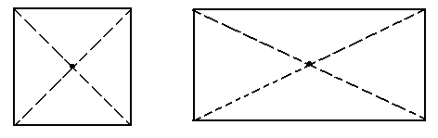  - For triangular plate, perpendicular bisectors of the sides are constructed. The point of intersection is the centre of gravity.  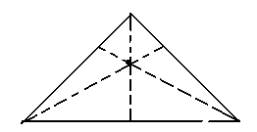 | - For circular plate construct diameters. The point of intersection, which is the centre of the circle, is the centre of gravity.  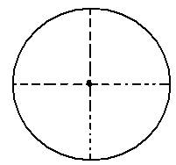  Examples  - A uniform meter rule is balanced at 20cm mark when a load of 1.2N is hung at the zero mark.  - Draw a diagram of meter rule showing all the forces acting on it.  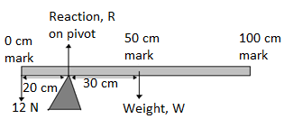  - Calculate the weight and mass of the meter rule  solution  At equilibrium (balance), Sum of clockwise moment = Sum of anticlockwise moment  $$W×0.3 m=1.2 N×0.2 m$$  $$0.3 W=0.24$$  $$∴W=\frac{0.24}{0.3}=0.8 N$$  - Determine the reaction on the pivot.  solution  $$total up ward forces=total downwaed forces$$  $$R=1.2+W$$  $$R=1.2+0.8$$  $$R=2.0 N$$
 | - The diagram below shows a metal plate 3m long, 1m wide and negligible thickness. A horizontal force of 100N applied at point D just makes the plate tilt. Calculate the weight of the plate.  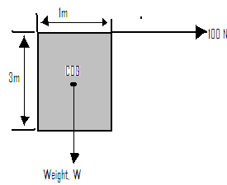  Solution  At equilibrium (balance), Sum of clockwise moment = Sum of anticlockwise moment  $$100 N×3 m=W×0.5 m$$  $$300=0.5 W$$  $$∴W=\frac{300}{0.5}=600 N$$  Exercise  - A uniform half- meter rule is pivoted at the 10cm mark. Find the position of a 2.0 N weight that will balance the rule horizontally if the weight of the rule is 0.4 N.  - The figure below shows a uniform plank of length 6.0m acted upon by the forces shown. If the plank has a weight of 300 N, draw the diagram showing all the forces acting on the plank. Calculate the tension T in the string and the reaction at the pivot.  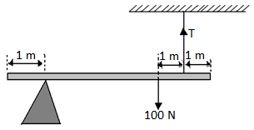  - Define the centre of gravity of a body | - The figure below shows a diagram, of mass 150kg and radius 0.5m being pulled by horizontal force F against a step 0.1 m high. What initial force, F, is just sufficient to turn the drawn so that it rises over the step. If the diagram below shows spherical balls placed at different positions on a surface.  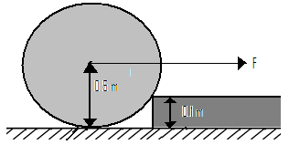  Equilibrium States  - State of equilibrium refers to state of balance of a body. There are three states of equilibrium:  - Stable equilibrium  - A body is said to be in a stable equilibrium if it returns to the original position after being displaced slightly. The funnel does not topple over since the line of action of weight still falls inside the base of the funnel.  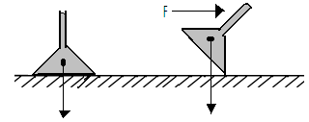  - Unstable equilibrium.  - A body is in unstable equilibrium if on being displaced slightly, it does not return to its original positions but occupies a new position. The funnel below topples over because the line of action of weight falls outside the base of the funnel.  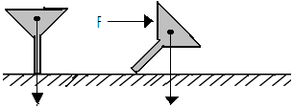  - Neutral equilibrium  - A body is said to be in neutral equilibrium if on being displaced it occupies a new position which is similar to the original position.  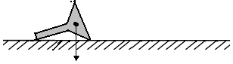
 | Conditions for Equilibrium  - The sum of forces on the body in one direction is equal to the sum of forces acting on the body in the opposite direction  - The sum of the clockwise moments about any point is equal to the sum of the anticlockwise moments about the same point.  Factors Affecting the Stability of a Body  - The position of COG of the body - the lower the position of the centre of gravity the more stable a body is.  - Base area of the body- a body is more stable when the base is wide. A narrow base makes the body to be less stable.  Examples of Application of Stability  - Containers for holding liquids such as conical flask in the laboratory have broad base to improve their stability.  - Racing cars (e.g. formula one car) have wider wheels and lower positions of center of gravity than ordinary cars.  - Most buses carry their cargo in space below the passenger level instead of the roof rack in order to keep the centre of gravity positions low.  - A hydrometer is able to stay upright in a liquid because it is weighted at its base and therefore its centre of gravity is at the base.  - A Bunsen burner has a wide heavy base to increase stability  - A person carrying a bucket of water in one hand has to lean his body to the other side to adjust the position his centre of gravity.  - Chairs, stools, tripod 73 stands, tables etc are provided with three or more legs. The legs are often made slightly inclined outwards to improve stability. | Exercise  - State the conditions of equilibrium for a body acted upon by a number of parallel forces.  - Explain why:  - It is not safe for a double Decker bus to carry standing passengers on the upper deck.  - Bus body- builders build luggage compartments under the seats rather than on roof racks.  - Laboratory stands are made with a wide heavy base.  - When is an object said to be in equilibrium?  - What type of equilibrium has:  - A marble at the bottom of a watch glass?  - A tight rope walker?  - A cylinder sitting on its base?  - A sphere on a level table top?  - A bird perched on a thin horizontal branch of a tree?  - State:  - Two ways in which the stability of a body can be increased.  - Two practical application of stability.  - Explain how a cyclist maintains the stability of a moving bicycle.  - Describe the state of equilibrium of the ball in each position  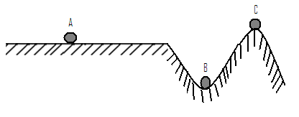
 | Chapter Five SOUND
 | Specific objectives  By the end of this topic the leaner should be able to:  - Perform and describe simple experiments to show that sound is produced by vibrating bodies  - Perform and describe an experiment to show that sound requires a material medium for a propagation.  - Explain the nature of sound waves.  - Determine the speed of sound in air by the echo method.  - State the factors affecting the speed of sound.  - Solve numerical problems involving velocity of sound. | Content  - Sound: nature and sources (experimental treatment required)  - Propagation of a sound  - Compressions and rarefaction  - Speed of a sound by echo sound  - Factors affecting the speed of a sound  - Problems on velocity of a sound
 | Definition of Sound  - Sound is a form of energy that originates from vibrating objects. It is a longitudinal mechanical wave.  Some Sources of Sound  - Vibrating wooden strip  - Vibrating wire e.g. guitar wire being pluck.  - Vibrating drum  - Tuning fork- the prongs of tuning fork are made to vibrate by striking them against a hard surface.  - Vibrating air columns e.g. blowing air a cross the mouth of a test- tube.  - Air siren- it is a form of disk with a ring of equally spaced holes which are equidistant from the centre. It is rotated at a constant rate as air is blown through the holes.  - Cog-wheel and card  - Voice box (larynx)  Propagation of Sound Energy  - Sound wave is propagated in form of compressions (areas of high pressure) and rarefactions (areas of low pressure) through propagating medium. Sound requires a material medium for propagation. | 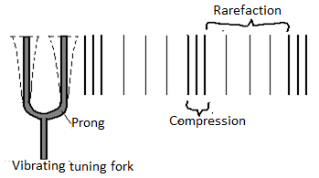  Exercise  - The figure below shows a vibrating fork. The time interval for the prong to go from A to B is 0.005 s. Find:  - The frequency of the fork  - The wavelength of the vibrations, if the velocity of sound in air is 340 m/s.  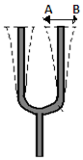
 | - The diagram below shows sound waves passing through air. Study it and answer the questions that follow.  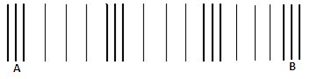  - Label the following:  - Compression  - Rarefaction  - wavelength  - If the wave front takes 0.1 s to travel from A to B, find:  - The frequency  - The wavelength, if velocity of sound in air is 330 m/s.  Experiment  Aim:  To show that sound requires a material medium to travel. (I.e. sound does not travel in vacuum)  Apparatus  Electric bell  Switch  Bell glass- jar  Vacuum pump  Wires  Cells  Glass plate  Procedure  - Set up the apparatus as shown in the diagram below.  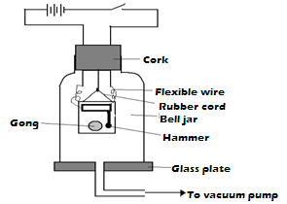 | - Close the switch and observe what happens.  Observation: It is observed that the bell begins to ring and the sound is heard outside.  - Gradually pump out some air and note the effect this has on sound reaching you.  Observation: The intensity of sound decreases gradually.  - Pump as much air out of the jar as possible and listen to the sound produced.  Observation: Sound is found to have almost disappeared though the hammer can be seen vibrating  Conclusion  The above observations show that the sound cannot travel through a vacuum. It needs a material medium for propagation.  Factors Affecting Velocity of Sound In Air  - Temperature of the air - sound travels faster in hot air than in cold air.  - Humidity of the air - the velocity of sound on air increases with humidity  - Direction of wind -wind blowing in the same direction as sound increases the velocity of the latter.  Sound Transmission in Solids, Liquids and Gases  - Sound travels fastest in solids, followed by liquids and then gases.  - Speed of sound in materials varies from solid to solid, liquid to liquid and gas to gas depending on the density of the material. Denser material transmits sound faster.  Reflection Property of Sound Waves  - Reflected sound is called echo. Sound is reflected when it falls on hard surfaces.  - Reflections of sound waves also obey the laws of reflection:  - The angle of incidence is equal to the angle of reflection at point of incidence  - The incident sound, the reflected sound and the normal lie on the same plane.
 | Reverberation  - Reverberation refers to the effect in which original sound seems prolonged due to overlap with the echo sound. It occurs in some halls, sound waves are reflected from walls, floor and ceiling and since the echo time is short; the echo overlaps with the original sound.  - To reduce reverberation in places like broadcasting studios and concert halls, walls are made using absorbent materials like cotton wool and foam rubber.  Applications of Reflection of Sound  - Determination of Speed of Sound  - In this case, sound is produced in front of an obstacle whose distance away is known. The time for the sound to reach the obstacle and back to the source (i.e. time for echo to be heard) is measured using a stop watch.  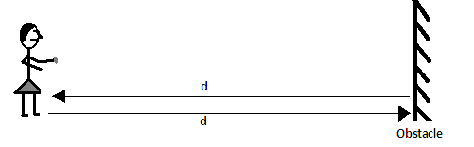  $$Speedofsound=\frac{distancetravelled, 2d}{timetaken , t}=\frac{2d}{t}$$  Example  - A man standing in a valley between two cliffs strikes a gong. He hears an echo from one cliff 0.7s later and from the other 0.2 s after the first. Determine the width of the valley. (Speed of sound in air, v=330ms⁻¹)  Solution  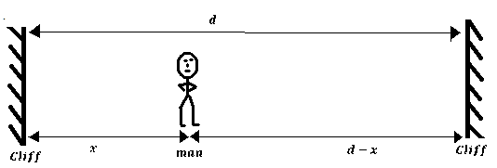  $$letditancefromnearestcliffbexand$$  $$thatbetweenthetwocliffsd$$  $$distance=speedofsound ×time$$ | $$∴2x=330\frac{m}{s}×0.7s$$  $$x=\frac{330×0.7}{2}=115.5 m$$  $$Also, 2(d-x)=330\frac{m}{s}×\left(0.7+0.2\right)s$$  $$d=\frac{297}{2}+x$$  $$d=148.5+115.5 =264 m (this is the width of the cliff)$$  - A time keeper in 100m race stands at the finishing point. He starts his watch the moment he hears the sound of a gun. What error does he make in the timing of the race? (Speed of sound in air is 330ms⁻¹)  Solution  The error is equal to the time taken for the sound from the gun to reach the time keeper, i.e. time taken for sound to travel 100m at the speed of 330ms⁻¹ the sound takes:  T=$\frac{100m}{{330ms}^{-1}}=0.303 seconds$  =============================================  - Determination of Distances by Producing Sound of a Known Speed (pulse-echo technique)  - Pulse-echo technique involves measuring distances by producing sound of known speed and measuring time taken to receive an echo.  - Ultrasound (sound of frequency of over 20 KHz) is used in pulse-echo technique because it penetrates deepest and can be reflected easily by tiny grains.  Exercise  A fishing boat uses ultra- sound of frequency 6.0x10⁴ Hz to detect fish directly below. Two echoes of the ultrasound are received, one after 0.09s coming from the shoal of fish and other after 0.12s coming from the sea bed. If the sea bed is 84m below the ultrasound transceiver, calculate:  - The speed of ultrasound waves in water  - The wavelength of the ultrasound waves in water  - The depth of the shoal of fish below the boat
 | Applications of Pulse- Echo Technique  Used:  - In the ship to determine the depth of the sea.  - In under water exploration of gas and oil.  - In fishing boats with pulse echo equipment to locate shoals of fish.  - In special types of spectacles used by the blind people to tell how far objects are ahead of them.  - By bats to detect the presence of obstacles in their flight path.  Revision Exercise  - State how the pitch of sound wave is affected by frequency  - The following diagram shows a set up that was used to demonstrate that sound requires a material medium for transmission.  - State what happens to the sound from the bell as air continues to be drawn from the jar  - What happens to the sound if some air is allowed back into the jar  - Give possible reasons why it is not possible to reduce sound completely in this experiment  - A girl standing some distance away from the cliff blows a whistle and hears an echo 1.10s later. If the speed of a sound in air is 350ms^{-1,} determine how for the girl is from the foot of the cliff.  - A loudspeaker placed between two walls but nearer to wall A than wall B is sending out constant sound waves. Determine how far the loudspeaker is from wall B if it is 100m from wall A and the time between the two echoes received is 0.2 seconds. (Speed of sound in air= 340ms⁻¹) | - In an experiment to determine speed of sound in air, a drum at a point 150m from a vertical wall was struck at varying frequency while listening to the echo. The echo coincides with the sound from the drum at a time when to successive strikes were made within a time of 18.5s.  - Determine the time taken for an echo to be heard  - Determine the speed of sound in air at the place  - What difference would you expect if the experiment was repeated on a colder day?  - A boy strikes a railway line with a hammer. A railway walker 600m a way hears two sounds, one from the railway line and the other from air. If the time interval between the two sounds is 1.65 s and the speed of sound in air is 340ms⁻¹, determine the speed of sound in the railway line.
 | Chapter Six HOOKE’S LAW
 | Specific objectives  By the end of this topic, the learner should be able to:  - State and verify experimentally Hooke’s law  - Determine the spring constant  - Construct and calibrate a spring balance  - Solve numerical problems involving Hooke’s law | Content  - Hooke’s law  - Spring constant  - Spring balance  - Problems on Hooke’s law
 | Introduction  - The knowledge of stretching materials when forces are applied is important particularly in the construction industry. It helps engineers to determine the strength of the materials to be used for specific work. This topic deals with study of how materials behave when stretched and the relationship between the extent of stretching and stretching force. The pioneer of the topic is the physicist Robert Hooke.  Characteristics of Materials  - Strength  - It is the ability of a material to resist breakage when under stretching, compressing or shearing force. A strong material is one which can withstand a large force without breaking.  - Stiffness  - Refers to the resistance a material offers to forces which tend to change its shape or size or both. Stiff materials are not flexible and resist bending.  - Ductility  - This is the quality of a material which leads to permanent change of shape and size. Ductile materials elongate considerably when under stretching forces and undergo plastic determination until they break e.g. lead, copper, plasticine.  - Brittleness  - This is the quality of a material which leads to breakage just after elastic limit is exceeded. Brittle materials do not undergo extension and break without warning on stretching. E.g. blackboard chalk, bricks, cast iron, glass, and dry biscuits. | - Elasticity  - This is the ability of a material to recover its original shape and size after the force causing deformation is removed. The materials with this ability are called elastic e.g. rubber bands, spring, and some wires.  - A material which does not recover its shape but is deformed permanently is called plastic e.g. plasticine.  Hooke’s Law  - Hooke’s law relates the stretching force and extension produced.  It states that “for a helical spring or any other elastic material, extension is directly proportional to the stretching force, provided elastic limit is not exceeded”  $$i.e.F∝e; F=ke,$$  $$Where k is the constant of$$  $$proportionalitycalledspringconstant.$$  - Sl unit of spring constant is the newton per meter (N/m).  - Spring constant is defined as the measure of stiffness of a spring.  - Graphically, Hooke’s law can be expressed as below.
 | 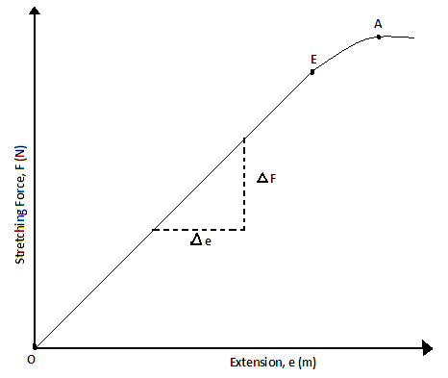  - The graph of stretching force against extension, for material that obeys Hooke’s law, is a straight line through the origin. The gradient (slope) of such a graph gives the spring constant of the spring used.  $$Gradient\left(slope\right)=\frac{changeinF}{changeine}=springconstant$$  $$S=\frac{ΔF}{Δe}=k$$  - If the stretching force exceeds a certain value, permanent stretching occurs.  - The point beyond which the elastic material does not obey Hooke’s law is called elastic limit.  - A point beyond which a material loses its elasticity is called yield point.  - Along OE the spring (or elastic material) is said do undergo elastic deformation.  - Along EA the spring is said to undergo plastic deformation  Factors Affecting Spring Constant  - Type of material making the wire  - Length of the spring  - The number of terms per unit length of the spring  - The diameter (thickness) of the spring  - The thickness of the wire  Examples  - A spring stretches by 1.2 cm when a 600g mass is suspended on it. What is its spring constant? | Solution  $$k=\frac{F}{e} =\frac{mg}{e}$$  $$k=\frac{\left(600×{10}^{-3}×10\right)N}{1.2×{10}^{-2}m}=500Nm^{-1}$$  - The figure below shows a spring when unloaded, when supporting a mass of 80g and when supporting a stone. Study the diagrams and use them to determine the mass of the stone.  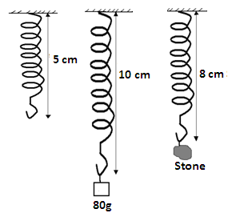  Solution  $$k=\frac{F}{e}=\frac{mg}{e}$$  $$k=\frac{\left(80×{10}^{-3}×10\right)N}{\left(10-5\right)×{10}^{-2}m}=16{Nm}^{-1}$$  $$F=W_{stone}=ke$$  $$W_{stone}=16\frac{N}{m}×3×{10}^{-2}=0.48N$$  $$m=\frac{W}{g}=\frac{0.48N}{10{Nkg}^{-1}}$$  $$=0.048kg (thisisthemassofthestone)$$  - A spiral spring produces an extension of 6mm when a force of 0.3N is applied to it. Calculate the spring constant for a system when two such springs are arranged in:  - Series
 | 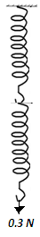  $$Totalextension = 2x6x{10}^{-3}m=1.2x{10}^{-2}m$$  $$Totalforce =0.3N$$  $$F=ke (fromHooke’slaw)$$  $${ K}_{s}=\frac{F}{e}=\frac{0.3}{1.2x{10}^{-2}}={25Nm}^{-1}$$  - Parallel  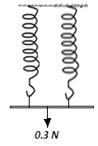  Since the two springs will share the weight, extension of the system is $\frac{1}{2}$x6mm = 3mm  Spring constant of the system, k_{P} is  k_{p}= $\frac{F}{e}=\frac{0.3N}{0.003m}=100Nm^{-1}$  - The data below represents the total length of a spring as the load suspended on it is increased | - Plot a graph of total length (y-axis) against weight  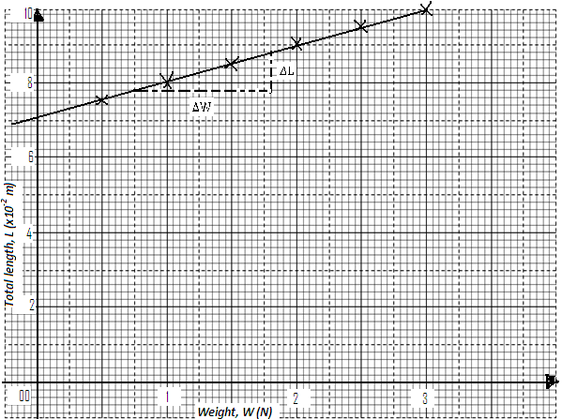  - Use the graph to determine  - The length of the spring  The length of the spring is that when force acting on it is zero. From the graph it is 7.1x10⁻² m  - The spring constant, k.  $$spring constant, k=\frac{1}{slope,S}$$  $$S=\frac{\left(8.8-7.8\right)×{10}^{-2}m}{\left(1.56-0.55\right)N}=0.009091mN^{-1}$$  $$spring constant, k=\frac{1}{0.009091mN^{-1}}=110.0 Nm^{-1}$$  Compressing a spring  - Compression refers to change in length that occurs when a spring is squeezed from its two ends. A sketch of length against compression for a spring which obeys Hooke’s law is as below.  - Beyond the point E, the turns of the spring are virtually pressing onto one another and further increase in force achieves no noticeable decrease in length.
  Weight,  W (N) | 0.5 | 1.0 | 1.5 | 2.0 | 2.5 | 3.0
  Total length, L (x10⁻²m) | 7.5 | 8.0 | 8.5 | 9.0 | 9.5 | 10.0
 | 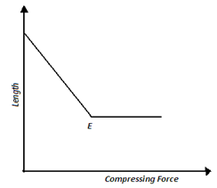  Exercise  - The figure below shows a simple apparatus for studying the behavior of a spring when subjected to forces of compression.  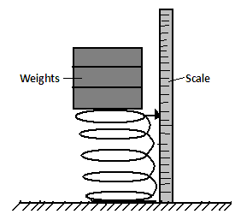  Describe how the apparatus may be used to obtain readings of compression force and corresponding length of spring.  - In a similar experiment the following readings were obtained  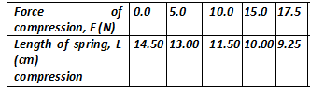  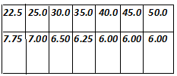  Plot a graph of:  - Compression forces versus length of the spring and from the graph determine the minimum force that will make the spring coils to just come into contact.  - Compression forces versus compression of spring and from the graph determine the spring constant. | Work Done in Stretching or Compressing a Spring  - The area under force versus extension graph is represents to work done in stretching the spring.  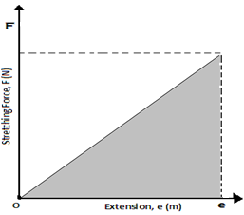  $$Area under the graph=\frac{1}{2}Fe,$$  $$where F is the force applied and e the extension$$  $$attained.sequaltoworkdoneinstrething50Nm-11.2x10-2 =12mm$$  $$From Hooke^{'}s law, F=ke$$  $$Workdone=\frac{1}{2}\left(ke\right)e=\frac{1}{2}ke^{2}$$  Exercise  Two springs of negligible weights and of constants k₁ = 50Nm⁻¹ and k₂ = 100Nm⁻¹ respectively are connected end to end and suspended from a fixed point. Determine  - The total extension when a mass of 2.0kg is hung from the one end  - The constant of the combination.  - Work done in stretching each spring (elastic potential energy of each)
 | Revision Exercise
- State Hooke’s law
- Define the following terms
- Elasticity
- Elastic material
- Plastic deformation
- Spring constant
- Stiffness
- A stiff material
- Elastic material
Yield point
- A 60g mass is suspended from a spring. When 1.5g wire is added, the spring stretches by 1.2cm.Given that the spring obeys Hooke’s law, find:
- The spring constant
- The total extension of the spring
- A piece of wire of length 12m is stretched through 2.5cm by a mass of 5kg. Assuming that the wire obeys Hooke’s law
- Through what length will a mass of 12.5kg stretch it?
- What force will stretch it through 4.0cm?
- The following readings where obtained in an experiment to verify Hooke’s law using a spring
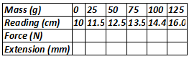
- For each reading calculate:
- The value of the force applied
- The extension in mm
- Plot a graph of extension against force. Does the spring obey Hooke’s law?
- From the graph determine:
- The elastic limit ( mark on graph)
- The spring constant
- The weight of a bottle of ink hung from the spring if the reading obtained is 12cm
- The extension in mm when a force of 0.3N is applied
- The scale reading in cm for a mass of 0.02kg

 | Chapter Seven MAGNETIC EFFECT OF AN ELECTRIC CURRENT
 | Specific objectives  By the end of this topic the learner should be able to:  - Perform and describe experiments to determine the direction of magnetic field round a current carrying conductor  - Construct simple electromagnet  - State the factors affecting the strength of an electromagnet  - Determine experimentally the direction of force on a conductor carrying current in a magnetic field  - Explain the working of a simple electric motor and electric bell | Content  - Magnetic field due to a current  - Oersted’s experiment  - Magnetic field patterns on straight conductors and solenoids (right hand grip rule)  - Simple electromagnets  - Factors affecting strength of an electromagnet  - Motor effect (Fleming’s right hand rule)  - Factors affecting force on a current carrying conductor in a magnetic field (qualitative treatment only)  - Applications:  - Electric bell  - Simple electric motor
 | Introduction  - This topic involves the study of magnetic field due to the flow of electric current in a conductor and the applications of this effect. The pioneer of this physics topic is Hans Oersted, a professor of physics.  Magnetic Effect of an Electric Current Flowing Through a Conductor  - Consider the diagram below of a set up that that can be used to investigate the magnetic effect of an electric current flowing through a conductor. This is commonly called Oersted’s experiment. A and B are magnetic compass needles  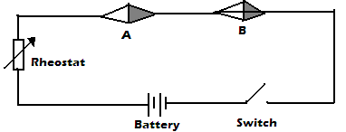  - When the switch is closed, it is observed that the compass needles deflect towards the directions shown in the diagram below. | 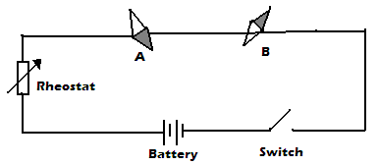  - The direction of deflection of the compass needles can be predicted by Ampere’s swimming rule which states that “if one imagines swimming along a conductor in the direction of electric current and facing the compass needle, then the north pole of the needle will be deflected towards the swimmer’s left hand”  Notes:  - The deflection of the compass needles is due to the interaction between the magnetic field due to the electric current in the conductor and the magnetic field of the compass needle.  - When the terminals of the battery are interchanged, the compass needles deflect in the opposite direction because the direction of current reverses.  - The extent of deflection of the compass needles increases when the amount of electric current flowing through the conductor increases.
 | Exercise  The figure below shows a compass placed under a vertical wire XY  A large current is passed from X to Y. Draw the position of the magnetic compass needle.  Magnetic Field Patterns on a Straight Current Carrying Conductor  - When a large electric current flows through a wire passing through a card board on which iron filings is sprinkled, the filings form a pattern of concentric circles around the wire as shown below.  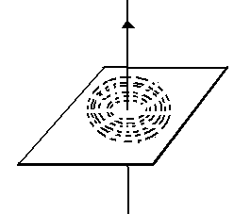  - This behavior of iron filings show that the magnetic field around a straight current carrying conductor forms a pattern of concentric circles and is perpendicular to the conductor.  - The direction of this magnetic field pattern can be predicted by Fleming’s right hand grip rule for a current carrying straight conductor which states that “if a current carrying conductor is gripped in the right hand with the thumb pointing along the wire in the direction of current, the other fingers will point in the direction of the magnetic field”.  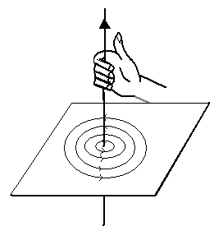 | - Note: The symbol represents current into the surface and current out of the surface.  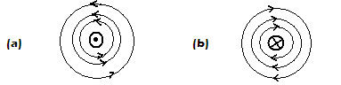  Magnetic Field on a Current Carrying Solenoid  - A solenoid refers to a wire wound into a long cylindrical coil with many connected loops.  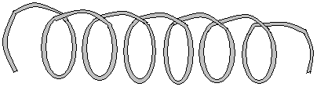  - Fleming’s right hand grip rule for a current carrying solenoid is used to predict the direction of magnetic field pattern inside the solenoid due to the current. It states that “If a coil carrying electric current is held in the right hand such that the fingers encircle the loops while pointing in the direction of current flow, the thumb points in the direction of the North Pole”  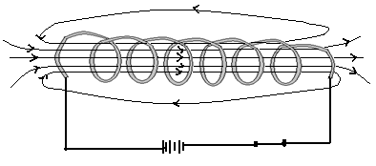  - Note that a solenoid carrying electric current produces a magnet field pattern like that of a bar magnet; one end behaves North Pole and the other end South Pole.  Exercise  Show the magnetic field pattern inside loop below  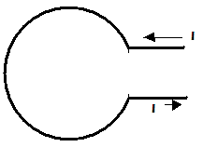
 | Simple Electromagnet  - An electromagnet is made by placing a soft iron core inside a solenoid carrying an electric current. This is shown below.  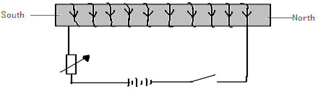  - The right hand grip rule for a current carrying solenoid can as well be used to predict the polarities of the electromagnet.  Factors Affecting the Strength of an Electromagnet  - The amount (size) of current in the solenoid – the strength of an electromagnet is directly proportional to the amount of electric current in the solenoid. Therefore, the large the current the strong the electromagnet.  - The number of turns in the solenoid – the strength of the electromagnet is directly proportional to the number of turns in the solenoid. Therefore, the more the number of turns the strong the electromagnet.  - The length of the solenoid – the strength of the electromagnet is directly proportional the length of the solenoid. Therefore the longer the solenoid the stronger the electromagnet.  - The shape of the core -horse - shoe shaped core produces a stronger electromagnet than u- shaped core while a u-shaped core produces a stronger electromagnet than a straight core.  Exercise  - In the diagram below the soft iron core is placed inside a coil connected to a d.c source.  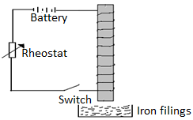 | End B was brought near the iron filings and many of them were attracted when the switch was closed.  - Explain why the iron filings got attracted at end of the core.  - Explain what is observed when the switch is opened.  - If soft iron was replaced with steel and switch closed: State what is observed when steel is brought near iron filings  - Mention three differences between soft iron and steel as illustrated in the above experiment.  - Explain what happens if steel is replaced with copper and dipped in the iron filings.  - The diagram below shows a wire wound on an open pipe at both ends. The wire is then connected to ad.c supply. A north pole of the magnet is near the end of the core B.  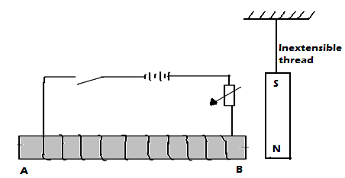  - What is observed at the magnet when the switch is closed?  - Explain the observation in the question above.  - If the terminals of the cells are reversed state what is observed on the magnets.  - What name of making a magnet is illustrated in the above arrangement?  - What are the two advantages of this method over other methods of magnetization?  - In an experiment to determine the strength of an electromagnet, the weight of pins that can be supported by the electromagnet, was recorded against the number of turns. The current was kept constant throughout the experiment.  The table below shows the data that was obtained.  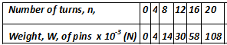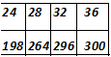  - Plot a graph of weight, W, against number of turns, n.  - Use the domain theory to explain the nature of the graph  - Sketch on the same axes the curve that will be obtained using a higher current
 | Force on a current carrying conductor (The Motor Effect)  - A conductor carrying current placed in a magnetic field experiences a force. This is called the motor effect.  - Consider the set up diagram below for a conductor carrying current in a magnetic field.  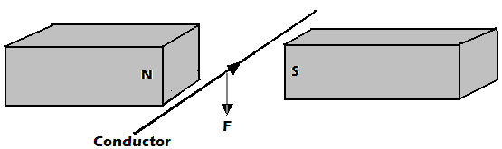  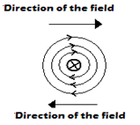  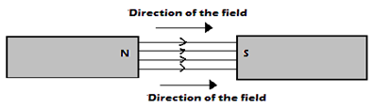  - The magnetic field concentrates at the top of the conductor than at the bottom thereby creating a region of strong field. The reason for this is that the field due to electric current in the conductor and that of the magnets reinforce each other since they are directed in the same direction.  - The relatively weak field at the bottom of the conductor is as result of cancellation between the two fields since they are directed in opposite directions. The resultant force therefore acts on the conductor downwards.  - The direction of force on conductor can be predicted by Fleming’s left hand rule which states that “If the thumb, first and second fingers are held mutually at right angles with the first finger pointing the direction of magnetic field, the second finger in the direction of current, then the thumb points in the direction of force”  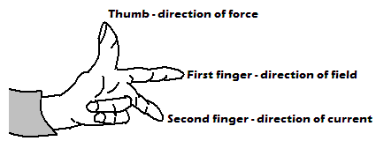 | Exercise  Show the resultant magnetic field and direction of force of the conductor in each of the following.  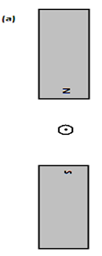  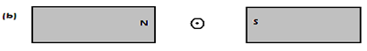  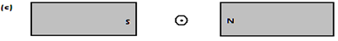  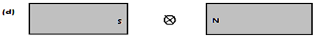  - For rectangular coil in a magnetic field, one side experiences an upward force and the other side a downward force and the coil is set into a rotation. Below is an example.  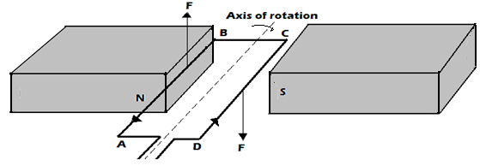  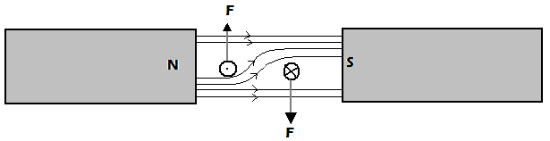
 | Force between Parallel Straight Current Carrying Conductors  - Parallel Conductors Carrying Current in Same Direction  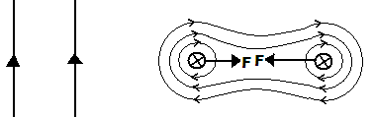  - The magnetic field between the conductors is weaker due to cancellation than the field from the outer side. The resultant force on the conductors acts to push them towards each other.  - Parallel Conductors Carrying Current In Opposite Direction  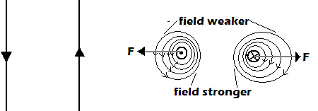  - The fields between the conductors repel each other since they are directed in same direction. A force, therefore, acts on the conductors to pull them apart (outwards)  Factors Affecting Force on a Conductor Carrying Current in a Magnetic Field  - Magnitude of electric current-force increases with current  - Strength of magnetic field – force increases with strength of the magnetic field  - Length of the conductor in the field – the longer the length the stronger the force  - Angle the conductor makes with the magnetic field – force increases with the angle. It is maximum when the conductor is at an angle of 90⁰ with the magnetic field  Exercise  - The figure below shows a rectangular coil PQRS of many turns of wire located in a magnetic field due to two poles north and south. The coil is free to rotate on the vertical axis CD.  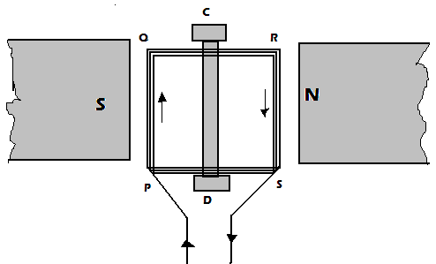 | When a current is passed through the coil in the direction PQRS the coil starts to turn, and eventually becomes to rest. With the aid of diagrams explain:  - Why the coil begins to turn  - In which direction it begins to turn  - Why it comes to rest  - The position in which it comes to rest  - The apparatus shown below may be used to cause rider AB move along the rods C and D  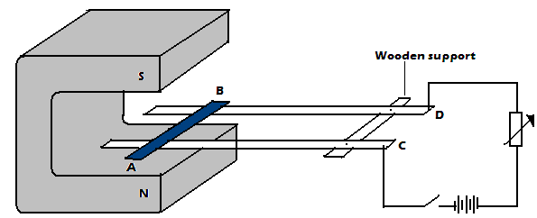  - When current flows along AB, in what direction will it roll? Explain.  - What happens to the rider when current is increased?  - State the rule that can be used to predict the direction of force acting on the rider.  Applications of Magnetic Effect of an Electric Current  - Electric bell  - The capacitor is used to reduce sparking effect at the contacts. The circuit is completed at the contact spring and contact screw.
 | Working Mechanism of an Electric Bell  - When current is switched on, it flows through the circuit and the soft iron core becomes magnetized. The magnetized iron core then attracts the sot iron armature, which has a hammer at its end. On attraction, the hammer knocks the gong and the bell rings.  - When the soft iron armature is attracted, the contact at the contact screw is broken and current stops flowing. The electromagnet loses its magnetism and releases the soft iron armature and this closes the contact again.  - This process is repeated and the bell rings continuously as long as the switch is closed.  - Electric Motor  - It is a devise which converts electrical energy into rotational kinetic energy.  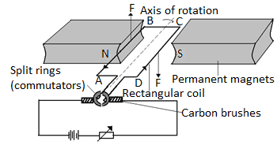  - The permanent magnets are curved at the ends to produce radial magnetic field.  Functions of Carbon Brush  - Presses lightly against the commutators so that that the coil rotates freely and easily.  - Connect the coil to the electric current source.  Reasons why carbon brushes and commutators are made of graphite  - Graphite is a good conductor of electricity.  - It serves as a lubricant since it is slippery.  Working Mechanism of the Electric Motor  - When the coil is horizontal and current passes through it as shown on the diagram, side AB experiences an upward force while BC experiences a downward force. The two forces make the coil rotate in the clockwise direction.  - When the coil is in the vertical position with AB at the top and CD at the bottom, the brushes touch the spaces between the two split rings.  - Due to momentum, the coil continues to rotate and the commutators interchange the contact positions with the brushes. | - The current is then reversed in the coil and the forces acting on each side reverse in direction. Side AB is now on the right with a downward force while side CD is on the left with an upward force. The coil continues to rotate.  - Simple magnetic relay  - In a magnetic relay, one circuit is used to control another circuit without any direct electrical connection between them.  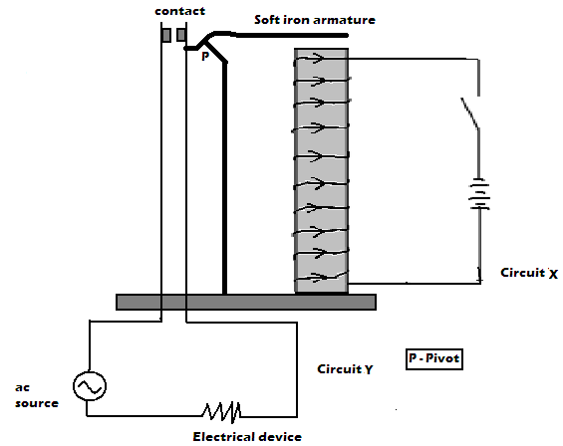  Working Mechanism of Magnetic Relay  - When the switch is closed, current flows through circuit X; electromagnet is made on the solenoid and in turn attracts the soft iron armature. The closes the contacts in circuit Y.  - Circuit Breakers  - Circuit breakers are used to protect electrical components from excessive flow of current.  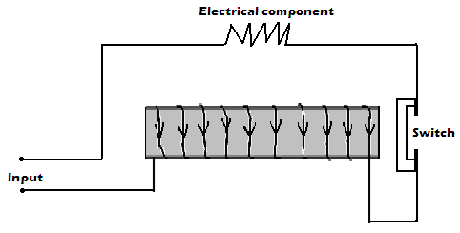
Working Mechanism of a Circuit Breaker
- When excess current flows through the circuit, increased magnetic power of the electromagnet opens the switch, thus stopping current flow.
Revision exercise
- State two factors that affect strength of an electromagnet
- In the set up below the suspended meter rule is balanced by the magnet and the weight shown. The iron core is fixed on the bench.
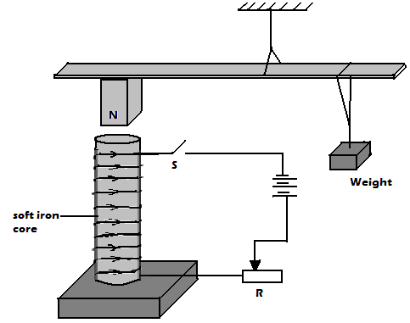
- State and explain the effect on the meter rule when the switch is closed.
- What would be the effect of reversing the battery terminals?
- Suggest how the set up in the figure can be adopted to measure the current flowing in the current circuit.

 | Chapter Eight WAVES I
 | Specific objectives  By the end of this topic the leaner should be able to:  - Describe the formation of pulses and waves  - Describe transverse and longitudinal waves  - Define amplitude (a), wavelength (λ), frequency (f), and periodic time (T)  - Derive the relation V= fλ  - Solve numerical problems involving V=fλ | Content  - Pulses and waves  - Transverse and longitudinal waves  - Amplitude (a) , wavelength (λ), frequency (f), periodic time(T)  - V= fλ  - Problems involving V= fλ.
 | Introduction  - In this topic basic concepts about waves are studied. Knowledge about waves has been broadly applied in daily life e.g. in radio and television, mobile phones, remote control system, heat energy radiation etc.  Definition of a wave  - A wave refers to the transmission of a disturbance. A wave therefore transmits energy from one point to another.  Classification of Waves  - Waves can be broadly classified as electromagnet or mechanical in nature.  - Electromagnet waves  - These are waves which do not require material medium for transmission. Such waves can be propagated in vacuum. Examples of electromagnetic waves are Radio waves, Radiant heat e.g. from sun, light, Microwaves etc.  - NB: Electromagnetic waves are transverse in nature  - Mechanical waves  - These are waves which do require a material medium for transmission. Such waves cannot be propagated in vacuum. Examples of mechanical waves are water waves, sound waves etc. | Classification of Mechanical Waves  - Transverse waves  - These are waves in which displacement of medium particles is at right angle to the direction of propagation of the wave. Examples of transverse wave are water waves, waves on a rope swung up and down. Transverse waves travel as a series of crests and troughs.  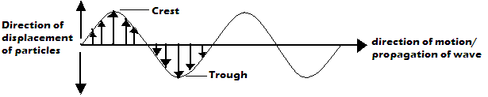  - A crest is the highest point of a transverse wave while a trough is the lowest point of a transverse wave  - Formation of transverse wave can be illustrated by swinging a slinky spring or a rope fixed at one end up and down.  - Longitudinal waves  - These are waves in which displacement of medium particles is parallel to the direction of propagation of the wave. Examples of longitudinal wave are Sound wave, waves on a slinky spring fixed at one end and vibrated to and two etc.
 | - Longtudional waves consists of sections of rarefactions andcompressions. Compressions are sections of high pressure in which particles are ppushed closer together while rarefactions are sections of low pressure in which particles are pulled slightly further a part from one another.Pressure variation in a longtudional wave is what causes wave motion.  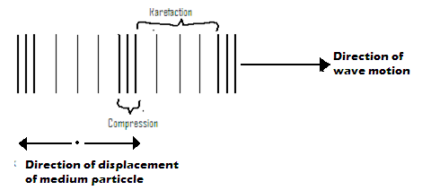  - Formaton of longtudinal wave ca be illustrated by vibrating a slinky spring fixed at one end to and fro along its length.  Examples  - What is a progressive wave?  It is a wave that moves continualy away from the source.  - Explain why the amplitude of a progressive wave decreases gradually from the source.  As the wave move away from the source, the energy is spread over an increasingly large area.  Exercise  - Diferentiate between electromagnetic and mechanical wave giving one example in each  - State two categories waves.  - State two types of mechanical waves. State the difference between them.  - Give two examples of mechanical waves.  Pulse  - A pulse is a single disturbance that is transimitted through a medium.It can be transverse or longtudional in nature. Generation of a pulse can be illustrated by jerking a rope fixed at one end just once. | 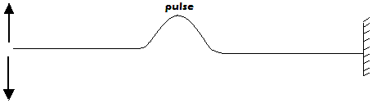  Terms Associated with Waves  - Consider the transverse waveform and an oscillating pendulum bobshown below.  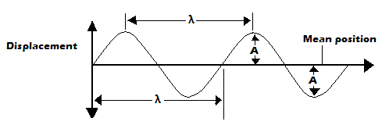  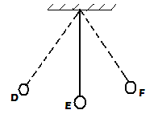  - Oscillation – an oscillation is a complete to and ffo motion. For example, in the above oscillating bob, a complete oscillation is D-E-F-E-D.  - Amplitude, A - it is the maximum displacement of a particle from mean position. Its SI unit is the metre (m). For an oscillating pendulum bob above DE or EF is the amplitude.  - Wavelength, λ – it is the distance between any two particles in a wave that are in phase. It is denoted by Greek letter lambda, λ. Its SI unit is the meter (m).  Note: Particles in a wave are said to be in phase if they are oscillating in same direction and at the same level of displacement.  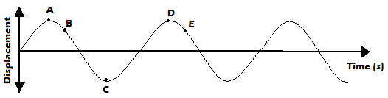  Particles A and D, B and E are in phase. C and D are out of phase by 180⁰.
 | 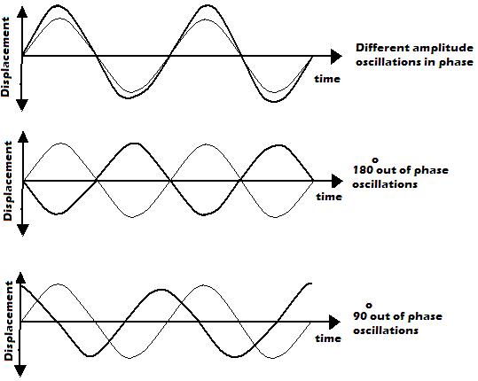  - Period, T- it’s the time taken by a particle to complete one oscillation. SI unit of period is the second(s )  - Frequency, f– it is the number of complete oscillations (full wavelengths) made by a particle in one second. SI unit of frequency is hertz (Hz).  Relationship between Frequency and Period  - Frequency is the reciprocal of period i.e. $f=\frac{I}{T}$  - Speed of the wave -It is the distance covered by a wave in one second.  The Wave Equation  - The wave equation relates Speed, V, Wavelength, λ and Frequency, f of a Wave  - Generally, $speed=\frac{distance}{time}$  - For a distance of wavelength covered by a wave, time taken is equivalent to the period of the wave.  $$∴speed=\frac{wavelength}{period}$$  $$V=\frac{λ}{T}=λ×\frac{I}{T}$$  $But, f=\frac{I}{T} and therefore V=λf$  This is called the wave speed equation | - From the wave equation, if speed of the wave is constant, frequency is inversely proportional to wavelength. This can be presented graphically as shown below.  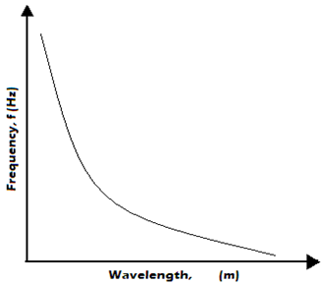  Example  The figure below shows a displacement-time graph of a wave travelling at 2500cms⁻¹  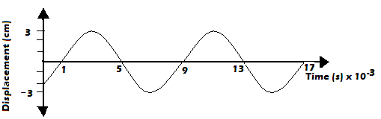  Determine for the wave:  - Amplitude  Solution  $$A= maximum displacement from mean position$$  $=3cm OR 0.03m in SI$ units  - Periodic time  Solution  $T=(9-1)x 10$⁻³$s$  $=8x10$⁻³$s$
 | - Frequency  Solution  $$f= \frac{I}{T}=\frac{1}{8X{10}^{-3}}Hz$$  $$=0.125×{10}^{-3}Hz=125Hz$$  d) Wavelength  Solution  $$V=fλ$$  $$λ=\frac{V}{f}=\frac{250{ms}^{-1}}{125s^{-1}.}=2m$$  Revision Exercise  - State the wave formula  - Sketch the variation of frequency with wavelength given that speed of the wave remains constant  - Name two types of progressive wave motion.  - A vibrator sends out 12 ripples per second across a ripple tank. The ripples are observed to be 5cm apart. Find the velocity of the ripples.  - A water wave travels 2m in 5 seconds. If the frequency of the wave is 10Hz, calculate the:  - Speed of the wave  - Wavelength of the wave  - The diagram below shows a displacement-time graph for a certain wave.  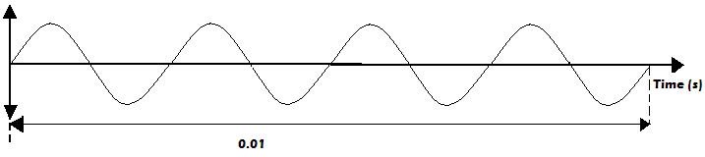  - How many oscillations are shown above?  - Calculate the frequency of the wave  - Calculate the periodic time of the wave  - Sketch the wave form of twice the frequency of the wave above.  - Electromagnetic waves travels at a velocity of 3.0x10⁸ms⁻¹ in air, calculate the wavelength in air of radio waves transmitted at a frequency of 200MHz.  - Wave ripples are caused to travel across the surface of a shallow tank by means of a suitable straight vibrator. The distance between successive crests is 6.0cm and the waves travel 50.4cm in 3.6 seconds. Calculate:  - The wavelength  - Velocity  - Frequency of the vibrator. | - Water waves are observed as they pass a fixed point at a rate of 30 crests per minute. A particular wave crest takes 2 seconds to travel between two points 6m apart. Determine:  - The frequency  - The wavelength  - Calculate the wavelength of the KBC FM radio wave transmitted at a frequency of 95.6 MHz  - The audible frequency range for a certain person is between 30 Hz and 16500 Hz. Determine the largest wavelength of sound in air the person can detect(speed of sound in air is 333m/s)  - The figure below represents a displacement-time graph for a wave.  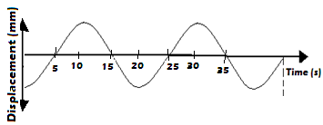  - Determine the frequency of the wave  - Sketch on the same axes the displacement-time graph of the wave of same frequency but 180⁰ out of phase and with smaller amplitude.
 | Chapter Nine FLUID FLOW
 | Specific objectives  By the end of this topic the leaner should be able to:  - Describe streamline flow and turbulent flow  - Derive the equation of continuity  - Describe experiments to illustrate Bernoulli’s effects  - Explain the Bernoulli’s effect  - Describe the application of Bernoulli’s effect  - Solve numerical problems involving the equation of continuity | Content  - Streamline and turbulent flow  - Equation of continuity  - Bernoulli’s effect (experimental treatment required)  - Application of Bernoulli’s effect: Bunsen burner, spray gun, carburetor, aero foil, spinning ball etc.  - Problems on equation of continuity
 | Fluid  - A fluid refers to any substance that is capable of flowing due to pressure difference. It includes both liquids and gases. Examples of fluid flow include: perfume spray from a perfume bottle, flow of water along a river bed, smoke from chimney etc. A flowing fluid experiences internal resistance called viscosity.  Types of Fluid Flow  - There two types of fluid flow: streamline (steady) and turbulent flows  1. Streamline (steady) flow  - It is a flow in which at any given point each and every particle of the fluid travels in the same direction and with same velocity.  - A streamline refers to the path followed by the particle in a streamline flow. It is represented by a line with an arrow head.  - Note: Streamlines do not cross each other but are closer where the fluid is moving faster  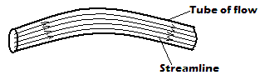 | Characteristics of Streamline Flow  - Streamlines are parallel to each other.  - Streamline flow is smooth and steady.  - Some shapes and bodies are designed to be streamlined to enhance their motion in fluids. A body is said to be streamlined if it does not affect the distribution of streamlines behind it.  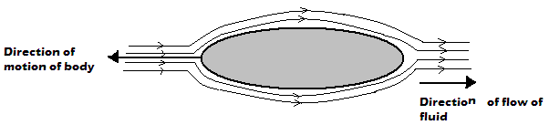  - Examples of streamlined bodies include: cars, jumbo jets, birds that fly, fish etc.  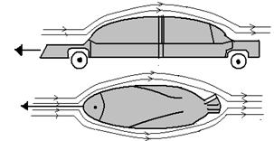
 | 2. Turbulent Flow  - It is a flow in which the speed and direction of the fluid particles passing at any point vary with time. Turbulent flow occurs due to:  - Abrupt change of cross sectional area of the tube of flow.  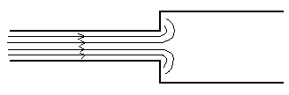  - Speed of the fluid flow changes sharply or suddenly and beyond a critical velocity.  - An obstacle is placed on the path of streamlines and blocks or breaks the streamlines.  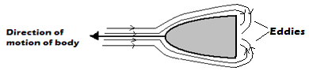  Characteristics of Turbulent Flow  - The streamlines are not continuous  - Particles do not travel in same direction and have different velocity.  Notes:  - When bodies which are not streamlined (non-streamlined) move in fluids, they cause eddies (turbulence) in the fluid. A body is said to be non- streamlined if it produces eddies behind it.  - Critical velocity is the speed of flow of fluid beyond which the fluid exhibits turbulent flow.  Volume Flux (Flow Rate)  - This is the volume of a fluid passing through a given section of a tube of flow per unit time.  $Volume flux=\frac{volume of fluid passing givensection }{time the fluid takes to pass the section}$.  - SI unit of volume flux is cubic meter per second (m³/s)  - Consider a fluid flowing through a section B of flow tube shown below.  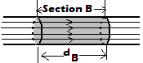 | - If the velocity of fluid through region B is${ v}_{B}$, the average cross-section area of tube is $A_{B}$ and the distance covered by the fluid in direction of flow is for time, $t_{B}$, is $d_{B}$, then the volume flux through that region is :  $$volume flux or flow rate=\frac{volume}{time}=\frac{V}{t_{B}}$$  $$But volume = cross–section area× length$$  $$V=A_{B}×d_{B}$$  $$Volume flux=\frac{d_{B}×A_{B}}{t_{B}}=\frac{d_{B}}{t_{B}}×A_{B}$$  $$But,\frac{d_{B}}{t_{B}}=Velocity, v_{B}$$  $$∴Volume flux=v_{B}×A_{B}$$  $$Volume flux=velocity ×cross section area of tube of flow$$  Mass Flux  - It is the mass of a fluid that flows through a given section of tube of flow per unit time.  $$mass flux=\frac{mass}{time}$$  $$But, mass=density ×volume.$$  $$That is, m=ρ×V.$$  $$∴mass flux=\frac{ρ×V}{t}$$  $$But, \frac{V}{ t}=volume flux.$$  $$mass flux=density of fluid,ρ×volume flux$$  $$∴mass flux=density of fluid×velocity of fluid×cross-section area of tube$$  The Equation of the Continuity  Assumptions made in deriving the equation of the continuity  - The fluid is flowing steadily (i.e. has a streamline flow)  - The fluid is incompressible  - The fluid is non- viscous.
 | Deriving Equation of Continuity  - Consider the tube of flow below with changing cross-section areas.  - Section 1 has a cross section area of $A_{1}$ while section 2 has cross section area of${ A}_{2}$.Velocity of fluid in section 1 is${ v}_{1}$ while in section 2 is $v_{2}$. ${ v}_{1}>v_{2}$  - Volume of fluid flowing through section 1 per unit time is equal to volume of fluid flowing through section 2 per unit time i.e. flow rate/ volume flux is a constant.  $$Volume flux in section 1 = volume flux in section 2$$  $$A_{1}v_{1}{=A}_{2 }v_{2}$$  - This is the equation of continuity which is also called flow rate equation. | - What is the velocity of the liquid between A and B?  Solution  $$Flow rate$$  $$=\frac{volume}{time}=cross-section area,A×velocity,v$$  $$\frac{8×{10}^{-6}m^{3}}{1 s}=1×{10}^{-4}m^{2}×v$$  $$v=\frac{8×{10}^{-6}m^{3}}{1 s×1×{10}^{-4}m^{2}}=8×{10}^{-2}{ms}^{-1}$$  - What is the velocity of the liquid between BC?  Solution  $$A_{1}v_{1}{=A}_{2 }v_{2}$$  $$1×{10}^{-4}m^{2}×8×{10}^{-2}{ms}^{-1}=1×{10}^{-6}m^{2}×v_{2}$$  $$v_{2}=\frac{1×{10}^{-4}m^{2}×8×{10}^{-2}{ms}^{-1}}{1×{10}^{-6}m^{2}}=8{ ms}^{-1}$$
  $$i.e. cross section area ×velocity=constant$$
  $$A v=constant.$$
 | Examples
- Water flows through a horizontal pipe at a rate of 1.00m³/min. Determine the velocity of the water at a point where the diameter of the pipe is 1.00cm
Solution
$$flow rate=Av$$
$$\frac{1.00 m^{3}}{60 s}=π({1.00×{10}^{-2}}/2)^{2}m^{2}×v$$
$$v=\frac{1.00}{60×π×2.5×{10}^{-5}}=212.18{ ms}^{-1}$$
- In figure below, the tube ABC is filled with a liquid. The piston moves from A to B in 1 second.
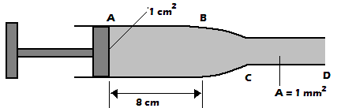
- What is the volume of the liquid in point AB
Solution
$$volume=cross-section area×length$$
$$volume=1×{10}^{-4}m^{2}×8×{10}^{-2}m=8×{10}^{-6}m^{3}$$
 |  | Exercise
- A garden sprinkler has small holes, each 2.00 mm² in area. If water is supplied at the rate of 3.0x10⁻³ m³s⁻¹ and the average velocity of the spray is 10ms⁻¹, calculate the number of the holes.
- Oil flows through a 6cm internal diameter pipe at an average velocity of 5ms⁻¹. Find the flow rate in m³/s and cm/s
- The velocity of glycerin in a 5cm internal diameter pipe is 1.00m/s. Find the velocity in a 3cm internal diameter pipe that connects with it, both pipes flowing full.
Bernoulli’s Effect
- It states that: provided a fluid is non- viscous, in compressible and its flow streamline an increase in its velocity produces a corresponding decreases in the pressure it exerts while a decrease in its velocity produces a corresponding increase in pressure.
Bernoulli’s Effect in Practice
- Consider the set- up below in which pipe A and C have some diameter tubes

 | 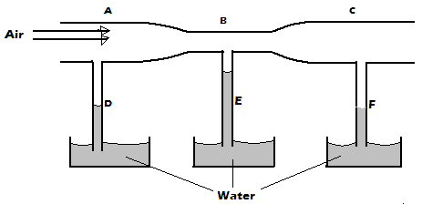  - When air is blown into the tube by a blower, it is observed that water rises to same level in tube D and F. In E the level of water is higher than D and F.  - Velocity of air in pipe A and C are the same due to same cross- sectional areas. Moving air causes a reduction of pressure and since resulting air pressure is the same, atmospheric pressure pushes up the water to the same level.  - The speed of moving air in narrower section B is higher and the resulting pressure is much lower than A and C, hence water rises to higher level in E.  - When air is blown above the opening of the flask shown the pith ball is observed to rise from the bottom.  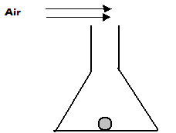  - The blown air causes reduction of pressure at the top therefore, there is a net force upwards as the pressure difference pushes the pith ball upwards.  - When air is blown horizontally between two suspended balloons in the horizontal direction, the balloons are observed to move towards each other.  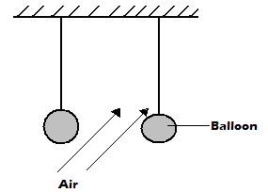  - Moving air leads to reduced pressure on the inner sides of the balloons. The higher atmospheric pressure acting on the outer surfaces causes the balloons to move closer to each other. | - A light paper held in front of the mouth and air blown horizontally over it is observed to rise. This is because the velocity of air above paper increases leading to reduction in pressure. The higher atmospheric pressure acting from below produces a force that lifts the paper upwards.  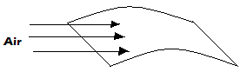  Bernoulli’s Principle  - It states that: ”provided the fluid is non- viscous incompressible and has a streamline flow, the sum of pressure, kinetic energy per unit volume and potential energy per unit volume is a constant”.  Mathematical Expression for Bernoulli’s Principle  - Consider a fluid of density, ρ, mass, m, flowing through a pipe with a velocity,$v$ and pressure at any given point, P.  $$The kinetic energy per unit volume=\frac{kinetic energy}{volume;}$$  $\frac{\frac{1}{2}mv^{2}}{V}=\frac{mv^{2}}{2V}$; $but ρ=\frac{m}{V}$  $$∴kinetic energy per unit volume=\frac{1}{2}ρV^{2}$$  $$Potential energy per unit volume=\frac{potential energy }{volume}$$  $$\frac{mgh}{V}=ρgh$$  $$∴Bernoulli’s principle can be expressed as:$$  $$P+\frac{1}{2}ρV^{2}+ρgh=constant$$  Applications of Bernoulli’s Principle  - The Aero foil  - It is a structure designed in such way that the fluid moving above it moves with a higher speed than the one moving below  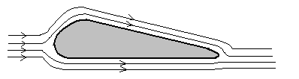
 | - The pressure above the aero foil is therefore lower than the pressure below it. The pressure difference between the top and bottom gives rise to the lift of the aero foil. This is called dynamic lift.  - Bunsen burner  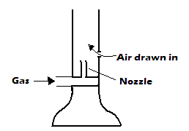  - When gas is made to flow into the Bunsen burner, its velocity increases as it passes through the nozzle; this decreases the pressure above the nozzle. Because of higher atmospheric pressure outside the barrel, air is then drawn in.  - The air and the gas then mix as they rise up and when ignited a flame is produced.  - Spray Gun  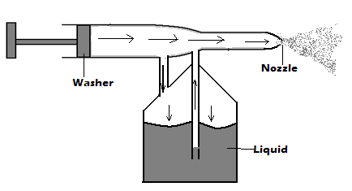  - When the piston is pushed forward air is made to flow through the barrel and therefore causes low pressure in the barrel. High atmospheric pressure on the surface of the liquid compels the liquid to move up the tube.  - The velocity of the liquid is increased as it pushes through the nozzle due to reduced cross section area. The liquid therefore emerges as a fine spray.  - The carburetor.  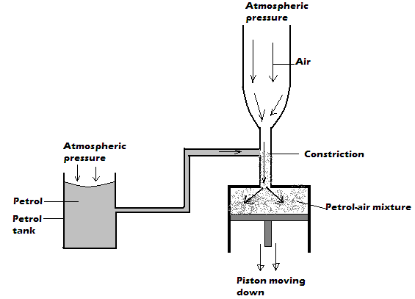 | - Air velocity at constriction is higher. This makes the pressure at the constriction drop. The atmospheric pressure being higher pushes the petrol to the constriction.  Revision Exercise  - The figure below shows a pith ball placed in a flask. When a jet of air is blown over the mouth of the flask as shown, the pith ball is observed to rise from the bottom.  Explain this observation  - State Bernoulli’s principle  - A pipe of radius 6mm is connected to another pipe of radius 9mm. If water flows in the wider pipe at the speed of 2ms⁻¹, what is the speed in the narrower pipe?  - The figure below shows a tube of varying cross- section area. $v_{1},v_{2,}v_{3}{ and v}_{4}$ represent the speed of water as it flows steadily through the sections of the tube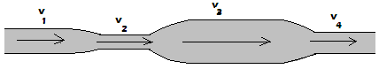  Arrange the speeds $v_{1},v_{2,}v_{3}{ and v}_{4}$ in decreasing order starting with the highest.  - The figure below shows a sheet of paper rolled into a tube.  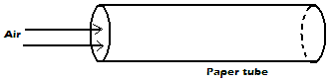  When a fast stream of air is blown into the tube as shown in the diagram the paper tube collapses. Explain the observation.  - The figure below shows a horizontal tube with two vertical tubes X and Y. water flows through the horizontal tube from right to left. The water level in tube X is higher than water level in tube Y.  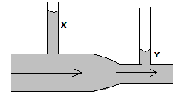 Explain this observation
 | Chapter Ten REFLECTION AT CURVED SURFACES
 | Specific objectives  By the end of this topic the learner should be able to:  - Describe concave, convex and parabolic reflectors  - Describe using ray diagrams the principal axis, principal focus centre of curvature and related terms.  - Locate images formed by curved mirrors by construction  - Determine experimentally the characteristics of images formed by concave mirror  - Define magnification  - Explain the applications of curved reflectors | Content  - Concave, convex and parabolic reflectors  - Principal axis, principal focus, centre of curvature and related terms  - Location of images formed by curved mirrors by construction method (experiment on curved mirrors required)  - Magnification formula  - Applications of curved reflectors
 | Introduction  - Curved reflectors are obtained from hollow spheres, cones or cylinders. The surfaces of these hollow solids are then highly polished from the inside or outside depending on the type of curved reflector being made. Concave and convex mirrors are also called spherical mirrors.  Types of Curved Reflectors  - Concave Reflector/ Mirror  - This is a reflector whose reflecting surface curves inwards. It is obtained by highly polishing the outside of a glass sphere portion.  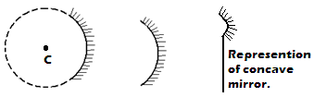  - Convex Reflector/ Mirror  - This is a reflector whose reflecting surface curves outwards. It is obtained by highly polishing the inside of a glass sphere portion.  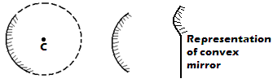 | - Parabolic Reflector/ Mirror  - It is a curved reflector whose reflecting surface curves more inwards than that of the concave reflector. It is obtained by highly polishing the outside of a glass cone.  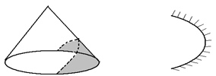  Terms Associated with Curved Reflectors  - Consider the diagrams below;  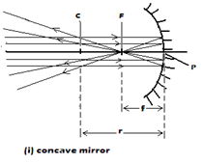
 | 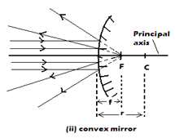  - Aperture  - This is the width of the mirror  - Pole, P  - This is the geometrical centre of the mirror.  - Centre of curvature, C  - This is the centre of the sphere of which the mirror forms a part. The centre of curvature of a concave mirror is in front while that of a convex mirror is behind the mirror.  - Radius of curvature, r  - It is the radius of a sphere of which the curved mirror forms a part.  - Principal/ main axis  - This is the line passing through the pole and the centre of curvature of the curved mirror.  - Paraxial rays and marginal rays  - These are rays which are close and parallel to the principal axis while marginal rays are those that are parallel but not close to the principal axis.  - Principal focus, F, of a concave mirror  - It is the point at which all the rays parallel and close to the principal axis converge after reflection. Principal focus of a concave mirror is real because reflected rays actually pass through it.  - Principal focus, F, of a convex mirror  - These is the point at which all rays parallel and close to the principal axis appear to emerge/ diverge from after reflection. The principal focus of a convex mirror is virtual because reflected rays only appear to pass through it.  - Focal plane  - This is a plane perpendicular to the principal axis and passes through the principal focus. For a concave mirror, parallel rays which are not parallel to the principal axis converge at a point on the focal plane after reflection. For a convex mirror, parallel rays which are not parallel to the principal axis appear to emerge from a point on focal plane after reflection. | 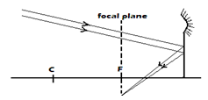  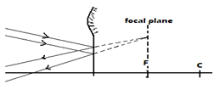  - Focal length, f  - This is the distance from the pole of the mirror to its principal focus.  Note: In optics full lines represent real rays and objects while dotted lines represent virtual rays and images.  Exercise  The figure below shows two parallel rays incident on a concave mirror. F is the focal point of the mirror.  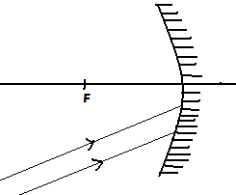  Sketch on the same diagram the path of the rays after striking the mirror.  Relationship between Radius of Curvature and Focal Length  - It can be shown through geometry that the radius of curvature is twice the focal length i.e.  $$r = 2f$$  Laws of Reflection in Curved Mirrors  - Reflection at curved surfaces also obeys laws of reflection:  - The angle of incidence is equal to the angle of reflection at the point of incidence  - The incident ray, the normal and the reflected ray all lie on the same plane at the point of incidence.
 | 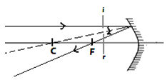  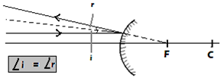  Ray Diagrams  - Ray diagrams are used to show and explain how images are formed by curved mirrors and the characteristics of these images.  Four Major Cases in the Construction of Ray Diagrams  - A ray close and parallel to principal axis passes through principal focus (for concave mirror) or appears to emerge from the principal focus (for convex mirror) after reflection.  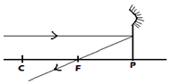  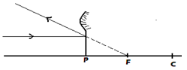  - A ray through the principal focus of a concave or appearing to be directed to the principal focus of convex mirror is reflected parallel to the principal axis.  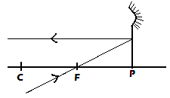  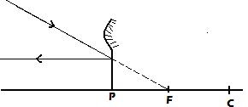 | - A ray through the centre of curvature (for concave) or appearing to pass through centre of curvature (for convex mirror) is reflected along the same path.  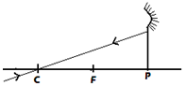  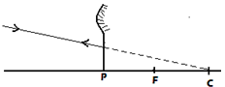  - A ray at an angle to the principal axis and incident at the pole is reflected in such a way that the angle of incidence is equal to the angle of reflection.  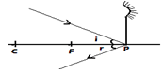  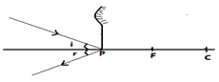  Characteristics of Images Formed by Curved Reflectors  - Concave mirrors  - Object at infinity  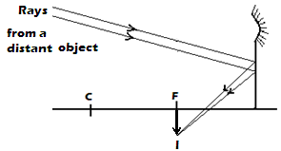  - Image is real, formed at F, inverted and smaller than the object.
 | - Object at c  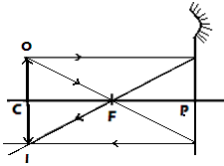  - Image formed is at C, real, inverted and same size as the object.  - Object beyond C  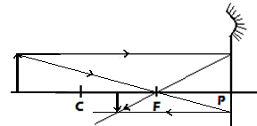  - Image formed is between C and F, real, inverted and smaller than the object.  - Object between C and F  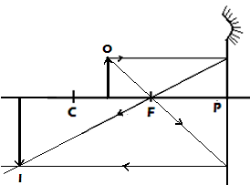  - The image formed is beyond C, real, inverted, larger than the object (magnified)  - Object at F  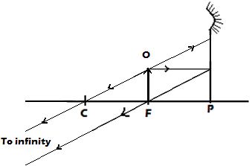  - The image is formed at infinity because the rays emerge parallel after reflection.  vi. Object between F and P  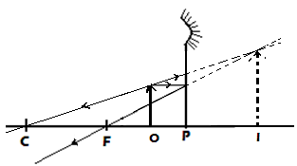 | - The image formed is behind the mirror, virtual, upright and larger than the object.  - Convex mirror  - Irrespective of the distance of the object in front of the mirror, images formed by convex mirrors are always upright, smaller than the object and between P and F.  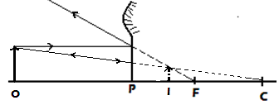  Example  A lady holds a large concave mirror of focal length 1 m, 80 cm from her face.  - Using suitable construction illustrate how her image is formed  - State two characteristics of her image in the mirror.  - Image upright  - Image magnified  Exercise  - The figure below shows a ray of light incident on a convex mirror  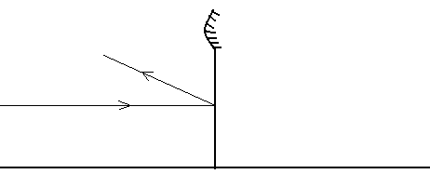  Using suitable construction, determine the radius of curvature of the mirror.  - The figure below shows parabolic surface with a source of light placed at its focal point F  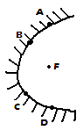
 | Draw rays to show reflection from the surface when rays from the source strike the surface at points A, B, C and D  - The figure below shows a vertical object, O, placed in front of a convex mirror  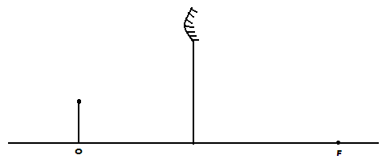  On the same diagram draw the appropriate rays and locate the image formed.  - The figure below shows a bright behind a screen which has a hole covered with wire gauze. A concave mirror of focal length 25 cm is placed in front of the screen. The position of the mirror is adjusted until a sharp image of the gauze is formed on the screen.  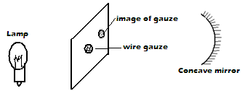  Determine the distance between the screen and the mirror.  Graphical Construction of Ray Diagrams  - Images are drawn to scale in a ray diagram and this is best done on graph paper.  Linear (Transverse) Magnification  - It is the ratio of the image height to the object height. It can also be defined as the ratio of the image distance to the object distance.  $$Linear \left(transverse\right) magnification$$  $$=\frac{image height}{object height}=\frac{image distance}{object distance}$$  Examples  - An object 3 cm high is placed 6 cm in front of a concave mirror of radius of curvature 10 cm. By scale drawing determine the:  - Position of the image | - Size of the image  - Nature of the image  - magnification  solution  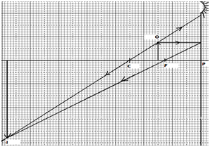  - Image position is 13.6 X 2 = 27.2 cm from P in front of the mirror.  - Size of the image is 6.6 X 2 = 13.2 cm  - Nature of the image: the image is inverted, real and magnified  - $magnification=\frac{image height }{object height}=\frac{13.2 cm}{3 cm}=4.4$  - A convex mirror of focal length 15 cm produces an image 10 cm away from the mirror. If the image is 3 cm high, determine by scale drawing  - The object distance  - Object height/ size  - Magnification  Solution  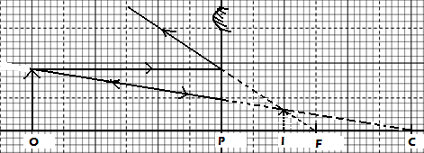  - The object distance is 6 X 5 = 30 cm  - Object height/ size is 1.4 X 5 = 7 cm  - $Magnification=\frac{image height }{object height}$  $$=\frac{3 cm}{7 cm}=0.4285$$
 | Exercise  - A concave mirror of focal length 10 cm forms a sharp image at 40 cm from the mirror. Determine graphically the position of the object and magnification of the image.  - A concave mirror of focal length 20 cm forms a real image two times the size of the object. If the object height is 10 cm, determine by scale drawing:  - The object distance  - The image distance  The Mirror Formula  The object distance $u$, the focal length $f$and the image distance $v$related by the $mirror formula$:  $$\frac{1}{f}=\frac{1}{u}+\frac{1}{v}$$  Real-Is-Positive Convention  - This is a sign convention used with the mirror formula in order to determine the position and nature of the image formed by a curved mirror. According to the real-is-positive sign convention:  - All distances are measured from the mirror as the origin.  - Distances of real objects and images are considered positive e.g. focal length of concave mirrors.  - Distances of virtual objects and images are considered negative e.g. focal length of convex mirror.  Examples  - An object is placed 10 cm in front of a concave mirror of focal length 20 cm. Determine the position and nature of the image.  Solution  $$\frac{1}{f}=\frac{1}{u}+\frac{1}{v}$$  $$\frac{1}{20}=\frac{1}{10}+\frac{1}{v}$$  $$\frac{1}{v}=\frac{1}{20}-\frac{1}{10}=-\frac{1}{20}$$  $$v=-20 cm$$  The image is virtual ( because v is negative), upright and magnified (because v is greater than u) | - An object is placed 10 cm in front of a convex mirror of focal length 20 cm. Determine the position and nature of the image.  Solution  f is negative (-20 cm) according to real-is-positive convention  $$\frac{1}{f}=\frac{1}{u}+\frac{1}{v}$$  $$-\frac{1}{20}=\frac{1}{10}+\frac{1}{v}$$  $$\frac{1}{v}=-\frac{1}{20}-\frac{1}{10}=-\frac{3}{20}$$  $$v=-\frac{20}{3}=-6.667 cm$$  The image is virtual ( because v is negative), upright and diminished (because v is smaller than u)  - A concave mirror with radius of curvature 10 cm produces an inverted image two times the size of an object placed in front of it and perpendicular to the principal axis. Determine the position of:  - The object  - The image  Solution  $$f=\frac{r}{2}=\frac{10}{2}=5 cm ;m=\frac{v}{u}=2; v=2u$$  $$\frac{1}{f}=\frac{1}{u}+\frac{1}{v} ; \frac{1}{f}=\frac{1}{u}+\frac{1}{2u}↔\frac{1}{5}=\frac{1}{u}+\frac{1}{2u}=\frac{3}{2u}$$  $$\frac{3}{2u}=\frac{1}{5}↔u=7.5 cm and ∴v=2×7.5 cm=15 cm$$  Exercise  - The distance between an erect image and the object is 40 cm. The image is twice as tall as the object. Determine:  - The object distance.  - The radius of curvature.  - A vertical object 10 cm high is placed 20 cm away from a con vex mirror of radius of curvature 30 cm. determine:  - The image distance.  - The height of the image.  - The magnification of the image.
 | - The distance between an object and its magnified real image produced by a concave mirror is 40 cm when the object is placed 20 cm from the pole of the mirror. Determine the:  - Transverse magnification of the image.  - The focal length of the mirror.  Graphical Analysis of the Mirror Formula  - Graph of $\frac{1}{u}against\frac{1}{v}$  - It is a straight line graph with a negative gradient, implying that the image is inverted relative to the object.  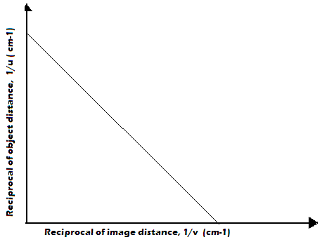  - $The\frac{1}{u}-intercept or the\frac{1}{v}-intercept gives\frac{1}{f}$  - $Graph of uv against u+v$  - From the mirror formula$\frac{1}{f}=\frac{1}{u}+\frac{1}{v}$,  $$\frac{1}{f}=\frac{v+u}{uv} ; f=\frac{uv}{v+u}$$  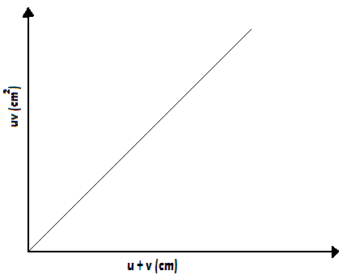 | - Therefore, a graph of $uv against u+v$ is a straight line through the origin whose gradient is positive. The gradient of the graph gives $f$  - Graph of $m against v$  - $From the mirror formula \frac{1}{f}=\frac{1}{u}+\frac{1}{v} , multiplying all through by v gives$  $$\frac{v}{f}=\frac{v}{u}+\frac{v}{v}↔\frac{v}{f}=\frac{v}{u}+1$$  $$\frac{v}{f}=m+ 1, since \frac{v}{u}=m$$  $$∴m=\frac{v}{f}-1$$  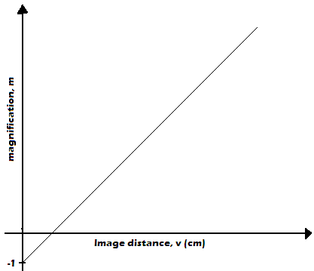  - Therefore, a graph of $m against v$is a straight line with a$gradient of \frac{1}{f}$and $m-intercept$ is -1. Also the $v-intercept$ gives the $focal length, f$  Exercise  A concave mirror and an illuminated object are used to produce a sharp image of the object on a screen. The object distances and image distances are given below.
 | - Complete the table  - Using suitable values:  - Plot a graph of$\frac{1}{u}against\frac{1}{v}$  - Determine the$radius of curvature, f$from the graph  - Plot a graph of $uv against u+v$and use it to find the$radius of curvature, f$  - Plot a graph of$magnification, m against v$and use it to find the $radius of curvature, f$  Applications of Curved Mirrors  - Concave Mirrors  - Used as shaving mirrors because they produce magnified and upright images when the object is between principal focus, F and the pole, P.  - Used by dentist when examining teeth they produce magnified and upright images when the object is between principal focus, F and the pole, P.  - Used as reflector behind projector lamp to reflect light travelling away from the projector. The lamp is placed at the centre of curvature of the concave mirror.  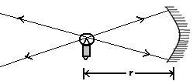  - Used in telescopes to bring distance objects (objects at infinity) like stars into focus at the focal point. | - Used as solar concentrators to bring light energy into focus.  - Convex Mirrors  - Used as car and motorcycle side mirrors because they form upright images and have a wide field of view  - Used in supermarkets to monitor movement of customers because they form upright images and have a wide field of view  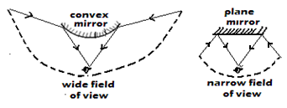  - Note: The defect of spherical mirrors in which marginal rays are not brought into focus at the principal focus resulting in blurred images is called spherical aberration.  Disadvantage of Convex Mirror  - Convex mirror forms diminished images giving an impression that the vehicles behind are farther away than they actually are.  - Parabolic Mirrors  - Used for propagation of parallel light beams of high intensity in hand torches, searchlights and car head lights.  Advantage of Parabolic Mirrors over Concave Mirrors  - Unlike concave mirrors in which marginal rays are not converged at principal focus, parabolic mirror converges all rays parallel to principal axis and incident on its surface at its principal focus.  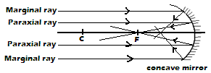
  $$Object distance,$$  $$u (cm)$$ | $$80.0$$ | $$26.7$$ | $$22.4$$ | $$20.6$$ | $$19.6$$
  $$Image distance,$$  $$v (cm)$$ | $$20.0$$ | $$40.0$$ | $$56.0$$ | $$72.0$$ | $$88$$
  $$u+v (cm)$$
  $$uv (cm^{2})$$
  $$Magnification,$$
  $$m$$
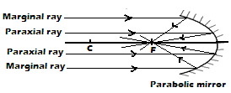

Revision questions
- With the aid of a well labeled diagram, explain the wide field of view of a convex mirror.
- State on application of each of the following
- Convex mirror.
- Parabolic mirror
- The figure below which is drawn to a scale of 1:5 represent an object O and its image I formed by a convex mirror.
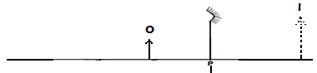
By drawing suitable rays, locate and mark on the figure the position of the principal focus, F of the mirror. Determine the focal length, f.
- The figure below shows a point object O placed in front of a convex mirror.
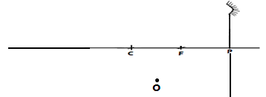
Draw appropriate rays to locate the image of the object.
- State the advantage parabolic mirror over concave mirror.

