NAME………………………………………………………………ADM.NO……………CLASS………

END OF TERM 3
FORM 2 MATHEMATICS EXAM
TIME: 2½ HRS.
INSTRUCTION TO STUDENTS:
- Write your name, admission number and class in the spaces provided above.
- Write the date of examination in spaces provided.
- This paper consists of two Sections; Section I and Section II.
- Answer ALL the questions in Section I and only five questions from Section II.
- All answers and working must be written on the question paper in the spaces provided below each question.
- Show all the steps in your calculation, giving your answer at each stage in the spaces provided below each question.
- Marks may be given for correct working even if the answer is wrong.
- KNEC Mathematical tables may be used, except where stated otherwise.
- Candidates should check the question paper to ascertain that all the pages are printed as indicated and that no questions are missing.
- Candidates should answer the questions in English.

FOR EXAMINER’S USE ONLY:

SECTION I
1 | 2 | 3 | 4 | 5 | 6 | 7 | 8 | 9 | 10 | 11 | 12 | 13 | 14 | 15 | 16 | TOTAL

SECTION II GRAND TOTAL

17 | 18 | 19 | 20 | 21 | 22 | TOTAL

Ensure that all the pages are printed and that no question(s) are missing.

SECTION A (Answer all questions in the spaces provided)
- Arrange the following sets of numbers in descending order. [2 Marks]
404,044 440,440 440,404 404,444 444,044

- Prove that 581,526 is divisible by both 9 and 11. [2 Marks]

- When a number $u$ is divided by either 36, 24 or 45, the remainder is always 5. Find the least value of$u$. [3 Marks]

- Using mathematical tables, find the cubes of each of the following numbers. Leave your answer in standard form.
- 2341 [2 Marks]

- 0.00472 (2mks)

- Use logarithms tables to evaluate; $\frac{743.1×34.8}{15.6×102.7}$ [4 Marks]

- Find the equation of a line that passes through (3, -5) and is perpendicular to a line whose equation is $4x-5y-6=0$ [3 Marks]

- Two similar vases have their heights in the ratio 3:2. What is the ratio of
- Their surface areas [1 Mark]

- Their volumes [1 Mark]

- A rectangular container measuring 1.2m long, 70 cm wide and 55 cm high is half full of water. All this water is poured into an empty cylindrical tank of diameter 1.4 metres. Find the height to which the water rises. (4 mks)

- In the triangle below, AB=12cm AC=13cm and ABC=BDC=90⁰.
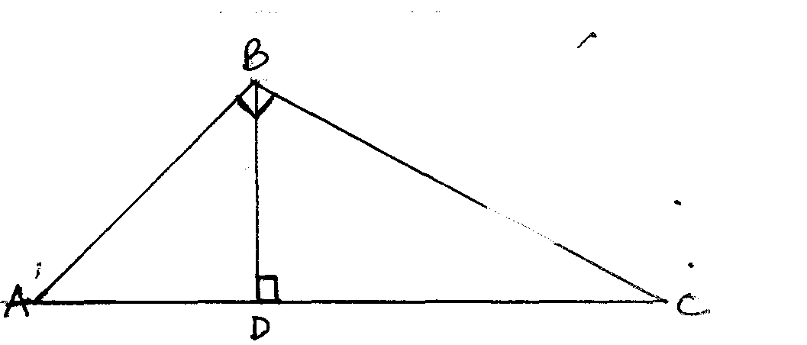
Calculate;
- The length of BC [2 Marks]

- The length of BD [2 Marks]

- Express as a single fraction in the simplest form; $\frac{x-3}{5}+\frac{2x-5}{4}$ [3 Marks]

- The ratio of boys to girls is 3:2. When $\frac{1}{3}$ of the boys and 6 girls are absent, the ratio remains the same. Find the number of students in the class. [4 Marks]

- The diagram below shows a triangular prism. Determine its total surface area.
[3 Marks]
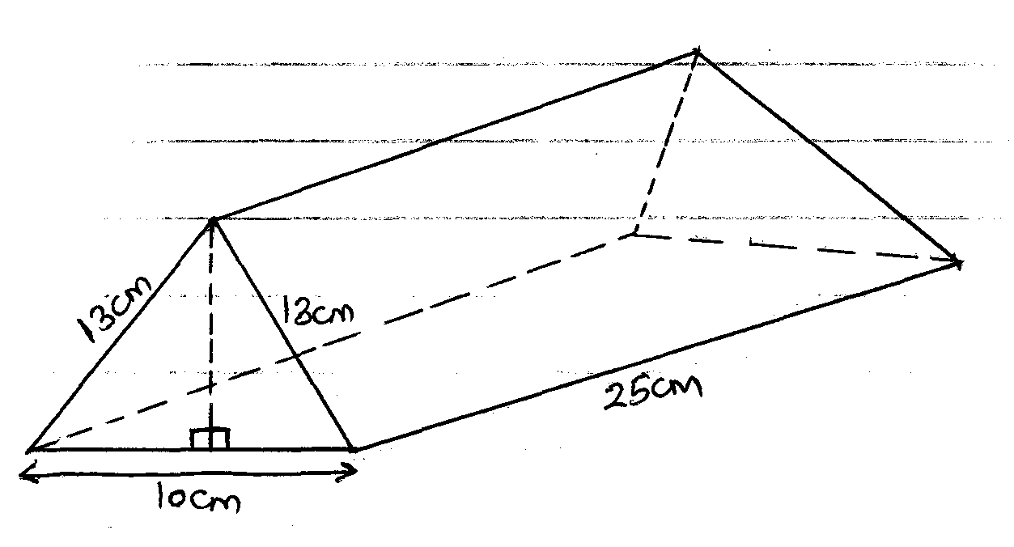

- The size of the interior angle of a regular polygon is $x°$ and the exterior angle is
$(\frac{x-36}{3})$⁰
- Calculate the value of $x$ [2 Marks]

- How many sides does the polygon have? [2 Marks]

- Solve for the value of $θ$if [2 Marks]
$$\sin\left(2θ+30\right)=\cos{(2θ+20)}$$

- A triangle measures 16cm by 20cm by 24cm. calculate its area using the Hero’s formula. [3 Marks]

- If $a=8 and b=36,$ calculate the value of; [3 Marks]
$$(a^{-\frac{2}{3}}+b^{\frac{1}{2}})^{\frac{1}{2}}$$

SECTION B (Answer any 5 questions)
- The table below is a bus timetable for journeys between towns E and J via towns FGH and I. Use it to answer the questions that follow.
Town | Arrival | Departure
E |  | 0500
F | 0630 | 0645
G | 0710 | 0720
H | 0820 | 0830
I | 1145 | 1230
J | 1345
- At what time does the bus leave town G in 12hr system. [1 Mark]

- How long does it take between town E and G. [1 Mark]

- In which town does the bus stop the longest and for how long? [2 Marks]

- If the bus does not stop anywhere;
- How long would it take to travel from town E to town J. [2 Marks]

- At what time would it arrive at town J. [1 Mark]

- If the distance between town G and J is 400km, calculate the average speed between G and J. [3 Marks]

- In a certain day secondary school in Vihiga County. There were 500 students. The ratio of boys to girls is 3:2.
- How many more boys than girls are there in the school? [2 Marks]

- i. One day 10% of the girls and two fifth of the boys went for music and drama festivals. How many students were left in the school? [3 Marks]

ii. During the Festivals each student was given 100/= and the two accompanying teachers were given 1000/= each for lunch. What was the total expenditure? [2 Marks]

- On a certain morning, ½ of the boys and 0.75 of the girls were sent home for fees. Given that each student brought 2500/= the following day, calculate the total amount of money that was collected. [3 Marks]

- A line L₁ passes through (3, -2) and (5,4).
- Determine the gradient of line L₁ [1 Mark]

- The equation of line L₁ [2 Marks]

- Line L₁ cuts $x-axis$ at point P and the $y-axis$ at point Q. determine the co-ordinates of P and Q. [4 Marks]

- Another line L₂ passes through (-3,7) and is perpendicular to L₁. Determine its equation. [3 Marks]

- a. Given that the ratio of the areas of two similar solids is 9:25
- What is the linear scale factor between the two solids? [2 Marks]

- If the length of the smaller solid is 1.2m, what is the length of the bigger solid?
[2 Marks]

b. The linear dimensions of a model car are $\frac{1}{16}$ of the dimensions of the actual car.
- What is the area of the windscreen of the actual car if the windscreen of the model car is 3cm²? [2 Marks]

- If the capacity of the boot of the model car is 15cm³, find the capacity of the boot of the model car. [2 Marks]

c. The volume of two similar jugs are in the ratio 8:125. What is the ratio of their surface areas? [2 Marks]

- A triangle PQR has co-ordinates P(1,1) Q (1,3) R (3,1)
- Plot the triangle in the graph paper provided. [1 Mark]
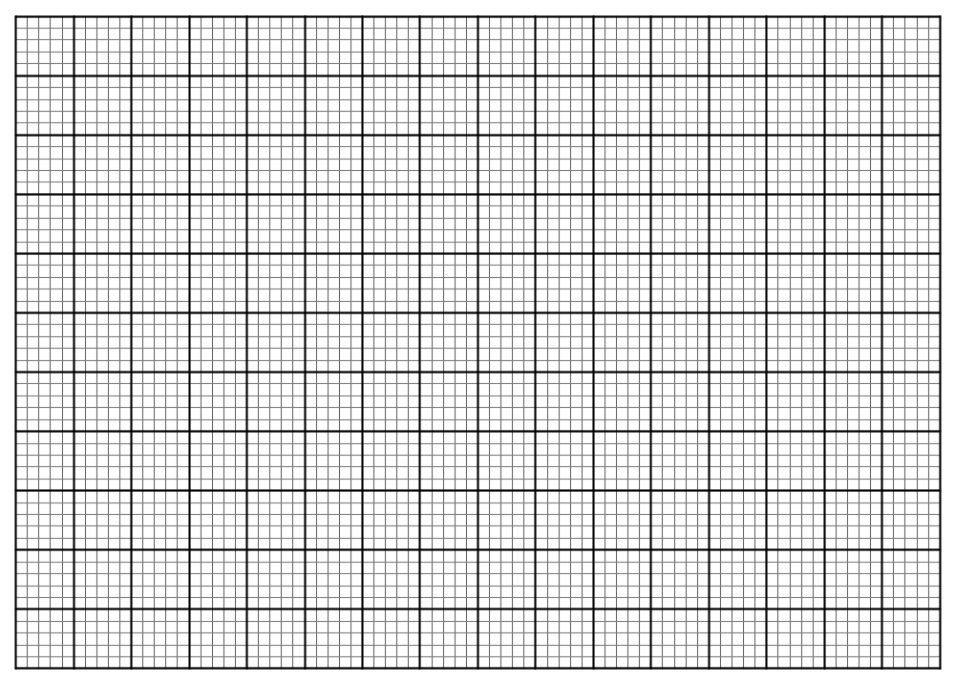
- PˈQˈRˈ is the image of PQR under an enlargement scale factor 2 about origin.
- Plot PˈQˈRˈ in the graph provided. [3 Marks]

- State the co-ordinates of PˈQˈRˈ. [1 Mark]

- PˈˈQˈˈRˈˈ is the image of PˈQˈRˈ under reflection in the $y-axis$. Plot PˈˈQˈˈRˈˈ in the graph paper and state its co-ordinates. [4 Marks]

- Calculate the area of triangle PˈˈQˈˈRˈˈ [1 Mark]

- In each of the following figures, calculate the area of the shaded regions.

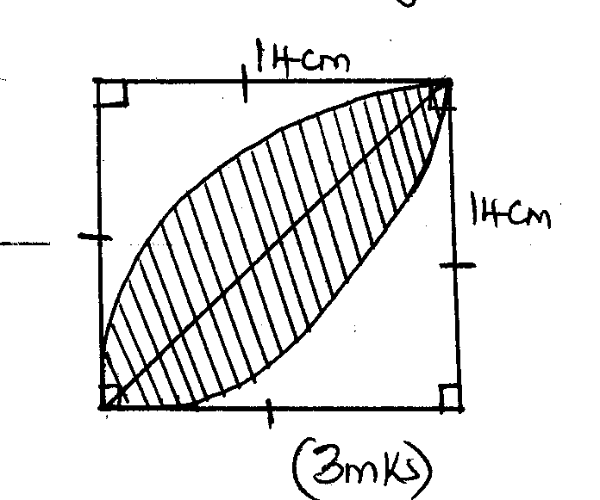

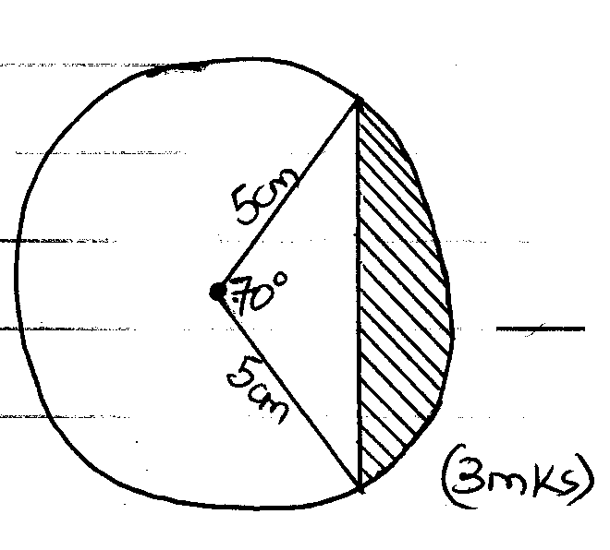

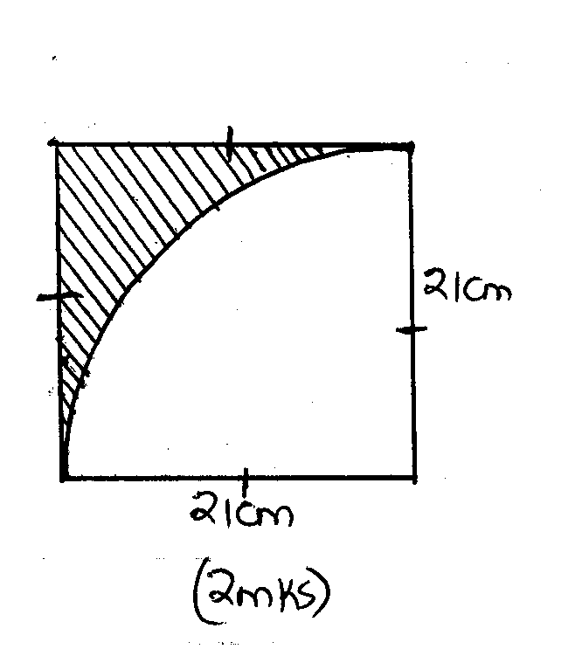

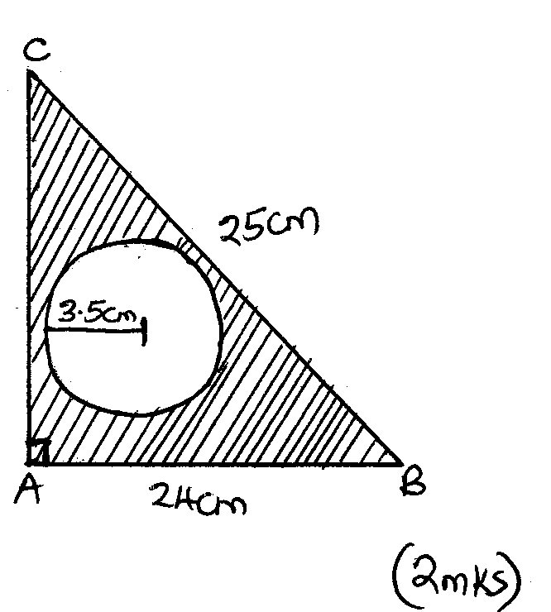
- Amina bought 3 pens and 2 pencils for shs. 13. Njoki bought 2 similar pens and 1 pencil and spent shs. 5 less than Amina.
- Form 2 simultaneous equations to represent the above information [2 Marks]

- Using substitution method, determine the price of each item. [3 Marks]

- Migwi bought 100 pencils and 150 pens from the same shop.
- What was the total cost? [2 Marks]

- He later sold all the pencils at a profit of 30% and all the pens at a profit of 50%. Determine the total profit. [3 Marks]

- A bus has a carrying capacity of 52 passengers and a Nissan 14 passengers. Both vehicles were used to ferry people from a village to a church for a wedding function. The distance from the village to church is 80km and the fuel consumption of the bus is 1 litrefor every 8km and the Nissan is 1 Litre for every 15 km. Fuel costs shs. 15 per litre. The bus made 5 complete round trips and the Nissan made 8 complete round trips with full capacity. If each passenger was paying shs. 100 to be ferried to the function; Find
- The total collection made by each vehicle. [3 Marks]

- The total cost of fuel used by each vehicle. [2 Marks]

- The net profit made by each vehicle. [3 Marks]

- The total number of people who were ferried to the function. [2 Marks]

