Name …………………………………………………………………………………… Adm. No. ……………………………..
Class …………………………………….
121/2
MATHEMATICS ALT 1
PAPER 2

2½ HRS
Instructions
(a) Write your name, class and admission number.
(b) Answer all the questions in section 1 and ONLY Five in section 11.
(c) Show all the calculations in the spaces provided
(d) KNEC mathematical tables and non-programmable calculators may be used.
For Examiners Use
Section 1
1 | 2 | 3 | 4 | 5 | 6 | 7 | 8 | 9 | 10 | 11 | 12 | 13 | 14 | 15 | 16 | Total

Section 11
17 | 18 | 19 | 20 | 21 | 22 | 23 | 24 | total
Grand total

SECTION 1 (50MKS)
Q1 A field measures 147m by 245m correct to the nearest metre. Find the percentage error in the calculated area of the field. (3mks)

Q2 Two buildings are next to each other such that from the top of the shorter one which is 20m high,the angle of elevation of the top of other is 18º and the angle of depression of its base is 24º. Calculate the height of the taller building. (3mks)

Q3 A school has enough food to last 840 students for 91 days. If an extra 70 students join the school, how long will the food last? (2mks)

Q4 A Kenyan bank buys and sells foreign currency as shown below
buying selling
1 US $ sh 78.4744 sh. 78.4921
1 SwissFranc sh. 49.8800 sh. 49.9301
A tourist from Switzerland arrived in Kenya with 889 Swiss Francs which he converted to Kenya shilling.
He spent ¾ of the money and converted the rest to US dollars before proceeding to the US. Calculate how many US $ he received to 2 dp. (3mks)

Q5 Express $\frac{4\sqrt{5} +3\sqrt{2}}{\sqrt{5}-\sqrt{2}}$ in the form a+ $b\sqrt{c }$ where a and b are improper fractions. (3mks)

Q6 Given that sin (90 - $∅$) = 0.8, find without using a calculator or mathematical table the value of tan $∅$ (2mks)

Q7 Use tables of reciprocal and squares roots to evaluate
$\frac{3}{\sqrt{179} - \sqrt{69}}$ (4mks)

Q8 Simplify the expressions
5a – 4b – 2[a –(2b + c)] (2mks)

Q9 A point (-5,4) is mapped onto (-1,-1) by a translation. Find the image of (-4,5) under the same translation. (3mks)

Q10 A man has 63kg of metal of density 7000kg/m³. He intends to make with it a rectangular pipe with external dimensions 12cm by 15cm and internal dimensions 10cm by 12cm. Calculate the length of the pipe in metres. (3mks)

Q11 Evaluate without using tables or calculator
$\frac{Log 128 –Log 18}{\log{16 –Log 6}}$ (3mks)

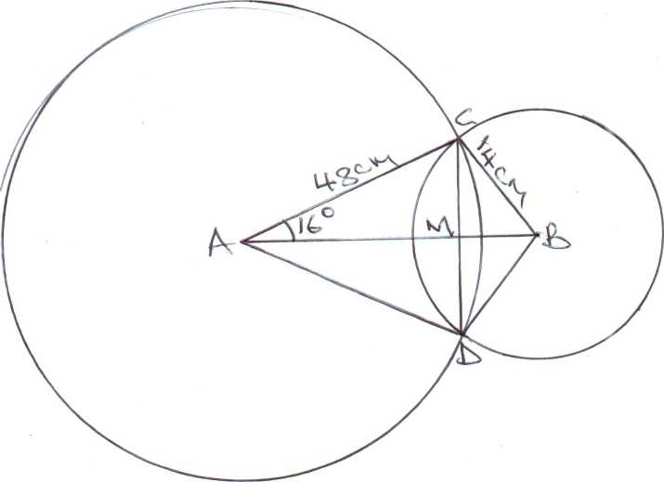

Q12

Triangle ABC is such that AB=8cm,AC=5cm and <BAC = 40^{O}.
(a) Calculate the area of triangle ABC (2mks)

(b) Calculate length BC (2mks)

Q13 Solve the quadratic equation by completing of squares 3x² - 4x - 2 = 0 (4mks)

Q14 The mean mark in a test for a class of 30 boys and 20 girls were 60 and 70 respectively. Find the mean mark for the whole class. (3mks)

Q15 Find the area of a triangle with dimensions 5.8cm by 7.4cm by 12.5cm. (3mks)

Q16 Solve for x in
2 log₁₀x - log₁₀ 2 = ½ log 64x - log₁₀2. (4mks)

SECTION 2 (50MKS)
Answer ONLY 5 questions
Q17 A group of people decided to raise sh. 72000 to buy a power saw. Each person was to contribute the same amount. Before the money was collected, five of the people withdrew and this meant that the remaining people had to pay more to meet the same target.
(a) If x represents the number of people originally in the group, express
(i) The amount each was to contribute originally in terms of x. (1mks)

(ii) The amount each has to contribute after the five left in terms of x. (1mks)

b) Write a simplified expression representing the increase in each person’s contribution after the five left. (2mks)

(c) If the increase in (b) above is sh. 1200,find the number of people originally in the group.
(4mks)

(d) Calculate the increase per person as a percentage to 1 dp. (2mks)

Q18 (a) Complete the table below for the equation
y=x² - 6x + 5
X | 0 | 1 | 2 | 3 | 4 | 5 | 6
X² | 0 |  | 4 | 9 |  | 25
-6x | 0 | -6 |  |  | -24 |  | -36
5 | 5 | 5 | 5 | 5 | 5 | 5 | 5
Y | 5 |  |  |  |  | 0

(2mks)

b) Draw the graph of y=x² – 6x + 5 using the values in the table. (3mks)

(c) Use the graph to solve the equations
(i) x² - 6x + 5 = 0 (1mk)

(ii) x² – 6x + 7 = 0 (2mks)

(iii) x² – 6.5x + 5 = 0 (2mks)

Q19 Use the figure below to find the angles given that 0 is the centre of the circle and FBG is a tangent.

Given that angle BAC = 32⁰, AED = 97⁰, find giving reasons
i) <ACB (2mks)

ii) <CBD (2mks)

iii) <CAD (2mks)

iv) <CBG (2mks)

v) Reflex <BOD (2mks)

Q20 A rectangle has vertices with co-ordinates A(2,0), B(4,0),C(4,3) and D(2,3).
(a) Draw the rectangle on the grid provided (2mks)

(b) A’B’C’D’ is the image of ABCD after an enlargement centre origin scale factor -1.
Draw A’B’C’D’ and write down its co-ordinates (2mks)

(c) A”B”C”D” is the image of A’B’C’D’ under a reflection in the line y=1. Draw it and write down its co-ordinates. (2mks)

(d) A”B”C”D” is given a rotation of 180⁰ about the origin to form A”’B”’C”’D”’. Draw this image and write its co-ordinates. (2mks)

(e) A”’B”’C”’D”’ is finally given a translation of $\left({4 \atop 2}\right)$ to give the image A””B””C””D””. Draw the final image and write down its co-ordinates. (2mks)

Q21 Two circles with centres A and B intersect at C and D as shown below. The circles have radii 48cm and 14cm. M the point of intersection of CD and AB and angle CAB = 16^{O}.

(a) Find
(i) CM (2mks)

(ii) angle CBD (2mks

(b) Calculate the area of the common region enclosed by the two circles. (6mks)

Q22 The region marked R below is enclosed by three inequalities as shown.

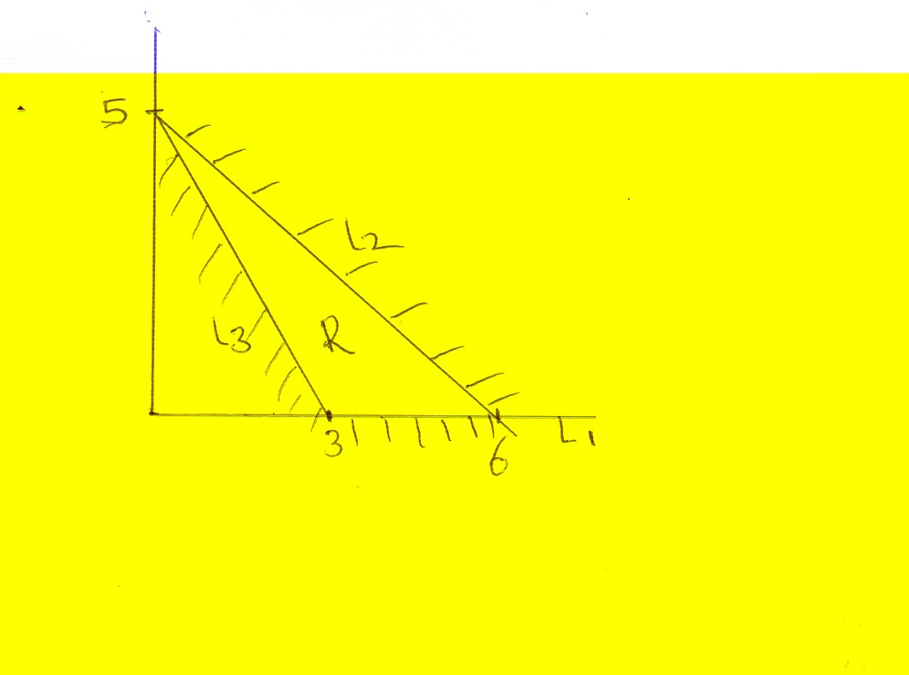

(a) Determine the area of region R (2mks)

(b) determine the inequalities that enclose the region
(i) L₁ (2mks)

(ii) L₂ (3mks)

(iii) L₃ (3mks)

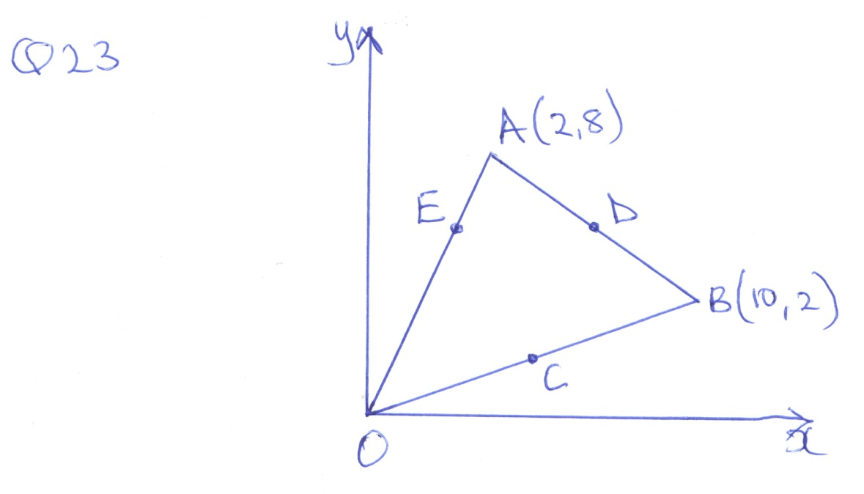

In triangle OAB shown below,QA= a,0B= b, C and D are the midpoimts of OB and AB respectively. E lies on OA such that OE: EA =3:1
(a) Express in terms of a and b the vectors
(i) OC (1mk)

(ii) OD (2mks)

(iii) OE (1mk)

b) Determine the co-ordinates of the points
i) C (2mks)

ii) D (2mks)

c) Calculate the magnitude of vector CD. (2mks)

24(a) Complete the table below for the graphs of y=Sin $∅$ and y=Cos $∅$ to 2dp. (2mks)
$∅$º | 0 | 30 | 60 | 90 | 120 | 150 | 180 | 210 | 240 | 270 | 300 | 330 | 360
Y=Sin $∅$ | 0 |  |  | 1 |  |  | 0 |  |  | -1 |  |  | 0
Y=Cos$∅$ | 1 |  |  | 0 |  |  | -1 |  |  | 0 |  |  | 1

b) Draw on the same set of axes the graphs y=Sin$∅$ and Y=Cos $∅$. Using a scale of x-axis 1cm rep 30º, and y-axis 1cm rep 0.25. (4mks)

(c) Find the values of $∅$where the two graphs meet. (2mks)

(d) Use the graph of y=Sin $∅$ to solve the equation Sin $∅$=0.5 for
0º $≤∅≤90$º (2mks)

