NAME: ………………………………………………………………….…........ INDEX NO. …….……………..........................
CANDIDATE’S SIGNATURE: …………………………………............... DATE: ……………………..............……………
SCHOOL: ………………………………………………………..….…………………..…………………...........……………………

121/1
MATHEMATICS (ALT A)
PAPER 1
JULY/AUGUST EXAM
2 ½ HOURS

JULY/AUGUST EXAM
FORM FOUR EVALUATION TEST
MATHEMATICS PAPER 1
2 ½ Hours

INSTRUCTIONS TO THE CANDIDATES
- Write your name and index number in the spaces provided above
- This paper contains two sections; Section 1 and Section 11.
- Answer all the questions in section 1 and only five questions from Section 11
- All workings and answers must be written on the question paper in the spaces provided below each question.
- Marks may be given for correct working even if the answer is wrong.
- Non programmable silent electronic calculators and KNEC Mathematical tables may be used EXCEPT where stated otherwise.
- Show all the steps in your calculations, giving your answers at each stage in the spaces below each question.
- This paper consists of 15 printed pages. Candidates should check carefully to ascertain that all the pages are printed as indicated and no questions are missing.

FOR EXAMINERS’S USE ONLY
Section 1
Question | 1 | 2 | 3 | 4 | 5 | 6 | 7 | 8 | 9 | 10 | 11 | 12 | 13 | 14 | 15 | 16 | Total
Marks

Section 1I GRAND TOTAL
Question | 17 | 18 | 19 | 20 | 21 | 22 | 23 | 24 | Total
Marks

SECTION 1 (50 MARKS)
Answer all questions in the spaces provided.
1. Evaluate without using a calculator 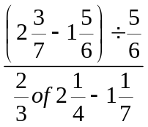 (3mks)

2. Calculate the standard deviation for the data below (3mks)
5,8,13,12,7,10,8,15,3,14

3. A straight line L₁ is perpendicular to another line L₂ whose equation is 3y+4x=12. If the two lines meet at point P which lines on the x-axis, find:
(i) The co-ordinate of point P (1mk)

(ii) The equation of line L1 in the form y=mx+c (3mks)

4. Mr. Otieno who deals in electronics sells a radio to a customer at Kshs. 1,440 after giving him a discount of 10% but finds that he still makes a 20% profit. Find the profit Mr. Otieno would make if he does not give a discount. (3mks)

5. A solid block in the shape of a cylinder has a height of 14cm and weighs 22kg. If it is made of material of density 5g/cm³, find the radius of the cylinder. Take π=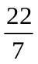 (3mks)

6. Simplify completely by factorization 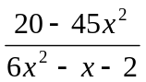 (3mks)

7. The figure below shows a triangle ABC not drawn to scale, D is a point on line AC. Given that BC=14cm, DC=7cm and ∠ABC=∠BDC. Find the length of AD (3mks)
B
C
D
A

8. Solve the simultaneous inequalities given below and list all the integral values of x (3mks)
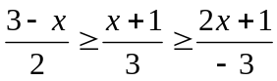

9. In the circle drawn to scale below A,B,C and D are points on its circumference, Chord BC=AC and angle ADC=138º
A
D
C
B
138º

Giving reasons calculate the angle ACB (3mks)

10. The figure below shows a triangular prism ABCDEF. AF=CD=BE=18cm, The ends ABC and EDF are equilateral triangles of side 8cm. calculate the angle plane ABD makes with the lie CD (3mks)
B
A
C
F
D
E

11. Patricia a student at Bidii mixed Secondary bought 5 pens and 3 exercise books from Solving supermarket at Kshs. 135, at the same time Jane her class mate also bought 4 pens and 5 exercise books and spent Ksh. 25 more than Patricia. Find the cost of each pen and exercise book (4mks)

12. Evaluate using mathematical tables only expressing your answer to 4 significant figures
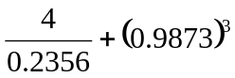 (3mks)

13. The diagram below shows the sketch of the curve y=x²-x-6
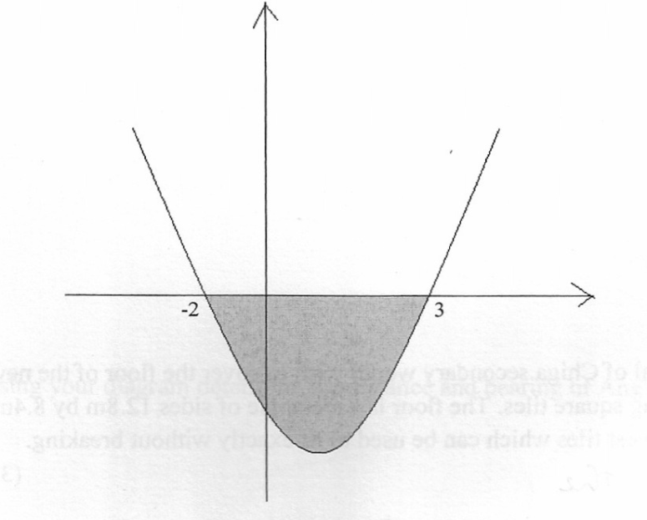

Using the mid-ordinate rule with five rectangles, calculate the area of the shaded region (4mks)

14. Given that sin (3x-35)º – cos (x+20)º= 0 and x is an acute angle, find its value (2 mks)

15. A train of length 80m crosses a bridge 20 m long in 5 seconds. Calculate the average speed of the train in km/h (3mks)

16. The principal of a secondary school would wish to cover the floor of the new administration block using the square tiles. The floor is a rectangle of sides 12.8m by 8.4m. Find the area of each of the largest tiles which can be used to fit exactly without breaking (3mks)

SECTION B (50 MARKS)
Answer ONLY FIVE questions in this section in the spaces provided
17. Four towns W, A, N and G are such that W 15km from A on a bearing of 158º, N is to the west of A and 20km away while G is to the South of N and on a bearing of 240º from W.
(a) Using a scale of 1:400,000 draw a scale diagram showing the relative positions of the four schools. (5mks)

(b) Using your diagram determine the distance and bearing ofG from A (2mks)

(c) A mast is to be erected so that its equidistant from A and N and 20km from G on the same diagram show the position of the mast and find its distance from W (3mks)

18. The table shows the marks obtained by 40 candidates in an examination

Marks | 5-14 | 15-29 | 30-34 | 35-44 | 45-49
Frequency | 2 | 12 | 7 | 15 | x
(a) Find the value of x (2mks)

(b) On the grid provided below draw a histogram to represent the data (5mks)



(c) By drawing a straight line on the graph above determine the median mark (3mks)

19. A matatu left Kakamega for Kisumu town 51km away at an average speed of 48km/h at 7.00am. At 7.30am a Boda boda left Kisumu for Kakamega travelling along the same route at an average speed of 60km/h
(a) The time when Boda boda meet the matatu (3mks)

(b) How far from Kisumu did the Boda boda meet the matatu (3mks)

(c) After meeting the Boda boda the matatu stopped for fifteen minutes before resuming the journey. At what speed should it travel then to reach Kisumu at the same time when the Boda boda reached Kakamega. (4mks)

20. A certain number of form four students agreed to contribute equally to buy a gift worth sh. 1200 for their class prefect’s birthday. Five students pulled out and so the others agreed to contribute an extra sh. 10. Their contribution enabled them to buy a gift worth sh. 200 more than they originally expected.

- If the original number of students was X, write an expression of how much each was
originally going to contribute. ( 1 mark )

(b) Write down two expressions of how much each contributed after the five students
pulled out. ( 2 marks )

(c ) Calculate how many students made the contribution. ( 5 marks )

(d) Find how much each contributed. ( 2 marks )

21.
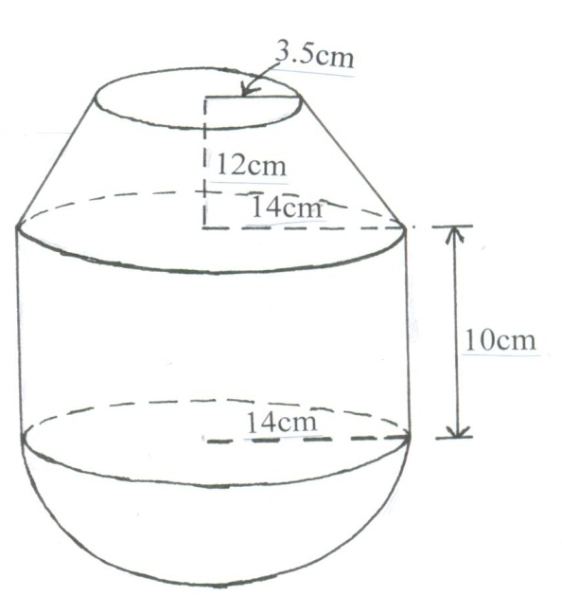
A right frustrum of base radius 14cm, top radius 3.5cm and height 12cm is stuck onto a cylinder of base radius 15.4cm and height 10cm and further attached to a hemisphere to form a closed solid as shown above.
(Use π = ²²/₇ )
Find
(a) The full height of the solid. ( 1 mark )

(b) The volume of the solid. ( 4 marks )

(c ) The total surface area of the solid. ( 5 marks )

22. The displacement of a particle S metres, t seconds after passing a fixed point O is given by
S=3+2t-5t²
Calculate:
(a) The displacement of the particle 2 seconds later (2mks)

(b) The time taken for the particle to return to O (2mks)

(c) The maximum displacement of the particle (3mks)

(d) The initial velocity of the particle (2mks)

(e) The acceleration of the particle after t seconds (1mk)

23. The diagram below shows a circle ABC with AB=12cm, BC=15cm, and AC=14cm
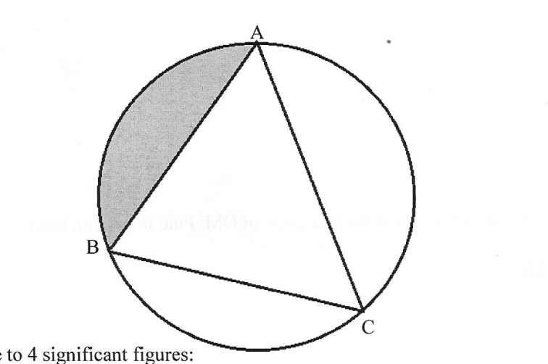

Calculate to 4 significance figures:
(a) The angle ACB (3mks)

(b) The radius of the circle (3mks)

(c) The area of the shaded region (4mks)

24. OABC is a trapezium such that the coordinates of O,A,B and C are (0,0),(2,-1) (4,3) and (0,y)
(a) Find the value of y (2mks)

(b) M is the mid-point of AB and N is the mid point of OM. Find in column form
(i) The vector AN (3mks

(ii) The vector NC (2mks)

(iii) Vector AC (1mk)

(c) Hence show that A, N and C are collinear (2mks)

