Name ……………………………………………………………………………………Adm. No. ………………………

Class …………………………………….
121/2
MATHEMATICS ALT 1
JULY/AUGUST 2016
2½ HRS
FORM 3
MWAKICAN(MJET) END OF TERM II EXAM
Instructions
(a) Write your name, class and admission number.
(b) Answer all the questions in section I and ONLY Five in section II.
(c) Show all the calculations in the spaces provided
(d) KNEC mathematical tables and non-programmable calculators may be used.

For Examiners Use
Section 1
1 | 2 | 3 | 4 | 5 | 6 | 7 | 8 | 9 | 10 | 11 | 12 | 13 | 14 | 15 | 16 | Total

Section 11
17 | 18 | 19 | 20 | 21 | 22 | 23 | 24 | Total
Grand total

SECTION I
- Evaluate using logarithms. [4 Marks]
$\frac{\sqrt[3]{0.04689}}{51.64×0.793}$

- Find the value of $k$ if the expression $4x^{2}-10x+k+3$ is a perfect square [2 Marks]

- A rectangular block has a square base whose sides are exactly 8cm. Its height, measured to the nearest millimeter is 3.2cm. calculate the greatest possible error in calculating its volume [4 Marks]

- A matrix is given by $T=\left(\begin{matrix}6 & 5 \\ -3 & 5\end{matrix}\right)$. Find $T^{-1}$ [2 Marks]

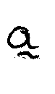
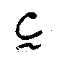
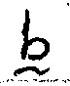
- The vectors $a, b, c$ are given as $\left({3 \atop 2}\right)$ $\left({4 \atop -3}\right)$and $\left({0 \atop 4}\right)$. Another vector $q$ is such that $q=2a-3b+2c$. Calculate $/q /$ correct to 3 decimal places. [3 Marks]

- Simplify by rationalizing the denominator; [2 Marks]
$\frac{3}{2\sqrt{3}-\sqrt{2}}$

- A scientific calculator is marked at sh. 1560. Under hire purchase it is available for a downpayment of sh. 200 and six monthly instalments of sh. 250 each. Calculate;
  - The Hire purchase price. [2 Marks]

  - The extra amount paid out over the cash price. [1 Mark]

- Solve the equation; [3 Marks]
$\log\left(x+24\right)-2log3=log⁡(9-2x)$

- In the figure below, ABCD is a square of side 14cm. CXB and CYB are arcs of circle centre A and D respectively. Calculate the area of the shaded region [3 Marks]
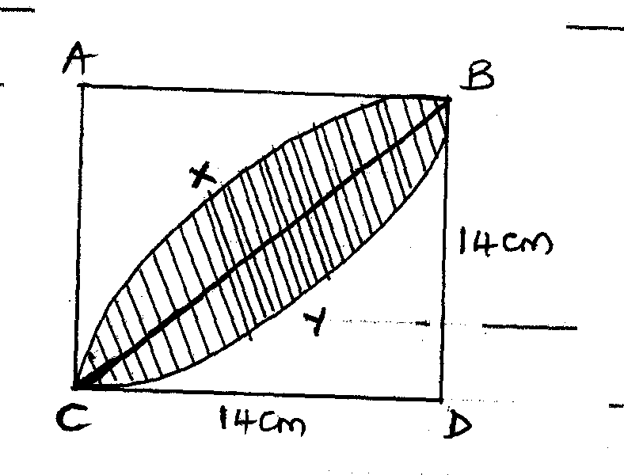

- Make $x$ the subject of the formula; [3 Marks]

$p=\frac{a\sqrt{x^{2}+b^{2}}}{y}$

- In the figure below, BT is a tangent to the circle to the circle at B. AXCT and BXD are straight lines. AX=6cm, CT=8cm, BX=4.8cm and XD=5cm.
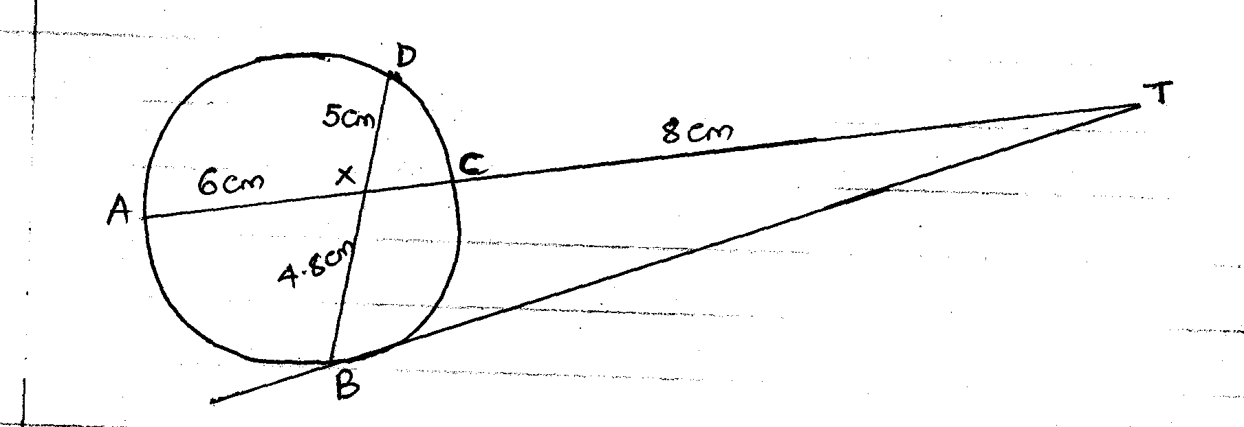
Find the length of;
  - XC [2 Marks]

  - BT [2 Marks]

- Find the value of $x$ if the matrix $\left(\begin{matrix}x & 1 \\ 4 & x-3\end{matrix}\right)$ is a singular matrix. [3 Marks]

- The first – term of an arithmetic sequence is -7 and the common difference is 4.
- List the first 6 terms of the sequence [2 Marks]

- Determine the sum of the first 30 terms of the sequence [2 Marks]

- A manufacturer sells a bottle of fruit juice to a trader at a profit of 40%. The trader sells it for sh. 84 at a profit of 20%. Find.
- The traders buying price. [2 Marks]

- The cost of manufacture of one bottle. [1 Mark]

- ABC is a triangle whose base BC = 35. The point X on BC is such that BX=21cm, AX=16cm and angle AXB=60⁰. Calculate;
  - The length of AB [1 Mark]

  - The length of AC [1 Mark]

  - The size of angle BAC [1 Mark]

- A small cone of height 8cm is cut off from a bigger cone to leave a frustrum of height 16cm. if the volume of the smaller cone is 160cm³, find the volume of the frustrum.
[3 Marks]

SECTION II answer ANY 5 questions in this section
(50 marks)
- The position vectors of A and B with respect to the origin are $(\begin{matrix}-8 \\ 5\end{matrix})and(\begin{matrix}12 \\ 5\end{matrix})$ respectively. Point M is the mid-point of AB and N is the mid-point of OA.
- Find;

- The coordinates of N and M [3 Marks]

- The magnitude of NM [3 Marks]

- Express vector NM in terms of OB [1 Mark]

- Point P maps onto P´ by a translation$(\begin{matrix}-5 \\ 6\end{matrix})$.
Given that OP=OM+2MN. [3 Marks]
Calculate the coordinates of P´

- Complete the table below for the function Y=2$x^{2}+4x-3$
- [2 Marks]
$$x$$ | $$-4$$ | $$-3$$ | $$-2$$ | $$-1$$ | $$0$$ | $$1$$ | $$2$$
$$2x^{2}$$ | $$32$$ |  |  | $$1$$ | $$0$$
$$4x$$
$$-3$$ |  |  | $$-3$$ |  |  | $$-3$$
$$y$$ |  |  | $$-3$$

- On the grid provided, draw the graph of the function
$y=2x^{2}+4x-3$ for $-4≤x≤2$ and use your graph to determine the roots of the quadratic equation $2x^{2}+4x-3=0$ to 1 decimal place. [3 Marks]
- Use your graph to solve the roots of the quadratic equations.
- $2x^{2}+x-5=0$ [2 Marks]

- $2x^{2}+3x-2=0$ [2 Marks]

- The table below shows the masses to the nearest kilograms of 65 animals in a farm.
Mass in Kg | 26-30 | 31-35 | 36-40 | 41-45 | 46-50 | 51-55
Frequency | 9 | 13 | 20 | 15 | 6 | 2

Use the table to find.
- Modal and median class [2 Marks]

- Mean of the data [3 Marks]

- The median mass [3 Marks]

- The percentage of animals with a mass between 36kg and 45kg. [2 Marks]

  - A matrix T is given by T=$\left(\begin{matrix}4 & 5 \\ 6 & 4\end{matrix}\right)$
Find T⁻¹ [2 Marks]

  - Truphena bought 20 bags of maize and 25 bags of beans at a total cost of sh. 77,000. If she had bought 30 bags of maize and 20 bags of beans, she would have spent sh. 7,000 more.
- Form a matrix equation from this information. [1 Mark]

- Determine the cost of a bag of maize and a bag of beans. [3 Marks]

  - She sold all the maize and beans at a profit of 10% on a bag of maize and 12 ½ % on a bag of beans. Calculate the total percentage profit. [4 Marks]

- At the beginning of the year 2000, Kanyora bought two houses, one in Thika and the other in Nakuru each at 1,240,000. The value of the house in thika appreciated at a rate of 12% p.a.
  - Calculate the value of the house in Thika after 9 years to the nearest shilling. [2 Marks]

  - After $n$ years, the value of the house in Thika was 2,741,245 while the value of the house in Nakuru was 2,917,231.
- Find $n$ [4 Marks]

- Find the annuakl rate of appreciation of the house in Nakuru. [4 Marks]

- The table below shows income tax rates.
Taxable income Rate in shs. per k£
in k£ per month
1 – 325 2
326 – 650 3
651 – 975 4
976 – 1300 5
1301 – 1625 6
Over 1626 7
Waketi earns a basic salary of 20,500. He has a house allowance of sh. 6,000 per month, medical allowance of sh. 4,000 per month and transport allowance of sh. 3,000 per month. He claims a tax relief of sh. 1,056 per month.
- Calculate
    - Waketi’s taxable income in k£ per month. [2 Marks]

    - Gross tax. [3 Marks]

    - Net Tax [2 Marks]

- His net income per month has the following deductions
Health insurance fund – sh. 150
Loan interest – sh. 200
Service charge – sh. 200
Sacco loan – sh. 2,500
Calculate his net income per month. [3 Marks]

- P varies directly as the square of Q and inversely as R.
- If Q increases by 5% and R decreases by 10%, find the percentage change in P
[5 Marks]

- Given that P=2 when R=5 and Q=4, find the positive value of Q when P=4.5cm and R=5cm. [5 Marks]

- The first term of an arithmetic progression is 2. The sum of the first 8 terms of the AP is 240.
- Find the common difference of the AP. [2 Marks]

- Given that the sum of the first $n$ terms of the AP is 1,560. Find $n$ [2 Marks]

- The 3rd, 5th and 8th terms of another AP from the first three terms of a G.P. If the common difference of the AP is 3.
Find.
- The first term of G.P [4 Marks]

- The sum of the first 9 terms of the G.P to 4 s.f. [2 Marks]

