Name: ________________________________Index No. ___________ /_____Adm No.______
Candidate’s Signature _____________
Date: _____________________________
232/3
PHYSICS PAPER 3
(PRACTICAL)
TIME: 2 ½ hours
KASSU JET EXAMINATION
Kenya Certificate of Secondary Education
PHYSICS (PRACTICAL) Paper 3
TIME: 2 ½ HOURS
Instructions
- Write your name, index number and admission number in the spaces provided above.
- Sign and write the date of examination in the spaces provided above.
- Answer ALL questions in the spaces provided in the question paper.
- You are supposed to spend the first 15 minutes of the 2 ½ hrs allowed for this paper reading the whole paper carefully before commencing your work.
- Marks are given for a clear record of the observations actually made, their suitability, accuracy and the use made of them.
- Candidates are advised to record their observations as soon as they are made.
- Non-programmable silent electronic calculators and KNEC mathematical tables may be used except where stated otherwise.
- This paper consists of 8 printed pages.
- Candidates should check the question paper to ascertain that all the pages are printed as indicated and that no questions are missing.
For Examiner’s Use Only
Question 1 | c | d | g | h | i | (j) | (k) |  | TOTAL
Maximum Score | 1 | 1 | 8 | 5 | 2 | 2 | 1 |  | 20
Candidate’s Score
Question 2 |  | c | e | f | g | h | i | j | k | TOTAL
Maximum Score |  | 1 | 6 |  |  | 5 | 3 | 3 | 2 | 20
Candidate’s Score |  |  |  |  |  |  |  |  |  | 40
GRAND TOTAL
Question one
You are provided with the following:
- 2 new dry cells size D
- A cell holder
- A switch
- A millimeter of range 0 to 1 mA
- A capacitor labeled C
- 8 connecting wires; at least four with crocodile clips on one end
- A stopwatch
- A carbon resistor labeled R
Proceed as follows
- Connect the circuit as shown in the figure 1below, where P and Q are crocodile clips.

mA
R
Crocodile clips
P
Q
C
S
- Close the switch S

- Name the process which takes place when the switch S is closed

………………………………………………………………. (1 mark)

- Connect the crocodile clips P and Q. Observe and record the highest reading of the millimeter I_{o}

………………………………………………………………. (1 mark)
- Open the switch S and at the same time start the stopwatch to measure the time taken for the current to decrease to four fifth the value of I_{o} i.e. ⁴/₅ I_{o.} Record your value in the table 1.

- Close the switch S for a second time and observe the deflection in the millimeter. (the pointer should rise back to the same initial value I_{o)}
- Repeat part (b) for other values of current as shown in the table 1 below. (8 marks)
Current I (mA) | ⁴/₅ I_{o} | ³/₄ I_{o} | ²/₃ I_{o} | ¹/₂ I_{o} | ²/₅ I_{o} | ¹/₃ I_{o} | ¹/₄ I_{o}
Your calculated fraction of I_{o} (mA)
Time t (s)

- Plot a graph of Current I (y – axis)(mA) against time t (s) (5 marks)


- From your graph, find W the value of I when t = 10s. (2 marks)
-----------------------------------------------------------------------------------------------------------------------------------------------------------------------------------------------------------------------------------------------------------------------------------------------------------------------------------------------------------------------------------------------------------------------------------------------------------------------------------------------------------------------------------------------------------------
- Given that A = 10W, determine the value of A. (2 marks)
-----------------------------------------------------------------------------------------------------------------------------------------------------------------------------------------------------------------------------------------------------------------------------------------------------------------------------------------------------------------------------------------------------------------------------------------------------------------------------------------------------------------------------------------------------------------
- Determine the voltage across R at t = 10s given that R = 4.7kΩ (1 mark)

-----------------------------------------------------------------------------------------------------------------------------------------------------------------------------------------------------------------------------------------------------------------------------------------------------------------------------------------------------------------------------------------------------------------------------------------------------------------------------------------------------------------------------------------------------------------

Question Two
You are provided with the following;

- a rectangular glass block
- 4 optical pins
- 2 thumb pins
- a soft board
- a plain paper

Proceed as follows:

- Place the glass block on the plain paper with one of the largest face upper most. Trace round the glass block using a pencil as shown below.

N₁
P₂
P₁
i
b
P₃
P₄
D
A
B
Eye

L

C

N₂

(b) Remove the glass block and construct a normal at B. Construct an incident ray AB of angle of incidence, i = 20⁰.

(c) Measure the breadth b of the glass block (1 mark)

……………………………………………………………

(c) Replace the glass block and trace the ray ABCD using the optical pins.

(d) Remove the glass block and draw the path of the ray ABCD using a pencil.
(e) Measure the length L and record it in the table below

Angle i⁰ | L (cm) | L² (cm) ² | $\frac{1}{L^{2}}$ (cm- ²) | Sin²i
20
30
40
50
60
70
(6 marks)

(f) Repeat the procedure above for the angles of incidence given.

(g) Calculate the values of $\frac{1}{L^{2}}$ and Sin² I; and record in the table above.

(h) Plot a graph of $\frac{1}{L^{2}}$ (y-axis) against Sin²i. (5 marks)

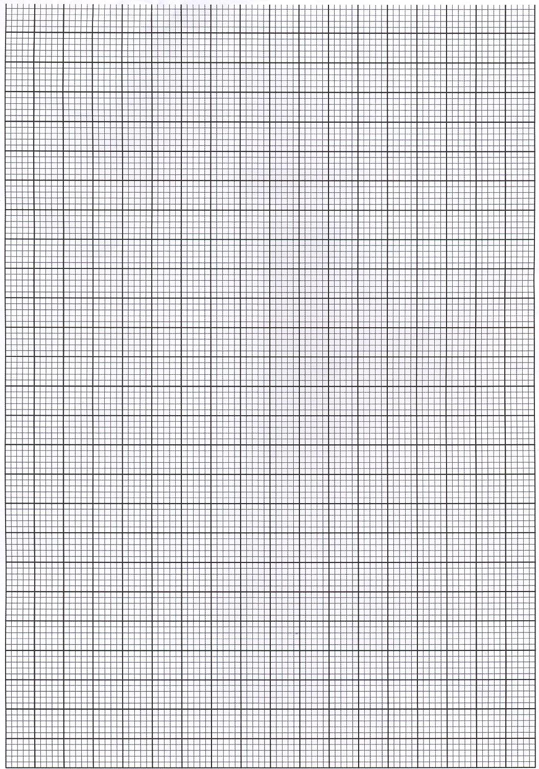

(i) Calculate the gradient S of the graph (3 marks)

-----------------------------------------------------------------------------------------------------------------------------------------------------------------------------------------------------------------------------------------------------------------------------------------------------------------------------------------------------------------------------------------------------------------------------------------------------------------------------------------------------------------------------------------------------------------
Given that the equation of that graph is; $\frac{1}{L^{2}}= - \frac{1}{{{0.1n}^{2}b}^{2}} Sin ^{2}i + \frac{1}{b^{2}}$

(j) Determine the value of n (3 marks)

----------------------------------------------------------------------------------------------------------------------------------------------------------------------------------------------------------------------------------------------------------------------------------------------------------------------------------------------------------------------------------------------------------------------------------------------------------------------------------------------------------------------------------------------------------------
(k) Present your work sheet; attached to the exam paper (2 mark)

THIS IS THE LAST PRINTED PAGE

