TERM III
232/1
PHYSICS
TIME: 2 HRS

INSTRUCTION TO CANDIDATES:
- Write your name and Admission number in the spaces provided.
- Answer all the questions in the spaces provided.
- Mathematical tables may be used.
- All workings must be clearly shown where necessary.
- This paper consists of 8 printed pages

FOR EXAMINERS USE ONLY:

SECTION | QUESTIONS | MAXIMUM SCORE | CANDIDATES SCORE
A | 1 – 11 | 25
B | 12 | 10
 | 13 | 9
 | 14 | 11
 | 15 | 15
 | 16 | 10
TOTAL |  | 80

SECTION A (25 MARKS)
- Study the arrangement and answer the questions that follow.
A and B are identical rubber strips and each has an elastic constant of 50Nm⁻¹. C has an elastic constant of 100Nm⁻¹.
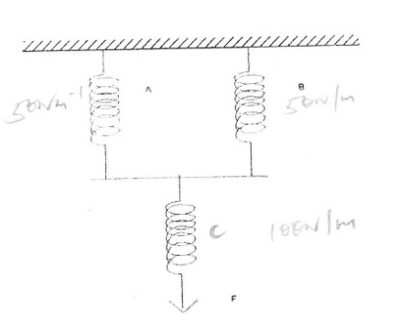

B
A

C

F

- If C extends by 4 cm, by how much would A extend? (2 mks)

- Determine the force F, which would cause these extensions. (2 mks)

- State two factors that affect the turning effect of a force. (2 mks)

- The figure below shows a u-tube manometer containing oil of density 0.9g/cm³. One end is connected to a gas tap.
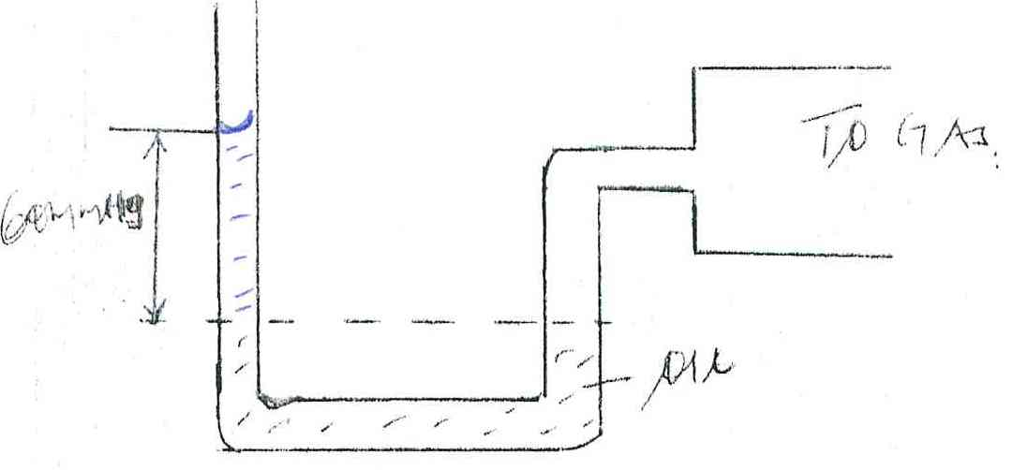
To Gas
60mmHg

Oil

If atmospheric pressure is 1.0 x10⁵ pa, find the pressure of the gas. (3 mks)

- State two advantages of an alkaline cell over a lead-acid cell. (2 mks)

- Three forces 12N due East, 4N due South and 15N due West acted on a body. If the body was in equilibrium, find the resultant force. (2 mks)

- Explain the following observation. A balloon, when rubbed on a blazer, it sticks to the ceiling board. (1 mk)

- A block measuring 20cm by 10cm by 4cm rests on a flat surface. The block has a weight of 6N. determine;
- The minimum pressure it exerts on the surface. (2 mks)

- The density of the block in kg/m³. (3 mks)

- The figure below shows a uniform cardboard in the shape of a parallelogram.

Locate the centre of gravity of the cardboard. (1 mk)

- (a) What is an electromagnet? (1 mk)

(b) Name the polarity of ends P and R on the diagram below, when the current is switched on
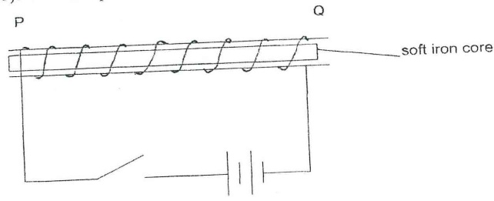

P ………………………… and Q ………………………………. (1 mk)

- The figure 4 below shows a ray of light incident on the surface of a plane mirror.

50⁰

The mirror is now rotated clockwise through an angle of 10⁰. Find the angle between the incident and the reflected rays. (1 mk)

- The force on a current carrying conductor in a magnetic field can be varied by changing among other, the magnetic field strength and magnitude of the current. Name two other factors that cause the force to vary. (2 mks)

SECTION B: (55 MARKS)
- (a) Sketch a diagram of micrometer screw gauge with the reading of 12.25 mm. (2 mks)

(b) The oil level in a burette is 10.0cm³. 5000 drops of the oil are run off the burette. If the radius of 1 drop is 0.7 mm.
- Calculate the volume of one drop. (2 mks)

- What is the final reading of the burette. (1 mk)

(c) The oil was made to spread on a surface of water forming a circular patch of diameter 21.0 m.
- Calculate the area of the oil patch. (2 mks)

- Calculate the thickness of the oil molecule. (2 mks)

(d) State one assumption made in c(ii) above. (1 mk)

- (a) State the Flemings left hand rule. (1 mk)

(b) Sketch the resultant field pattern around the following current carrying conductor and show the
direction of the forces acting on the conductors.
- Current flowing into the paper. (1 mk)

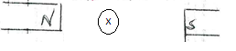
- Current flowing out of the paper. (1 mk)

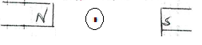
(c) The diagram below shows an electric bell.
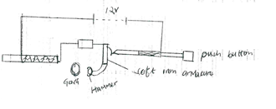
- Describe how the electric bell works. (4 mks)

- Explain what would happen if the armature is made of steel. (1 mks)

- What adjustment should be done to the system to make it operate effectively with a lower voltage battery. (1 mk)

- (a) Differentiate between a real image and a virtual image. (1 mk)

(b) An object of height 10cm is placed 5cm infront of a concave mirror of local length 10cm.
- By use of ray diagram shows the location of the image on the grid provided (4 mks)

Use the ray diagram in (i) above to determine the
- Image distance (2 mks)

- Magnification (3 mks)

(c) State the reason why convex mirror is used as a driving mirror instead of plane mirror. (1 mks)

- (a) State Hooke’s law. (1 mk)

(b) A spring with the upper end fixed, hang vertically and several masses are suspended from its lower end one at a time. The readings were recorded as shown.
Mass in kg | 0 | 0.02 | 0.04 | 0.06 | 0.08 | 0.10
Extension mm | 0 | 11 | 9 | 29 | 41 | 51
Force N
Extension in m
- Fill in the table. (2 mks)

- Plot a graph of extension in (m)(y-axis) against force in N. (5 mks)

(c) (i) From the graph determine the extension of a mass 0.045kg. Give your answer in mm.(2 mks)

(ii) Determine the spring constant of the spring. (3 mks)

(d) If two such springs were connected in series, what extension would they show when a mass of 1.5kg
hangs from one end. (2 mks)

- (a) State two advantages of a lead acid accumulator over dry cells. (2 mks)

(b) The figure below shows a highly negatively charged rod being brought slowly near the cap of a
positively charged gold leaf electroscope.
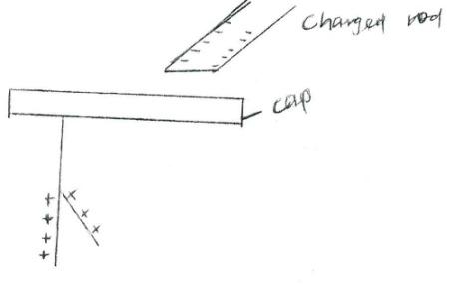

State and explain what will be observed on the leaf of the electroscope. (2 mks)

(c) The figure below shows how keepers are used to store magnets. (2 mks)
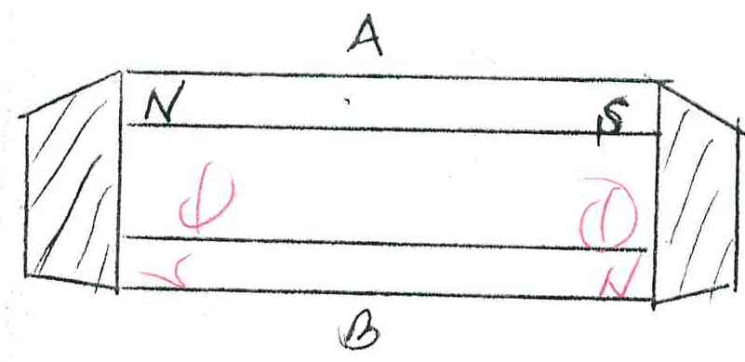

- Mark on the diagram the polarity of the magnet B. (2 mks)

- Briefly explain how keepers assist in storing magnets. (2 mks)

