PHYSICS
FORM 2 MARKING SCHEME
SECTION A (25 MARKS)
- Study the arrangement and answer the questions that follow.
A and B are identical rubber strips and each has an elastic constant of 50NM⁻¹. C has an elastic constant of 100NM⁻¹.
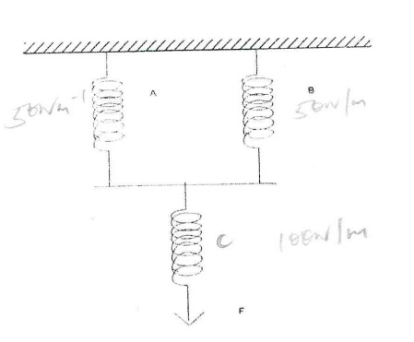

- If C extends by 4 cm, by how much would A extend? (2 mks)
F = ke
= 100 x $\frac{4}{100}$
= 4N (1)
A & B share the weights
$∴$ F = ke
E = $\frac{F}{k}$
= $\frac{2}{50}×100$
= 4cm (1)

- Determine the force F, which would cause these extensions. (2 mks)
F = ke (1)
= 100 x ⁴/₁₀₀
= 4N (1)

- State two factors that affect the turning effect of the force. (2 mks)
- Force (1)
- Law distance from the pivot (1)

- The figure below shows a u-tube manometer containing oil of density 0.9g/cm³. One end is connected to a gas tap.
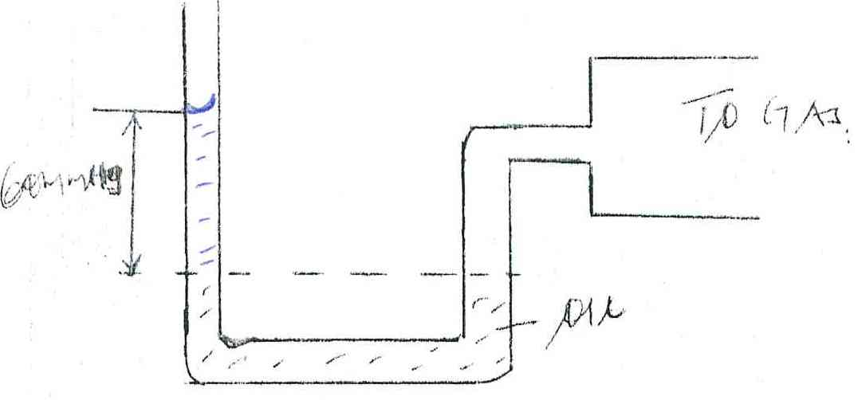

60mmHg

If atmospheric pressure is 1.0 x10⁵ pa, find the pressure of the gas. (3 mks)
Pg = Pa + hpg (1)
= 1.0 x 10⁵ + 0.06 x 900 x 10 (1)
= 1.0054 x 10⁵ Pa

- State two advantages of an alkaline cell over a lead-acid cell. (2 mks)
- Large current can be drawn from them
- Can be kept in discharged condition for a long time
- Require little attention

- Three forces 12N due East, 4N due South and 15N due West acted on a body. If the body was in equilibrium, find the resultant force. (2 mks)
15N
(½ )
4 N
x
12N

3 N
(½ )
4N
Resultant force = $\sqrt{16+9}$
= $\sqrt{25}$
= 5N (1)

- Explain the following observation. A balloon, when rubbed on a blazer, it sticks to the ceiling board. (1 mk)
- On rubbing balloon acquires static charges thereby getting attracted to ceiling board.

- A block measuring 20cm by 10cm by 4cm rests on a flat surface. The block has a weight of 6N. determine;
- The minimum pressure it exerts on the surface. (2 mks)
D = 0.2m x 0.1m x 0.04m
W = 6N
Pm = $\frac{F}{A}$ (1)
= $\frac{6}{0.2 ×0.1}$
= $\frac{600}{2}$
= 300NM⁻² (1)

- The density of the block in kg/m³. (3 mks)
M = w/g
= 6/10
= 0.6kg (1)
W = m/v
= $\frac{0.6}{0.2×0.1×0.04}$ (1)
= 750kg/m³

- The figure below shows a uniform cardboard in the shape of a parallegram.
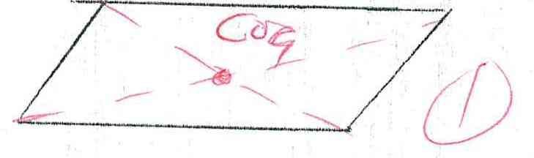

Locate the centre of gravity of the cardboard. (1 mk)

- (a) What is an electromagnet? (1 mk)
is a temporary magnet formed when current passes through a solenoid in a core (1)

(b) Name the polarity of ends on the diagram below.
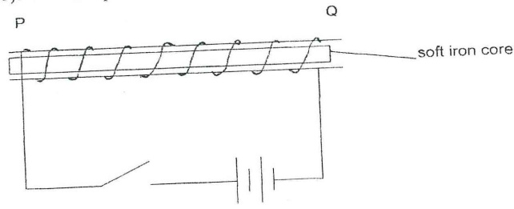

P ……………N (1) ………… and Q ……………S (1)………. When the current is switched on.

- The figure 4 below shows a ray of light incident on the surface of a plane mirror.

fig 4
50⁰

The mirror is now rotated clockwise through an angle of 100⁰. Find the angle between the incident and the reflected rays. (1 mk)
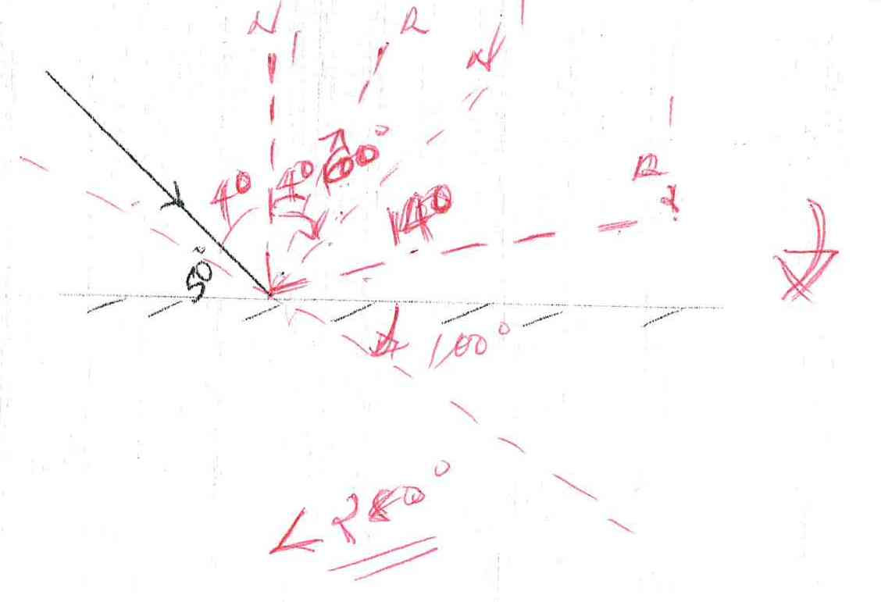

- The force on a correct carrying conductor in a magnetic field can be varied by changing among other, than the magnetic field strength and magnitude of the current. Name two other factors that cause the force to vary. (2 mks)
- Number of turns. (1)
- Angle of the conductor with the field. (1)
SECTION B: (55 MARKS)
- (a) Sketch a diagram of micrometer screw gauge with the reading of 12.25 mm. (2 mks)
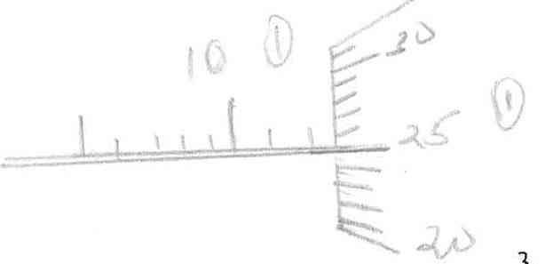

(b) The oil level in a burette is 10.0cm³. 5000 drops of the oil are run off the burette. If the radius of 1 drop is 0.7 mm.
- Calculate the volume of one drop. (2 mks)
V = $\frac{4}{3}πr^{3}$
= $\frac{4}{3}×\frac{22}{7}×0.01 ×0.07×0.07$
= 0.001437cm³

- What is the final reading of the burette. (1 mk)
Total vol. of drops = 0.001437 x 500
= 7.187cm³
Final level = 10.000
7.187
17.187 cm³ (1)

(c) The oil was made to spread on a surface of water forming a circular patch of diameter 21.0 m.
- Calculate the area of the oil patch. (2 mks)
A = $πr^{2}$ (1)
= $\frac{22}{7}×21×21$
= 1386m³ (1)

- Calculate the thickness of the oil molecule. (2 mks)
t = V/A (1)
= $\frac{7.187×{10}^{-6}}{1386}$ = 5.185 x 10⁻⁹m³ (1)

(d) State one assumption made in c(ii) above. (1 mk)
- Oil spread to one molecule thick. (1)

- (a) State the Flemings left hand rule. (1 mk)
- It the thumb first and second finger of the left hand are held at right angle to each other then the first finger represent the direction of the current the thumb represent the direction of the motion.

(b) Sketch the resultant field pattern around the following current carrying conductor and show the direction of the forces acting on the conductors. (2 mks)

- Current flowing into the paper. (1 mk)
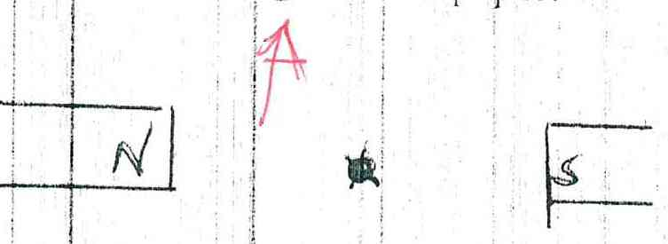

- Current flowing out of the paper. (1 mk)
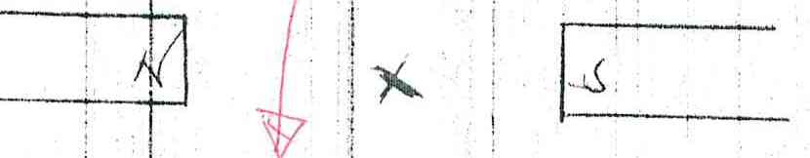

(c) The diagram below shows an electric bell.
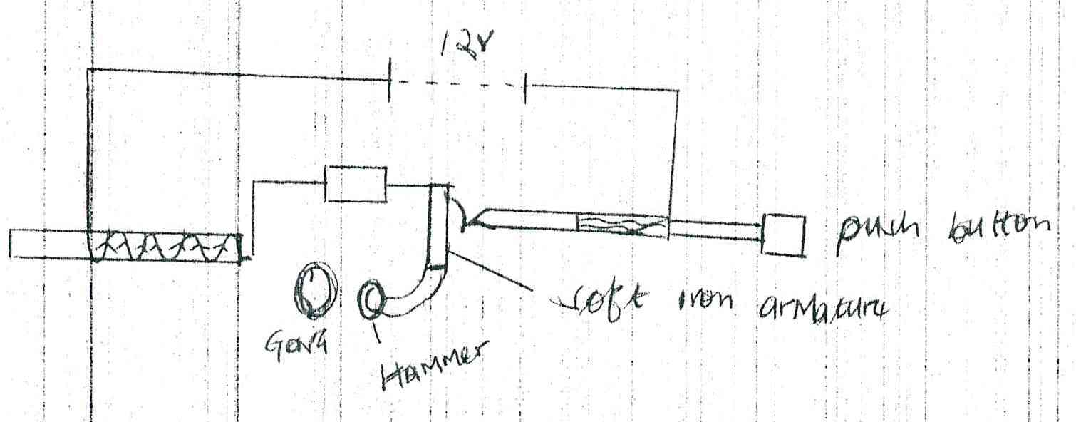

- Describe how the electric bell works. (4 mks)
- When the push button is pushed on current flows and the soft iron ore is magnetized, the soft iron core attracts the soft iron armature (1) and the hammer hits the gong meanwhile the contact is broken stopping current flow (1). The core diamagnetic releases the armature and the hammer goes back (1). The process is repeated.

- Explain what would happen if the armature is made of steel. (1 mks)
The hammer hits the gong and remains there (1) the bell ring once this is because steel acquire permanent magnetism. (1)

- What adjustment should be done to the system to make it operate effectively with a lower voltage battery. (1 mk)
- The soft iron should be u-shaped.

- (a) Differentiate between a real image and a virtual image. (1 mk)
Real | Virtue
- Formed on a screen  - Formed by convergent of two or more actual rays | - Not Formed on a screen  - Formed by convergent of two or more normal rays

(b) An object of height 10cm is placed 5cm infront of a concave mirror of local length 10cm.
- By use of ray diagram shows the location of the image. (4 mks)
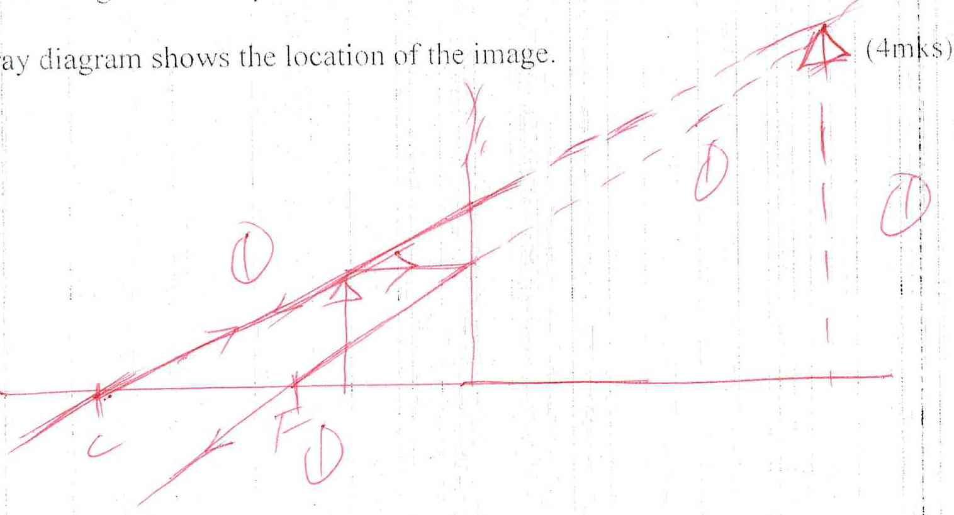

Use the ray diagram in (i) above to determine the
- Image distance (2 mks)
= 2.4 x 4
= 9.6 cm (1)

- Magnification (2 mks)
M = V/u (1)
= 9.6/5
= 1.92 (1)

(c) Explain why convex mirror is used as a driving mirror instead of plane mirror. (3 mks)
- always gives upright images no matter the position of the object
- It also gives a wide field of view

- (a) State Hooke’s law. (1 mk)
- For a helical spring or any other elastic material extension is directly proportional to the force applied provided. Elastic limit is not exceeded.

(b) A spring with the upper end fixed, hang vertically and several masses are suspended from its lower end one at a time. The readings were recorded as shown.
Mass in kg | 0 | 0.02 | 0.04 | 0.06 | 0.08 | 0.10
Extension mm | 0 | 11 | 9 | 29 | 41 | 51
Force N | 0 | 0.2 | 0.4 | 0.6 | 0.8 | 1.0
Extension in m | 0 | 0.011 | 0.019 | 0.029 | 0.041 | 0.051
- Fill in the table. (2 mks)

- Plot a graph of extension in (m) against force in N. (5 mks)
A = 1
S = 1
P = 2
L = 1
e(m)

FN

(c) (i) From the graph determine the extension of a mass 0.045kg. give your answer in mm.(2 mks)
Soln:
0.045 x 1.0 = 0.45N (1)
From the graph =
(ii) Determine the spring constant of the spring. (2 mks)
G = De/Df (1)
Recip. of gradient = k (1)

(d) If two such springs were connected in series, what extension would they show when a mass of 1.5kg hangs from one end. (2 mks)
- The extension doubles hence k is halfed
F = $\frac{K2}{e}$
15N = $\frac{k2}{e}$ (1)
e= 15/k₂ (1)

- (a) State two advantages of a lead acid accumulator over dry cells. (2 mks)
- Low internal reinstate
- Have high emf

(b) The figure below shows a highly negatively charged rod being brought slowly near the cap of a positively charged gold leaf electroscope.
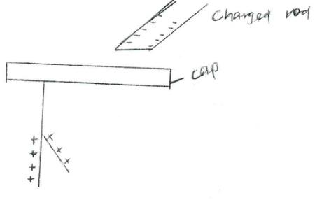

State and explain what will be observed on the leaf of the electroscope. (2 mks)
- The leaf falls then rises (1)
- Reason: electrons are repelled to the leaf and plate neutralizing the charge as more electrons are repelled. The leaf and plate gains same charge item rises.

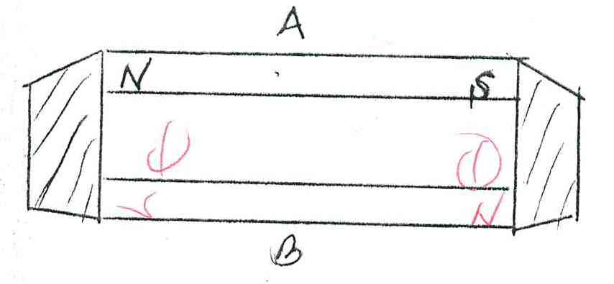
(c) the figure below shows how keepers are used to store magnets. (2 mks)

- Mark on the diagram the polarity of the magnet B. (2 mks)

- Briefly explain how keepers assist in storing magnets. (2 mks)
Keepers create complete loops which reduce repulsion of the dipoles in the domains. The dipoles are linked together. (1)

