INSTRUCTIONS TO CANDIDATES
- Write your name and Index Number in the spaces provided above.
- Sign and write date of examination in the spaces provided above.
- Answer all questions in the spaces provided
- All working must be clearly shown
- Non-programmable silent calculator may be used

FOR EXAMINERS USE ONLY
Question | Maximum | Candidates Score
1 | 20mks
2 | 16mks
ii) | 4mks
Total

1.You are provided with the following apparatus
- Two new dry cells and a cell holder
- A voltmeter (0-3v) or (0-5v)
- A ammeter(0-1A)
- 5 connecting wires – at least two with crocodile clips
- 1m length nichrome wire mounted on a mm scale (SWG 32)
- A micrometer screw gauge
- A switch
In this experiment you are required to determine the resistivity of the wire
Connect the apparatus as shown in the diagram below

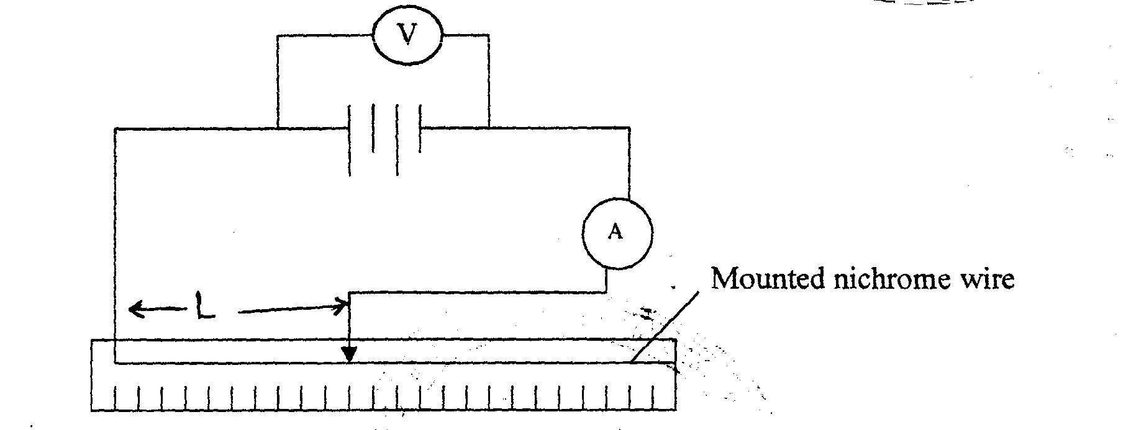

ii) Slide the wire mounted on the meter rule to give a set of readings for values of I and V respectively for length L ranging from 10cm to 70cm .Record the results in the table below (6 marks)
LEGTH L(cm) | LEGTH L(m) | Current I(A) | Voltage (V) | R=V/I
0.1
0.2
0.3
0.4
0.5
0.6
0.7

iii)from the table what relationship is there between length of the wire and R.(1mk)
…………………………………………………………………………………………………………………………………………………………………………………………………………………………………………………………………………………………………………………………………..
iv)use the micrometer screw gauge provided to measure the diameter of the wire
d=……………………………………mm d = ………………………………………….m (1 mk)
Hence find the cross sectional area A of the wire mounted on the ruler that you used.(2mks)
…………………………………………………………………………………………………………………………………………………………………………………………………………………………………………………………………………………………………………………………………….
v)Using the results from your table to plot a graph of R against L. (4mks)

vi)From the graph find the value of I when L=0.2 m and V =1.8V.(2MKS)
…………………………………………………………………………………………………………………………………………………………………………………………………………………………………………………………………………………………………………………………………..
(VII)Calculate the slope of the graph (2mks)
…………………………………………………………………………………………………………………………………………………………………………………………………………………………………………………………………………………………………………………………………….
(viii)Hence calculate the resistivity of the wire given that R=$\frac{pL}{A}$ (2mks)
…………………………………………………………………………………………………………………………………………………………………………………………………………………………………………………………………………………………………………………………………….
QUESTION 2
2. You are provided with the following apparatus
- A pendulum bob
- A cotton thread 1m long
- Two small pieces of wood
- A retort stand and clamp
- A metre rule
- A stop watch
- Some cello tape

Proceed as follows
- Clamp the pendulum as shown starting with L= 80cm
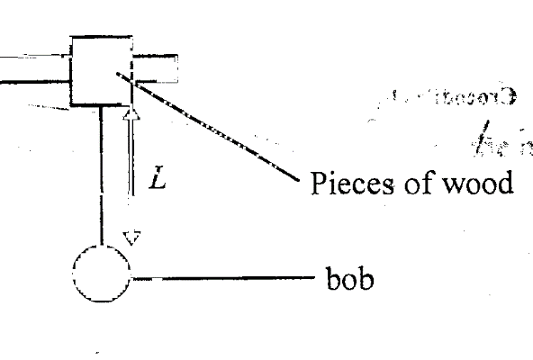

You are required to determine the constant ‘b’ using a simple pendulum
(a) Give the bob a small displacement 0 and record the time‘t’ for 20 oscillations. .Record also the periodic time T, for one complete oscillation
(b) Repeat (b) for values of L as shown in the table. Enter your readings in the table. Work out also T² and enter these values in the table.

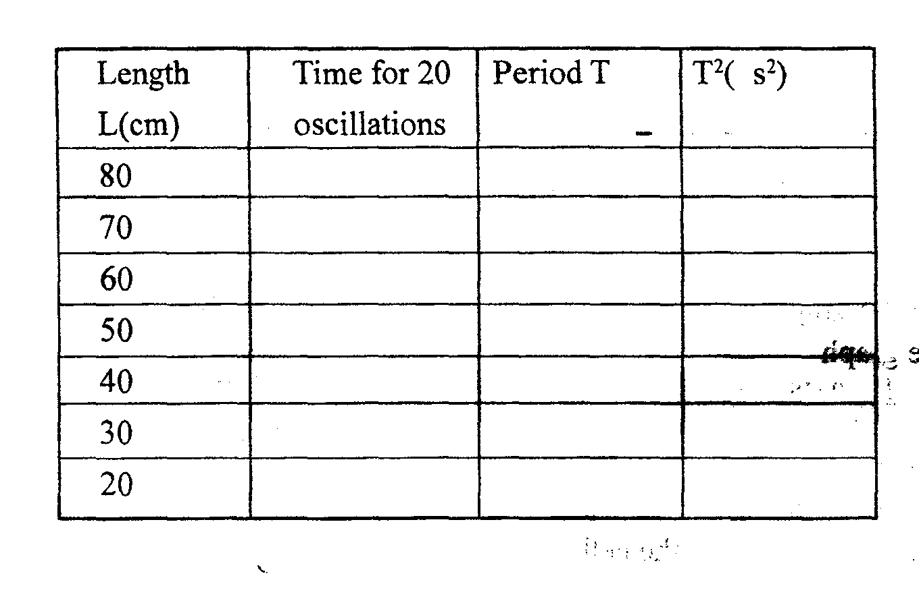

(9 mks)
(c) Plot a graph of T² against L. (5 mks)

(d) Determine the slope of the graph and state its units. (3 mks)

(e) The equation for the graph is given by
$$T^{2}=\frac{4π^{2}L}{ b} +C$$
Where b and C are constants. Determine the value of b stating its significance. (3 mks)

