Name……………………………………………………………………… Index No……………..
School………………………………………………………………………….. Date………………….
Candidate’s signature…………………………………..

232/3
PHYSICS
PRACTICAL
PAPER 3
JULY/AUGUS 2018
TIME: 2 ½ HOURS

SCHOOL BASED FORM FOUR EXAMINATION 2018

INSTRUCTIONS TO THE CANDIDATES:

1. Write your name and Index Number in the spaces provided above.
2. Sign and write the date of examination in the spaces provided above
3. Answer all the questions in the spaces provided in the question paper.
4. You are supposed to spend the first 15 minutes of the 2 ½ hours allowed for this paper reading the whole paper carefully before commencing.
5. Marks are given for a clear record of the observation actually made, their suitability, accuracy and the use of them.
6. Candidates are advised to record their observations as soon as they are made.
7. Non-programmable silent electronic calculators and KNEC mathematical tables may be used.
8. Candidates should answer the questions in English.

FOR EXAMINERS’ USE ONLY
Question I | c | d | e | fi | fii | Total
Maximum Score | 8 | 5 | 3 | 2 | 2 | 20
Candidate’s score

Question 2
 | c | e | fi | fii | g | h | i | j | Total
Maximum Score | 4 | 7 | 1 | 1 | 2 | 1 | 1 | 1 | 20
Candidate’s score

Grand Total | 40
Candidate’s score

This paper consists of 8 Printed pages.
Candidates should check to ascertain that all pages are printed as indicated and that no questions are missing.

Question 1
1. You are provided with the following apparatus:
- 2 size D dry cells
- 100cm nichrome wire on a mm scale, labelled P at one end.
- A bulb (2.5V) and a bulb holder.
- 8 connecting wires (at least 4 with crocodile clips)
- Cell holder
- A voltmeter (0-5V)
- An ammeter (0-1A)
- A jockey
a) Connect the apparatus provided as shown in the diagram.
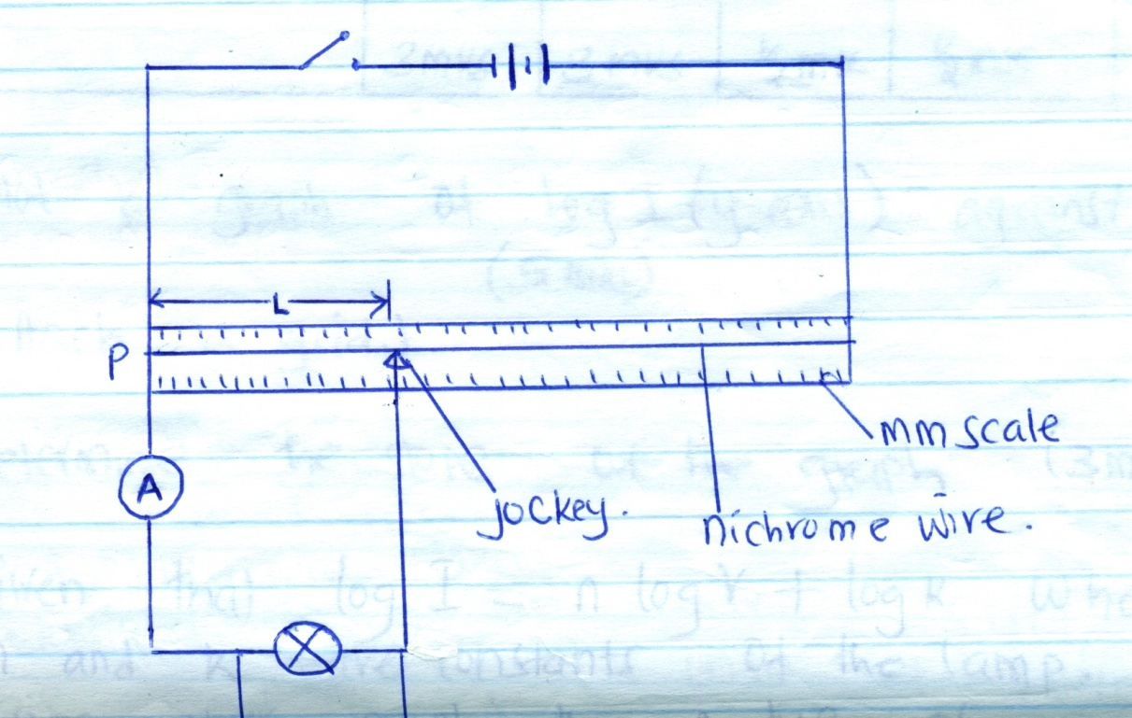

b) Place the jockey at x = 20cm from P, then close the switch.
Record the ammeter reading and the voltmeter reading in the table below.
c) Repeat the experiment by placing the jockey at x = 30, 40, 50, 60 and 80cm from P.
Record your readings and complete the table below.

Length l (cm) | I (A) | Pd, V(V) | I(mA) | Pd, v(MV) | log I | log V
20
30
40
50
60
80
 | 3mks | 3mks | -½ mk | -½ mk | -½ mk | -½ mk

d) Plot a graph of log I (y-axis) against log V (5mks)
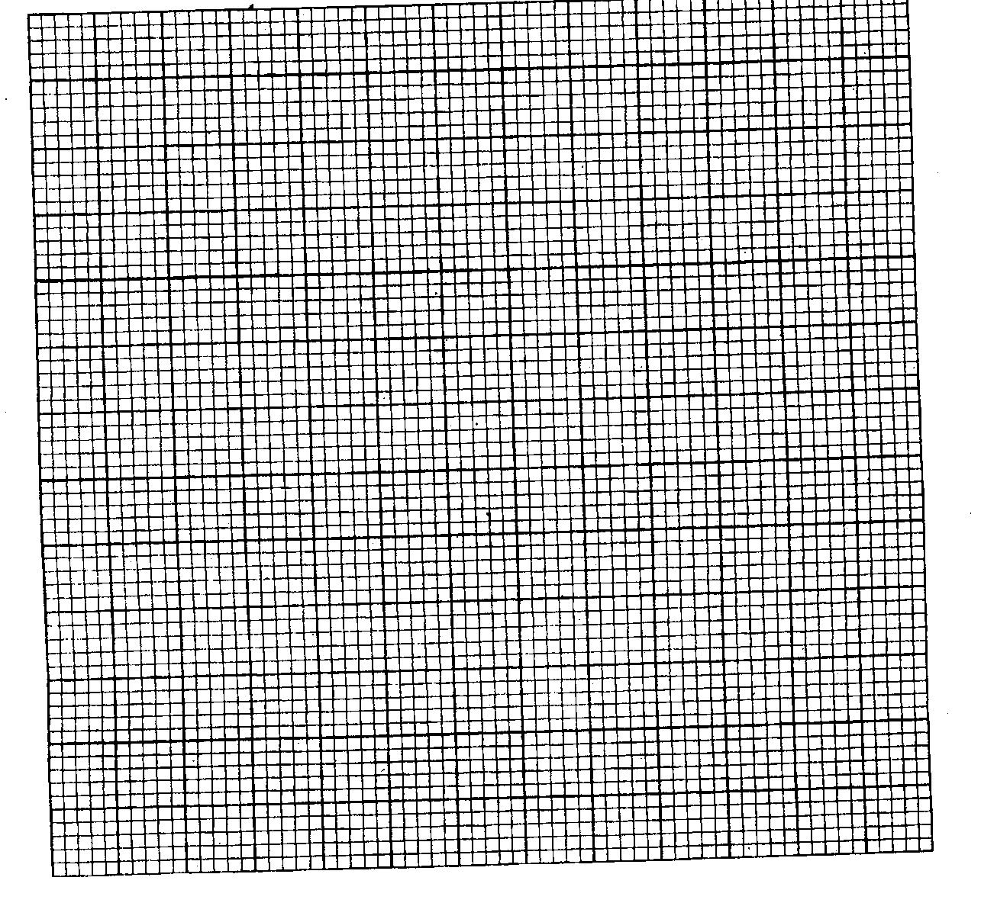
e) Determine the slope of the graph. (3mks)
f) Give that log I = nlog V + log K where n and k are constants of the lamp. Determine using your graph the value of:

i) K (2mks)

ii) n (2mks)

Question 2
Part A
You are provided with the following:
- A retort stand, boss and clamp.
- 2 boiling tubes
- A thermometer
- Some distilled water in a beaker labelled W
- Some liquid in a beaker, labelled L
- A 250ml beaker containing some water.
- A measuring cylinder
- A stop watch
- A tripod stand and wire gauze
- A card board with a hole in the middle
- A burner.

Proceed as follows
a) Clamp one boiling tube on the retort stand. Measure and pour 45ml, of the distilled water, W
into a boiling tube. Set up the apparatus as shown in the figure below.
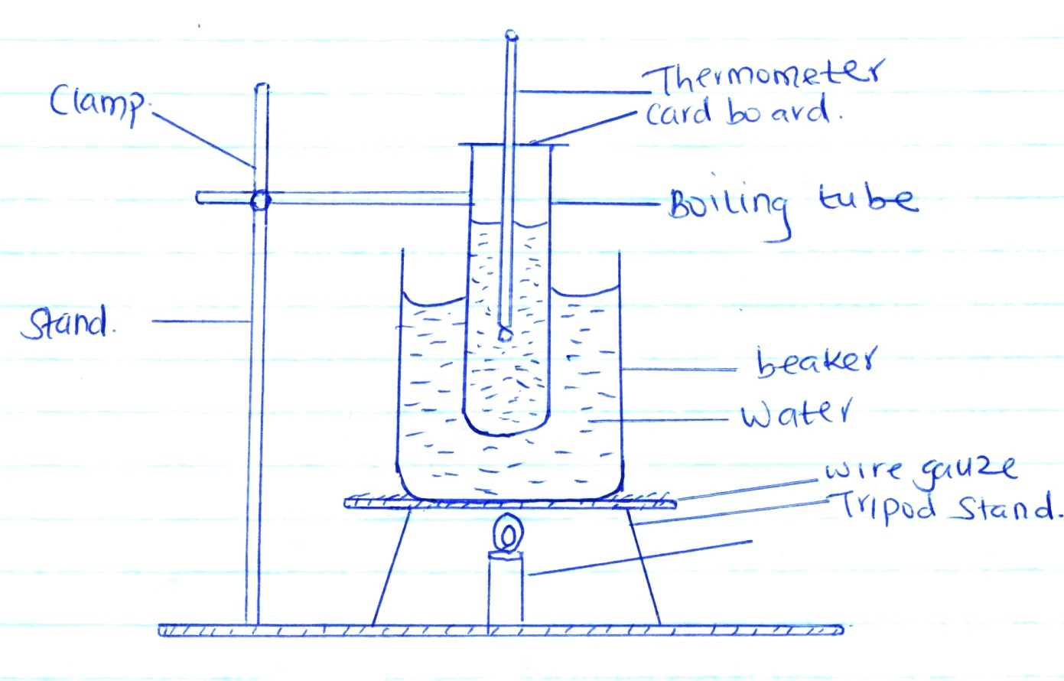
b) Heat the water in the large beaker (250ml) until the temperature of the distilled water reached 85⁰C. Remove the boiling tube from the hot water by lifting up the retort stand and placing it away from the burner.
c) Stir the water in the boiling tube using the thermometer. Record in the table below the temperature of the distilled water at intervals of 30 seconds starting at 80⁰C until it drops to 60⁰C (stir the distilled water before taking any reading).
Time in minutes | 0 | 0.5 | 1.0 | 1.5 | 2.0 | 2.5 | 3.0 | 3.5 | 4.0 | 4.5
Temperature of W(⁰C)
Temperature of L(⁰C)

Time in minutes | 5.0 | 5.5 | 6.0 | 6.5 | 7.0 | 7.5 | 8.0 | 8.5 | 9.0 | 9.5
Temperature of W(⁰C)
Temperature of L(⁰C)

(4mks)
d) Using the second boiling tube, repeat the procedure in b and c using 45ml of liquid L instead of distilled water. Record your results in the same table.
e) Using the same axis on the grid provided, plot a graph of temperature (y-axis) against time for
i) Distilled water, W
ii) Liquid L
(Label the graphs of L and W. (7mks)

f) From the graph, determine:
i) the time, t taken for the distilled water to cool from 75⁰C to 65⁰C.
t_{w} = _____________ minutes (1mk)
ii) the time, t taken for liquid L, to cool from 75⁰C to 65⁰C
t_{L}= _____________ minutes (1mk)
g) Determine the constant r given that 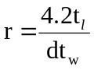 where d, density of liquid, L = 0.8g/cm³. (2mks)

PART B
You are provided with the following:
- Copper wire of length 130cm.
- Test tube of diameter 1.5cm (ordinary)
- Metre rule.

Procedure
By using the wire provided, make 20 closely packed turns around the said ordinary test tube as shown.

h) Measure the length x = ______ cm (1mk)

i) Use the result “X” to determine the thickness of the wire, d = ______ cm. (1mk)
j) Given that the volume of the wire 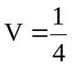πd²L, determine the volume, V of the wire if
L = 120cm. (3mks)

