NAME…………………………………….ADM. NO………………CLASS……………

END OF TERM 2 EXAM
FORM 2 MATHEMATICS

TIME: 2½ HRS.

INSTRUCTION TO STUDENTS:
- Write your name, admission number and class in the spaces provided above.
- Write the date of examination in spaces provided.
- This paper consists of two Sections; Section I and Section II.
- Answer ALL the questions in Section I and only five questions from Section II.
- All answers and working must be written on the question paper in the spaces provided below each question.
- Show all the steps in your calculation, giving your answer at each stage in the spaces provided below each question.
- Marks may be given for correct working even if the answer is wrong.
- KNEC Mathematical tables may be used, except where stated otherwise.
- Candidates should check the question paper to ascertain that all the pages are printed as indicated and that no questions are missing.
- Candidates should answer the questions in English.

FOR EXAMINER’S USE ONLY:
SECTION I
1 | 2 | 3 | 4 | 5 | 6 | 7 | 8 | 9 | 10 | 11 | 12 | 13 | 14 | 15 | 16 | TOTAL

17 | 18 | 19 | 20 | 21 | 22 | 23 | 24 | TOTAL
SECTION II
GRAND TOTAL

Ensure that all the pages are printed and no question(s) are missing

SECTION I (50 MARKS)
Answer ALL the questions in this section in the spaces provided.
- Evaluate (3 Marks)
$$\frac{-12 3 x 4-(-15)}{-5 x 2+(-5)}$$

- Work out the following giving your answer as a mixed number in its simplest form. $\frac{ \frac{2}{5 } ÷ \frac{ 1}{2} of \frac{4}{9} - 1\frac{1}{10}}{\frac{1}{8} - \frac{1}{6} x \frac{3}{8}}$ (3 Marks)

- Find the equation of the L₁ which is perpendicular to the line 3y + 2x = 6 and passes through the point (-3, 4). ( 3mks)

- Use logarithms to evaluate. (3 Marks)
$\sqrt[4]{\frac{3.521 x 0.8921}{795.3}}$

- The diagram below represents a prism of length 6cm whose cross-section is an equilateral triangle of sides 3cm. Draw a well labeled sketch of the net of the prism. (3 Marks)
6cm
C
B
E
A
3cm
3cm
3cm
D
F

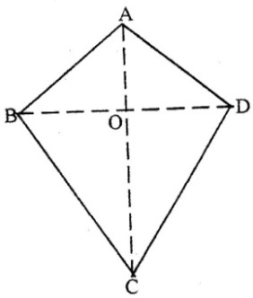
- The figure below represents a kite ABCD, AB = AD = 15 cm. The diagonals BD and AC intersect at O. AC = 30cm and AO = 12 cm.

Find the area of the kite (3mks)

- Mrs. Kangogo has Sh. 700 in Sh. 50 notes and Sh. 100 notes only. If she has a total of 11 notes find how many notes she has of each denomination. (3mks)

- In the figure below AD // BC. AC and BD intersect at E. Given that AE: EC = 1:5 and BD =12 cm, calculate the length of DE.

A D

E

(3 marks)
B C

- Given that sin (x + 60)⁰ = cos (2x), find tan (x + 60 )⁰ (3marks)

- A salesman gets a commission of 2.4% on sales up to Sh. 100,000. He gets additional commission of 1.5% on sales above this. Calculate the commission he gets for sales worth Sh. 280,000. (3 Marks)

- In the figure below, lines AB and LM are parallel.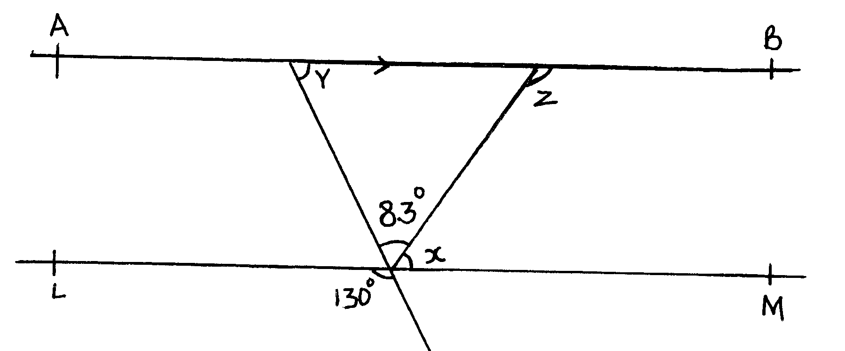
Find the values of the angles marked x, y and z. (3mks)

- The surface areas of two similar bottles are 12cm² and 108cm² respectively. If the bigger one has a volume of 810cm³. Find the volume of the smaller one. (3 Marks)

- In the figure below, triangle A ′B′ C′ is the image of triangle ABC under a rotation, centre O.
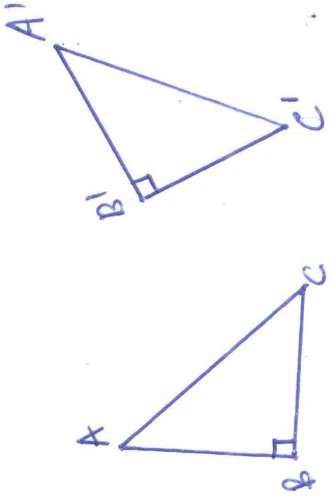
By construction, find and label the centre O of the rotation. Hence, determine the angle of the rotation.(3mks)

14. In the figure below triangle ABO represents a part of a school badge. The badge has as symmetry of order 4 about O. Complete the figure to show the badge. (3mks)
A
B
O

15. A rectangular tank of base 2.4 m by 2.8 m and a height of 3 m contain 3,600 liters of water initially. Water flows into the tank at the rate of 0.5 litres per second. Calculate the time in hours and minutes, required to fill the tank ( 4 marks)

16. The exterior angle of a regular polygon is equal to one-third of the interior angle. Calculate the number of sides of the polygon and give its name. (4mks)

SECTION II (50MKS)

Answer 5 questions only in this section

17. The vertices of quadrilateral OPQR are O (0, 0), P (2, 0), Q (4, 2) and R (0, 3). The vertices of its image under a rotation are O’ (1, -1), P'(1, -3) Q'(3, -5) an R'(4, -1).
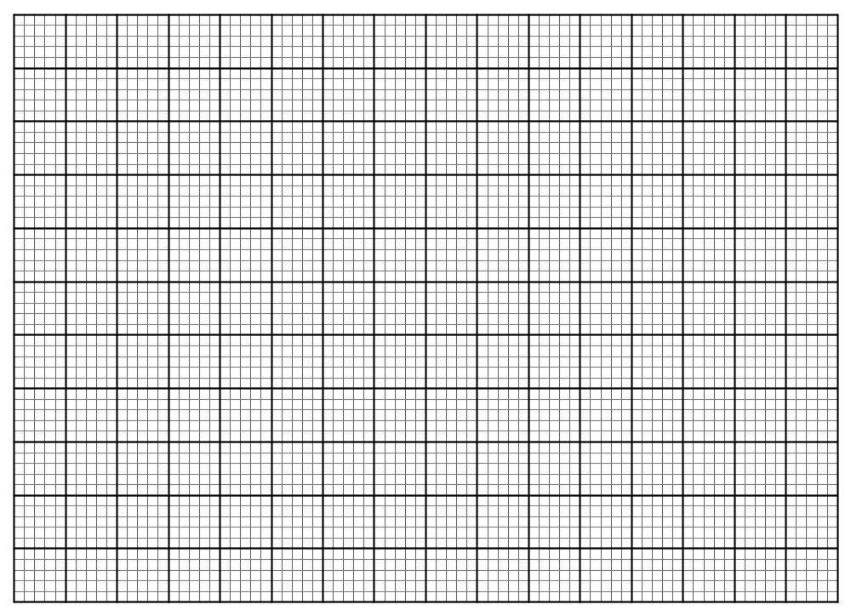

- (i) On the grid provided, draw OPQR and its image O'P'Q'R' (2marks)
- (ii) By construction, determine the centre and angle of rotation. (3marks)

- On the same grid as (a) (i) above, draw O''P''Q''R'', the image of O'P'Q'R' under a reflection in the line y = x (3marks)
- From the quadrilaterals drawn, state the pairs that are:
- Directly congruent; (2marks)

- Oppositely congruent (2marks)

- A slaughter house bought a number of goats at Sh. 2000 each and a number of bulls at Sh. 15000 each. They paid a total of Sh. 190,000. If they bought twice as many goats and three bulls less, they would have saved Sh. 5000.
- Find the number of each type of animals bought. (6 Marks)

- The slaughter house sold all the animals at a profit of 25% per goat and 30% per bull. Determine the total profit they made. (4 Marks)

- a) In a safari rally drivers are to follow route ABCDA. B is 250km from A on a bearing of 075⁰ from A. C is on a bearing of 110⁰ from A and 280km from B. The bearing of C from D is 040⁰ and a distance of 300km. By scale drawing show the position of the point A, B, C and D. (4mks)

- Determine
(i) The distance of A from C. (2mks)

(ii) The bearing of B from C. (1mk)

(iii) The distance and bearing of A from D. (3mks)

20.A saleswoman is paid a commission of 20% on goods sold worth over Ksh 100,000.She is also paid a monthly salary of Ksh 12,000.In a certain month, she sold 360 handbags at Ksh 500 each.
- Calculate the saleswoman’s earnings that month. (3 mks)

The following month, the saleswoman’s monthly salary was increased by 10%.Her to total earnings that month were Ksh17,600.
Calculate:
  - The total amount of money received from the sales of handbags that month.(5mks)

  - The number of handbags sold that month. (2 mks)

- Using a ruler and a pair of compasses only, draw a parallelogram ABCD, such that angle DAB = 75⁰. Length AB = 6.0cm and BC = 4.0cm from point D, drop a perpendicular to meet line AB at N. (7 Marks)

(i) Measure length DN. (1 Mark)

(ii) Find the area of the parallelogram. (2 Marks)

- United Millers imports wheat from U.S.A at initial cost of 350 dollar per tone. The shipping costs and customs duty are then charged as 25% and 15% respectively. When the wheat reached Mombasa, an 8% of the initial cost is incurred to transport it to Kisumu.
- Given that 1US dollar = Ksh82.40, calculate the total cost of importing 5 tonnes of wheat in Ksh. (5 marks)

- The united millers intend to make a profit of 25%. Giving your answer to the nearest ten cents, calculate the price at which a 2 kg packet of wheat should be sold. ( 3 marks)

c. How much profit shall the company realize from the sale of 1 tonne of wheat? (2 marks)

23. 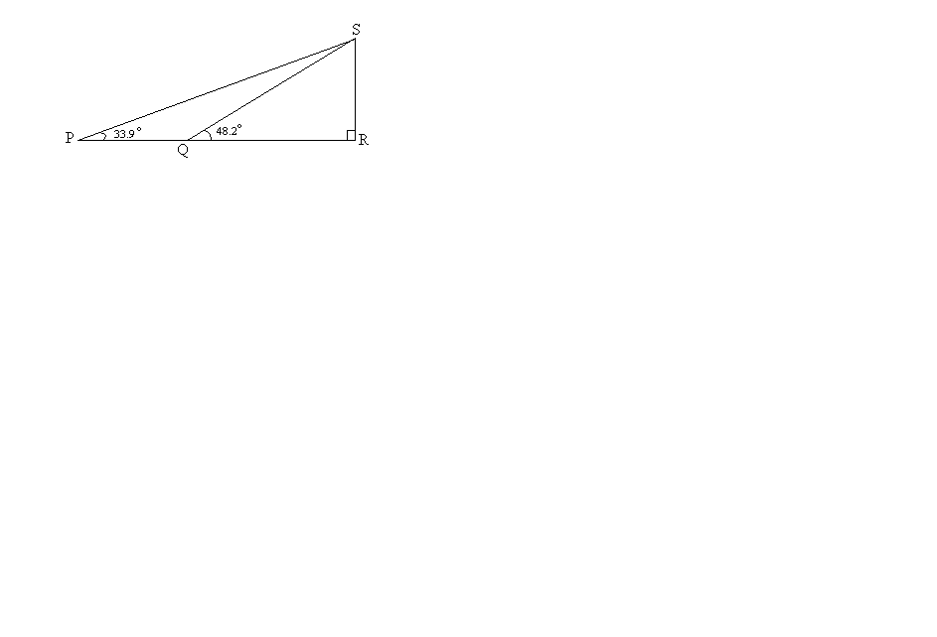
The diagram shows vertical telephone pole RS supported by wires SP and SQ pegged at points P and Q respectively on a level ground. Points P and Q are on the same straight line from the base R of the pole. The angles of elevation of S from P and Q are 33.9⁰ and 48.2⁰ respectively. Given that PR = 5 m, calculate:
- The distance QR (4 marks)

- The length of the wires SP and SQ (4 marks)

- If the cost of the pole and labour is sh. 1600 and the cost of 1 meter of the wire is sh. 233. Find the total cost of the installation. (2 marks)

24. a) Construct the image of quadrilateral ABCD under enlargement scale factor -2 center of enlargement E. (4mks)
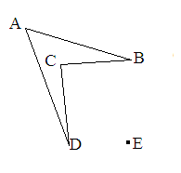

- A model of a freezer has a rectangular shutter measuring 4cm by 2cm. The area of the actual shutter of the freezer is 0.72m².
i) Given that the actual freezer is 2.7m long, calculate the length of the model in centimeters. (3mks)

ii) Calculate the volume in m³ of the actual freezer if the models volume is 12cm³ (3mks)

