SUNRISE EVALUATION EXAMS FORM 2
Name……………………………………………………......................Adm No……………Class…………

School …………………………………………………………..Candidate’s Signature ……………………

GRAND TOTAL
MATHEMATICS
PAPER 1
TIME: 2 ½ HOURS

Mathematics
Paper 1
2¹/₂ hours

INSTRUCTIONS TO THE CANDIDATES
- This paper contains two sections; Section I and Section II.
- Answer all the questions in section I and Section II.
- All workings and answers must be written on the question paper in the spaces provided below each question.
- Non programmable silent electronic calculators and KNEC Mathematical tables may be used EXCEPT where stated otherwise.
- Show all the steps in your calculations, giving your answers at each stage in the spaces below each question.

FOR EXAMINER’S USE ONLY
Section 1
Question | 1 | 2 | 3 | 4 | 5 | 6 | 7 | 8 | 9 | 10 | 11 | 12 | 13 | 14 | 15 | 16 | Total
Marks

Section 1I
Question | 17 | 18 | 19 | 20 | 21 | Total
Marks

SECTION II (50MKS)
- Without using calculators or mathematical tables, evaluate leaving your answer in standard form. (3mks)
$$\frac{1.33×0.51}{0.19×0.0017}$$

- Three bells are programmed to ring after an interval of 15 minutes, 25 minutes and 50
minutes. If they all rang together at 6.45am, when will they next ring together? (3mks)

- The volumes of two similar solid cylinders are 1920cm³ and 810cm³. If the area of the
curved surface of the smaller cylinder is 300cm², find the area of the curved surface of the larger cylinder. (3mks)

- Solve for x in the equation (3mks)
${\left(3^{2x}\right)}^{3 }=81×9^{4}$

- Class of 30 students uses 75 pencils in a term. If the number of students is reduced to 24,
how many pencils are likely to be used in a term? (2mks)

- An empty 300ml bottle has a mass of 270g. Calculate the mass of the bottle when it is full
of a liquid whose density is 1.1g/cm³. (3mks)

- Use tables of squares, square root and reciprocal only to evaluate. (4mks)
${\left(0.06458\right)}^{\frac{1}{2}}+{\left(\frac{2}{0.4327}\right)}^{2}$

- Find the sum of interior angles of a regular polygon with 18 sides. (2mks)

- Find the area in hectares of a field whose measurements are shown in the table below AB=300metres (3mks)

B
TO X80 220
100 TO Y 150
TO Z 100 80
A

- Use logarithms to evaluate (4mks)
$\frac{{16.92}^{2} x \sqrt{0.6318}}{327.5}$

- Three pens and four exercise books cost Sh. 87. Two pens and five exercise books cost Sh. 93. Find the cost of one pen and one exercise book. (4mks)

- Find the equation of a line through the point (2, 1), perpendicular to the line
½ x +2y = -3. (3mks)

- Using a ruler and a pair of compasses only, construct a rhombus QRST in which
angle TQR = 60⁰ and QS = 10cm. (4mks)

- Evaluate without using a calculator or Mathematical tables leaving your answer in
the simplest form. (3mks)
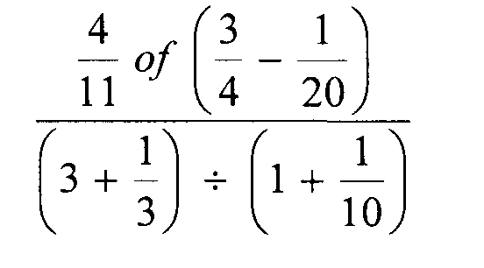

- All prime numbers between ten and twenty are arranged in descending order to form a number.
(i) Write down the number. (1mk)

(ii) State the total value of the third digit of the number formed in (i) above. (1mk)

- Without using tables or a calculator, evaluate (3mks)
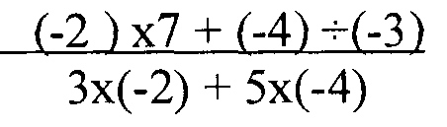

SECTION II (50MKS)
- A straight line L₁ whose equation is 3y – 2x = -2 meets the x – axis at R
- Determine the coordinates of R. (2mks)

- A second line L₂ is perpendicular to L₁ at R. Find the equation of L₂ in the form
y = mx+c where m and c are constants. (3mks)

- A third line L₃ passing through (-4, 1) is parallel to L₁. Find
The equation of L₃ in the form y=mx+c where m and c are constants. (2mks)

- The coordinates of points S at which L₃ intersects L₂ (3mks)

- A construction company requires to transport 144 tonnes of stones to sites A and B. the company pays Kshs. 24000 to transport 48 tonnes of stone for every 28 km. kimani
transported 96 tonnes to a site A, 49km away.
- Find how much he paid. (3mks)

- Kimani spends Kshs. 3000 to transport every 8 stones to the site. Calculate his total profit. (4mks)

- Achieng transported the remaining stones to sites B, 84km away. If she made 44% profit, find her transport cost. (3mks)

- A model of a tent consists of cube and a pyramid on a square base as shown below.

5cm

8cm
8cm
- Draw accurately the net of the model. (2mks)

- Use the net to calculate the total surface area of the model. (4mks)

- If the ratio of the area of the model to the area of the actual is 1:10000, find the area
of the material required to make the tent (floor area inclusive) in m². (4mks)

- (a) On the grid provided draw the square whose vertices are A(6, -2), B (7, -2), C (7,-1)
and D ( 6, -1) . (1mk)

(b) On the same grid draw
(i) A¹B¹C¹D¹ the image of ABCD, under an enlargement scale factor 3, centre (9,-4). (3mks)
(ii) A¹¹B¹¹C¹¹D¹¹, the image A¹B¹C¹D¹ under a reflection in the line x = 0. (2mks)
(iii) A¹¹¹B¹¹¹C¹¹¹D¹¹¹, the image of A¹¹B¹¹C¹¹D¹¹ under a rotation of +90⁰ about
the origin. (2mks)
(c ) Describe a single transformation that maps A¹B¹C¹D¹ onto A¹¹¹B¹¹¹C¹¹¹D¹¹¹. (2mks)

- The relation between two quantities F and L is given by the formula
F= $\frac{4}{5}L+20$
The table below shows some values of F and L
L | 0 | 10 | 20 | 30 | 40 | 50 | 60 | 70 | 80 | 90 | 100 | 110
F | 20 |  |  |  |  |  | 68

- Complete the table (2mks)

- Using a suitable scale, draw a straight line graph of F[y-axis] against L[x-axis] (3mks)
- Use your graph to find the value of (5mks)
- F when L = 48 =
- L when F = 82 =
- F when L = 108 =
- L when F = 66 =
- F when L = 120 =

