CHEMICAL FAMILIES;
PATTERNS IN PROPERTIES

Table of Contents
Organizer 📌

1. The Alkali Metals - 2 -
Gradation in Size of the Atom and Ion - 3 -
Physical Properties of Alkali metals - 3 -
Chemical Properties of Alkali Metals - 4 -
Uses of Alkali metals and their compounds - 7 -
2. Alkaline Earth Metals - 7 -
Gradation in Size of Atom and Ion - 7 -
Physical Properties - 8 -
Chemical Properties of Alkaline Earth Metals - 9 -
Uses of some Alkaline Earth Metals and their Compounds - 13 -
3. Halogens - 13 -
Gradation in Size of Atoms and Ion…………- 13 -
Physical Properties of Halogens - 14 -
Chemical Properties of Halogens - 15 -
Uses of Halogens and their Compounds - 19 -
4. Noble gases - 19 -
Physical Properties of Noble gases - 20 -
Uses of Noble Gases - 20 -
5. Properties and Trends across A period - 21 -
(a) Trends in Physical Properties of Elements in Period 3 - 21 -
(b) Trends in Chemical Properties of the Elements in Period 3 - 23 -

Objectives
By the end of this topic, the learner should be able to:
(a) Identify and write electron arrangement of alkali metals, alkaline earth metals, halogens and noble gases.
(b) State and explain the trends in physical properties of elements in group I, II, VII and VIII.
(c) State and explain the trends in reactivity of elements in group I, II, VII and VIII.
(d) Explain the similarities in chemical formulae of compounds of the elements in a group.
(e) Explain the unreactive nature of group VIII elements.
(f) Identify and write electron arrangement of period 3 elements.
(g) State and explain the trends in physical and chemical properties of the elements in period 3.

CHEMICAL FAMILIES;

PATTERNS IN PROPERTIES
Elements in the same group are said to belong to the same chemical family.
Trends in physical and chemical properties provide useful information in predicting the physical and chemical behaviour of the elements within a family.

1. The Alkali Metals
The elements in group I of the periodic table are called Alkali metals.
These include, lithium, sodium, potassium, rubidium, caesium and francium. The electron arrangements of the first three alkali metals are as follows:
Lithium (L) : 2.1
Sodium (Na) : 2.8.1
Potassium (k) : 2.8.8.1
Each alkali metal atom has one electron in the outermost energy level. Down the group there is an increase in the number of occupied energy levels.
Task: Draw the atomic structure of the first 3 Alkali Metals.

Gradation in Size of the Atom and Ion
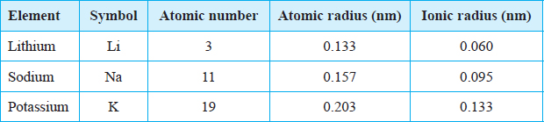
It is not possible to measure the sizes of atoms and ions of elements in the laboratory due to their small size. The table below gives a summary of the atomic and ionic radii of the Alkali Metals.
Atomic radius is the distance between the centre of the nucleus of an atom and the outermost energy level occupied by an electron or electrons.
Discussion Questions
1. State and explain the trends in the atomic and ionic radii down the group
The atomic radii and ionic radii of the alkali metals increase down the group. This is because each alkali metal has one more occupied energy level than the preceding member in the group.
Lithium has two energy levels. Sodium has three while potassium has four. The outermost electron in a sodium atom is therefore further from the nucleus than the outermost electron in a lithium atom. This explains the increase in the atomic and ionic radii down the group.
- How does the ionic radius and atomic radius of an element compare?
The ionic radius of an alkali metal is less than its atomic radius.
An alkali metal forms an ion by losing the single electron from the outermost energy level. The resulting ion (cation) has one occupied energy level less than the corresponding atom.
When an atom loses an electron to form a positively charged ion, the remaining electrons experience greater nuclear attraction. The remaining energy levels move closer to the nucleus resulting in a reduction in the radius.

Physical Properties of Alkali metals
The table below shows some physical properties of alkali metals.
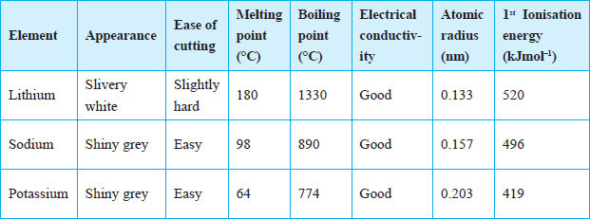
Ionization energy is the minimum energy required to remove an electron from the outermost energy level of an atom in the gaseous state.

Discussion Questions
State and explain the trends in the following properties down the group?
- Appearance
The alkali metals have a shiny metallic lustre when freshly cut. However, the surface quickly tarnishes. The surface tarnishes because of reacting with air.
- Ease of cutting
The alkali metals are soft and easy to cut.
The softness and ease to cut increases down the group due to the decrease in the strength of the forces holding the atoms together as you move down the group.
- Melting and boiling points.
The alkali metals have relatively low melting and boiling points.
The melting and boiling points decrease down the group due to the weakening of the forces holding the atoms together.
The strength of the forces holding atoms together depends on the size of the atoms. The larger the atoms, the weaker the force. Thus as the atomic radius increases the forces of attraction between the atoms weaken, hence the decrease in the melting and boiling points down the group.
- Electrical conductivity.
Alkali metals are good conductors of heat and electricity. Conductivity in metals is due to the presence of delocalised electrons in the structure of the metal. Since they all have one electron in their outermost energy level, their conductivity is similar.
In metals, the electrons in the outermost energy level move randomly throughout the metallic structure. Since the electrons do not remain in one fixed position, they are said to be delocalised.
(v) 1st ionization energy
Down the group from lithium to potassium, the 1st ionization energy decreases. This means that less energy is needed to remove the electron from the outermost energy level of a potassium atom than a sodium atom and a lithium atom. This is because the effective force of attraction on the outermost electron by the positive nucleus decreases with increasing atomic size and distance from the nucleus.

Chemical Properties of Alkali Metals
Alkali metals react by losing the one electron from their outermost energy level to attain a stable electron configuration. Their reactivity increases down the group.

Reaction with air and water
- Lithium, sodium and potassium react vigorously with both air and water. Potassium is the most reactive and lithium, the least reactive.
- When sodium is exposed, it reacts with moisture in the air to form sodium hydroxide. The sodium hydroxide further reacts with carbon (IV) oxide in the air to form sodium carbonate.
2Na(s) + 2H2O(l) 2NaOH(aq) + H2(g)
2NaOH(aq) + CO2 (g) Na2CO3 · H2O(s)
- Sodium burns in air with a yellow flame to form a yellowish white solid which is mainly sodium oxide.
Sodium + Oxygen Sodium Oxide
4Na(s) + O2(g) 2Na2O(s)
- When sodium burns in air enriched with oxygen it forms mainly sodium peroxide.
Sodium + Oxygen Sodium peroxide
2Na(s) + O2(g) Na2O2(s)
- Potassium burns in air with a lilac flame to form a white solid which is potassium oxide.
Potassium + oxygen Potassium oxide
4K(s) + O2(g) 2K2O(s)

The observations made when alkali metals react with water are summarised in the table below.
Metal | Observation when metal reacts with water | Rate of reaction
Lithium | Lithium floats in water. A colourless gas is produced.  The gas does not ignite spontaneously. The resulting solution turns red litmus paper blue. | Vigorous
Sodium | Sodium metal darts on the water surface as it melts into a silvery ball. A hissing sound is produced. A colourless gas is produced which may ignite spontaneously. The solution formed is alkaline. | More vigorous
Potassium | The metal darts about on the surface of the water and melts into a silvery ball. A colourless gas is produced which spontaneously bursts into a flame. Potassium vapour burns with a lilac flame. The resulting solution is alkaline. | Explosive
- Alkali metals react with water to form alkaline solutions and hydrogen gas.
Metal + Water Metal hydroxide + Hydrogen
Lithium + Water Lithium hydroxide + hydrogen gas
2Li(s) + 2H2O(l) 2LiOH(aq) + H2(g)
Sodium + Water Sodium hydroxide + Hydrogen gas
2Na(s) + 2H2O(l) 2NaOH(aq) + H2(g)
Potassium + water Potassium hydroxide + Hydrogen gas
2K(s) + 2H2O(l) 2KOH(aq) + H2(g)

- Potassium is the most reactive alkali metal. This is because the electron in the outermost energy level is loosely held by the nucleus and is easily removed during a reaction.
- The ease of losing valence electrons increases down the group as the atomic radius increases, hence the increase in reactivity from lithium to potassium.

Reaction with chlorine
Alkali metals react with chlorine gas to form the corresponding metal chlorides. The reactivity of alkali metals with chlorine increases down the group. This is because of the increase in atomic radius which leads to increasing ease to lose the electron in the outermost energy level.
Task: Cut a small piece of sodium and place it in a deflagrating spoon. Warm it and quickly lower it into a gas jar containing chlorine. Record your observations.
Discussion Questions
- What is observed when a hot piece of sodium metal is lowered into a gas jar containing chlorine?
When hot sodium metal is lowered into chlorine gas, the metal bursts into flame, white fumes of sodium chloride are formed.
- What is formed when sodium metal reacts with chlorine?
Sodium metal + chlorine gas Sodium chloride
2Na(s) + Cl₂(g) 2NaCl(s)
- Predict how lithium and potassium would react with chlorine.
Lithium reacts less vigorously with chlorine while potassium reacts much more violently with chlorine than sodium.
Lithium + chlorine gas Lithium chloride
2Li(s) + Cl₂(g) 2LiCl(s)
Potassium + chlorine gas Potassium chloride
2K(s) + Cl₂(g) 2KCl (s)

Similarity of Ions and formulae of some compounds of Alkali metals.
Formulae of hydroxides, oxides and Chlorides of Alkali metals
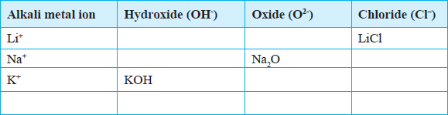
Discussion Question
Explain the similarity in the chemical formulae of the compounds formed between alkali metal ions and hydroxides, oxides and chloride ions.
Each alkali metal ion combines with a single hydroxide ion to form the respective hydroxide namely; Lithium hydroxide (LiOH), sodium hydroxide (NaOH) and potassium hydroxide (KOH). This is because the valency of Group I elements is one. The same applies in the formation of lithium chloride (LiCl), sodium chloride (NaCl) and potassium chloride (KCl)
Two alkali metal ions combine with one oxide ion to form the corresponding oxide namely; Lithium oxide (L2O), sodium oxide (Na2O) and potassium oxide (K2O).
This is because the valency of oxygen is two. Therefore one oxygen ion requires two alkali metal ions to combine with to form the corresponding oxide.
Due to their high reactivity, alkali metals are not found as free elements. They are normally found in the combined state in the earths’ crust.

Uses of Alkali metals and their compounds
1. Sodium is used in the manufacture of Sodium cyanide for use in the extraction of gold.
2. Lithium is used in the manufacture of special high strength glasses and ceramics
3. Lithium compounds are used in the manufacture of dry cells for use in mobile phones, laptops, stop watches and zero emission electric vehicles.
4. A molten mixture of sodium and potassium is used as a coolant in nuclear reactors.
5. Sodium vapour is used to produce the yellow glow in streetlights.
6. Molten sodium is used as a reducing agent in the extraction of titanium from titanium (IV) chloride.
TiCl4(g) + 4Na(l) Ti(s) + 4NaCl(l)
7. Sodium chloride is used as a food additive.
8. A mixture of Sodium hydroxide (caustic soda) and carbon disulphide is used in the manufacture of artificial silk called rayon.

2. Alkaline Earth Metals
The elements in group II of the periodic table are called alkaline earth metals.
They consist of beryllium, magnesium, calcium, strontium, barium and radium. The electron arrangement of the first three alkaline earth metals is as follows:
Beryllium (Be) ; 2.2
Magnesium (Mg); 2.8.2
Calcium (Ca) ; 2.8.8.2
An atom of an alkaline earth metal has two electrons in the outermost energy level.
Task: Draw the atomic structure of the first 3 Alkaline Earth Metals

Gradation in Size of Atom and Ion
The table below summaries the atomic and ionic sizes of the Alkaline Earth Metals.
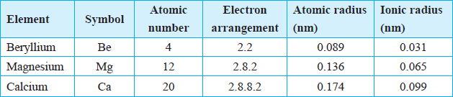
Discussion Question
State and explain the trends in atomic and ionic sizes down the group
Among the alkaline earth metals, the atomic radius increases down the group as more energy levels are occupied.
Beryllium has the smallest atomic radius among the alkaline earth metals because it has the least number of occupied energy levels.
Group II elements form ions by losing the two electrons in the outermost energy level in order to attain a stable electron arrangement. The loss of two electrons in the outermost energy level accounts for the smaller ionic radius compared to the atomic radius of the corresponding atom.
Ion | Electron arrangement
Be2+ | 2
Mg2+ | 2.8
Ca2+ | 2.8.8
Beryllium ion with only one occupied energy level is therefore the smallest ion.

Physical Properties of the Alkaline Earth Metals
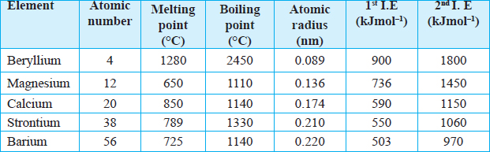
The table below summarises the Physical Properties of Alkaline Earth Metals
Discussion Questions
- What is the appearance of a polished surface of an alkaline earth metal?
- When an alkaline earth metal is polished, it acquires a metallic lustre.
- Alkaline earth metals lose their metallic lustre when exposed to air because of oxidation.
- The purpose of polishing the surface of the alkaline earth metals before using them in experiments is to remove the thin oxide layer that usually forms on their surface. Both magnesium and calcium have a metallic lustre.
- What is observed when:
(a) One cuts an alkaline earth metal?
- Magnesium is hard to cut with a knife. However it is ductile and malleable. Calcium is brittle hence it cannot be cut with a knife.
A ductile material is one which can be drawn into a wire. Materials which can be hammered into sheets are said to be malleable. A brittle substance is one which is hard and likely to break.
- Magnesium and calcium are separately used to complete an electric circuit?
Both magnesium and calcium are good conductors of heat and electricity due to the presence of delocalised electrons.
- How do the physical properties of alkaline earth metals compare with those of alkali metals?
- State and explain the trend in:
- Melting and boiling points
The melting and boiling points of beryllium are very high compared to other alkaline earth metals. This is because the beryllium atom is very small and the forces of attraction between the atoms are very strong.
Down the group the melting point and boiling points decrease. This is because in metals atoms are held together by forces of attraction between positive nuclei and delocalised electrons. As the atomic radius increase this attraction decreases because of the increasing distance from the positive nucleus to the delocalised electrons. This explains why the melting point and boiling point decreases down the group.
- Ionization energy down the group.
The first and second ionization energies decreases down the group. This is because the effective force of attraction on the outermost electron by the positive nucleus decreases with increasing atomic size and distance from the nucleus.
The first ionization energy for magnesium is the minimum amount of energy required to remove one electron from the outer most energy level.
Mg(g) Mg⁺(g) + e– (1st I.E. = 736 kJmol^{–1})
The second ionisation energy of magnesium is the minimum amount of energy required to remove a second electron from a magnesium ion with a single positive charge.
Mg²⁺(g) Mg²⁺(g) + e– (2nd I.E. = 1450 kJmol–)
5. Explain why the second ionization energy is always higher than the first ionization energy.
Once an electron has been lost from an atom, the overall positive charge holds the remaining electrons more firmly. This then means that removing a second electron form the ion requires more energy than the first electron.

Chemical Properties of Alkaline Earth Metals

Reaction with air and water

Discussion Questions
- What is observed when magnesium and calcium are heated in air?
Magnesium burns in air with a blinding brilliant white flame forming a white solid. The white solid is a mixture of magnesium oxide and magnesium nitride.
Magnesium + Oxygen Magnesium oxide
2Mg(s) + O₂(g) 2MgO(s)
Magnesium + nitrogen Magnesium nitride
3Mg(s) + N₂(g) Mg₃N₂(s)
Calcium on the other hand burns with a faint orange-red flame forming a white solid, which is a mixture of calcium oxide and calcium nitride.
Calcium + Oxygen Calcium oxide
2Ca(s) + O₂(g) 2CaO(s)
Calcium + Nitrogen Calcium nitride
3Ca(s) + N₂(g) Ca₃N₂(s)
The trend in reactivity of the alkaline earth metals when burning in air is not clear due to the oxide coating on calcium.
- What is observed when magnesium and calcium are placed in water and solution tested with litmus paper?
Magnesium reacts slowly with cold water to form magnesium hydroxide and hydrogen gas bubbles of which stick on the surface of the metal. Magnesium hydroxide dissolves slightly in water to form an alkaline solution.
Magnesium + Water Magnesium hydroxide + Hydrogen gas
Mg(s) + 2H₂O(I) Mg(OH)₂(aq) + H₂(g)
A steady stream of hydrogen gas is evolved when calcium reacts with cold water. A white suspension appears in the beaker due to the formation of calcium hydroxide which is sparingly soluble in water. The calcium hydroxide solution formed is alkaline.
Calcium + Water Calcium hydroxide + Hydrogen gas
Ca(s) + 2H₂O (s) Ca(OH)₂(aq) + H₂(g)
2. Which of the two metals is more reactive?
The atomic radii increase from beryllium to calcium. Therefore, the two outer electrons in a calcium atom are more loosely held by the positive nucleus than the outer electrons in magnesium. This means that less energy is required to remove the outer electrons in calcium than in magnesium. Calcium is therefore more reactive than magnesium.
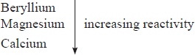
The order of reactivity of the alkaline earth metals increases down the group.

Reaction with steam
Magnesium reacts slowly with cold water. However, it reacts faster with steam.
To react magnesium with steam, Put some wet sand at the bottom of a test tube. Insert a clean piece of magnesium ribbon (5 cm) into the middle of the test-tube ensure that the coil touches the sides of the tube. Set up the apparatus as shown in below.
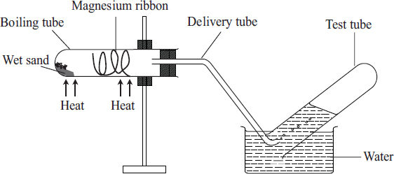
Heat the sand gently first, then heat the magnesium ribbon strongly until it glows, then continue to heat the wet sand to generate steam. Record your observations. Test any gas produced using a burning splint. Before the heating is discontinued, the delivery tube should be removed from the water.

Discussion Questions
- State and explain what is observed in the reaction tube.
Magnesium burns in steam with a white flame. A white solid is formed and a colourless gas is produced. A pop sound is produced when a burning splint is introduced into a test-tube containing the gas. Therefore the colourless gas is hydrogen.
Magnesium + Steam Magnesium oxide + Hydrogen
Mg(s) + H₂O(g) MgO(s) + H₂(g)
- Why is the wet sand heated initially?
The sand is heated initially to drive out the air that would otherwise react with magnesium by generating some steam.
- Why should the delivery tube be removed before heating is discontinued?
The delivery tube is removed from the water before heating is stopped at the end of the experiment to prevent sucking back as the apparatus cools.
- Explain the observation made when a burning splint is lowered into a test tube of the gas collected.
A pop sound is produced when a burning splint is introduced into a test-tube containing the gas. Therefore the colourless gas is hydrogen.

Reaction with chlorine
Discussion Questions
- State and explain what is observed when chlorine gas reacts with:
- A burning piece of magnesium
When a burning piece of magnesium is lowered into a gas jar containing chlorine, the metal continues to burn with a brilliant white flame to form a white powder. The white ash formed is magnesium chloride.
Magnesium + Chlorine Magnesium chloride
Mg(s) + Cl₂(s) MgCl₂(s)
- A hot piece of calcium
Calcium may not react steadily with chlorine. This is because a coating of calcium oxide is formed first when the metal is heated. However, under suitable conditions calcium may react with chlorine to form calcium chloride.
Calcium + Chlorine gas Calcium chloride
Ca(s) + Cl₂(g) CaCl₂(s)

Reaction with dilute acids
Discussion Questions
1. State and explain what is observed when magnesium ribbon reacts with dilute hydrochloric and sulphuric acids.
There is effervescence when a piece of magnesium is placed in hydrochloric acid. The gas produced during the reaction produces a ‘pop’ sound when a burning splint is introduced to the mouth of the test tube. This shows that the gas produced is hydrogen.
Magnesium + Hydrochloric acid Magnesium chloride + Hydrogen gas
Mg(s) + 2HCl(aq) MgCl₂(aq)+ H₂(g)
Magnesium + Sulphuric acid Magnesium sulphate + hydrogen gas
Mg(s) + H₂SO4(aq) MgSO₄(aq) + H₂(g)
2. State and explain what is observed when calcium reacts with dilute hydrochloric and sulphuric acids.
Calcium reacts with dilute hyrdrochloric acid to produce hydrogen gas and calcium chloride.
Calcium + Hydrochloric acid calcium chloride + hydrogen gas
Ca(s) + 2HCl(aq) CaCl2(aq) + H2(g)
When sulphuric (VI) acid is used, the reaction quickly stops. This is due to to the formation of insoluble calcium sulphate which forms a coating on the surface of calcium metal preventing further reaction.
Calcium + Sulphuric acid Calcium sulphate + Hydrogen gas
Ca(s) + H2SO4 (aq) CaSO4(s) + H2(g)

Similarity of ions and formulae of some compounds of alkaline earth metals
All alkaline earth metals have a valency of two (2). Hence the chemical formulae of their compounds are similar.
Formation of hydroxides, oxides and chlorides of alkaline earth metals.
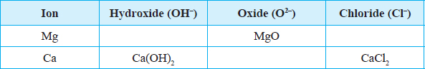
Both magnesium and calcium ions have a valency of 2. The hydroxide ion and chloride ion have a valency of 1. Therefore two hydroxide ions combine with one magnesium ion to form magnesium hydroxide, Mg(OH)2. Similarly, two chloride ions will combine with one magnesium ion to form magnesium chloride, MgCl2.
On the other hand, the oxide ion has valency of 2. therefore, one calcium ion combines with one oxide ion to form calcium oxide, CaO.

(e) Uses of some Alkaline Earth Metals and their Compounds
1. Magnesium is used in the manufacture of magnesium hydroxide which is used as anti-acid medicine. This is because magnesium hydroxide is a non-toxic base.
2. A low-density alloy of magnesium and aluminium is used in aeroplane construction.
3. Hydrated calcium sulphate (Plaster of Paris) is used in hospitals to set fractured bones.
4. Cement is made by heating a mixture of calcium carbonate (limestone), clay and sand.
5. Calcium carbonate is used in the extraction of iron.
6. Calcium oxide (quicklime) is added to acid soils to raise pH for agriculture purposes.
7. Calcium nitrate is used as a nitrogenous fertilizer.
8. Magnesium oxide is used in the lining of furnances.
9. Barium sulphate is used in diagnosis of ulcers.
10. Barium nitrate is used to produce the green flame in fireworks.
11. Calcium carbonate is mixed with oil to make putty.

3. Halogens
The word halogen is derived from the Greek word ‘halo’ meaning salt and ‘gen’ meaning producer. Halogen thus means salt producer. Halogens are non-metals in Group VII of the periodic table. Fluorine, chlorine, bromine and iodine are the first four members of the halogen group. The electron arrangement of fluorine and chlorine is as follows:
Fluorine 2.7
Chlorine 2.8.7
Task: Draw the atomic structure of the first 2 Halogens

Gradation in Size of Atoms and Ion in halogens
The table below gives the atomic and ionic sizes of the Halogens.
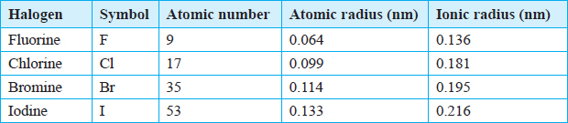
Discussion Questions
1. Explain the trends in the atomic and ionic radii of Halogens down the group:
The atomic and ionic radii of the halogens increase down the group. This is because of the increase in the number of occupied energy levels.
2. How do the atomic radii of the halogens compare with their ionic radii?
The atomic radius of a halogen atom is less than the radius of its ion.
For example, the atomic radius of a chlorine atom is less than the ionic radius of a chloride ion. This is because the chlorine atom has 17 protons in the nucleus attracting 17 electrons in the energy levels. The chloride ion has 17 protons in the nucleus attracting 18 electrons. The effect of the positive nucleus is thus lower. The reduction in the nuclear attraction is due to repulsive effect between the existing electrons and the incoming electron.

Physical Properties of Halogens
Chlorine can be prepared by the action of concentrated hydrochloric acid on potassium manganate (VII) (KMnO4) or Manganese (IV) oxide (MnO2). Heat is required when manganese (IV) oxide is used.
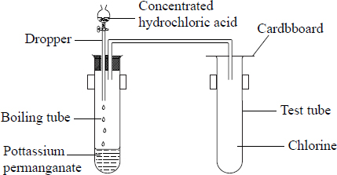
Set up for preparing chlorine gas
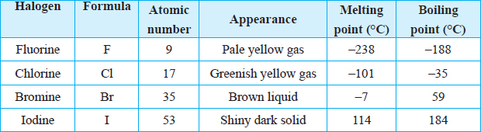
The table below gives a summary of the physical properties of halogens.
Discussion Questions
- What is the physical state of chlorine, bromine and iodine at room temperature?
Fluorine and chlorine are gases at room temperature. Bromine is a volatile liquid while iodine is a solid.
- What is the colour of chlorine, bromine and iodine?
Fluorine is pale yellow while chlorine is green-yellow. Bromine is a brown liquid while iodine is a shiny dark grey solid.
- What is observed when chlorine and bromine are shaken with Water and Tetra chloromethane
When a boiling tube containing chlorine gas or bromine vapour is inverted in water or tetrachloromethane, the level of the solution rises in the boiling tube.
The level of the solution rises more in tetrachloromethane than in water. The rise in water level is higher in the case of chlorine compared to bromine. This shows that chlorine is more soluble in water than bromine. Solubility of halogens in water therefore decreases down the group. All halogens are soluble in tetrachloromethane.

- Explain what is observed when iodine is heated.
Iodine sublimes when heated to form a purple vapour. This is because the particles are held by weak forces which require little energy to break.
- Does iodine conduct electricity? Explain.
Halogens are non conductors of heat and electricity. This is because there are no delocalised electrons in their structures.
- Explain the trends in the melting and boiling points of halogens down the group.
The melting and boiling points of halogens increase down the group.
Halogens exists as diatomic molecules. The forces of attraction between molecules (intermolecular forces) increase with the increase in the size of the molecules. Hence, the forces of attraction between molecules among the four halogens are strongest in iodine and weakest in fluorine.

Chemical Properties of Halogens
It is not easy for non metals to lose electrons because the amount of energy required (ionisation energy) is very large. Therefore non metals do not easily form positively charged ions. Non metals therefore react by gaining electrons to form negatively charged ions.

Ion formation
Halogens have seven electrons in their outermost energy level. They react by gaining one electron to attain a stable electron configuration and form negatively charged ions. During ion formation, energy is released. The energy change for this process of electron gain is called electron affinity.
F + e– F– (Elctron affinity = –322 kJmol–1)
Cl + e– Cl– (Electron affinity = –349 kJmol–1)
Br + e– Br– (Electron affinity = –325 kJmol–1)
I + e– I– (Electron affinity = –295 kJmol–1)
Generally, the electron affinity decreases as the size of the atoms increases hence reactivity decreases down the group.

Reaction with metals
The reaction between iron and a halogen results in the formation of a salt.
The procedure below can be used to react halogens with metals. Pass a stream of dry chlorine gas over heated iron wool as shown below. Record your observations.
For bromine and iodine, heat the iron wool in a test-tube in which bromine and iodine vapour is generated and passed over the wool as shown below. The test-tube should be held with a test-tube holder. Alternatively, using a defragrating spoon, place hot iron wool into a gas jar of chlorine.
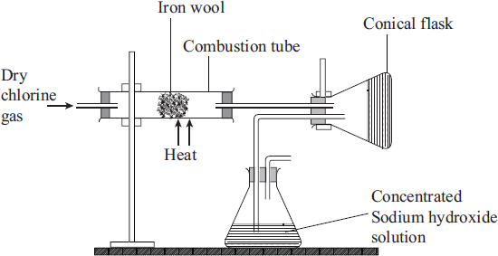
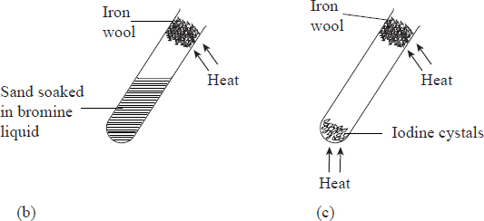
Discussion Questions
1. What is observed when the hot iron wool reacts with the halogens?
Chlorine reacts most vigorously with hot iron forming dark-brown crystals of iron (III) chloride. Hot iron glows in bromine vapour to form dark-red crystals of iron (III) bromide. Iodine vapour reacts slowly with hot iron to form grayish black crystals of iron (II) iodide. Iodine is not reactive enough to form a salt with iron.
The equations below represent the reactions which occur.
Iron + Chlorine Iron (III) chloride
2Fe (s) + 3 Cl₂(g) 2FeCl₃(s)
Iron + Bromine Iron (III) bromide
2Fe(s) + 3Br₂(g) 2FeBr₃(s)
Iron + Iodine Iron (II) iodine
Fe(s) + I₂(g) Fel₂(s).
- State and explain the role of the concentrated sodium hydroxide.
Concentrated sodium hydroxide is used to react with excess chlorine to avoid emitting poisonous chlorine gas into the air.
- Write chemical equations for the reactions between chlorine, bromine and iodine with zinc.
Halogens react with heated zinc to form zinc salts.
Zinc + Chlorine Zinc chloride
Zn(s) + Cl₂(g) ZnCl₂(s)
Zinc + Bromine Zinc bromide
Zn (s) + Br (g) ZnBr₂(s)
Zinc + Iodine Zinc iodide
Zn(s) + I₂(g) ZnI₂(s)
Other salts formed in the same method are MgCl₂, AlCl₃ and NaCl.
- What is the order of reactivity of halogens? Explain
The reaction between chlorine and metals is more vigorous than that of bromine. The order of reactivity of the halogens with metals decreases down the group.
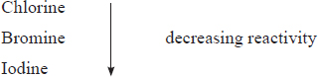
The ability of an atom to gain an electron in its outermost energy level decreases as the size of the atoms increase, hence the decrease in reactivity of halogens down the group.

Reaction with water
To study the reaction between halogens and water, bubble chlorine through water in a conical flask for a few minutes using an experimental set-up as shown below.
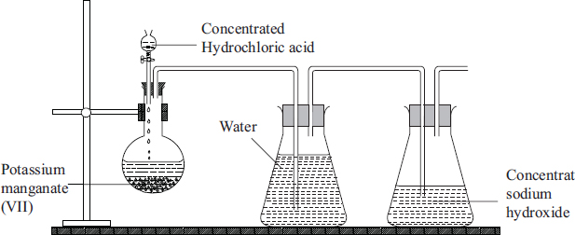
Observe the colour of the resulting solution. Test the solution with litmus paper.
Discussion Questions
1. What is observed when chlorine is passed through water for some time?
Chlorine dissolves in water to form chlorine water which is a mixture of hydrochloric acid and chloric (I) acid.
Chlorine + water Hydrochloric acid + Chloric (I) acid
Cl₂(g) + H₂O(g) HCl(aq) + HClO (aq)
2. What changes are observed on the litmus papers? Explain
When the chlorine water is tested with litmus paper, the blue one turns red, showing that the solution is acidic. Then the litmus papers are bleached (decolourised) immediately.
The bleaching action is a property of Chloric (I) acid. Chloric (I) acid is unstable and decomposes to form hydrochloric acid and an atom of oxygen. The oxygen atom then combines with the natural dye in the litmus papers to form a colourless compound.
Chlorine does not bleach dry litmus paper because chloric (I) acid cannot be formed in the absence of water. The bleaching action is only possible in the presence of water.
Chlorine water is yellow due to the presence of chloric (I) acid.
In sunlight, the chlorine water is decolourised due to the decomposition of chloric (I) acid to oxygen gas and hydrochloric acid by the sunlight.
This reaction does not take place in the dark.
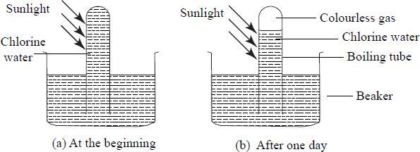

Some uses of Halogens and their Compounds
1. Fluorine is a raw material in the preparation of a synthetic fibre known as polytetraflouroethene.
2. Some compounds of fluorine are added to water and some tooth pastes in small quantities to reduce tooth decay.
3. Fluorine is used to manufacture hydrogen fluoride used to engrave words or pictures on glass.
4. Chlorine is used to make bleaches used in paper pulp and textile industries.
5. Chlorine is added to water to kill micro-organisms in water treatment works.
6. Chlorine is used in the manufacture of a plastic known as polyvinylchloride (PVC).
7. Chlorine is used in the large-scale manufacture of hydrochloric acid.
8. Bromine is used in the manufacture of silver bromide which is used to make the light sensitive photographic paper and films.
9. A solution of iodine in alcohol (tincture of iodine) is used as a disinfectant.

4. Noble gases
The elements in group (VIII) of the periodic table are called noble gases. Noble gases are found as free atoms in nature and form about 1% of air. They include helium, neon, argon, krypton, xenon and radon. Argon is the most abundant and forms about 0.9% of air by volume.
Noble gases were initially called inert gases because they were thought to be unreactive.
Task: Draw the atomic structure of the first 3 noble gases
Electron Arrangements of the first three Noble Gases
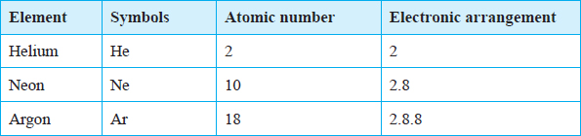
Helium with only two electrons has one occupied energy level which is full. Hence it has a duplet. The rest have eight electrons in their outermost occupied energy level. Thus they have the octet.
Under normal conditions noble gases neither gain nor lose electrons. They are therefore stable and non reactive.

Physical Properties of Noble gases
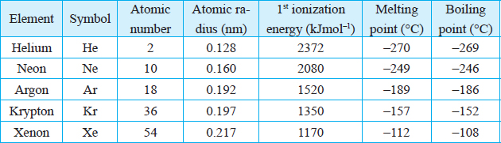
Group VIII elements are colourless monoatomic gases.
Discussion Questions
1.What happens to each of the following properties down the group?
- Atomic radius.
Atomic radii increase down the group due to the increase in the number of energy levels. The increase in atomic radii down the group explains why the first ionization energy of the gases decreases down the group.
- Melting point and boiling point.
Noble gases have low melting and boiling points. This is because of the weak inter atomic forces of attraction between the atoms. However, as the atomic size increases down the group there is increase in strength of inter atomic forces of attraction between atoms. Hence the rise in melting and boiling points down the group.
- Ionization energies.
Helium has a duplet electron arrangement while the others have an octet in their outermost energy level. Therefore they all have a stable electron arrangement. This explains the high ionization energies for all the elements.

2.Xenon takes part in some reactions. Explain.
Xenon has a large atomic radius. In xenon an electron in the outermost energy level is relatively far from the positive nucleus. It therefore has a low ionization energy compared to the other noble gases. For this reason, xenon takes part in some reactions.

Uses of Noble Gases
The inert nature of the noble gases enables them to have a wide range of uses.
1. Argon is used in light bulbs to provide an inert environment to prevent oxidation.
2. Argon is used as an insulator in arch-welding.
3. Neon gas is used in street and advertisement lights.
4. Helium mixed with oxygen is used in deep sea diving and mountaineering. The mixture is also used in hospitals for patients with respiratory problems and those undergoing certain forms of surgery.
5. Helium can be used instead of hydrogen in balloons for meteorological research.
6. Helium is used in thermometers for the measurement of very low temperatures.
7. Liquid helium is used to keep certain metal alloys at temperatures low enough for them to become super conductors.

5. Properties and Trends across A period
Elements in the same period have the same number of occupied energy levels. As you move across the period, the number of electrons in the outermost energy level increases by one. While the elements in the same group exhibit similar properties, those across a period show a gradual change in properties. This can be illustrated by considering elements in Period 3 from left to right.

(a) Trends in Physical Properties of Elements in Period 3

The table below gives a summary of the physical properties of Elements in Period 3.
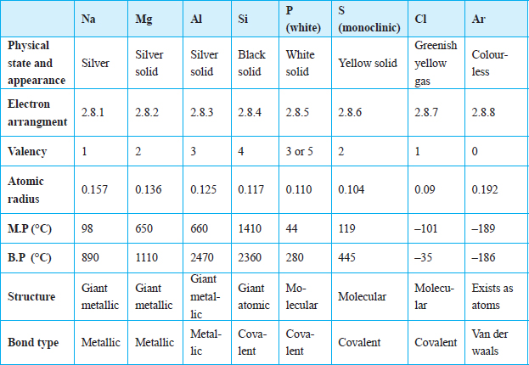

(i) Trends in Electrical conductivity
Discussion Questions
1. List the elements in period 3 that conduct electricity.
Sodium, magnesium and aluminium are good conductors of electricity.
2.Explain the trends in the electrical conductivity of the elements in period 3.
Sodium, magnesium and aluminium have delocalised electrons in their structures. These delocalised electrons are responsible for the conduction of electricity. Conductivity increases with increase in the number of delocalised electrons. Therefore, aluminium with three delocalised electrons from each atom in the structure has the highest electrical conductivity.
Phosphorus, sulphur, chlorine and argon are all made up of molecules and therefore are non-conductors of electricity.
Silicon is unique among the elements because it is a semi-conductor. Its electrical conductivity increases with increase in temperature.

(ii) Other physical properties
Discussion Questions
- Explain the trends in atomic radii across the period
The atomic radii of the elements gradually decrease across the period from left to right. This is explained by the increase in the nuclear charge across the period due to an increase in the number of protons. Although there is an additional number of electrons, they enter the same energy level. This means that the shielding effect remains the same as the nuclear charge increases. The forces of attraction between the nuclei of these elements and the electrons in the outermost energy levels progressively increase across the period. As a result, the electrons in the outermost energy level are pulled closer to the nucleus, thereby decreasing the size of the atoms across the period from sodium to chlorine.
- Explain the trends in melting points and boiling points across the period.
Sodium, magnesium and aluminium have giant metallic structures. Therefore, they have strong metallic bonds. These bonds require a lot of energy to break hence high melting and boiling points. Silicon has giant atomic structure hence high melting and boiling points. The rest of the non-metals have molecular structures held together by weak Van der Waals forces which require little energy to break hence low melting and boiling points.
- Why is the melting point of aluminium higher than that of sodium?
Aluminium contributes three electrons to the metallic lattice whereas sodium contributes only one. Also, due to the small size of the aluminium atom, the packing of the atoms is close. Therefore, the metallic bonds in aluminium are stronger than in sodium and magnesium, hence the higher melting and boiling points of aluminium.
- Silicon, a non-metal, has a much higher melting point than all the other elements in the period. Explain.
Silicon has a giant atomic structure in which all the atoms are held together by strong covalent bonds. These need a lot of heat energy to break, hence the high melting and boiling points of silicon. In contrast, phosphorus and chlorine are molecular. The atoms in the molecules are held together by strong covalent bonds while the molecules themselves are held together by van der Waals forces which require little energy to break. Melting involves breaking the van der Waals forces.
- Why are boiling points of chlorine and argon very low?
Chlorine and argon exist as gases at room temperature. They have low melting and boiling points due to the presence of weak van der Waals forces. Chlorine is diatomic while argon is monoatomic.

(b) Trends in Chemical Properties of the Elements in Period 3

Summary of reaction of period 3 elements with air, water and dilute acids.
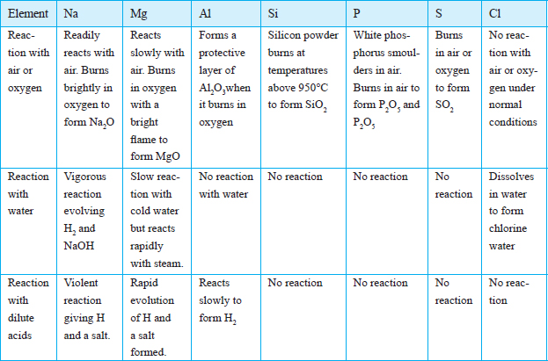

Reaction with oxygen
Discussion Questions
1. Describe how elements in Period 3 react with oxygen. Explain the nature of the resulting solutions when the products are dissolved in water.
- Sodium reacts vigorously with oxygen to form a white solid, sodium oxide.
Sodium + Oxygen Sodium oxide
4Na(s) + O₂ (g) 2Na₂O (s)
The sodium oxide produced in the reaction readily dissolves in water to form an alkaline solution
Sodium oxide + Water Sodium hydroxide
Na₂O(s) + H₂O(l) 2NaOH(aq)
- Magnesium burns with a bright white light to give a white solid, magnesium oxide.
Magnesium + Oxygen Magnesium oxide
2Mg (s) + O₂(g) 2MgO(s)
The magnesium oxide produced in the reaction is slightly soluble in water. The solution formed is alkaline.
Magnesium oxide + water Magnesium hydroxide
MgO(s) + H₂O(l) Mg(OH)₂(aq)
- Aluminium foil is usually coated with a layer of aluminium oxide, Al₂O₃. This prevents the reaction with oxygen. When polished, aluminum reacts slowly with oxygen to form the white solid, aluminium oxide.
Aluminium + Oxygen Aluminium oxide
4Al(s) + 3O₂(g) 2Al₂ O₃(s)
The aluminium oxide is insoluble in water.
- Silicon powder can only burn in oxygen at high temperatures (about 450°C) to form solid silicon (IV) oxide.
Silicon + Oxygen Silicon (IV) oxide
Si(s) + O₂(g) SiO₂(s)
Silicon (IV) oxide is insoluble in water.
- Phosphorus readily burns in oxygen with a bright orange flame to form a white solid, phosphorus (V) oxide.
Phosphorus + Oxygen Phosphorus (V) oxide
P₄(s) + 5O₂(g) 2P₂O₅(s)
Phosphorus (V) oxide readily dissolves in water to form an acidic solution.
Phosphorus (V) oxide + Water Phosphorus (V) acid
P₂O₅(s) + 3H₂O(l) 2H₃PO₄(aq)
- Sulphur burns in oxygen with a blue fame to form a gas sulphur (IV) oxide.
Sulphur + Oxygen Sulphur (IV) oxide
S(s) + O₂(g) SO₂(g)
The sulphur (IV) oxide gas readily dissolves in water to give an acidic solution of sulphuric (IV) acid, H₂SO₃, which is easily oxidized to sulphuric (VI) acid H₂SO₄.
Sulphur (IV) oxide + Water Sulphuric (IV) acid
SO₂(g) + H₂O(l) H₂SO₃(aq)
Sulphuric (IV) acid + Oxygen Sulphuric(VI) acid
2H₂SO₃(aq) + O₂(g) 2H₂SO₄(aq)
- Chlorine burns in oxygen under certain conditions to form acidic oxides while argon is not reactive.

2. State the trend in how elements in period 3 react with oxygen
The following trends in the elements of period 3 can be identified.
• All the elements across period 3, with the exception of argon, burn in oxygen to form oxides.
• The reactivity of the metals with oxygen decreases from left to right across the period. Sodium is the most reactive of the three metals in the period and aluminium the least. The order of reactivity with oxygen is therefore Na > Mg > Al. This is because of the increase in nuclear charge from sodium to aluminium, which makes it easier to remove an electron from a sodium atom than from an aluminium atom.
• Metallic elements burn in oxygen to form basic oxides. Soluble metallic oxides dissolve in water to form alkaline solutions.
• The reactivity of the non-metallic elements with oxygen increases from left to right across the third period. This is because the ease of gaining electrons increases from left to right. Phosphorus is the least reactive and chlorine the most reactive. The order of reactivity with oxygen, starting with the most reactive is therefore: Cl > S > P. Non-metals react by gaining electrons.
• The non-metallic elements burn in oxygen to form acidic oxides which dissolve in water to form acidic solutions.

Reaction with Water

Discussion Questions
- Describe how each of the elements in period 3 react with water.
- Sodium reacts violently with cold water to form sodium hydroxide and hydrogen gas.
Sodium + Water Sodium hydroxide + Hydrogen
2Na(s) + H₂O(l) 2NaOH(aq) + H₂(g)
- Magnesium reacts very slowly with cold water to form magnesium hydroxide and hydrogen gas.
Magnesium + water Magnesium hydroxide + Hydrogen
Mg(s) + 2H₂O(l) Mg(OH)₂(aq) + H₂(g)
- Aluminium does not normally react with cold water or steam due to the presence of a coating of aluminium oxide, which prevents any reaction. However, at temperatures above 700 °C steam can react with aluminium. Due to its apparent inability to react with water, aluminium was prefered for making cooking vessels such as pans and sufurias.
- Explain why the reactivity varies across the period.
- In general, the reactivity of the metals with water decreases from sodium to aluminium, Na > Mg > Al. sodium is more reactive because it loses its valence electron more readily than magnesium and aluminium.
- Non-metals do not displace hydrogen from water. Therefore, silicon, phosphorus and sulphur do not react with either cold water or steam.
- Chlorine is an exception since it dissolves in water to form chlorine water, which is a mixture of hydrochloric acid and chloric (I) acid.
Chlorine + water Hydrochloric acid + Hypochlorous acid
Cl2(g) + H2O(l) HCl(aq) + HOCl(aq)

Reaction with Acids

Discussion Questions
Explain the trend in reactivity of the period 3 elements with dilute acids.
- Magnesium reacts with both dilute hydrochloric acid and dilute sulphuric (VI) acid to form a salt and hydrogen gas.
Magnesium + hydrochloric acid Magnesium chloride + Hydrogen gas
Mg(s) + 2HCl(aq) MgCl₂(aq) + H₂(g)
Magnesium + Sulphuric (VI) acid Magnesium sulphate + Hydrogen gas.
Mg(s) + H₂SO₄(aq) MgSO₄(aq) + H₂(g)
- Aluminium does not readily react with dilute acid due to the presence of an aluminium oxide coating. However, on removing the oxide coating, the metal reacts.
Aluminium + Hydrochloric acid Aluminium chloride + Hydrogen gas
2Al(s) + 6HCl(aq) 2AlCl₃(aq) + 3H₂(g)
2Al(s) + 3H₂SO₄(aq) Al₂(SO)₄ (aq) + 3H₂(g).
- The reaction between sodium and acids is explosive and should NEVER be tried. The order of reactivity with acid is Na > Mg > Al.
- Silicon, phosphorus, sulphur and chlorine do not react with dilute acids.

- 2006 Q19 P1
  - Starting from solid magnesium oxide, describe how a solid sample of magnesium hydroxide can be prepared. (2 marks)
  - Give one use of magnesium hydroxide. (1 mark)

- 2006 Q 3a,b P2
- Distinguish between isotopes and allotropes.
- The chart below is part of the periodic table. Study it and answer the questions that follow. (The letters are not the actual symbols of the elements).
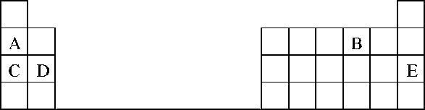
- Select the element in period three which has the shortest atomic radius. Give a reason for you answer. (2 marks)
- Element F has the electronic structure, 2.8.18.4. On the chart above; indicate the position of element F. (1 mark)
- State one use of the elements of which E is a member. (1 mark)

- 2007 Q3a P1

Both chlorine and iodine are halogens. What are halogens? (1 mark)

- 2007 Q 8 P1

Explain why there is general increase in the first ionization energies of the elements in period 3 of the periodic table from left to right. (2 marks)

- 2007 Q 25b

Give a reason why helium is increasingly being preferred to hydrogen in weather balloons. (1 mark)

- 2008 Q 18 P1
The grid below is part of the periodic table. Use it to answer the questions that follow, (the letters are not the actual symbols of the elements).
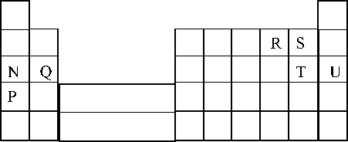
- Indicate on the grid the position of an element represented by letter V whose atomic number is 14. (1 mark)
- Select a letter which represents a monoatomic gas. (1 mark)

- 2009 Q 1 P1
The ionization energies for three elements A, B and C are shown in the table below.
Element | A | B | C
Ionisation energy (kJ /mole) | 519 | 418 | 494
- What is meant by ionization energy? (1 mark)
- Which element is the strongest reducing agent? Give a reason (2 marks)
- 2009 Q 21 P1,2011 Q 5 P1
Give the name of the product formed when magnesium reacts with phosphorus. (1 mark)

- 2011 Q5 P1
The diagram below represents part of the periodic table. Use it to answer the questions that follow.
M |  |  |  |  | Q
T | V |  | W
- Write the electron arrangement for the stable ion formed by W (1 mark)
- Write an equation for the reaction between V and Q (1 mark)
- How do the ionization energies of the elements M and T compare? (1 mark)

- 2011 Q 22 P1
The table below gives some properties of three elements in group (VII) of the periodic table. Study it and answer the questions that follow.
Element | Atomic No. | Melting Point (°C) | Boiling Point (°C)
Chlorine | 17 | -101 | -34.7
Bromine | 35 | -7 | 58.8
Iodine | 53 | 114 | 184
- Which element is in liquid form at room temperature? Give a reason. (1 mark)
- Explain why the boiling point of iodine is much higher than that of chlorine. (2 marks)

- 2011 Q 31 P1
What name is given to elements which appear in group (II) of the periodic table? (1 mark)

- 2012 Q14 P1
Distinguish between ionisation energy and electron affinity of an element. (2 marks)

- 2012 Q2 P2
The grid below is part of the periodic table. Use it to answer the questions that follow. (the letters are not the actual symbols of the elements).
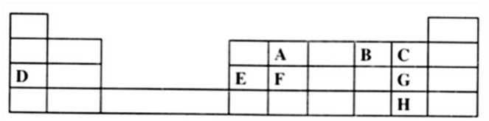
- Which is the most reactive non-metallic element shown in the table? Explain. (2 marks)

- (i) Write the formula of the compound formed when element A reacts with element B (1 mark)
(ii) Name the bond type in the compound formed in b (i) above (1 mark)

- (i) What is the name given to the group of elements where, C, G and H belong?
(ii) Write an equation for the reaction that occurs when C in gaseous form is passed through a solution containing ions of element H (1 mark)

- The melting points of elements F and G are 14100C and -101 respectively. In terms of structure and bonding, explain why there is a large difference in the melting points of F and G. (2 marks)
- D forms two oxides. Write the formula of each of the two oxides. (1 mark)

- J is an element that belongs to the 3rd period of the periodic table and a member of the alkaline earth elements. Show the position of j in the grid (1 mark)

- 2012 Q4 P1
The table below shows properties of some elements A, B, C and D which belong to the same period of the periodic table. The letters are not the actual symbols of the elements.
Element | A | B | C | D
MP (°C) | 1410 | 98 | -101 | 660
Atomic radii (nm) | 0.117 | 0.186 | 0.099 | 0.143
Electrical conductivity | Poor | Good | Non-conductor | Good
- Arrange the elements in the order they would appear in the period. Give a reason (2 marks)
- Select the metallic element which is the better conductor of electricity. Give a Reason. (1 mark)

- 2012 Q27 P1
- The electronic arrangement of the ion of element Q is 2.8.8. If the Formula of the ion is Q³⁻, state the group and period to which Q belongs,
Group: (½ mark)
Period: (½mark)
- Helium, neon and argon belong to group 8 of the periodic table. Give:
(i) The general name of these elements; (1 mark)
(ii) One use of these elements (1 mark)

- 2013 Q20 P1
The plots below were obtained when the atomic radii of some elements in groups I and II were plotted against atomic numbers.
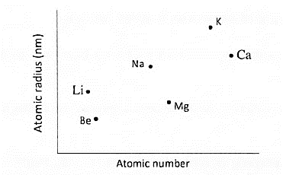
Explain:
- The trend shown by Li, Na and K. (1 mark)
- Why the atomic radii of elements Be, Mg, and Ca are lower than those of Li, Na and K. (2 marks)

- 2013 Q1 P2
- The grid below represents part of the periodic table. Study it and answer the questions that follow. The letters do not represent the actual symbols of the elements.
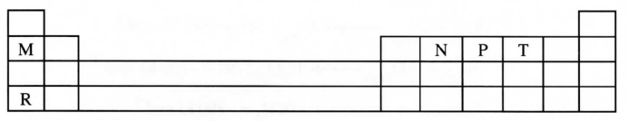
    - Select a letter which represents an element that losses electrons most readily. Give a reason for your answer. (2 marks)
    - Explain why the atomic radius of P is found to be smaller than that of N. (2 marks)
    - Element M reacts with water at room temperature to produce 0.2 dm³ of gas. Determine the mass of M which was reacted with water. (molar gas volume at r.t.p is 24 dm³, relative atomic mass of M = 7). (3 marks)

- Use the information in the table below to answer the questions that follow. (The letters are not the actual symbols of the elements).
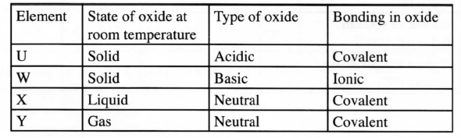
Identify a letter which represents an element in the table that could be calcium, carbon or sulphur. Give a reason in each case.
- Calcium____________ (½ mark)
Reason____________ (½ mark)
- Carbon ____________ (½ mark)
Reason_____________ (½ mark)
- Sulphur ____________ (½ mark)
Reason_____________ (½ mark)

- 2014 Q2 P1
- The grid below represents part of the periodic table. Study it and answer the questions that follow. The letters are not the actual symbols of the elements
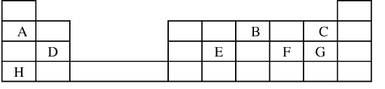
- Select the most reactive metal. Explain (2 marks)
- Select an element that can form an ion with a charge of 3⁻ (1 mark)
- Select an alkaline earth metal (1 mark)
- Which group 1 element has the highest first ionization energy? Explain (2 marks)
- Element A combines with chlorine to form a chloride of A. State the most likely pH value of a solution of a chloride of A. Explain (2 marks)

- (i) Explain why molten calcium chloride and magnesium chloride conduct electricity while carbon tetrachloride and silicon tetrachloride do not. (2 marks)
(ii)Under the same conditions, gaseous neon was found to diffuse faster than gaseous fluorine. Explain this observation. (F=19.0; Ne=20.0) (2 marks)
- 2015 Q23 P1
The table below is part of the periodic table. The letters are not the actual symbols of the elements. Study it and answer the questions that follows. 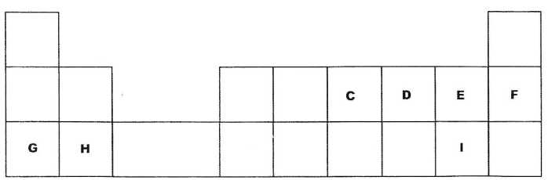
    - Select an element which is stored in paraffin in the laboratory. (1 mark)

    - How do the ionic radii of E and I compare? Explain (2 marks)

- 2015 Q3c-d P2
- The diagram below shows part of a periodic table. The letters do not represent the actual symbols of elements. Use the diagram to answer the questions that follow.
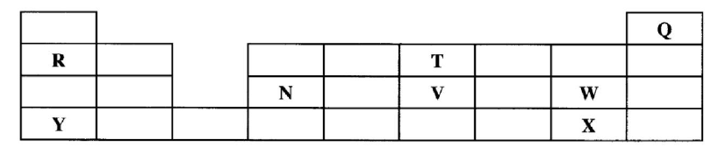
- Explain why the oxidizing power of W is more than that of X. (1 mark)
- How do the melting points of R and T compare? Explain. (2 marks)

- Sketch an element that could be used
  - In weather balloons (1 mark)
  - For making a cooking pot (1 mark)

- (i) Classify the substances water, iodine, diamond and candle wax into elements and compounds (2 marks)
Elements | Compounds

- Give one use of diamond. (1 mark)

- 2015 Q20 P1
A crystal of iodine, heated gently in a test tube gave off a purple vapour.
- Write the formula of the substance responsible for the purple vapour. (1 mark)

- What type of bond is broken when the iodine crystal is heated gently? (1 mark)

- State one use of iodine. (1 mark)

- 2016 Q1 P2
Use the information in the table below to answer the questions that follow. The letters do not represent the actual symbols of the elements.
Element | Atomic Number | Melting Point (°C)
R | 11 | 97.8
S | 12 | 650.0
T | 15 | 44.0
U | 17 | -102
V | 18 | -189
w | 19 | 64.0
      - Give reasons why the melting point of:
(i) S is higher than that of R; (1 mark)
(ii) V is lower than that of U. (2 marks)

      - How does the reactivity of W with Chlorine compare with that of R with chlorine? Explain. (2 marks)
      - Write an equation for the reaction between T and excess oxygen.
(1 mark)
      - When 1.15g of R were reacted with water, 600cm3 of gas was produced. Determine the relative atomic mass of R. (Molar gas volume = 24 000 cm³). (3 marks)

      - Give one use of element V. (1 mark)

- 2017 Q1 P1
Table 1 shows the atomic numbers and the first ionisation energies of three elements. The letters are not actual symbols of the elements. Use it to answer the questions that follow.
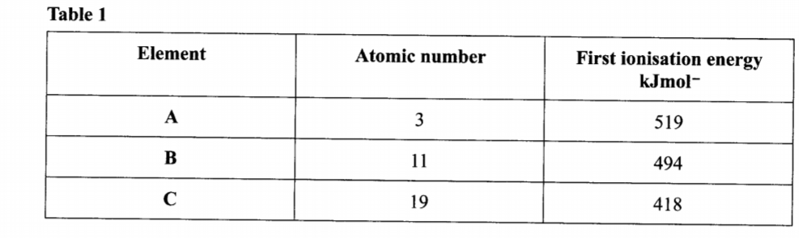
  - Explain the trend in first ionisation energy from A to C. (2 mark)
  - Write the electronic configuration for the ion of C. (1 mark)

- 2018 P1 Q5.
Describe an experiment to show that group one elements react with cold water to form alkaline solutions. (3 marks)

- 2018 Q2 P2
Figure 2 is a section of the periodic table. Study it and answer the questions that follow. The letters do not represent the actual symbols of elements
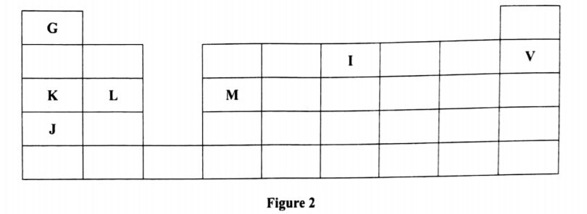
- (i) Select elements which belong to the same chemical family. (1 mark)
(ii) Write the formulae of ions for elements in the same period. (1 mark)

- The first ionisation energies of two elements K and M at random are 577 kJ/mol and 494 kJ/mol. (1 mark)
- Write equations for the 1ˢᵗ ionisation energies for elements K and M and indicate their energies. (1 mark)
- Explain the answer in b(i). (1 mark)
- Write the formula of the compound formed when L and I react. (1 mark)
- Give one use of element V. (1 mark)
- (i) State another group that G can be placed in Figure 1. Explain. (2 marks)
(ii) How do the reactivity of elements J and K compare? Explain. (2 marks)

- (i) Elements L and M form chlorides. Complete the following table by writing the formulae of each chloride and state the nature of the solutions. (2 marks)
Element | Formula of chloride | Nature of chloride solution
L
M

(ii) The chloride of element M vaporises easily while its oxide has a high melting point. Explain. (2 marks)

- 2019 P1 Q21
Study the information in Table 3 and use it to answer the questions that follow.
Elements | Na | Mg | Al | Si | P | S | Cl
Atomic Numbers | 11 | 12 | 13 | 14 | 15 | 16 | 17
Atomic radii(nm) | 0.157 | 0.136 | 0.125 | 0.117 | 0.110 | 0.104 | 0.099
  - Explain the trend in atomic radii from sodium to chlorine. (1 mark)

  - Explain how the chloride of aluminium differs from those of other metals in the period. (2 marks)

