Name…………………………………… ………………………….. Adm No:………………………….

School……………………………………………………………….. Class …………..……………

BIOLOGY
PAPER 1
(THEORY)
TIME: 2 HOURS

SUNRISE EXAMINATIONS

BIOLOGY
PAPER
(THEORY)
TIME: 2 HOURS

INSTRUCTIONS TO CANDIDATES
      - Write your name and index number in the spaces provided.
      - Answer all the questions in the spaces provided.
      - Additional pages must not be inserted.

FOR EXAMINER’S USE ONLY
QUESTION | MAXIMUM SCORE | CANDIDATE’S SCORE
1 – 22 | 80

This paper consists of 11 printed pages. Candidates should check to ascertain that all pages are printed as indicated and that no questions are missing.
- a) Name the field of science that specializes in the study of chemical substances in an organism and the reactions in which they take part. (1mk)

………………………………………………………………………………………………………………
b) The biological name of housefly is MUSCA domestica.
(i) State one mistake in the way the scientific name is written. (1mk)
………………………………………………………………………………………………………………
………………………………………………………………………………………………………………
(ii) Write the name in the correct manner following the rules of the binomial nomenclature. (1mk)
………………………………………………………………………………………………………………
- a) What is the structural difference between the cell wall and the cell membrane? (1mk)
………………………………………………………………………………………………………………
………………………………………………………………………………………………………………
………………………………………………………………………………………………………………
b) An organelle was magnified 800 times by an electron microscope. Its diameter was 2 millimetres. Calculate the actual diameter in micrometres. (2mks)
………………………………………………………………………………………………………………
………………………………………………………………………………………………………………
………………………………………………………………………………………………………………
………………………………………………………………………………………………………………
- Distinguish between haemolysis and plasmolysis. (2mks)
………………………………………………………………………………………………………………
………………………………………………………………………………………………………………
………………………………………………………………………………………………………………
………………………………………………………………………………………………………………

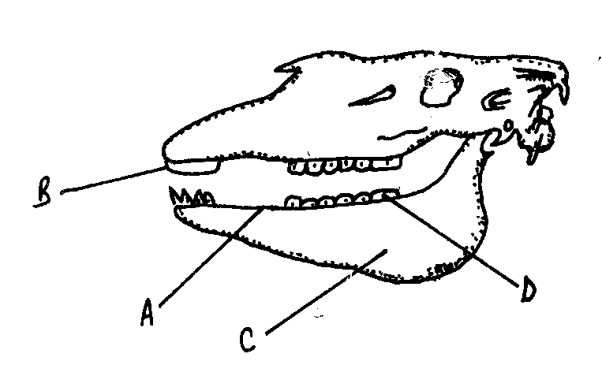
- Study the figure below and answer the questions that follow:

D

B

A

C

- Name the parts labelled A, B, C and D (2mks)
A……………………………………
B……………………………………
C……………………………………
D……………………………………
b) State the function of part labelled A. (1mk)
………………………………………………………………………………………………………………
………………………………………………………………………………………………………………
- a) Why are people with blood group O called universal donors? (1mk)
………………………………………………………………………………………………………………
………………………………………………………………………………………………………………
………………………………………………………………………………………………………………
b) Most carbon (IV) oxide is transported from tissues to the lungs within the red blood cells and not in the blood plasma. Give two advantages of this mode of transport. (2mks)
………………………………………………………………………………………………………………
………………………………………………………………………………………………………………
………………………………………………………………………………………………………………

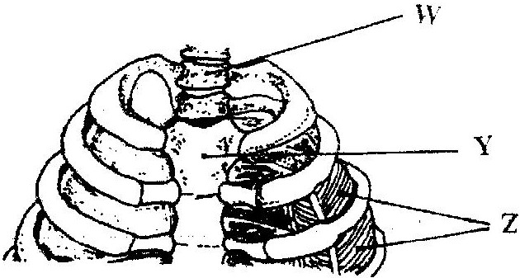
- The diagram below represents a part of the rib cage:

a) Name the parts labelled W and Y: (2mks)
W…………………………………………………
Y……………………………………………….…
b) How does the part labelled Z facilitates breathing out? (2mks)
…………………………………………………….………………………………………………………
……………………………………………….……………………………………………………………
………………………………………………….…………………………………………………………
- Active yeast cells were added to dilute sugar solution in a container. The mixture was left in a warm room. After a few hours bubbles of gases were observed escaping from the mixture.
a) Write a word equation to represent the chemical reaction that took place. (1mk)
…………………………………………………………….………………………………………………
………………………………………………………….…………………………………………………
b) What is the importance of this type of reaction in industries? (1mk)
……………………………………………………….……………………………………………………
………………………………………………………………………………………………………………
- Account for the absence of glucose and proteins in the glomerular filtrate.
(a) Glucose (1mk)
……………………………………………………….……………………………………………………
………………………………………………………….…………………………………………………
(b) Proteins (1mk)
………………………………………………….…………………………………………………………………………………………………………………….…………………………………………………
- Explain how hair in human beings keeps the body warm (2mks)
………………………………………………………………………………………………………………
……………………………………………………………………………………………………………… ………………………………………………………………………………………………………………
- Explain how light intensity would affect the distribution of fish in a pond. (2mks) ………………………………………………………………………………………………………………………………………………………………………………………………………………………………………………………………………………………………………………………………………………
- In an experiment to investigate a factor affecting photosynthesis, a leaf of a potted plant which had been kept in the dark overnight was covered with aluminum foil as shown in the diagram below.
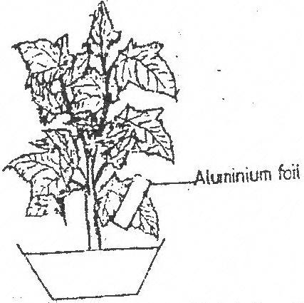
Aluminum foil

The set up was kept in sunlight for three hours after which a food test was carried out on the leaf.
i) Which factor was being investigated in the experiment? (1mk)
…………………………………………….………………………………………………………………
ii) What food test was carried out? (1mk)
……………………………………………………….……………………………………………………
iii) State the results of the food test. (1mk)
………………………………………………….………………………………………………………………………………………………………………………………………………………………………
………………………………………………….………………………………………………………
- In an experiment to determine the population size of mosquitoes in Kisumu Museum, Kenya Research Institute researchers caught 600 mosquitoes which they marked and released. After 24hrs 300 mosquitoes were caught out of which 100 already had the marks.
a) Suggest a possible instrument of capturing the insects. (1mk)
………………………………………………………………………………………………………………
b) Estimate the population size of mosquitoes in Kisumu Museum. (2mks)

- Give two classes of the phylum Chordata whose members are all poikilothermic. (2mks)
……………………………………………………………………………….……………………………
……………………………………………………………………………….………………………………………………………………………………………………………………………………………….
- State one use of each of the following excretory products in plants.
- Colchine (1mk)
……………………………………………………….……………………………………………………
b) Papain (1mk)
……………………………………………………………….……………………………………………
……………………………………………………………………………………………………………
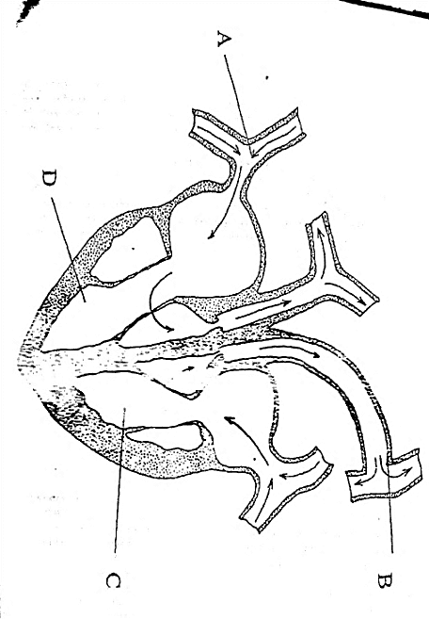
- The diagram below represents a section through a mammalian heart.

- Label the parts marked A and B (2mks)
A……………………………………………………
B……………………………………………………
- Explain why chamber C has thick walls than the chamber D. (1mk)
……………………………………………………………………..……………………………………
……………………………………………………………………………………………………………
- Name three sites where gaseous exchange takes place in plants. (3mks)
………………………………………………………………………………………………………………
………………………………………………………………………………………………………………
………………………………………………………………………………………………………………
- State the transport and synthetic roles of the rough endoplasmic reticulum. (2mks)
Transport role ……………………………………………………….……………………………………….……………
Synthetic role ………………………………………………………..……………………………………………………
- a) Name the chemical compound formed in the mitochondria which is the source of energy. (1mk)
………………………………………………………………….…………………………………………
b) Explain why fats are not considered as the main respiratory substrate yet they yield more energy when completely oxidized than carbohydrates. (2mks)
………………………………………………………………………………………………………………
………………………………………………………………………………………………………………………………………………………………………………………………………………………………
- In an experiment two equal volumes of solution L and M were placed into visking tubing.
The visking tubing was suspended into beakers containing equal volumes of solutions K. The set –up is as shown in the diagram A and B. The set-up was allowed to stand for 45minutes and results are as shown in the diagrams.

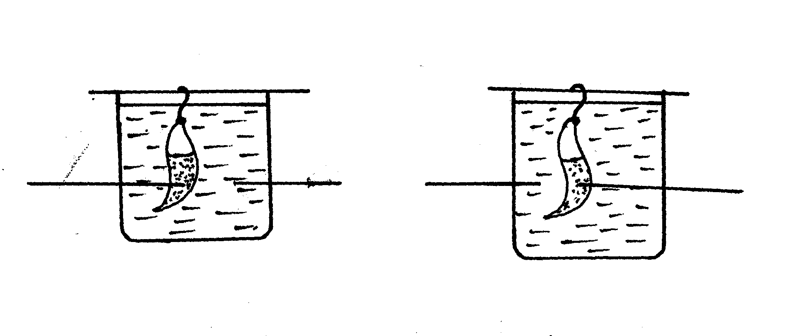
A
B
Solution L
Solution K
Solution M

At the end of experiment

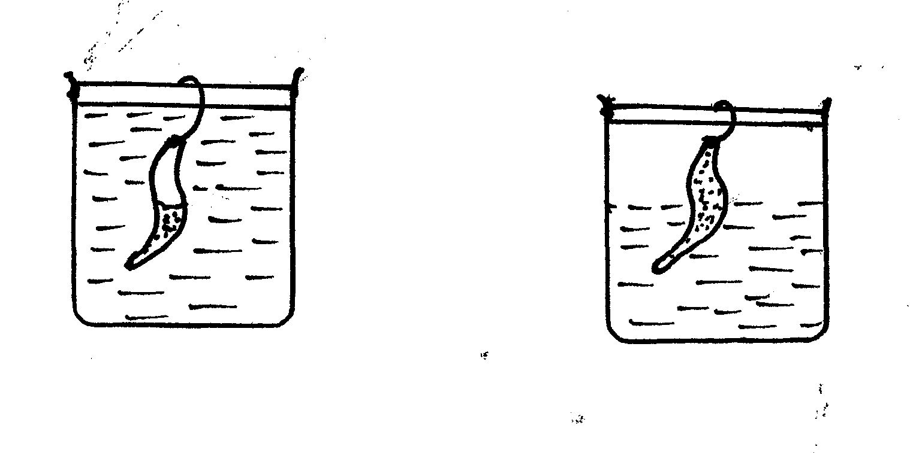
A
B
B
A

(a) Name the process that was being demonstrated. (1mrk)
..................................................................................................................................................................
(b) Explain the results that were obtained at the end of the experiment in
(i) Set-up A. (2mks)
.................................................................................................................................................................
................................................................................................................................................................
(ii) Set up B. (2mks) ...............................................................................................................................................................
..............................................................................................................................................................
(c) What is the biological importance of the process demonstrated in this experiment to plants? (2mks)
................................................................................................................................................................................................................................................................................................................................................
(d) What happens to a marine Amoeba when it is transferred from sea water to freshwater?
(1mk)
...............................................................................................................................................................
- The diagram below shows a portion of a lower epidermis of a sukuma wiki leaf.
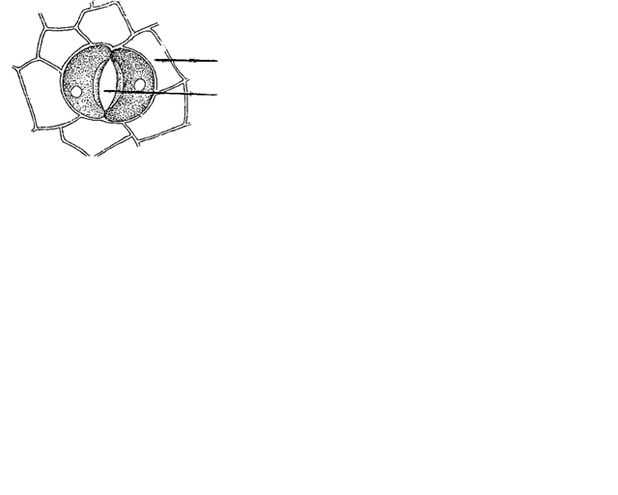
Q
P

(a) Name the parts labeled P and Q. (2mks)
P ………………………………………………………
Q. ………………………………………………………
(b) Briefly describe the photosynthetic theory of stomatal opening. (5mks)
…………………………………………………………………………………………………..………
…………………………………………………………………………………………………..………
…………………………………………………………………………………………………..………
…………………………………………………………………………………………………..………
…………………………………………………………………………………………………..………
…………………………………………………………………………………………………..………
…………………………………………………………………………………………………..………
…………………………………………………………………………………………………..………
(c) State one modification in the stomata of xerophyte plant other than being sunken and hairy (1mk)
…………………………………………………………………………………………………..………
…………………………………………………………………………………………………..………

- A student observed feeding relationship while on a tour in a coastal Island.
Eagles feed on small fish, Small fish feed on sea grass, Insect larvae and molluscs feed on sea grass, Insect larvae fed on by small fish, while crabs feed on insect larvae and molluscs.

a) From the above information, construct a food web. (3mks)

b) In which trophic level is small fish found. (1mk)
……………………………………………………………………………………………………..
……………………………………………………………………………………………………..
c) Extract a food chain where the Eagle is a tertiary consumer. (1mk)

d) Suppose all the crabs were poisoned, what would be the immediate effect in the ecosystem? Give a reason. (1mk)
……………………………………………………………………………………………………..
……………………………………………………………………………………………………..
(e) Give a reason why pyramid of biomass is a better representation of energy flow in an
ecosystem than pyramid of numbers. (1mk)
……………………………………………………………………………………………………..
……………………………………………………………………………………………………..
- Describe how water molecules are absorbed from the soil and moves to the leaves in a tree. (10mks)
………………………………………………………………………………………………………………………………………………………………………………………………………………………………………………………………………………………………………………………………………………………………………………………………………………………………………………………………………………………………………………………………………………………………………………
………………………………………………………………………………………………………………………………………………………………………………………………………………………………………………………………………………………………………………………………………………………………………………………………………………………………………………………………………………………………………………………………………………………………………………
………………………………………………………………………………………………………………………………………………………………………………………………………………………………………………………………………………………………………………………………………………………………………………………………………………………………………………………………………………………………………………………………………………………………………………
………………………………………………………………………………………………………………………………………………………………………………………………………………………………………………………………………………………………………………………………………………………………………………………………………………………………………………………………………………………………………………………………………………………………………………
………………………………………………………………………………………………………………………………………………………………………………………………………………………………………………………………………………………………………………………………………………………………………………………………………………………………………………………………………………………………………………………………………………………………………………
………………………………………………………………………………………………………………………………………………………………………………………………………………………………………………………………………………………………………………………………………………………………………………………………………………………………………………………………………………………………………………………………………………………………………………
………………………………………………………………………………………………………………………………………………………………………………………………………………………………………………………………………………………………………………………………………………………………………………………………………………………………………………………………………………………………………………………………………………………………………………
………………………………………………………………………………………………………………………………………………………………………………………………………………………………………………………………………………………………………………………………………………………………………………………………………………………………………………………………………………………………………………………………………………………………………………
………………………………………………………………………………………………………………………………………………………………………………………………………………………………………………………………………………………………………………………………………………………………………………………………………………………………………………………………………………………………………………………………………………………………………………

