- (a) (i) Cracking√ 1
(ii) When the gas is burnt in air√ 1 it burns with a pale blue flame. √ 1
OR
Does not decolourize √ 1purple acidified potassium manganate (VII). √ 1

(iii) I. A. Ethane√ 1
II. B 1- Chloroethane√ 1
(iv)

H H

C C

H H n√ 1

(v) (i) Combustion√ 1
(ii) Dehydration√ 1
(vi) Conc. H₂SO_{4√ 1}
Temperature of 170⁰C. √ 1
(b) (i) Pent-2-ene√ 1
(ii) Prop-1-yne. √ 1

- a) (i) Mass of Mg is 20.36-19.52=0.84g√ ½
Mass of MgO is 20.92-19.52=1.40g
Mass of oxygen is 20.92-20.36=0.56g√ ½
% mass of Mg in MgO is $\frac{0.84}{1.40}×100\%$
=60%√ ½
%mass of O₂ in MgO is $\frac{0.56}{1.40}×100\%$
=40%√ ½

(ii)

Elements | Mg | O
%comp | 60 | 40
R. A. M | 24 | 16
Moles | 60$÷24$  =2.5 | 40÷16  =2..5
Mole ratio | 1√ 1 | 1√ 1

Empirical formula is thus MgO√ 1

b) (i) 2NaOH_{(aq)} +H₂SO_{4(aq)} Na₂SO_{4(aq)} +2H₂O_{(l)} √ 1
(ii)
I. Moles of H₂SO₄ in 20cm³ is $\frac{20×0.25}{1000}$
=0.005moles√ 1
Mole ratio of base to acid is 2:1
Moles of NaOH is thus $\frac{2}{1}×0.005$
=0.01 moles of NaOH√ 1
II. Moles of NaOH in 1L is thus
$\frac{0.01×1000}{50}$ √ 1
=0.2moles√ 1

III. Mass of NaOH in 1L is
$0.2×40$ =8g
Mass of NaCl in the mixture is 8.8-8= 0.8g√ 1
% mass of NaCl is ${0.8}/{8.8}×100\%$
= 9.09%√ 1

- a) (i) Bonds Broken are 4C-H= 4 x 413 = 1652
1C = C = 1 x 610 =610
1Br – Br = 1 x 193 = 193
Total energy absorbed = 2455 kJmol⁻¹ √1

Bonds formed are 4C-H= 4 x 413 = 1652
2C = Br = 2 x 280 =560
1C – C = 1 x 346 = 346
Total energy given out = 2558 kJmol⁻¹ √1

ΔH = 2455 – 2558 = -103 kJmol⁻¹ √1

(ii) Addition reaction √1

b) (i) 4C _{(s)} + 5H₂ _{(s)} ΔH₁ C₄ H_{10(g)}

ΔH₃
ΔH₂ √1

4CO_{2 (g)} + 5H₂O _{(g)}

ΔH^{θ}_{f} (C₄H₁₀) = ΔH₃ - ΔH₂
=4 (-393) + 5(-286) – (-2877) √1
= -3002 + 2877
= -125 kJmol⁻¹ √1

(ii) ∆H +∆Hhyd
= 690 + -322 + - 364
= 690- 686
= + 4 kJ / mol
- a) √ 1
- Burrete √ 1
- Pippete√ 1
- Measuring cylinder
b)
    - Due to incomplete combustion, it produces white hot carbon particles that emittes a lot of light √ 1

    - It produces soot that makes apparatus dirty √ 1
It does not produce much heat √ 1
c)
- Nitrogen √ 1and oxygen√ 1
- It can be separated by physical means √ 1
Components of air are not chemically combined √ 1
- Pass air through lime water (Ca(OH)₂√)√ 1 the lime water forms white precipitate indicating presence of carbon(IV)oxide √ 1

- (a) Alkali metals √ 1
(b) Electron arrangement 2.8.5 √1
position: group V period 3√1
(c) The atom of R is larger √ ½ // has a larger atomic radius than the ion √ ½ This is because the ion of R is formed when the atom loses the electrons in the outermost energy level √ ½ therefore, the ion has one less energy level than the atom.√ ½
(d) (i) P₂W √ ½
(ii) TY₄ √ ½
(e) S has a higher √ ½ melting point than Q √ ½
This is because e S has more valence electrons in its metallic structure hence a stronger metallic bond √ ½ than Q √ ½
(f) M √1
It has a completely filled outermost energy level √ ½ and therefore, does not need to react with other elements to gain stability √ ½
(g) S has a higher electrical conductivity than Q√ 1.
S does not corrode easily like Q. √ 1
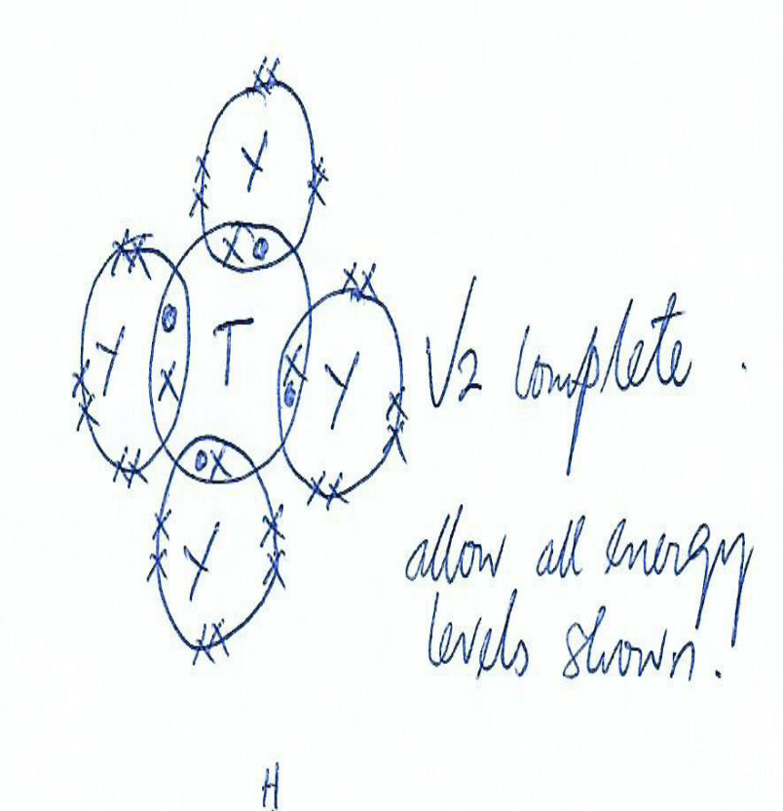
(h)

- (a) A – Ammonia √1
B – Calcium oxide √1

(b) CaO _{(s)} + H₂O _{(l)} Ca(OH)_{2 (aq)} √1
(c ) Reaction is exothermic √1
(d) Filtration √1
(e) - Ammonia √1
- Carbon (IV) oxide √1
(f) (i) C _{(s)} + 2H₂SO_{4 (l)} CO_{2 (g)} + 2H₂O _{(l)} + 2SO_{2 (g)} √1
(ii) Oxidising property √1
(g) - Manufacture of glass√½
- Softening of hard water √½
- Making of soaps and detergents
- For making sodium hydrogen carbonate used in baking soda and fire extinguishers
(Any 2 correct answers each ½ mk )

- (a) (i)
Substance | Carbon (IV) oxide | Carbon (II) oxide
K | Dilute hydrochloric acid √½ | Concentrated sulphuric (VI) acid √½
L | Marble chips or calcium carbonate √½ | Sodium methanoate or ethanedioc acid (oxalic acid) √½

(ii)
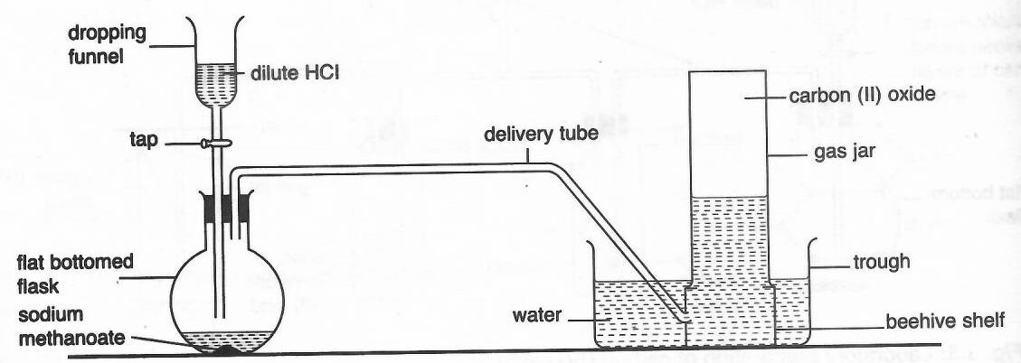
Complete diagram = 1 mark, Labelling = 1 mark
(iii) Carbon (IV) oxide reacts with lime water / calcium hydroxide solution√½ to yield
white precipitate while carbon (II) oxide does not. √½
Carbon (II) oxide burns √½with blue flame while carbon (IV) oxide does not burn. √½
(b) (i) CO_{2(g)} + C_{(s)} → 2CO_{(g)} √1
(ii) Reducing agent in extraction of some metals from their oxides. √1
(c) The bulb lights in set up I or conducts electricity while set up II does not. √ √1
In graphite, three out of four valence electrons of carbon atom are bonded leaving one
delocalised√1 electron thus conducts electricity while in diamond, all the four valence
electrons are bonded and is without delocalised electrons. √1

