SULPHUR AND ITS COMPOUNDS

Table of Contents
Organizer 📌

Sulphur and its allotropes - 3 -
Extraction Of Sulphur: The Frasch process - 3 -
Allotropes of Sulphur - 3 -
Rhombic Sulphur - 4 -
Monoclinic Sulphur - 4 -
Physical Properties of Sulphur - 5 -
Effect of heat on sulphur. - 6 -
Chemical Properties of Sulphur - 6 -
Reaction of sulphur with oxygen, iron powder and copper - 6 -
Reaction of sulphur with concentrated acids - 7 -
Uses of Sulphur - 7 -
The Compounds of Sulphur - 8 -
Oxides of Sulphur - 8 -
Sulphur(IV) Oxide, SO₂ - 8 -
Laboratory preparation of sulphur (IV) oxide. - 8 -
Physical Properties of Sulphur(IV) Oxide - 8 -
Chemical Properties of Sulphur (IV) Oxide - 9 -
Bleaching Action of Sulphur(IV) Oxide - 9 -
Reducing Action of Sulphur(IV) Oxide - 10 -
Oxidising Action of Sulphur(IV) Oxide - 11 -
Sulphur (VI) Oxide, SO₃ - 11 -
Preparation of Sulphur (VI) Oxide (SO₃) - 11 -
Test for Sulphate and Sulphite ions. - 12 -
Uses of Sulphur(VI) Oxide - 13 -
Sulphuric (VI) acid - 13 -
Large Scale Manufacture of Sulphuric(VI) Acid - 13 -
Properties of Sulphuric(VI) acid - 15 -
Reactions of Dilute Sulphuric(VI) Acid - 16 -
Reactions with metals - 16 -
Reactions with carbonates. - 16 -
Reaction with metal oxides and hydroxides - 17 -
Uses of Sulphuric(VI) acid - 17 -
Hydrogen Sulphide (H₂S) - 17 -
Preparation and properties of hydrogen sulphide - 17 -
Physical properties of hydrogen sulphide - 18 -
Chemical properties of hydrogen sulphide - 18 -
(a) Reaction with water - 18 -
(b) Reaction with Oxygen - 18 -
(c) Reactions of hydrogen sulphide as a reducing agent - 18 -
(d) Reaction with aqueous metallic ious - 19 -
Pollution of the Atmosphere by Compounds of Sulphur - 19 -

Objectives
By the end of the Chapter, the learner should be able to:
(a) Name the sources of sulphur.
(b) Describe the extraction of sulphur.
(c) Describe the preparation of the allotropes of sulphur.
(d) State the properties and uses of sulphur.
(e) Name and describe the preparation of the oxides of sulphur.
(f) State the properties and uses of the oxides of sulphur.
(g) Describe the contact process for the manufacture of sulphuric acid.
(h) Describe the properties and state the uses of sulphuric acid.
(i) Describe the preparation and state the properties of hydrogen sulphide.
(j) Explain pollution effects of sulphur containing compounds.

SULPHUR AND ITS COMPOUNDS
Sulphur is the second member of group VI elements. It is placed just below oxygen in the periodic table. It has an atomic number 16 hence its electron arrangement is 2.8.6.
Sulphur occurs naturally as an element in deposits in places such as Texas and Louisiana in U.S.A, Sicily in Italy, and various places in Japan.
Sulphur also occurs in combination with other elements as sulphides and sulphates. The sulphide ores include copper pyrites (CuFeS₂) and iron pyrites (FeS₂).
The sulphate ores include gypsum (CaSO₄.2H₂O)and anhydrite (CaSO₄). Petroleum gas and coal mines contain sulphur in the form of hydrogen sulphide gas.

Sulphur and its allotropes

Extraction Of Sulphur: The Frasch process
The Frasch process is employed in the extraction of Sulphur. The process is based on the low melting point of sulphur which ranges between 113 °C and 119°C. In the Frasch process, three concentric pipes of different diameters 2 cm, 8 cm, and 15 cm are sunk into the sulphur deposits underground.
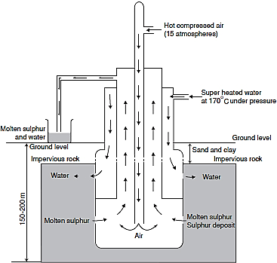
Water is heated to about 170°C under pressure of about 10 atmospheres and is forced down the outermost pipe. The pressure ensures that the water remains in liquid state at such high temperature.
Hot air at a pressure of 15 atmospheres is forced down the innermost pipe. This produces a light froth consisting of a mixture of molten sulphur and water. The high pressure forces the mixture up the middle pipe.
The mixture is run into large tanks on the surface where the sulphur solidifies at 115°C, Separates from the water and is stored. Sulphur obtained this way in usually over 99% pure.

Allotropes of Sulphur
Sulphur exhibits allotropy. The main allotropes are rhombic and monoclinic sulphur

Rhombic Sulphur


Rhombic sulphur is also referred to as octahedral or α-sulphur. It is a bright yellow crystalline solid with an octahedral shape.
(a) A crystal of rhombic sulphur. (b) Packing of rhombic sulphur molecules in a crystal
How to prepare Rhombic sulphur:
Place two spatulafuls of powdered sulphur in a boiling tube containing 10 cm³ of carbon(IV) sulphide. Stir and filter the contents of the tube into a dry beaker using a dry filter paper. Allow the filtrate to evaporate slowly. Use a hand lens to examine the crystals formed.
Rhombic sulphur melts at 113°C and has a density of 2.06 g/cm³. It is the stable allotrope below 96°C. Above this temperature, it slowly changes into monoclinic sulphur.

Monoclinic Sulphur
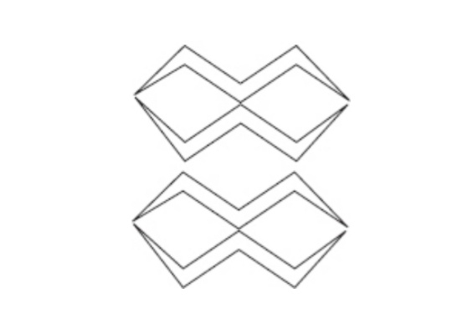
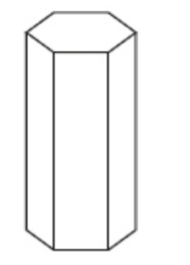
Monoclinic sulphur is also referred to as prismatic or ß - sulphur. It is a pale yellow crystalline solid. The crystals appear needle-like when observed using a hand lens. The actual shape of the crystal is a hexagonal prism.
- A crystal of monoclinic Sulphur. (b) Packing of monoclinic Sulphur molecules in a crystal

How to prepare monoclinic sulphur
Place some powdered sulphur in an evaporating dish and heat gently until the sulphur melts. Using a glass rod, stir and add more sulphur a little at a time until the dish is almost full of molten sulphur.
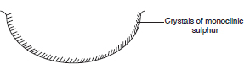
Remove the source of heat and allow the sulphur to cool and form a crust on the surface. Using a thin glass rod, carefully pierce two holes on widely separated points in the crust as shown below .
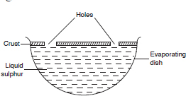
Immediately pour out the molten sulphur. Remove the crust by cutting round the edge of the dish with a knife. Use a hand lens to observe the crystals that have formed on the underside of the crust.
Monoclinic sulphur has a melting point of 119°C and a density of 1.98 g/cm³. Below 96°C monoclinic sulphur gradually changes to rhombic sulphur. This temperature of 96°C is the transition temperature for rhombic and monoclinic sulphur.
The temperature at which one allotrope of an element changes to another is called the transition temperature.
Non-crystalline – (amorphous) forms of Sulphur
Include plastic, colloidal, and powdery sulphur.
Plastic sulphur is prepared by heating powdered sulphur until it boils. The boiling sulphur is then poured in a thin continuous stream into a beaker containing cold water. Long elastic yellow threads of plastic sulphur are formed.
This form of sulphur is insoluble in carbon(IV) sulphide. It turns into hard rhombic sulphur if left for a few days.
When dilute hydrochloric acid is added to a test-tube containing a dilute solution of sodium thiosulphate, Na₂S₂O₃, a yellow precipitate of colloidal sulphur is deposited.
N₂S₂O₃,(aq) + 2HCl(aq) 2NaCl(aq) + H₂O(l) + SO₂(g) + S(s)
Powdery sulphur may be prepared by saturating distilled water with hydrogen sulphide. The solution is then exposed to air. A white powder is deposited.
H₂S(g) + Water H₂S(aq)
2H₂S(aq) + O₂(g) 2H₂O(l) + 2S(s)

Physical Properties of Sulphur
Sulphur is a yellow non-metallic element. A molecule of sulphur consists of a puckered ring of eight atoms of sulphur joined together by strong covalent bonds as shown below. .
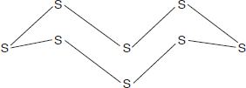
Sulphur is soluble in organic solvents such as benzene, methyl benzene, and carbon(IV) sulphide. It does not dissolve in water.

Effect of heat on sulphur.
When the yellow powder is gently heated, it melts at 113°C to a clear amber liquid. At this temperature molten sulphur has a low viscosity, and flows easily. This liquid is made up of rings of sulphur molecules consisting of eight atoms of sulphur, S₈.


On further heating the liquid gradually darkens. At 160°C, it becomes reddish-brown, and very viscous such that the test-tube may be inverted without the liquid sulphur pouring out. These changes are due to the breaking of the S₈ rings which join to form long chains with over 100,000 atoms of sulphur. As the chains entangle with one another, the viscosity of the liquid increases.
Long chains of sulphur atoms. Shorter chains of sulphur atoms
Above 160°C, the liquid darkens further and becomes almost black. Near the boiling point the liquid becomes more mobile. This is due to the breaking of the long chains to shorter chains.
The liquid boils at 444°C and forms a reddish-brown vapour consisting of S₈, S₆ and S₂ molecules which cools to form a yellow sublimate. This sublimate is known as “flowers of sulphur” and consists mainly of S₈ rings.

Chemical Properties of Sulphur

Reaction of sulphur with oxygen, iron powder and copper
Sulphur burns in oxygen with a bright blue flame forming misty fumes with a choking smell.
The gas is mainly sulphur(VI) oxide (sulphur dioxide) SO₂, with traces of sulphur(IV) oxide (sulphur trioxide, SO₃).
S(s) + O₂(g) SO₂(g)
2S(s) + 3O₂(g) 2SO₃(g)
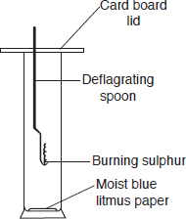
The moist blue litmus paper turns red indicating that the oxides produced when sulphur burns are acidic.
Sulphur combines directly with some elements to form sulphides.
- When a mixture of sulphur, and iron powder is heated, a highly exothermic reaction occurs. Once the reaction has started at one point, the glow spreads through the mixture without further heating, forming iron(II) sulphide. This is because the heat produced during the reaction is high enough to sustain the reaction.
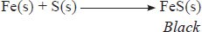
- Hot powdered copper similarly combines with heated sulphur forming copper(I) sulphide.
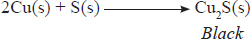
- Sulphur also combines with some non-metals such as carbon and hydrogen forming non-metallic sulphides.
Carbon combines with sulphur at high temperatures to form carbon(IV) sulphide. Hydrogen combines with sulphur to form hydrogen sulphide.
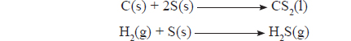

Reaction of sulphur with concentrated acids
Sulphur is easily oxidised by both concentrated nitric(V) and sulphuric(VI) acids.
- When warmed with concentrated nitric(V) acid, sulphur is oxidised to sulphuric(VI) acid. The sulphate () ion in the acid forms a white precipitate with barium ions in the solution. The nitric(V) acid itself is reduced to red brown nitrogen(IV) oxide and water.
S(s) + 6HNO₃(aq) H₂SO₄(aq) + 6NO₂(g) + 2H₂O(l)
- Concentrated sulphuric(VI) acid oxidises sulphur to sulphur(IV) oxide while the acid is reduced to sulphur(IV) oxide, and water.
S(s) + 2H₂SO,(l) 3SO₂(g) + 2H₂O(l)
Concentrated hydrochloric acid does not react with sulphur because it is not an oxidising agent.

Uses of Sulphur
• Manufacture of sulphuric(VI) acid.
• As a fungicide.
• In the manufacture of bleaching agent used to bleach wood pulp in the paper industry.
• Vulcanisation (hardening) of rubber.
• Used in smaller quantities in the manufacture of dyes, and fireworks..

The Compounds of Sulphur
Sulphur forms several compounds. The common compounds include the oxides, sulphuric acid and hydrogen sulphide

Oxides of Sulphur
Sulphur forms two oxides namely sulphur(IV) oxide, SO₂, and sulphur(VI) oxide SO₃.

Sulphur(IV) Oxide, SO₂

Laboratory preparation of sulphur (IV) oxide.
Sulphur(IV) oxide is prepared in the laboratory by the action of dilute hydrochloric acid on a suitable sulphite such as sodium sulphite.
Na₂SO₃(s) + 2HCl(aq) SO₂(g) + 2NaCl(aq) + H₂O(l)
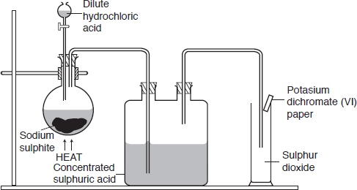
The gas may also be prepared by the action of concentrated sulphuric(VI) acid on copper turnings. The reaction should be carried out in a fume cupboard.
Cu(s) + 2H₂SO₄(aq) SO₂(g) + 2H₂O(l) + CuSO₄(aq)
Sulphur(IV) oxide is dried by passing it through concentrated sulphuric(IV) acid and collected by downward delivery. The gas jar is confirmed to be full of the gas when the paper soaked in orange potassium chromate(VI) turns green.

Physical Properties of Sulphur(IV) Oxide
Sulphur(IV) oxide is a colourless poisonous gas with a characteristic irritating, and choking smell.
It has a boiling point of –10°C and is readily liquefied under pressure.
Discussion Questions
- Give a reason why sulphur(IV) oxide is collected by downward delivery.
It is denser than air, hence can be collected by downward delivery.
- Explain the observation made when a test-tube full of sulphur(IV) oxide is inverted in a trough of water.
When a test-tube full of the gas is inverted in a trough of water, the water level rises rapidly inside the test-tube. This shows that the gas is soluble in water.
3. Explain the observation made when:
(a) A damp litmus paper was dropped into a test-tube containing sulphur(IV) oxide gas.
When a moist blue litmus paper is dropped into a test-tube containing sulphur(IV) oxide, it turns red showing that the gas is acidic. The gas has no effect on dry litmus. The solution of the gas in water is sulphuric(IV) acid. This is a weak dibasic acid.
SO₂(g) + H₂O(l) H₂SO₃(aq)
The acid is responsible for the change in colour of the moist litmus.
  - Sodium hydroxide solution is added to sulphur(IV) oxide.
When sodium hydroxide solution is added to sulphur(IV) oxide gas, neutralisation occurs. The sulphuric(IV) acid formed reacts with sodium hydroxide forming a salt and water. During the reaction between the acid and sodium hydroxide, two types of salts are formed, a normal and an acid salt.
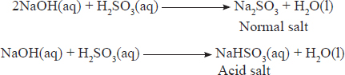

Chemical Properties of Sulphur (IV) Oxide

Bleaching Action of Sulphur(IV) Oxide
Sulphur(IV) Oxide is a bleaching agent. It bleaches by reduction. This property is applied in paper industries to bleach paper.
Discussion Questions
- State and explain what is observed when coloured flowers are dropped in a gas jar containing Sulphur (IV) oxide.
When coloured flowers are dropped into a gas jar containing sulphur(VI) oxide, the flowers are bleached. Sulphur(IV) oxide combines first with the moisture, forming sulphuric(IV) acid. The sulphuric(IV) acid then combines with oxygen from the dye to form sulphuric(VI) acid. When the dye loses oxygen it becomes colourless. In this reaction, the dye undergoes reduction while the sulphuric(IV) acid is oxidised.
SO₂(g) + H₂O(l) H₂SO₃(aq)
H₂SO₃(aq) + Dye H₂SO₄(aq) + Colourless material.
- Give a reason why newsprint paper turns brown after some time.
During the manufacture of paper, reducing agents such as sulphuric(IV) acid are used to bleach the materials. When such paper is exposed to the atmosphere in the presence of sunlight, the oxygen removed during bleaching is restored. This explains why newsprint paper turns brown after sometime.

Reducing Action of Sulphur(IV) Oxide
Sulphur(IV) oxide is a strong reducing agent. The reducing property is only displayed when the gas is in aqueous state.
Discussion Questions
1. Explain the observations made when sulphur(IV) oxide gas is reacted with:
(i) Acidified potassium chromate(VI) solution.
Acidified potassium dichromate(VI) turns from orange to green when reacted with sulphur(IV) oxide. The chromium(VI) ion in the dichromate () is reduced to chromium(III) ion.
This is a test for Sulphur (IV) Oxide

(ii) Acidified potassium manganate(VII) solution
The colour of acidified potassium manganate(VII) turns from purple to colourless when reacted with sulphur(IV) oxide. This is because the manganese(VII) ion in the manganate ion () is reduced to manganese(II) ion.
(iii) Acidified bromine water followed by a few drops of barium chloride solution.
Red brown acidified bromine water is decolourised when reacted with sulphur(IV) oxide. The bromine water is reduced to hydrobromic acid as the sulphur(IV) oxide is oxidised to sulphate.
2. Explain the observations made when:
(i) Concentrated nitric(V) acid is added to a test-tube full of sulphur(IV) oxide, followed by barium chloride solution.
When concentrated nitric(V) acid is added to a test-tube containing sulphur(IV) oxide gas brown fumes of nitrogen(IV) oxide are given off.
The nitric(V) acid is reduced to nitrogen(IV) oxide while the sulphuric(IV) acid is oxidised to sulphuric(VI) acid. When a solution of barium chloride is added to the mixture, a white precipitate of barium sulphate is formed indicating the presence of sulphate, ions.
(ii) Sulphur(IV) oxide is reacted with a hot solution of iron(II) chloride.
When warm iron(III) chloride solution is added to sulphur(IV) oxide the yellow colour changes to green. Sulphur(IV) oxide reduces yellow iron(III) ions, Fe³⁺(aq) to pale green iron(II), Fe²⁺(aq) ions.
(iii) Sulphur (IV) Oxide is reacted with hydrogen peroxide
Similarly, hydrogen peroxide is reduced to water.
(Iv) A burning splint is lowered into a gas jar containing Sulphur (IV) oxide.
When a burning splint is lowered into a test-tube containing sulphur(IV) oxide, it is put off showing that the gas does not support combustion or burn. However, in the presence of a catalyst, the gas is oxidised to sulphur(VI) oxide.

Oxidising Action of Sulphur(IV) Oxide
Sulphur (IV) Oxide also acts as an Oxidising agent. It oxidises burning magnesium to magnesium oxide and hydrogen sulphide to Sulphur.
Discussion Questions
Explain the observations made when burning magnesium is lowered into a gas jar of sulphur(IV) oxide.
When burning magnesium is lowered into a gas jar of sulphur(IV) oxide, it continues to burn for some time. White fumes of magnesium oxide, and yellow specks of sulphur are formed.
Burning magnesium continues to burn in sulphur(IV) oxide because the heat produced by the burning magnesium decomposes the sulphur(IV) oxide to sulphur and oxygen. The magnesium combines with the oxygen to form magnesium oxide.
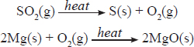
In this reaction, sulphur(IV) oxide is an oxidising agent, supplying oxygen to magnesium.
Explain the observations made when a gas jar of dry hydrogen sulphide gas is inverted over a test-tube containing Sulphur(IV) Oxide and a few drops of water added.
When a gas jar of dry hydrogen sulphide gas is inverted over a test-tube containing dry sulphur(IV) oxide, there is no observable change. When a few drops of water are added into each gas jar and the mixture is shaken, a yellow deposit of sulphur is produced.
2H₂S(g) + SO₂(g) 3S(s) + 2H₂O(l)
The reaction only takes place when the gases are moist. Sulphur(IV) oxide acts as an oxidising agent.

Sulphur (VI) Oxide, SO₃

Preparation of Sulphur (VI) Oxide (SO₃)
In the laboratory, sulphur(VI) oxide is prepared by reacting sulphur(IV) oxide with oxygen in the presence of a platinum catalyst..
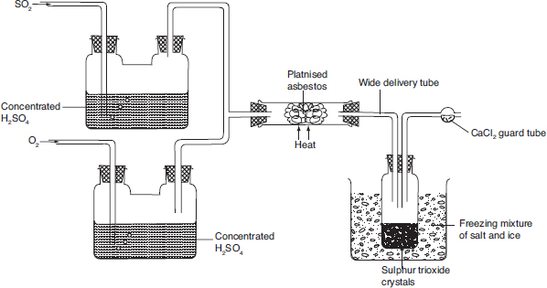
Lab Preparation of Sulphur Trioxide, SO₃

Equation for the reaction taking place,
2SO₂(g)+ O₂(g) 2SO₃(s)
Other Methods
Decomposing of sodium hydrogen sulphate.
Discussion Questions
1. State the purpose of the following in the set up.
(a) Concentrated sulphuric(VI) acid.
Sulphur(IV) oxide and oxygen gases are dried by passing them through concentrated sulphuric(VI) acid
(b) Freezing salt ice mixture.
The sulphur(VI) oxide is cooled by the freezing salt-ice mixture and it solidifies.
(c) Anhydrous calcium chloride.
Since sulphur(VI) oxide is deliquescent, calcium chloride is used to keep it free from moisture
- Write an equation for the reaction that takes place in the combustion tube.
2SO₂(g)+ O₂(g) 2SO₃(s)
- Comment on the method of collection of sulphur(VI) oxide.
The sulphur(VI) oxide is cooled by the freezing salt-ice mixture and it solidifes. This allows it to be collected as illustrated.

Test for Sulphate and Sulphite ions.
The addition of barium chloride on sodium sulphate and sodium sulphite is used to test for sulphate and sulphite ions.
Test
To 2 cm³ of sodium sulphate in a test-tube:
(i) Add 2 cm³ of barium chloride(or nitrate) solution.
(ii) To the mixture in(i) above add 2 cm³ of dilute hydrochloric acid (or dilute nitric(V) acid).
Repeat procedure (i) and (ii) using 2 cm³ solution of sodium sulphite.
Discussion Questions
1. State the observations made when barium chloride solution is added to:
(a) Sodium sulphate solution and barium sulphite solutions.
When barium chloride solution is added to sodium sulphate and sodium sulphite solutions, a white precipitate is formed in each case. The white precipitates are barium sulphate and barium sulphite respectively.
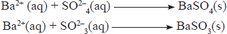
2. Why is the acid added to the mixture?
The acid is added to distinguish between the sulphate and sulphite ions.
When dilute hydrochloric acid is added to the mixture containing barium sulphate precipitate, the precipitate does not dissolve.
However, when dilute hydrochloric acid is added to the mixture containing barium sulphite precipitate, the precipitate dissolves. This is the test for sulphite ions.
BaSO₃(s) + 2HCl(aq) BaCl₂(aq) + SO₂(g) + H₂O(l)
BaSO₃(s) + 2H⁺(aq) Ba²⁺(aq) + SO₂(g) + H₂O(l)

Uses of Sulphur(VI) Oxide
Sulphur(VI) oxide is used:
• As a major raw material in the large scale manufacture of sulphuric(VI) acid.
• To make calcium hydrogen sulphite, Ca(HSO₃)_{2,} used to bleach wood pulp in the manufacture of paper.
• As a fumigant.
• As a preservative in jam and fruit juices.

Sulphuric (VI) acid

Large Scale Manufacture of Sulphuric(VI) Acid
Sulphuric(IV) acid is manufactured by the contact process shown below.
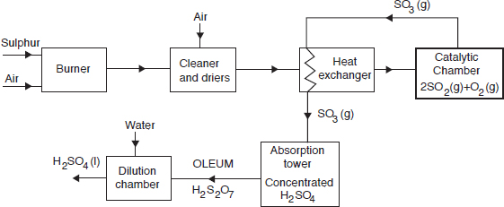
The raw materials for its manufacture are sulphur(IV) oxide and air.
Sulphides or sulphur are burnt in air to produce sulphur(IV) oxide.
- Burning of sulphur is the most convenient method of producing sulphur(IV) oxide.
S(s) + O₂(g) SO₂(g)
The sulphur(IV) oxide contains dust particles as impurities.
- The impurities reduce the surface area of the catalyst, thus impairing its efficiency. These impurities are said to poison the catalyst.
- The dust impurities are removed by electrostatic precipitation.
The mixture of gases is passed through concentrated sulphuric(VI) acid in order to dry it.
After purification, the gaseous mixture is pre-heated in the heat exchanger to attain suitable reaction temperature before being passed into the catalytic chamber.
In the catalytic chamber, sulphur(IV) oxide and oxygen react to form sulphur(VI) oxide.
Either platinum or vanadium(V) oxide may be used as catalyst.
- However, the vanadium(V) oxide(V₂O₅) is preferred because it is cheaper and less easily poisoned.
For maximum yield of sulphur(VI) oxide in the contact process, low temperature and high pressure are necessary.
- However, at low temperature the reaction is slow while high pressure is expensive to maintain. A temperature of 450°C and pressure of 2 to 3 atmospheres are used and are referred to as optimum conditions.
The sulphur(VI) oxide is not dissolved directly in water because the excessive heat generated could boil the acid to produce a mist of fine droplets of sulphuric(VI) acid in air. Hence, the gas is dissolved in concentrated sulphuric(VI) acid to form oleum (H₂S₂O₇).
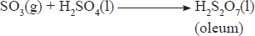
- Sulphuric(VI) acid is obtained by diluting oleum with water.
H₂S₂O₇(1) + H₂O(l) 2H₂SO₄(l)
During the contact process, not all the sulphur(IV) oxide is converted into sulphur (VI) oxide: only 98% conversion of sulphur(IV) oxide to sulphur(VI) oxide occurs.
- Sulphur(IV) oxide is a pollutant, passing the exhaust gases through chimneys lined with calcium hydroxide reduces the amount of sulphur(IV) oxide released to the atmosphere. This is referred to as scrubbing the gas.
Ca(OH)₂(aq) + SO₂(g) CaSO₃(s) + H₂O(l)
- In some industries, filters fitted with strong alkalis are installed to remove any traces of acid or mist from exhaust gases.

Properties of Sulphuric(VI) acid
Concentrated sulphuric(VI) acid is a colourless oily liquid.
It has a density of 1.84 g/cm³ and boils at 338°C.
It is very soluble in water. It dissolves with evolution of heat (exothermic reaction)
Concentrated sulphuric(VI) acid is hygroscopic. This property makes the acid a suitable drying agent for gases which do not react with it. The acid readily removes water from hydrated salts.
Concentrated sulphuric(VI) acid is a strong dehydrating agent.
A dehydrating agent is a substance which is capable of removing chemically combined water or the elements of water from a compound.
The process of removing water or its elements from a compound is called dehydration.
The acid dehydrates alcohols to to alkenes, methanoic acid to carbon(II) oxide and sugar to carbon. The sugar crystals are charred to a black mass when concentrated sulphuric (VI) acid is added to it.
Hot concentrated sulphuric(VI) acid is a strong oxidising agent. It oxidises metals such as copper and non metals such as carbon and sulphur.
It is also a less volatile acid and displaces more volatile acids from their salts.
Discussion Questions
- Explain why the acid should be added to water and not water to acid.
If water is added to the acid, fumes are produced since the reaction is quite exothermic. For this reason, dilution of the concentrated acid should always be carried out by adding small portions of the acid slowly to a large volume of water with constant stirring.
2. Explain the observation made when concentrated sulphuric(VI) acid was added to:
(a) Copper(II) sulphate crystals.
When the acid is added to blue crystals of copper(II) sulphate pentahydrate, CuSO₄.5H₂O, a white powder of the anhydrous salt is formed.
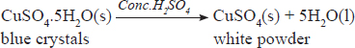
- Sugar crystals.
When concentrated sulphuric(VI) acid is added to sugar crystals, the crystals are charred to a black mass.
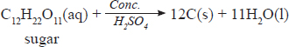
(c) Methanoic acid and ethanol
Methanoic acid is dehydrated to form carbon(II) oxide.
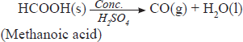
The acid also dehydrates alcohols to alkenes.
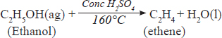
3. Explain the observations made when concentrated sulphuric(IV) acid was reacted with:
(a) Copper and zinc metals
When copper or zinc metal is added to concentrated sulphuric(IV) acid, a gas is produced which turns acidified potassium chromate(VI) solution from orange to green and decolourises acidified potassium manganate(VII) solution.
Cu(s) + 2H₂SO₄(l) CuSO₄(aq) + SO₂(g) + 2H₂O(l)
Zn(s) + 2H₂SO₄(l) ZnSO₄(aq) + SO₂(g) + 2H₂O(l)
(b) Carbon and Sulphur powder.
Hot concentrated sulphuric(VI) acid oxidises non-metals such as sulphur and carbon.
S(s) + 2H₄SO₄(l) 3SO₂(g) + 2H₂O(l)
C(s) + 2H₂SO₄(l) 2SO₂(g) + CO₂ (g) + 2H₂O(l)
4. Explain the observation made when concentrated sulphuric(VI) acid was added to Potassium nitrate crystals and Sodium chloride.
Concentrated sulphuric(IV) acid is a less volatile acid. It displaces more volatile acids from their salts.
KNO₃(s) + H₂SO₄(l) HNO₃(g) + KHSO₄(s)
NaCl(s) + H₂SO₄(l) HCl(s) + NaHSO₄(s)

Reactions of Dilute Sulphuric(VI) Acid

Reactions with metals
When dilute sulphuric(VI) acid is added to magnesium or zinc, an effervescence occurs as a colourless gas which produces a ‘pop’ sound when a burning splint is applied is produced. The reaction between magnesium and dilute sulphuric acid is more vigorous than that of zinc and dilute sulphuric(VI) acid.
Mg(s) + H₂SO₄ (aq) MgSO₄(aq) + H₂(g)
Zn(s) + H₂SO₄(aq) ZnSO₄(aq) + H₂(g)
Copper is below hydrogen in the reactivity series of the metals. It does not therefore displace hydrogen from dilute sulphuric(VI) acid.
The reactions between metals high in the reactivity series such as potassium and sodium with dilute acids are very violent and should never be attempted. The vigour of the reaction decreases as you go down the reactivity series.

Reactions with carbonates.
Effervescence occurs when dilute sulphuric(VI) acid is added to the carbonates of zinc, sodium and copper. The colourless gas produced forms a white precipitate with lime water showing that it is carbon(IV) oxide.
ZnCO₃(s) + H₂SO₄(aq) ZnSO₄(aq) + H₂O(l) + CO₂(g)
Na₂CO₃(s) + H₂SO₄(aq) Na₂SO₄(aq) + H₂O(l) + CO₂(g)
CuCO₃(s) + H₂SO₄(aq) CuSO₄(aq) + H₂O(l) + CO₂(s)
The reaction between calcium carbonate and dilute sulphuric (VI) acid stops soon after it starts. This is because the calcium sulphate produced during the reaction is insoluble.
CaCO₃(s) + H₂SO₄(aq) CaSO₄(s) + H₂O(l) + CO₂(g)
The insoluble calcium sulphate forms a coating on the sulphate calcium preventing further contact with the acid. As a result the reaction stops. Lead(II) carbonate behaves in a similar manner.

Reaction with metal oxides and hydroxides
When dilute sulphuric(VI) acid reacts with a metal oxide or hydroxide, a salt and water are formed. However, those metal oxides whose sulphates are insoluble react only for a short while.
Thus, the reaction between dilute sulphuric(VI) acid, and lead(II) oxide stops almost immediately. This is due to the formation of an insoluble layer of lead(II) sulphate which effectively prevents further contact between the acid and the oxide.
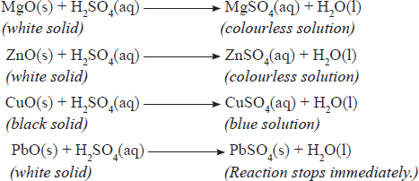
2NaOH(aq) + H₂SO₄(aq) Na₂SO₄(aq) + 2H₂O(l)

Uses of Sulphuric(VI) acid
1. Manufacture of fertilisers.
2. Processing of metal ores.
3. Manufacture of detergents.
4. Manufacture of plastics.
5. Manufacture of dyes and paints.
6. Used in lead acid accumulators

Hydrogen Sulphide (H₂S)
Hydrogen sulphide is a gaseous compound of sulphur which is very poisonous. It occurs naturally in some deposits mixed with natural gas.

Preparation and properties of hydrogen sulphide
The set-up below can be used to prepare hydrogen sulphide.
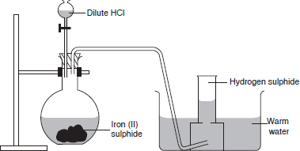
.
Hydrogen sulphide is formed when dilute hydrochloric acid is added to iron(II) sulphide.
FeS(s) + 2HCl(aq) FeCl₂(aq) + H₂S(g)
However, any metal sulphide, and dilute acid can be used to prepare hydrogen sulphide gas.
The gas is collected over warm water since it dissolves in cold water.
The gas can be dried by passing it through a U-tube packed with anyhydrous calcium chloride.
The gas cannot be dried using concentrated sulphuric(VI) acid because it would be oxidised to sulphur.
3H₂S(g) + H₂SO₄(l) 4S(s) + 4H₂O(l)

Physical properties of hydrogen sulphide
Hydrogen sulphide is a colourless gas with a characteristic smell of rotten eggs. It is very poisonous. It is slightly soluble in cold water. It is denser than air.

Chemical properties of hydrogen sulphide

(a) Reaction with water
Hydrogen sulphide dissolves in water to form a weak acidic solution of H₂S(aq).
Aqueous hydrogen sulphide is a weak dibasic acid. It forms two types of salts, the hydrogen sulphides, and the sulphides, e.g., sodium hydrogen sulphide (NaHS) and sodium sulphide (Na₂S).

(b) Reaction with Oxygen
Hydrogen sulphide burns in air with a pale blue flame. In a limited supply of air, sulphur and water are formed.
2H₂S(g) + O₂(g) 2S(s) + 2H₂O(g)
In excess air, sulphur(IV) oxide and water are formed.
2H₂S(g) + 3O₂(g) 2SO₂(g) + 2H₂O(g)

(c) Reactions of hydrogen sulphide as a reducing agent
Hydrogen sulphide is a strong reducing agent and is readily oxidised to sulphur, which is precipitated as a yellow solid. Red-brown bromine water is reduced by hydrogen sulphide forming colourless hydrogen bromide solution and a yellow precipitate of sulphur.
Br₂(aq) + H₂S(g) 2HBr(aq) + S(s)
Yellow iron(III) chloride in solution is reduced to green iron(II) chloride.
H₂S(g) + 2FeCl₃(aq) 2FeCl₂(aq) + S(s) + 2HCl(aq)
Acidified purple potassium manganate(VII) solution is reduced to a colourless manganese(II) solution.
Similarly, acidified orange chromate(VI) is reduced to green chromium(III) ions solution.
A solution of hydrogen peroxide is reduced to water, and a yellow precipitate of sulphur is formed.
H₂O₂(aq) + H₂S(g) 2H₂O(l) + S(s)
Brown fumes of nitrogen(IV) oxide are produced and pale yellow sulphur is deposited when hydrogen sulphide is bubbled into dilute nitric(V) acid.
2HNO₃(aq) + H₂S(g) 2NO₂(g) + 2H₂O(l) + S(s)
Dilute sulpharic(VI) acid is reduced to sulphur by hydrogen sulphide.
H₂SO₄(aq) + 3H₂S(g) 4S(s) + 4H₂O(T)

(d) Reaction with aqueous metallic ious
Hydrogen sulphide reacts with some metal ions in solution to form precipitates of metal sulphides. When bubbled through aqueous copper(II) sulphate, a black precipitate of copper(II) sulphide is formed.
Cu²⁺(aq) + S²⁻(aq) CuS(s)
Other metal sulphides are precipitated as shown by the following ionic equations.
Zn²⁺(aq) + S²⁻(aq) ZnS(s)
Pb²⁺(aq) + S²⁻(aq) PbS(s)
Fe²⁺(aq) + S²⁻(aq) FeS(s)
Most sulphides are insoluble in water except those of sodium, potassium and ammonium. When equal volumes of equimolar hydrogen sulphide and sodium hydroxide solutions are reacted, sodium hydrogen sulphide, an acid salt is formed.
NaOH(aq) + H₂S(aq) NaHS(aq) + H₂O(l)
When excess sodium hydroxide is used sodium sulphide, a normal salt is formed.
2NaOH(aq) + H₂S(aq) Na₂S(aq) + 2H₂O(l)

Pollution of the Atmosphere by Compounds of Sulphur
Sulphur compounds especially sulphur(IV) oxide and hydrogen sulphide, are among the major atmospheric pollutants. Sulphur(IV) oxide is usually emitted into the atmosphere when sulphur containing fuels are burnt. Some sulphur(IV) oxide is also emitted during the extraction of metals such as copper and in the manufacture of sulphuric(VI) acid. In the atmosphere sulphur(IV) oxide dissolves in water to form sulphuric(IV) acid.
SO₂(g) + H₂O(l) H₂SO₃(aq)
The sulphuric(IV) acid is then oxidised by atmospheric oxygen to sulphuric(VI) acid, which comes down as acid rain or acid fog. These have serious environmental effects. These include:
• Stunted growth in plants due to loss of chlorophyll from plants' leaves.
• Death of plants as a result of defoliation.
• Destruction of aquatic life in acidified lakes.
• Corrosion of stone work on buildings.
• Corrosion of metallic structures.
• Leaching of minerals in the soil.
• Irritation of the respiratory system

Review Exercises

- 2006 Q 6
In an experiment to study the properties of concentrated sulphuric acid, a mixture of the acid and wood charcoal was heated in a boiling tube.

- Write the equation of the reaction that took place in the boiling tube. (1 mark)

- Using oxidation numbers, show that reduction and oxidation reactions took place in the boiling tube. (2 marks)

- 2006 Q 16
When hydrogen sulphide gas was bubbled into an aqueous solution of iron (III) chloride, a yellow precipitate was deposited.

- State another observation that was made. (1 mark)

- Write an equation for the reaction that took place. (1 mark)

- What type of reaction was undergone by hydrogen by hydrogen sulphide in this reaction? (1 mark)

- 2006 Q 27 P1
Study the flow chart below and answer the questions that follow.
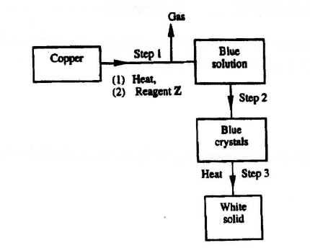

- Name reagent z. (1mark)

- Describe the process which takes place in step 2. (1mark)

- Identify the white solid. (1mark)

- 2006 Q 4 P2
- The diagram below shows some processes that take place during the industrial manufacture of sulphuric acid.
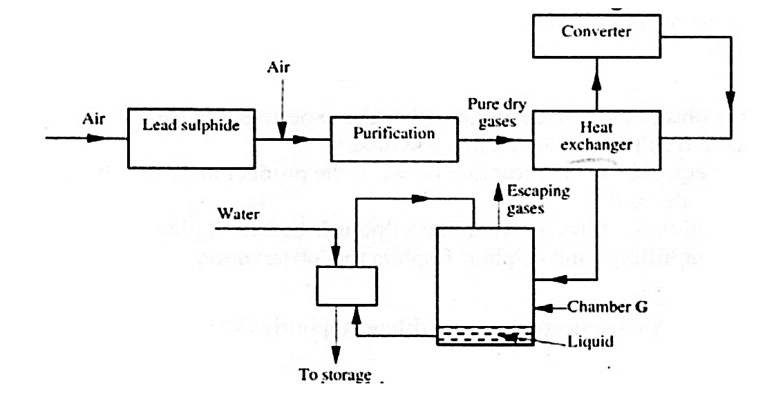

- Write the equation for the reaction in which sulphur dioxide gas is produced. (1 mark)
- Why is it necessary to keep the gases pure and dry? (1 mark)

- Describe the process that takes place in chamber G. (1 mark)

- Name the gases that escape into the environment. (1 mark)

- State and explain the harmful effect on the environment of one of the gases named in (iv) above (1 mark)

- Give one reason why it is necessary to use a pressure of 2-3 atmospheres and not more. (1 mark)

- (i) Complete the table below to show the observations made when concentrated sulphuric acid is added to the substances shown. (2 marks)
Substance | Observation
Iron fillings
Crystals of white sugar

(ii) Give reasons for the observations made using:
- iron fillings (1 mark)
- Crystals of white sugar. (1 mark)

- Name one fertilizer made from sulphuric acid. (1 mark)

- Suggest a reason why BaSO₄(a pigment made from sulphuric acid) would be suitable in making paint for cars. (1 mark)

- 2007 Q 30 P1
Below is a sketch of a graph showing the change in viscosity? (Ease of flow) with temperature when solid sulphur is heated.
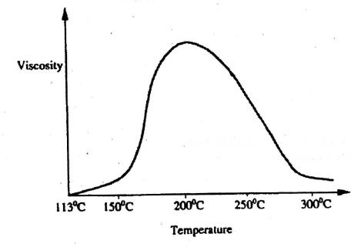
Describe what happens to the sulphur molecules when sulphur is heated from 150 °C to about 200 °C. (2 marks)

- 2008 Q 8 P1
- State the observation made at the end of the experiment when a mixture of iron powder and sulphur is heated in a test tube. (1 mark)
- Write an equation for the reaction the product in (a) above and dilute hydrochloric acid. (1 mark)
- When a mixture of iron powder and sulphur is heated, it glows more brightly than that of iron fillings and sulphur. Explain this observation. (1 mark)

- 2008 Q 9 P1
Zinc reacts with both concentrated and dilute sulphuric (VI) acid. Write equations for the two reactions. (2 marks)

- 2008 Q 30 P1
Crude oil contains sulphur. What would be the effect to the environment of using fuel containing sulphur? (1 mark)

- 2009 Q 22 P1
A student added very dilute sulphuric (VI) acid to four substance and recorded the observations shown in the table below.

Test | Substance | Gas given off
1 | Sodium | Yes
2 | Iron | No
3 | Carbon | Yes
4 | Copper | No

For which tests are the observations wrong? Explain. (3 marks)

- 2010 Q 11 P1 ,2016 Q26 P1
Hydrogen sulphide is a highly toxic and flammable gas. It is normally prepared in a fume chamber.
- Name two reagents that can be used to prepare hydrogen sulphide in the laboratory. (1 mark)
- One of the uses of hydrogen sulphide is to produce sulphur as shown in the following equation;
2H₂S(g) + SO₂(g) 3S(s) + 2H₂O(l)
Identify the reducing agent in this reaction and give a reason for your answer. (1 mark)
- Other than production of sulphuric (IV) acid, state one commercial use of sulphur. (1 mark)

- 2011 Q 17 P1
The set up below was used to prepare a gas and study some of its properties.
Study it and answer the questions that follow:
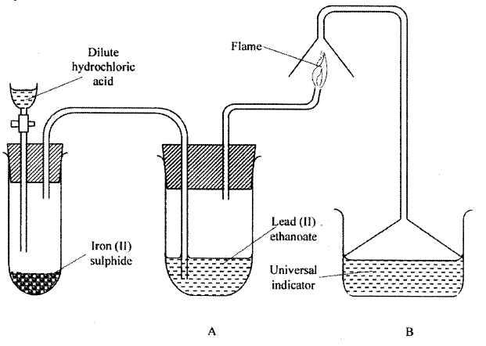
- State and explain the observations made in the.
        - tube labelled A; (1 mark)
        - beaker labelled B. (1 mark)
- State one precaution that should be taken when carrying out this experiment. (1 mark)

- 2011 Q 1 P2
The flow chart below shows some of the processes involved in large scale production of sulphuric (VI) acid. Use it to answer the questions that follow.
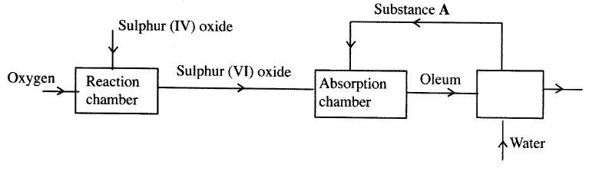
- Describe how oxygen is obtained from air on a large scale. (3 marks)

- (i) Name substance A. (1 mark)
(ii) Write an equation for the process that takes place in the absorption
chamber (1 mark)

- Vanadium (V) Oxide is a commonly used catalyst in the contact process.
- Name another catalyst which can be used for this process. (1 mark)
- Give two reasons why vanadium (V) Oxide is the commonly used catalyst. (2 marks)

- State and explain the observation made when concentrated sulphuric acid is added to crystals of copper (II) sulphate in a beaker. (2 marks)

- The reaction of concentrated sulphuric (VI) acid with sodium chloride produces hydrogen chloride gas. State the property of concentrated sulphuric (VI) acid illustrated in this reaction. (1 mark)

- Name four uses of sulphuric (VI) acid. (2 marks)

- 2012 Q18 P1
Acidified potassium manganate (VII) solution is decolourised when sulphur (IV) oxide is bubbled through it. The equation for the reaction is given below.
2H₂O (l) + 5SO₂(g) +2KMnO₄(aq K₂SO₄(aq) + 2MnSO₄(a + 2H₂SO₄(aq)

- Which reactant is oxidised? Explain. (2 marks)

- Other than the manufacture of sulphuric (VI) acid, state other use of sulphur (IV) oxide (1 mark)

- 2013 Q12 P1
- What would be observed if sulphur (IV) oxide is bubbled through acidified potassium manganate(VII)? (1 mark)

- In an experiment, sulphur (IV) oxide was dissolved in water to form solution L.
- What would be observed if a few drops of barium nitrate solution were immediately added to solution L? (1 mark)
- Write an ionic equation for the reaction that occurred between solution L and aqueous barium nitrate in (b) (i) above. (1 mark)

- 2013 Q3 P2
  - The diagram below shows the Frasch process used for extraction of sulphur. Use it to answer the question that follows.
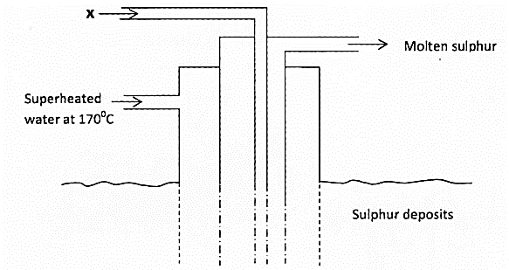
- Identify X. (1 mark)
- Why is it necessary to use superheated water in this process? (1 mark)
- State two physical properties of sulphur that makes it possible for it to be extracted by this method. (2 marks)

- The diagram below shows part of the process in the manufacture of sulphuric (VI) acid. Study it and answer the questions that follow.
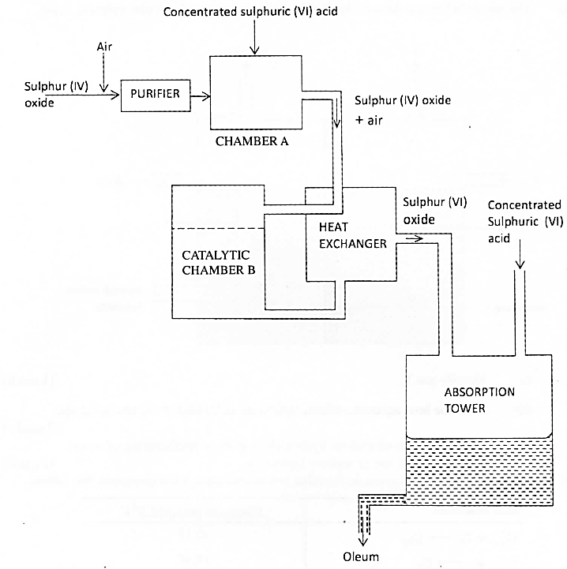

- Write an equation for the formation of sulphur (IV) oxide from sulphur. (1 mark)
- What is the role of concentrated sulphur (VI) acid in chamber A? (1 mark)
- Name two catalysts that can be used in the catalytic chamber B. (2 marks)
- State two roles of the heat exchanger. (1 mark)

- Explain one way in which sulphur (IV) oxide is a pollutant (1mark)

- What observation will be made when a few drops of concentrated sulphuric (VI) acid are added to crystals of sugar? Explain your answer. (1 mark)

- 2014 Q11 P1
Study the flow chart below and answer the questions that follow.
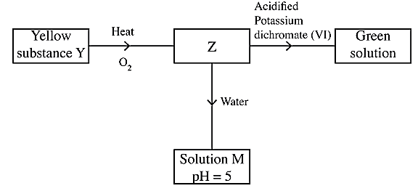
Identify Z and M. (2 marks)

- 2014 Q20 P1
In the contact process, during the production of sulphur (VI) oxide, a catalyst is used. Give two reasons why vanadium (V) oxide is preferred to platinum. (2 marks)
- 2015 Q17 P1
- One of the allotropes of sulphur is rhombic sulphur, name the other allotrope. (1 mark)
- Concentrated sulphuric (VI) acid reacts with ethanol and copper.
State the property of the acid shown in each case. (2 marks)
- Ethanol
- Copper ............................................................................................

- 2015 Q5 P2
- The set up below can be used to generate a gas without heating. This occurs when substance M reacts with solid N.
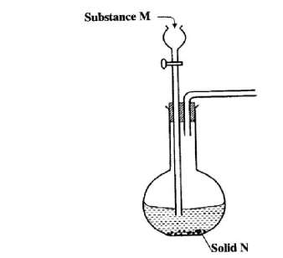

- Complete the table below giving the names of substance M and solid N if the gasses generated are chlorine and sulphur (IV) oxide. (2 marks)
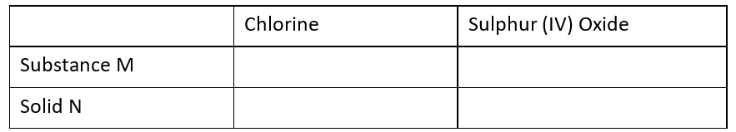
- Complete the diagram above to show how a dry sample of sulphur (IV) oxide can be collected. (2 marks)

- Describe two chemical methods that can be used to test the presence of sulphur (IV)oxide. (3 marks)
- Other than the manufacture of sulphuric (VI) acid, state two uses of sulphur (IV) oxide. (2 marks)

- 2017 P1 Q7.
A sample of water is suspected to contain sulphate ions. Describe an experiment that can be carried out to determine the presence of sulphate ions. (3 marks)

- 2017 P2 Q3 (a)
A student used Figure 2 to investigate the action of dilute sulphuric (VI) acid on some metals.
Beaker I and II contained equal volumes of dilute sulphuric (VI) acid. To beaker I, a clean iron rod was dipped and to beaker II, a clean copper rod was dipped.
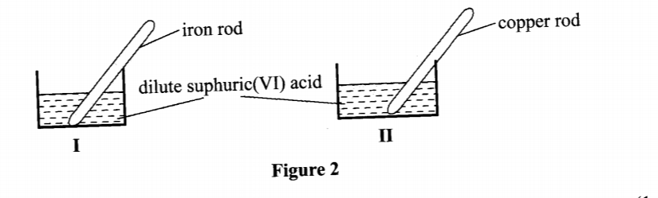
  - Why was it necessary to clean the metal rods? (1 mark)
  - Describe the observations made in each beaker.
Beaker I: (1 mark)
Beaker II: (1 mark)
  - Explain the observations in (a) (ii). (2 marks)

- 2018 P1 Q 4.
One of the allotropes of sulphur is rhombic sulphur.
- Name the other allotrope of sulphur. (1 mark)

- Draw a diagram to show the shape of the allotrope named in (a) above. (1 mark)
- Write an equation for the reaction between concentrated sulphuric(VI) acid and sulphur. (1 mark)

- 2019 P1 Q9.
Sulphur(IV) oxide is prepared in the laboratory using the set-up in Figure 3.
Study it and answer the questions that follow.
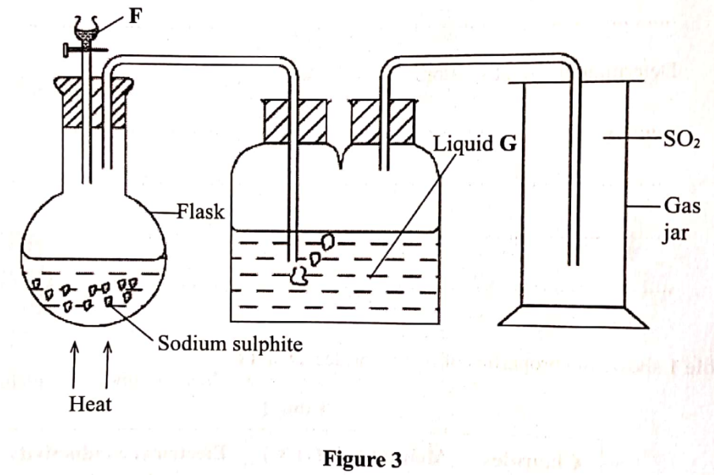
  - Identify substance F. (1 mark)
  - Write an equation for the reaction that takes place in the flask. (1 mark)
  - State the purpose of liquid G. (1 mark)

