ELECTROCHEMISTRY

Table of Contents
Organizer 📌

ELECTROCHEMISTRY 1
Redox Reactions 2
Oxidation Numbers 2
Displacement Reactions 5
The Electrochemical Cell 7
Electrochemical Half-Cell . 7
The Electrochemical Cell. 7
Standard Electrode Potentials 9
Uses of Electrochemical Cells 14
Electrolysis 16
Preferential Discharge of Ions During Electrolysis 16
Quantitative Treatment of Electrolysis 22
Applications of Electrolysis 23

Objectives
By the end of the topic the learner should be able to:
(a) Explain reduction and oxidation in terms of gain and loss of electrons.
(b) Determine changes in oxidation number to keep track of the movement of electrons in redox reactions and write balanced redox equations.
(c) Describe the electrochemical cell and explain its working in terms of electron transfer process.
(d) Draw cell diagrams using correct cell notations.
(e) Use displacement reactions to compare reducing and oxidising power of ions.
(f) Calculate the electromotive force of a cell given standard electrode potentials.
(g) State the role of water during electrolysis and explain the factors affecting preferential discharge of ions.
(h) Relate the quantity of charge passed to the amount of substance liberated at the electrodes and explain some applications of electrolysis.

ELECTROCHEMISTRY

Electrochemistry is the study of how chemical reactions produce electrical energy and in turn how electrical energy causes chemical reactions.
These chemical reactions involve transfer of electrons.

Redox Reactions
A redox reaction is one in which reduction and oxidation processes occur simultaneously. Redox reactions involve electron gain and electron loss.
Gain of electrons is a reduction process. The species that gains electrons is an oxidising agent.
Loss of electrons is an oxidation process. The species that loses electrons is a reducing agent.

The reaction between iron fillings and copper(II) sulphate solution can be used to illustrate a redox reaction. When iron filings are added to a solution of copper(II) sulphate, a brown solid which is copper metal is formed. The colour of the solution changes from blue to light-green due to the formation of iron(II) ions in the solution.
Fe(s) + Cu2+(aq) Fe2+(aq) + Cu(s)
The reaction between iron and copper(II) ions involves transfer of electrons from the iron atoms to copper(II) ions. The reaction can be used to keep track of the transfer of electrons during the reaction as illustrated by the following ionic half equations
Fe (s) Fe2+ (aq) + 2e–
Cu2+(aq) + 2e– Cu(s)
In the first half equation, iron atoms lose electrons (gets oxidized) and form iron(II) ions. Iron atoms acts as a reducing agent.
In the second half equation copper(II) ions gain electrons (gets reduced) to form copper atoms. The copper (II) ions is an oxidising agent.

Oxidation Numbers
An oxidation number is the apparent charge that an element has in a compound or the charge on an ion.
Oxidation number is written with the plus (+) or minus (–) sign in front., ie +2 or – 3.
The knowledge of oxidation numbers helps one to keep track of electron movements in redox reaction and to understand the naming of inorganic compounds.

Rules of Assigning Oxidation Numbers
- The oxidation number of an uncombined element is zero (0), e.g., in molecules, O2, Cl2, H2, the oxidation number of all the atoms is zero.
- The charge on an ion containing one element is equal to the oxidation number of that element. For example,
Ion | Na⁺ | S²⁻ | Mg2+ | N3– | O2– | H+
Oxidation number | +1 | -2 | +2 | –3 | –2 | +1
- Oxidation number of hydrogen in all compounds that contain it is + 1 except in metal hydrides where it is –1.
Compound | HCl | H2O | HF | NaH | MgH2
Oxidation number | +1 | +1 | +1 | –1 | –1
- Oxidation number of oxygen in all compounds that contain it is –2, except in peroxides where it is –1 and OF2 where it is +2.
Compound | H2O | CuO | H2O2 | OF2
Oxidation number | –2 | –2 | –1 | +2
- In compounds, the sum of the oxidation numbers of all constituent atoms is equal to zero, e.g.,
Compound | H2O | Na2O2 | NaCl
Oxidation number | 2 (+1) –2=0 | 2 (+1) + 2(–1) = 0 | (+1) + (–1) = 0
- In ions containing more than one element, the overall charge is equal to the sum of the oxidation numbers of the constituent elements.
NH4+ | OH– | SO42–
–3 + 4 (+1) = +1 | –2 + (+1) = –1 | + 6 + 4 (–2) = –2

When the oxidation number of an element in a compound or ion is not known, it is calculated from those of others by using rule 5 and 6 respectively.

Some elements have variable oxidation number. A good example is nitrogen.
Example 1
What is the oxidation number of sulphur in sulphuric acid, H2SO4?
The sum of oxidation numbers in H2SO4 = 0 (Rule 5)
2 (Oxidation number of H) + (Oxidation number of S) + 4 (Oxidation number of O) = 0
2 (+ 1) + oxidation number of S + – 8 = 0
(+ 2) + oxidation number of S + 4 (– 2) = 0
Oxidation number of S = + 6
Therefore the oxidation number of sulphur in Sulphuric(VI) acid is +6
Example 2
Determine the oxidation number of manganese in MnO4–
The sum of oxidation number in MnO4– = –1 (Rule 6)
(Oxidation number of Mn) + 4 (Oxidation number of O)=1
Oxidation number of Mn + 4 (– 2) = –1
Oxidation number of Mn + (– 8) = –1
Oxidation number of manganese = + 7
Therefore, the oxidation number of manganese in MnO4– is + 7

Species | Oxidation number | Species | Oxidation number
NO3– | + 5 | N₂O | + 1
NO2 | + 4 | N₂ | 0
NO | + 2 | NH3, NH4, Mg3N2 | – 3

Use of oxidation numbers

Naming compounds.
Oxidation numbers are used for assigning names to compounds of elements which have more than one oxidation number.
For example, copper has two oxidation numbers + 1 and + 2. Compounds containing copper with an oxidation number of +1 are referred to as copper(I) compounds. Those compounds containing copper with a oxidation number of +2 are called copper(II) compounds.
The oxidation state of an element in a compound is always denoted by a Roman number written in brackets, as shown in the table below.
Substance | Oxidation number of: | IUPAC name
CuSO₄ | Cu (+2) | Copper(II) sulphate
CuCl | Cu (+1) | Copper(I) chloride
FeS | Fe (+2) | Iron(II) sulphide
H₂SO₃ | S (+4) | Sulphuric(IV) acid
H₂SO₄ | S (+6) | Sulphuric(VI) acid
K₂Cr2O₇ | Cr (+6) | Potassium dichromate(VI)
KMnO₄ | Mn (+7) | Potassium manganate(VII)
CO | C (+2) | Carbon(II) oxide
CO₂ | C (+4) | Carbon(IV) oxide
SO₂ | S (+4) | Sulphur(IV) oxide
SO₃ | S (+6) | Sulphur(VI) oxide

Keeping track of electron movement in redox reactions.
Knowledge of oxidation number helps in determining whether a reaction is a redox one or not. It also helps in determining which substance has been oxidised or reduced.
Oxidation involves increase in oxidation number while reduction involves decrease in oxidation number.
Consider the following reaction between acidified iron(II) sulphate and hydrogen peroxide.
2FeSO4(aq) + H2O2(aq) + H2SO4(aq) 2Fe2(SO4)3(aq) + 2H2O(l)
In the reaction above, iron(II) ions are converted to iron(III) ions, thus the oxidation number of iron increases from +2 to +3. Such a change is an oxidation.
On the other hand the oxygen from the hydrogen peroxide undergoes a reduction by having its oxidation number decrease from –1 to –2 on forming the water molecules.
The above is illustrated using an ionic equation thus,
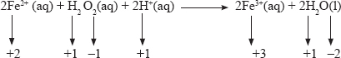

Other Examples of Redox Reactions
- Reaction of a metal and water
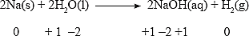
Sodium undergoes oxidation because its oxidation number increases from 0 to + 1. Hydrogen undergoes reduction since its oxidation number decreases from + 1 to 0.
- Reaction of a metal and an acid
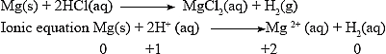
Magnesium undergoes oxidation and its oxidation number increases from 0 to + 2 while the hydrogen ion is reduced. The oxidation number of hydrogen decreases from +1 to 0.

Displacement Reactions
A displacement reaction takes place when a more reactive element takes the place of another element which is less reactive in a compound.

Reducing power of metals.
Metals higher in the reactivity series displace from solutions those metals which are lower in the series.
For example, when magnesium is reacted with copper(II) sulphate solution, a brown solid which is copper metal is formed. The colour of the solution changes from blue to colourless. This is because the blue copper (II) ions in the solution are displaced by magnesium ions which are colourless. The ionic half equations for the formation of magnesium ions and copper metal are:
Mg(s) Mg2+(aq) + 2e– (oxidation step)
Cu2+(aq) + 2e– Cu(s) (reduction step)
When the two ionic half equations are combined, the following overall ionic equation is obtained:
Mg(s) + Cu2+(aq) Mg2+(aq) + Cu(s)
The oxidation number of magnesium increases from 0 to +2 while that of copper decreases from +2 to 0. Magnesium is oxidised and Copper is reduced.
Displacement reactions are therefore redox reactions. The more reactive metal (Magnesium) is the reducing agent while copper(II) ions are the oxidising agent.
The more reactive elements such as sodium and calcium lose their electrons readily and are strong reducing agents.
The less reactive metals such as lead and copper lose electrons less readily and are weak reducing agents.
The order of reducing power is:
Potassium Strongest reducing agent
Sodium
Calcium
Magnesium
Aluminium Decreasing reducing power
Zinc
Iron
Lead
Copper
Silver Weakest reducing agent

Other Displacement Reactions
- Aluminium displaces copper from a solution of copper(II) ions.
Oxidation step; 2Al(s) 2Al3+(aq) + 6e–
Reduction step; 3Cu3+(aq) + 6e– 3Cu(s)
2Al(s) + 3Cu2+(aq) Al3+(aq) + 3Cu(s)
- Copper metal displaced from a solution by silver ions.
Oxidation step; Cu(s) Cu2+(aq) + 2e–
Reduction step; 2Ag+(aq) +2e– 2Ag(s)
Cu(s) + 2Ag+(aq) Cu2+(aq) + 2Ag(s)

Oxidizing Power of Halogens.
Halogens have a tendency to accept electrons and are therefore strong oxidising agents.
Among the halogens fluorine is the strongest oxidising agent. However, in most reactions, chlorine is the most common halogen used as an oxidising agent.
The more reactive halogens oxidises the less reactive halogens and vice versa.
For example, Chlorine displaces bromine and iodine from their solutions.
Oxidation step 2Br–(aq) Br (l) + 2 e–
Reduction step Cl2 + 2e– 2Cl–(aq)
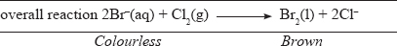
The oxidation number of bromine increases from –1 to 0 while that of chlorine decrease from 0 to –1. Bromine is oxidised while chlorine is reduced. Chlorine is the oxidising agent and the bromide ion is the reducing agent.

The ionic equation for the displacement of iodine by chlorine is:
Cl2(g) + 2I–(aq) 2Cl–(aq) + I2(s)
The oxidation number of iodine increases from –1 to 0 and that of chlorine decreases from 0 to –1. Iodine is oxidised while chlorine is reduced.

The above reactions show that chlorine has a greater tendency to accept electrons than both bromine and iodine. Chlorine takes electrons from the bromide and iodide ions forming bromine and iodine respectively.
Similarly, bromine is more reactive than iodine and takes electrons from iodide ions. Bromine has a higher tendency to accept electrons than iodine. The ionic equation for the reaction is:
Br2(l) + 2I–(aq) 2Br –(aq) + I2 (s)
The oxidation number of bromine decreases from 0 to –1 and that of iodine increases from –1 to 0.
The greater the tendency of an element to accept electrons, the higher is its oxidising power.
Among the halogens considered, chlorine is the strongest oxidising agent.
The order of oxidising power is;
Chlorine
Bromine Decreasing oxidising power
Iodine

The Electrochemical Cell
An electrochemical cell is a device that generates a potential difference between electrodes using chemical reactions.

Electrochemical Half-Cell
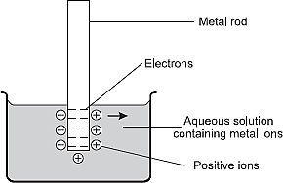
An electrochemical half-cell is formed by dipping a metal rod (electrode) in an aqueous solution of its ions, where some of its surface atoms lose electrons and go into solution as ions. The lost electrons remain on the metal surface.
Metal atoms solution Metal ions in solution
M(s) Mn+(aq) + ne–
The metal rod develops a negative charge and this attracts the ions back again, some of the ions accept electrons from the rod and form atoms once more.
Mn+ (aq) + ne– M(s)
As the negative charge on the surface of the rod builds up, the rate at which the ions combine with electrons increases until eventually it is equal to the rate at which metal atoms lose electrons to form positive ions. At this point an equilibrium is established. The equation for the equilibrium is:
Metal atoms Metal ions
M(s) Mn+(aq) + ne–
A potential difference is created between the metal rod and the positively charged ions in the solution.
The concentration of electrons on the metal rod is measured by a quantity called the electrode potential.
The half-cell can be represented as: metal | metal ion. The vertical line represents the phase boundary where a potential difference develops. For example, a zinc half-cell is represented as;
Zn(s) | Zn2+(aq)
The tendency of metals to form ions when in contact with their ions differs from one metal to another.

The Electrochemical Cell.
An electrochemical cell is obtained when the half-cells of two different metals are connected to form a complete cell so that the difference between the potential of the half cells can be measured.
The electrodes of the two half-cells are connected by metallic wires while the solutions are connected through a salt-bridge.
The salt-bridge is in the form of a filter paper soaked in a saturated solution of potassium nitrate or sodium nitrate.
The salts chosen for a salt-bridge must not react with either of the salt solutions in the half cells.
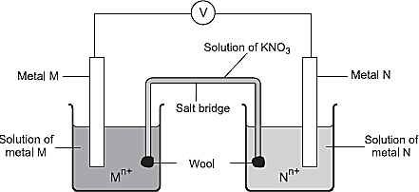
Electrons flow along the wire from the electrode with a higher concentration of electrons to the electrode with a lower concentration of electrons.
The difference between the electrode potentials of the two electrodes is called the electromotive force (e.m.f.) of the cell. The e.m.f. is measured in volts using a voltmeter.

Functions of the Salt Bridge
The functions of the salt-bridge are:
- Complete the circuit by making contact between the two solutions (electrolytes).
- Maintains balance of charges in electrolytes by providing ions to replace those ions that are used up or those that are formed.

Relative tendency of metals to Ionize.
The tendency of metals to form ions when in contact with their ions differs from one metal to another. This property can be used to obtain electrochemical cells, for example the zinc-copper electrochemical cell shown below.
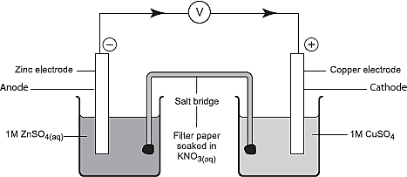
When a copper-copper ions half-cell, Cu(s) | Cu²⁺ (aq) is connected to a zinc-zinc ions half-cell, Zn(s) | Zn²⁺(aq), the following observations are made:
- The zinc rod in the zinc-zinc ions half-cell wears out.
- The intensity of the blue colour of copper(II) sulphate solution decreases and red-brown deposits appear on the copper rod in the copper-copper ions half-cell.
- A voltage of 1.10V is registered by the voltmeter.
In the Zn(s) | Zn 2+| | Cu2+| Cu(s) cell, the following equations represent what happens in the two half cells:
Zinc electrode (anode)
Zn (s) Zn2+(aq) + 2e–
Copper electrode (cathode)
Cu2+(aq) + 2e– Cu(s)
In the Zn (s) | Zn2+(aq) half-cell the oxidation number of zinc increases from 0 to +2.
In the Cu(s) | Cu2+ (aq) half-cell the oxidation number of copper decreases from +2 to 0.

The anode is defined as the electrode at which oxidation takes place while the cathode is the electrode at which reduction takes place.
Oxidation occurs at the Zn(s) | Zn2+(aq) half-cell where electrons are released.
Reduction takes place at the Cu(s) | Cu2+(aq) where electrons are gained.
These reactions show that the zinc electrode has a higher tendency to form ions than the copper electrode when the metals are placed in solutions of their ions.
The zinc electrode has a higher accumulation of electrons and is more negative compared to the copper electrode which has a lower accumulation of electrons.
Therefore, the zinc terminal is relatively more NEGATIVE with respect to the copper terminal.
When the two half cells are connected, electrons flow FROM the zinc terminal through the connecting wire TO the copper terminal.
Electrons lost by the zinc electrode are gained by the copper(II) ions.
When the two ionic half equations are combined, the ionic equation for the electrochemical cell is obtained.
Zn2+(s) + Cu(aq) Zn2+(aq) + Cu(s)
The ionic equation and the e.m.f. of the electrochemical cell can be summed up in what is called a cell notation.
Zn(s) | Zn22+(aq) | | Cu2+(aq) | Cu(s) E = + 1.10 V
The single vertical line represents phase boundaries in the half-cells while the two vertical parallel lines represent the salt-bridge.
The half-cell in which electrons are released (oxidation takes place) is always on the left– hand side of the cell diagram, i.e., Zn(s) | Zn2+(aq).

Electrons flow FROM the left hand half-cell TO the right hand half-cell.

Standard Electrode Potentials

The standard electrode potential of any element | element ions half-cell is taken as the difference between its potential and that of hydrogen | hydrogen ions half-cell.
The chosen standard electrode is hydrogen and is usually referred to as the standard hydrogen half cell. Being the reference electrode, it is assigned an electrode potential 0.00 V.
The standard conditions for measuring electrode potential are:
(i) Temperature of 25°C.
(ii) All solutions have a concentration of 1 mole per litre (1 M).
(iii) Pressure of 1 atmosphere.
Platinised platinum electrode is used as the electrode when the half-cell does not include a metal, e.g., H2(g) | H+(aq).
The platinised platinum electrode has three functions:
(i) It acts as an inert metal connection to the H | H+(aq) system.
(ii) It provides a surface area on which dissociation of hydrogen molecules can take place, i.e.,
H2(g) 2H+(aq) + 2e–
(iii) It serves as an electrical conductor to the external circuit.
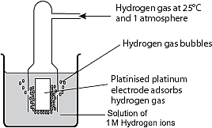
The hydrogen electrode consists of an inert platinum electrode which is immersed in a 1.0 mole per litre solution of hydrogen ions, H+ Hydrogen gas is bubbled on the platinum electrode which is dipped in a solution containing 1 M hydrogen ions.
½ H2(g) H+(aq) + e–
The standard hydrogen half-cell is presented as:
Pt(s), H2(g) | H+(aq).
While the standard electrode potential, E for this reference half-cell which is zero can be represented as:
½ H2(g) H+(aq) + e– E = 0.00 V
The standard electrode potential difference is the potential difference for a cell comprising a particular element in contact with one molar solution of its ions and the standard hydrogen electrode. It is denoted by the symbol, E^{θ}.
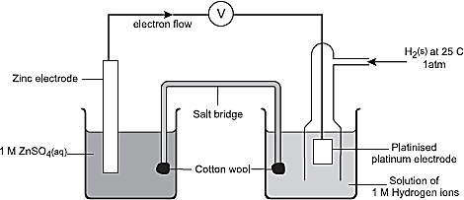
If an element has a greater tendency to lose electrons than hydrogen, the electrode potential of its half-cell is negative with respect to the hydrogen half-cell. (e.g., zinc)
The ionic half equations for the reactions occurring at the electrode are:
Zn (s) Zn2+(aq) + 2e– Eθ= 0.76 V
2H+(aq) + 2e– H2(g) Eθ = 0.00 V
The overall ionic equation is:
Zn(s) + 2H+(aq) Zn2+(aq) + H2(g) Eθ = – 0.76 V
Similarly, if a F | F–(aq) half-cell is connected with the Pt(s)H(g) | H+(aq) half-cell, the e.m.f. registered for the cell is + 2.87 V. The half-cell reaction is as follows:
F2(g) + 2e– 2F–(aq)
H2(g) 2H+(aq) + 2e–
The overall ionic equation being:
H2(g) + F2(g) 2F–(aq) + 2H+(aq) Eθ = + 2.87 V
On the other hand, if the tendency of an electrode to lose electrons is lower than the hydrogen electrode, the electrode is positive with respect to hydrogen electrode and its potential is positive, e.g., copper.
Standard electrode potentials are sometimes referred to as standard reduction potential because they relate to the reduction reactions.
The table of standard electrode potentials for some elements is arranged so that the strongest oxidising agent, fluorine, which has the most positive value for E° is at the top of the list. The weakest oxidising agent, lithium ions, Li+, with the most negative value of E° is at the bottom.
Similarly, fluoride ions is the weakest reducing agent while lithium is the strongest reducing agent.

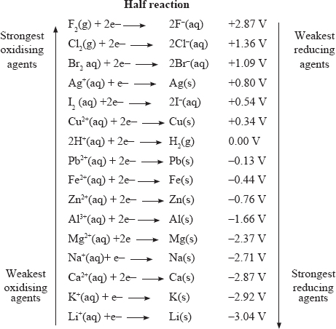

Uses of Standard Electrode Potentials
Standard electrode potentials are used in:
- Comparing the oxidising and reducing powers of substances.
- Determining the e.m.f. of a cell.
- Predicting whether or not a reaction will take place.

Comparing Oxidising and Reducing Power
Lithium with Eθ = – 3.04 V has the highest tendency to lose electrons and therefore it is the strongest reducing agent. The more negative the Eθ value the greater the reducing power. Lithium has the least tendency to accept electrons hence it is the weakest oxidising agent.

Fluorine with Eθ of + 2.87 V has the highest tendency to accept electrons and therefore the strongest oxidising agent. The more positive the Eθ value, the greater the oxidising power. Conversely, fluorine is the weakest reducing agent since it has the least tendency to lose electrons.
Using Standard Electrode Potentials to calculate the e.m.f of a Cell
The e.m.f of a cell is obtained by changing the sign of the electrode potential of the half-cell that undergoes oxidation and then adding to the electrode potential of the half-cell that undergoes reduction.
Eθcell = Ereduction – Eoxidation
Ereduction is the electrode potential of the half-cell that undergoes reduction.
Eoxidation is the electrode potential of the half-cell that undergoes oxidation.
Example 1
The reduction potentials of Mg(s) | Mg2+(aq) and Zn(s) | Zn2+(aq) half-cells are:
Mg2+(aq) + 2e– Mg(s) Eθ = – 2.37V
Zn2+(aq) + 2e– Zn(s) Eθ= – 0.76 V
Using the electrode potentials, answer the following questions.
(i) Write an ionic equation for a cell made by combining the two half cells.
(ii) Calculate the e.m.f. of the cell formed in part (i).
(iii) Write the cell notation for the cell.
Solution
- Since the electrode potential of magnesium is more negative, magnesium is the stronger reducing agent. Zinc undergoes reduction while magnesium is oxidised. The sign of the E^{θ} value of Mg changes from negative to positive.
Mg(s) Mg2+ (aq) + 2e– + 2.37 V
Zn2+ (aq) + 2e Zn(s) –0.76 V
Mg(s) + Zn2+(aq) Mg2+(aq) + Zn(s) + 1.61 V
- The e.m.f. of the cell is obtained by changing the sign of the electrode potential of magnesium and adding them, i.e. + 2.37 V + (– 0.76) = + 1.61 V.
- Mg(s) | Mg2+(aq) | | Zn2+ (aq) | Zn (s) Eθcell = + 1.61V

Example 2
Calculate the e.m.f. for the electrochemical cell represented below:
Al(s) | Al3+(aq) | | Zn 2+(aq) | Zn(s)
Given that:
Al3+(aq) + 3e– Al(s) E° = – 1.66 V
Zn2+(aq) + 2e– Zn (s) E° = –0.76 V
Solution
Al(s) Al3+(aq) + 3e– + 0.66 V
Zn2+ (aq) +2e– Zn(s) –0.76 V
To combine the two half equations, the number of electrons should be equal. To do this, we multiply the first equation by 2 and the second equation by 3. The electrode potentials remain the same. This is because the voltage does not depend on the number of electrons flowing.
2A(s) 2Al3+(aq) + 6e– + 1.66 V
3Zn2+ (aq) + 6e– 3Zn(s) –0.76 V
2Al(s) + 3Zn2+(aq) 2Al3+(aq) + 3Zn (s) + 0.90 V
Or
Eθcell = EθR.H.S – EθL.H.S
= – 0.76 V – (– 1.66 V)
= – 0.76 V + 1.66 V
= + 0.90 V
Example 3
Use the cell representation below to answer the question that follows
Cu(s) | Cu2+(aq) | | Ag+(aq) | | Ag(s) Eθcell = + 0.46 V
Given that the E value for Ag+(aq) | Ag(s) is + 0.80 V, calculate the Eθ value for Cu(s) | Cu2+(aq).
Solution
EθCell = EθR.H.S – EθL.H.S
Substituting
0.46 V = 0.180 V – EL.H.S
0.46 V – 0.80 V = –EL.H.S
– 0.34 = – EL.H.S
EθL.H.S = + 0.34 V
Example 4
Use the standard electrode potentials for elements A, B, C, D and E given below to answer the questions that follow. The letters do not represent actual symbols of elements.
 | Eθ (volts)
A2+(aq) + 2e– A(s) | –2.37
B2+(aq) + 2e– B(s) | –0.76
C+(aq) +e– ½ C2(g) | 0.00
D2+(aq) +2e D2(s) | +0.34
½ E2(g) + e– E–(aq) | + 1.36

(i) What is the Eθ value of the strongest oxidising agent? Explain.
Answer: + 1.36 most positive.
(ii) Which two of the above elements would produce the largest e.m.f or potential difference in an electrochemical cell Explain.
Answer: A and E, the elements with the most positive Eθ and the most negative Eθ.
(iii) What would be the initial potential difference of the cell chosen in(ii) above?
Answer:
E.m.f of cell = E reduction – R oxidation
= 1.36 – (–2.37)
= 1.36 V + 2.37 V
= + 3.73 V
(vi) Write the cell representation for the electrochemical cell formed.
Answer: A(s) | A2+(aq) | | E2(g) | E–(aq), Pt Eθ = 3.73 V
Using standard Electrode potential to predict it a Reduction will take place
Previously it was established that Zn reduces Cu2+

Zn(s) Zn2+(aq) + 2e | + 0.76 V
Cu2+ + 2e– Cu(s) | + 0.34 V
Zn(s) + Cu2+(aq) Zn2+(aq) + Cu(s) | + 1.10 V
The cell potential or e.m.f., + 1.10 V is positive showing the reaction takes place. The e.m.f. for the reverse reaction:
Cu(s) + Zn2+(aq) Cu2+(aq) + Zn(s) is Eθ = – 1.10 V
The negative value implies that the reaction is unlikely to occur. In general reactions with an overall positive e.m.f can take place; while those with negative: e.m.f. cannot.
Example
Predict whether a reaction will occur between iodine and chloride ions.
I2(aq) + 2e– 2I– (aq) Eθ = + 1.36 V
Cl2 (aq) 2e– 2Cl–(aq) Eθ= + 1.51 V
Solution
Adding the ionic half equations;
I2(aq) + 2e– 2I–(aq) | Eθ = + 1.36 V
2Cl(aq) Cl2(aq) + 2e | Eθ = –1.51 V
I2(aq) + 2Cl–(aq) 2I–(aq) + Cl2(g) | Eθ = –0.15 V
The overall Eθ of the cell is negative. Therefore, iodine cannot displace chlorine from a chloride solution.

Uses of Electrochemical Cells
Electrochemical cells are used as a source of energy.

Dry Cells
Dry cells are used in a wide range of electrical appliances such as radios, watches, clocks, flashlights and electric bells. The dry cells are cheap and convenient to use because they contain the electrolyte in form of a paste rather than a liquid therefore cannot spill or leak.
An example of a dry cell is the Le’ Clanche cell shown below.
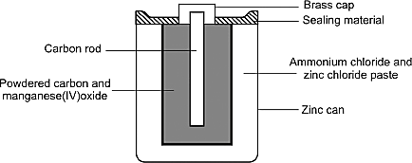
It consists of a zinc can which forms the negative terminal and a graphite rod which is the positive terminal.
The graphite rod is surrounded by a paste of ammonium chloride and zinc chloride, and powdered manganese(IV) oxide mixed with carbon. The powder increases the surface area of the positive terminal.
The function of manganese(IV) oxide is to oxidise the hydrogen produced at the electrode to water thus preventing any bubbles from coating the carbon terminal which would reduce its efficiency.
At the negative terminal:
Zn(s) Zn 2+(aq) + 2e–
At the positive terminal, ammonium ions are converted to ammonia and hydrogen gases
2NH4+(aq) + 2e– 2NH3(g) + H2(g)
The gases produced do not escape but are immediately used up in other reactions. The hydrogen is oxidised to water by the manganese(IV) oxide. Ammonia forms a complex with the zinc chloride in the paste.
A simple dry cell can produce a potential of 1.5 V.
Dry ammonium chloride does not conduct an electric current hence a paste, which is an electrolyte is used.
Such a cell is called a primary cell because once the cell is used to supply energy the chemicals are used up and therefore the cell has to be discarded (it cannot be recharged).

Some cells can be reused after being recharged. These are called secondary cells. The lead acid accumulator is the most common secondary cells.

Accumulators
The main features of a lead-acid accumulator are the lead plate which is the negative terminal and the lead (VI) oxide plate which is the positive terminal. Both of these electrodes dip into an aqueous solution of sulphuric(VI) acid.
At the negative terminal, lead atoms lose electrons to form lead(II) ions.
Pb(s) Pb2+(aq) + 2e–
At the positive terminal, lead(IV) oxide reacts with hydrogen ions in sulphuric (VI) acid forming lead(II) Ions:
PbO2(s) + 4H+(aq) + 2e– Pb2+(aq) + 2H2O(l)
The lead (II) ions formed react instantly with the sulphate ions to form lead(II) sulphate which is insoluble and adheres to the electrodes.
Pb2+(aq) + SO42–(aq) PbSO4(s)
The net reaction that takes place is:
As the battery discharges, lead and lead(IV) oxide are depleted and the concentration of sulphuric(VI) acid decreases.
Since the density of the aqueous solution depends on the concentration of sulphuric(VI) acid, measurement of its density can be used as means of telling how far the battery is discharged.
During recharging of the battery, the electrode reactions shown are reversed so as to restore its original reactants:

Fuel Cells
Fuel cells are electrochemical cells which convert the chemical energy of a fuel directly to electrical energy such as the hydrogen oxygen cell shown below.
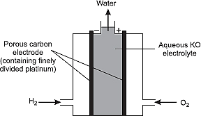
At the negative terminal, hydrogen reacts with hydroxide ions to form water and electrons are released.
2H2(g) + 4OH–(aq) 4H2O(l) + 4e–
At the positive terminal, oxygen and water acquire electrons to form hydroxide ions.
O2(g) + H2O(l) + 4 e–(aq) 4OH(aq)
The overall reaction in the hydrogen | oxygen cell is
2H2(g) + O2(g) 2H2O(l)
The cell goes on producing electricity as long as hydrogen and oxygen are fed into it, so that it does not become exhausted like a primary cell.
The fuel cell unlike a secondary cell does not store energy.
The electrode, other than completing the circuit also catalyses the reactions which increase the output of the cell.

Electrolysis
Electrolysis is the process in which electrical energy is used to cause non-spontaneous chemical reactions to occur.
In these reactions, the substance undergoes chemical decomposition.

Preferential Discharge of Ions During Electrolysis
In the aqueous solution, there are more than two ions since water also ionises. During electrolysis, only one of the anions and one of the cations can be discharged. Preferential discharge therefore takes place, according to the factors discussed below.

Factors Affecting Preferential Discharge During Electrolysis
1. The concentration of the electrolyte
A cation or anion whose concentration is high is preferentially discharged if the ions are close in the electrochemical series.
2. The product obtained at the electrode depends on the nature of electrode used.
3. Position in the Electrochemical Series
The ease of reduction of cations and oxidation anions depends on their position in the electrochemical series. The cations high in the series require more energy to be reduced. Anions high in the series require more energy to be oxidised.
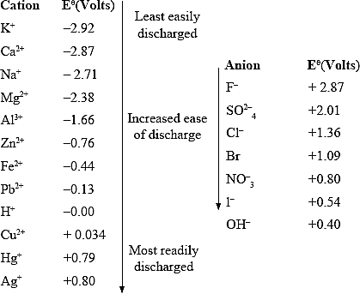

1. Electrolysis of dilute sodium chloride
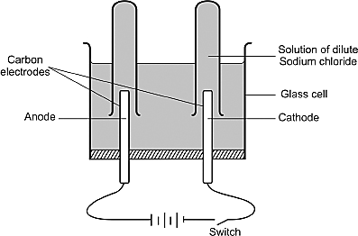
Sodium chloride solution contains sodium ions (Na+) and chloride ions (Cl–) from sodium chloride, hydrogen ions (H+) and hydroxide ions (OH–) from water.
When an electric current is passed through the solution, chloride ions (Cl–) and hydroxide ions (OH–) migrate to the anode.
Hydroxide ions (Eθ= + 0.04 V) have a greater tendency to lose electrons compared to the chloride ions. (Eθ= +1.36 V).
Reaction at Anode
4OH–(aq) 4OH(aq) + 4e–
The anion with a low Eθ value is preferentially discharged.

4OH(aq) 2H2O(l) + O2(g)
Overall;
4OH–(aq) 2H2O(l) + O2(g) + 4e–
Sodium ions (Na+) and hydrogen ions (H+) migrate to the cathode but hydrogen ions (Eθ= 0.00 volts) are preferentially discharged because they have a greater tendency to gain electrons than sodium ions (Eθ = –2.71 volts).

Reactions at Cathode
The cations with a higher Eθ has a higher tendency to gain electrons.
4H+(aq) +4e 4H(aq)
4H(aq) 2H2(g)
Overall;
4H+(aq) + 4e– 2H2(g)
Electrolysis of dilute sodium chloride evolves oxygen gas at the anode and hydrogen gas at the cathode. This is essentially the electrolysis of water since oxygen and hydrogen are the constituents of water.

2. Electrolysis of concentrated sodium chloride solution (Brine)
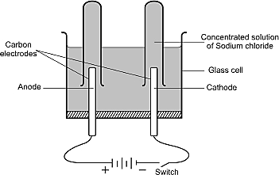
Brine is concentrated sodium chloride solution. The solution therefore contains the same ions as dilute sodium chloride.
When an electric current is passed through brine, chloride ions (Cl–) and hydroxide ions
(OH–) migrate to the anode. The chloride ions (Eθ = + 1.36 volts) are preferentially discharged because of their relatively high concentrations.

Reaction at Anode
2Cl–(aq) 2Cl(g) + 2e–
2Cl(g) Cl2(g)
Overall;
2Cl–(aq) Cl2 (g) + 2e–
Sodium ions (Na+) and hydrogen ions (H+) migrate to the cathode.
At the cathodes, sodium ions are not preferentially discharged in spite of their high concentration. This is because the tendency of hydrogen ions (Eθ = 0.000 volts) to gain electrons is much higher than that of sodium ions(Eθ = –2.71 volts).
Therefore, hydrogen ions are preferentially discharged.
Reactions at Cathode
2H+(aq) + 2e– 2H(g)
2H(g) H2(g)
Overall;
2H+(aq) +2e– H2(g)
The discharge of hydrogen ions leads to an increase in hydroxide (OH–) ions concentration and the solution becomes alkaline.
As the electrolysis process continues, the concentration of chloride ions decreases and eventually hydroxide ions are oxidised to water and oxygen gas.

3. Electrolysis of dilute sulphuric (VI) acid.
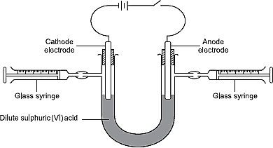
Dilute sulphuric(VI) acid contains sulphate (SO42–), hydroxide (OH–) and hydrogen (H+) ions.
When an electric current is passed through the dilute acid, sulphate and hydroxide ions migrate to the anode while the hydrogen ions migrate to the cathode.
Reaction at anode
The hydroxide ions(Eθ = + 0.40 volts) are preferentially discharged because they have a greater tendency to lose electrons than sulphate ions (Eθ = + 2.01 volts).
4OH–(aq) 4OH(aq) + e–
4OH(aq) 2H2O(l) + O2(g)
Overall;
4OH–(aq) 2H2O(l) + O2(g) + 4e–
Reaction at Cathode
4H+(aq) + 4e– 4H(g)
4H(g) 2H2(g)
Overall;
4H+(aq) + 4e– 2H2(g)
The four electrons lost by hydroxide ions to form one mole of oxygen molecules are gained by the four hydrogen ions to form two moles of hydrogen molecules. For every mole of oxygen gas produced at the anode two moles of hydrogen are formed at the cathode.
The volume of hydrogen is therefore twice that of oxygen.
The amount of water in the electrolyte decreases as the electrolysis process continues. This causes an increase in the concentration of the acid.

4. Electrolysis of aqueous magnesium sulphate
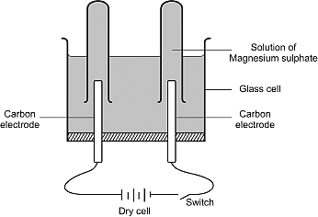
The ions present in magnesium sulphate solution are magnesium (Mg2+), sulphate (SO42–), hydrogen (H+) and hydroxide (OH–).
When an electric current is passed through the solution, hydroxide ions (Eθ = + 0.40 volts) and sulphate ions (Eθ = + 2.01 volts) migrate to the anode.
Hydroxide ions are preferentially discharged because of their greater tendency to lose electrons.
Reaction at Anode
4OH–(aq) 4OH(aq) +4e–
4OH(aq) 2H2O(l) + O2(g)
Overall;
4OH–(aq) 2H2O(l) + O2(g) + 4e
Both magnesium (Eθ = –2.38 volts) and hydrogen ions (Eθ = 0.00 volts) migrate to the cathode.
Hydrogen ions are preferentially discharged because of their greater tendency to gain electrons.
Reactions at Cathode
4H+(aq) +4e– 4H(g)
4H(g) 2H2(g)
Overall;
4H+ (aq) + 4e– 2H2(g)
It is observed that the volume of oxygen gas produced at the anode and hydrogen gas at the cathode are in the ratios of 1:2 respectively.

5. Electrolysis of copper(II) sulphate solution using different electrodes.
  - Using inert electrodes (carbon or platinum)
Copper(II) sulphate solution contains copper(II) (Cu2+), Sulphate (SO42–), hydrogen ions (H+), and hydroxide (OH–) ions.
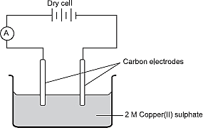
When the solution is electrolysed using carbon or platinum electrodes, sulphate ions (Eθ = + 2.01 volts) and hydroxide ions (Eθ= 0.20 volts) migrate to the anode while the copper(II) (Eθ= +0.34 volts) and hydrogen ions (Eθ = 0.00 volts) migrate to the cathode.
Reactions at Anode
The hydroxide ions have a greater tendency to lose electrons and therefore are preferentially discharged.
4OH–(aq) 4OH(aq) + 4e–
4OH(aq) 2H2O(l) + O2(g)
Overall;
4OH (aq) 2H2O(l) + O2(g) + 4e–
Reactions at Cathode
The copper(II) ions have greater tendency to gain electrons that the hydrogen ions and is therefore preferentially discharged. The atoms are deposited on the cathode as red-brown coating.
As a result, the mass of the cathode increases while that of the anode remains the same.
Cu2+(aq) + 2e Cu(s)
The concentration of copper(II) ions in solution decreases and the blue colour of the copper(II) sulphate solution becomes pale and finally colourless.
Hydrogen ions accumulate in the solutions and therefore the solution becomes acidic.
(b) Using copper electrodes
When copper electrodes are used in the electrolysis of copper(II) sulphate solution, the mass of the anode decreases, while that of the cathode increases.
Sulphate and hydroxide ions migrate to the anode, but none of them is discharged; instead the copper anode is gradually oxidised and goes into solution.
Cu(s) Cu2+(aq) + 2e
This explains the loss in mass of the anode. Less energy is needed for the copper anode to lose electrons than hydroxide ions.
Hydrogen and copper(II) ions migrate to the cathode where copper(II) ions are preferentially discharged because they have greater tendency to accept electrons.
Cu2+(aq) + 2e Cu(s)
The cathode is thus coated with a red-brown deposit of copper metal.
The amount of copper oxidised at the anode is equal to the amount of copper deposited on the cathode and therefore the concentration of copper(II) ions in the solution remains the same. The colour of the blue solution does not fade.
Carbon or platinum electrodes allow passage of an electric current into and out of the electrolyte without wearing out such electrodes.

Summary of Electrolysis
1. Electrolyte: dilute sodium chloride
Ions Present
Cations | Anions
Sodium, Na⁺(aq) and hydrogen H⁺(aq) ions.  Hydrogen, H⁺(aq) ions discharged at the cathode, because sodium is above hydrogen in electro-chemical series.  Hydrogen gas evolved. | Chloride Cl–(aq) and hydroxide OH–(aq) ions.  Hydroxide (OH–)(aq) discharged at the anode, because hydrogen ions required less energy to discharge than chloride Cl–(aq) ions.  Oxygen gas evolved.

2. Electrolyte: Brine (Concentrated Sodium chloride)
Ions Present
Cations | Anions
Sodium, Na⁺(aq) and hydrogen H⁺(aq) ions.  Hydrogen, H⁺(aq) ion discharged at the cathode, because sodium is above hydrogen in electro-chemical series.  Hydrogen gas evolved. | Chloride Cl–(aq) and hydroxide OH–(aq) ions  Hydroxide (OH–)(aq) discharged at the anode, because hydrogen ions required less energy. To discharge than chloride Cl–(aq) ions.  Chlorine gas evolved.

3. Electrolyte: dilute sulphuric acid
Ions Present
Cations | Anions
Hydrogen, H⁺(aq)  Hydrogen, H⁺(aq) ions discharged at the cathode, because no other cations are present.  Hydrogen gas evolved. | Sulphate, SO₄^{2–}(aq) and hydroxide, OH–(aq)  Hydroxide (OH–)(aq) discharged at the anode, because hydroxyl ions require less energy to discharge than sulphate ions.  Oxygen gas evolved.

4. Electrolyte: Magnesium sulphate
Ions Present
Cations | Anions
Magnesium, Mg²⁺(aq) and hydrogen, H₊ (aq) ions.  Hydrogen ions discharges at the cathode, because magnesium is above hydrogen in the electro-chemical series.  Hydrogen gas evolved. | Sulphate, SO₄^{2–} (aq) and Hydroxide OH–(aq) ions.  Hydroxide ions discharged at the anode because hydroxide ions require less energy to discharge than sulphate ions.  Oxygen gas evolved.

5. Electrolyte: Copper(II) sulphate Electrode: Carbon rods
Ions Present
Cations | Anions
Copper, Cu²⁺⁽aq) and Hydrogen H⁺(aq) ions.  Copper ions discharged at the cathode, because copper is below hydrogen in the electro-chemical series.  Colour of solution eventually fades. | Sulphate, SO₄^{2–(}aq) and Hydroxide OH–(aq) ions.  Hydroxide ions discharged at the anode because hydroxide ions require less energy to discharged than sulphate ions.  Oxygen gas evolved.

6. Electrolyte: copper(II) sulphate Electrode: Carbon
Ions Present
Cations | Anions
Copper, Cu²⁺ (aq) and Hydrogen H⁺ (aq) ions.  Copper ions discharged at the cathode, because copper is below hydrogen in the electro-chemical series.  Colour of solution does not fades. | Sulphate, SO₄^{2–} (aq) and Hydroxide OH– (aq) ions.  No ion discharged at the anode instead the electrode dissolves, and goes into solution as copper (II) ions.

Quantitative Treatment of Electrolysis
An electric current is measured in amperes. The quantity of electric charge(Q) is measured in coulombs(C).
- A coulomb is the quantity of electricity passed when a current (I) of one ampere flows for a time(t) of one second.

The relationship between the mass of substance produced and the quantity of electricity passed is the basis of Faraday’s Law of electrolysis which states that the mass of a substance produced during electrolysis is directly proportional to the quantity of electricity passed.
The quantity of electricity carried by one mole of electrons is a constant called a Faraday (F) and is equivalent to 96,487 coulombs.

- 1 Faraday is equivalent to one mole of electrons. The number of electrons required to deposit a given ion is equivalent to the charge on the ion.

Worked Examples
- What mass of copper would be deposited on the cathode when a steady current of one ampere flows for 30 minutes through copper(II) sulphate solution?
(Cu = 63.5) Faraday constant = 96,487 C mol^{–1})
Solution
Reaction at the cathode
Cu²⁺(aq) + 2e Cu(s)
One mole of Cu ions required 2 moles of electrons.
Quantity of electricity (Q) = 1 × 30 × 60 coulombs.
1 mole of electrons carries a charge of 96,487 coulombs.
2 moles of electrons will carry 2 × 96,487 coulombs.
2 × 96,487 coulombs deposit 63.5 g of copper at the cathode.
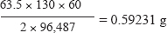
Therefore 1 × 30 × 60 coulombs deposits:

- What volume of oxygen will be liberated at the anode when a current of 3 amperes is passed through magnesium sulphate solution for 45 minutes and 30 seconds?
(Molar gas volume at r.t.p. = 24.0 litres, Faraday constant = 96,500 coulombs).
Solution
Reaction equation at the anode
4OH–(aq) 2H₂O(l) + O₂(g) + 4e
1 mole of electrons carry 96,500 coulombs.
4 moles of electrons carry 4 × 96,500 coulombs.
4 × 96,500 coulombs liberate 24 litres of oxygen.
3 × (45 × 60) +30) coulombs will liberate 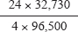
= 0.50922 litres.
- In an experiment to electrolyse copper(II) sulphate solution using copper electrodes, 0.2 amperes were passed through the solution for 1,930 seconds. The mass of copper cathode increased from 6.35 to 6.478 g. Find the charge on a copper ion. (1 Faraday = 96,500 coulombs, Cu = 64).
Solution
Mass of copper deposited = (6.478 – 6.350) g = 0.128 g
Quantity of electricity passed = 0.2 × 1,930 = 386 C
0.128 g copper was deposited by 386 C
64 g of copper would be deposited by 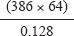 C = 193,000 C
1 mole of copper atoms (Mass 64 g) require 193,000 C
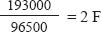
Number of Faradays required to deposit 64 g of copper at cathode is therefore

Applications of Electrolysis
Extraction of Reactive Elements
Electrolysis is used in the extraction of reactive elements such as sodium, magnesium, aluminum and chlorine.
Electroplating
This is the process of using electricity to coat one metal with another. This is done to protect some metals from corrosion. Electroplating is also done to make an article look attractive. Gold plated watches, silver utensils are common items.
Sacrificial metal (cathodic protection)
Iron or steel structures are protected from corrosion through sacrificial protection either by galvanising or cathodic protection.
Cathodic protection
Corrosion involves loss of electrons by an element to form ions. If it is a less reactive metal it is connected to a more reactive metal by a conductor when the conditions for causing corrosion are present, the more reactive metal ionises at the expenses of the less reactive. The more reactive metal is sacrificed and the method is sacrificial protection.
Galvanising
When the galvanised surface is scratched and iron is exposed, zinc passes into solution as zinc ions rather than Fe2+ ions. This is possible because zinc is easily oxidised than iron.
Purification of Metals
Copper and other less reactive metals are purified by electrolysis. The impure metal is made the anode and pure metal the cathode. The electrolyte contains the cation of the metals being purified.

Manufacture of Sodium Hydroxide and Chlorine from Electrolysis of Concentrated Sodium Chloride (Brine)
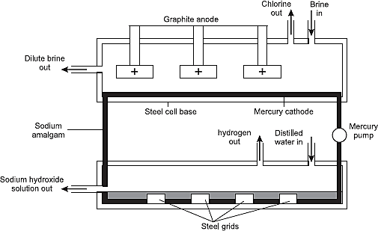
Sodium hydroxide and chlorine are manufactured by the electrolysis of brine by use of mercury cell, shown alongside.

The electrolyte in the mercury cell is a concentrated solution of sodium chloride (Brine). The anode in the cell is made of carbon or titanium because they do not react with chlorine gas. While the cathode is a moving film of mercury.

When an electric current is passed through concentrated sodium chloride solution, chloride (Cl–) ions and hydroxide (OH–) ions migrate to the anode. Chloride ions are preferentially discharged because of their relatively high concentration.
2Cl–(aq) 2Cl(g) + 2e–
2Cl(g) Cl₂(g)
Both sodium (Na+) ions and hydrogen (H+) ions migrate to the cathode (moving film of mercury). Hydrogen ions are not discharged because of the over-potential (excess power) required to discharge it. Sodium ions are preferentially discharged instead.
2Na+(aq) + 2e– 2Na(l)
The sodium atoms formed dissolve in the hot mercury to form sodium amalgam (Na Hg)
Na(l) + Hg(l) NaHg(l)
The sodium amalgam is passed through a trough in the cell that contains distilled water. The sodium in the amalgam then reacts with water to form a solution of sodium hydroxide and hydrogen gas. Hydrogen is pumped out to the required place, while mercury is regenerated and recycled.
2NaHg(l) + 2H2O(l) 2NaOH(aq) + 2Hg(l) + H2(g)
The sodium hydroxide obtained this way is about fifty per cent pure. Pure sodium hydroxide is obtained by evaporating the water in the aqueous sodium hydroxide solution to get pellets or flakes.
The process is expensive due to the high cost of mercury and the safety measures applied since mercury is poisonous.

Review Exercises
- 2006 Q 15 P1
Study the standard reduction potential given and answer the questions that follow. (The letters are not the actual symbols of the elements).
E^{θ} (volts)
M²⁺ (aq) + 2e⁻ M(s) -0.76
N²⁺ (aq) + 2e⁻ N(s) -2.37
P⁺ (aq) + e⁻ P(s) +0.80
Q²⁺ (aq) + 2e⁻ Q(s): -0.14
- The standard reduction potential for Fe ²⁺ (aq) is -0.44 volts. Select the element which would best protect iron from rusting. (1 mark)
- Calculate the E^{Ѳ} value for the cell represented as M(s)/ M²⁺ (aq) // P⁺(aq)/P(s). (2 marks)

- 2006 Q 1 P2
- What is an electrolyte? (1 mark)

- State how the following substances conduct electricity.
- Molten calcium chloride. (1 mark)
- Graphite. (1 mark)

- The diagram below shows a set up that was used to electrolyse aqueous magnesium sulphate.
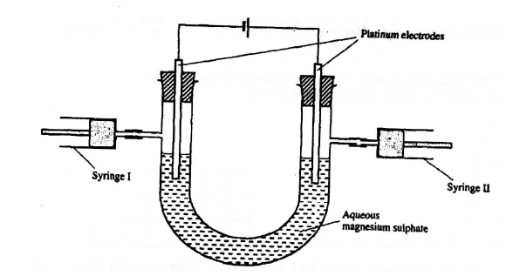
- On the diagram above, using an arrow, show the direction of flow of electrons. (1 mark)
- Identify the syringe in which hydrogen gas would be collected. Explain (1 mark)

- Explain why the concentration of magnesium sulphate was found to have increased at the end of the experiment. (2 marks)

- During the electrolysis, a current of 0.72 A was passed through the electrolyte for 15 minutes. Calculate the volume of gas produced at the anode. (1 Faraday = 96 500 coulombs; molar gas volume is 24000 cm³ at room temperature). (4 marks)

- 2006 Q 2b P2
Use the reduction potentials given below to explain why a solution containing copper ions should not be stored in a container made of zinc.
Zn²⁺ (aq) + 2e⁻ Zn(s); E^{θ} = -0.76 V
Cu²⁺ (aq) + 2e⁻ Cu(s); E^{θ} = +0.34 V
(2 marks)
- 2007 Q 7 P1
- Use the information given below to draw a labelled diagram of an electrochemical cell that can be constructed to measure the electromotive force between G and J. (2 marks)
G²⁺ (aq) + 2e⁻ G(s); E^{θ} = - 0.74 V
J²⁺ (aq) + 2e⁻ J(s); E^{θ} = -0.14 V

- Calculate the E^{θ} value for the cell constructed in (a) above. (1 mark)

- 2007 Q 21 P1
  - When brine is electrolyzed using inert electrodes, chlorine gas is liberated at the anode instead of oxygen. Explain this observation.
(2 marks)
  - Name the product formed at the cathode. (1 mark)

- 2007 Q 28 P1
During the electrolysis of aqueous silver nitrate, a current of 5.0 A was passed through the electrolysis for 3 hours.
  - Write the equation for reaction which took place at the anode. (1 mark)
  - Calculate the mass of silver deposited (Ag = 108; 1 F=96500 C) (2 marks)

- 2008 Q 19 P1
Select a letter which represents a mono atomic gas.
E^{θ} (Volts)
Zn²⁺ (aq) + 2e⁻ Zn (s) -0.76
Pb²⁺ (aq) +2e⁻ Pb (s) -0.13
Ag⁺ (aq) + 2e⁻ Ag (s) +0.80
Cu²⁺ (aq) + 2e⁻ Cu (s) +0.30

  - Write the cell representation for the electrochemical cell that would give the highest E (1 mark)
  - State and explain the observations made when a copper rod is placed in a beaker containing silver nitrate solution. (2 marks)

- 2008 Q 21
The diagram below represents an experiment that was set up to investigate movement of ions during electrolysis.
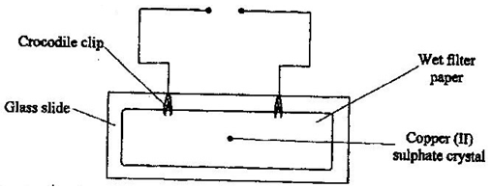
When the circuit was completed, it was noticed that a blue colour spread towards the right.
- Explain this observation (2 marks)
- Write the equation for the reaction that occurred at the anode. (1 mark)

- 2008 Q 6 P2
The diagram below represents a set up that can be used to electrolyze aqueous copper (II) sulphate.
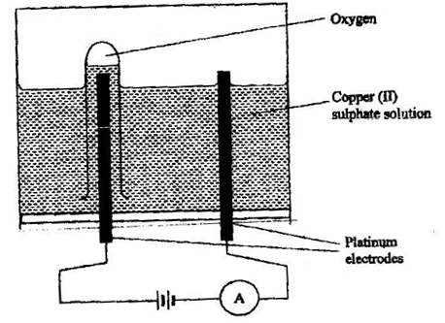
- (i) Describe how oxygen gas is produced during the electrolysis.
(2 marks)
(ii) Explain why copper electrodes are not suitable for this electrolysis. (2 marks)

- Impure copper is purified by an electrolytic process
- Name one ore from which copper is obtained (1 mark)
- Write the equation for the reaction that occur at the cathode during the purification of copper. (1 mark)
- In an experiment to electroplate a copper spoon with silver, a current of 0.5 A was passed for 18 minutes. Calculate the amount of silver deposited on the spoon (n = 96500 coulombs, Ag = 108) (3 marks)
- Give two reasons why some metals are electroplated (2 marks)

- 2009 Q 7 P1
When aluminium oxide was electrolysed, 1800kg of aluminium metal was obtained.
(a) Write an equation for the formation of aluminium metal. (1 mark)
(b) Calculate the quantity of electricity in faradays used. (Al = 27) (2 marks)
- 2009 Q 10 P1
Hydrogen and oxygen can be obtained by electrolysis of acidified water. Using equations for the reactions at the electrodes, explain why the volume of hydrogen obtained is twice that of oxygen. (2 marks)
- 2009 Q 12 P1
The standard reduction potentials of two half cells are:
Ag⁺ (aq) + e⁻ Ag(s) E^{θ} = 0.80V
2H₂O (l) + 2e⁻ H₂ (g) + 2OH⁻ (aq); E^{θ} = 0.83V
Draw a labelled diagram of an electrochemical cell that can be constructed using the two half cells. (3 marks)

- 2009 Q 3 P2
The set-up below (figure 2) was used to electrolyse a bromide of metal D, DBr₂
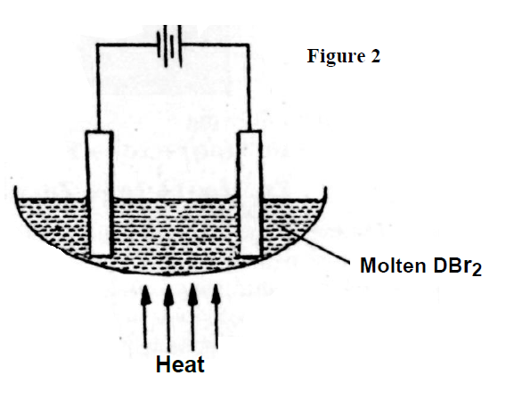
  - Write the equation for the reaction at the:
(i) Cathode (1 mark)
(ii) Anode (1 mark)

  - The electrodes used in the experiment were made of carbon and metal D which of the two electrodes was used as the anode? Give a reason. (2 marks)

  - Give a reason why this experiment is carried in a fume cupboard. (1 mark)

  - When a current of 0.4A is passed for 90 min, 2.3g of metal D were deposited.
- Describe how the amount D deposited was determined. (3marks)

- Calculate the relative atomic mass of metal D. (1 Faraday=96500 coulombs) (3marks)

- 2010 Q 7 P1
Complete the table below by writing the product formed at the electrodes during the electrolysis of the electrolytes given in the table. (3 marks)
Electrolyte | Product at anode | Product at cathode
Aqueous sodium sulphate using inert electrodes | (½mark) | (½mark)
Aqueous copper (II) sulphate using copper electrodes. | (1 mark) | (1 mark)

- 2010 Q 19 P1
The half equations involved in a cell are:
2H₂O (l) + 2e⁻ H₂ (g) + 2OH-(aq): E^{θ} = - 0.83V
O₂ (g) + 2H₂O (l) + 4e⁻ 4OH⁻(aq): E^{θ} = + 0.40V
- Write the overall equation for the electrochemical cell. (1 mark)

- Calculate the e.m.f. generated by a battery consisting of ten cells.
(1 mark)
- State one environment advantage of using these cells in spacecrafts. (1 mark)

- 2010 Q 1 P2
- Which one of the following compounds; urea, ammonia, sugar and copper (II) chloride will conduct an electric current when dissolved in water? Give reasons. (2 marks)

- The diagram below shows an electrochemical cell. Study it and answer the questions that follows.
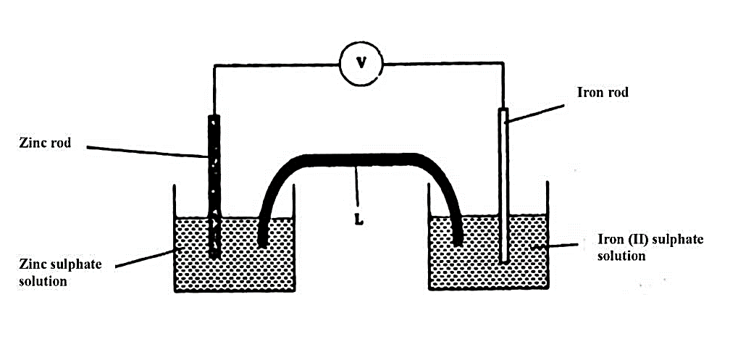
Given the following;
Fe²⁺ (aq) + 2e Fe (s); E^{θ} = - 0.44V
Zn²⁺ (aq) + 2e Zn (s); E^{θ} = - 0.76 V
- Show on the diagram using an arrow, the direction of flow of electrons (1 mark)
- Name two substances that are used to fill the part labelled L
(2 marks)
- In an experiment to electroplate iron with silver, a current of 0.5 amperes was passed through a solution of silver nitrate for one hour.
- Give two reasons why it is necessary to electroplate iron with silver. (2 marks)

- Calculate the mass of silver that was deposited on iron (Ag = 108, 1 Faraday= 96,500 coulombs) (3 marks)

- 2011 Q 12 P1, 2016 Q15 P1
Sodium hydroxide can be prepared by the following methods; I and II.
I. Sodium metal $\underset{→}{ cold water }$Sodium hydroxide + Hydrogen
II. Concentrated $\underset{→}{Process A }$Sodium hydroxide + Chlorine + Hydrogen
sodium chloride

(a) Name one precaution that needs to be taken in method I. (1 mark)

(b) Give the name of process A. (1 mark)

(c) Give one use of sodium hydroxide. (1 mark)

- 2011 Q 2 P2
The set-up below was used by a student to investigate the products formed when aqueous copper (II) chloride was electrolysed using carbon electrodes.
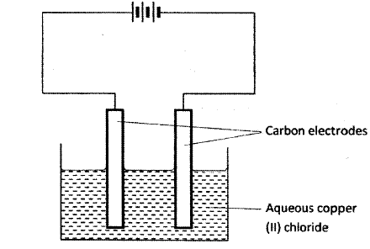
- (i) Write the equation for the reaction that takes place at the cathode. (1 mark)
- Name and describe a chemical test for the product initially formed at the anode when a highly concentrated solution of copper (II) chloride is electrolysed. (3 marks)
- How would the mass of the anode change if the carbon anode was replaced with copper metal? Explain. (2 marks)

- 0.6g of metal B were deposited when a current of 0.45A was passed through an electrolyte for 72 minutes. Determine the charge on the ion of metal B. (Relative atomic mass of B = 59, 1 Faraday = 96 500 coulombs) (3 marks)

- The electrode potentials for cadmium and zinc are given below:
Cd²⁺ (aq) + 2e⁻ $⇌$Cd(s); E^{θ} = - 0 .4V
Zn²⁺ (aq) + 2e⁻ ⇌ Zn(s); E^{θ} = -0 .76V
Explain why it is not advisable to store a solution of cadmium nitrate in a container made of zinc. (2 marks)

- 2012 Q15 P1
Below is a representation of an electrochemical cell.
Pb(s) / Pb²⁺ (aq) // Ag⁺(aq) / Ag(s)
- What does // represent? (1 mark)

- Given the following:
E^{θ} V
Pb²⁺ (aq) + 2e⁻ Pb(s); - 0.13
Ag⁺ (aq) + e⁻ Ag(s); - 0.80
Calculate the E.M.F of the electrochemical cell. (2 marks)

- 2012 Q28 P1
The apparatus shown in the diagram below were used to investigate the products formed when concentrated sodium chloride was electrolysed using inert electrodes.
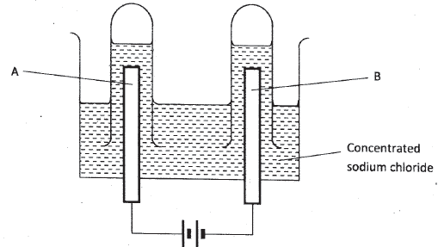
- Write the equation for the reaction that takes place at electrode A. (1 mark)

- If the concentrated sodium chloride was replaced with dilute sodium chloride, what product would be formed at electrode A? Explain. (2 marks)

- 2012 Q5 P2
    - The set up below was used to investigate the products formed at the electrodes during electrolysis of aqueous magnesium sulphate using inert electrodes. Use it to answer the questions that follow.
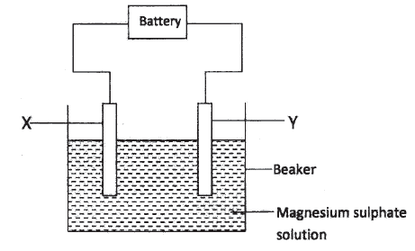
- During the electrolysis, hydrogen gas was formed at electrode Y. Identify the anode. Give a reason for your answer. (2 marks)
- Write the equation for the reaction which takes place at electrode X (1 mark)
- Why is the concentration of magnesium sulphate expected to increase during electrolysis? (2 marks)
- What will be observed if red and blue litmus papers were dipped into the solution after electrolysis? (2 marks)

    - During electrolysis of magnesium sulphate, a current of 0.3a was passed for 30 minutes. Calculate the volume of gas produced at the anode
(Molar gas volume = 24dm3; 1 faraday = 96,500C) (3 marks)
    - State two applications of electrolysis (1 mark)

- 2013 Q6 P1
- A student electroplated a spoon with copper metal. Write an equation for the process that took place at the cathode. (1 mark)

- Calculate the time in minutes required to deposit 1.184g of copper if a current of 2 amperes was used. (1 Faraday = 96500 coulombs, Cu=63.5). (2 marks)

- 2013 Q4 P2, 2016 Q4 P2.
- The set below can be used to produce sodium hydroxide by electrolyzing brine
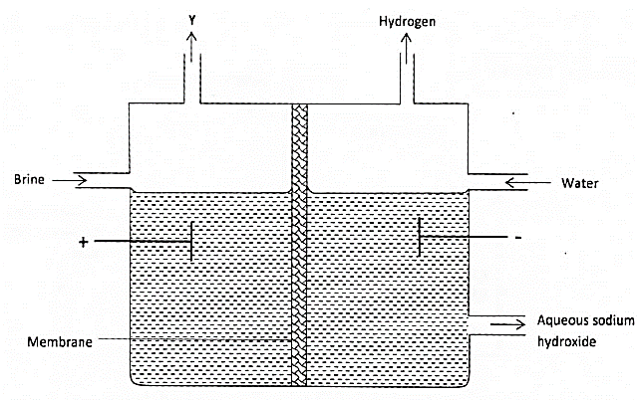
- Identify gas Y. (1 mark)
- Describe how aqueous sodium hydroxide is formed in the above set-up.
(2 marks)
- One of the uses of sodium hydroxide is in the manufacturing of soaps. State one other use of sodium hydroxide. (1 mark)

- Study the information given in the table below and answer the question that follows

Half reaction | Electrode potential E^{θ} (V)
D²⁺ (aq)+2e⁻ D (s)  E⁺ (aq)+e⁻ E (s)  F (aq) + e⁻ F⁻ aq  G²⁺(aq) +2e G(s)  H²⁺(aq) +2e⁻ H (s)  J⁺(aq) + e⁻ J(s) | -0.13  +0.80  +0.68  -2.87  +0.34  -2.71
- Construct an electrochemical cell that will produce the largest e.m.f (3 marks)
- Calculate the emf of the cell constructed in(i) above (2 marks)
- Why is it not advisable to store a solution containing E⁺ ions in a container made of H? (2 marks)

- 2014 Q24 P1
- A student electrolyzed dilute sodium chloride solution using inert carbon electrodes. Name the products at:
      - Anode:
      - Cathode: (2 marks)
- If the experiment was repeated using concentrated sodium chloride instead of dilute sodium chloride solution, write the half equation at the anode. (1 mark)

- 2015 Q11 P1
Dilute sulphuric (VI) acid was electrolysed using platinum electrodes.
Name the product formed at the anode and give a reason for your answer. (2 marks)

- 2015 Q18 P1
Study the standard electrode potentials in the table below and answer the questions that follow.
E^{θ} (volts)
Cu²⁺ (aq) + 2e⁻ Cu (s) + 0.34
Mg²⁺ (aq) + 2e⁻ Mg (s); - 2.38
Ag⁺ (aq) + e⁻ Ag (s); + 0-80
Ca²⁺ (aq) + 2e⁻ Ca (s); -2-87
- Which of the metals is the strongest reducing agent? (1 mark)
- What observations will be made if a silver coin was dropped into an aqueous solution of copper (II) sulphate? Explain. (2 marks)

- 2015 Q4 P2
- The diagram below represents a dry cell. Use it to answer the questions that follows.
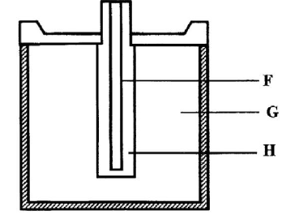
- Which of the letters represent;
- Carbon electrode? (1 mark)
- The electrolyte? (1 mark)
- One of the substances used in a dry cell is manganese (IV) oxide.
State two roles of manganese (IV) oxide in the dry cells. (2 marks)

- Below is simplified electrolytic cell used for purification of copper. Study it and answer the questions that follows.
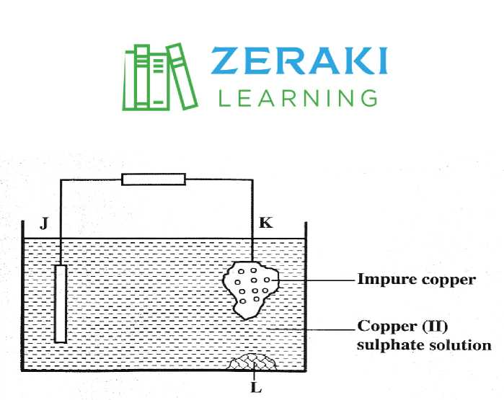
- Identify the cathode. (1 mark)
- Write the equation for the reaction at the anode. (1 mark)
- What name is given to L? (1 mark)
- A current of 0.6 A was passed Through the electrolyte for 2 hours. Determine the amount of copper deposited.
(Cu=63.5; 1 Faraday = 96,500 coulombs) (3 marks)
- State two uses of copper metal (1 mark)

- 2017 P1 Q3.
The diagram in Figure 1 shows a section of a dry cell. Study it and answer the questions that follow.
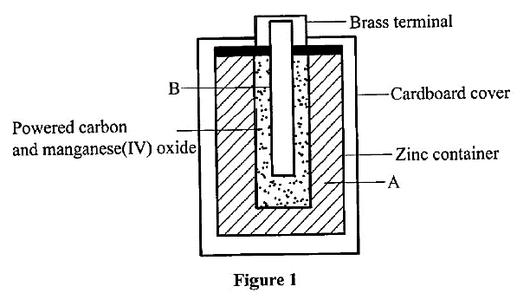
  - Name the part labelled B. (1 mark)
  - The part labelled A is a paste. Give a reason why it is not used in dry form. (1 mark)
  - What is the purpose of the zinc container? (1 mark)

- 2017 P1 Q22.
(a) What is an inert electrode? (1 mark)
(b) State the products formed when brine is electrolysed using inert electrodes.
Anode: ……………. (1 mark)
Cathode: …………... (1 mark)

- 2017 P2 Q2(b)
- Copper (II) sulphate solution was electrolysed using the set up in Figure 1.
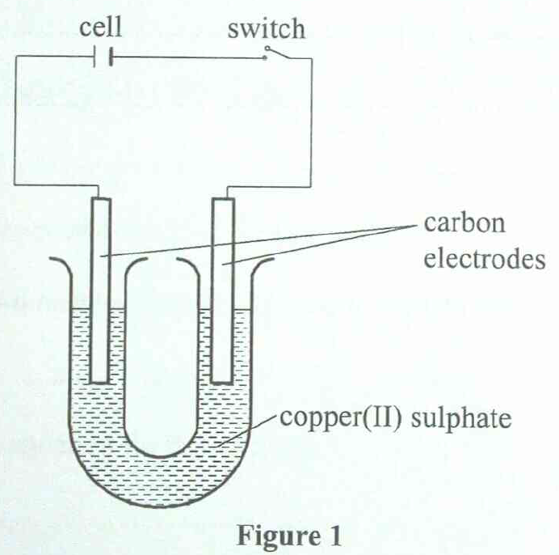
  - State the observations made during electrolysis. (1½ marks)
  - Write the equation for the reaction that occurs at the anode. (1 mark)
  - State the expected change in pH of the electrolyte after electrolysis. (½mark)
- The experiment was repeated using copper electrodes instead of carbon electrodes. Describe the observations made at each electrode. (1 mark)

- Electroplating is an important industrial process.
- What is meant by electroplating. (1 mark)
- State the purpose of electroplating. (1 mark)
- During electroplating of an iron spoon, a current of 0.6 amperes was passed through aqueous silver nitrate solution for 11/2 hours. Calculate the mass of silver that was deposited on the spoon. (3 marks)
(Ag = 108.0; 1 F = 96,500 C mol⁻¹)

- 2018 P1 Q 16.
Metals X and Y have standard electrode potentials of -0.13 V and -0.76V respectively. The metals were connected to form a cell as shown in Figure 4.
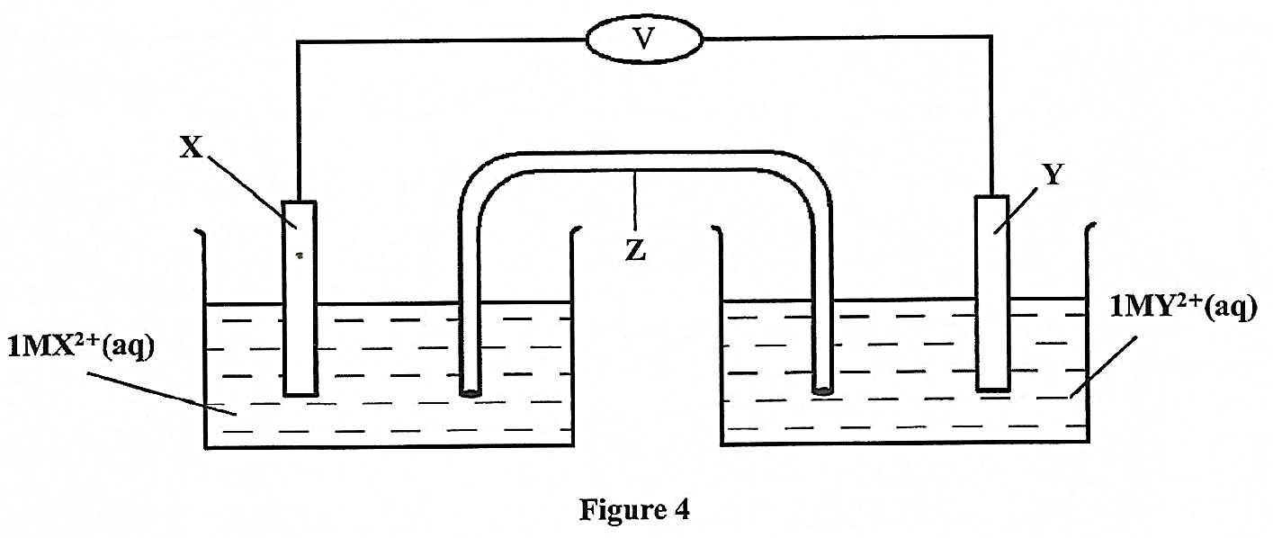
  - Name the part labelled Z. (1 mark)
  - State one function of the part labelled Z. (1 mark)
  - Calculate the e.m.f. of the cell. (1 mark)

- 2018 P2 Q3(c)
Use the standard electrode potentials in Table 2 to answer the questions that follow.
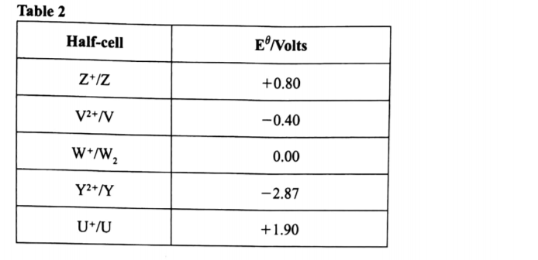
  - Write the half-cell representation for the element whose electrode potential is for hydrogen. (1 mark)
  - Arrange the elements in order of reducing power, starting with the weakest reducing agent. (1 mark)
  - I. Select two half cells which combine to give a cell with the least e.m.f. (1 mark)
II. Calculate the e.m.f of the half cells identified in (iii) I. (1 mark)

- 2019 P1 Q 19.
Given that the E^{θ} of Cu(s)/Cu²⁺(aq) is + 0.34V and that 0f Zn(s)/Zn²⁺(aq) is - 0.76V, draw a labelled diagram of zinc and copper electrochemical cell.
(3 marks)

- 2019 P2 Q6.
  - What is meant by standard electrode potential of an element? (1 mark)
  - Use the standard electrode potentials given below to answer the questions that follow.
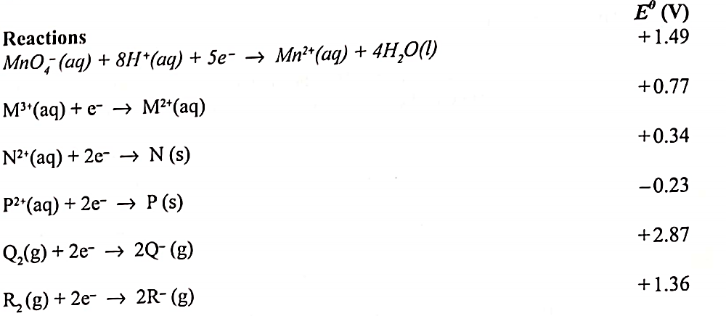

  - State whether acidified MnO⁻⁴ can oxidise M²⁺. Give a reason. (2 marks)
  - Select two half-cells which when combined will give the highest e.m.f. (1 mark)
  - Write the cell representation for the cell formed in b (ii). (1 mark)
  - Calculate the E^{θ} value for the cell formed in b (iii). (1 mark)

  - A mass of 1.24g of a divalent metal was deposited when a current of 6A was passed through a solution of a metal sulphate for 12 minutes. Determine the relative atomic mass of the metal.
(1 Faraday = 96,500 C mol ⁻¹) (3 marks)

  - State two applications of electrolysis. (1 mark)

