ORGANIC CHEMISTRY II
(ALKANOLS AND ALKANOIC ACIDS)

Table of Contents
Organizer 📌

Alkanols (Alcohols) 2
Nomenclature 2
Isomerism 4
Preparation of Alkanols 5
Properties of Alkanols 5
Uses of Alkanols 8
Alkanoic Acids (Carboxylic Acids) 8
Nomenclature 9
Laboratory Preparation of Ethanoic Acids 9
Properties of Alkanoic acids 10
Uses of Alkanoic Acids 11
Detergents 11
Soapy Detergents 12
Soapless Detergents 14
Polymers 15
Addition Polymerisation 16
Condensation Polymerisation 17
Some polymers and their uses 19
Review Exercises 19
Objectives
By the end of the topic, the learner should be able to:
- Name and draw the structures of simple alkanols and alkanoic acids.
- Describe the preparation and explain the physical and chemical properties of alkanols and alkanoic acids.
- State the main features of a homologous series.
- State and explain the uses of some alkanols and alkanoic acids.
- Describe the preparation, properties and uses of detergents and explain their effect on hard water.
- List some natural and synthetic polymers and fibres and state their uses.
- Describe the preparation, properties and uses of some synthetic polymers.
- Identify the structure of a polymer given the monomer.
- State the advantages and disadvantages of synthetic materials compared to those of natural polymers.

ORGANIC CHEMISTRY II

Alkanols (Alcohols)
Alkanols belong to a class of organic compounds which contain carbon, hydrogen and oxygen. Alkanols have a hydroxyl group (OH–) which is the functional group of the series.
Alkanols have a general formula CnH2n+1 OH where n = 1, 2, 3, 4…
Alkanols may be considered as derivatives of water in which one of the hydrogen atoms in the water molecule is substituted by an alkyl group. For example, methanol (CH3OH) is obtained by replacing one hydrogen atom by a methyl (-CH3) group. Ethanol is obtained by replacing one hydrogen atom in the water molecule by an ethyl (-CH2CH3) group.

Nomenclature
Name of Alkane | Name of corresponding alkanol
Methane | Methanol
Ethane | Ethanol
Propane | Propanol
Butane | Butanol
Pentane | Pentanol
Alkanols are named by replacing the ‘e’ of the corresponding alkane with the suffix -ol, for example:

When naming alkanols, the following rules are used:
- Identify the longest carbon chain containing the hydroxyl group (-OH) which gives the parent name:
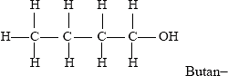
- Number the longest carbon chain such that the carbon to which the hydroxyl group is attached has the lowest number possible.
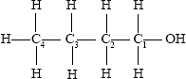
- Indicate the position of the hydroxyl group in the name, e.g.,
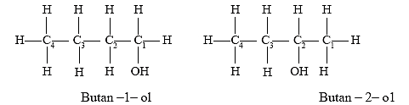
- Locate the position of the other substituent groups using numbers that correspond to their position along the carbon chain.
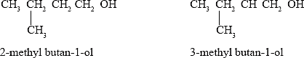

The first 5 alkanols
Alkanol | Molecular formula | Structure | Condensed structural formula
Methanol | CH₃OH | 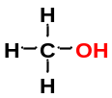 | CH₃OH
Ethanol | C₂H₅OH | 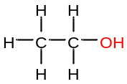 | CH₃CH₂OH
Propanol | C₃H₇OH | 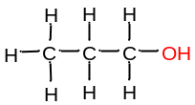 | CH₃CH₂CH₂OH
Butanol | C₄H₉OH | 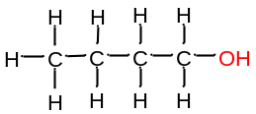 | CH₃CH₂CH₂CH₂OH
Pentanol | C₅H₁₁OH | 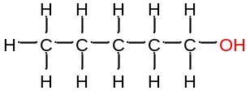 | CH₃CH₂CH₂CH₂CH₂OH
Hexanol | C₆H₁₃OH | 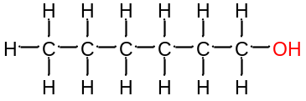 | CH₃CH₂CH₂CH₂CH₂CH₂OH

Isomerism
Alkanols exhibit two types of isomerism, positional and branching isomerism.
In positional isomerism the position of the functional group (-OH) varies within the carbon chain. For example: When the -OH group is attached to the first carbon atoms, the molecular structure can be represented as:
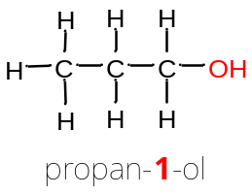
When the OH group is attached to the second carbon atom the molecular structure will be:
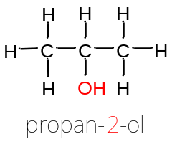
In branching isomerism, the molecular formula of the compound remains the same. However, there is rearrangement of carbon atoms such that one or more carbon atoms from the molecule form alkyl groups attached to the longest carbon chain. For example:
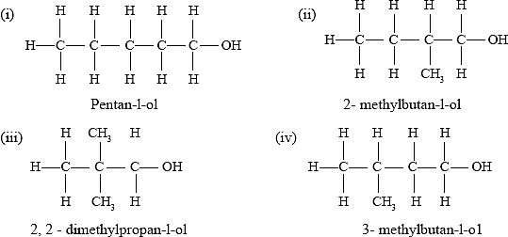
In condensed structural formula of isomers, constituents may be shown in brackets after the carbon atom to which they are attached.
The condensed formula of 2-methylbutan-1-ol may be written as CH3CH(CH3) CH2CH2OH

Preparation of Alkanols
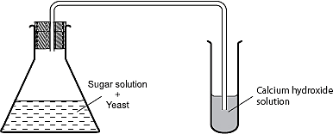
Ethanol can be prepared by the decomposition of glucose molecules in the presence of enzymes.

The sugar (C6H12O6) molecules are broken down into ethanol and carbon(IV) oxide by the enzymes in the yeast. Calcium hydroxide is used to test the presence of carbon(II) oxide.
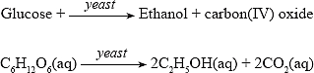
This process is referred to as fermentation. Fermentation is the decomposition of an organic substance by micro-organisms to produce alcohol, carbon(IV) oxide and heat.
However, a very small amount of alcohol is usually produced by fermentation (about 10% ethanol by volume). The alcohol content can be increased by fractional distillation of the crude solution.
The ethanol obtained contains 5% water. The water can be removed by using a suitable drying agent such as calcium oxide, to obtain absolute ethanol.

Alternatively, ethene may be hydrolysed using concentrated sulphuric(VI) acid.
CH2H4(g) + H2SO4(aq) C2H5OSO3H(l)
When water is added to the mixture, the ethylhydrogen sulphate is hydrolysed to ethanol.
CH3CH2OSO3H(g) + H2O(l) CH3CH2OH(l) + H2SO4(aq)
The mixture of ethanol and the acid is separated by distillation because of the difference in boiling points.
On a large scale, ethanol is manufactured by reacting steam and ethene at a temperature of 300°C and a pressure of about 60–70 atmospheres over phosphoric(V) acid. The acid is used as a catalyst.
The ethene for this reaction is obtained from cracking of large alkanes.

Properties of Alkanols

Physical Properties of Alkanols.
- Ethanol is a colourless liquid with a characteristic odour. It has a melting point of –114°C and boiling point of 78°C.
These values are high when compared with those of alkanes having corresponding molecular masses. This is due to the presence of hydrogen bonds in addition to van der Waals forces.
- Ethanol is highly soluble in water. The high solubility of ethanol in water is because the ethanol molecules are polar like those of water. The ethanol molecules are therefore able to form hydrogen bonds with the water molecules.
Name | Molecular mass | Molecular formula | Boiling point (°C) | Melting point (°C) | Solubility g/100 g water
Methanol | 32 | CH₄O | 65 | -97.5 | Highly soluble
Ethanol | 46 | C₂H₆O | 78 | -114 | Highly soluble
Propan-1-ol | 60 | C₃H₈O | 97 | -126 | Highly soluble
Butan-1-ol | 74 | C₄H₁₀O | 117 | -90 | 8
Pentan-1-ol | 88 | C₅H₁₂O | 138 | -79 | 2.7
Hexan-1-ol | 102 | C₆H₁₄O | 157 | -52 | 0.6

- Alkanols are soluble in water but their solubility decreases gradually as the molecular mass increases. For example, methanol is more soluble than hexan-1-ol.
- The melting points and boiling points of alkanols increase down the series due to the increases in the strength of intermolecular forces of attraction. Alkanols have higher melting and boiling points than their corresponding alkanes with the same molecular mass.
This is because of the hydrogen bonds between alkanol molecules, caused by the functional group (-OH). Hydrogen bonds are stronger than van der Waals’ forces.
- The melting and boiling points increase with increase in molar mass. This is attributed to the increase in the strength of inter-molecular forces.

Chemical Properties of Alkanols
In solution, ethanol has a pH slightly below 7. This is because in solution it behaves as a weak acid.

Combustion
Ethanol burns readily in air with a pale blue flame to produce carbon(IV) oxide and water. This is because ethanol is saturated and undergoes complete combustion.
C2H5OH(l) + 2O2(g) 2CO2(g) + 3H2O(l)

Reactions with Sodium metal
Ethanol reacts with sodium liberating hydrogen gas and a salt, sodium ethoxide. The sodium ethoxide hydrolyses in water to generate -OH which makes the solution alkaline.
2CH₃CH₂OH (l)+ 2Na (s) 2CH₂CH₂ONa (aq)+ H₂ (g)
Sodium metal reacts with any other alkanol to liberate a salt and hydrogen gas, e.g.,
2ROH(l) + 2Na(s) 2RONa(s) + H2(g)

Esterification
Ethanol reacts with ethanoic acid in the presence of a few drops of concentrated sulphuric(VI) acid to form a substance with a pleasant smell. The product formed is known as ethylethanoate which belongs to a group of compounds known as esters. The process of ester formation is known as esterification.
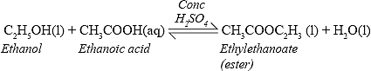
Below is the equation showing the structural formulae of the reactants and products.
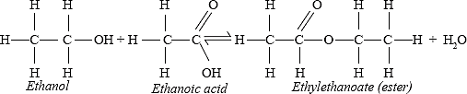
The alkyl part of the ester is derived from the alkanol, while the alkanoate part is derived from the acid. The alkyl group from the alkanol attaches itself to the carboxylic acid thereby displacing a hydrogen atom.
Ethanol also reacts with propanoic acid to form an ester known as ethylpropanaote.
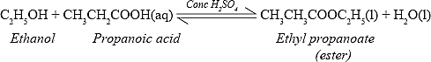
Below is the equation showing the structural formulae of the reactants and products.
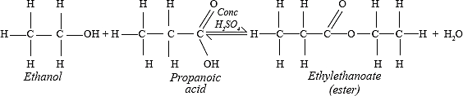
Under ordinary conditions the reaction takes place slowly. Therefore, concentrated sulphuric(VI) acid is added to catalyse the reaction.

Oxidation by oxidising agents (KMnO₄ and K₂Cr₂O₇)
Ethanol is oxidised by oxidising agents such as potassium manganate(VII) and potassium dichromate(VI) to form ethanoic acid. When reacted with ethanol, acidified purple potassium manganate(VII) turns colourless. This is due to the reduction of manganate ions (MnO4-) which are purple to manganese ions (Mn2+) which are colourless.
Acidified orange potassium dichromate(VI) turns green due to the reduction of chromate ions (Cr2O72–) to chromium ions (Cr3+).
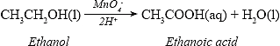
The structure of the reactant and product in the equation can be represented as:
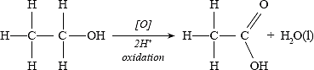
The oxidising property of the chromate (VI) is used in some breathalysers to indicate the level of alcohol (alkanol) content in the breath of motorists.
Generally, alkanols are oxidised by oxidising agents to alkanoic (carboxylic) acids.
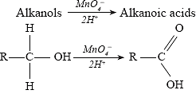
R- represents an alkyl group

Dehydration by concentrated sulphuric (VI) acid.
Concentrated sulphuric(VI) acid reacts with ethanol at 180°C to form ethene and water. The concentrated sulphuric(VI) acid acts as a dehydrating agent.
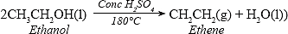
At a temperature of 140°C, incomplete dehydration occurs in which an ether is formed.
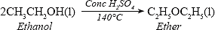

Uses of Alkanols
- As solvents, i.e., in the preparation of drugs.
- As fuels when blended with gasoline to form gasohol.
- In the manufacture of synthetic fibres, e.g., polyvinylchloride and polythene.
- As an antiseptic when used under specified concentrations.
- Ethanol is used as an alcoholic drink only in low concentrations.

Alcohol and Health
Over-consumption of ethanol causes damage to some body organs such as the liver, the brain and the heart. It also leads to addiction.
When small amounts of methanol are added to ethanol, it causes blindness and may even lead to death. In many parts of the world it is illegal to sell ethanol to persons under the age of eighteen.
Methylated spirit is an alcohol containing about 95% absolute alcohol and 5% methanol. Methanol and a purple dye called methylviolet are added to ethanol to make the methylated spirit unsuitable for human consumption.

Alkanoic Acids (Carboxylic Acids)
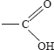
Alkanoic acids belong to a homologous series of organic compounds that contains a carboxyl group (-COOH) as a functional group.
A carboxyl group has the structural formula
Alkanoic acids have a general formula CnH2n+1COOH where n = 1, 2, 3…
The first five alkanoic acids
Alkanoic acid | Molecular formula | Structural formula
Methanoic | HCOOH | 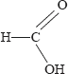
Ethanoic | CH₃COOH | 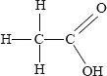
Propanoic | C₂H₅COOH | 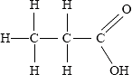
Butanoic | C₃H₇COOH | 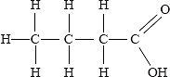
Pentanoic | C₄H₉COOH | 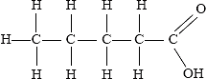

Alkanoic acids are naturally found in fruits such as oranges, lemon and pepper. Methanoic acid is present in nettle leaves and insect stings such as bees and wasps. Ethanoic acid is commonly known as vinegar. Butanoic acid is found in beef fat (Butter). Hexandioic acid is found in palm oil and olive oil.

Nomenclature
Alkanoic acids are named by replacing the “e” ending of the corresponding alkane by the suffix – oic. The carbon atom to which the functional group is attached is given position one.
The simplest member of the alkanoic acid series when n = 0 is HCOOH (Methanoic acid) and when n = 1 is CH2COOH (ethanoic acid).
Names and formulae of the first ten alkanoic acids
Name of acid | Molecular formula | Condensed structural formula
Methanoic | CH2O2 | HCOOH
Ethanoic | C2H4O2 | CH3COOH
Propanoic | C3H6O2 | CH3CH2COOH
Butanoic | C4H8O2 | CH3CH2CH2COOH
Pentanoic | C5H10O2 | CH3CH2CH2CH2COOH
Hexanoic | C6H12O2 | CH3CH2CH2CH2CH2COOH
Heptanoic | C7H14O2 | CH3CH2CH2CH2CH2CH2COOH
Octanoic | C8H16O2 | CH3CH2CH2CH2 CH2CH2CH2COOH
Nonanoic | C9H18O2 | CH3CH2CH2CH2CH2CH2CH2CH2COOH
Decanoic | C10H20O2 | CH3CH2CH2CH2CH2CH2CH2CH2CH2COOH

Laboratory Preparation of Ethanoic Acids
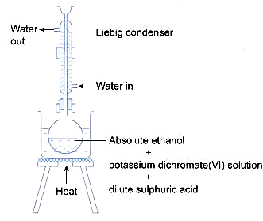
In the laboratory, ethanoic acid can be prepared by oxidising ethanol using suitable oxidising agents such acidified potassium manganate (VII) or potassium dichromate (VII).
On heating, acidified potassium manganate(VII) oxidises ethanol to ethanoic acid.
During the reaction the purple solution turns colourless. The colour of the solution is colourless because the purple manganate(VII) (MnO⁻⁴) ions are reduced to colourless manganese(II) (Mn²⁺) ions.

When acidified potassium chromate(VI) is used, the solution in the flask is orange before heating but after heating it turns green. The orange colour is due to chromate(VI) ions which are reduced to green chromium(II) ions.
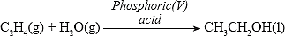
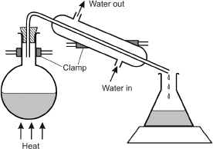
To ensure complete oxidation, excess oxidising agent is used. The condenser ensures any vapour escaping is condensed back into the flask for further reaction.
The solution in the flask contains the oxidising agent, water and ethanoic acid. In order to obtain pure ethanoic acid the mixture is distilled. The distillate collected at about 118 °C is ethanoic acid which is a colourles liquid with a sharp smell.

Properties of Alkanoic acids

Physical properties of alkanoic acids
Name of acid | Molecular mass | State at room temperature | Solubility | Melting point (°C)) | Boiling point (°C
Methanoic | 46 | Liquid | Very high | 8.4 | 101
Ethanoic | 70 | Liquid | Very high | 16.6 | 118
Propanoic | 84 | Liquid | Highly soluble | -20.8 | 141
Butanoic | 98 | Liquid | Highly soluble | -6.5 | 164
Pentanoic | 112 | Liquid | Moderate | -34.5 | 186
Hexanoic | 116 | Liquid | Low | -1.5 | 205
- Alkanoic acids are soluble in water because their molecules are able to form hydrogen bonds with water molecules. Their solubility decreases with increase in molecular mass because of the decreases in polarity of the acid molecules.
- Melting and boiling points increase with increase in molecular mass. This is due the increase in the strength of van der Waals’ forces.
- The alkanoic acids have higher melting and boiling points than their corresponding alkanols with the same molecular mass because the alkanoic acids form more hydrogen bonds per molecule than the corresponding alkanol.

Chemical Properties of alkanoic acids

Acidic properties in solution.
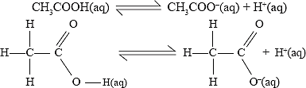
Ethanoic acid has a pH of about 5 and is a weak acid because it partially dissociates in solution to form ethanoate ions and hydrogen ions. The dissociation can be represented as:

Reaction with metals.
Ethanoic acid reacts with metals to form hydrogen gas and a salt (organic salt).
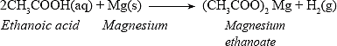
Alkanoic acids react with metals to form alkanoate and hydrogen gas.
Alkanoic acid + Metal Metal Alkanoate + Hydrogen gas

Reaction with bases and alkalis (neutralization)
Ethanoic acid neutralises sodium hydroxide forming a salt and water.
Generally, alkanoic acids react with alkalis to form a salt and water.
Alkanoic acid + Alkali Alkanoate + water
Ethanoic acid also reacts with sodium carbonate to produce a salt, carbon(IV) oxide and water.
2CH3COOH(aq) + Na2CO3(aq) 2CH3COONa(aq) + CO2(g) + H2O(g)

Reaction with alkanols (esterification)
When ethanoic acid reacts with ethanol, in the presence of a few drops of concentrated sulphuric(VI) acid, a pleasant smelling compound called an ester is formed.

Uses of Alkanoic Acids
- Used as solvents.
- In the manufacture of drugs and chemicals.
- In flavouring of foods, e.g., ethanoic acid (vinegar).
- In the manufacture of synthetic fibres such as terylene, dacron and nylon.
- In preservation of food, e.g., benzoic acid.

Detergents
Detergents are substances which improve the cleaning properties of water. There are two types; soapy and soapless detergents.

Soapy Detergents
Soapy detergents are referred to as soap. They are prepared from either fats or oils.
Soap is a sodium or potassium salt with a general formula CnH2n+1COO–Na+ or C_{n}H2n+1COO–K+
Fats and oils are esters. Fats occur naturally in animals while oils occur both in plants and animals. Some examples of oils include whale oil, groundnut oil, corn oil and coconut oil. Naturally occurring fats are butter from milk, lard from pigs and tallow from animals.
Fats are saturated organic compounds while oils are unsaturated.

Preparation of soap.
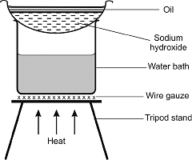
In the laboratory, soap can be prepared by mixing 5 cm³ of castor oil and 20 cm³ of 4 M sodium hydroxide in an evaporating dish. The mixture is then heated in a water bath for about 20 minutes, stirring continuously while adding small amounts of distilled water. Finally, three spatulafuls of sodium chloride are added, the mixture is stirred and allowed to cool. The mixture is then filtered and the residue washed with cold distilled water.

When an alkali is boiled with fat or oil, a hydrolysis reaction takes place.
Fat + NaOH Soap + glycerol
When a fatty acid is hydrolysed in the presence of an alkali the process is referred to as saponification.
In the hydrolysis of a fatty acid, sodium hydroxide neutralises the acid to form the sodium salt of the acid.
For example;
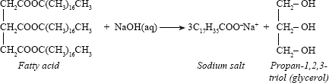
The soap formed (sodium octadecanoate) is commonly known as sodium stearate.
- Sodium chloride crystals are added to the mixture to reduce the solubility of the soap in glycerol. This is known as salting out.
- The soap obtained is rinsed in distilled water to remove impurities such as glycerol, other salts and unused alkali solution.

The Mode of Action of Soap in Cleaning
The cleaning property of soap depends on its structure. For example, sodium stearate consists of an oil soluble long hydrocarbon end and a polar end which is water soluble (C11H35COO–Na+)
A soap molecule has:
- A hydrocarbon chain end which is non-polar and has no attraction for water (water – hating) and is called hydrophobic.
- A carboxylate end which is polar and is attracted to water or is ‘water-loving’ and is called hydrophilic. This end is in fact negatively charged in water.
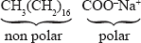
The above can also be represented by a skeletal structure as shown.
The hydrocarbon chain may also be represented by ‘R’. Thus R – COO–Na+
In water, soap dissociates into carboxylate and sodium ions, CH3(CH2)16COO– and Na+. The non-polar end of the carboxylate ion is oil soluble while the polar end is water soluble.
Water alone is not sufficient to clean grease stained linen or surfaces because water cannot dissolve grease as the two are immiscible.
When soap is added to water during washing, the non-polar hydrophobic end of the carboxylate ions lodge themselves onto the grease while the hydrophilic ends stick out in the water, since they are attracted by water molecules.
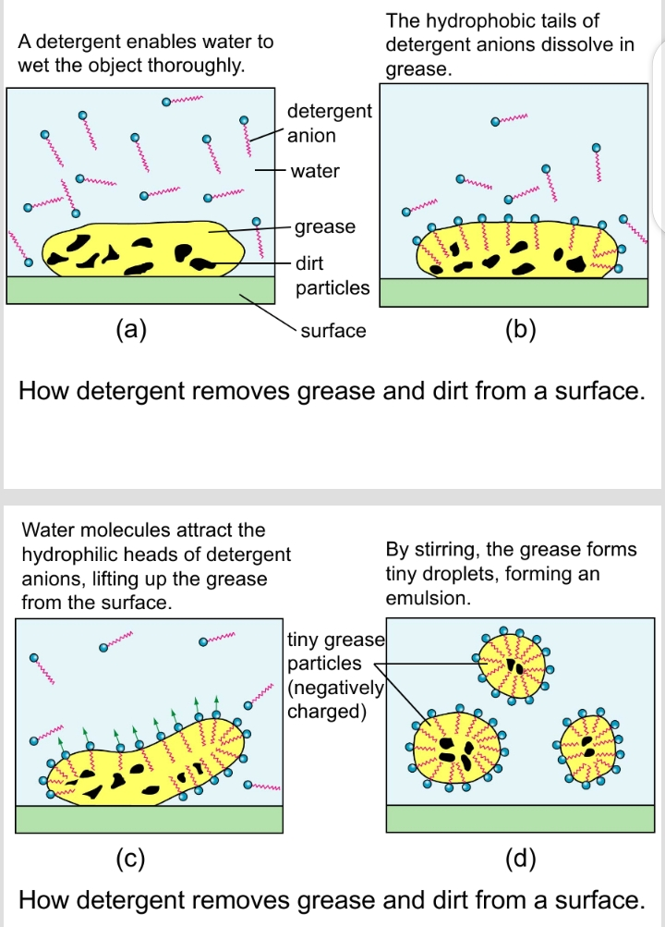
Agitation of the material being washed causes enough of the carboxylate ions to stick into grease particles and dislodge them, this forms small droplets with the water loving ends poking out (micelles). The micelles cannot coalesce together as they repel one another due to the charge on their surface. This way they are washed away by water when the garment is rinsed.
The detergents ‘heads’ are attracted by water molecules.

Effect of Hard Water on Soap
When soap is added to water containing calcium and magnesium ions, a precipitation reaction takes place. For example:
2C17H35COO–Na+(aq) + Ca2+(aq) (C17H35COO–)2Ca2+(s) + 2Na+(aq)
Lather does not form until all the calcium or magnesium ions responsible for the hardness have been precipitated. The precipitate floats on the water as scum.

Soapless Detergents
These are detergents in which a carboxylic group of the soap is replaced by an alkyl sulphonate group. For example:
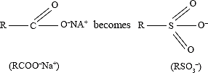
Where R represents the long hydrocarbon chain.
Soapless detergents act like soap in the cleaning process but they are not affected by hard water unlike ordinary soap. Therefore, unlike soap, soapless detergents lather readily with water since the corresponding calcium and magnesium salts are soluble.
Soapless detergents are manufactured from petroleum products. They can also be made from vegetable oil or fats which do not contain the benzene ring.
The initial step in the preparation involves the heating of the long chain hydrocarbons with benzene molecules at very high temperature to produce alkylbenzene as the organic part of the detergent.
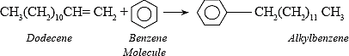
The alkylbenzene is further reacted with concentrated sulphuric(VI) acid to form alkylbenzene sulphonate.
The alkylbenzene sulphonate is reacted with sodium hydroxide solution to form sodium alkylbenzene sulphonate which is the detergent.
The long hydrocarbon chain can be presented by R. Thus, the sodium alkylbenzene sulphonate may be written as:

The flow diagram below is a summary of the process involved during preparation of soapless detergents.
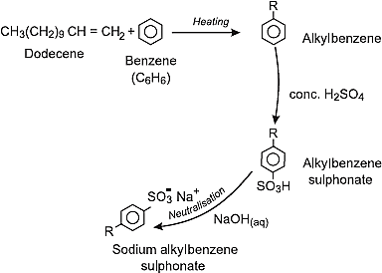
Soapless detergents are manufactured in liquid or solid form.
In order to improve the cleaning properties of soapy and soapless detergents, tetraoxophosphate materials are added. The compounds prevent formation of compounds with Ca2+, Mg2+ ions hence no scum is formed.
Examples of soapless detergents sold locally are: Omo, Dynamo, Perfix, Persil, Sunlight and Toss.

Comparison between soapless detergents and soap
Soapless detergents | Soapy detergents
Very soluble in water and therefore can be used well in hard water. | Form scum in hard water
Cause water pollution because some are non-biodegradable. | Do not cause pollution because they are biodegradable.
Are expensive. | Are cheap.

Pollution Effect of Detergents
Detergents contain long chains of alkylbenzene groups which are difficult to break down through bacterial action. When large quantities of detergents are released into lakes, rivers and dams, froth forms. Eventually, the forth forms a protective blanket layer on top of the water preventing air from dissolving in the water. Lack of oxygen in water causes death of animals due to high biological and chemical oxygen demand.
The tetraoxophosphate and other compounds added to remove Ca2+ and Mg2+ during cleaning provides nutrients for aquatic plants, e.g., algae and water hyacinth. The population of the aquatic plants grows quickly depleting the dissolved oxygen in water. This is referred to as eutrophication.
In order to control pollution by detergents, efforts are being made by manufacturers to use biodegradable materials in detergents, i.e., more unbranched long chain hydrocarbons.

Polymers
A polymer is a long chain organic molecule formed when a small chain molecule undergoes self addition reaction.
The unit molecule is referred to as a monomer. Monomers may be of the same molecule or different compounds.
The process through which the monomers combine to form a long chain molecule is known as Polymerisation.
The polymers may be man-made (synthetic) or naturally occurring. Naturally occurring polymers include rubber, cellulose, wool, silk and starch while synthetic polymers include nylon, terylene and polyethene.
Synthetic polymers are made using two methods; addition polymerisation and condensation polymerisation.

Addition Polymerisation
Addition polymerisation occurs when unsaturated molecules (monomers) join to form long chain molecules (polymers) without the formation of any other product. Monomers open and bond with each other.
Polymers formed through addition polymerisation are: polythene, polypropene, polyvinylchloride (PVC), polystyrene, polytetrafluoroethene and perspex.
The following equations show the formation of these polymers:
Polymerization process | General structure
(a) Polypropene  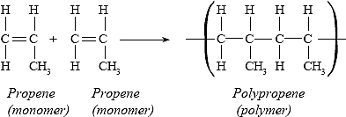 | 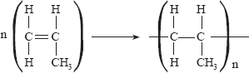
(b) Polychloroethene (Polyvinylchoride)  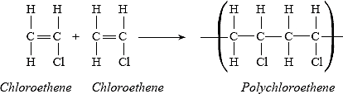 | 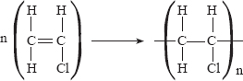
(c) Polyphenylethene (polystyrene)  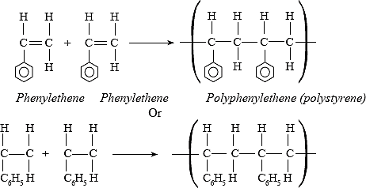 | 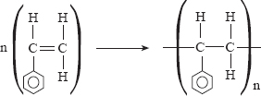
(d) Polytetrafluoroethene
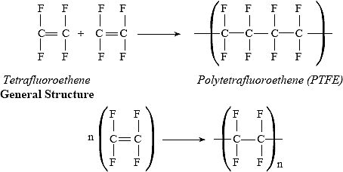
(e) Polymethylmetacrylate (PMMA)  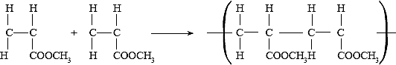  2-methyl propanoate polymethylmetacrylate (PMMA)  (methyl metacrylate) | 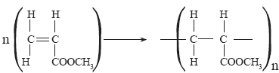

A polymer formed by addition of identical molecules will have a relative molecular mass that is an integral multiple of the relative molecular mass of that monomer. If the relative molecular mass of a polymer and part of its structure is given, the number of monomers forming the polymer can be determined.
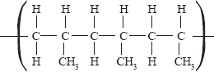
For example:
A polymer has the following structure and has a molecular mass of 4200.
(i) Identify the monomer and draw its structure.
(ii) Determine the relative molecular mass of the monomer.
(iii) Determine the number of monomers in the polymer.
Solution
(a) The monomer is determined by determining the repeating units in the polymer given:
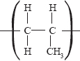
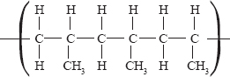
Thus in the polymer: , the repeating unit is:

Since the monomer must be an unsaturated hydrocarbon, then the monomer forms the repeating unit.
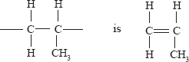
Thus: is
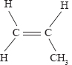
(ii) The relative molecular mass of the monomer is: ⇒ (12 × 3) + (1 × 6) =42

(iii) Number of monomers = $\frac{\text{Molecular mass of polymer}}{\text{Molecular mass of monomer}}\text{=}\frac{\text{4200}}{\text{42}}$ =100

Condensation Polymerisation
In condensation polymerisation, identical or different monomers combine to form long chain molecules with the loss of small molecules like water. The monomer should have two functional groups at each end so that molecules can join at both ends to form long chain molecules. The functional groups may be identical or different. For example:

Name | Polymerization process
(a) Starch | 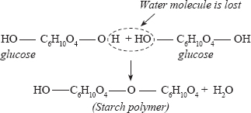
(b) Protein | 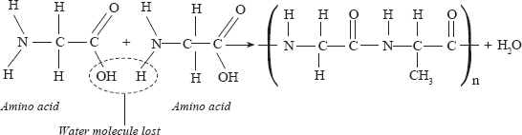
(c) Nylon 6.6 | The polymer is formed from the reaction between hexane -1, 6. diamine and hexane -1, 6 -dioic acid.  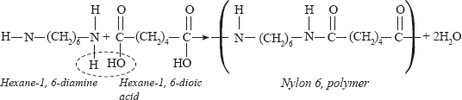
Rubber  Naturally occurring rubber is obtained from the rubber tree.  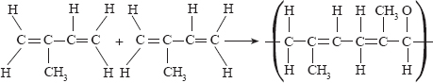  isoprene | Rubber trees produce a liquid called latex which is collected from cuts made on the trunks of the rubber trees. The latex is then allowed to coagulate resulting in a hydrocarbon polymer which is made up of isoprene (2- methyl but -1, 3-diene).  The monomer polymerises as shown below.  Synthetic rubber can also be obtained by polymerisation of isoprene.  The product is usually soft hence must be hardened by a process called vulcanisation. This involves heating the rubber with sulphur. The sulphur atoms form links between chains of rubber molecules reducing the number of double bonds in the polymers. This makes the material tougher, less flexible and less soft. This improves the quality of rubber.

Advantages of Synthetic Polymers and Fibres
Synthetic polymers have many advantages over natural materials:
- They are less affected by acids, alkalis, water and air.
- They are lighter.
- They are stronger.
- They can be moulded into desired shapes easily.
- They are less expensive.

Disadvantages of Synthetic Fibres
- Some synthetic fibres burn more readily than natural ores.
- They do not decompose easily, i.e., are non-biodegradable. This results in environmental pollution.
- Some synthetic polymers give off poisonous gases when they burn, e.g., polythene gives off hydrogen cyanide and carbon(IV) oxide.

Some polymers and their uses
Polymer | Uses
Polyethene | Film wrappers, flexible bottles, electrical wire insulators, water pipes.
Polypropene | Crates, carpets, plastic bottles, chairs, ropes.
Polychloroethene | Floor tiles, car dash boards, cool water pipes, hose pipes, gutters.
Polyphenyethene | Ceiling lines, insulation materials.
Polytetrafluoroethane | Non-stick coating on pressing boxes and cooking utensils.
Perspex | Substitute for glass.
Nylon | Substitute for cotton in the textile industry, ropes carpets, brushes, fishing nets, parachutes.
Rubber | Vehicle tyres.

Review Exercises

- 2006 Q7 P1
A group of compounds called chlorofluorocarbons have a wide range of uses but they also have harmful effects on the environment. State one:
(a) Use of chlorofluorocarbons. (1 mark)
(b) Harmful effect of chlorofluorocarbons on the environments. (1 mark)

- 2006 Q5 (P2)
  - What name is given to a compound that contains carbon and hydrogen only? (½ mark)
  - Hexane is a compound containing carbon and hydrogen.
- What method is used to obtain hexane from crude oil? (1mark)
- State one use of hexane (1mark)

- Study the flow chart below and answer the questions that follow.

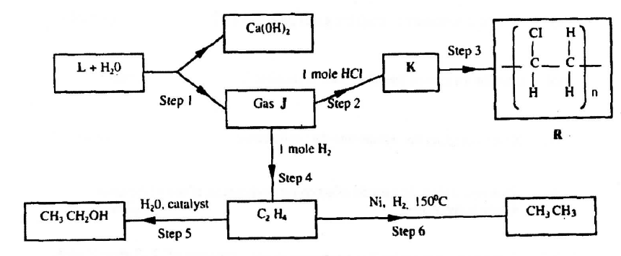

- Identify reagent L. (1mark)
- Name the catalyst used in step 5. (1mark)
- Draw the structural formula of gas J. (1mark)
- What name is given to the process that takes place in step 5? (½ mark)
- What name is given to the process that takes place in step 5? (½ mark)

- (i)write the equation for the reaction between aqueous sodium hydroxide and aqueous ethanoic acid. (1 mark)
(ii) Explain why the reaction between 1g of sodium carbonate and 2M hydrochloric acid is faster than the reaction between 1g of sodium carbonate and 2M ethanoic acid. (2 marks)

- 2007 Q20 P1
An alkanol has the following composition by mass: hydrogen 13.5%, oxygen
21.6% and carbon 64.9%
  - Determine the empirical formula of the alcohol. (C=12.0; H=1.0, O=16.0). (2marks)

  - Given that the empirical formula and molecular formula of the alkanol are the same, draw the structure of the alkanol. (1 mark)

- 2007 Q2 P2
- Give the systematic names of the following compounds
(i) CH₂ = C - CH3
I
CH3 (1 mark)

(ii) CH₃CH₂CH₂C ≡ CH (1 mark)

- State the observations made when Propan-1-ol reacts with:
(i) Acidified potassium dichromate (VI) Solution, (1 mark)
(ii) Sodium metal. (1 mark)

- Ethanol obtained from glucose can be converted to ethane as shown below
C₆H₁₂O₆ $\underset{→}{ Step I }$ C₂H₅OH $\underset{→}{ Step II }$CH₂ = CH₂
Name and describe the process that takes place in steps I and II. (3 marks)
- Compounds A and B have the same molecular formula C₃H₆O₂. Compound A liberates carbon (IV) oxide on addition of aqueous sodium carbonate while compound B does not. Compound B has a sweet smell. Draw the possible structures of:
(i) Compound A (1 mark)
(ii) Compound B (1 mark)

- Give two reasons why the disposal of polymers such as polychloroethane by burning pollutes the environment. (2 marks)

- 2008 Q4 P1
The structure of a detergent is:

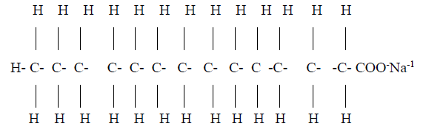
  - Write the molecular formula of the detergent. (1 mark)
  - What type of detergent is represented by the formula? (1 mark)
  - When this type of detergent is used to wash linen in hard water, spots (marks) are left on the linen. Write the formula of the substance responsible for the spots (1 mark)

- 2008 Q1 P2
- Biogas is a mixture of mainly carbon (IV) oxide and methane.
- Give a reason why biogas can be used as a fuel. (1mark)
- Other than fractional distillation, describe a method that can be used to determine the percentage of methane in biogas. (3marks)

- A sample of biogas contains 35.2% by mass of methane. A biogas cylinder contains 5.0 kg of the gas.
Calculate the;
- Number of moles of methane in the cylinder. (Molar mass of methane=16) (2marks)
- Total volume of carbon (IV) oxide produced by the combustion of methane in the cylinder (Molar gas Volume=24.0 dm³ at room temperature and pressure).(2marks)

- Carbon (IV) oxide, methane, nitrogen (I) oxide and trichlorofluoromethane are green-house gases.
- State one effect of an increased level of these gases to the environment. (1 mark)
- Give one source from which each of the following gases is released to the environment;
I. Nitrogen (I) oxide (1 mark)
II. Trichlorofluoromethane. (1 mark)

- 2009 Q25
  - Draw the structure of compound N formed in the following reaction (1 mark)

  - Give one use of the following compound N (1 mark).
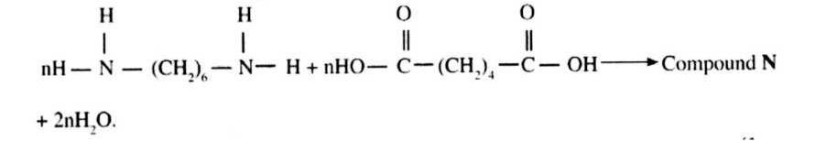

- 2009 Q2 P2
- Draw the structure of the following compounds (2 marks)
(i) 2 -methlybut-2-ene
(ii) heptanoic acid
- Describe a physical test that can be used to distinguish between hexane and hexanol (2 marks)

- Use the flow chart to answer the questions that follow.
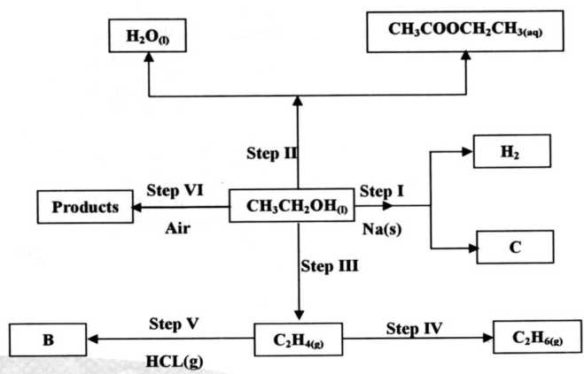
- Name
- The type of reaction that occurs in the step II (1mark)
- Substance B (1mark)
- Give the formula of substance C (1 mark)
- Give the reagent and the condition necessary for the reaction in step (IV) (3marks)

- 2010 Q13 P1
Some animal and vegetable oils are used to make margarine and soap. Give the reagents and conditions necessary for converting the oils into:
(a) Margarine (2 marks)
(b) Soap (1 mark)

- 2010 Q21 P1
The use of CFCs has been linked to depletion of the ozone layer.
- What does CFC stand for? (1 mark)
- Explain the problem associated with the depletion of the ozone layer
(1 mark)
- State another environment problem caused by CFCs. (1 mark)

- 2010 Q2 (P2)
  - Give the name of the following compounds:
- CH₃
I
CH₃ − C − CH₃ (1 mark)
I
CH₃

- CH₃ C ≡ C CH₂CH₃ (1 mark)

- Describe a chemical test that can be carried out in order to distinguish between
CH₃
I
CH₃ − C − CH₃ and CH₃ C ≡ C CH₂CH₃
I
CH₃ (2 marks)

- Study the flow chart below and answer the questions that follows
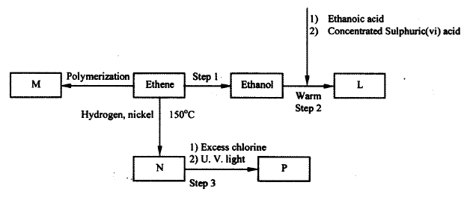

- Name the compounds: (2 marks)
- L
- N

- Draw the structural formula of compound M showing two repeating units (1 mark)
- Give the reagent and the conditions used in step I (1 mark)
- State the type of reaction that take place in: (2 marks)
- Step 2
- Step 3

- The molecular formula of compound P is C₂H₂Cl₄. Draw the two structural formulae of compound P (2 marks)

- 2011 Q14 P1
Two organic compounds P and Q decolourise acidified potassium manganate (VII) solution; but only P reacts with sodium metal to give a colourless gas. Which homologous series does compound P belong? Give a reason. (3 marks)

- 2011 Q15 P1
Soap dissolves in water according to the equation below;
NaSt (aq) Na⁺ (aq) + St⁻ where St⁻ is the stearate ion
- Write the formula of the scum formed when soap is used in hard water (1 mark)
- Write the ionic equation for the reaction that occurs when sodium carbonate is used to remove in hardness in water. (1 mark)

- 2011 Q6 P2
- Study the flow chart below and answer the questions that follow.
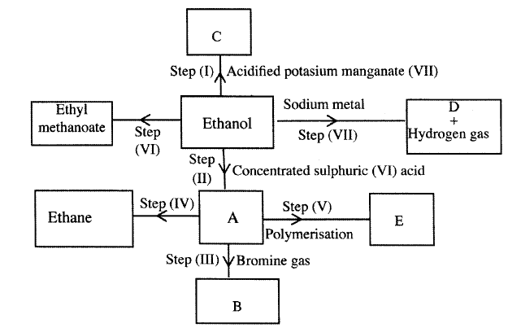
- I. What observation will be made in Step I? (1 mark)
II. Describe a chemical test that can be carried out to show the identity of Compound C (2 marks)
- Give the names of the following: (2 marks)
    - E ………………
    - Substance D ………………

- Give the formula of substance B (1 mark)
- Name the type of reaction that occurs in: (1 mark)
- Step (II) ……………………….
- Step (IV) ………………………
- Give the reagent and conditions necessary for Step (IV). (2 marks)
Reagent ………………………….
Conditions ……………………….

- (i) Name the following structure 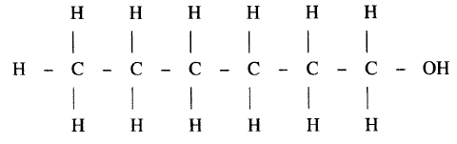
(1 mark)

(ii) Draw the structure of an isomer of pentene. (1 mark)

- 2012 Q21 P1
Give two uses of the polymer polystyrene. (1 mark)

- 2012 Q1 P2, 2016 Q6 P1
- Draw the structural formula for all the isomers of C₂H₃Cl₃ (2 marks)

- Describe two chemical tests that can be used to distinguish between ethene and ethane. (4 marks)
- The following scheme represents various reactions starting with propanol-1-ol.
Use it to answer the questions that follow.
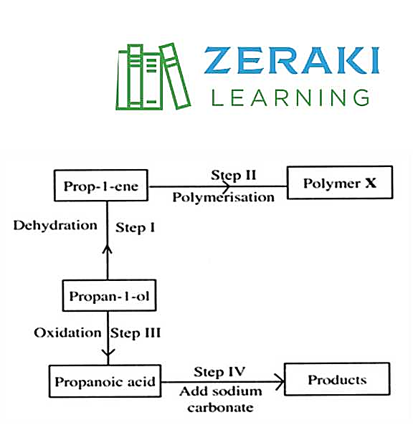
- Name one substance that can be used in step 1 (1 mark)
- Give the general formula of X (1 mark)
- Write the equation for the reaction in step IV (1 mark)
- Calculate the mass of propanol-1-ol which when burnt completely in air at room temperature and pressure would produce 18 dm³ of gas.
(C = 12.0; O = 16.0; H = 1.0; Molar gas volume = 24 dm³) (2 marks)

- 2013 Q7 P2
- Give the systematic names for the following compounds
(i) CH₃CH₂COOH; (1 mark)
(ii) CH₃CH₂CH₂CHCH₂; (1 mark)
(iii) CHC CH₂CH₃; (1 mark)
- Study the flow chart below and use it to answer the questions that follow
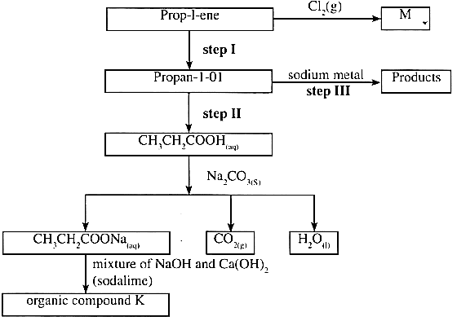

- Identify the organic compound K. (1 mark)
- Write the formula of M (1 mark)

- Give one reagent that can be used in
(a) Step I; (1 mark)
(b) Step II . (1 mark)

- Write the equation of the reaction in step III (1 mark)

- The structure below represents a type of a cleaning agent.
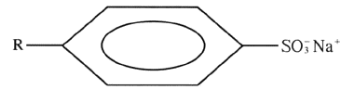
Describe how the cleansing agent removes grease from a piece of cloth. (3marks)

- 2014 Q9 P1
The table below shows the relative molecular masses and boiling points of pentane and ethanoic acid.
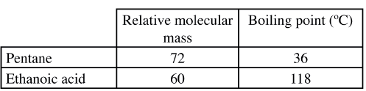
Explain the large difference in boiling point between ethanoic acid and pentane. (2 marks)

- 2014 Q23 P1
Study the flow chart below and answer the question the follow.
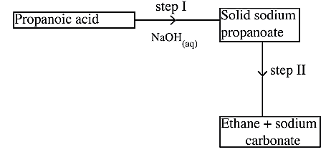
(a) Name the process in step I. (1 mark)
(b) Identify the reagent in step II. (1 mark)
(c) Give one use of ethane. (1 mark)

- 2014 Q26 P1
Cotton is a natural polymer. State one advantage and one disadvantage of this polymer. (2 marks)

- 2014 Q3 P2
- Draw the structures of the following.
(i) Butan -1- ol (1 mark)
(ii) Hexanoic acid. (1 mark)

- Study the flow chart below and answer the questions that follow
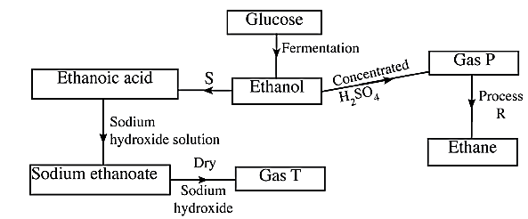

- State the conditions necessary for fermentation of glucose to take place. (1 mark)
- State one reagent that can be used to carry out process S. (1 mark)
- Identify gases: (2 marks)
- P: ………………………
- T: …………………….
- How is sodium hydroxide kept dry during the reaction (v) Give one commercial use of process R. (1 mark)

- When one mole of ethanol is completely burnt in air, 1370kJ of heat energy is released. Given that 1 lire of ethanol is 780 g , calculate the amount of heat energy released when 1 litre of ethanol is completely burnt (C = 12.0; H=1.0; 0=16.0) (3 marks)

- State two uses of ethanol other than as an alcoholic drink. (2 marks)

- 2015 Q1b P1
Describe a chemical test that can be used to distinguish butanol from butanoic acid. (2 marks)

- 2015 Q22 P1
Study the flow chart below and use it to answer the questions that follows.
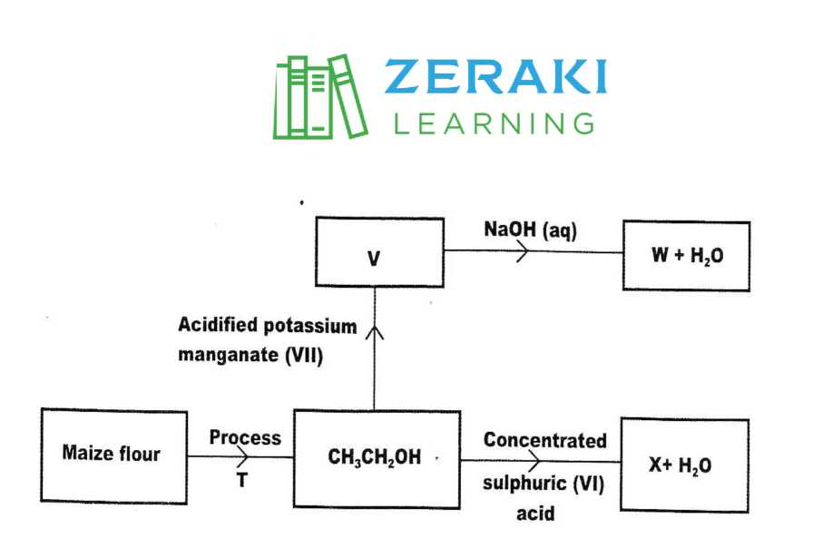
(a) Name process T (1 mark)
(b) Give the formula of W. (1 mark)
(c) State two uses of X (1 mark)

- 2015 Q2 P2
- Draw the structure of the folio wing compounds. (2 marks)
(i) Butanoic acid;
(ii) Pent-2-ene.

- Explain why propan-1-ol is soluble in water while prop-1-ene is not. (Relative molecular mass of propan-1-ol is 60 while that of prop-1-ene is 42). (2 marks)

- What would be observed if a few drops of acidified potassium manganate (VII) were added to oil obtained from nut seeds? Explain. (2 marks)

- State one method that can be used to convert liquid oil from nut seeds into solid. (1mark)

- Describe how soap is manufactured from liquid oil from nut seeds. (3 marks)

- 0.44 g of an ester A reacts with 62.5 cm3 of 0.08 M potassium hydroxide giving an alcohol B and substance C. Given that one mole of the ester reacts with one mole of the alkali, calculate the relative molecular mass of the ester. (2 marks)

- 2016 Q2 P1 R
An alkanol has the following composition by mass; hydrogen 13.5%, oxygen 21.6% and carbonate 64.9%

- Determine the empirical formula of the alkanol. (C=12.0, H=1.0, O=16) (2 marks)

- Given that the empirical formula and the molecular formula of the alkanol are the same, draw the structure of the alkanol (1 mark)

- 2017 P1 Q20.
Study the flow chart in Figure 5 and answer the questions that follow.
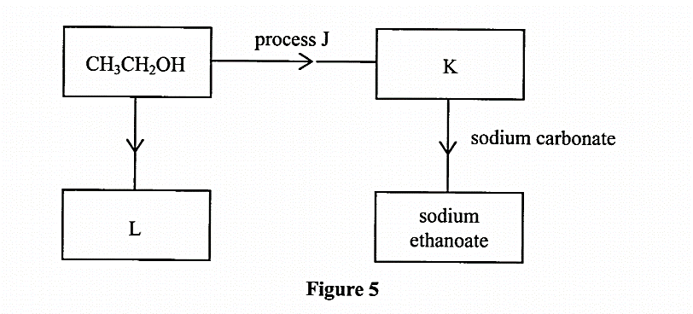
  - Identify substances K and L.
K: (1 mark)
L: (1 mark)
  - Name one reagent that can be used to carry out process J. (1 mark)

- 2017 P1 Q28.
When an aqueous solution of compound X was mixed with a few drops of bromine water, the colour of the mixture remained yellow.
When another portion of solution X was reacted with acidified potassium dichromate (VI), the colour of the mixture changed from orange to green.
(a) What conclusion can be made from the use of:
(i) bromine water? (1 mark)
(ii) acidified potassium dichromate (VI)? (1 mark)

(b) Solution X was reacted with a piece of a metal and a colourless gas was produced. Describe a simple experiment to identify the gas. (1 mark)

- 2017 P2 Q1.
(a) Name the homologous series represented by each of the following general formulae.
(i) C_{n}H_{2n-2} (1 mark)
(ii) C_{n}H_{2n} (1 mark)

(b) Compound G is a tri-ester.
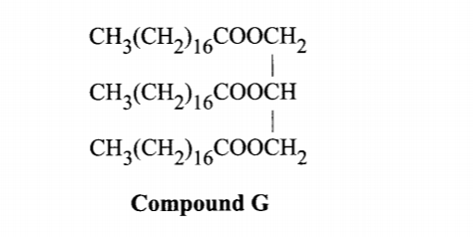
(i) Give the physical state of compound G at room temperature. (1 mark)
(ii) G is completely hydrolysed by heating with aqueous sodium hydroxide.
(I) Give the structural formula of the alcohol formed. (1 mark)
(II) Write a formula for the sodium salt formed. (1 mark)
(III) State the use of the sodium salt. (1 mark)

(c) Ethyne is the first member of the alkyne family.
(i) Name two reagents that can be used in the laboratory to prepare the gas. (1 mark)
(ii) Write an equation for the reaction. (1 mark)

(d) Perspex is an addition synthetic polymer formed from the monomer,
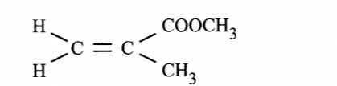
(i) What is meant by addition polymerisation? (1 mark)
(ii) Draw three repeat units of Perspex. (1 mark)
(iii) Give one use of Perspex (1 mark)
(iv) State two environmental hazards associated with synthetic polymers. (1 mark)

- 2018 P1 Q3.
The following are formulae of organic compounds. Use the formulae to answer the questions that follow:
CH₃CH₂CH₂OH
CH₃COOH
CH₃CH₂CH₂CH₃
CH₃CCCH₃

(a) Select:
(i) two compounds which when reacted together produce a sweet-smelling compound. (1 mark)
(ii) an unsaturated hydrocarbon. (1 mark)

(b) Name the compound selected in (a) (ii). (1 mark)

- 2018 P2 Q1.
The diagram in figure 1 shows some natural and industrial processes. Study it and answer the questions that follows
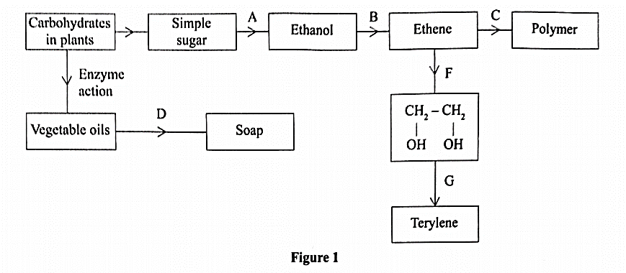
(a) Identify the processes labelled: (2 marks)
A...................
B...................
C...................
D...................
(b) State the reagents and conditions required for processes B and D.
(i) Process B:
Reagent................ (1 mark)
Conditions ............ (1 mark)
(ii) Process D:
Reagent................ (1 mark)
Conditions ............ (1 mark)
(b) Describe how process D is carried out. (2 marks)

(c) State two additives used to improve the quality of soap. (1 mark)

(d) State the reagents required in steps F and G.
(i) F………………………………… (1 mark)
(ii) G………………………………… (1 mark)
(e) Draw the structure of terylene. (1 mark)

(d) (i) Name the polymer formed in step C. (1 mark)
(ii) State one disadvantage of the polymer formed in (d) (i). (1 mark)

- 2019 P1 Q4.
A monomer has the following structure.
CH= CH₂
∣
C₆H₅
(a) Draw the structure of its polymer that contains three monomers. (1 mark)
(b) A sample of the polymer formed from the monomer has a molecular mass of 4992.Determine the number of monomers that formed the polymer.
(C= 12; H= 1.0). (2 marks)

- 2019 P2 Q1.
(a) Alkanes are said to be saturated hydrocarbons.
(i) What is meant by saturated hydrocarbons? (1 mark)
(ii) Draw the structure of the third member of the alkane homologous series and name it. (2 marks)

(b) When the alkane, hexane, is heated to high temperature, one of the products is ethene.
(i) Write the equation for the reaction. (1 mark)
(ii) Name the process described in (b). (1 mark)
(c) Study the flow chart in Figure 1 below and answer the questions that follow.
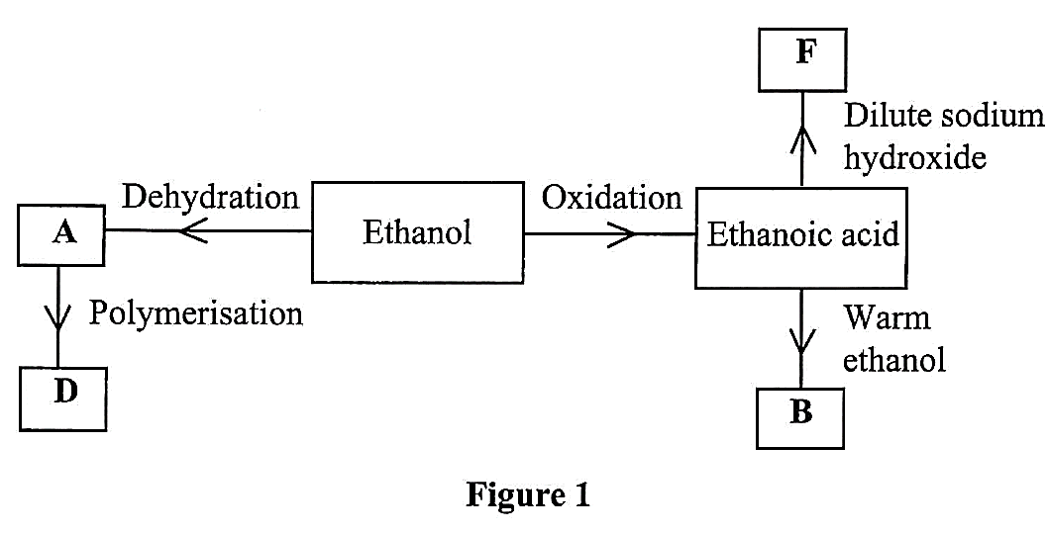
(i) Identify A. (1 mark)
(ii) State one physical property of B. (1 mark)
(iii) Draw the structure of D. (1 mark)
(iv) Give a reason why D pollutes the environment. (1 mark)
(v) Write an equation for the formation of F. (1 mark)

(d) Describe an experiment which can be used to distinguish butene from butanol. (2 marks)

