SUNRISE EVALUATION EXAMS FORM 3
NAME……………………………………………………ADM NO.………………. CLASS………
DATE: …………………………….. SIGN: …………………….………

443 AGRICULTURE
PAPER
(THEORY)
DURATION:: 2HRS
Kenya Certificate of Secondary Education (K.C.S.E)
Instructions to candidates
a) Write your name and index in the spaces provided above
b) Sign and write the date of examination in the spaces provided above
c) This paper consists of three sections A, B and C.
d) Answer all the questions in sections A and B.
e) Answer any two questions in section C
f) All answers should be written in the spaces provided in the question paper.

For Examiner’s Use Only
Section | Question | Maximum Score | Candidates Score
A | 1 – 17 | 30
B | 18 - 24 | 40
C | 25-27 | 20
Total Score |  | 90

- Give four activities that may be undertaken in organic farming. (2 marks)
………………………………………………………………………………………………………………
………………………………………………………………………………………………………………
………………………………………………………………………………………………………………
………………………………………………………………………………………………………………
- State four harmful effects of wind on crop production (2 marks)
………………………………………………………………………………………………………………
………………………………………………………………………………………………………………
………………………………………………………………………………………………………………
………………………………………………………………………………………………………………
- State four practices that can be used to improve water logged clay soils (2 marks)
………………………………………………………………………………………………………………
………………………………………………………………………………………………………………
………………………………………………………………………………………………………………
………………………………………………………………………………………………………………
- State four factors considered when selecting planting materials (2 marks)
………………………………………………………………………………………………………………
………………………………………………………………………………………………………………
………………………………………………………………………………………………………………
………………………………………………………………………………………………………………
- Give two causes of blossom-end rot in tomatoes (1 mark)
……………………………………………………………………………………………………………..
…………………………………………………………………………………………………………….
- Give four pieces of information contained in a land title deed. (2 marks)
………………………………………………………………………………………………………………
………………………………………………………………………………………………………………
………………………………………………………………………………………………………………
………………………………………………………………………………………………………………
- Name three macro-nutrient elements whose deficiency symptom is chlorosis (1½ marks)
………………………………………………………………………………………………………………
………………………………………………………………………………………………………………
………………………………………………………………………………………………………………
- State two water treatment processes that take place in the coagulation and sedimentation tank.
(1 mark)
…………………………………………………………………………………………………………….
…………………………………………………………………………………………………………….
- State four reasons for pruning fruit crops (2 marks)
………………………………………………………………………………………………………………
………………………………………………………………………………………………………………
………………………………………………………………………………………………………………
………………………………………………………………………………………………………………
- Name three practices carried out to improve and maintain permanent pastures (1½ marks)
………………………………………………………………………………………………………………
………………………………………………………………………………………………………………
………………………………………………………………………………………………………………
- State four advantages of timely harvesting of crops (2 marks)
………………………………………………………………………………………………………………
………………………………………………………………………………………………………………
………………………………………………………………………………………………………………
………………………………………………………………………………………………………………
- List three tertiary operations that may be carried out in a seedbed (1½ marks)
………………………………………………………………………………………………………………
………………………………………………………………………………………………………………
………………………………………………………………………………………………………………
- List four disadvantages of using compost manure in crop production (2 marks)
………………………………………………………………………………………………………………
………………………………………………………………………………………………………………
………………………………………………………………………………………………………………
………………………………………………………………………………………………………………
- Name the camel breed with two humps. (1 mark)
………………………………………………………………………………………………………………

- Name the vectors for each of the following livestock diseases. (2 marks)
- East coast fever……………………………………………………………………………………
- Rift valley fever…………………………………………………………………..........................
- Trypanosomiasis…………………………………………………………………………………
- Nairobi sheep disease…………………………………………………………….......................
- Give four factors considered when selecting a site for fish pond. (2 marks)
………………………………………………………………………………………………………………
………………………………………………………………………………………………………………
………………………………………………………………………………………………………………
………………………………………………………………………………………………………………
- Name the tools used in (2 marks)
(i) Cutting curves on thin wood…………………………………………………………………………
(ii)Measuring the inner diameter of a circular object/surface……………………………………….
(iii)Cutting thin sheets of metal…………………………………………………………………………
(iv)Tightening wires during fencing…………………………………………………………………..

SECTION B (40MKS)
- Study the illustration below and answer questions that follow.
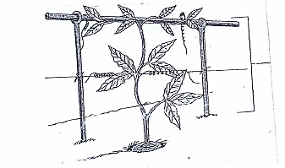

- Identify the management practice indicated above. (1 mark)
………………………………………………………………………………………………….
………………………………………………………………………………………………….

- Give three problems that could arise if the above practice is not carried out. (3 marks)
………………………………………………………………………………………………….
………………………………………………………………………………………………….
………………………………………………………………………………………………….
………………………………………………………………………………………………….
- The diagram below illustrates an experiment carried out by a Form one student on soil. Study it carefully and answer the questions that follow.
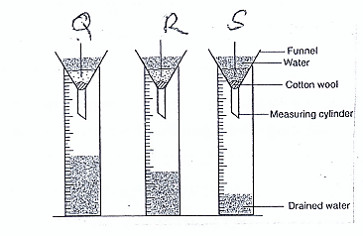
- State the aim of experiment above. (1 mark)
………………………………………………………………………………………………….
………………………………………………………………………………………………….
- Identify the soil samples in each of the funnels labeled Q and R (2 marks)
Q………………………………………………………………………………………………….
R………………………………………………………………………………………………….
- Give two ways in which the soil structure of the sample labeled S above can be improved.
(2 marks)
………………………………………………………………………………………………….
………………………………………………………………………………………………….

- The diagram below illustrates a method of preparing compost manure. study it and answer the questions that follow.

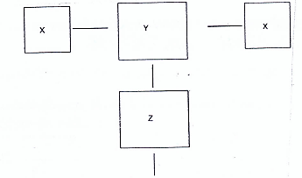
- Identify the method illustrated above. (1 mark)
………………………………………………………………………………………………….
- By using arrows, indicate the direction of the materials form X to the field (2 marks)

- State two desirable factors considered when siting compost manure pit. (2 marks)
………………………………………………………………………………………………………………
………………………………………………………………………………………………………………
- a) Diagram below show a plunge dip.
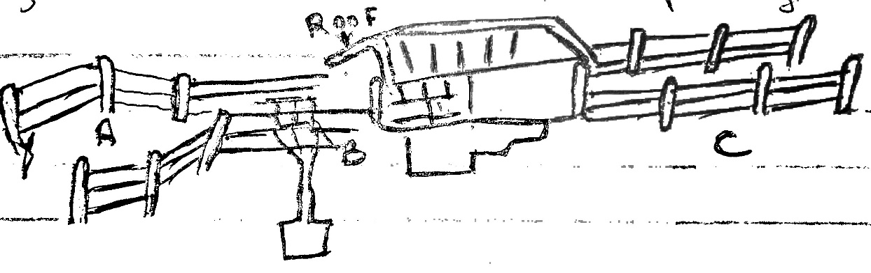

- Using a arrow on the diagram show the movement of cattle (½mark)

- State one use of parts A, B and C (3marks)
A……………………………………………………………………………………………
B……………………………………………………………………………………………
C……………………………………………………………………………………………

(c) State two precautions a farmer should take on dip to ensure effective dipping (2marks)
(i)……………………………………………………………………………………………………………
ii)……………………………………………………………………………………………………………
(d) State two uses of the roof of the dip (2marks)
(i)……………………………………………………………………………………………………………
ii)……………………………………………………………………………………………………………
b) State three disadvantages of a plunge dip (3marks) ………………………………………………………………………………………………………………………………………………………………………………………………………………………………………………………………………………………………………………………………………………
- Below is a diagram showing parts of a fence. Use it to answer the questions that follow.

H

K
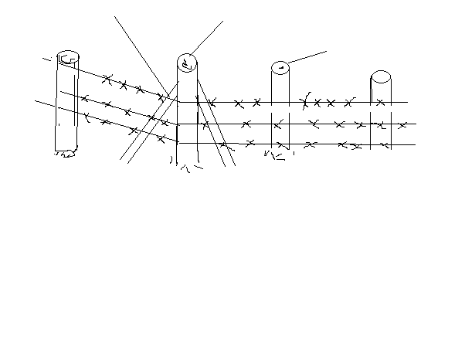
J
J
(a) Identify the type of fence above. (1mk)
………………………………………………………………………………………………………………
(b) Name the parts labeled H and J. (2mks)
H……………………………………………………………………………………
J…………………………………………………………………………………….
(c) What is the role of the part labeled K? (1mk)
........................................................................................................................................................................
………………………………………………………………………………………………………………
(d) On the diagram, draw a dropper in the right position. (1mk)

- The diagram below shows a pest and the damaged crop study it and answer the questions that follow.
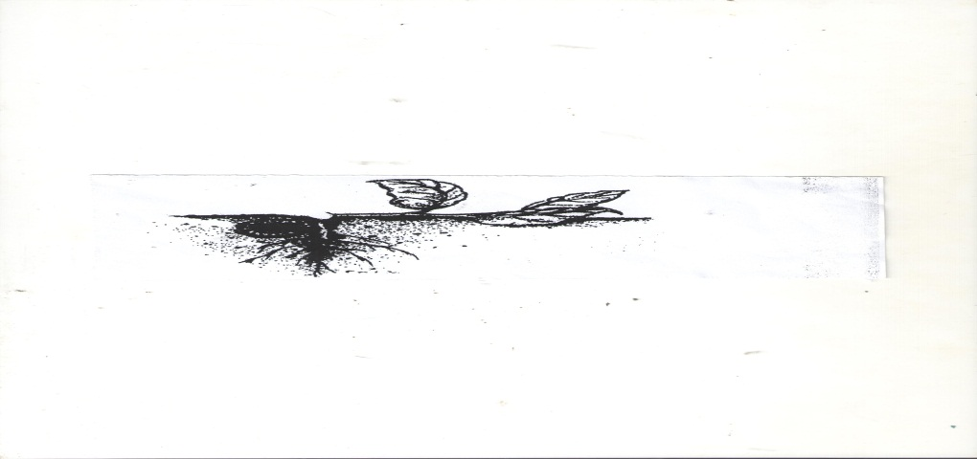
a) Identify the pest illustrated above (1mk)
................................................................................................................................................................................................................................................................................................................................................
b) Explain two ways of controlling the pest (2mks)
................................................................................................................................................................................................................................................................................................................................................
...............................................................................................................................................................................................................................................................................................................................................
c) State two ways in which the pest economically important. (2mks)
................................................................................................................................................................................................................................................................................................................................................
- a) Distinguish between straight and compound fertilizers. (1mk)
................................................................................................................................................................................................................................................................................................................................................
................................................................................................................................................................................................................................................................................................................................................
b) A farmer applied 200kg of C A N (20%N) per hectare maize crop. Calculate the amount
of Nitrogen applied on his 5 hectare crop. Show your working (4mks)

SECTION C (20MKS)
- (a) Describe the production of beans under the following sub-topics;
(i) Planting (4 marks)
................................................................................................................................................................................................................................................................................................................................................
................................................................................................................................................................................................................................................................................................................................................
................................................................................................................................................................................................................................................................................................................................................
(ii) Field practices (4 marks)
................................................................................................................................................................................................................................................................................................................................................
................................................................................................................................................................................................................................................................................................................................................
................................................................................................................................................................................................................................................................................................................................................
(iii) Harvesting (4 marks)
................................................................................................................................................................................................................................................................................................................................................
................................................................................................................................................................................................................................................................................................................................................
................................................................................................................................................................................................................................................................................................................................................
b) Outline four safety measures undertaken in the use of herbicides to minimize
environmental pollution. (4 marks)
................................................................................................................................................................................................................................................................................................................................................
................................................................................................................................................................................................................................................................................................................................................
................................................................................................................................................................................................................................................................................................................................................
c) Describe the precautions taken into account during harvesting of cotton (4 marks)
................................................................................................................................................................................................................................................................................................................................................
................................................................................................................................................................................................................................................................................................................................................
................................................................................................................................................................................................................................................................................................................................................
- (a) Describe five pre-disposing factor of livestock diseases. (5marks)
................................................................................................................................................................................................................................................................................................................................................
................................................................................................................................................................................................................................................................................................................................................
........................................................................................................................................................................
(b) Describe six mechanical methods of controlling ticks (6marks)
................................................................................................................................................................................................................................................................................................................................................
................................................................................................................................................................................................................................................................................................................................................
................................................................................................................................................................................................................................................................................................................................................
(c) Describe the factors that affect milk composition of a cow (9marks)
................................................................................................................................................................................................................................................................................................................................................
................................................................................................................................................................................................................................................................................................................................................
................................................................................................................................................................................................................................................................................................................................................
................................................................................................................................................................................................................................................................................................................................................
................................................................................................................................................................................................................................................................................................................................................
- (a) Describe various cultural uses of livestock. (8mks)
................................................................................................................................................................................................................................................................................................................................................
................................................................................................................................................................................................................................................................................................................................................
................................................................................................................................................................................................................................................................................................................................................
................................................................................................................................................................................................................................................................................................................................................
........................................................................................................................................................................
(b) Describe various livestock rearing practices. (12mks)
................................................................................................................................................................................................................................................................................................................................................
................................................................................................................................................................................................................................................................................................................................................
................................................................................................................................................................................................................................................................................................................................................
................................................................................................................................................................................................................................................................................................................................................
................................................................................................................................................................................................................................................................................................................................................
................................................................................................................................................................................................................................................................................................................................................
........................................................................................................................................................................
................................................................................................................................................................................................................................................................................................................................................
………………………………………………………………………………………………………………
........................................................................................................................................................................
................................................................................................................................................................................................................................................................................................................................................
………………………………………………………………………………………………………………

