NAME……………………………………………………………………………………ADM NO.…………..
CANDIDATES SIGNATURE………………………………… DATE……………………………………………..

AGRICULTURE
PAPER 1
444/1
TIME 2 HOURS
SET 2
FORM 4

INSTRUCTIONS TO CANDIDATES:
- Write your name and index number in the spaces provided above.
- Sign and write the date of examination in the spaces provided above.
- This paper consists of THREE Sections A, B and C.
- Answer all questions in Section A and B.
- Answer two questions in Section C in the spaces provided.

FOR EXAMINER’S USE ONLY

Section | Question | Maximum  Score | Candidate’s  Score
A | 1 - 20 | 30
B | 21 - 25 | 20
C | 26 - 28 | 20
C |  | 20
Total Score |  | 90

SECTION A (30 MARKS)
Answer all questions in this section.
1. Give two characteristics of plantation farming. (1 mark)
………………………………………………………………………………………………………………………
………………………………………………………………………………………………………………………
………………………………………………………………………………………………………………………
………………………………………………………………………………………………………………………
………………………………………………………………………………………………………………………
2. Name two chemical processes of weathering. (1 mark)
………………………………………………………………………………………………………………………
………………………………………………………………………………………………………………………
………………………………………………………………………………………………………………………
………………………………………………………………………………………………………………………
………………………………………………………………………………………………………………………
3. State three advantages of organic farming. (1 ½ marks)
………………………………………………………………………………………………………………………
………………………………………………………………………………………………………………………
………………………………………………………………………………………………………………………
………………………………………………………………………………………………………………………
………………………………………………………………………………………………………………………
………………………………………………………………………………………………………………………
4. Mention three effects of soil organisms which benefit plant growth. (1 ½ marks)
………………………………………………………………………………………………………………………
………………………………………………………………………………………………………………………
………………………………………………………………………………………………………………………
………………………………………………………………………………………………………………………
………………………………………………………………………………………………………………………
5. Give two types of labour records in the farm. (1 mark)
………………………………………………………………………………………………………………………
………………………………………………………………………………………………………………………
………………………………………………………………………………………………………………………
………………………………………………………………………………………………………………………

6. Give three ways in which land consolidation helps to improve farm management. (1 ½ marks)
………………………………………………………………………………………………………………………
………………………………………………………………………………………………………………………
………………………………………………………………………………………………………………………
………………………………………………………………………………………………………………………
………………………………………………………………………………………………………………………
………………………………………………………………………………………………………………………
7. State four importance of raising tomato seedlings in a nursery bed. (2 marks)
………………………………………………………………………………………………………………………
………………………………………………………………………………………………………………………
………………………………………………………………………………………………………………………
………………………………………………………………………………………………………………………
………………………………………………………………………………………………………………………
……………………………………………………………………………………………………………………..
8. Give three ways of controlling weeds in a field of beans. (1 ½ marks)
………………………………………………………………………………………………………………………
………………………………………………………………………………………………………………………
………………………………………………………………………………………………………………………
………………………………………………………………………………………………………………………
………………………………………………………………………………………………………………………
9. Give four reasons for earthing up in crops as a field practice. (2 marks)
………………………………………………………………………………………………………………………
………………………………………………………………………………………………………………………
………………………………………………………………………………………………………………………
………………………………………………………………………………………………………………………
………………………………………………………………………………………………………………………
………………………………………………………………………………………………………………………
10. State three activities the farmer carries out on a store before storing grains. (1 ½ marks)
………………………………………………………………………………………………………………………
………………………………………………………………………………………………………………………
………………………………………………………………………………………………………………………
………………………………………………………………………………………………………………………
………………………………………………………………………………………………………………………
11. Give four characteristics of certified seeds. (2 marks)
………………………………………………………………………………………………………………………
………………………………………………………………………………………………………………………
………………………………………………………………………………………………………………………
………………………………………………………………………………………………………………………
………………………………………………………………………………………………………………………
………………………………………………………………………………………………………………………
12. (a) Name two liming element in crop production. (1 mark)
………………………………………………………………………………………………………………………
………………………………………………………………………………………………………………………
………………………………………………………………………………………………………………………
(b) Give the forms in which the following elements are available to plants: (1 mark)
(i) Calcium
………………………………………………………………………………………………………………………
………………………………………………………………………………………………………………………
(ii) Potassium
………………………………………………………………………………………………………………………
………………………………………………………………………………………………………………………
13. List three general symptoms of viral diseases in crops. (1 ½ marks)
………………………………………………………………………………………………………………………
………………………………………………………………………………………………………………………
………………………………………………………………………………………………………………………
………………………………………………………………………………………………………………………
………………………………………………………………………………………………………………………
………………………………………………………………………………………………………………………
14. Give four factors that influence the choice of tools and equipment used in Primary cultivation. (2 marks)
………………………………………………………………………………………………………………………
………………………………………………………………………………………………………………………
………………………………………………………………………………………………………………………
………………………………………………………………………………………………………………………
………………………………………………………………………………………………………………………
………………………………………………………………………………………………………………………
……………………………………………………………………………………………………………………..
15. State four factors that contribute to competitive ability of weeds. (2 marks)
………………………………………………………………………………………………………………………
………………………………………………………………………………………………………………………
………………………………………………………………………………………………………………………
………………………………………………………………………………………………………………………
………………………………………………………………………………………………………………………
………………………………………………………………………………………………………………………
………………………………………………………………………………………………………………………
………………………………………………………………………………………………………………………
16. Name four physical methods of erosion control.
………………………………………………………………………………………………………………………
………………………………………………………………………………………………………………………
………………………………………………………………………………………………………………………
………………………………………………………………………………………………………………………
………………………………………………………………………………………………………………………
………………………………………………………………………………………………………………………
………………………………………………………………………………………………………………………
17. List four features of plastic pipes a farmer should consider before buying. (2 marks)
………………………………………………………………………………………………………………………
………………………………………………………………………………………………………………………
………………………………………………………………………………………………………………………
………………………………………………………………………………………………………………………
………………………………………………………………………………………………………………………
………………………………………………………………………………………………………………………
………………………………………………………………………………………………………………………
……………………………………………………………………………………………………………………...
18. State three causes of blossom end rot disease in tomato crop. (1½ marks)
………………………………………………………………………………………………………………………
………………………………………………………………………………………………………………………
………………………………………………………………………………………………………………………
………………………………………………………………………………………………………………………
………………………………………………………………………………………………………………………
………………………………………………………………………………………………………………………
19. State three desirable characteristics of agro forestry trees a farmer would consider before planting in the farm. (1½ marks)
………………………………………………………………………………………………………………………
………………………………………………………………………………………………………………………
………………………………………………………………………………………………………………………
………………………………………………………………………………………………………………………
………………………………………………………………………………………………………………………
………………………………………………………………………………………………………………………
20. Name two items that a maize farmer can enter into his consumable inventory records. (1 mark)
………………………………………………………………………………………………………………………
………………………………………………………………………………………………………………………
………………………………………………………………………………………………………………………
SECTION B (20 MARKS)
Answer all the questions from this section in the spaces provided.
21. Study the diagram below carefully and answer the questions that follow.
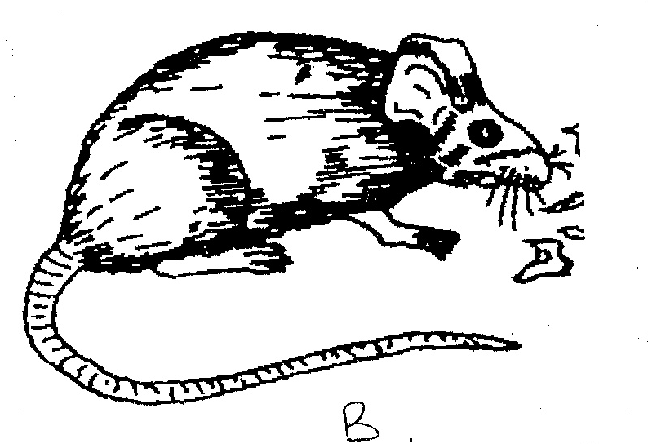
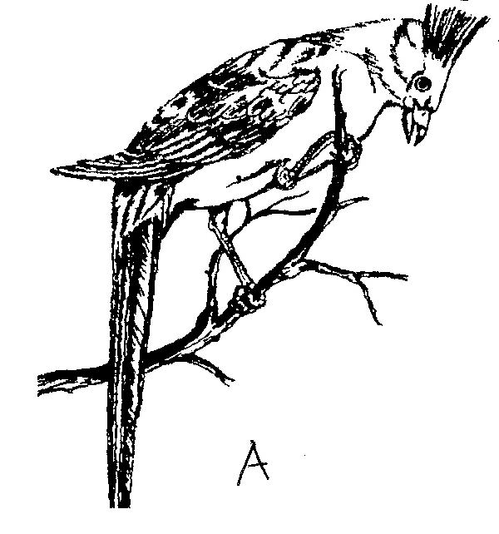

(a) Identify the field pest shown in the illustration A and B above. (2 marks)
A -
B–
(b) State two effect the pest expressed in A above has on maize plant. (2 marks)
………………………………………………………………………………………………………………………
………………………………………………………………………………………………………………………
………………………………………………………………………………………………………………………
………………………………………………………………………………………………………………………
………………………………………………………………………………………………………………………
………………………………………………………………………………………………………………………
22. The diagram below shows a farm record. Sturdy it and answer the question that follow
Enterprise…………………………………………………………………………………………
Type of feed………………………………………………………………………………………
Date | No. of animal | Amount Received  (Kg) | Amount used  (Kg) | Balance in stock  (Kg) | Remark

a) Identify the farm record (1 mark)
………………………………………………………………………………………………………………………
b) Name four other records kept in the farm. (2 marks)
………………………………………………………………………………………………………………………
………………………………………………………………………………………………………………………
………………………………………………………………………………………………………………………
………………………………………………………………………………………………………………………
………………………………………………………………………………………………………………………
………………………………………………………………………………………………………………………

23. The diagram labeled is an illustration of coffee established using a certain formative pruning system. Study it and answer the questions that follow.
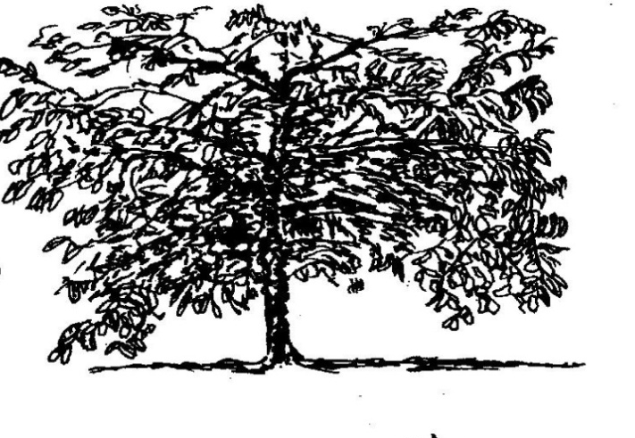

a) Name the system of pruning illustrated in diagram above (1 mark)
……………………………………………………………………………………………………………………
b) Explain how the pruning system illustrated above is carried out. (2 marks)
………………………………………………………………………………………………………………………
………………………………………………………………………………………………………………………
………………………………………………………………………………………………………………………
………………………………………………………………………………………………………………………
………………………………………………………………………………………………………………………
………………………………………………………………………………………………………………………
24. The diagram below illustrates an experiment on soil. Study it carefully and answer the questions that follow.
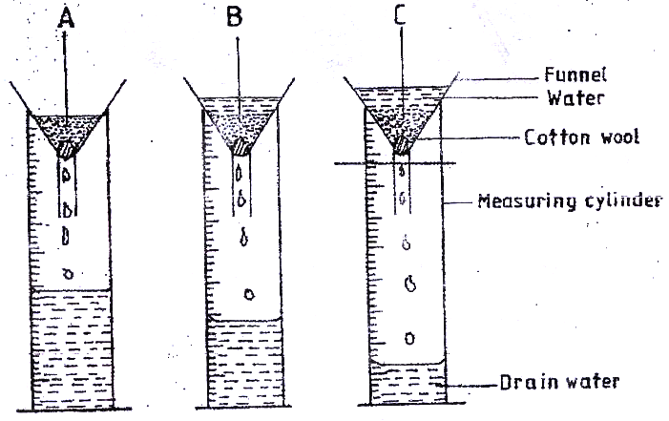

(a) State the aim of the experiment (1 mark)
………………………………………………………………………………………………………………………
………………………………………………………………………………………………………………………
………………………………………………………………………………………………………………………
………………………………………………………………………………………………………………………
………………………………………………………………………………………………………………………
………………………………………………………………………………………………………………………

(b) If the volume of water illustrated in the measuring cylinders was observed after one hour, identify the
soil samples labeled A and B. (1 mark)
A ……………………………………………………………….. B ……………………………………………………………………..
(c) State four ways in which the soil structure of the soil sample labeled C above can be improved. (4 marks)
………………………………………………………………………………………………………………………
………………………………………………………………………………………………………………………
………………………………………………………………………………………………………………………
………………………………………………………………………………………………………………………
………………………………………………………………………………………………………………………
25. The diagram below shows a method of forage preservation.
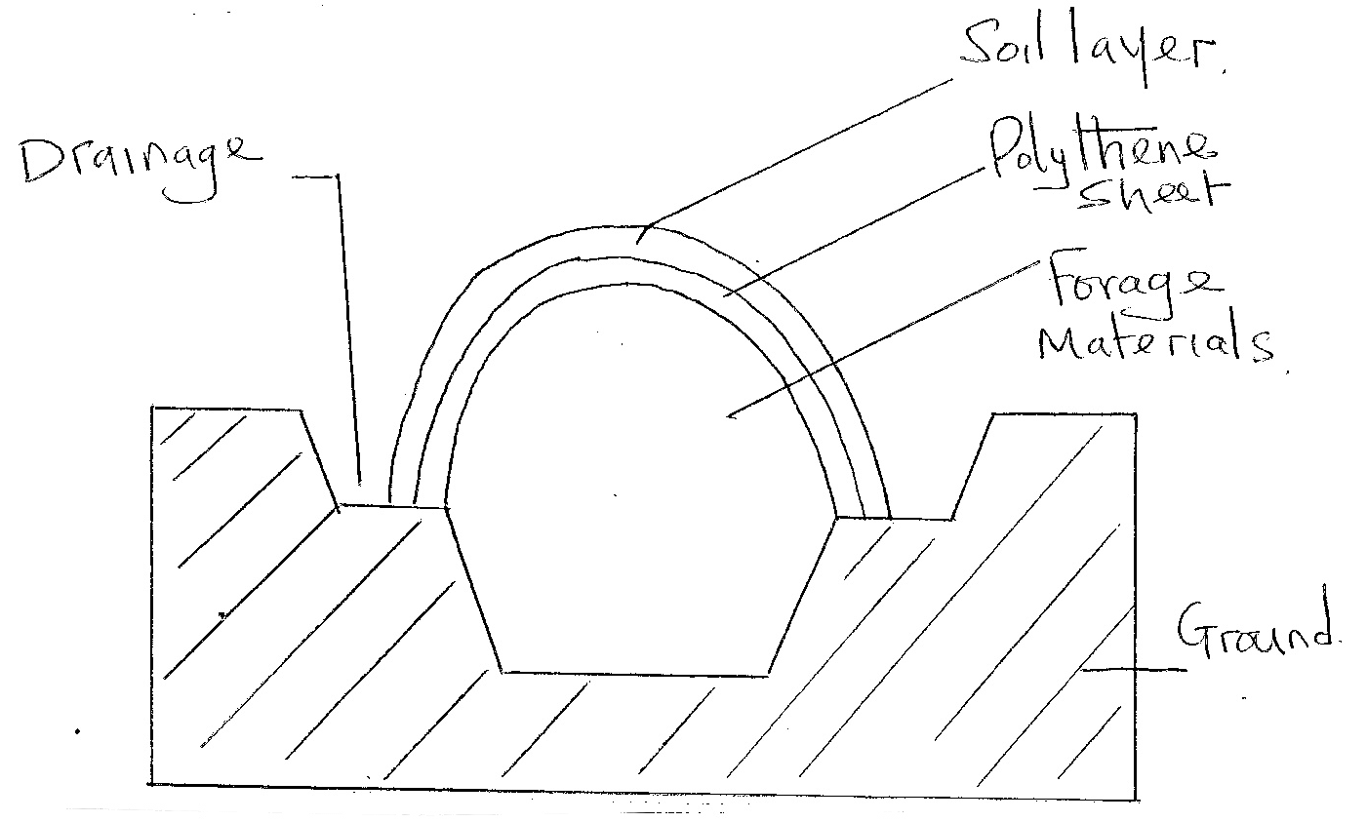

(i) Identify the structure illustrated above. (1 mark)
………………………………………………………………………………………………………………………
(ii) State the form in which forage is conserved as illustrated above. (1 mark)
………………………………………………………………………………………………………………………
………………………………………………………………………………………………………………………
(iii) Give the role of the following in the structure above. (2 marks)
- Polythene sheet.
- Drainage
………………………………………………………………………………………………………………………
………………………………………………………………………………………………………………………
………………………………………………………………………………………………………………………
………………………………………………………………………………………………………………………
………………………………………………………………………………………………………………………
………………………………………………………………………………………………………………………
SECTION C (40 MARKS)
Answer TWO questions from this section.
26. a) Describe coffee harvesting procedure. (5 marks)
b) i) A farmer is supposed to apply a compound fertilizer 20:30:10 on a plot measuring 5m long and 4m wide at the rate of 200kg/ha. What do the figures 20:30 stand for? (2 marks)
ii) Calculate the amount of fertilizer the farmer will require per plot. Show your working. (3 marks)
c) Explain ten ways of maintaining soil fertility in a farm. (10 marks)
27. a) Explain ten factors to consider when selecting implements for primary tillage. (10 marks)
b) Explain five routine management practices in raising cabbage seedlings. (5 marks)
c) Calculate the plant population if maize is plant at a spacing of 90 cm by 30 cm in a plot measuring
4 × 3m. ( Show your working) (3 marks)
d) Explain five ways of preventing of water pollution. (5 marks)
28. a) Explain factors which influence the site selection of a nursery bed. (12 marks)
b) Explain land preparation and planting in carrot production. (8 marks)
………………………………………………………………………………………………………………………
………………………………………………………………………………………………………………………
………………………………………………………………………………………………………………………
………………………………………………………………………………………………………………………
………………………………………………………………………………………………………………………
………………………………………………………………………………………………………………………
………………………………………………………………………………………………………………………
………………………………………………………………………………………………………………………
………………………………………………………………………………………………………………………
………………………………………………………………………………………………………………………
………………………………………………………………………………………………………………………
………………………………………………………………………………………………………………………
………………………………………………………………………………………………………………………
………………………………………………………………………………………………………………………
………………………………………………………………………………………………………………………
………………………………………………………………………………………………………………………
………………………………………………………………………………………………………………………
………………………………………………………………………………………………………………………
………………………………………………………………………………………………………………………
………………………………………………………………………………………………………………………
………………………………………………………………………………………………………………………
………………………………………………………………………………………………………………………
………………………………………………………………………………………………………………………
………………………………………………………………………………………………………………………
………………………………………………………………………………………………………………………
………………………………………………………………………………………………………………………
………………………………………………………………………………………………………………………
………………………………………………………………………………………………………………………
………………………………………………………………………………………………………………………
………………………………………………………………………………………………………………………
………………………………………………………………………………………………………………………
………………………………………………………………………………………………………………………
………………………………………………………………………………………………………………………
………………………………………………………………………………………………………………………
………………………………………………………………………………………………………………………
………………………………………………………………………………………………………………………
………………………………………………………………………………………………………………………
………………………………………………………………………………………………………………………
………………………………………………………………………………………………………………………
………………………………………………………………………………………………………………………
………………………………………………………………………………………………………………………
………………………………………………………………………………………………………………………
………………………………………………………………………………………………………………………
………………………………………………………………………………………………………………………
………………………………………………………………………………………………………………………
………………………………………………………………………………………………………………………
………………………………………………………………………………………………………………………
………………………………………………………………………………………………………………………
………………………………………………………………………………………………………………………
………………………………………………………………………………………………………………………
………………………………………………………………………………………………………………………
………………………………………………………………………………………………………………………
………………………………………………………………………………………………………………………
………………………………………………………………………………………………………………………
………………………………………………………………………………………………………………………
………………………………………………………………………………………………………………………
………………………………………………………………………………………………………………………
………………………………………………………………………………………………………………………
………………………………………………………………………………………………………………………
………………………………………………………………………………………………………………………
………………………………………………………………………………………………………………………
………………………………………………………………………………………………………………………
………………………………………………………………………………………………………………………
………………………………………………………………………………………………………………………
………………………………………………………………………………………………………………………
………………………………………………………………………………………………………………………
………………………………………………………………………………………………………………………
………………………………………………………………………………………………………………………
………………………………………………………………………………………………………………………
………………………………………………………………………………………………………………………
………………………………………………………………………………………………………………………
………………………………………………………………………………………………………………………
………………………………………………………………………………………………………………………
………………………………………………………………………………………………………………………
………………………………………………………………………………………………………………………
………………………………………………………………………………………………………………………
………………………………………………………………………………………………………………………
………………………………………………………………………………………………………………………
………………………………………………………………………………………………………………………
………………………………………………………………………………………………………………………
………………………………………………………………………………………………………………………

