NAME ____________________________________ INDEX NO. _______________
SCHOOL ____________________________________ SIGNATURE _______________ DATE _______________

443/1
AGRICULTURE
PAPER 1
TIME: 2 HOURS

SET 7
FORM 4

443/1
AGRICULTURE
PAPER 1
TIME: 2 HOURS

INSTRUCTIONS TO CANDIDATES
- Write your name, school and index number, in the spaces provided above.
- Sign and write the date of the examination in the spaces provided above.
- This paper consists of three sections: A, B and C.
- Answer all the questions in section A and B and any two questions from section C.
- All answers must be written in the spaces provided in this booklet.
- This paper consists of 12 printed pages.
- Candidates should check the question paper to ascertain that all pages are printed as indicated and that no questions are missing

For OFFICIAL use only
SECTION | QUESTIONS | MAXIMUM SCORE | CANDIDATES SCORE
A | 1 − 18 | 30
B | 19 − 22 | 20
C |  | 20
C |  | 20
 | TOTAL SCORE | 90

SECTION A (30MARKS)
Answer ALL the questions in the spaces provided
- Give four biotic factors which influence Agriculture positively. (2 marks)
_______________________________________________________________________________________________________________________________________________________________________________________________________________________________________________________________________________________________________________________________________________________________________________________________________________________________
- State two farming practices which enhance organic farming. (1 mark)
_________________________________________________________________________________________________________________________________________________________________________________________________________________________________________________________
- Which chemical are used during water treatment to; (1½ marks)
- Coagulate solid particles _____________________________________________________________
- Soften the water _____________________________________________________________
- Kill pathogens _____________________________________________________________
- Give two reasons that makes phosphatic fertilizers good for use during planting time. (1 mark)
_________________________________________________________________________________________________________________________________________________________________________________________________________________________________________________________
- List down four qualities of a good farm record. (2 marks)
_______________________________________________________________________________________________________________________________________________________________________________________________________________________________________________________________________________________________________________________________________________________________________________________________________________________________
- What do you understand by the following terms? (1½ marks)
- Seed dressing
______________________________________________________________________________________________________________________________________________________________________
- Seed inoculation
______________________________________________________________________________________________________________________________________________________________________
- Chitting
______________________________________________________________________________________________________________________________________________________________________
- How would a farmer prepare propagules for establishment in the main field in tissue culture? (1½ marks)
____________________________________________________________________________________________________________________________________________________________________________________________________________________________________________________________________________________________________________________________________________
- List down four land reforms programmes which have been carried out in Kenya since independence. (2 marks)
_______________________________________________________________________________________________________________________________________________________________________________________________________________________________________________________________________________________________________________________________________________________________________________________________________________________________
- List down four common methods of harvesting water. (2 marks)
_______________________________________________________________________________________________________________________________________________________________________________________________________________________________________________________________________________________________________________________________________________________________________________________________________________________________
- Give three properties of weeds that make them adopt well in their environment. (1½ marks)
____________________________________________________________________________________________________________________________________________________________________________________________________________________________________________________________________________________________________________________________________________
- What do you understand by the following terms as used in pests classification according to mode of action. (2 marks)
- Stomach poisons
______________________________________________________________________________________________________________________________________________________________________
- Systemic poisons
______________________________________________________________________________________________________________________________________________________________________
- Contact poisons
______________________________________________________________________________________________________________________________________________________________________
- Suffocants
______________________________________________________________________________________________________________________________________________________________________
- List down four diseases of maize in Kenya. (2 marks)
_______________________________________________________________________________________________________________________________________________________________________________________________________________________________________________________________________________________________________________________________________________________________________________________________________________________________
- State four good qualities of silage. (2 marks)
_______________________________________________________________________________________________________________________________________________________________________________________________________________________________________________________________________________________________________________________________________________________________________________________________________________________________
- Name three (3) sources of capital used in Agriculture. (1½ marks)
____________________________________________________________________________________________________________________________________________________________________________________________________________________________________________________________________________________________________________________________________________
- Give four financial Books used in farm accounts. (2 marks)
____________________________________________________________________________________________________________________________________________________________________________________________________________________________________________________________________________________________________________________________________________
- Name three (3) types of farmers co-operative societies in Kenya. (1½ marks)
____________________________________________________________________________________________________________________________________________________________________________________________________________________________________________________________________________________________________________________________________________
- State two factors that determine the price of a commodity in the market. (1 mark)
_________________________________________________________________________________________________________________________________________________________________________________________________________________________________________________________
- Briefly explain four qualities of trees and shrubs suitable for Agroforestry. (2 marks)
_______________________________________________________________________________________________________________________________________________________________________________________________________________________________________________________________________________________________________________________________________________________________________________________________________________________________
SECTION B (20 MARKS)
Answer ALL the questions in the spaces provides
- Below are two types of soil structures A and B.
A
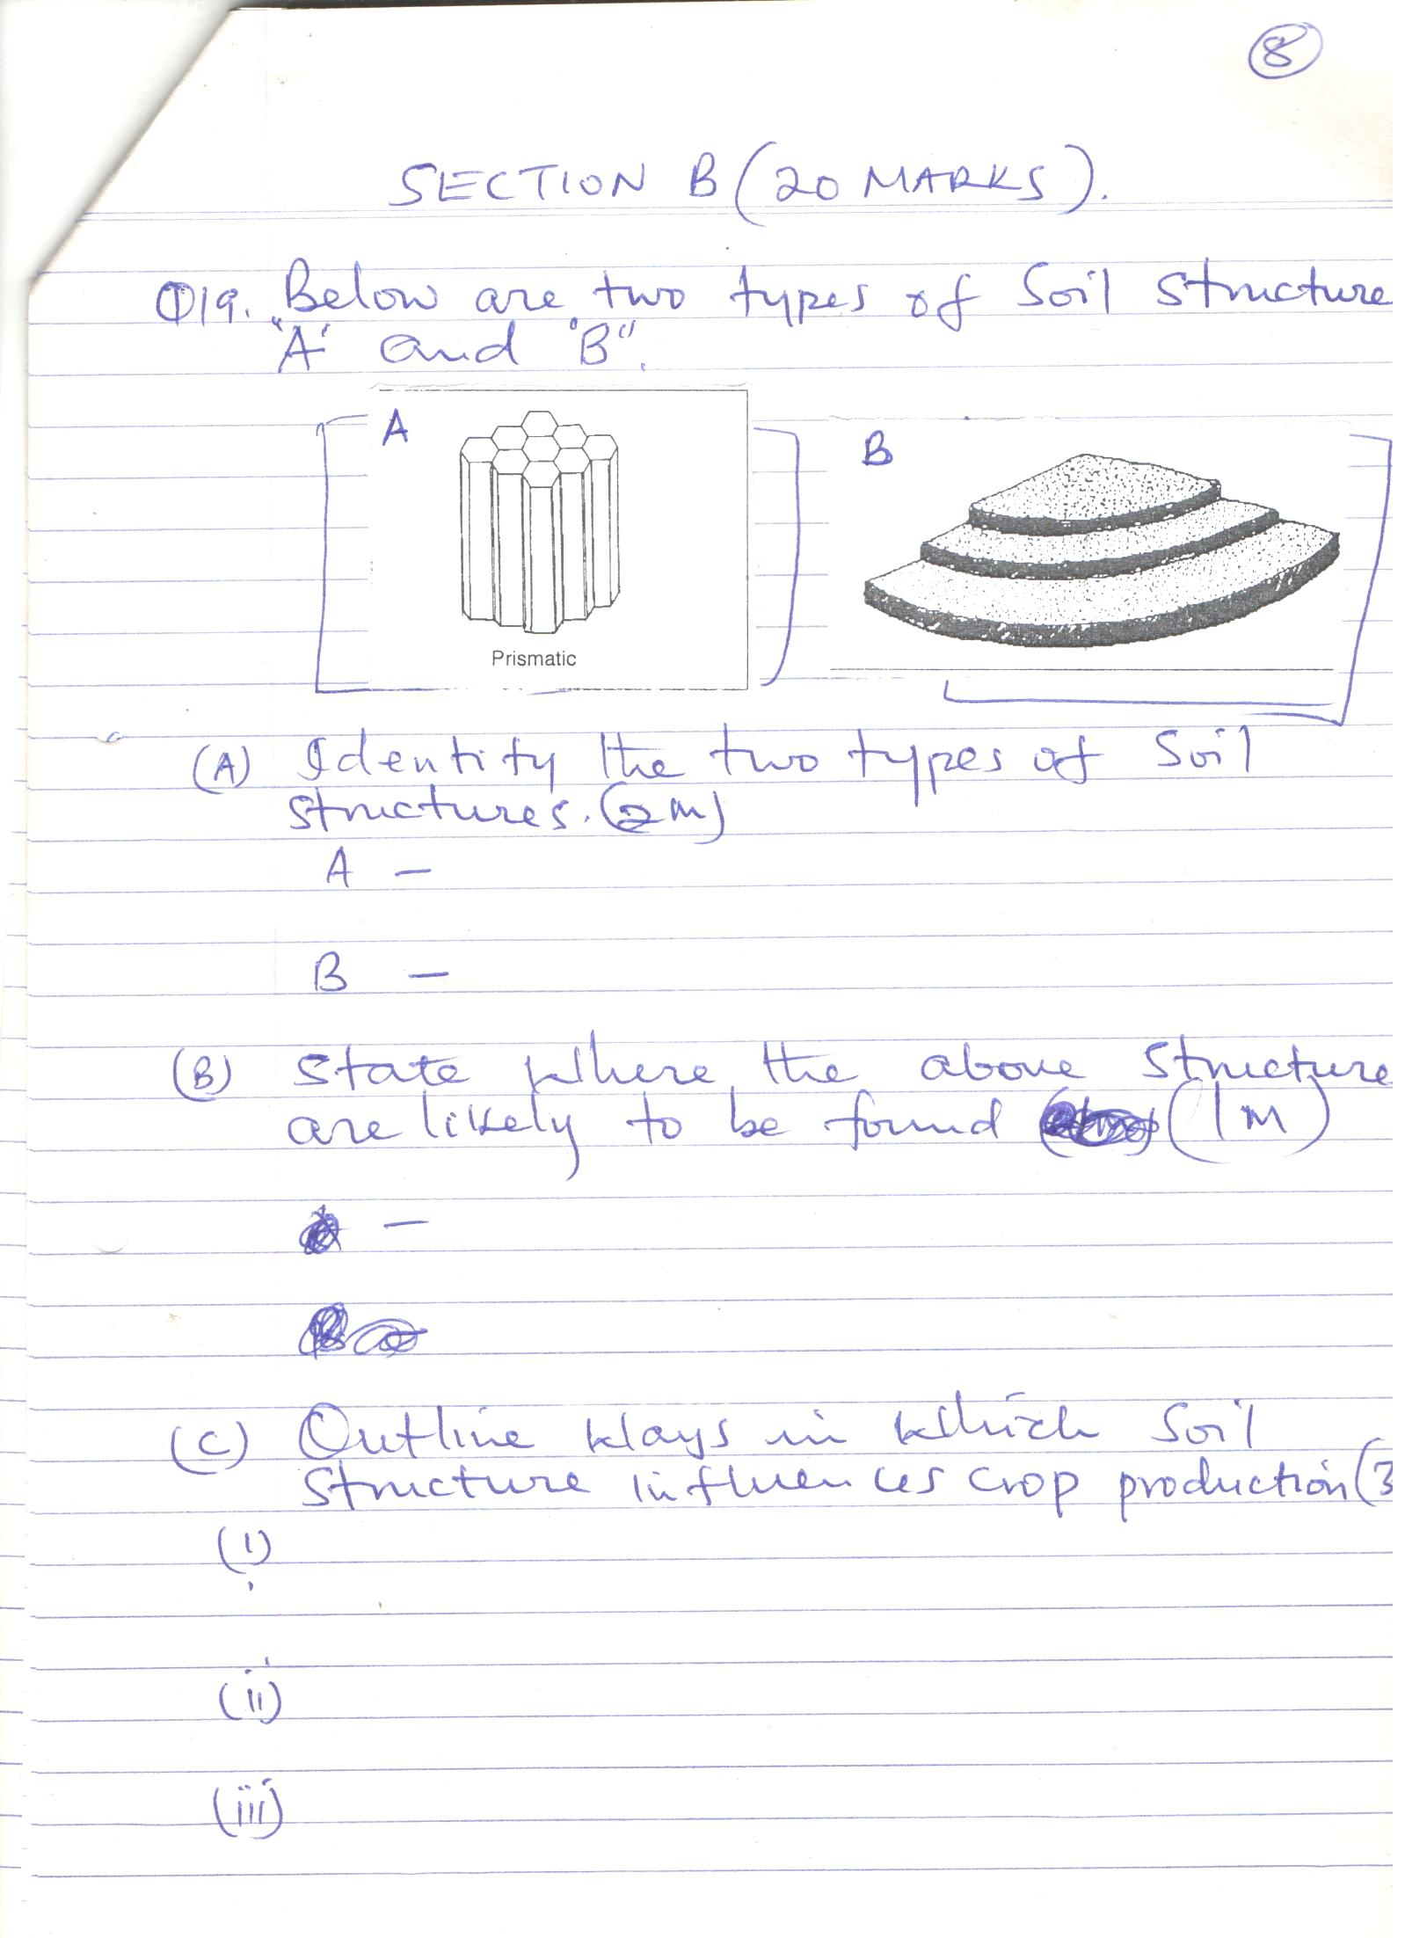

B
- Identify the two- types of soil structures. (2 marks)
A _________________________________________________________________________________
B _________________________________________________________________________________
- State where the above soil structures are likely to be found. (1 mark)
___________________________________________________________________________________
- Outline ways which soil structure influences crop production. (3 marks)
____________________________________________________________________________________________________________________________________________________________________________________________________________________________________________________________________________________________________________________________________________
- The diagram below gives an illustration of a type of irrigation.
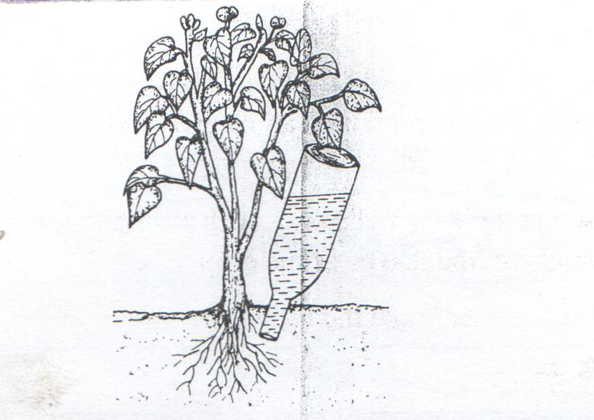
- Identify the method of irrigation shown above. (1 marks)
___________________________________________________________________________________
- State two advantages of the above irrigation. (2 marks)
_________________________________________________________________________________________________________________________________________________________________________________________________________________________________________________________

- Outline two main Reasons why the above method of irrigation is NOT commonly used by most farmers. (2 marks)
_________________________________________________________________________________________________________________________________________________________________________________________________________________________________________________________
- The diagram below shows common weeds, study them and answer the questions that follow. 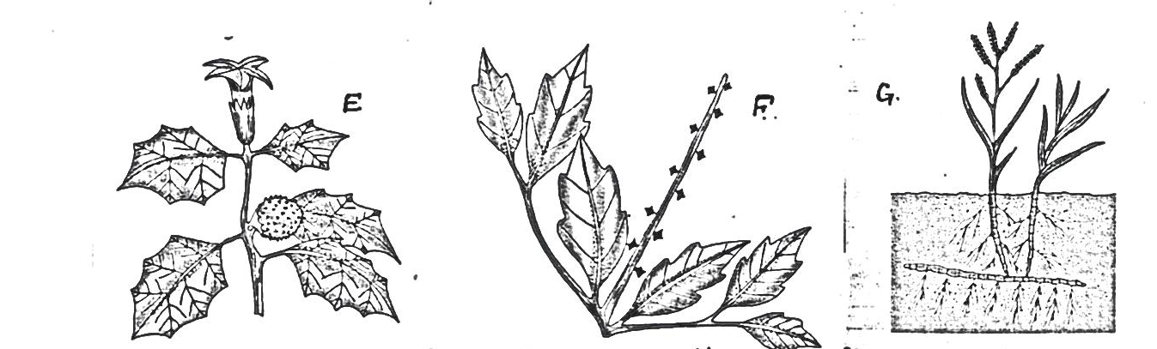
G
F
E
- Identify the weeds E, F and G. (1½ marks)
E _________________________________________________________________________________
F _________________________________________________________________________________
G _________________________________________________________________________________
- State three harmful effects of the weeds. (1½ marks)
____________________________________________________________________________________________________________________________________________________________________________________________________________________________________________________________________________________________________________________________________________
- State two safety precautions that should be observed in order to protect the user and environment when using herbicides. (1 mark)
_________________________________________________________________________________________________________________________________________________________________________________________________________________________________________________________
- State the effects of weed labeled E to livestock. (1 mark)
______________________________________________________________________________________________________________________________________________________________________
- Give one reasons why it is difficult to control the weed labeled G. ( 1 mark)
______________________________________________________________________________________________________________________________________________________________________

- Below is a graph showing the relationship between supply and demand in price determination.
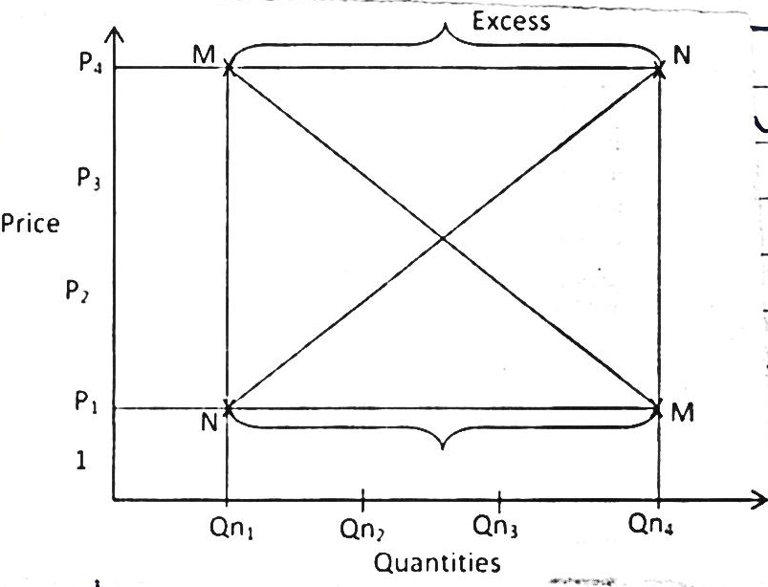
Quantities
Qn₁ Qn₂ Qn₃ Qn₄

Price

- Name the curves. (1 mark)
M_________________________________________________________________________________
N__________________________________________________________________________________
- State the name given to the profit where the two curves M and N intersect.
___________________________________________________________________________________
- Give two reasons why there is excess supply above P4.
_________________________________________________________________________________________________________________________________________________________________________________________________________________________________________________________

SECTION C (40MARKS)
Answer any TWO questions in this section in the spaces provided after question 25
- a) Outline the factors affecting rooting of cuttings. (5 marks)
b) State and explain human factors that influence Agricultural production. (10 marks)
c) Highlight the management practices carried out in a nursery. (5 marks)

- The following information was obtained from Nguuni farm records on 31/12/2013.
Loans payable to bank 300,000
Five milking cows 250,000
Twenty Goats 30,000
400 layers 80,000
Debts payable to co-op society 20,000
Building and structure 600,000
Bonus payable to workers 19,000
Cattle feeds in store 10,000
Debt receivable 18,000
Animal drugs in store 4,000
Repairs 30,000
Cash at hand 20,000
Cash in bank 30,000
Spray equipment 20,000
- i) Using the above information prepare a balance sheet for Nguuni farm. (9 marks)
- Was the business solvent or insolvent? (1 mark)

b) Describe five effects of fragmentation and subdivision of land. (5 marks)
c) Explain any five effects of weeds on pastures. (5 marks)

- a) State and explain five ways through which soil loses its fertility. (10 marks)
b) Describe five characteristics of Nitrogenous fertilizers. (5 marks)
c) Outline five methods used in application of inorganic fertilizers. (5 marks)

____________________________________________________________________________________________________________________________________________________________________________________________________________________________________________________________________________________________________________________________________________________________________________________________________________________________________________________________________________________________________________________________________________________________________________________________________________________________________________________________________________________________________________________________________________________________________________________________________________________________________________________________________________________________________________________________________________________________________________________________________________________________________________________________________________________________________________________________________________________________________________________________________________________________________________________________________________________________________________________________________________________________________________________________________________________________________________________________________________________________________________________________________________________________________________________________________________________________________________________________________________________________________________________________________________________________________________________________________________________________________________________________________________________________________________________________________________________________________________________________________________________________________________________________________________________________________________________________________________________________________________________________________________________________________________________________________________________________________________________________________________________________________________________________________________________________________________________________________________________________________________________________________________________________________________________________________________________________________________________________________________________________________________________________________________________________________________________________________________________________________________________________________________________________________________________________________________________________________________________________________________________________________________________________________________________________________________________________________________________________________________________________________________________________________________________________________________________________________________________________________________________________________________________________________________________________________________________________________________________________________________________________________________________________________________________________________________________________________________________________________________________________________________________________________________________________________________________________________________________________________________________________________________________________________________________________________________________________________________________________________________________________________________________________________________________________________________________________________________________________________________________________________________________________________________________________________________________________________________________________________________________________________________________________________________________________________________________________________________________________________________________________________________________________________________________________________________________________________________________________________________________________________________________________________________________________________________________________________________________________________________________________________________________________________________________________________________________________________________________________________________________________________________________________________________________________________________________________________________________________________________________________________________________________________________________________________________________________________________________________________________________________________________________________________________________________________________________________________________________________________________________________________________________________________________________________________________________________________________________________________________________________________________________________________________________________________________________________________________________________________________________________________________________________________________________________________________________________________________________________________________________________________________________________________________________________________________________________________________________________________________________________________________________________________________________________________________________________________________________________________________________________________________________________________________________________________________________________________________________________________________________________________________________________________________________________________________________________________________________________________________________________________________________________________________________________________________________________________________________________________________________________________________________________________________________________________________________________________________________________________________________________________________________________________________________________________________________________________________________________________________________________________________________________________________________________________________________________________________________________________________________________________________________________________________________________________________________________________________________________________________________________________________________________________________________________________________________________________________________________________________________________________________________________________________________________________________________________________________________________________________________________________________________________________________________________________________________________________________________________________________________________________________________________________________________________________________________________________________________________________________________________________________________________________________________________________________________________________________________________________________________________________________________________________________________________________________________________________________________________________________________________________________________________________________________________________________________________________________________________________________________________________________________________________________________________________________________________________________________________________________________________________________________________________________________________________________________________________________________________________________________________________________________________________________________________________________________________________________________________________________________________________________________________________________________________________________________________________________________________________________________________________________________________________________________________________________________________________________________________________________________________________________________________________________________________________________________________________________________________________________________________________________________________________________________________________________________
____________________________________________________________________________________________________________________________________________________________________________________________________________________________________________________________________________________________________________________________________________________________________________________________________________________________________________________________________________________________________________________________________________________________________________________________________________________________________________________________________________________________________________________________________________________________________________________________________________________________________________________________________________________________________________________________________________________________________________________________________________________________________________________________________________________________________________________________________________________________________________________________________________________________________________________________________________________________________________________________________________________________________________________________________________________________________________________________________________________________________________________________________________________________________________________________________________________________________________________________________________________________________________________________________________________________________________________________________________________________________________________________________________________________________________________________________________________________________________________________________________________________________________________________________________________________________________________________________________________________________________________________________________________________________________________________________________________________________________________________________________________________________________________________________________________________________________________________________________________________________________________________________________________________________________________________________________________________________________________________________________________________________________________________________________________________________________________________________________________________________________________________________________________________________________________________________________________________________________________________________________________________________________________________________________________________________________________________________________________________________________________________________________________________________________________________
________________________________________________________________________________________________________________________________________________________________________________________________________________________________________________________________________________________________________________________________________________________________________________________________________________________________________________________________________________________________________________________________________________________________________________________________________________________________________________________________________________________________________________________

