NAME...........................................................................................INDEX NO.................................../......
CANDIDATE’S SIGNATURE............................................... DATE......................................................
443/2
AGRICULTURE
Paper 2
2 Hours
SET 3
FORM 4
Instructions to candidates
- Write your name and index number in the spaces provided above.
- Sign and write the date of examination in the spaces provided above.
- This consists of three sections: A, B and c.
- Answer all the questions in sections A and B.
- Answer any two questions from section C.
- Answers should be written in the spaces provided.
- This paper consists of 12 printed pages.
- Candidates should check the question paper to ascertain that all the pages are printed as indicated and that no questions are missing.
For Examiner’s Use Only.
Section | Question | Maximum score | Candidate’s Score
A | 1 – 20 | 30
B | 21 – 25 | 20
C |  | 20
C |  | 20
Total Score

SECTION A – (30 Marks)
Answer all the questions in this section in the spaces provided
1. State three reasons for castrating a billy goat. (1 ½ marks)
……………………………………………………………………………………………………………………………………………………………………………………………………………………………………………………………………………………………………………………………………………….
……………………………………………………………………………………………………………………………………………………………………………………………………………………………………………………………………………………………………………………………………………….
2. Give reasons for maintaining farm machines (2 marks)
……………………………………………………………………………………………………………………………………………………………………………………………………………………………………………………………………………………………………………………………………………….
……………………………………………………………………………………………………………………………………………………………………………………………………………………………………………………………………………………………………………………………………………….
3. Name three functions of lubricating system (1 ½ marks)
……………………………………………………………………………………………………………………………………………………………………………………………………………………………………………………………………………………………………………………………………………….
………………………………………………………………………………………………………………
4. Name implements powdered by P.T.O: (1½ marks)
……………………………………………………………………………………………………………………………………………………………………………………………………………………………………………………………………………………………………………………………………………….
……………………………………………………………………………………………….
5 Give four disadvantages of using a hedge as a fence. (2marks)
……………………………………………………………………………………………………………………………………………………………………………………………………………………………………………………………………………………………………………………………………………….
……………………………………………………………………………………………………………………………………………………………………………………………………………………………………………………………………………………………………………………………………………….
6. State the four methods a farmer can use to control livestock diseases. (2marks)
……………………………………………………………………………………………………………………………………………………………………………………………………………………………………………………………………………………………………………………………………………….
……………………………………………………………………………………………………………………………………………………………………………………………………………………………………………………………………………………………………………………………………………….
7. Give four notifiable diseases in livestock. (2 marks)
……………………………………………………………………………………………………………………………………………………………………………………………………………………………………………………………………………………………………………………………………………….
……………………………………………………………………………………………………………………………………………………………………………………………………………………………………………………………………………………………………………………………………………….
8. a) State the advantages of artificial method of calf rearing (2 marks)
……………………………………………………………………………………………………………………………………………………………………………………………………………………………………………………………………………………………………………………………………………….
………………………………………………………………………………………………………………………………………………………………………………………………………………………………
b) Give three factors that enable ruminants to break down fibrous feed material.
(1½ marks)
……………………………………………………………………………………………………………………………………………………………………………………………………………………………………………………………………………………………………………………………………………….
………………………………………………………………………………………………………………………………………………………………………………………………………………………………
9. List the main source of electrical power. (2 marks)
……………………………………………………………………………………………………………………………………………………………………………………………………………………………………………………………………………………………………………………………………………….
………………………………………………………………………………………………………………………………………………………………………………………………………………………………
10. Name a tool used for tightening barbed wires during fencing. (½ mark)
……………………………………………………………………………………………………………………………………………………………………………………………………………………………………………………………………………………………………………………………………………….
………………………………………………………………………………………………………………………………………………………………………………………………………………………………
11. Name the hormone that influences milk synthesis in lactating cattle. (¹/₂ mark)
……………………………………………………………………………………………………………………………………………………………………………………………………………………………………………………………………………………………………………………………………………….………………………………………………………………………………………………………………………………………………………………………………………………………………………………

12. State the part of digestive system of a rabbit that enables it to digest vegetative feed.
(¹/₂ mark)
……………………………………………………………………………………………………………………………………………………………………………………………………………………………………………………………………………………………………………………………………………….
……………………………………………………………………………………………………………………………………………………………………………………………………………………………………………………………………………………………………………………………………………….
13. Name the part of the tractor where trailed implements are attached. (½ mark)
……………………………………………………………………………………………………………………………………………………………………………………………………………………………………………………………………………………………………………………………………………….
14. State three uses of green houses on the farm. (1 ½ marks)
……………………………………………………………………………………………………………………………………………………………………………………………………………………………………………………………………………………………………………………………………………….
……………………………………………………………………………………………………………………………………………………………………………………………………………………………………………………………………………………………………………………………………………….
15. State four dual purpose breeds of cattle reared in Kenya. (2 marks)
……………………………………………………………………………………………………………………………………………………………………………………………………………………………………………………………………………………………………………………………………………….
……………………………………………………………………………………………………………………………………………………………………………………………………………………………………………………………………………………………………………………………………………….
16. State two functions of a thermostat on a cooling system of a tractor engine. (1 mark)
……………………………………………………………………………………………………………………………………………………………………………………………………………………………………………………………………………………………………………………………………………….
………………………………………………………………………………………………………………………………………………………………………………………………………………………………
17. State two routes of a vaccination against. (1 mark)
……………………………………………………………………………………………………………………………………………………………………………………………………………………………………………………………………………………………………………………………………………….
……………………………………………………………………………………………………………………………………………………………………………………………………………………………….
18. What is culling in livestock? (½ mark)
……………………………………………………………………………………………………………………………………………………………………………………………………………………………………………………………………………………………………………………………………………….
19. Name four warm fresh water fish (2 marks)
……………………………………………………………………………………………………………………………………………………………………………………………………………………………………………………………………………………………………………………………………………….
………………………………………………………………………………………………………………
20. Give the functional difference between a Tenon Saw and a rip saw. (1 mark)
……………………………………………………………………………………………………………………………………………………………………………………………………………………………………………………………………………………………………………………………………………….

SECTION B – (20 Marks)
Answer all the questions in this section in the spaces provided.
21. The following diagram illustrates a symptom of a disease in poultry. Study it carefully and answer the questions that follow.
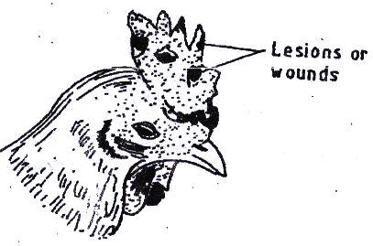

- Identify ;
(i) The disease (1 mark)
………………………………………………………………………………………………..
(ii) The causal organism (1 mark)
………………………………………………………………………………………………..
(b) Apart from lesions, state two other symptoms of the disease. (2 marks)
……………………………………………………………………………………………………………………………………………………………………………………………………………………………………………………………………………………………………………………………………………….
………………………………………………………………………………………………………………
(c) State two control measures for the disease (2 marks)
……………………………………………………………………………………………………………………………………………………………………………………………………………………………………………………………………………………………………………………………………………….
22. Below is a diagram showing a practice carried out in dairy cattle. Study and answer the questions that follow.
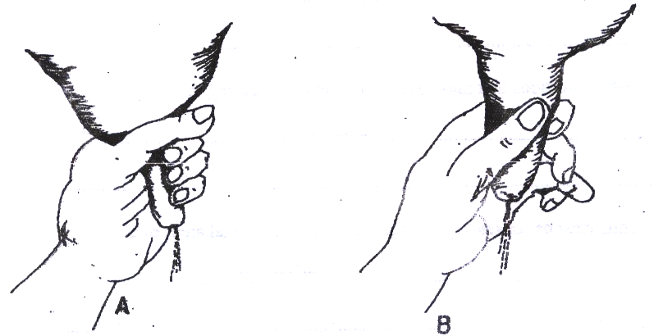

(a) Identify the appropriate techniques for milking (1 mark)
…………………………………………………………………………………………….
(b) Describe the procedure of milking technique in (a) above (2 marks)
……………………………………………………………………………………………………………………………………………………………………………………………………………………………………………………………………………………………………………………………………………….
23. The diagram below shows a farm implement. Study it and answer the questions that
follow.
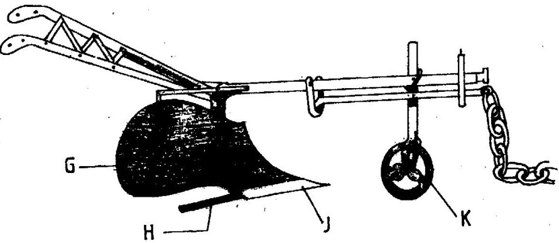

a) Identify the farm implement illustrated above. (1 mark)
……………………………………………………………………………………………

b) Name the parts labeled G, H, J and K. (4 marks)
G
H
J
K.
c) State four functions of the farm implement illustrated as G and H . (2 marks)

G
H
24. The diagram below illustrates a method of identification in livestock production.
Study the diagram and answer the Questions that follow.

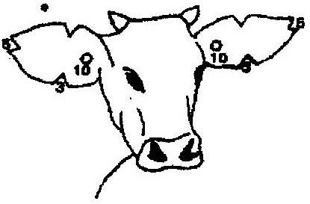

- Name the type of identification illustrated above. (1 mark)
……………………………………………………………………………………
- Give the identification number of the animal illustrated in the diagram above.
(1 mark)
……………………………………………………………………………………………………………………………………………………………………………………………………………………………………………………………………………………………………………………………………………….

25. Diagram R₁ and R₂ are illustration of an activity in bee farming. Study it carefully and answer the questions that follow.
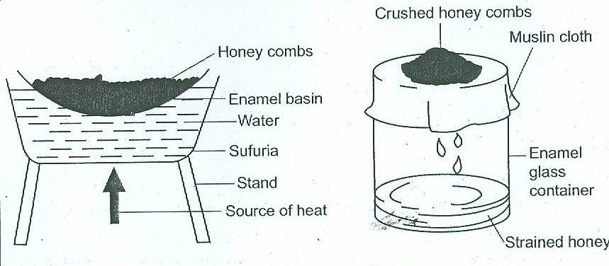
R₁ R₂
- Identify the activity in R₁ and R₂. ( 1 mark)
R₁
R₂
- State two factors which affect the quality of the above honey. (2 marks)
………………………………………………………………………………………………………………………………………………………………………………………………………………………………………………………………………………………………………………………………………………………………………………………………………………………………………………………………
SECTION C: (40 marks)
Answer two questions from this section
26. a) Explain ten Characteristics of a poor layer that a farmer should look for in a hen
during culling. (10 marks)
b) Describe ten daily maintenance practices that should be carried out on a farm
tractor. (10 marks)

27. a) Explain the importance of keeping livestock healthy. (10 marks)
b) Name the strokes in a four stroke engine and describe how each operates.
(10 marks)
28. a) Describe the procedure followed when constructing a barbed wire fence.
(5 marks)
b) Describe ten advantages of battery system in rearing poultry. (10 marks) c) Explain five functions of any parts of a zero grazing unit in dairy farming.
(5 marks) ……………………………………………………………………………………………………………………………………………………………………………………………………………………………………………………………………………………………………………………………………………….
……………………………………………………………………………………………………………………………………………………………………………………………………………………………………………………………………………………………………………………………………………….
……………………………………………………………………………………………………………………………………………………………………………………………………………………………………………………………………………………………………………………………………………….
……………………………………………………………………………………………………………………………………………………………………………………………………………………………………………………………………………………………………………………………………………….
……………………………………………………………………………………………………………………………………………………………………………………………………………………………………………………………………………………………………………………………………………….
……………………………………………………………………………………………………………………………………………………………………………………………………………………………………………………………………………………………………………………………………………….
……………………………………………………………………………………………………………………………………………………………………………………………………………………………………………………………………………………………………………………………………………….
……………………………………………………………………………………………………………………………………………………………………………………………………………………………………………………………………………………………………………………………………………….
……………………………………………………………………………………………………………………………………………………………………………………………………………………………………………………………………………………………………………………………………………….
……………………………………………………………………………………………………………………………………………………………………………………………………………………………………………………………………………………………………………………………………………….
……………………………………………………………………………………………………………………………………………………………………………………………………………………………………………………………………………………………………………………………………………….……………………………………………………………………………………………………………………………………………………………………………………………………………………………………………………………………………………………………………………………………………….
……………………………………………………………………………………………………………………………………………………………………………………………………………………………………………………………………………………………………………………………………………….……………………………………………………………………………………………………………………………………………………………………………………………………………………………………………………………………………………………………………………………………………….
……………………………………………………………………………………………………………………………………………………………………………………………………………………………………………………………………………………………………………………………………………….

