Name: …………………………………………………………… Index no ………....................................

School: …………………………………………………………. Candidate’s sign…….....…...…........…

Date: ……………………………………………………………

443/2
AGRICULTURE
PAPER 2
TIME: 2 HOURS

SET 8
FORM 4

Kenya Certificate of Secondary Education (K.C.S.E.)

AGRICULTURE
PAPER 2
2 HOURS

INSTRUCTIONS TO CANDIDATES:

- Write your name, index number and the name of your school in the spaces provided.
- Sign and write the date of the examination in the spaces provided.
- This paper consists of three sections; A, B and C.
- Answer all questions in section A and B.
- Answer any two questions in section C in the spaces provided.
- This paper consists of 10 printed pages. Candidates should check the question paper to ascertain that all pages are printed as indicated and that no questions are missing

For Examiner’s Use Only

SECTION | QUESTION | MAXIMUM  SCORE | CANDIDATE’S SCORE
A | 1 – 16 | 30
B | 17 -20 | 20
C |  | 20
C |  | 20
 | TOTAL SCORE | 90

SECTION A (30 MARKS)
Answer all the questions in this section in the spaces provided.
- State four heavy breeds in poultry (2 marks)
………………………………………………………………………………………………………………………………………………………………………………………………………………………………………………………………………………………………………………………………………………………………………………………………………………………………………………………………………………………………………………………………………………………………………………
- Give two effects of sheep lice infection in sheep production ( 1 mark)
………………………………………………………………………………………………………………………………………………………………………………………………………………………………………………………………………………………………………………………………………………
- State the advantages of contemporary comparison in selection of livestock. ( 2 marks)
………………………………………………………………………………………………………………………………………………………………………………………………………………………………………………………………………………………………………………………………………………………………………………………………………………………………………………………………………………………………………………………………………………………………………………
- State two reasons tailing in sheep management (2 marks)
………………………………………………………………………………………………………………………………………………………………………………………………………………………………………………………………………………………………………………………………………………………………………………………………………………………………………………………………
- State two functions of differential in a tractor transmission system. (1 mark)
………………………………………………………………………………………………………………………………………………………………………………………………………………………………………………………………………………………………………………………………………………
- Give four effects of protein deficiency in livestock production. (2 marks)
………………………………………………………………………………………………………………………………………………………………………………………………………………………………………………………………………………………………………………………………………………………………………………………………………………………………………………………………………………………………………………………………………………………………………………………………………………………………………………………………………………………………
- State four predisposing factors of pneumonia in livestock production. (2 marks)
………………………………………………………………………………………………………………………………………………………………………………………………………………………………………………………………………………………………………………………………………………………………………………………………………………………………………………………………………………………………………………………………………………………………………………
- Give four factors influencing milk let down in dairy cattle production. (2 marks)
………………………………………………………………………………………………………………………………………………………………………………………………………………………………………………………………………………………………………………………………………………………………………………………………………………………………………………………………………………………………………………………………………………………………………………
- Name four instances where animal power is advantageous over other form of powers. (2 marks)
………………………………………………………………………………………………………………………………………………………………………………………………………………………………………………………………………………………………………………………………………………………………………………………………………………………………………………………………………………………………………………………………………………………………………………
- State four reasons for handling dairy cattle in livestock production. (2 marks)
………………………………………………………………………………………………………………………………………………………………………………………………………………………………………………………………………………………………………………………………………………………………………………………………………………………………………………………………………………………………………………………………………………………………………………
- Give factors considered in choice of rearing systems in poultry production. (2 marks)
………………………………………………………………………………………………………………………………………………………………………………………………………………………………………………………………………………………………………………………………………………………………………………………………………………………………………………………………………………………………………………………………………………………………………………
- State four factors that affect the choice of feed stuff in livestock. (2marks)
………………………………………………………………………………………………………………………………………………………………………………………………………………………………………………………………………………………………………………………………………………………………………………………………………………………………………………………………
- Give four practices carried out on fish before preservation. (2 mark)
………………………………………………………………………………………………………………………………………………………………………………………………………………………………………………………………………………………………………………………………………………………………………………………………………………………………………………………………………………………………………………………………………………………………………………
- State four disadvantages of live fence in livestock production. (2 marks)
………………………………………………………………………………………………………………………………………………………………………………………………………………………………………………………………………………………………………………………………………………………………………………………………………………………………………………………………………………………………………………………………………………………………………………
- a) Give four prophylactic measures used in controlling diseases in livestock. (2 marks)
………………………………………………………………………………………………………………………………………………………………………………………………………………………………………………………………………………………………………………………………………………………………………………………………………………………………………………………………………………………………………………………………………………………………………………
- State four mechanical measures of controlling ticks in livestock production. (2 marks)
………………………………………………………………………………………………………………………………………………………………………………………………………………………………………………………………………………………………………………………………………………………………………………………………………………………………………………………………………………………………………………………………………………………………………………
- State two functions of caecum in poultry production. (1 mark)
………………………………………………………………………………………………………………………………………………………………………………………………………………………………………………………………………………………………………………………………………………

SECTION B (20 MARKS)
Answer all the questions in this section in the spaces provided.
- Below is a diagram illustrating a farm implement, Study it and answer the questions that follow.
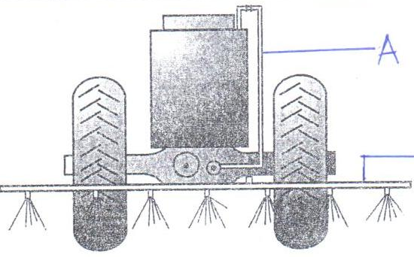

- Identify the implement illustrated above. (1 mark)
………………………………………………………………………………………………………………………………………………………………………………………………………………………………
- State the use of the implement on the farm. (1 mark)
………………………………………………………………………………………………………………………………………………………………………………………………………………………………
- Explain three maintenance practices carried out on the implement. (3 marks)
………………………………………………………………………………………………………………………………………………………………………………………………………………………………………………………………………………………………………………………………………………………………………………………………………………………………………………………………………………………………………………………………………………………………………………………………………………………………………………………………………………………………………………………………………………………………………………………………………………………………………………………………………………………………………………………………………………………………………………………………………………………………………………

- Below are illustrations of farm tools and equipment.
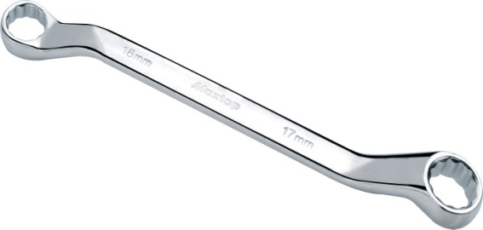
A

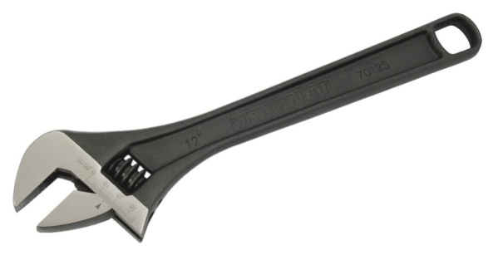
B

C
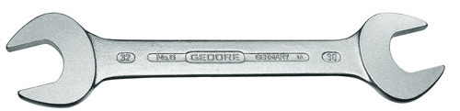

- Identify the tool labelled A and C
A (1 mark)
………………………………………………………………………………………………………………
B (1 mark)
………………………………………………………………………………………………………………
- State the advantage of tool B over tool C (1 mark)
………………………………………………………………………………………………………………………………………………………………………………………………………………………………
- State two maintenance practices carried out on tool labelled B. (2 marks)
………………………………………………………………………………………………………………………………………………………………………………………………………………………………………………………………………………………………………………………………………………
- Below is a farm structure. Study it carefully and answer the questions that follow.
X

- Identify the farm structure above (1 mark)
………………………………………………………………………………………………………………………………………………………………………………………………………………………………
- State the requirement of the part labelled X (1 mark)
………………………………………………………………………………………………………………………………………………………………………………………………………………………………
- State three maintenance practices that should be carried on the structure. (3 marks)
………………………………………………………………………………………………………………………………………………………………………………………………………………………………………………………………………………………………………………………………………………………………………………………………………………………………………………………………………………………………………………………………………………………………………………………………………………………………………………………………………………………………
- The diagram below is an illustration of an egg. Study it carefully and answer the questions that follow.
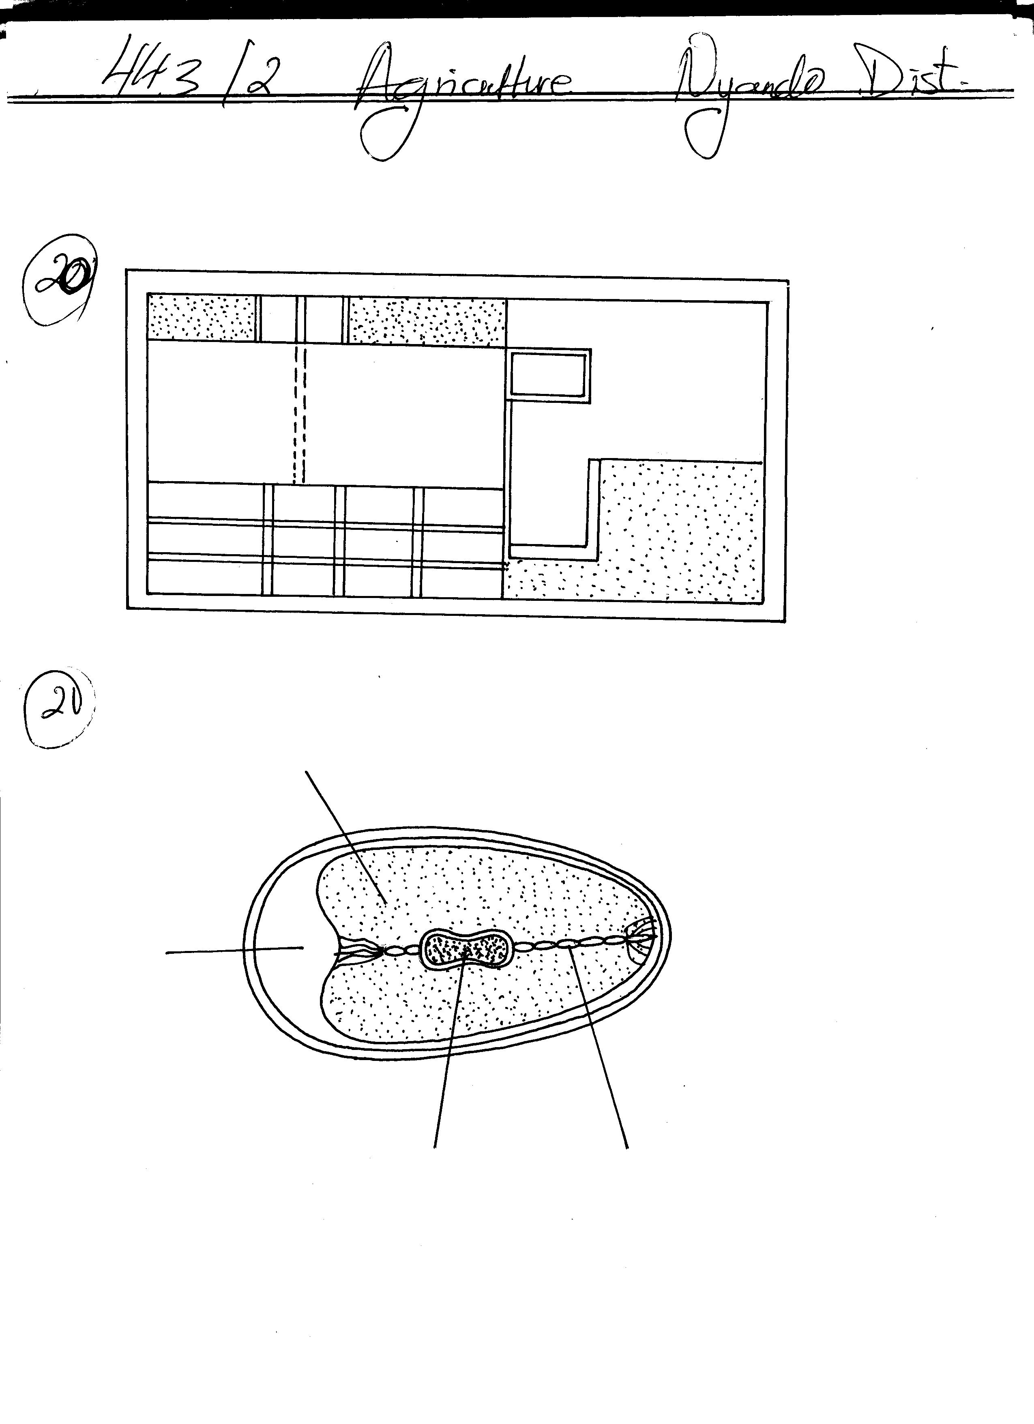
L
M
H
J
I
K

- Name the parts labelled I, J, K and M. (2 Marks)
………………………………………………………………………………………………………………………………………………………………………………………………………………………………………………………………………………………………………………………………………………………………………………………………………………………………………………………………
- Give two qualities of the part labelled H that would be considered when selecting eggs for incubation. (2 Marks)
……………………………………………………………………………………………………………………………………………………………………………………………………………………………………………………………………………………………………………………………………………………………………………………………………………………………………………………………..
- What is the function of the part labelled L (1 Mark)
………………………………………………………………………………………………………………………………………………………………………………………………………………………………
SECTION C (40 Marks)
Answer any two questions from this section.
- a) State five reasons for feeding livestock (5 marks)
- Describe the factors a farmer should consider when selecting a gilt for breeding. (8 marks)
- Outline routine management practices that should be carried out on a lactating ewe. (7 marks)
- a) Outline routine maintenance practices that should be carried out in deep litter system. (6 marks)
- State eight practices that would ensure clean milk production. (6 marks)
- Compare the use of an ox-drawn mouldboard plough with that of a tractor drawn plough (10 marks)
- a) Describe the importance of farm mechanization. (6 marks)
- Describe East Coast Fever under the following sub headings
- Causal organism (1 marks)
- Signs of infection (5 marks)
- Control measures ( 3 marks)
- Outline five causes of stress in poultry. (5 marks)

………………………………………………………………………………………………………………………………………………………………………………………………………………………………………………………………………………………………………………………………………………………………………………………………………………………………………………………………………………………………………………………………………………………………………………………………………………………………………………………………………………………………………………………………………………………………………………………………………………………………………………………………………………………………………………………………
………………………………………………………………………………………………………………………………………………………………………………………………………………………………………………………………………………………………………………………………………………………………………………………………………………………………………………………………………………………………………………………………………………………………………………………………………………………………………………………………………………………………………………………………………………………………………………………………………………………………………………………………………………………………………………………………
………………………………………………………………………………………………………………………………………………………………………………………………………………………………………………………………………………………………………………………………………………………………………………………………………………………………………………………………………………………………………………………………………………………………………………………………………………………………………………………………………………………………………………………………………………………………………………………………………………………………………………………………………………………………………………………………
………………………………………………………………………………………………………………………………………………………………………………………………………………………………………………………………………………………………………………………………………………………………………………………………………………………………………………………………………………………………………………………………………………………………………………………………………………………………………………………………………………………………………………………………………………………………………………………………………………………………………………………………………………………………………………………………
………………………………………………………………………………………………………………………………………………………………………………………………………………………………………………………………………………………………………………………………………………………………………………………………………………………………………………………………………………………………………………………………………………………………………………………………………………………………………………………………………………………………………………………………………………………………………………………………………………………………………………………………………………………………………………………………
………………………………………………………………………………………………………………………………………………………………………………………………………………………………………………………………………………………………………………………………………………
………………………………………………………………………………………………………………………………………………………………………………………………………………………………………………………………………………………………………………………………………………………………………………………………………………………………………………………………………………………………………………………………………………………………………………………………………………………………………………………………………………………………………………………………………………………………………………………………………………………………………………………………………………………………………………………………
………………………………………………………………………………………………………………………………………………………………………………………………………………………………………………………………………………………………………………………………………………………………………………………………………………………………………………………………………………………………………………………………………………………………………………………………………………………………………………………………………………………………………………………………………………………………………………………………………………………………………………………………………………………………………………………………
………………………………………………………………………………………………………………………………………………………………………………………………………………………………………………………………………………………………………………………………………………
………………………………………………………………………………………………………………………………………………………………………………………………………………………………………………………………………………………………………………………………………………………………………………………………………………………………………………………………………………………………………………………………………………………………………………………………………………………………………………………………………………………………………………………………………………………………………………………………………………………………………………………………………………………………………………………………
………………………………………………………………………………………………………………………………………………………………………………………………………………………………………………………………………………………………………………………………………………………………………………………………………………………………………………………………………………………………………………………………………………………………………………………………………………………………………………………………………………………………………………………………………………………………………………………………………………………………………………………………………………………………………………………………
………………………………………………………………………………………………………………………………………………………………………………………………………………………………………………………………………………………………………………………………………………
………………………………………………………………………………………………………………………………………………………………………………………………………………………………………………………………………………………………………………………………………………………………………………………………………………………………………………………………………………………………………………………………………………………………………………………………………………………………………………………………………………………………………………………………………………………………………………………………………………………………………………………………………………………………………………………………

