NAME………………………………………………………ADM NO…………………………………………

CLASS……………………........DATE……………………..SIGN.............……………………………………...

443/1

PAPER 1

TIME: 2 HOURS

CHUGU BOYS SECONDARY SCHOOL
Kenya certificate of secondary education (K.C.S.E)
AGRICULTURE
PAPER ONE
TIME: 2 HOURS

INSTRUCTIONS TO CANDIADATES
- Write your name, admission number and class
- This paper contain three sections
- Answer all question in section A and B
- In section C answer any two questions
- Candidates should check the question paper to ascertain that all pages are printed as from page one to fourteen as indicated and that no questions is missing
- Candidates must answer all the questions in English

For examiner’s use only

Section | Questions | Maximum score | Candidate score
A | 1 -17 | 30
B | 18 -21 | 20
C |  | 20
 |  | 20
Total score |  | 90

SECTION A
ANSWER ALL QUESTIONS 30MARKS
- Define organic farming (1Mark)
………………………………………………………………………………………………………………………………………………………………………………………………………………………………………………………………………………………………………………………………………………………..
- State Four reasons why agriculture is regarded as a science. (2Marks)
……………………………………………………………………………………………………………………………………………………………………………………………………………………………………………………………………………………………………………………………………………………………………………………………………………………………………………………………………………………………………………………………………………………………………………………………..
- Give Four effects of HIV/Aids on agricultural production and development. (2Marks)
……………………………………………………………………………………………………………………………………………………………………………………………………………………………………………………………………………………………………………………………………………………………………………………………………………………………………………………………………………………………………………………………………………………………………………………………..
- a)State Three farming practices that help in reducing the effects of water shortage in crop production (3Marks)
…………………………………………………………………………………………………………………………………………………………………………………………………………………………………………………………………………………………………………………………………………………………………………………………………………………………………………………………………………
b) Give Four advantages of rotational grazing in cattle farming. (2Marks)
……………………………………………………………………………………………………………………………………………………………………………………………………………………………………………………………………………………………………………………………………………………………………………………………………………………………………………………………………………………………………………………………………………………………………………………………..
- State Two disadvantages of small scale farming. (1Mark)
………………………………………………………………………………………………………………………………………..………………………………………………………………………………………………………………………………………..………………………………………………………………………
- State Four ways of treating water for use in the farm. (2Marks)

………………………………………………………………………………………………………………………………………..………………………………………………………………………………………………………………………………………..………………………………………………………………………………………………………………………………………...………………………………………………
- State Four benefits of using organic materials for mulching. (2Marks)
………………………………………………………………………………………………………………………………………..………………………………………………………………………………………………………………………………………..………………………………………………………………………………………………………………………………………...………………………………………………..…………………………………………………………………………………………………………………..
- State Four disadvantages of non-capped multiple stem pruning in coffee. (2Marks)
………………………………………………………………………………………………………………………………………..………………………………………………………………………………………………………………………………………..………………………………………………………………………………………………………………………………………...…………………………………………………………………………………………………………………………………………………………………..
- State Four factors considered in selecting the site for making compost manure. (2Marks)
………………………………………………………………………………………………………………………………………..………………………………………………………………………………………………………………………………………..………………………………………………………………………………………………………………………………………...………………………………………………..…………………………………………………………………………………………………………………..
- Give Two reasons for flooding in the growing of paddy rice. (1Mark)
………………………………………………………………………………………………………………………………………..………………………………………………………………………………………………………………………………………………………………………………………………………………..
- Give Two appropriate situations under which foliar spraying is most suitable. (1Mark)
………………………………………………………………………………………………………………………………………..………………………………………………………………………………………………………………………………………..………………………………………………………………………

- State Four factors contributing to the competitive ability of weeds (2Marks)

………………………………………………………………………………………………………………………………………..………………………………………………………………………………………………………………………………………..………………………………………………………………………………………………………………………………………...………………………………………………..…………………………………………………………………………………………………………………..
- Give Four conditions of land which may make it necessary to carry out reclamation practices
(2Marks)
………………………………………………………………………………………………………………………………………..……………………………………………………………………………………………………………………………………..………………………………………………………………………………………………………………………………………...………………………………………………………………
- Name Four physical weathering agents in the soil formation process (2Marks)

………………………………………………………………………………………………………………………………………..………………………………………………………………………………………………………………………………………………………………………………………………………………..
- State Two Mechanical methods of separating soil particles according to size during soil analysis
(1Mark)
………………………………………………………………………………………………………………………………………..……………………………………………………………………………………………………………………………………………………………………………………………………………………………
- State Four functions of Boron in crop development (2Marks)

………………………………………………………………………………………………………………………………………..………………………………………………………………………………………………………………………………………..………………………………………………………………………………………………………………………………………...………………………………………………………………
- State Four factors that should be considered when classifying crop pests (2 Marks)

………………………………………………………………………………………………………………………………………..………………………………………………………………………………………………………………………………………..………………………………………………………………………………………………………………………………………...………………………………………………………………

SECTION B 20 MARKS
ANSWER ALL QUESTIONS IN THIS SECTION
- The diagram below shows a weed study it carefully.
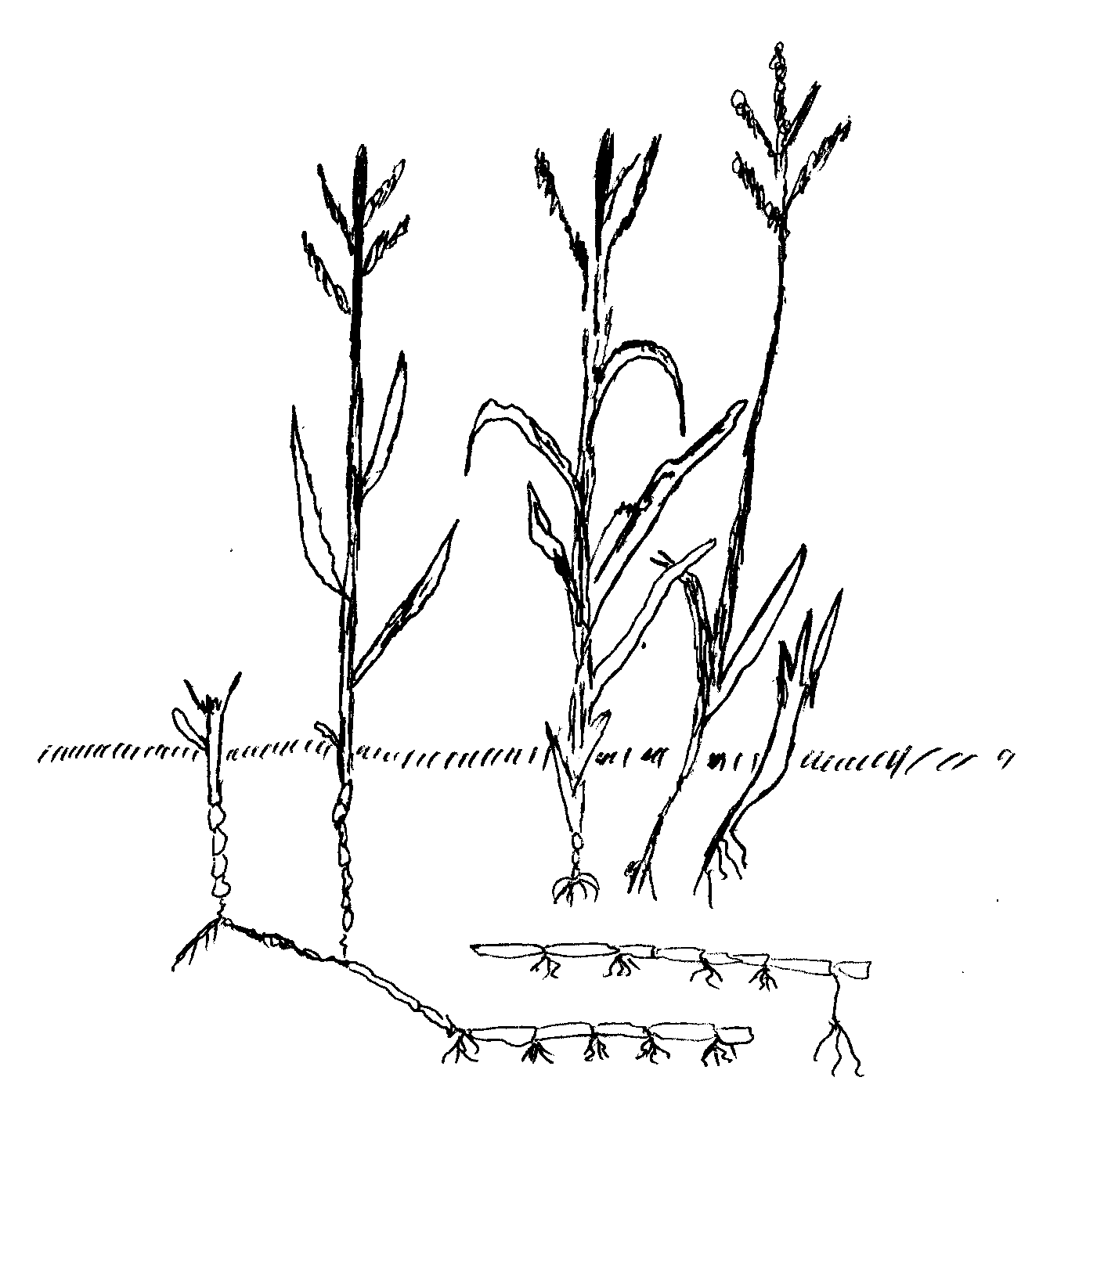
- Identify the weed. (1Mark)
………………………………………………………………………………………………………………………………………………………………………………………………………………………………
- State Two economic importance of the weed. (2Marks)
………………………………………………………………………………….…………………………………………………………………………………………………………………………………………
- Why is it difficult to control the weed? (1Mark)
………………………………………………………………………………………………………………………………………………………………………………………………………………………………
- The diagrams below labeled A and B illustrate field pests. Study the diagrams carefully and answer the questions that follow.

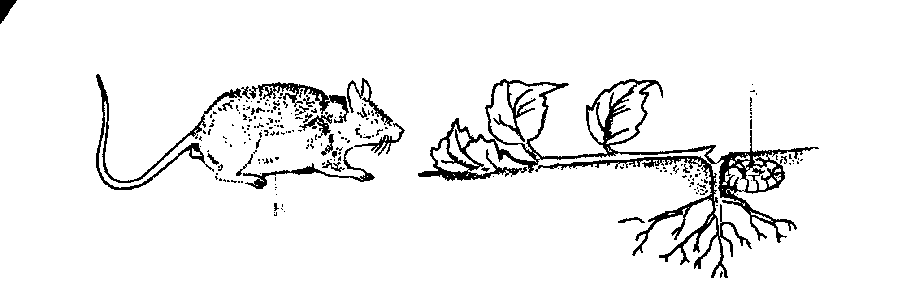
B
A
- Identify the field pests illustrated in the diagrams A and B. (2Marks)

A …………………………………………………………………………………………………………..

B ……………………………………………………………………………………………………………

- Classify the pests A and B (2Marks)

A……………………………………………………………………………………………………………

B ………………………………………………………………………………………………………….

- State One control measure of pest B (1Mark)
…………………………………………………………………………………………………………………………………………………………………………………………………………………………………...
- Below is a diagram of a nursery for raising the seedlings.
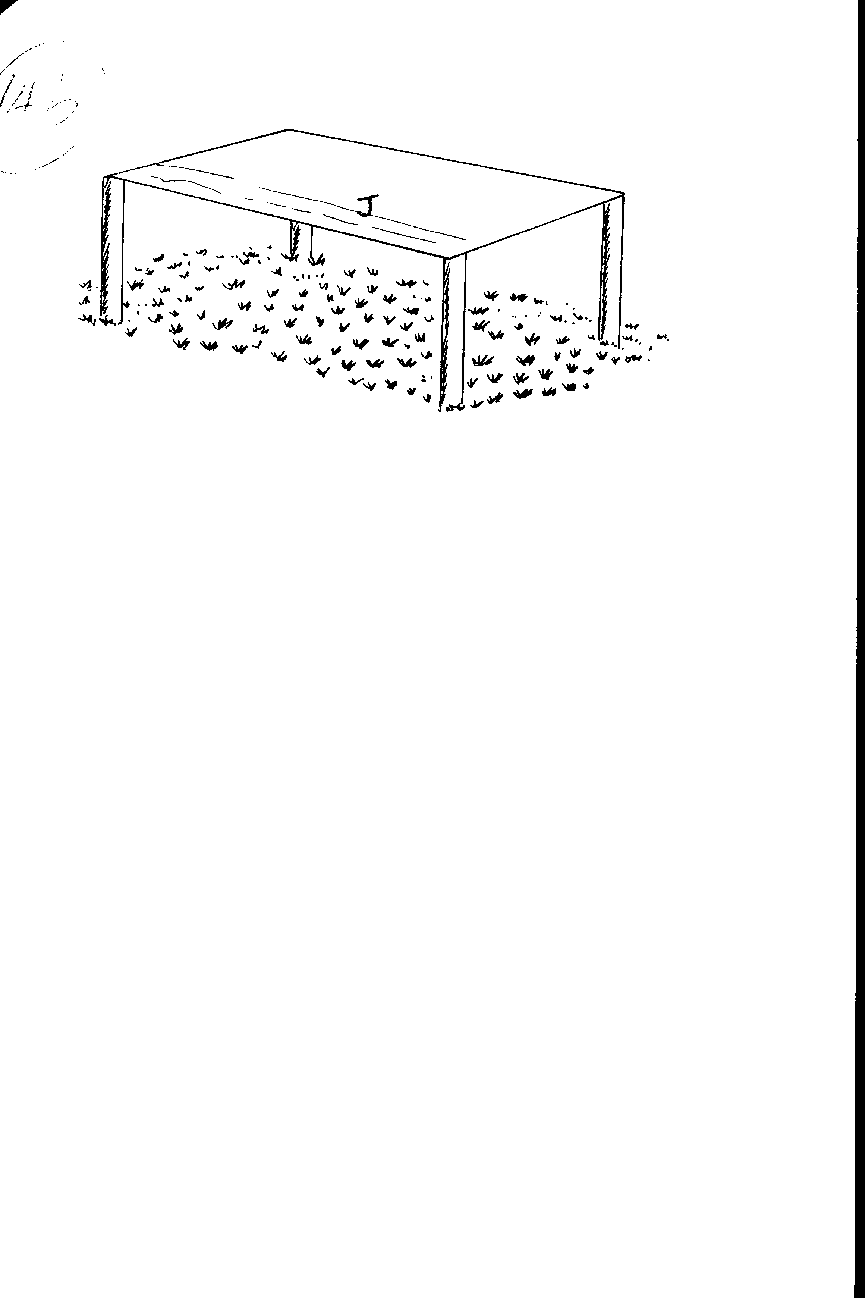
- State Two advantages of having the part labeled J (2Marks)
………………………………………………………………………………………………………………….……………………..………………………………………………………………………………………………………………………………………………………………………………………………………………..
- State any three management practices that should be carried out on the nursery from the time seedlings emerge to the stage of transplanting (3Marks)
…………………………………………………………………………………………………………………………………………………………………………………………………………………………………………………………............................................................................................................................................................................................................................................................................................................................

- The diagram F, below illustrates a method of training in crops.

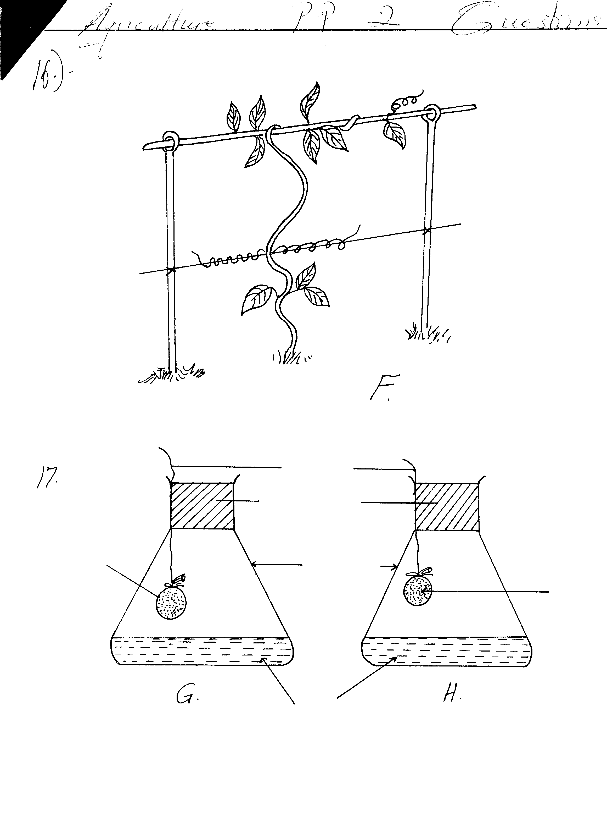

- Identify the method shown in F above. (1Mark)
………………………………………………………………………………………………………………………………………………………………………………………………………………………………

- Name Two other methods used in training in crop production. (2Marks)
………………………………………………………………………………………………………………………………………..…………………………………………………………………………………….………………………………………………………………………………………………………………
- State Two advantages of training in crop production. (2Marks)
………………………………………………………………………………………………………………………………………..……………………………………………………………………………………………………………………………………………………………………………………………………

- List Two crops that require training. (1Mark)
………………………………………………………………………………………………………………………………………..……………………………………………………………………………………………………………………………………………………………………………………………………

SECTION C 40 MARKS
ANSWER ANY TWO QUESTION
- a) i) Define the term land tenure (2Marks)
ii) Give Three benefits of a Title deed to a farmer. (3Marks)
iii) State Five effects of land fragmentation in crop farming. (5Marks)
b) Describe the production of onions under the following sub-headings:
i) Seedbed preparation. (3Marks)
ii) Field management practices. (5Marks)
iii) Harvesting. (2Marks)
- a) Describe Seven harmful effects of crop pests. (7Marks)
b) Describe Eight safety measures a farmer should observe when using herbicide to control weeds.
(8Marks)
c) Describe the harvesting of cotton. (5Marks)
- a) Describe the importance of vegetable crop. (6Marks)
b) Explain the cultural methods of pest control. (7Marks)
c) Discuss the management practices in the production of maize grains from planting to harvesting.
(7Marks)
……………………………………………………………………………………………………………………………………………………………………………………………………………………………………………………………………………………………………………………………………………………………………………………………………………………………………………………………………………………………………………………………………………………………………………………………………………………………………………………………………………………………………………………………………………………………………………………………………………………………………………………………………………………………………………………………………………………………………………………………………………………………………………………………………………………………………………………………………………………………………………………………………………………………………………………………………………………………………………………………………………………………………………………………………………………………………………………………………………………………………………………………………………………………………………………………………………………………………………………………………………………………………………………………………………………………………………………………………………………………………………………………………………………………………………………………………………………………………………………………………………………………………………………………………………………………………………………………………………………………………………………………………………………………………………………………………………………………………………………………………………………………………………………………………………………………………………………………………………………………………………………………………………………………………………………………………………………………………………………………………………………………………………………………………………………………………………………………………………………………………………………………………………………………………………………………………………………………………………………………………………………………………………………………………………………………………………………………………………………………………………………………………………………………………………………………………………………………………………………………………………………………………………………………………………………………………………………………………………………………………………………………………………………………………………………………………………………………………………………………………………………………………………………………………………………………………………………………………………………………………………………………………………………………………………………………………………………………………………………………………………………………………………………………………………………………………………………………………………………………………………………………………………………………………………………………………………………………………………………………………………………………………………………………………………………………………………………………………………………………………………………………………………………………………………………………………………………………………………………………………………………………………………………………………………………………………………………………………………………………………………………………………………………………………………………………………………………………………………………………………………………………………………………………………………………………………………………………………………………………………………………………………………………………………………………………………………………………………………………………………………………………………………………………………………………………………………………………………………………………………………………………………………………………………………………………………………………………………………………………………………………………………………………………………………………………………………………………………………………………………………………………………………………………………………………………………………………………………………………………………………………………………………………………………………………………………………………………………………………………………………………………………………………………………………………………………………………………………………………………………………………………………………………………………………………………………………………………………………………………………………………………………………………………………………………………………………………………………………………………………………………………………………………………………………………………………………………………………………………………………………………………………………………………………………………………………………………………………………………………………………………………………………………………………………………………………………………………………………………………………………………………………………………………………………………………………………………………………………………………………………………………………………………………………………………………………………………………………………………………………………………………………………………………………………………………………………………………………………………………………………………………………………………………………………………………………………………………………………………………………………………………………………………………………………………………………………………………………………………………………………………………………………………………………………………………………………………………………………………………………………………………………………………………………………………………………………………………………………………………………………………………………………………………………………………………………………………………………………………………………………………………………………………………………………………………………………………………………………………………………………………………………………………………………………………………………………………………………………………………………………………………………………………………………………………………………………………………………………………………………………………………………………………………………………………………………………………………………………………………………………………………………………………………………………………………………………………………………………………………………………………………………………………………………………………………………………………………………………………………………………………………………………………………………………………………………………………………………………………………………………………………………………………………………………………………………………………………………………………………………………………………………………………………………………………………………………………………………………………………………………………………………………………………………………………………………………………………………………………………………………………………………………………………………………………………………………………………………………………………………………………………………………………………………………………………………………………………………………………………………………………………………………………………………………………………………………………………………………………………………………………………………………………………………………………………………………………………………………………………………………………………………………………………………………………………………………………………………………………………………………………………………………………………………………………………………………………………………………………………………………………………………………………………………………………………………………………………………………………………………………………………………………………………………………………………………………………………………………………………………………………………………………………………………………………………………………………………………………………………………………………………………………………………………………………………………………………………………………………………………………………………………………………………………………………………………………………………………………………………………………………………………………………………………………………………………………………………………………………………………………………………………………………………………………………………………………………………………………………………………………………………………………………………………………………………………………………………………………………………………………………………………………………………………………………………………………………………………………………………………………………………………………………………………………………………………………………………………………………………………………………………………………………………………………………………………………………………………………………………………………………………………………………………………………………………………………………………………………………………………………………………………………………………………………………………………………………………………………………………………………………………………………………………………………………………………………………………………………………………………………………………………………………………………………………………………………………………………………………………………………………………………………………………………………………………………………………………………………………………………………………………………………………………………………………………………………………………………………………………………………………………………………………………………………………………………………………………………………………………………………………………………………………………………………………………………………………………………………………………………………………………………………………………………………………………………………………………………………………………………………………………………………………………………………………………………………………………………………………………………………………………………………………………………………………………………………………………………………………………………………………………………………………………………………………………………………………………………………………………………………………………………………………………………………………………………………………………………………………………………………………………………………………………………………………………………………………………………………………………………………………………………………………………………………………………………………………………………………………………………………………………………………………………………………………………………………………………………………………………………………………………………………………………………………………………………………………………………………………………………………………………………………………………………………………………………………………………………………………………………………………………………………………………………………………………………………………………………………………………………………………………………………………………………………………………………………………………………………………………………………………………………………………………………………………………………………………………………………………………………………………………………………………………………………………………………………………………………………………………………………………………………………………………………………………………………………………………………………………………………………………………………………………………………………………………………………………………………………………………………………………………………………………………………………………………………………………………………………………………………………………………………………………………………………………………………………………………………………………………………………………………………………………………………………………………………………………………………………………………………………………………………………………………………………………………………………………………………………………………………………………………………………………………………………………………………………………………………………………………………………………………………………………………………………………………………………………………………………………………………………………………………………………………………………………………………………………………………………………………………………………………………………………………………………………………………………………………………………………………………………………………………………………………………………………………………………………………………………………………………………………………………………………………………………………………………………………………………………………………………………………………………………………………………………………………………………………………………………………………………………………………………………………………………………………………………………………………………………………………………………………………………………………………………………………………………………………………………………………………………………………………………………………………………………………………………………………………………………………………………………………………………………………………………………………………………………………………………………………………………………………………………………………………………………………………………………………………………………………………………………………………………………………………………………………………………………………………………………………………………………………………………………………………………………………………………………………………………………………………………………………………………………………………………………………………………………………………………………………………………………………………………………………………………………………………………………………………………………………………………………………………………………………………………………………………………………………………………………………………………………………………………………………………………………………………………………………………………………………………………………………………………………………………………………………………………………………………………………………………………………………………………………………………………………………………………………………………………………………………....................................................................................................................................................................................................................................................................................................................................................................................................................................................................................................................................................................................................................................................................................................................................................................................................................................................................................................................................................................................................................................................................................................................................................................................................................................................................................................................................................................................................................................................................................................................................................................................................................................................................................................................................................................................................................................................................................................................................................................................................................................................................................................................................................................................................................................................

