PAVEMENT FORM 4 TRIAL 1 EXAMINATION 2022
Kenya certificate of secondary education (K.C.S.E)
AGRICULTURE
PAPER 2
MARKING SCHEME.
- Four dairy breeds of goats (4x ½ ) 2Marks)
- Saanem
- Toggenburg
- British alpine
- Anglo Nubian
- Jamnapan
- Control measures of roundworms (2 x ½ )1Mark)
- Practising rotational grazing and resting the pasture to starve the larvae to death
- Improving sanitation in animal houses by ensuring that the infected dung is cleaned
- All animals should be drenched with appropriate antihelmintics regularly
- Proper use of latrines by the farm works
- Avoid contamination of hay and feed by faeces
- Maintenance practice on wheelbarrow ( ½ x4) 2Marks)
- Cleaning after
- Oil the wheel axle
- Replace worn out tyre
- Paint the metallic part to prevent rusting
- Three ways of transmitting livestock diseases (3x ½ ) 1 ½ Marks)
- Through vectors
- Through ingestion of contaminated food and water
- Through inhalation of contaminated air
- Appropriate use of each of the following tools
- Stock and die –for cutting threads on pipe (1x1) 1Mark
- Oil stone – used for sharpening other tools (1x1) 1Mark
- A zoonotic disease – this is a disease that can be transmitted from livestock to humans and viceversa while notifiable disease is highly contagious disease that spreads very fast whose outbreak must be reported to the relevant authorities. (2Marks)
- Reasons for keeping livestock healthy (4 x ½ ) 2Marks
- Healthy animals grow faster to reach maturity quickly
- Good health gives animals a longer economic and productive life
- Healthy animals produce good quality products hence high market value
- Healthy animals do not spread diseases to either animals of human beings
- Healthy animals are economical and easy to keep as the farmers spends less money on disease treatment
- (a) Intermediate host for liverfluke (1 Mark)
- Fresh water snails / mud snail
(b) Oestrus cycle in a cow (1 Mark)
- 21 days
- Advantages of upgrading cattle (2x1) 2Marks
- Improves low grade livestock
- It is cheaper compared to buying a purebred
- Helps develop breeds that can adopt to harsh environments
- Can be used to introduce desired characteristics in a herd
- Functions of a swath stick ( ½ Mark)
- Keeps the cut crop or grass falling correctly
Function of the shoe ( ½ Mark)
- Has a runner to absorb the weight and tear
Function of the cutter bar ( ½ Mark)
- Guides fingers of the mower
- Function of the Albumen (1x2) 2Marks
- Provides nutrients to the developing chick
- Cushions small movement of the inner egg contents
- Good quality wool ( ½ x4) 2Marks
- Physically clean
- Should be long
- Should be strong
- Should be elastic
- Should be fine
- Should be preferably white in color
- Should have a high fleece weight
- Why honey harvesting is discouraged at night (1x2) 2Marks
- It is difficult to distinguish between white combs and dark combs
- There is contamination of harvested honey with brood
- Bees can be crushed because they are not visible in the dark
- Accidental bush fires can break out
- Hormone that stimulate milk let down is Oxytocin hormone (1 Mark)
- Qualities of creep feed (1 x 2) 2Marks
- Highly digestible
- High in carbohydrate value
- Highly palatable
- Have a high digestible crude protein
- Rich in minerals
- Contains vitamins A, B and D
- Reasons for seasoning timber (1x2) 2Marks
- Prevents warping due to uneven expansion and contraction
- Prevents decay due to fungal attack
- Prevents cracking of timber
- Improves durability and strength
- Causal organisms for
- Anthrax - Bacillus anthracis (bacteria) ( ½ Mark)
- Nagana - Trypanosoma sp (protozoa) ( ½ Mark)

SECTION B

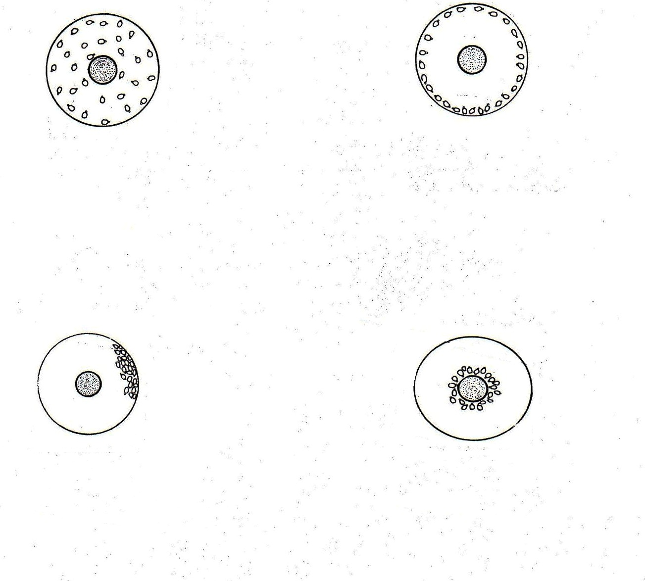
Source of heat too cold
(1 mk)
Chicks reacting to draught
(1 mk)
draught
Source of heat too hot
(1 mk)
(1 mk)
Chicks
Source of heat
Correct temperature
- (i)
1 mk

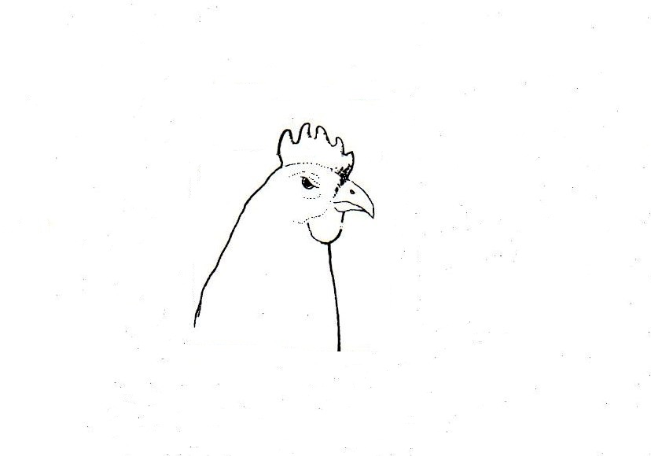
(ii) Reasons for debeaking (2x1) 2 Marks
- To control egg eating habit
- To control cannibalism
- To control toe pecking
- (a) The activity is hoof trimming ( ½ Mark)
(b) Hoof D predisposes hoof to foot rot infection (½ Mark)
(c) Reasons for activity (2x1) 2 Marks
- For proper walking
- To minimise injuries during service
- (a) F – Toe (1 Mark)
G – Blade (1 Mark)
- Maintenance practices on H (3x1) 3Marks
- Sharpening of teeth regularly to improve efficiency
- Regular cleaning after use to remove dirt
- Setting the teeth to maintain cutting angles
- Apply oil before storage to prevent rusting.
- (a) ( ½ x4) 2mks
1 – Egg hatches and larvae emerge
4 – nymphs climb onto the 2nd host and feed
5 – Engorged nymphs drop down to lay legs
7 – Engorged female drop down to lay eggs
b) (1 Mark)
- Tick keeps on dropping off the animal at every stage of development so its not affected by acaricides when animal is sprayed.
c) (2 x 1) 2 Marks
- Ears
- Base of the horns
- Around the eyes
- Tail switch
SECTION C
- (a) Control measures of cannibalism (10 x 1) 10 Marks
- Avoid bright light in the house
- Avoid overcrowding
- Provide balance diet
- Contol external parasites
- Hang vegetables in the house to keep birds busy
- Debeak birds which peck at others
- Cull perpetual cannibals
- Cull birds with prolapse
- Provide adequate equipment feeders, water, perches
- Avoid introduction of new birds in the stock
b) State five advantages of using a sub soiler in seedbed preparation (5Marks)
- Used in breaking hard pan
- Facilitate aeration
- Facilitate water infiltration
- Help in pulling deep rooted weeds
- They loosen up the soil through the vibration they make
c). Five functions of water in the body (5x1)5mks
- Acts as solvent for chemical Substances
- It’s a medium of transport of nutrients in the animals body
- Help in excretion of waste product from animals body
- Regulates temperature through sweating and evaporation
- Maintaining solute –solvent balance in body fluids (osmoregulation)
- Make cells turgid ;maintaining the shape of the body cells
- Used in bio chemical reactions in the body e.g. digestion of food
It’s a component of body
- (a) describe effects of parasites on livestock (6 x 1) 6Marks
- Cause anaemia – blood sucking parasites take large volumes of blood from the host animals leading to anaemia.
- Deprive the host animal of food especially the internal parasites, compete for food with the host.
- Injury and damage to tissues and organs e.g. biting parasites break the skin of the animal exposing it to secondary infection
- Disease transmission –some parasite acts as vectors of some diseases
- Cause irritation –some external parasites irritate the animals through their biting
- Obstruction to internal organs – internal parasites may cause mechanical obstruction or blockage of the internal passages leading to mal-functioning of the organs thus affected
b) Explain reasons for maintaining farm tools and equipment (5x1) 5Marks
- To increase durability
- To reduce the replacement cost
- Increased efficiency
- To avoid injury to the user
- To avoid damage to the tool
c) Discuss the management of layers in a deep litter system (1 x 9) 9 Marks
- Ensure enough space in the house 0.3 -0.5 m² per bird
- The litter should be kept dry by regularly raking
- Provide enough perches which should be well spaced in the house
- Provide enough waterers, feeders and well distributed
- Provide clean and adequate water
- Ensure the nest is dark enough to avoid cannibalism
- Collect eggs at least twice a day
- Provide adequate layers mash
- Supply some grit to help in digestion
- Ensure adequate supply of greens for vitamins
- Cull poor layers or diseased birds
- Debeak birds to prevent cannibalism and egg eating
- Vaccinate against prevailing diseases
- Provide grains on the litter to avoid cannibalism
- Isolate and treat sick animals
- a) Five causes of stress in poultry and describe their control (10Marks
- Sudden change in routine practices
- Sudden change of feed
- Presence of predators / strangers in the house
- Attack by external parasites and diseases
- Sudden loud noise
- Abrupt change in weather
- Poor handling of birds during routine practices
- Inadequate feed and water
- Overcrowding
b) Importance of fences in a farm any(5 x 1) 5Marks
- Fences mark boundaries
- They keep out unwanted visitors e.g thieves and wild animals
- Live fences act as windbreaks reducing wind erosion and lodging of weak stem crops e.g. maize
- They separate crop fields from pastures in mixed farming
- They divide pasture lands onto paddocks facilitating paddocking grazing system
- Enhances control of livestock parasites and livestock diseases by restricting movement of livestock
- Fences help to isolate sick animals from the rest of the herd to avoid the spread of diseases
- They enable the farmers to control breeding by rearing different animals in different paddocks
- They provide security to the homestead and farm animals.
c) Using pearson’s square compute a ration with 20% DCP from oats which contains
10% DCP and simsim seedcake containing 60% DCP. ½ x 10 = (5Marks)

Oats 10%
40 parts of oats
20
Simsim 60%

10 parts of simsim
50 parts
Oats - 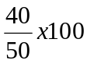 = 80 kgs of oats
Simsim - 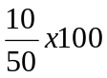 = 20 kgs of simsim

