NAME…………………………………………………… ADM NO ……………………………………….
CLASS……………………………..CANDIDATE’S SIGNATURE ………………………………………
DATE………………………………………..

443/2
Agriculture
Paper 2
Time: 2 Hours
CHUGU BOYS SECONDARY SCHOOL
Kenya certificate of secondary education (K.C.S.E)

INSTRUCTIONS TO CANDIDATES
- Write your name, Admission number and date in the spaces provided.
- This paper consists of three sections; A, B and C.
- Answer All questions in Section A and B in the spaces provided.
- Answer any two questions in Section C in the spaces provided.

For Examiners use only.
SECTION | QUESTION | MAXIMUM SCORE | CANDIDATE’S SCORE
A | 1-17 | 30
B | 18-22 | 20
C |  | 20
 |  | 20
 |  | 20
TOTAL |  | 90

SECTION A
- Name Four dairy breeds of goats. (2 Marks)

…………………………………………………………………………………………………………………………………………………………………………………………………………………………………………………………………………………………………………………....………………………………………………………………………………………………………………………………
- Outline Two control measures of roundworm. (1 Mark)
………………………………………………………………………………………………………………………………………………………………………………………………………………………………………………………………………………………………………………………………………
- State Four maintenance practice carried on a wheelbarrow. (2 Marks)
………………………………………………………………………………………………………………………………………………………………………………………………………………………………………………………………………………………………………………………………………………………………………………………………………………………………………………………………………………………………………………………………………..........................................
- Give Three ways of transmitting livestock diseases. (1 ½ Marks)
………………………………………………………………………………………………………………………………………………………………………………………………………………………………………………………………………………………………………………………………………………………..............................................................................................................................................
- State the appropriate use of each of the following farm tool.
- Stock and die (1 Mark)
………………………………………………………………………………………………………………………………………………………………………………………………………………………………………………………………………………………………………………………………………
- Oil stone (1 Mark)
…………………………………………………………………………………………………………………………………………………………………………………………………………………………
- Distinguish between zoonotic disease and a notifiable disease. (2 Marks)
………………………………………………………………………………………………………………………………………………………………………………………………………………………………………………………………………………………………………………………………………………………………………………………………………………………………………………………………………………………………………………………………………………………………
- State Four reasons for keeping livestock healthy. (2 Marks)
…………………………………………………………………………………………………………………………………………………………………………………………………………………………………………………………………………………………………………………………………………………………………………………………………………………………………………………………………………………………………………………………………………………………………
- a) What is the intermediate host for liverfluke. (1 Mark)

…………………………………………………………………………………………………………………………………………………………………………………………………………………………
b) What is the duration of oestrus cycle in a cow. (1 Mark)

………………………………………………………………………………………………………………………………………………………………………………………………………………………….
- State Two advantages of upgrading cattle. (2 Marks)

……………………………………………………………………………………………………………………………………………………………………………………………………………………………………………………………………………………………………………………………………….
- Give the functions of the following parts of a reciprocating mower.
- swath stick ( ½ Mark)

…………………………………………………………………………………………………………………………………………………………………………………………………………………………
- Shoe ( ½ Mark)

…………………………………………………………………………………………………………………………………………………………………………………………………………………………
- Cutter bar ( ½ Mark)

………………………………………………………………………………………………………………………………………………………………………………………………………………………….
- Give Two functions of the albumen in an egg. (2 Marks)

………………………………………………………………………………………………………………………………………………………………………………………………………………………........................................................................................................................................................................................................................................................................................................................................................................................................................................................................................................................
- State Four qualities of good wool. (2 Marks)

…………………………………………………………………………………………………………………………………………………………………………………………………………………………………………………………………………………………………………………………………………………………………………………………………………………………………………………….
- Give Two reasons why honey harvesting is discouraged at night. (2 Marks)
……………………………………………………………………………………………………………………………………………………………………………………………………………………………………………………………………………………………………………………………………….
- Which hormone stimulates milk let down? (1 Mark)
…………………………………………………………………………………………………………………………………………………………………………………………………………………………
- Give Two qualities of a creep feed. (2 Marks)

……………………………………………………………………………………………………………..……………………………………………………………………………………………………………..
- State Two reasons for seasoning timber before use in construction. (2 Marks)

…………………………………………………………………………………………………………………………………………………………………………………………………………………………
- Name the causal organisms of the following diseases.
- Anthrax ( ½ Mark)

………………………………………………………………………………………………………………………………………………………………………………………………………………………………………………………………………………………………………………………………………………..
b) Nagana ( ½ Mark)
………………………………………………………………………………………………………………………………………………………………………………………………………………………………………………………………………………………………………………………………………………………

SECTION B

- Study the diagram below carefully and answer the questions that follow.

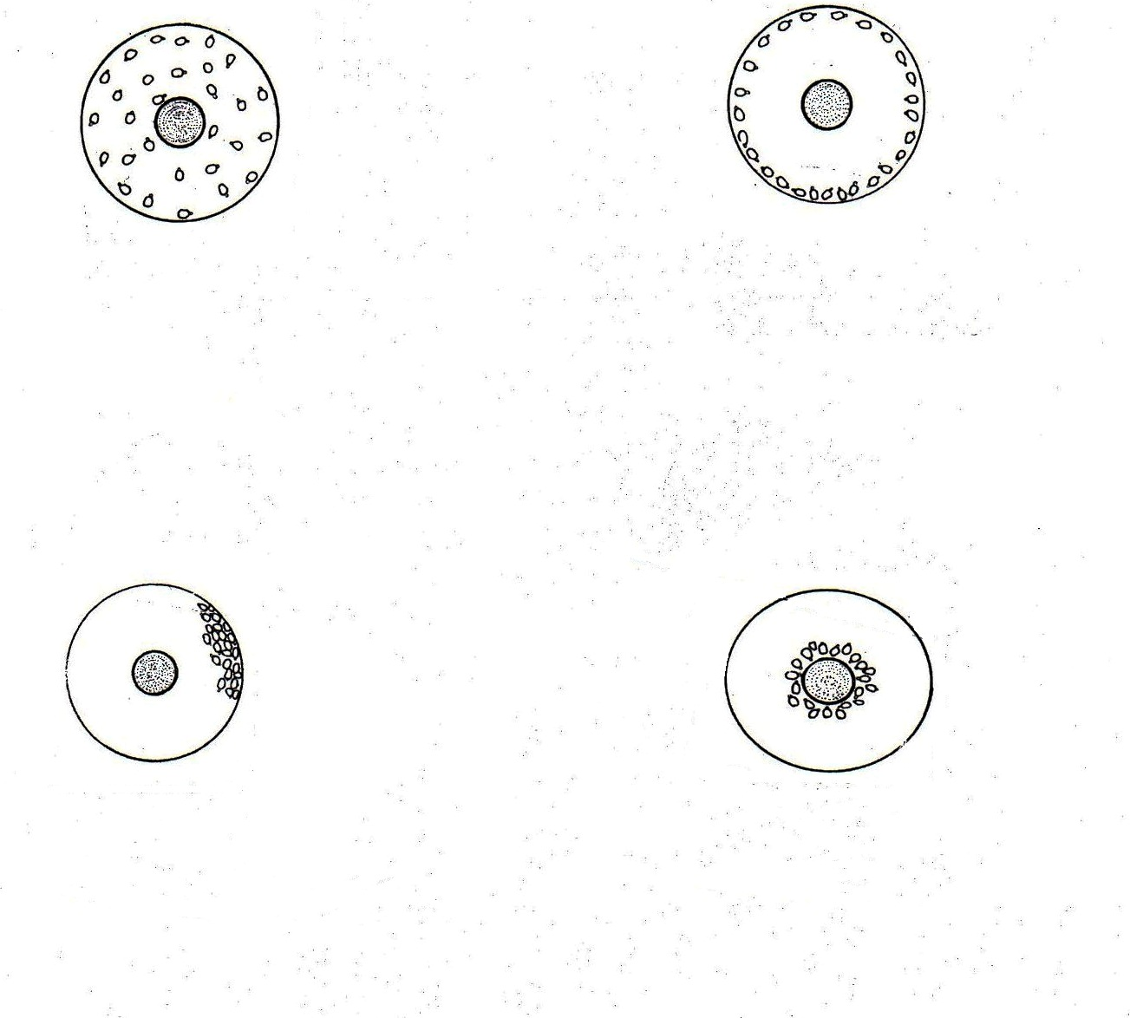
Indicate below each diagram the conditions in the brooder. (4 Marks)

- Study the diagram below and answer the questions

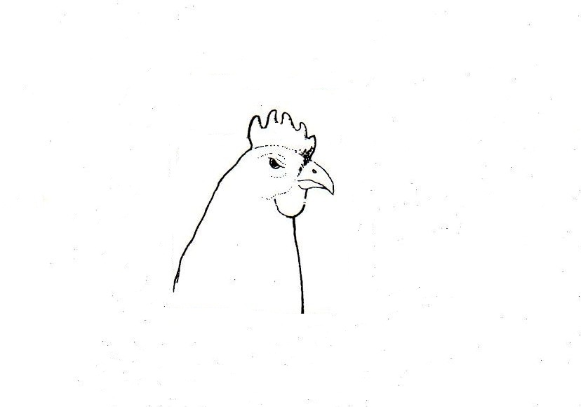
- Draw a line in the diagram indicating the correct position of debeaking the birds. (1 Mark)

- Give the reasons for debeaking birds. (2 Marks)

……………………………………………………………………………………………………....……………………………………………………………………………………………………………………….
- Below are illustrations of animal hooves and an activity being done?

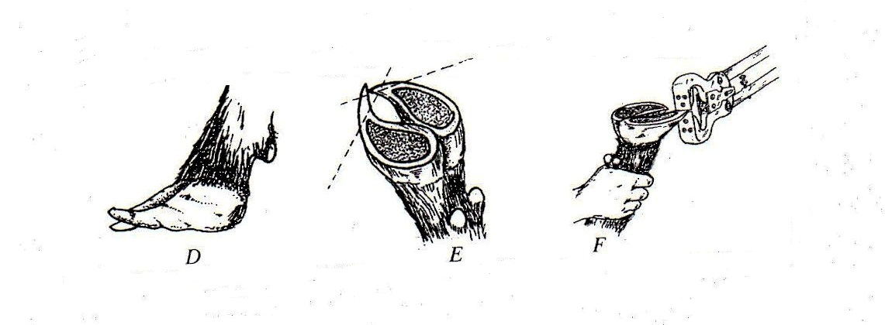
- What activity is going on in the diagram F? ( ½ Mark)
…………………………………………………………………………………………………………………………………………………………………………………………………………………………

- Which of the above hooves is likely to predispose foot rot infections? ( ½ Mark)
…………………………………………………………………………………………………………………………………………………………………………………………………………………………

- Other than protecting animals from foot rot, give two other reasons for carrying out the above activity. (2 Marks)

………………………………………………………………………………………………………………………………………………………………………………………………………………………………………………………………………………………………………………………………………………………
- The following is an illustration of a handsaw. Study it carefully and answer the questions that follow.

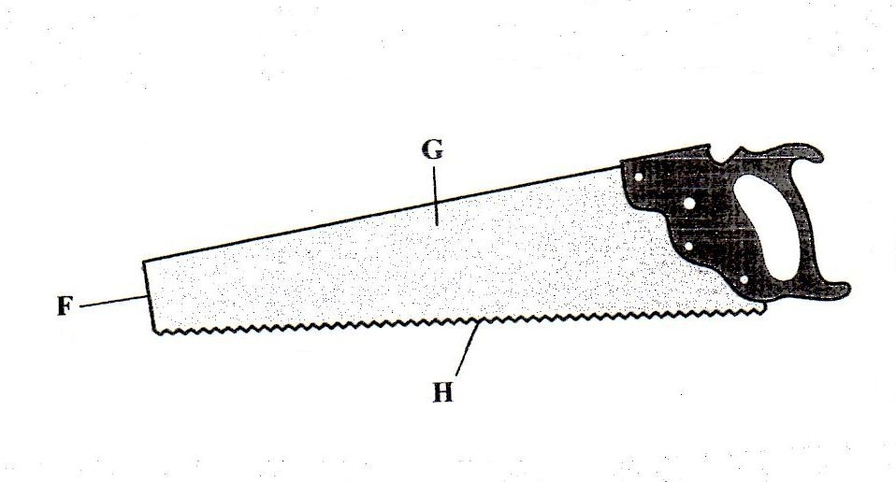

- Name the parts labelled.
F - (1 Mark)
……………………………………………………………………………………………………………………………………………………………………………………………………………………………………
G - (1 Mark)
……………………………………………………………………………………………………………………………………………………………………………………………………………………………………
b) Explain Three maintenance practices that should be carried out on the part labelled H. (3 Marks)
………………………………………………………………………………………………………………………………………………………………………………………………………………………………………………………………………………………………………………………………………………………

- The illustrations below represent the different stages of development of a three host tick.
Study it carefully and then answer the questions that follow.

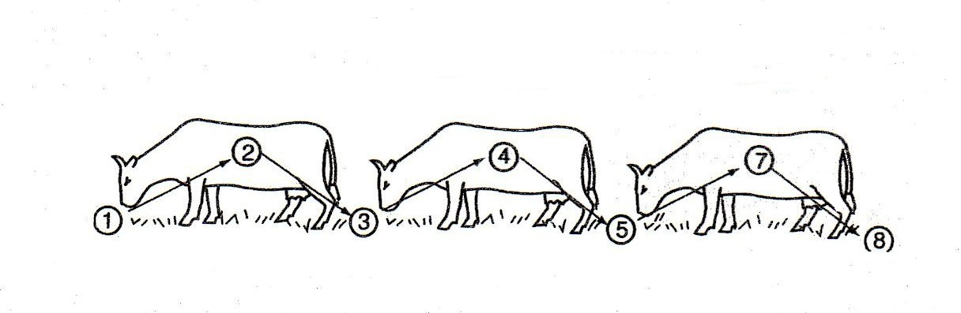

- Briefly explain what is happening in the following stages. (2 Marks)
1 –
……………………………………………………………………………………………………………………………………………………………………………………………………………………………………
4 –
……………………………………………………………………………………………………………………………………………………………………………………………………………………………………
5 –
……………………………………………………………………………………………………………………………………………………………………………………………………………………………………
7 –
……………………………………………………………………………………………………………………………………………………………………………………………………………………………………
- Why could it be difficult to control the above tick using acaricides? (1 Mark)

………………………………………………………………………………………………………………………………………………………………………………………………………………………………………………………………………………………………………………………………………………………
- Name the most common sites the tick can be found on the body of an animal. (2 Marks)
…………………………………………………………………………………………………………………………………………………………………………………………………………………………………………………………………………………………………………………………………………………………………………………………………………………………………………………………………………

SECTION C

- (a) Describe the control measures of cannibalism in layers. (10 Marks)
(b) State Five advantages of using a sub soiler in seedbed preparation (5Marks)
c) State Five function of water in animal’s body (5Marks)
- (a) Describe Six effects of parasite on livestock (6 Marks)
(b) Explain Five reasons for maintaining farm tools and equipment (5 Marks)
(c) Discuss the management of layers in a deep litter system (9 Marks)
- (a) Outline Five causes of stress in poultry and describe their control (10Marks)
(b) Explain the importance of fences in a farm (5Marks) (c)Using Pearson’s square compute a ration with 20% DCP from oats which contains 10% DCP and simsim seedcake containing 60% DCP. (show your working) (5Marks)

…………………………………………………………………………………………………………………………………………………………………………………………………………………………………………………………………………………………………………………………………………………………………………………………………………………………………………………………………………………………………………………………………………………………………………………………………………………………………………………………………………………………………………………………………………………………………………………………………………………………………………………………………………………………………………………………………………………………………………………………………………………………………………………………………………………………………………………………………………………………………………………………………………………………………………………………………………………………………………………………………………………………………………………………………………………………………………………………………………………………………………………………………………………………………………………………………………………………………………………………………………………………………………………………………………………………………………………………………………………………………………………………………………………………………………………………………………………………………………………………………………………………………………………………………………………………………………………………………………………………………………………………………………………………………………………………………………………………………………………………………………………………………………………………………………………………………………………………………………………………………………………………………………………………………………………………………………………………………………………………………………………………………………………………………………………………………………………………………………………………………………………………………………………………………………………………………………………………………………………………………………………………………………………………………………………………………………………………………………………………………………………………………………………………………………………………………………………………………………………………………………………………………………………………………………………………………………………………………………………………………………………………………………………………………………………………………………………………………………………………………………………………………………………………………………………………………………………………………………………………………………………………………………………………………………………………………………………………………………………………………………………………………………………………………………………………………………………………………………………………………………………………………………………………………………………………………………………………………………………………………………………………………………………………………………………………………………………………………………………………………………………………………………………………………………………………………………………………………………………………………………………………………………………………………………………………………………………………………………………………………………………………………………………………………………………………………………………………………………………………………………………………………………………………………………………………………………………………………………………………………………………………………………………………………………………………………………………………………………………………………………………………………………………………………………………………………………………………………………………………………………………………………………………………………………………………………………………………………………………………………………………………………………………………………………………………………………………………………………………………………………………………………………………………………………………………………………………………………………………………………………………………………………………………………………………………………………………………………………………………………………………………………………………………………………………………………………………………………………………………………………………………………………………………………………………………………………………………………………………………………………………………………………………………………………………………………………………………………………………………………………………………………………………………………………………………………………………………………………………………………………………………………………………………………………………………………………………………………………………………………………………………………………………………………………………………………………………………………………………………………………………………………………………………………………………………………………………………………………………………………………………………………………………………………………………………………………………………………………………………………………………………………………………………………………………………………………………………………………………………………………………………………………………………………………………………………………………………………………………………………………………………………………………………………………………………………………………………………………………………………………………………………………………………………………………………………………………………………………………………………………………………………………………………………………………………………………………………………………………………………………………………………………………………………………………………………………………………………………………………………………………………………………………………………………………………………………………………………………………………………………………………………………………………………………………………………………………………………………………………………………………………………………………………………………………………………………………………………………………………………………………………………………………………………………………………………………………………………………………………………………………………………………………………………………………………………………………………………………………………………………………………………………………………………………………………………………………………………………………………………………………………………………………………………………………………………………………………………………………………………………………………………………………………………………………………………………………………………………………………………………………………………………………………………………………………………………………………………………………………………………………………………………………………………………………………………………………………………………………………………………………………………………………………………………………………………………………………………………………………………………………………………………………………………………………………………………………………………………………………………………………………………………………………………………………………………………………………………………………………………………………………………………………………………………………………………………………………………………………………………………………………………………………………………………………………………………………………………………………………………………………………………………………………………………………………………………………………………………………………………………………………………………………………………………………………………………………………………………………………………………………………………………………………………………………………………………………………………………………………………………………………………………………………………………………………………………………………………………………………………………………………………………………………………………………………………………………………………………………………………………………………………………………………………………………………………………………………………………………………………………………………………………………………………………………………………………………………………………………………………………………………………………………………………………………………………………………………………………………………………………………………………………………………………………………………………………………………………………………………………………………………………………………………………………………………………………………………………………………………………………………………………………………………………………………………………………………………………………………………………………………………………………………………………………………………………………………………………………………………………………………………………………………………………………………………………………………………………………………………………………………………………………………………………………………………………………………………………………………………………………………………………………………………………………………………………………………………………………………………………………………………………………………………………………………………………………………………………………………………………………………………………………………………………………………………………………………………………………………………………………………………………………………………………………………………………………………………………………………………………………………………………………………………………………………………………………………………………………………………………………………………………………………………………………………………………………………………………………………………………………………………………………………………………………………………………………………

