NAME…………………………………………….ADMISSION NUMBER………………………
443/1
AGRICULTURE
TIME:2 HOURS

.
.
TIME 2HOURS
INSTRUCTIONS TO CANDIDATES.
- Write your name and admission number in the spaces provided.
- Answer all questions in the spaces provided.
- This question paper consists of three sections A, B and C.
- Answer all the questions in sections A and B any two questions from section c.
- Answers should be written in the spaces provided.
For Examiner’s use only
Section | Question | Maximum score | Candidate,s score
A | 1-24 | 30
B | 25-28 | 20
C |  | 20
C |  | 20
C | Total score | 90

This paper consists of 12 printed pages.
Candidates should check the question paper to ascertain that all the pages are printed as indicated and no questions are missing.
SECTION A(Answer all the questions)
- Define the term Agriculture. 1mk
………………………………………………………………………………………………………………………………………………………………………………………………
- Give the meaning of the following terms as used in Agricultural Production. 1½mks
- Olericulture…………………………………………………………………………...……………………………………………………………………………………….
- Pomoculture………………………………………………………………………..…………………………………………………………………………………………..
- Floriculture…………………………………………………………………………………………………………………………………………………………………….
- State four advantages of mixed farming. 2mks
………………………………………………………………………………………………………………………………………………………………………………………………………………………………………………………………………………………………………………………………………………………………………………………………………………………………………………………………………………………………
- State four importance of Agriculture. 2mks
………………………………………………………………………………………………………………………………………………………………………………………………………………………………………………………………………………………………………………………………………………………………………………………………………………………………………………………………………………………………
- Give four ways in which Health influence Agricultural production. 2mks
………………………………………………………………………………………………………………………………………………………………………………………………………………………………………………………………………………………………………………………………………………………………………………………………………………………………………………………………………………………………
- State three negative effects of wind in crop production. 1½mks
……………………………………………………………………………………………………………………………………………………………………………………………………………………………………………………………………………………………………………………………………………………………………………………………
- State four aspects of rainfall that influence agricultural production. 2mks
………………………………………………………………………………………………………………………………………………………………………………………………………………………………………………………………………………………………………………………………………………………………………………………………………………………………………………………………………………………………
- Differentiate between the following terms. 3mks
- Soil in “situ” and soil in deposition.
………………………………………………………………………………………………………………………………………………………………………………………………………………………………………………………………………
- Soil structure and soil texture
……………………………………………………………………………………………………………………………………………………………………………
- Mixed cropping and mixed farming.
………………………………………………………………………………………………………………………………………………………………………………
- Give two reasons why burning is discouraged as a method of clearing land .(1mk)
……………………………………………………………………………………………………………………………………………………………………………………………………………………………………………………………………………………………..
- State three tertially operations that are carried out in the farm. 1½mks
…………………………………………………………………………………………………………………………………………………………………………………………………………………………………………………………………………………………………………………………………………………………………………………………….
- Give three importance of carrying out minimum tillage 1½mks
………………………………………………………………………………………………………………………………………………………………………………………………………………………………………………………………………………………………………………………………………………………………………………………………
- State four importance of drainage in Agriculture 2mks
……………………………………………………………………………………………………………………………………………………………………………………………………………………………………………………………………………………………………………………………………………………………………………………………………………………………………………………………………………………………..
- Give three reasons as to why green manure is not commonly used. 1½mks
……………………………………………………………………………………………………………………………………………………………………………………………………………………………………………………………………………………………………………………………………………………………………………………………………………………………………………………………………………………..

- State three basic concept of economics. 1½mks
……………………………………………………………………………………………………………………………………………………………………………………………………………………………………………………………………………………………………………………………………………………………………………………………..
- State four roles of Nitrogen in plants.2mks
………………………………………………………………………………………………………………………………………………………………………………………………
………………………………………………………………………………………………………………………………………………………………………………
- Outline three characteristics of Nitrogenous fertilizers. 1½mks
……………………………………………………………………………………………………………………………………………………………………………………………………………………………………………………………………………………………………………………………………………………………………………………………………………………………………………………………………………………………..
- State three importances of testing soil.1½mks
………………………………………………………………………………………………………………………………………………………………………………………………………………………………………………………………………………………………………………………………………………………………………………………………
- Give two areas to be avoided when carrying out soil sampling. 1mk
……………………………………………………………………………………………………………………………………………………………………………………………………………………………………………………………………………………………..

SECTION B(Answer all the questions in this section)
- The following is a diagram of a certain crop. Study it carefully and answer the questions that follow.
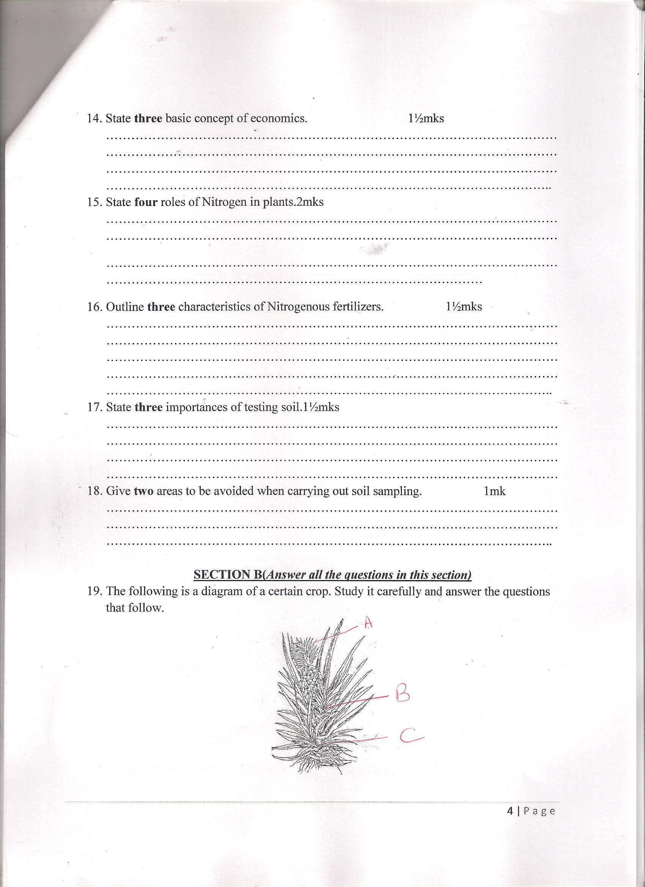
- Identify the crop ……………………………………………………….. 1mk
- Label the parts labeled A ,B and C. 1½mks
A…………………………………………………………
B…………………………………………………………
C…………………………………………………………
- Why is the part labeled A more preferred when propagating the above crop. 1mk
…...……………………………………………………………………………..
…………………………………………………………………………………
- State four factors to be considered when selecting materials for planting. 2mks
……………………………………………………………………………………………………………………………………………………………………………………………………………………………………………………………………………………………………………………………………………………………………………………………………………………………………………………………………………………………………………………………………………………………
- State four factors which determine the depth of planting. 2mks
………………………………………………………………………………………………………………………………………………………………………………………………………………………………………………………………………………………………………………………………………………………………………………………………………………………………………………………………………………………………………………………………………………………………
- The following is a pruned crop. Study it carefully and answer the questions that follows.

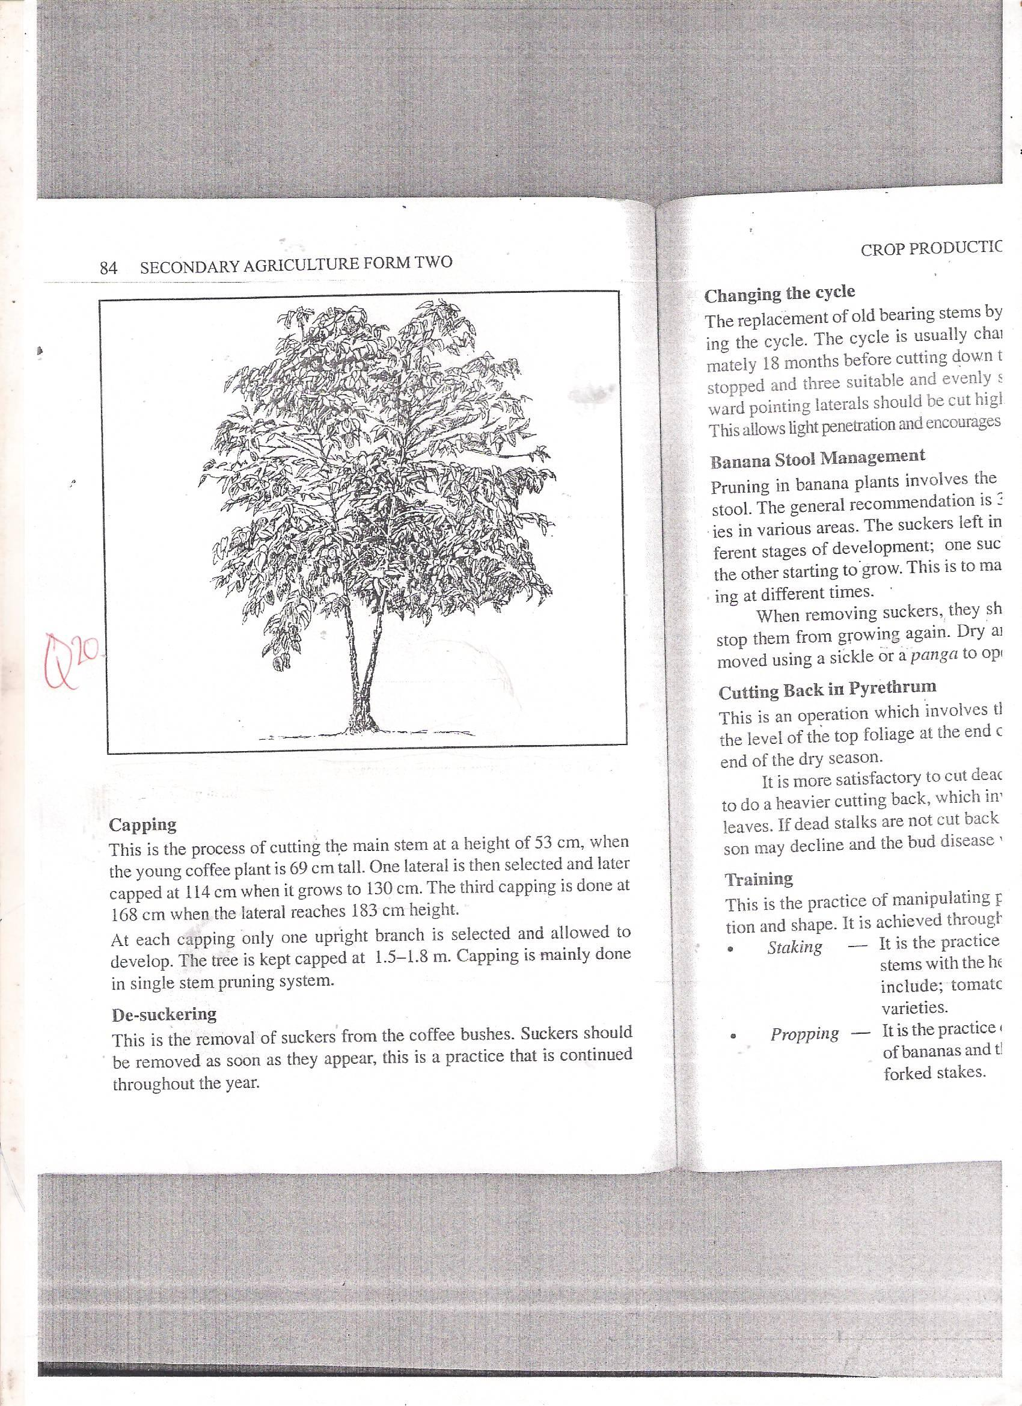
- Identify the method of pruning. 1mk
…………………………………………………………………………….

- Give four disadvantages of using the above method of pruning. 2mks
……………………………………………………………………………………………………………………………………………………………………………………………………………………………………………………………………………………………………………………………………………………………………………………………………………………………………………………………………………………………………………………………………………………………..
- Apart from the above give any other method of pruning coffee. 1mk
………………………………………………………………………………………
- State four factors which determine the time of harvesting crops. 2mks
……………………………………………………………………………………………………………………………………………………………………………………………………………………………………………………………………………………………………………………………………………………………………………………………………………………………………………………………………
…………………………………………………………………………………………………………………………………………………………………………………………………………………………………………………………………………………………………………………………………………………………………………
- The following are soil erosion control structures .Study the diagrams and answer the questions that follows.
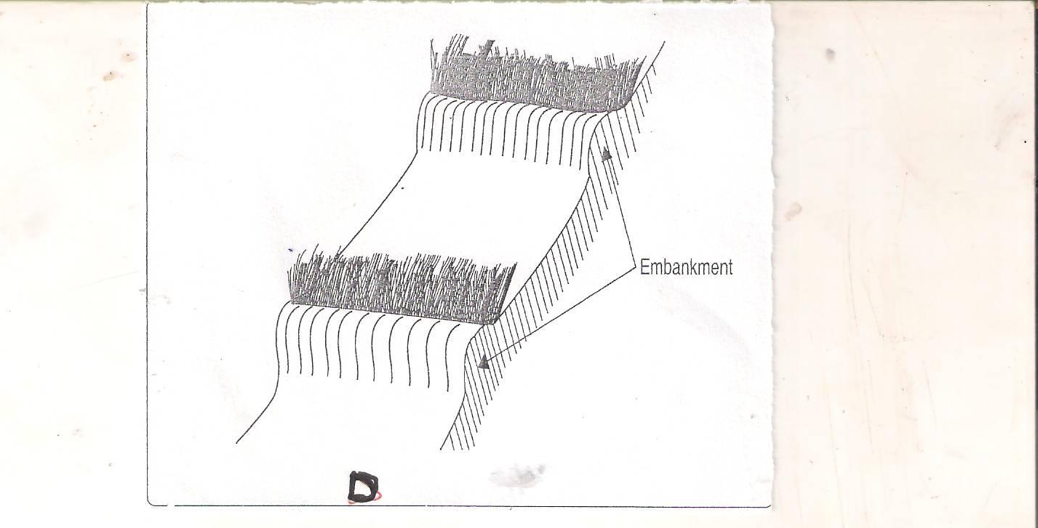

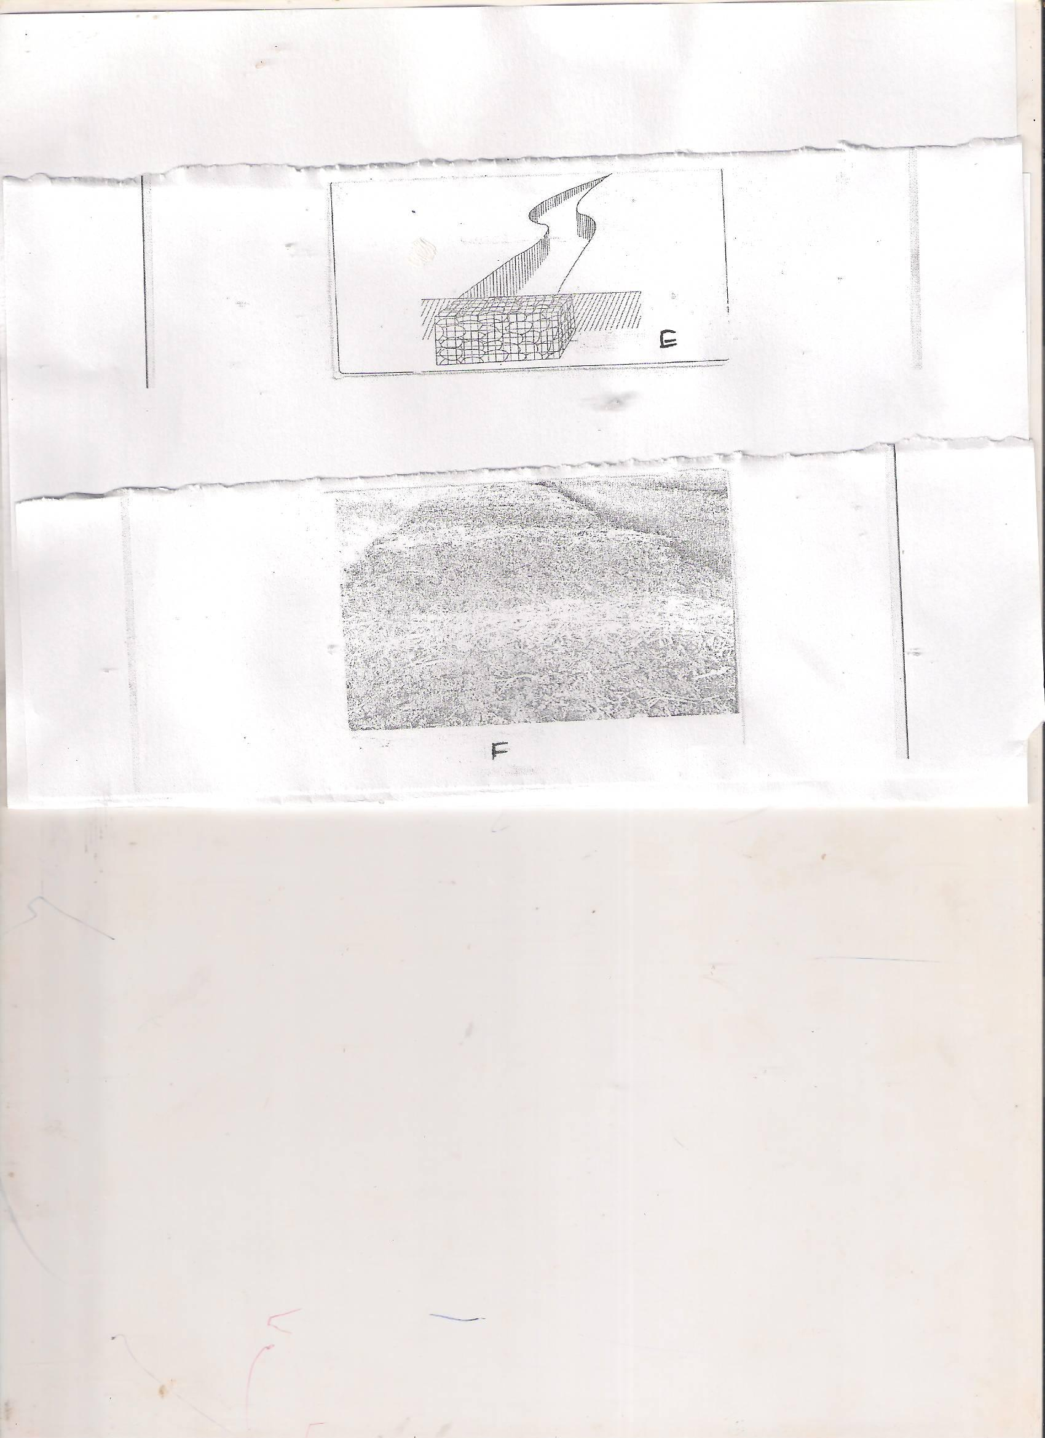
- Identify the structures 2mks
D-

E-

- Give two ways in which structure E will control soil erosion. 1mks
……………………………………………………………………………………………………………………………………………………………………………………………………………………………………………………………………………………………………………………………………………………………………………………………………………………………………………………………………

- The following are diagrams of common weeds in Kenya.

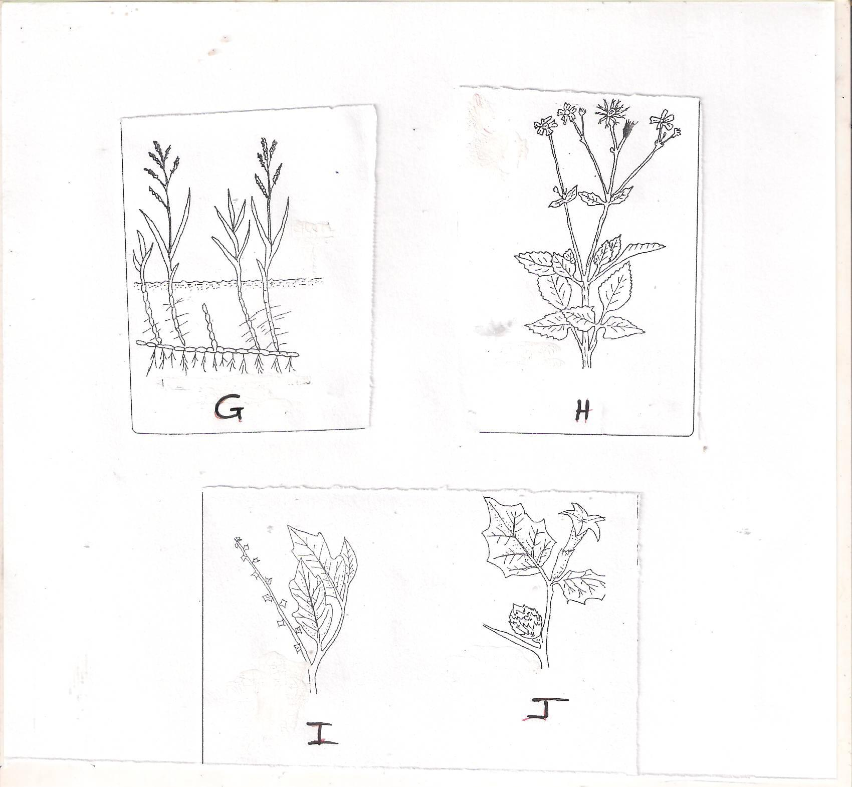

- Identify the above weeds. 2mks
G…………………………………………………………….
H…………………………………………………………….
I………………………………………………………………
J……………………………………………………………..
- What is the economic importance of weed 1½mks
G…………………………………………………………………………………………………………………………………………………………………………………II……………………………………………………………………………………………………………………………………………………………………………………JJ……………………………………………………………………………………………………………………………………………………………………………………

SECTION C.
(Answer any TWO questions in this section.)
- Describe the tomato production under the following the heading.
- Ecological requirement 3mks
…………………………………………………………………………………………………………………………………………………………………………………….
……………………………………………………………………………………………………………………………………………………………………………………
- Transplanting 5mks
…………………………………………………………………………………………
………………………………………………………………………………………………………………………………………………………………………………………………………………………………………………………………………………………………………………………………………………………………………………………………………………………………………………………………………………………………
……………………………………………………………………………………………..
…………………………………………………………………………………………………………………………………………………………………………………………………………………………………………………………………………….
- Field practices 5mks
………………………………………………………………………………………………………………………………………………………………………………………………………………………………………………………………………………………………………………………………………………………………………………………………………………………………………………………………………………………………………………………………………………………………………………………………………………………………………………………………………………………………
………………………………………………………………………………………………………………
…………………………………………………………………………………………………………………………………………………………………………………………………………………………………………………………………………………………………………………………………………….

- Diseases and their control. 4mks
……………………………………………………………………………………………………………………………………………………………………………………………………………………………………………………………………………………………………………………………………………………………………………………………………………………………………………………………………………………………
……………………………………………………………………………………………..
…………………………………………………………………………………………
………………………………………………………………………………………
………………………………………………………………………………………
- Harvesting 3mks
…………………………………………………………………………………..
………………………………………………………………………………………………………………………………………………………………………………………………………………………………………………………………………………...........................................................................................................................................
- (a) Describe the nursery management practices. 6mks
………………………………………………………………………………………………………………………………………………………………………………………………………………………………………………………………………………………………………………………………………………………………………………………………………………………………………………………………………………………………………………………………………………………………………………………………………………………………………………………………………………………………………………………………………………………………………………………………………………………………………………………………………………………………………………………………………………………………………..
…………………………………………………………………………………………………………………………………………………………………………………………………………………………………………………………………………………………….

(b) Outline five objectives of land reform. 5mks
………………………………………………………………………………………………………………………………………………………………………………………………………………………………………………………………………………………………………………………………………………………………………………………………………………………………………………………………………………………………
…………………………………………………………………………………………………………………………………………………………………………………………………………………………………………………………………………………………………………………………………………………………………………………………………………………………………………………………………………………

(c) State and explain five factors which determine the effectiveness of a herbicide. 5mks
………………………………………………………………………………………………………………………………………………………………………………………………………………………………………………………………………………………………………………………………………………………………………………………………………………………………………………………………………………………………
………………………………………………………………………………………………………………………………………………………………………………………………………………………………………………………………………………………………………………………………………………………………………………………………
(d) State four precaution measures that one should take when using any chemical in the farm. 4mks
………………………………………………………………………………………………………………………………………………………………………………………………………………………………………………………………………………………………………………………………………………………………………………………………………………………………………………………………………………………………
………………………………………………………………………………………………………………………………………………………………………………………………
- (a) State five advantages of landlordism and tenancy system of land tenure. 5mks
………………………………………………………………………………………………………………………………………………………………………………………………………………………………………………………………………………………………………………………………………………………………………………………………………………………………………………………………………………………………
……………………………………………………………………………………………
………………………………………………………………………………………………………………………………………………………………………………………………
(b) State and explain five factors which determine the spacing of any crop. 5mks
………………………………………………………………………………………………………………………………………………………………………………………………………………………………………………………………………………………………………………………………………………………………………………………………………………………………………………………………………………………………
…………………………………………………………………………………………….
………………………………………………………………………………………………………………………………………………………………………………………………………………………………………………………………………………………………………………………………………………………………………………………………
(c) State and explain five cultural methods of controlling soil erosion. (10mks) ………………………………………………………………………………………………………………………………………………………………………………………………………………………………………………………………………………………………………………………………………………………………………………………………………………………………………………………………………………………………………………………………………………………………………………………
…………………………………………………………………………………………….
………………………………………………………………………………………………………………………………………………………………………………………………………………………………………………………………………………………………………………………………………………………………………………………………………………………………………………………………………………………………
…………………………………………………………………………………………….
………………………………………………………………………………………………………………………………………………………………………………………………………………………………………………………………………………………………………………………………………………………………………………………………………………………………………………………………………………………………
…………………………………………………………………………………………….

