.
FORM 3: AGRICULTURE
MAKING SCHEME
TERM II
SECTION A: (30 MARKS)
- Name the two types of bees 1mk
African wild bee
European bee

- Define the following terms as used in livestock production 1½
- Dehorning - this is the removal of horns or horn buds 1 x ½ = ½ mk

- Culling - this is the removal of unproductive animals from the farm to leave high quality and productive animals 1 x ½ = ½ mk

- Parturition - this is the act of giving birth to a mature feotus 1 x ½ = ½ mk

- State four reasons why a farmer should strive to keep livestock healthy 2mks
- Healthy animals reduce the cost of production because the farmer spends less
- Money on treatment
- Healthy animals are high producers
- Good health gives animals a longer and productive life
- Healthy animals grow well and fast
- Healthy animals produce good quality products which command a high market value
- Healthy animals do not spread diseases to other animals or human beings
4 x ½ = 2 mk

- Outline the effects of parasites on their hosts
- Cause anemia
- Causes obstruction to internal organs
- Transmits diseases
- Cause injury and damage to animal tissues and organs
- Cause irritation
- Deprive the animal food 3 x 1 = 3 mk
- Give two importances of water in an animal’s body
- Water helps in the transportation of food nutrients within the body
- Water helps in the regulation of body temperature in animals
- Water make the cells turgid thus maintaining the shape of the animals body
- Components of body cells and many body fluids
- Used in the biochemical reactions
- Helps in excretion of waste products from the body
2 x ½ = 1mk
- Give two examples of equipments that a livestock farmer can use in administering oral antihelminthes
- Borus gun
- Drenching fun
- Narrow necked bottle
2 x ½ = 1mk
- Flushing is giving high quality feed to an an animal around service time
Steaming up is giving high quality feeds to an animal during the last weeks of gestation
2 x ½ = 1mk
- (a) Name a dual purpose cattle breed reared in Kenya
- Sahiwal
- Simmental
- Redpoll 1 x ½ = ½ mk

(b) Outline four general characteristics of indigenous cattle 2mks
- They have humps for storing fat
- Tolerant to high temperatures
- They have a slow growth rate in maturity rate
- Able to resist tropical diseases of E.C.F
- Have relatively long calving interval
- Can walk for long distances without serious loss in condition
4 x ½ = 2mk
- Name four breeds of dairy goats 2mks
- Saanen
- Jamnapari
- Aglo-Nubia
- Toggenburg
- British alphine
- State four ways of controlling tsetse flies 2mks
- Sterilizing the male flies
- Bush clearing to destroy the breeding ground for the parasite
- Spraying their breeding grounds with insecticides
- Use of fly traps such as nets treated with appropriate chemicals to trap the insects
4 x ½ = 2mk
- List the methods of selection in livestock
- Mass selection
- Progeny testing
- Contemporary companson
3 x ½ = 1½ mk
- Give three types of bees found in a colony
- Queen
- Drone
- Worker bee
3 x ½ = 1½ mk
- List three advantages of hoof trimming in sheep production
- Facilitates easy movement of the animals
- Controls diseases such as foot rot disease
- Prevents the ram from injuring the owe during tupping
- Prevent the cracking of the hooves
3 x ½ = 1½ mks

- State two uses of a foot bath in cattle dip
- Remove mud from animal hooves
- Contains copper sulphate solution to control foot rot disease

- State six routes by with disease causing organisms can enter into an animal’s body
- Through the eyes
- Through the reproductive tracts
- Open skin, cuts, wounds & lesions
- Orally through the mouth
- Inhalation through the nose
- Through the umbilical cords
6 x ½ = 3 mks
- (a) state three characteristics of succulent roughages
- High fibre content
- High carbohydrate content
- Low protein
- High moisture content
1½ mk
(b) Name two types of concentrates 1mk
- Energy concentrates
- Protein concentrates
17. State four features of a good calf-pen
- It should be easy to clean
- Dryness and warm
- Proper lighting/well lit
- Single housing
- Should be spacious
- Should be leak proof
- It should be draught free
- Should be well ventilated
- It should be sighted in a well drained area
4 x ½ = 2 mks
SECTION B (30MKS)
18. (a) Below are farm tools, study them and answer the questions that follows:-
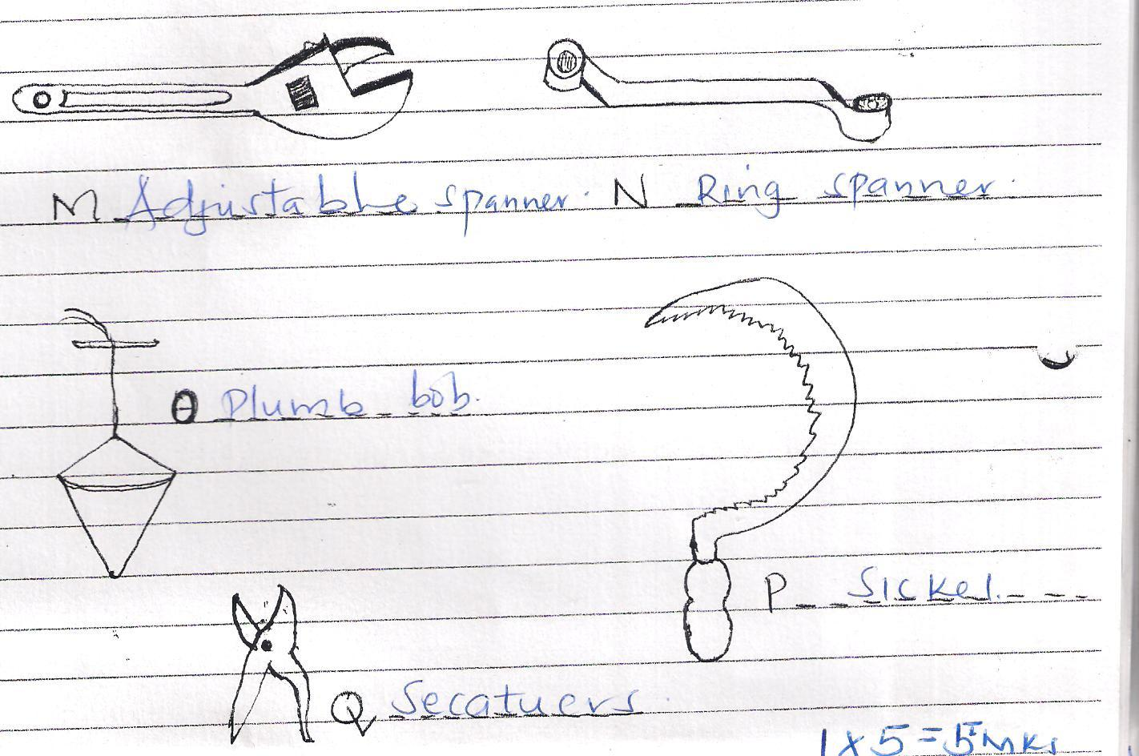

- Name the tools labeled M, N, O, P, Q. 21/2mrks

- Give one functional advantage of tool M over N can be adjusted to fit any nut or bolt
1 x 1 = 1mk
- State the use of each tool named in (i) above
M - Tightening & loosening nuts and bolts of various sizes
N - For lightening and loosening bolts and nuts of different size depending on
spanner size
O - Used for checking the vertical straighten of a wall
P - Harvesting crops like rice, wheat. Also used in cutting grass
Q - Prunning crops
5 x ½ = 2½ mks

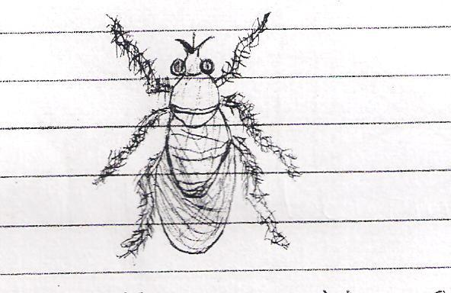
19. Study the diagram below and then answer the questions that follows:-

- Identify the parasite shown above 1mk
Tsetse fly
- Name the livestock species attacked by the parasite above 1½mks
Cattle
Sheep
Horses
3 x ½ = 1½ mks

- How does the above parasite obtain its food from the host?
By sucking blood from the animal after piercing the skin of the animal
1 x 1 = 1mks

- What are the harmful effects of the parasite you have mentioned in (a) above?
- Damages the skin and hides
- Causes anaemia by sucking blood from the animals.
- Transmits nagana
2 x 1 = 2 mks

- How would a farmer control the above parasite
- Clearing the bush nearby
- Spraying the breeding grounds with the appropriate insecticide
2 x 1 = 2 mks
20. Study the illustrations of a farm structure below and answer the questions that follows:-
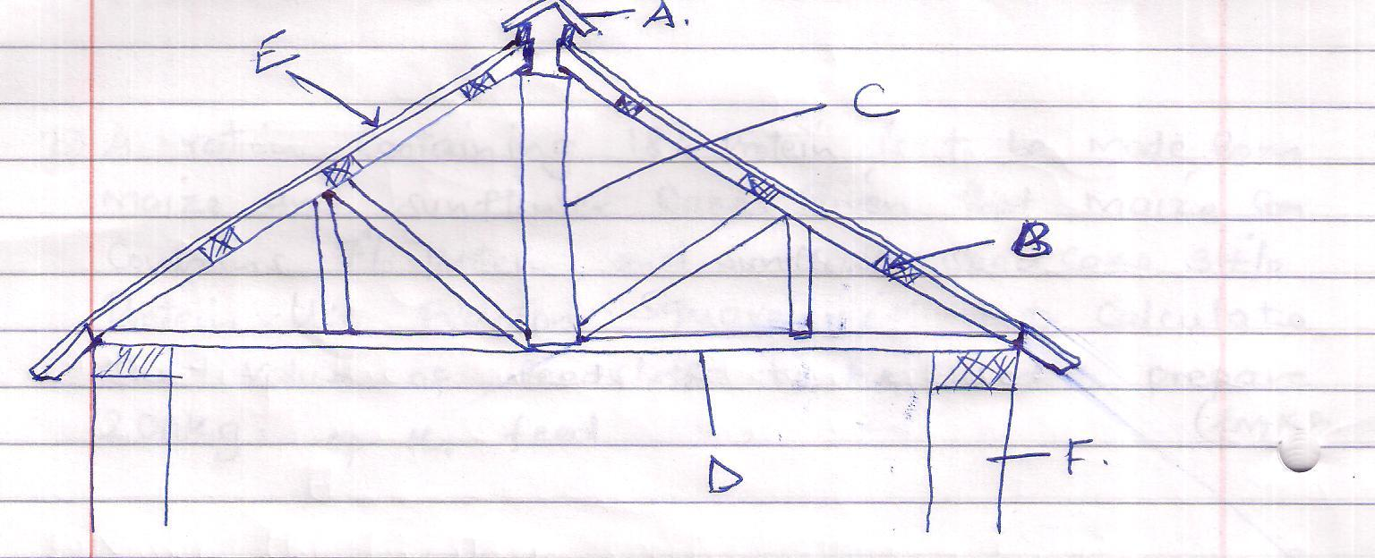

- Name the parts labeled A, B, C, D 4mks
A - Apex/ridge cap
B - Purlin
C - King post
D - Cross tie
(ii) State the function of the parts labeled E 1mk

(iii) State three maintenance practices carried out on the roof of a farm structure
- Repair and Replace if worn out
- Paint to prevent rusting
- Broken frames should be replaced
2 1/2mks

SECTION C (40MKS)
21.a} Outline the importances of fences in the farm
- mark boundaries
- Provides privacy & security
- Separates crop land from pastures
- Used separate animals
- To used control pest and diseases
- Provides effective grazing and land use
- Adds value to the farm
- Controls soil erosions
- Live fences acts as wind breakers
- Fences are used to protect water catchments or sources
- Some live fence have medicinal value
- When trimmed live fence act as a source of organic matter,fuel
- Add aesthetic value
- Some eg lantana camara acts as livestock feeds
- Live fence provide shade to livestock
- Prevents creation of unneccesary paths (10mrks
(b) Give two methods used for ration computation 2mks
- - Pearson’s square method
- - Trial and error method
(c) A ration containing 18% protein is to be made from maize and sunflower cake. Given that maize contains 7% protein, and sunflower seed cake 34% protein. Use pearson square method to calculate the value of feedstuffs to be used to prepare 200Kg of the feed. 3mks
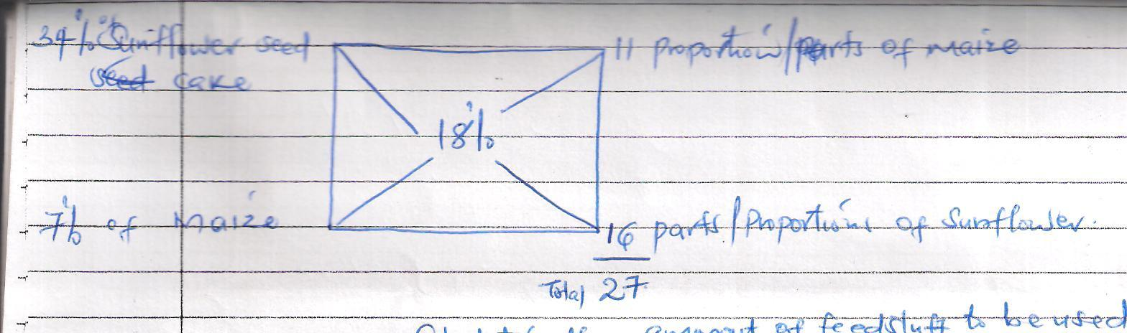
Calculate the amount of feedstuff to be used
11 x 200 = 81.48Kg of maize
27

16 x 200 = 118.52Kg of sunflower
27
e]differences between ruminant and non ruminant
- Ruminants chew cud non ruminants do not chew cud
- Ruminants have four stomach chambers non ruminants have one stomach
- Ruminants regurgitate food non ruminants do not regurgitate food
- Ruminants can digest cellulose ,non ruminants do not digest cellulose
- Have alkaline saliva due to presence of ammonia,non ruminants have neutral saliva
- Ruminants have no ptyalin hence no enzymatic digestion in the mouth while non ruminants have ptyalin in the saliva hence enzymatic digestion stars in the mouth
22. (a) Outline the life cycle of a three host tick 10mks
- Eggs on the ground
- Hatch into larvae
- The emerging larvae climbs the first host, and feed on blood, becomes engorged. Drops to the ground and moult’s to Nymphs.
- Emerging Nymph climbs the second host, sucks blood becomes engorged and drops to the ground.
- Moults to adult. The adults climbs to the third host sucks blood becomes engorged, mates the female and the female drops to the ground to lay eggs.
5 x 2 = 10 mks

(b) State five effects of tick to livestocks
- Their bites lower the value of hides and skins
- They cause irritation
- Sucks blood from the host leading to anaemia
- Transmits disease – causing organisms
- Cause wounds which are routes for disease infection
5 x 1 = 5mks
(c) How can a farmer control ticks in livestock production?
- Hand picking and killing
- Burning infested pasture
- Using acancides (spraying, dipping)
- Use of tick predator
- Double fencing
- Rotational grazing
5 x 1 = 5mk
24. (a) Explain five factors considered when selecting a breeding stock
- Age
- Body conformation
- Mothering ability
- Health
- Physical fitness
- Level of performance
- Behavior of the animal
- Pulificacy
5 x 2 = 10mks (explained)

(b) With a well labeled diagram, describe egg formation in a hen 10mks
- When mature, the ovum is released into the oviduct where it is received by the funnel
- In the funnel/infundibulum - fertilization takes place.
- Chalazae is added to hold the yolk in position
- The egg moves to the magnum where thick albumen is added
- The egg moves to the Isthmus where the inner router membrane water, mineral salts and vitamin are added.
- The egg moves to the uterus where the shell pigment and more albumen are added
- The egg moves to the vagina where it is temporarily stored before it’s laid in the cloaca through the vent
Describing -7 x 1 = 7mks
drawing and labeling -3mks

