443/2 - AGRICULTURE - Paper 2


𝟐HRS

2022 TRIAL 2 JULY INTERNAL EXAMINATION

Name ……………………………………………… Index Number ………………………... Class ………………………................. Candidates Signature……………………………. Date ……………………………………

INSTRUCTIONS TO THE CANDIDATES:-

a) Write your name and index number in the space provided at the top of this page. b) Sign and write the date of the examination in the space provided above.
c) This paper consists of three sections A, B, and C.
d) Answer all questions in section A and B.
e) Answer any two questions in section C.
f) All answers should be written in the spaces provided.
g) Candidate should check the question paper to ascertain that all pages are printed as indicated and that no question is missing.
h) Candidate should answer the question in English. FOR EXAMINERS USE ONLY

SECTION | QUESTION | MAXIMUM  SCORE | CANDIDATE  SCORE
A | 1-16 | 30
B | 17-20 | 20
C |  | 20
 |  | 20
 | TOTAL SCORE | 90

SECTION A: (30MARKS)
Answer all questions from this section on the spaces provided.
1(a) Give two qualities of milk of the Friesian breed of cattle. (1 mark)

b) Name three components of a truss. (1½
marks)

2. Give two reasons why Jersey breed of cattle is well suited to semi-arid conditions. (1 mark)

3(a) State the effect of an incubator with internal humidity of 100%. (½
mark)

b) State the use soluble grit to layer birds? (½
mark)

4. Give two uses of a wood float. (1 mark)
5. Give three conditions may lead to culling of a breeding boar? (1½
marks)

6. Identify two practices carried out during sap displacement in timber preservation. (1 mark)

7(a) State three characteristics of the Galla goat (1½
marks)

b) Name the two breeds of camels. (1 mark)

8(a) List three sources of water to livestock. (1½
marks)

b) Maize germ, a livestock feed has a starch equivalent of 30%. Explain
(1mark)
9(a) State four ways in which fleas cause economic losses to the farmer. (2mark)

b) List three limitations of water as a source of power in the farm. (1½
marks)

10. Tabulate two features that differentiate between dairy and beef cattle. (2 marks)

11. Define the following terms as used in livestock production. (1½
marks)
a) Digestibility

b) Prolificacy

c) Malpresentation

12. Give three methods of selecting livestock for breeding
(1½marks)

13. Why should bees be fed on sugar syrup? (1mark)

14. State four conditions that would encourage hens to eat eggs in poultry production
(1½mark)

15. Distinguish between tupping and serving. (1mark)

16. What is the advantage of using forage harvesters compared to a mower? (1mark)

17. Give three maintenance practices of ox ploughs. (1½marks)
18. State four disadvantages of using live fence on the farm
(2marks)

19(a) Give two pre disposing factors of mastitis. (1mark)

b) Using letter X identify three areas infested with a three- host tick in the picture below. (1½marks)
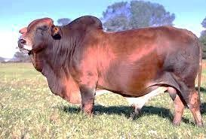
SECTION B: (20MARKS)
ANSWER ALL QUESTIONS FROM THIS SECTION ON SPACES PROVIDED

20. Study the structure of a goat pen below and then answer the questions that follow.

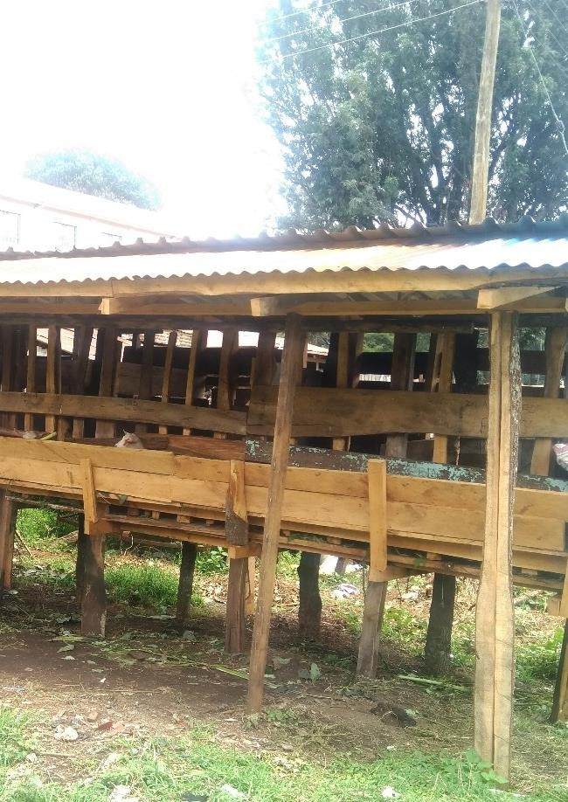K

H

N

a) Specify the measurements between H and N. (½mark)

Give a reason for your answer in a) above. (½mark)

b) State the function of part K. (1mark)

c) Which type of floor is recommended for the pen shown in the picture above
(½mark)

d) List two reasons for housing the calves singly. (1mark)

21(a) Identify the equipment X and Y below.
(1mark) 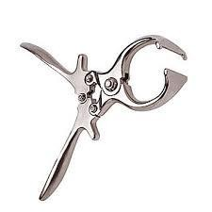
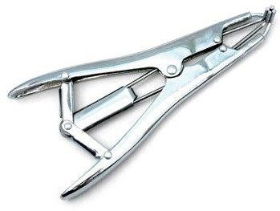
X Y
b) State the functions of each of the equipment. (2marks)

(1mark)
ii) Give two reasons for castrating a male piglet.

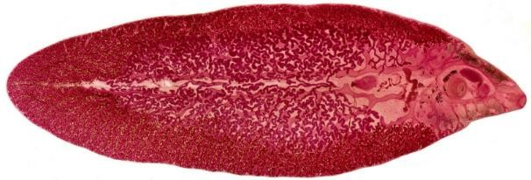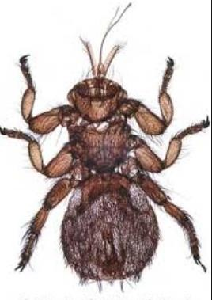22(a) Identify the parasites below. (1mark)

U W

b) Name two species of parasite U. (1mark)

c) Why is it difficult to control parasite U? (1mark)

d) State the livestock commonly affected by parasite W? (½mark)

with 12%DCP and Soya bean meal containing 36% DCP. Calculate the quantities of each feedstuff he would have in the ration.
(2marks)

23(a) Using x draw the behaviour of the chicks expected in the following conditions in a brooder.(2marks)

brooder wall

Heat source

V

Draught wind Excess heat for heat source

b) What is the role of the part labelled V? (½
mark)
c) i) Identify the got breed below. (1mark)

1

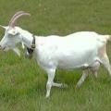2

3

ii) On the diagram name parts 1-3. (1½
marks)
d) List two features that are used to identify the goat breed
(1mark)
SECTION C: (40MARKS)

Answer ANY TWO questions from this section on foolscaps provided.

24(a) Describe the procedure for honey harvesting in a Kenya Top Bar Hive. (5marks)
b) Name ten parts of an ox- drawn plough and state the function of each. (10marks)
c) Explain how physiological factors are used as a sign of ill or good health. (5marks)

25(a) Describe the process of milk let down in a cow. (6marks)
b) Describe the procedure of embryo transplant in cattle. (9marks)
c) Describe cattle management during dipping

(5marks)

26(a) Outline the control measures of mastitis. (5marks)
b) Describe the marketing of eggs. (10marks)
c) Outline the general characteristics of chinchilla breed of rabbits. (5marks)

© Zeraki- 2021 Page 13 of 16

© Zeraki- 2021 Page 14 of 16

© Zeraki- 2021 Page 15 of 16

© Zeraki- 2021 Page 16 of 16

