Name…………………………………………………………………..Index No……………………School………………………..
231/1 Candidate’s Signature…………………………………………….
BIOLOGY Date……………………………..Stream…………………………….
Paper 1
(Theory)
2hours
CHAMPIONS JET 2, 2024 MOCK EXAMINATIONS .

Kenya Certificate of Secondary Education (kcse)

Instructions to candidates
(a) Write your name and index number in the spaces provided above
(b) Sign and write the date of examination in the spaces provided above
(c) Answer ALL questions in the spaces provided
(d) This paper consists of 9 printed pages
(e) Candidates should check the question paper to ascertain that all pages are printed as indicated and that no questions are missing.

question | Maximum score | Candidate’s score
1-26 | 80

1. State two ways in which the heart muscles are special. (2mks)
…………………………………………………………………………………………………………………………………………………………………………………………………………………………………………………………………………………………………………
2. (a) Name the branch of biology that deals with the study of the Phylogenetic relationship among organism (1mk)
……………………………………………………………………………………………………………………………………………………
(b) state one environmental problem that can be solved by studying biology (1mk)
……………………………………………………………………………………………………………………………………………………
3.a) (i) The liger is an offspring of a lion and a tiger. Explain why the liger is infertile (1mk)
…………………………………………………………………………………………………………………………………………………………………………………………………………………………………………………………………………………………………………
(ii) Name two members of kingdom Protoctista (2mks)
…………………………………………………………………………………………………………………………………………………………………………………………………………………………………………………………………………………………………………
b) State two characteristics of fungi (2mks)
………………………………………………………………………………………………………………………………………………………………………………………………………………………………………………………………………………………………………..
4. (a) State the function of diaphragm in the microscope (1mk)
…………………………………………………………………………………………………………………………………………………………………………………………………………………………………………………………………………………………………………
(b) State the advantage of using light microscope over electron microscope (1mk)
……………………………………………………………………………………………………………………………………………………
5. What is the role of cristae in respiration? (1mk)
…………………………………………………………………………………………………………………………………………………………………………………………………………………………………………………………………………………………………………
5. Describe the process of wilting (2mks)
………………………………………………………………………………………………………………………………………………………………………………………………………………………………………………………………………………………………………………………………………………………………………………………………………………………………………………………………
7. (a) Use the equation below to answer questions that follow (3mks)
Maltose + A process B glucose + C
Identify: A………………………………………………………………………………………………………………………………………………. B…………………………………………………………………………………………………………………………………………………. C………………………………………………………………………………………………………………………………………………….
(b) Explain why patients who cannot feed orally are given glucose in a drip (2mks)
……………………………………………………………………………………………………………………………………………………………………………………………………………………………………………………………………………………………………………………………………………………………………………………………………………………………………………………………
8. (a) The diagram below represents the apical growth in a root
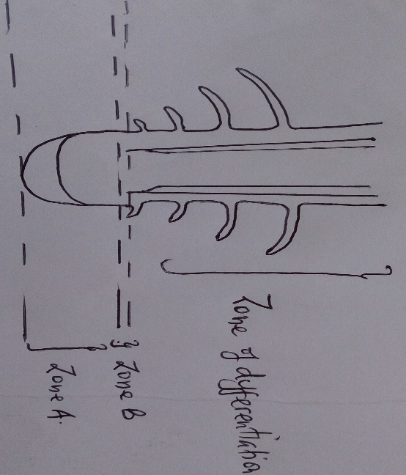

(i) What happens to the cells at zone B (2mks)
……………………………………………………………………………………………………………………………………………………
(ii) Name the hormone produced at zone A that brings about a change in zone B (1mk)
……………………………………………………………………………………………………………………………………………………
(b) State two adaptations of phloem tissue to its functions (2mks)
………………………………………………………………………………………………………………………………………………………………………………………………………………………………………………………………………………………………………………………………………………………………………………………………………………………………………………………………
9. (a) Distinguish between natural and natural acquired immunity (2mks)
…………………………………………………………………………………………………………………………………………………………………………………………………………………………………………………………………………………………………………………………………………………………………………………………………………………………………………………………………………………………………………………………………………………………………………………………………………………..
(b) State why it is a disadvantage to have blood group O (1mk)
…………………………………………………………………………………………………………………………………………………………………………………………………………………………………………………………………………………………………………
10. 60 white and 60 black mice were released in an area inhabited by jackals. After six weeks, it was established that 24 black and 8 white mice had remained. Account for the above observation. (3mks)
……………………………………………………………………………………………………………………………………………………………………………………………………………………………………………………………………………………………………………………………………………………………………………………………………………………………………………………………………………………………………………………………………………………………………………………………………………………………………………………………………………………………………………………………………………………………………………………………………………………………………………………………………………………………………………………………………………………………………………………………………………………………………………………………………………………
11. The diagram below is a structure used in gaseous exchange in insects
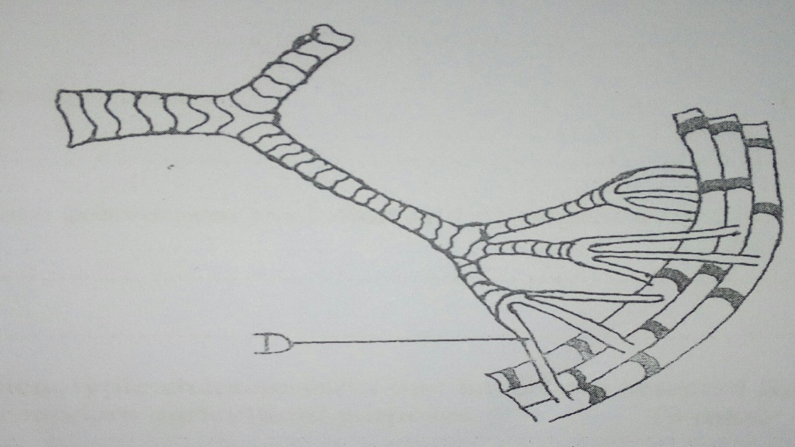
(a) Identify part labelled D (1mk)
……………………………………………………………………………………………………………………………………………………
(b) State one adaptation of structure D to its function (1mk)
……………………………………………………………………………………………………………………………………………………
(c) A person cannot breath while swallowing food. Explain (2mks)
…………………………………………………………………………………………………………………………………………………………………………………………………………………………………………………………………………………………………………
12. (a) Give an equation to show that respiration involves oxidation of a food substance (1mk)
………………………………………………………………………………………………………………………...............................
………………………………………………………………………………………………………………………...............................
(b) Explain what happens when there is oxygen debt in the human muscles (2mks)
……………………………………………………………………………………………………………………………………………………
………………………………………………………………………………………………………………………...............................
………………………………………………………………………………………………………………………...............................
………………………………………………………………………………………………………………………...............................
(c)Name the end products of Kreb’s cycle (2mks)
……………………………………………………………………………………………………………………………………………………
13. (a) Name the excretory product removed through guttation (1mk)
……………………………………………………………………………………………………………………………………………………

(b) Name the structures in the skin that deals with (2mks)
(i) Temperature regulation
……………………………………………………………………………………………………………………………………………………
(ii) Excretion
……………………………………………………………………………………………………………………………………………………
(c) Seals have very thick layer of fatty tissue under the skin. In what way is this useful to them? (2mks)
………………………………………………………………………………………………………………………………………………………………………………………………………………………………………………………………………………………………………………………………………………………………………………………………………………………………………………………………

14. a) Name the organism:
(i) that causes malaria (1mk) ……………………………………………………………………………………………………………………………
(ii) that transmits malaria (1mk)
…………………………………………………………………………………………………………………………………………………….
15.State two reasons why green plants are included in a fish aquarium (2mks)
………………………………………………………………………………………………………………………………………………………………………………………………………………………………………………………………………………………………………………………………………………………………………………………………………………………………………………………………
16. Study the diagram below
Fox fleas hawk
Rabbits ladybird bluetits

Aphids caterpillars

Grass tree leaflitter fungus
(a) Name the organism with the highest biomass (1mk)
……………………………………………………………………………………………………………………………………………………

(b) State reasons why not all energy stored in the rabbit’s body is transferred to the fox (2mk)
…………………………………………………………………………………………………………………………………………………………………………………………………………………………………………………………………………………………………………
17. Give the functions of the following ecological instruments (2mks)
(a) Seechi disc
……………………………………………………………………………………………………………………………………………………
(b) Photographic light meter
……………………………………………………………………………………………………………………………………………………

18. (a) Explain why fertilization must take place in the fallopian tube but not uterus (2mks)
………………………………………………………………………………………………………………………………………………………………………………………………………………………………………………………………………………………………………………………………………………………………………………………………………………………………………………………………
(b) Explain double fertilization in flowering plants (2mks)
……………………………………………………………………………………………………………………………………………………………………………………………………………………………………………………………………………………………………………………………………………………………………………………………………………………………………………………………………………………………………………………………………………………………………………………………………………………
19. Explain what happens in humans when the concentration of glucose in the blood decreases below the normal level. (4 mks)
……………………………………………………………………………………………………………………………………………………………………………………………………………………………………………………………………………………………………………………………………………………………………………………………………………………………………………………………………………………………………………………………………………………………………………………………………………………
……………………………………………………………………………………………………………………………………………………
20. State three main features of a thoracic vertebra (3 mks)
………………………………………………………………………………………………………………………………………………………………………………………………………………………………………………………………………………………………………………………………………………………………………………………………………………………………………………………………………………………………………………………………………………………………………………………………………………………………………………………………………………………………………………………………………………………………………..
21. Differentiate between skeletal muscles and smooth muscles (2mks) …………………………………………………………………………………………………………………………………………………………………………………………………………………………………………………………………………………………………………

22. List down three phenotypic characteristics that have been selected for the production of varieties suitable for modern agricultural purposes. (3mks)
………………………………………………………………………………………………………………………………………………………………………………………………………………………………………………………………………………………………………………………………………………………………………………………………………………………………………………………………
23.a) Explain why when reading a book the words looked at directly are clearly defined while the surrounding words are blurred. (2mks)
…………………………………………………………………………………………………………………………………………………………………………………………………………………………………………………………………………………………………………………………………………………………………………………………………………………………………………………………………………………………………………………………………………………………………………………………………………………………………………………………………………………………………………………………………………………………………………
(b) The diagram shows the position of an image formed in a defective eye
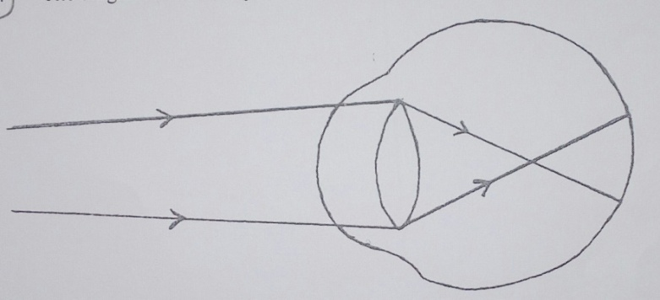

(i) Draw a diagram to show how the defect can be corrected (2mks)

24. Give two importance of tropic responses (2mks)
……………………………………………………………………………………………………………………………………………………………………………………………………………………………………………………………………………………………………………………………………………………………………………………………………………………………………………………………………………………………………………………………………………………………………………………………………………………
25. (a) What does Lamarck’s idea of evolution emphasize? (1mk)
…………………………………………………………………………………………………………………………………………………………………………………………………………………………………………………………………………………………………………
(b) What evidence is there to suggest that vertebrates have a common ancestral origin?(1mk)
…………………………………………………………………………………………………………………………………………………………………………………………………………………………………………………………………………………………………………
26. (a) Name the hormone that sustains the larval stage in insects and the structure that produce it. (2mks)
Hormone……………………………………………………………………………………………………………………………………
Structure……………………………………………………………………………………………………………………………………
(b) State the type of growth which occurs in insects (1mk)
…………………………………………………………………………………………………………………………………………………

THIS IS THE LAST PRINTED PAGE.

