Name………………………………………………………. ADM No……….. Class…………

Candidates Signature…………… Date…………………………….

231/1
BIOLOGY
Paper 1
(THEORY)
TIME 2 HOURS

SET 1
FORM 4
Kenya certificate of secondary education (K.C.S.E)

231/1
BIOLOGY
Paper 1
(THEORY)
TIME: 2 HOURS

INSTRUCTIONS TO CANDIDATES

- Write your name and Index Number in the spaces provided above.
- Sign and write date of examination in the spaces provided above.
- Answer ALL questions in the spaces provided.

FOR EXAMINER’S USE ONLY

Question | Maximum score | Candidate’s score
1-28 | 80

Candidates should check the question paper to ensure that all the 8 pages are printed as indicated and no questions are missing.

1. Name the branch of Biology that involves the study of: (2 marks)
a) Organisms for the sake of classifying them.
...........................................................................................................................................................
b) Microscopic organisms.
………………………………………………………………………………………………………
2. The diagram below represents a plant
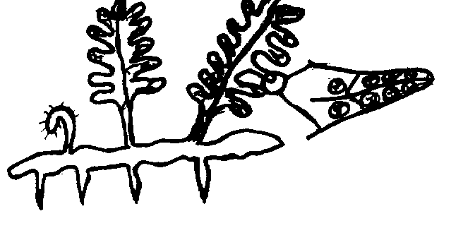

a) Name the division to which the plant belongs. (1 mark)
………………………………………………………..………………………………………………..
b) Give three reasons for your answer in (a) above. (3 marks)
……………………….………………………………………………………………………………….
…………………………………………..…..………………………………………………………….
……………………………………………..…..……………………………………………………….
3. State three parameters that can be used to estimate growth in seedlings. (3 marks)
……………………….………………………………………………………………………………….
…………………………………………..…..………………………………………………………….
……………………………………………..…..……………………………………………………….
4. Equal amounts of crushed Irish potato was placed in equal volumes of hydrogen peroxide solution at indicated pH. The volume of the gas produced was measured and recorded as shown in the table below.
pH | 4.0 | 7.0 | 9.0
Volume of gas (cm³) | 2.7 | 5.7 | 7.7

(a) Name the gas that was produced. (1 mark)
………………………………………………………………………………………………………..
(b) Account for the difference in the volume of the gas produced in pH 4.0 and pH 9.0 (2 marks)
……………………….………………………………………………………………………………….
…………………………………………..…..…………………………………………………………..

5. The diagram below shows a longitudinal section of mammalian skin.
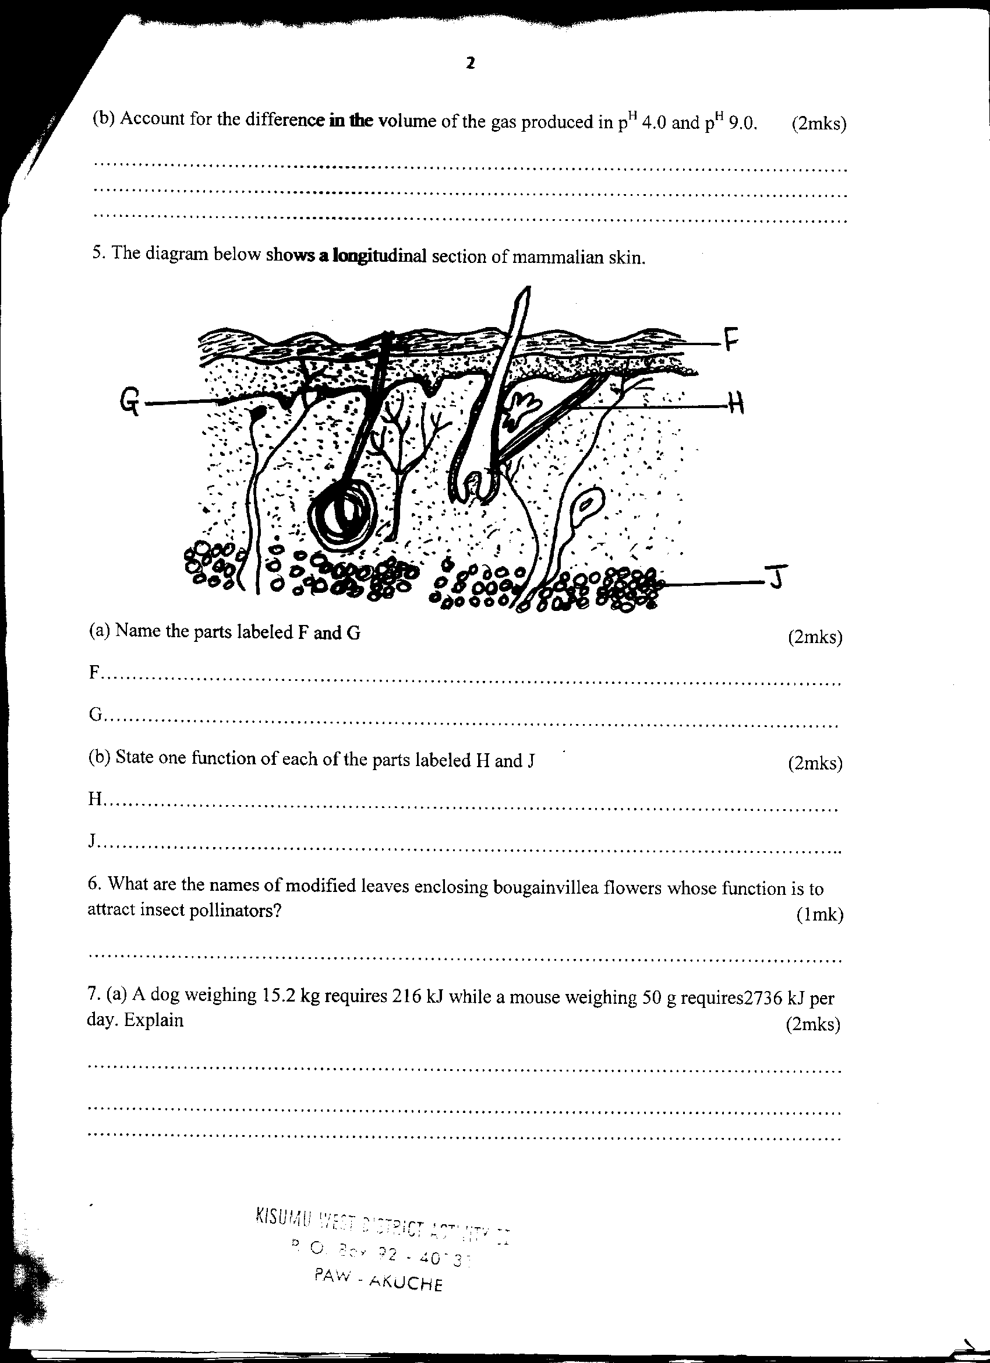

a) Name the parts labeled F and G. (2 marks)
F……………………………………………………………
G……………………………………………………………
b) State one function of each of the parts labeled H and J (2 marks)
H ……………………………………………………………
J ……………………………………………………………
6. What are the names of modified leaves enclosing bougainvillea flowers whose function is to attract insect pollinators? (1 mark)
………………………………………………………………………………………………………..
7. (a) A dog weighing 15.2kg requires 216kJ while a mouse weighing 50g requires 2736 kJ per day.
Explain. (2 marks)
………………………………………………………………………………………………………..
………………………………………………………………………………………………………...
(b) Under what condition is lactic acid formed in human muscles? (1 mark)
………………………………………………………………………………………………………
………………………………………………………………………………………………………
8. The diagram below represents a section through a human tooth.
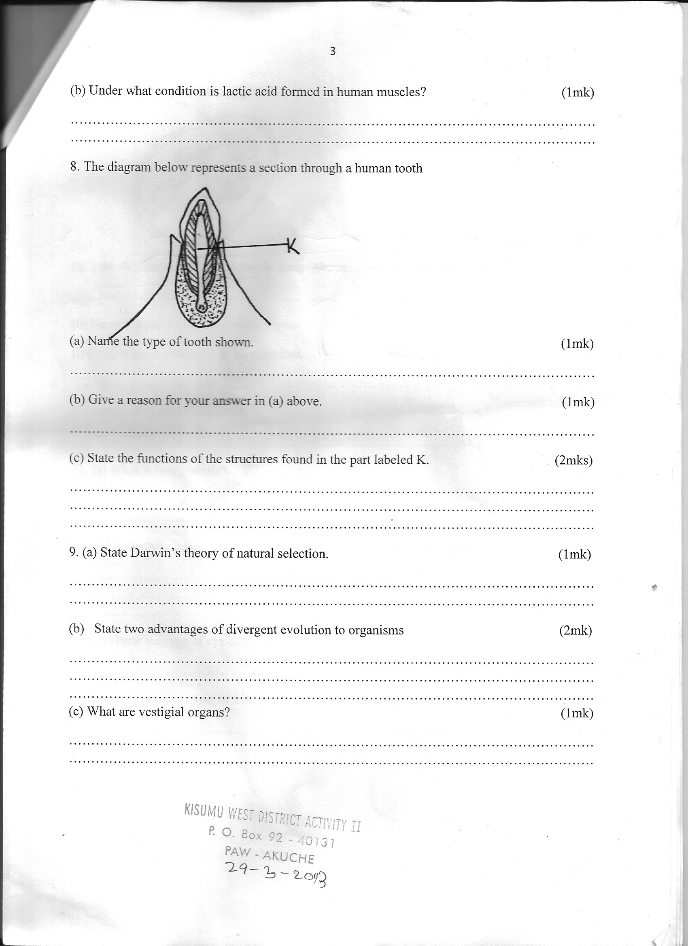

(a) Name the type of tooth shown. (1 mark)
……………………………………………………………………………………………………….
(b) Give a reason for your answer in (a) above. (1 mark)
……………………………………………………………………………………………………….

(c) State the functions of the structures found in the part labeled K. (2 marks)
……………………………………………………………………………………………………….
……………………………………………………………………………………………………….
……………………………………………………………………………………………………….
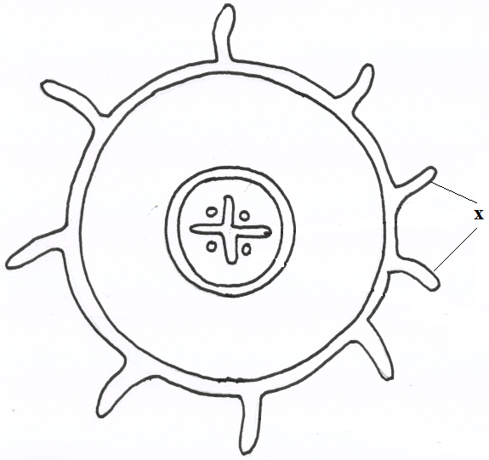
9. The diagram below represents a transverse section of a plant part. Study it and answer the questions that
follow.

- Name the class in which the plant belongs. ( 1 mark)
…………………………………………………………………………………………………………….…………
- Give a reason for answer (a) above ( 1 mark)
……………………………………………………………………………………………………………….………………………………………………………………………………………………………………………………………………………………………………………………………………………….
c) State one adaptation for the structures labeled X to their functions. (1 mark) ……………………………………………………………………………………………………………….………………………………………………………………………………………………………………………………………………………………………………………………………………………….
10. Below is a diagram of an organelle. (2 marks)
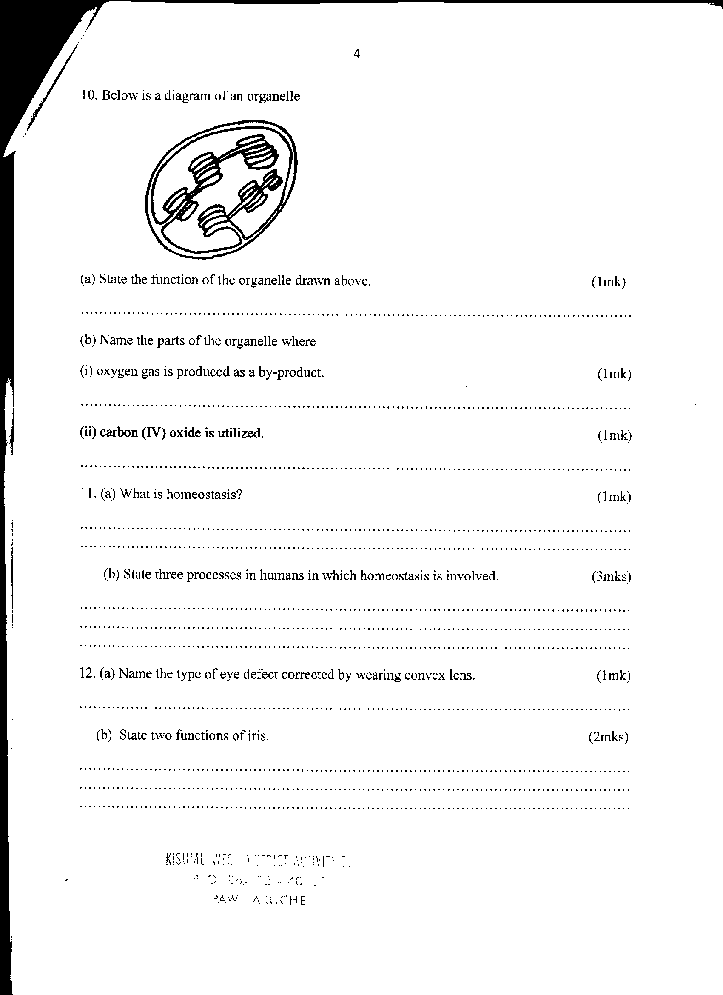

- State the function of the organelle drawn above. (1 mark)
…………………………………………………………………………………………………………..
- Name the parts of the organelle where :
  - Oxygen gas is produced as a byproduct. (1 mark)
…………………………..………………………………………………………………………

  - Carbon (IV) oxide is utilized. (1 mark)
…………………………………………………………………………………………………..
11. (a) What is homeostasis? (1 mark)
……………………..……………………………………………………………………………………
…………………………………………………………………………………………………………
(b) State three processes in humans in which homeostasis is involved. (3 marks)
……………………….………………………………………………………………………………….
…………………………………………..…..………………………………………………………….
……………………………………………..…..……………………………………………………….
12. The equation below represents a metabolic process that occurs in the mammalian liver.
Amino Acids Organic + Urea
Compounds
- Name the process (1 mark)
……………………………………………………………………………………………………………….……………………………………………………………………………………………………………………………….
- What is the importance of the process to the mammal? (2marks)
……………………………………………………………………………………………………………….……………………………………………………………………………………………………………………
13. The diagram below represents a set up that was used to investigate a certain process in a plant.
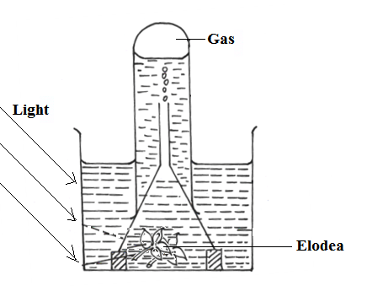

- State the process that was being investigated. (1 mark)
……………………………………………………………………………………………………………….………………………………………………………………………………………………………………………………
- Other than the factors shown, state two factors that would affect the process named in (a) above. ( 2 marks)
……………………………………………………………………………………………………………….……………………………………………………………………………………………………………………
14. a) Name the causal organism for amoebic dysentery. (1 mark)
……………………………………………………………………………………………………………….………………………………………………………………………………………………………………………………
b) State three preventive measures of schistosomiasis in human beings (3 marks)
……………………………………………………………………………………………………………….………………………………………………………………………………………………………………………………
15. (a) Why is the wall of the left ventricle thicker than that of the right ventricle. (1 mark)
…………………………………………………………………………………………………………
……………………….………………………………………………………………………………….
(b) State three adaptations of xylem to water transportation (3 marks)
……………………….………………………………………………………………………………….
…………………………………………..…..………………………………………………………….
……………………………………………..…..……………………………………………………….
16. Use the graph below to answer the following questions.


(a) Why does the activity of the enzyme become constant after a while? (1 mark)
……………………….………………………………………………………………………………….
……………………….………………………………………………………………………………….
(b) State how the activity of the enzyme may be increased in (a) above. (1 mark)
……………………….………………………………………………………………………………….
……………………….………………………………………………………………………………….
17. Describe capture - recapture method of estimating population. (3 marks)
……………………….………………………………………………………………………………….
…………………………………………..…..………………………………………………………….
……………………….………………………………………………………………………………….
……………………….………………………………………………………………………………….
18. What is meant by self sterility with reference to flowers? (1 mark)
……………………….………………………………………………………………………………….
……………………….………………………………………………………………………………….
19. Why do plants lack complex excretory system? (3 marks)
……………………….………………………………………………………………………………….
…………………………………………..…..………………………………………………………….
……………………………………………..…..……………………………………………………….
20. State three advantages of asexual reproduction in plants. (3 marks)
……………………………………………………………………………………………………………….………………………………………………………………………………………………………………………………
……………………………………………………………………………………………………………….………………………………………………………………………………………………………………………………
21. How does sunken stomata help in lowering transpiration? (3 marks)
……………………………………………………………………………………………………………….……………………………………………………………………………………………………………………………………………………………………………………………………………………………………………….…………………………………………………………………………………………………………
22. State the importance of active transport in living organisms. (3 marks)
……………………….………………………………………………………………………………….
…………………………………………..…..………………………………………………………….
……………………………………………..…..……………………………………………………….
23. Why does carboxyhaemoglobin lead to death? (2 marks)
……………………….………………………………………………………………………………….
…………………………………………..…..………………………………………………………….
24. (a) Name two gaseous exchange sites in higher plants. (2 marks)
……………………….………………………………………………………………………………….
…………………………………………..…..………………………………………………………….
(b) State the difference between the amount of oxygen and carbon (IV) oxide that enters and
leaves the human lungs (2 marks)
……………………….………………………………………………………………………………….
…………………………………………..…..………………………………………………………….
……………………….………………………………………………………………………………….
……………………….………………………………………………………………………………….
25. What causes apical dominance? (1 mark)
……………………….………………………………………………………………………………….
……………………….………………………………………………………………………………….
26. The diagram below shows a simplified nitrogen cycle

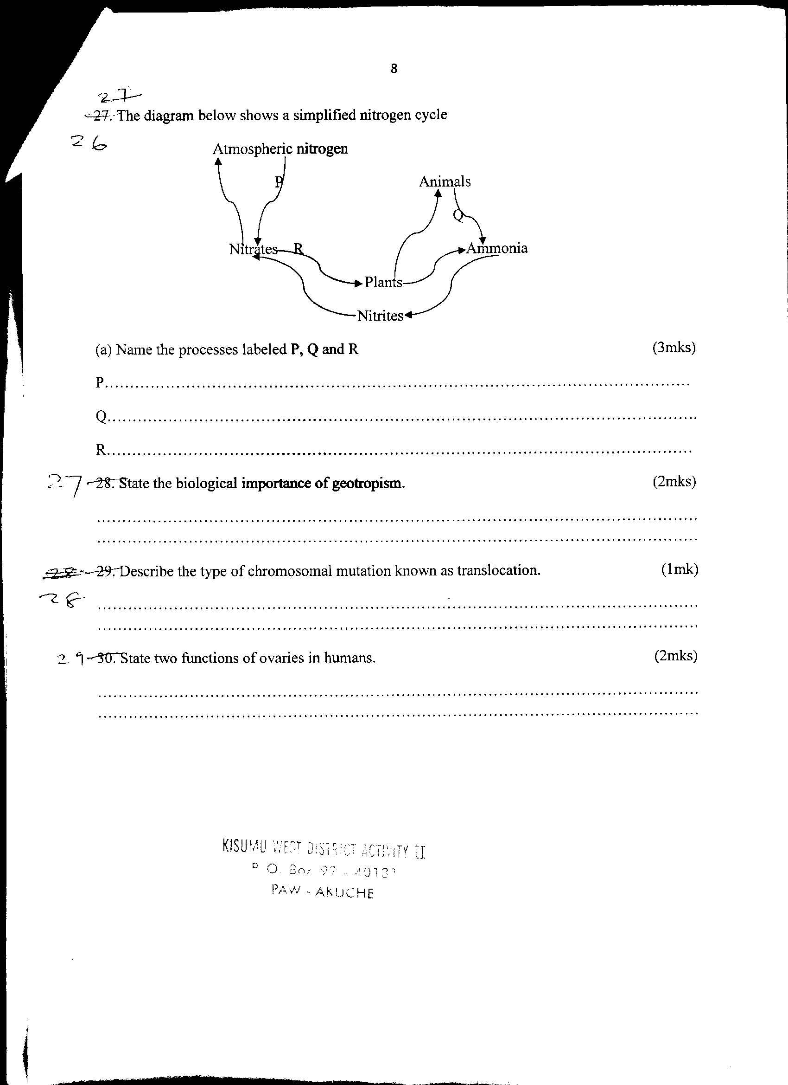

(a) Name the processes labeled P,Q and R (3 marks)
P………………………………………………………………………………………………
Q………………………………………………………………………………………………
R……………………………………………………………………………………………….
27. The diagram below shows a phenomenon which occurs during cell division.
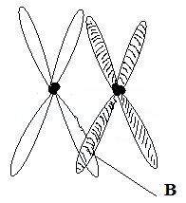

- Identify the stage of cell division in which this phenomenon occurs. (1 mark)
……………………………………………………………………………………………………………….…………………………………………………………………………………………………………….…………………
- State the importance of the phenomenon taking place in the part labeled B. (2 marks)
……………………………………………………………………………………………………………….………………………………………………………………………………………………………………………………………………………………………………………………………………………………………
28. State two functions of ovaries in humans. (2 marks)
……………………….………………………………………………………………………………………….
…………………………………………..…..…………………………………………………………………..

