SET 1 F4
BIOLOGY PAPER 2 MARKING SCHEME

- (a) Chorion;
(b) Umbilical vein carrying oxygenated blood to foetus; Umbilical artery carrying deoxygenated blood to maternal;
(c) Highly vascularized; Large surface area due to numerous villi; selectively allows some substances to pass;
- Amniotic fluid;Cushions foetus/ absorbs shock:

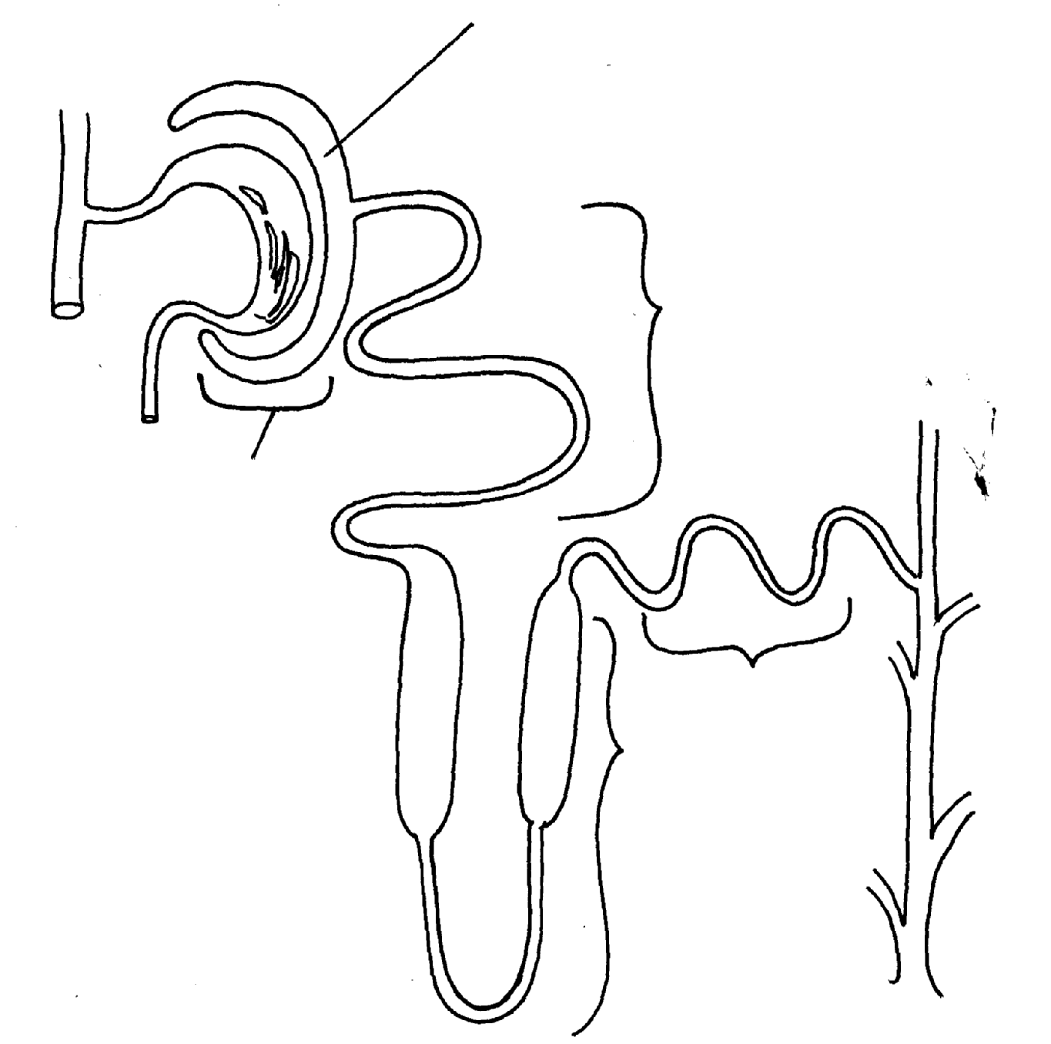
X
B
A
C
D
C

(a) (i)Active transport/diffusion;
Tie (ii) Numerous Mitochondria in its wall to generate energy; microvilli/coiling increase surface area; thin epithelium for quick diffusion;
(b) Cortex;
(c) On the diagram
(d) Plasma proteins; Blood cells; accept specific examples e.g. albumins, red blood cells;
(e) (i) Regulate re-absorption of Sodium salts;
(ii) Regulate re-absorption of water;

(a) Rate of transpiration;
(b) i. Cut short under water;
Apply petroleum jelly to cork, glass/ bung glass;
Open reservoir:

(ii) To ensure no air enters leafy shoot xylem;
To ensure the apparatus is airtight;
To remove air bubbles from tube
(c) Stomata size and number;
Hairy leaf;
Leaf size and shape;
Leaf fall;
Cuticle;

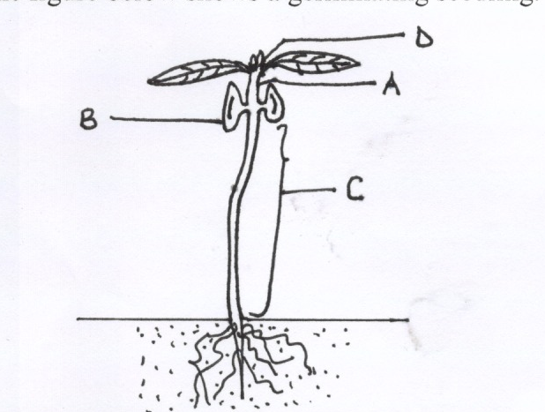

(a) A – Epicotyl B – cotyledon
C – Hypocotyl D – Terminal Bud (acc. Apical meristem)
(b) –Stores food reserves for the seed
- On emergency, turns green and photosynthesizes for the seedling.
(c) - Epigeal germination
(d) – They catalyse hydrolysis of stored food into simpler soluble nutrients; which are used by the plant for growth.
- Respiratory enzymes catalyse oxidation of food substances (subtrates) to release energy
used in cell division of the embryo;

(a)(i) Villus;

(ii A -Epithelial cells; - absorption of digested good;
B - Goblet cell; - secretion of mucus that coat internal lumen;

C - Lacteal; - absorption of fatty acids and glycerol;

- Transport digested foods to the least part of the body.

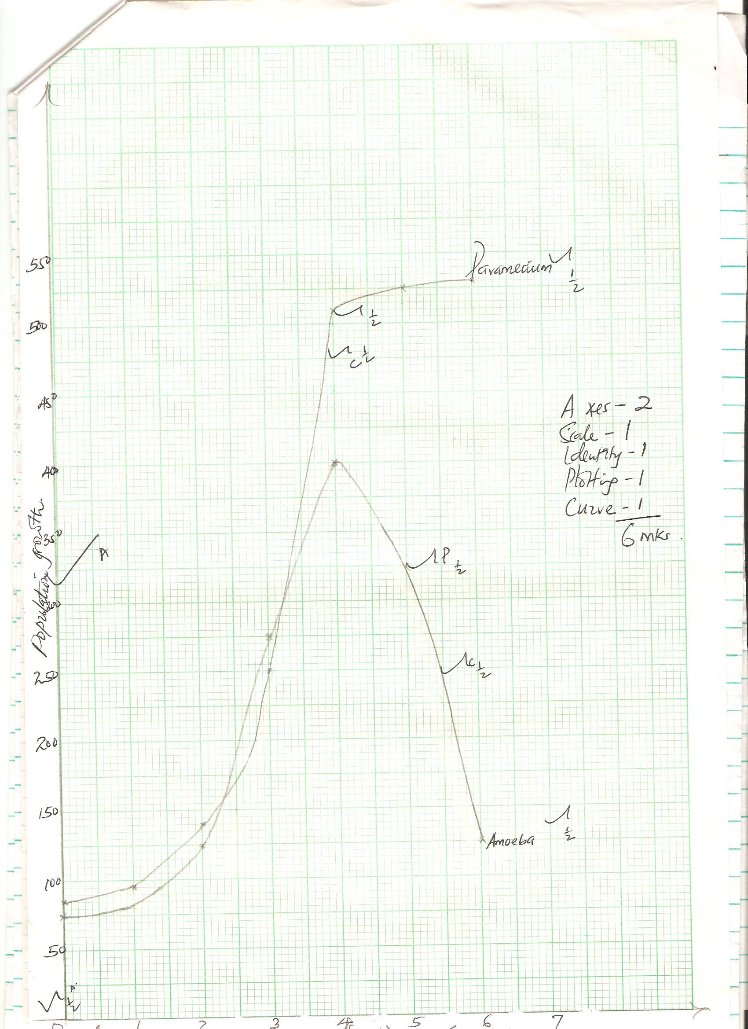

6. (b) (i) 1;
(ii) 4;
- i. 1 and 2 slow growth rate; due to few organisms reproducing/adjusting to the new environments;
3 and 4 Faster/ rapid growth rate; due to many organisms reproducing/ the environmental limiting factors/favourable conditions/plenty of foods/ absence of diseases/ predators/ birth rate higher than death rate; 5 and 6 Population growth rate constant; due to environmental limiting factors/carrying capacity attained/ death rate is equal to birth rate;
(ii) 5 and 6 rapid decrease in growth rate; lack of enough food/ competition for space/ accumulation of toxic wastes/ death rate higher than birth rate;
- Maximum population growth for each species would be lower and at an earlier time; since nutrients would be depleted fast; due to competition;
7. Describe how human male reproductive system is adapted to its functions (20 marks)
The testes found/ hang outside the body; to provide a cooler environment for sperm production;Seminiferous tubules; consist of actively diving cell; which give rise to/ produce sperms; Epididymis; is highly coiled; to store sperms; Sperm duct / vas deferens ; connect the epididymis to the urethra;Seminal vesicle; provides an alkaline fluid which contains nutrients for spermatozoa;Prostate gland; produce alkaline secretion to neutralize the vaginal fluids; also to activates the sperms; Cowper’s gland; produce fluid to neutralize the acidity along the urethra; Urethra used for the expulsion of urine to the exterior; Penis is made up of spongy tissue/ muscles and blood vessels filled with blood; to enable vessels filled with blood to enable it penetrate during coitus;
8. Discus how the various seeds and fruits are adapted to their mode of dispersal (20 marks)
Water dispersal;
Such seeds and fruits enclose air in them; are fibrous/ spongy; to lower the density for buoyancy; Have impermeable seed coat or epicarp; to prevent water from entering/ to avoid rotting; some seeds can remain viable while in water/ only germinate while on a suitable medium;
Wind dispersal;
They are light; small; have developed extension/Parachute like structures/ Wing like structures; which create a larger surface area; so as to be kept afloat/ lower density in wind currents;
Animal dispersal;
Brightly colored; Fleshy/ juicy/ succulent; some have hook like structures; to attach on animals fur; scented; to attract animals;Hard seed coat; to resists digestive enzymes; Hence come out a long with feaces/dropping of animals.
Self-dispersal;
They have weak lines/sutures on the fruit wall; along which they burst open; to release Seeds; which get scattered. This occurs when temperature changes suddenly;

