SET 7
BIOLOGY Paper 2
Time: 2 Hours

- (a) (i) Ribosomes;
(ii) Rough endoplasmic reticulum/ Rej. RER
Smooth endoplasmic reticulum; Rej. SER
(iii) Lysosomes;
(iv) Golgi apparatus/Golgi bodies;
(b) Cell diameter = $\frac{Diameter of field of view in m}{Number of cells in field of view}$
= $\frac{6000m}{55}$; = 109μm;
(c) - To avoid refraction of light;
- To prevent wetting of slide;
(Mark any one = 1 Mark)
- (a) Homozygous recessive plants do not have chlorophyll/cannot photosynthesize;
(b) Parental phenotype Normal green Pale green
Plants plants
Parental genotypes NN x Nn ;

N
N
N
n
Gametes ;

F₁ offspring NN Nn NN Nn ;
genotypes

Punnet’s Square
Parental genotype NN x Nn;

♂  ♀ | N | N;
N | NN | NN;
n | Nn | Nn

c) Parental genotype Nn x Nn
N
n
N
n
Gametes

Offsprings NN Nn Nn nn;

Have chlorophyll survive lack chlorophyll die early

$\frac{3}{4 }$ x 100 = 75% ; Grow to maturity

(d) Due to incomplete dominance of the gene for normal colour;
- (a) Metaphase of meiosis1;
(b) A = Cell membrane;
B – Spindle fibre;
C – Centriole;
(c)
 | Mitosis | Meiosis
(i) | Occurs in all somatic cells | Occurs only in reproductive cells;
(ii) | Occurs in one phase | Occurs in 2 phases;
(iii) | Daughter cells produced are diploid | Daughter cells produced are haploid;
(iv) | Homologous chromosomes do not come together/do not pair | Homologous chromosomes come together/pair;
(v) | No variation at the end | Variation occurs at the end;
(Any first 3 @ 1 Mark = 3 Marks)
(d) Crossing over;
- (a) The total area of habitats is measured and the area of study is marked.
- Quadrant is thrown at random in the study area.
- The various plant species in the quadrants are identified and labelled.
- The number of each plant species is counted and recorded.
- Several throws are made in the study area at random and the process repeated several times. The average number of each plant species per quadrant is worked out.
- Calculation is made for the population for the total area of study.
(6 x ½ = 3 Marks)
(b) (i) Population size (N) =$\frac{No. of beetles in 1st catch x No. of beetles in 2nd catch}{Beetles marked recaptured}$
= $\frac{400 x 374}{80}$;
= 1870 (beetles);
- (a) (i) $\frac{15}{100}$ x 100 = 15%
(b) (i) The allele O appears in many blood groups/Allele O appears in blood group A, B and O;
therefore higher chances of being inherited in a population;
(ii) Allele A and B are co-dominant; hence express themselves only in blood group AB;
- (i) To increase the surface area for efficient transport/increase efficiency of delivery of oxygen; (to
tissue)

(ii) At high altitude air is less dense/partial pressure of oxygen is low/there is low concentration of
oxygen, hence the number of red blood cells/structure C increases to increase oxygen carrying
capacity of blood;
(iii) Phagocytosis;
- (a)
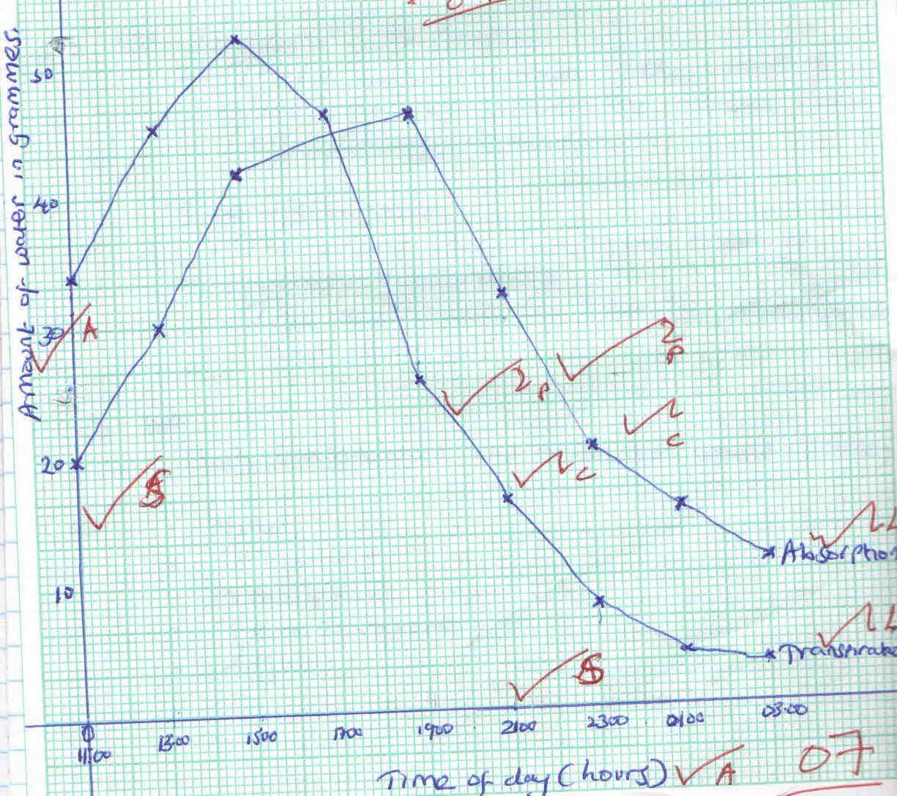
Amount of water in grammes
Time of day (hours)
A = 2 marks
S = 2 marks
P = 1 mark
C = 1 mark
L = 1 mark
07marks

(b) 17:00 – 19:00
(c) (i) 11:00 – 19:00 hours
- There was rapid increase in the rate of transpiration;
- This was due to high light intensity;
- Also due to high temperature;
(ii) 11:00 – 19:00 hours
- There was increase in the rate of absorption of water to replace water lost through transpiration;
19:00 – 3:00 hours
- There was decrease in the rate of water absorption.
- This is because the rate of transpiration had declined;
(d) Both transpiration and absorption would decline;
(e) - Wind;
- Humidity;
- Atmospheric pressure;
- Temperature;
- Light; (Any 1st two = 2 Marks)

(f) - Wind – The rate of transpiration is faster when it is windy and lower when air is still;
- Temperature – Rate of transpiration is high at high temperature and low at low temperature;
- Humidity – When humidity is low, the rate of transpiration is faster while the rate of transpiration is
low when humidity is high;
- Atmospheric pressure – The rate of transpiration is high when atmospheric pressure is low while at
high atmospheric pressure, the rate of transpiration is low;
- Light intensity – It affects photosynthetic rate hence opening and closing of stomata that allows for
water loss;
- (i) Process of inhalation in mammals
- External intercostals muscles contract; while internal intercostals muscles relax;
- (This movement) pulls ribs upwards and outwards;
- The diaphragm muscles contract; and the diaphragm flattens;
- (All the above movements) increases the volume of thoracic cavity; and decreases its pressure; Atmospheric pressure being higher than thoracic cavity pressure; Forces the air to rush into the lungs; (through the nose and trachea)
- The lungs are inflated. (Max. 10 Marks)
(ii) During the day, chloroplast of guard cells accumulate sugar/glucose produced through the process
of photosynthesis;
- Accumulated sugar/glucose in the guard cells increases osmotic pressure of the cell sap of the guard cells;
- Water is drawn from the neighbouring epidermal cells by osmosis;
- Guard cells become turgid and bulges outward;
- This opens the stomata;
- At night, sugar/glucose which had accumulated in guard cells is converted to starch;
- Osmotic pressure of guard cells falls;
- The cells lose water to the neighbouring epidermal cells and become flaccid;
- The guard cells are drawn towards one another.
- The stomata closes; (Max 10 Marks)
- How is the human eye adapted to its functions. (20 Marks)
- Conjuctiva – Thin/transparent/tough; allow light to pass through/protect the eye;
- Sclerotic layer – Is made up of (collagen) fibres/fibrous; It maintains shape of eye (ball)/protect the eye.
- Choroid – (Is a layer of tissue) with black/dark pigments; Prevents internal reflection of light in the eye; Contains blood vessels; that supply oxygen/nutrients/remove (metabolic) waste from the eye;
- Cornea – Is transparent/curved; thus refracts light rays/allows light to pass through;
- Retina – Has rods/cones for colour/bright light vision and rods for low light vision;
- Fovea/Fovea centralis/yellow spot – has high concentration of cons for accurate vision/visual acuity;
- Blind spot - Has no cones and rods; place where optic nerves leaves/enters the eye;
- Optic nerve – Has sensory nerve fibres/neurons; for transmission of impulses to the brain (for interpretation);
- Lens – Is biconvex/made of elastic/transparent material; adjust to focus for a near object/accommodation/allow light to pass through/for refraction of light rays;
- Ciliary body – Is made up of muscle fibres/glandular; which contracts/relax; to change shape/curvature of lens/produces aqueous humour;
- Suspensory ligaments – Are elastic; hold lens in position/attach it to ciliary body;
- Iris – Has radial and circular muscles; which control the size of the pupil;
- Pupil – Is the hole at the centre of iris; through which light passes into the eye;
- Aqueous humour – Is a fluid/transparent/clear; through which oxygen/nutrients pass to cornea/lens/maintain shape of eye (ball) refracts light rays/allows light to pass through;
- Vitreous humour – Is a fluid/transparent/clear; which maintain shape of eye/refracts light rays/allows light to pass through;

