SET 8
231/2 BIOLOGY PAPER 2 MARKING SCHEME
- (a)
- Selective reabsorption of substances that are useful to the body. 1mk
- Intake of sodium chloride salts. 1mk
- Reabsorption of water by osmosis1mk
(b) (i) Adrenal gland1mk (ii) Pituitary gland1mk
(c) The osmotic pressure of blood would fall as a result of excessive intake of water. This will cause the pituitary gland to reduce its secretion of ADH into blood. 1mk Water reabsorption in the kidney is thereby reduced and this results in production of large amount of dilute urine. 1mk
2.a)(i) Tube A and B – liver cells have very high metabolic rates hence higher concentration of enzyme catalase.
- The resultant gas is oxygen. 1mk
- However, boiling denatures the enzyme catalase in the liver cells hence no action on hydrogen peroxide. 1mk
(ii) Tube A & C –1mk liver cells have higher metabolic rate than muscle cells hence higher concentration of enxyme catalase. 1mk
- Tube D & E - cells of bean seeds have lower metabolic rates than soaked beans hence a lower concentration of enzymes catalase 1mk
Dry conditions inactivate enzymes in the cells of dry bean seeds 1mk
- F & G – crushing increases S.A of contact between enzymes catalase in a potato cells and hydrogen peroxide hence faster reaction than in the potato cubes. 1mk
Catalase
(b) Hydrogen peroxide Water + Oxygen1mk
(c) It is toxic and thus would kill body cells 1mk
3. (a) (i) Complete metamorphosis 1mk
(ii) Life cycle has intermediate stages that transform into one another and each
look morphologically different. 1mk
(b) It enables organisms to survive (escape) unfavorable environment conditions (through pupal stage) 1mk
It encourages random disposal of various stages preventing overcrowding colonization of different environments. 1mk
Adult & larval stages exploit different ecological niches hence no competition for food.
(c) Y B V & M1mk
(d) (i) Stage V1mk
(ii) B1mk
(e) B – encourages the disposal of opportunity to other areas V1mk
V – is the dormant stage for developmental stages to occur and important in serving harsh environmental conditions. 1mk
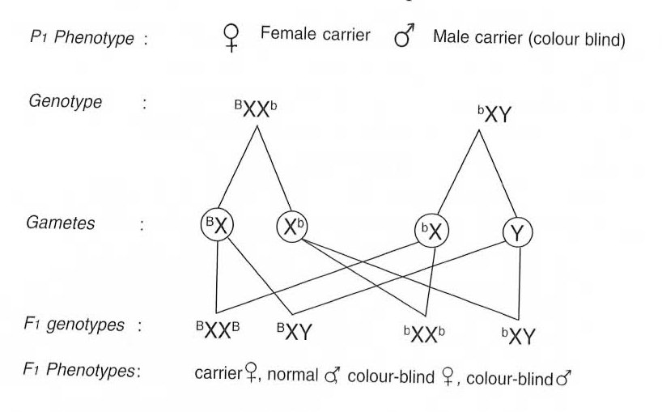
4. 4mks

×

(ii) Albinism1mk
Sickle cell 1mk
Anaemia

(iii) These are genes that are located in the same chromosome and therefore inherited together. 2mks

5. Gland hormone
Pancreas islets of Langerhans ¹/₂mk insulin –¹/₂mk controls blood sugar¹/₂mk
Converts glucose to glycogen

Ovary ¹/₂mk Oestrogen¹/₂mk female ovary ¹/₂mk
Secondary sexual features
Progesterone - change in uterus after ovulation and pregnancy

Adrenal gland¹/₂mk Adrenalin¹/₂mk Affects blood circulation by increased heart beat, blood flow
Vasodilation, prepares body for fight or flight¹/₂mk

Thyroid gland ¹/₂mk thyroxine¹/₂mk Controls body metabolism, energy release in mitochondria¹/₂mk

(ii) This is because controls the secretory activities of several other endocrine glands of the body.

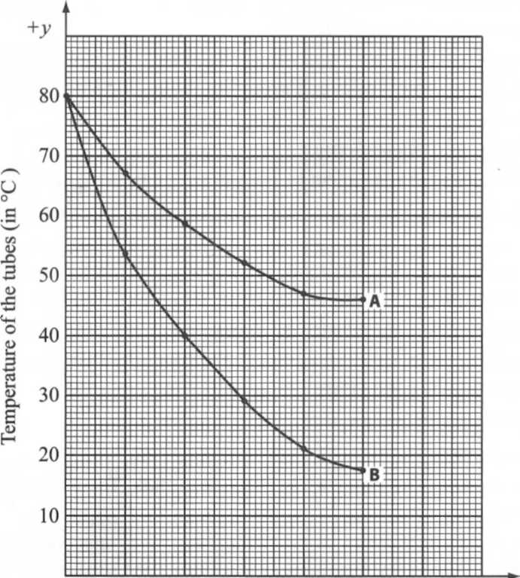
0 5 10 15 20 25
Time (in minutes)

A – axis (1 mk) ×2
Plotting (1 mk)×2
Curve (1 mk)×2
Identification (1 mk)

(a)$\frac{80-18}{25}= \frac{62}{25}=2.48℃/minute$2mks
(c) Control experiment 1mk
(d) The rate was faster in tube A because it’s surface was being wiped with cotton wool having methylated spirit. 1mk The methylated spirit absorbed latent heat of vaporization from tube releasing it to the air, 1mk therefore encourages the cooling of the tube content. 1mk
(e) Conduction1mk
Radiation1mk
(f) would have low rate of heat loss1mk
(g) (i) Feathers1mk
(ii) Fur1mk
(h) (i) Receptors in the skin1mk
(ii) Hypothalamus1mk
7. Explain how plant and animal cells are suited to performing their functions.(20 marks)
Plant cells have a non-living tough rigid cellulose cell wail; that provides protection to inner delicate from chemical and mechanical damage; and stores cellulose;
Semi-permeable cell membrane; to allow selective movement of materials in and out of the cells; allow reception of information (stimuli); and ensure physical connection with other cells,
Plant cell have semi-permeable tonoplast; that facilitates the exertion of an outward pressure (turgor pressure) when vacuole is fully filled with sap and this leads to turgidity and hence support, and allows selective movement of materials in and out of the sap vacuole.
Have a double layered nuclear membrane enclosing the nucleus and the nucleolus; that allows for communication between the nucleus and other components of the cytoplasm,
Have a thick, semi-transparent elastic fluid-filled cytoplasm containing suspended particles I.e.
Organelles and inclusions (starch, glycogen and fat droplets); which offers a favourable medium in which cellular chemical reactions occur; packages chemicals for transport to other parts of the cell or other body cells and facilitates excretion of waste materials,
Have a spherical or oval nucleus; which controls all the activities of the cell
Have a gel-like/viscous karyolymph that fills the nucleus thus forms the main nuclear material; hence control all cellular activities such as growth, repair, energy acquisition and use etc.
Spherical nucleolus is composed of proteins, ribosomes at various stages of synthesis, DNA and RNA that provide the sites of ribosome synthesis,
Have tiny spherical granule-like ribosomes; that form sites for protein synthesis (translation);
Smooth Endoplasmic reticulum lack ribosomes; and are the sites for synthesis and transportation of lipids
Smooth endoplasmic reticulum in liver cells contain enzymes that detoxify harmful drugs and metabolic by-products.
Rough endoplasmic reticula have sites for attachment of ribosomes on their surfaces and are thus studded with ribosomes and form sites for storage and transport of proteins to areas of need.
Have membrane-bound golgi apparatus; that modify materials e.g. it adds sugars to proteins to make glycoproteins; packap.es and transports materials such as enzymes and glycoproteins; secrete -synthesized proteins and carbohydrates; processes cisternae; and are often involved in lysosomes formation.
Have small, spherical single-membrane bound lysosomes; that contain a mixture of powerful digestive enzymes called acid hydrolyses; to supply the enzymes to destroy old (worn out) and surplus organelles as well as old cells that have stopped functioning.
Have sausage-shaped mitochondria; with double membranes and cristae; that provide sites for respiration (energy production in form of ATP); and hence acts as the powerhouses of the cell.
Animal cells have centrioles; a pair of cylindrical structures found within the centrosome at right angles of each other; that form spindle fibres which guide chromosomes during cell division; and also form cilia and flagella in cells where these occur e.g. in sperm cells.
Plant cell have egg-shaped chloroplasts composed of double membranes surrounding grana and a gel-like matrix called stroma; that forms the site for photosynthesis,
Some plant cell have plastids for storage of pigments;
Plants cells have large sap filled vacuoles; that create turgor pressure contributing to support especially in herbaceous plants; store of food substances such as sugars and mineral salts; store pigments that give colour to plant structures such as petals; and may accumulate waste products and by-products of metabolism thus providing a means of excretion in plants,
Some animal cells have vesicles; for storage of enzymes and other substances.
8. Plants have lower metabolic rate
Produce less toxic wastes,
Some excretory products are reused by plant
Plant tissues are tolerant to toxic wastes. (3xl = 3marks)
b) Diffusion.
- Transpiration / guttation.
- Exudation.
- Accumulation in old leaves / flowers/leaf fall.
- Storage in bark/wood.
- Re-used e.g. in photosynthesis (5×1=5 marks)
Excretory products
CNS stimulant
Meat tenderiser/ treats indigestion, leather tanning
Heart stimulant/insecticide /reduce stress
Manufacture of tyre/rubber products. Anti-malarial drug
Increase heart beat /dries up secretions/dilate eye pupil.
Cancer treatment. Maximum 12 marks

Caffein
Papain.
Tannin
Nicotine.
Latex.
Quinine.
Atropine.
Morphine.

