NAME ____________________________________ INDEX NO. _______________
SCHOOL ____________________________________ SIGNATURE _______________ DATE _______________
231/2
BIOLOGY
(THEORY)

PAPER 2

TIME: 2 HOURS

SET 5
FORM 4

INSTRUCTIONS TO CANDIDATES
- Write your name, index number and school in the spaces provided above.
- Sign and write date of examination in the spaces provided above.
- Answer ALL the questions in section A by filling in the spaces provided.
- In section B, answer question 6 (compulsory question) and any other one question from the remaining two questions. (i.e. 7 or 8)
- Candidates may be penalized for false information and even wrong spellings of technical terms.
- This paper consists of 10 printed pages.
- Candidates should check to ensure that all pages are printed as indicated and no questions are missing

FOR EXAMINER’S USE ONLY
Section | Question | Maximum score | Candidate’s score
A | 1 | 8
A | 2 | 8
A | 3 | 8
A | 4 | 8
A | 5 | 8
B | 6 | 20
B | 7 | 20
B | 8 | 20
 | Total Score | 80

SECTION A (40 MARKS)
Answer ALL the questions in the space provided
- The pedigree chart below illustrates the inheritance of haemophilia in a given family.
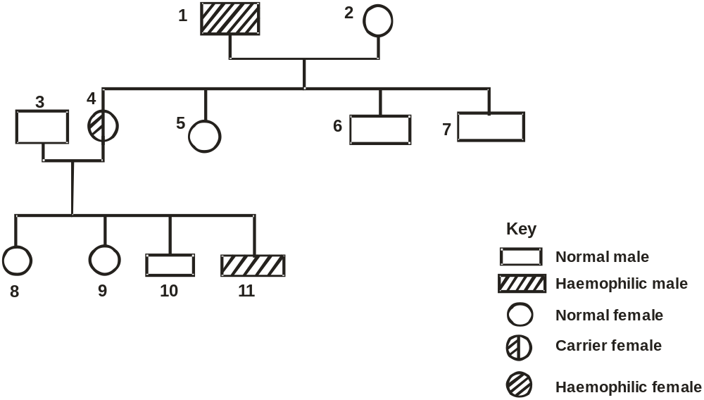
- Suggest the possible genotype of: (2 marks)
- Individual 1.
___________________________________________________________________________________
- Individual 4.
___________________________________________________________________________________
- Using a punnet square, work out the possible phenotypes of offspring’s, if individual 4 married a haemophilic male. (4 marks)

- Explain why;
- There are no carrier males. (1 mark)
______________________________________________________________________________________________________________________________________________________________________

- Some females are healthy although they carry the defective gene. (1 mark)
______________________________________________________________________________________________________________________________________________________________________

- Study the diagram below and answer the questions that follow.
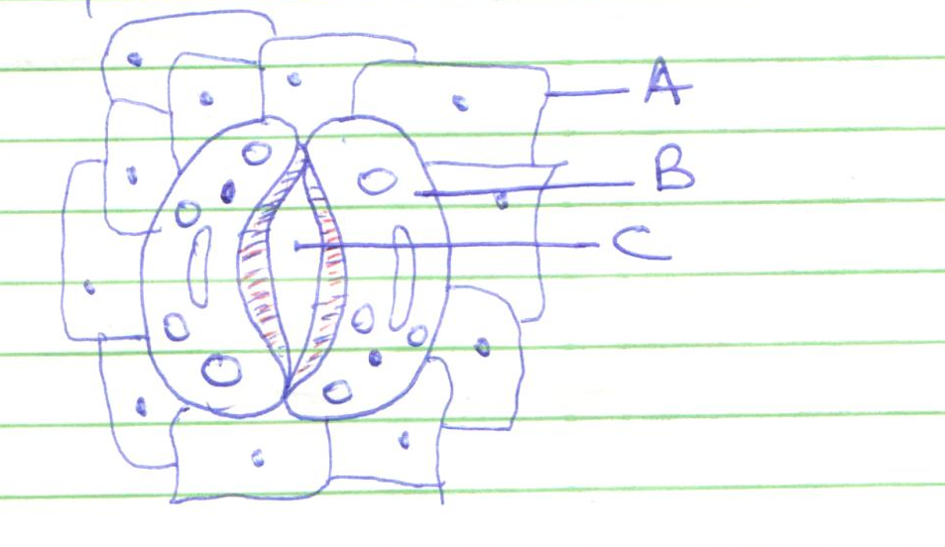
C
B
A
- Name the tissue where the cells drawn above are found. (1 mark)
___________________________________________________________________________________
- Identify cells A and B. (2 marks)
A _________________________________________________________________________________
B _________________________________________________________________________________
- Give two structural differences between cell A and cell B. (2 marks)
____________________________________________________________________________________________________________________________________________________________________________________________________________________________________________________________________________________________________________________________________________
- Describe how structure C opens as explained by the photosynthetic theory. (3 marks)
____________________________________________________________________________________________________________________________________________________________________________________________________________________________________________________________________________________________________________________________________________

- During a study, 48 larvae were put in unpainted side of the petri dish as shown below.
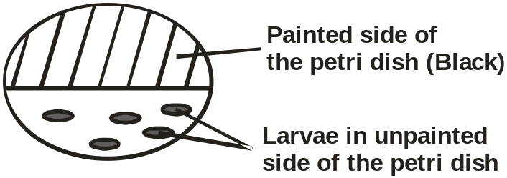

The petri dish was left in bright sunshine, the number of larvae on unpainted side was counted every minute for five minutes, the results obtained were as shown below.
Time (min) | Number of larvae
Time (min) | In painted side | In unpainted side
0 | 0 | 48
1 | 38 | 10
2 | 41 | 7
3 | 45 | 3
4 | 47 | 1
5 | 48 | 0

- i) What conclusion can you draw from these results about the behaviour of the larvae? (1 mark)
______________________________________________________________________________________________________________________________________________________________________
ii) Name the response exhibited by the larvae. (1 mark)
______________________________________________________________________________________________________________________________________________________________________
- What is the survival value of this behaviour to the larvae? (2 marks)
_________________________________________________________________________________________________________________________________________________________________________________________________________________________________________________________
- A potted plant was placed horizontally with agar blocks as shown.
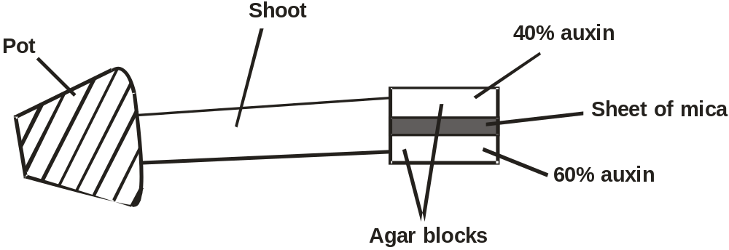
- Predict the growth curvature of the shoot. (1 mark)
______________________________________________________________________________________________________________________________________________________________________
- Account for your answer in (i) above. (3 marks)
____________________________________________________________________________________________________________________________________________________________________________________________________________________________________________________________________________________________________________________________________________
- The diagram below represents structure found in the walls of ileum.
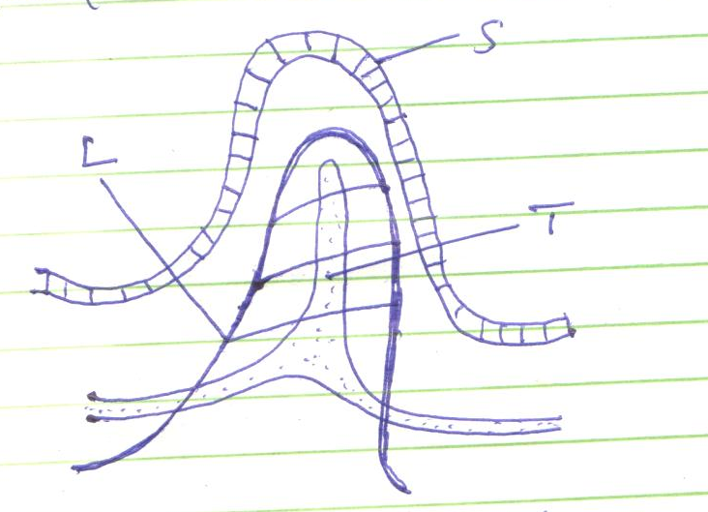
L
T
S
- Identify the structure shown in the diagram. (1 mark)
___________________________________________________________________________________
- Name parts labelled S, T and L. (3 marks)
S ________________________________________________________________________________
T _________________________________________________________________________________
L _________________________________________________________________________________
- Name products of digestion which are absorbed into; (2 marks)
L _________________________________________________________________________________
T _________________________________________________________________________________
- State how the above structure is adapted to its function. (2 marks)
_________________________________________________________________________________________________________________________________________________________________________________________________________________________________________________________

- Diagram below represents a germinating seedling.
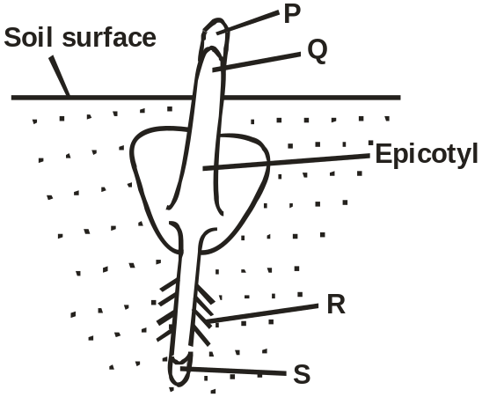
- What is germination? (1 mark)
______________________________________________________________________________________________________________________________________________________________________

- Name the part labelled P, Q and R. (3 marks)
P _________________________________________________________________________________
Q _________________________________________________________________________________
R _________________________________________________________________________________
- Identify the type of germination shown in the diagram. (1 mark)
______________________________________________________________________________________________________________________________________________________________________
- What is the role of the following in germination of the above seedling?
- Oxygen (1 mark)
______________________________________________________________________________________________________________________________________________________________________
- Enzymes (1 mark)
______________________________________________________________________________________________________________________________________________________________________
- Water (1 mark)
______________________________________________________________________________________________________________________________________________________________________

SECTION B (40 MARKS)
Answer question 6 (compulsory) and either question 7 or 8 in the spaces provided after question 8
- The pressure in the flow of blood in a mammal was determined at two different vessels; A and B. The data was taken within a period of 1 minute and was presented as follows.
Time in seconds | Blood pressure in
Time in seconds | Vessel A | Vessel B
0 | 160 | 320
10 | 165 | 360
20 | 170 | 320
30 | 180 | 400
40 | 170 | 360
50 | 160 | 320
60 | 160 | 360

- Plot the graph of blood pressure in both vessels against time on the same axis. (7 marks)

- Describe the trend of each curve. (2 marks)
_________________________________________________________________________________________________________________________________________________________________________________________________________________________________________________________
- I) From the graph, suggest the possible identity for:
- Blood vessel A. (1 mark)
______________________________________________________________________________________________________________________________________________________________________
- Blood vessel B. (1 mark)
______________________________________________________________________________________________________________________________________________________________________
- Give reasons for your answer in (c) i) and ii) above. (2 marks)
_________________________________________________________________________________________________________________________________________________________________________________________________________________________________________________________
- Explain a factor that would result to an increase in blood pressure in both the blood vessels above. (2 marks)
_________________________________________________________________________________________________________________________________________________________________________________________________________________________________________________________
- State two structural differences between the two vessels mentioned in (c) above. (2 marks)
_________________________________________________________________________________________________________________________________________________________________________________________________________________________________________________________
- i) Name two diseases of circulatory system in humans. (2 marks)
_________________________________________________________________________________________________________________________________________________________________________________________________________________________________________________________
ii) Other than transport of substances give one other function of blood. (1 mark)
_________________________________________________________________________________________________________________________________________________________________________________________________________________________________________________________
- Give an account of changes that occur in a flower from pollination to the formation of seeds and fruits. (20 marks)
- a) Describe the mechanism of hearing. (10 marks)
- Describe the role of the following hormones in homeostasis.
- Anti-diuretic hormone. (6 marks)
- Insulin and glucagon (4 marks)
_________________________________________________________________________________________________________________________________________________________________________________________________________________________________________________________________________________________________________________________________________________________________________________________________________________________________________________________________________________________________________________________________________________________________________________________________________________________________________________________________________________________________________________________________________________________________________________________________________________________________________________________________________________________________________________________________________________________________________________________________________________________________________________________________________________________________________________________________________________________________________________________________________________________________________________________________________________________________________________________________________________________________________________________________________________________________________________________________________________________________________________________________________________________________________________________________________________________________________________________________________________________________________________________________________________________________________________________________________________________________________________________________________________________________________________________________________________________________________________________________________________________________________________________________________________________________________________________________________________________________________________________________________________________________________________________________________________________________________________________________________________________________________________________________________________________________________________________________________________________________________________________________________________________________________________________________________________________________________________________________________________________________________________________________________________________________________________________________________________________________________________________________________________________________________________________________________________________________________________________________________________________________________________________________________________________________________________________________________________________________________________________________________________________________________________________________________________________________________________________________________________________________________________________________________________________________________________________________________________________________________________________________________________________________________________________________________________________________________________________________________________________________________________________________________________________________________________________________________________________________________________________________________________________________________________________________________________________________________________________________________________________________________________________________________________________________________________________________________________________________________________________________________________________________________________________________________________________________________________________________________________________________________________________________________________________________________________________________________________________________________________________________________________________________________________________________________________________________________________________________________________________________________________________________________________________________________________________________________________________________________________________________________________________________________________________________________________________________________________________________________________________________________________________________________________________________________________________________________________________________________________________________________________________________________________________________________________________________________________________________________________________________________________________________________________________________________________________________________________________________________________________________________________________________________________________________________________________________________________________________________________________________________________________________________________________________________________________________________________________________________________________________________________________________________________________________________________________________________________________________________________________________________________________________________________________________________________________________________________________________________________________________________________________________________________________________________________________________________________________________________________________________________________________________________________________________

