SET 3
BIOLOGY PAPER 3 MARKING SCHEME.
(12 mrks)
FOOD BEING TESTED FOR | Procedure | Observations | Conclusion
Starch | Add iodine solution to  Q | Colour changes to blue black | Starch present
Reducing sugars | Add Benedict’s solution to Q then heat | Colour changes to yellow/Orange | Reducing sugars present
Vitamin c  (ascorbic acid) | Add Q to DCPIP  (dropwise) | DCPIP  Is discolourised | Vitamin C present
Lipids | Put a drop of Q on filter paper and on another point put a drop of water and dry it over flame. | The marks on the paper disappears | Absence of lipids

specimen | Steps followed | identity
P1 | 1a,2a,3a | Zea
P2 | 1b, | Cassia
P3 | 1a,2a,3b,4a,7b | Hibiscus
P4 | 1a,2a,3b,4b,6b | Mangifera
P5 | 1a,2b,3b,4b,6a | Bougavillea
P6 | 1a,2a,3b,4b,5a | Solanum

- PI Class monocotyledonae
Parallel venation/Narrow leaf
P4 class Dicotyledonae
Network venation/broad leaf.
Specimen Part Organism (2 mrks)
M Gill Fish
Gill raker
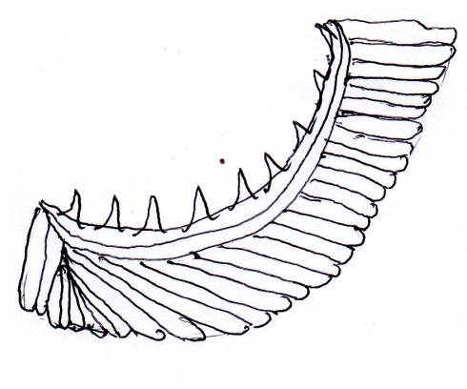

Gill bar Gill filament
A1
-must be curved
-Must have continuous line
-Must be proportional
Magnification =Drawing Size =7 cm = X0.7
Actual size 10 cm

Range X 0.5 - xX2

-Many numerous /several gills filament to increase surface area of gaseous exchange/absorption of oxygen
- Thin filaments to reduce distance through which gas diffuse.
-Gill bar is rigid to provide/support/attachment of gill filament and gill rakers.

-Gill rankers are tooth like to prevent solid particles from reaching gill filaments
-Long gill filaments to increase the surface area for gaseous exchange

Any 4 points

BIOLOGY CONFIDENTIAL
DCPIP
Iodine solution
Benedict’s solution
Means of heating
Filter paper
Each student to get about 5ml of Q.
Three clean test tubes in a test-tube rack
How to prepare Q.
-Squeeze juice of 5 ripe Oranges in a beaker of 1 litre to the juice add 20 grams of wheat flour.
-Add water to make it up to 750 ML then heat mixture to simmer.
M-A gill of a fish.
P1 maize leaf
P2 cassia leaf
P3 hibiscus leaf
P4 Mango leaf
P5 Bouganvillea
P6 Solanum leaf (Sodom apple leaf)

