2022 TRIAL 2 JULY INTERNAL EXAMINATION

231/2
BIOLOGY PP2
MARKING SCHEME.

1.a)
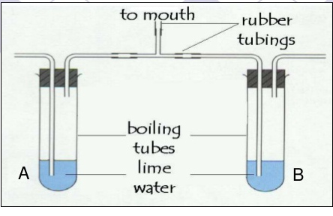
Each arrow ½ marks;
b carbon (IV)oxide;
c) Boiling tube A Lime water remains clear;
Boiling tube B A white precipitate is formed.;
- In tube A the level of Carbon (IV) Oxide in inhaled air is low; compared to high amount of Carbon (IV) Oxide exhaled from the body; due to high rate of respiring cells;

2. (a) A pair of genes occurring on chromosomes, controlling a particular trait./ Alternative form of a gene controlling a particular trait
(b)
R
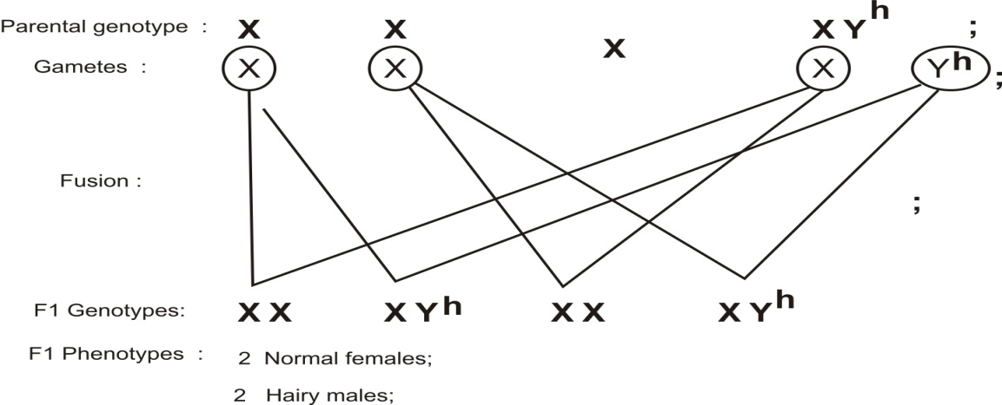
With premature baldness;
R
R
R
(c) The gene is located only on the y chromosome; /have no alleles on the chromosome; females do not inherit y-chromosome/females have xx only;
d) Hairs on the pinna/ nose;
3(a) Process that moves substances/ions/amino acids/sugar across the cell membrane against a concentration gradient by use of energy; OWTTE.
(b) State three factors that increase the rate of active transport. (3 marks)
- Increase in oxygen concentration;
- Increase in glucose concentration;
- Increase in temperature towards optimum for best working of respiratory enzymes/optimum temperature for respiratory enzymes;
- Optimum pH for best working of respiratory enzymes;
(c) - Re-absorption of water from the kidney (tubules);
- Absorption of water in the large intestines;
-movement of water into the cells from tissue fluids; MARK THE FIRST TWO
d) It gains water by osmosis; and become turgid ;
- a) Pelvic girdle/Pubic bones/ innominate bones;
b) i) Sacral vertebra/Sacrum;
ii) Acetabulum;
c) Ball and socket joint;
d) i) Obturator foramen
ii) Its an aperture through which blood vessels nerves and muscles pass;
Reduce the weight of the pelvic girdle;
e) i) Pubis symphysis;
ii) It relaxes thus expanding the size of pelvic cavity;
5. a) Dicotyledonae;
b) They have broad leaves;
They have network veins;
- Their floral parts are arranged in fours or fives or their multiples;
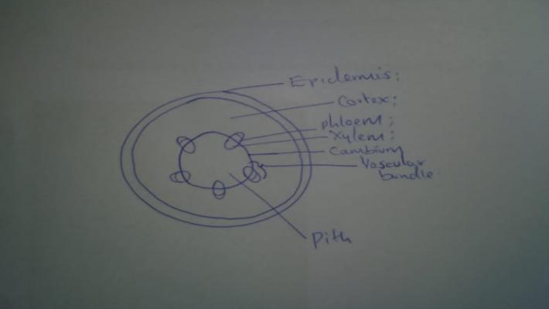
Drawing …1mk
Labels……3mks
6(a) (i) High rainfall is followed a month later by high grasshopper population/low
rainfall is followed a month later by low population of grasshoppers;
(ii) vegetation/grass sprouts; vegetation/grass provide food for grasshoppers hence multiply rapidly; vegetation also offer shelter/camouflage for grasshoppers hence predators do not spot them easily;
(b) Presence of large number of grasshopper is associated with large number of crows in the same month; Acc — the reverse. The crows feeding on grasshopper/predating on the grasshopper; if grasshopper population is low the crow population decrease due to migration to other areas in search of alternative food (sources);
(c) (i) grasshoppers — 2nd (trophic) level/ primary consumers;
(ii) crows — 3rd (trophic) level/secondary consumers;
(iii) the grass in the study area — 1st (trophic) level/producers;
(d) (i) Total count;
(ii Capture re-capture;
(e) Vegetation/grass would sprout/increase due to decrease of grasshoppers; The predator would compete for food/grasshoppers with the crows (causing some grasshoppers to migrate) rapidly declining grasshopper population;
f) Maximum number of organism an area/habitat can comfortably support without depletion of the available resources; OWTTE.
(g) Cattle feed on the same type of food/grass (hence high competition food); while wild animals feed on a variety of foods/some are browsers while some are carnivores/; or cattle occupy same ecological nitche; while wild animals occupy different ecological nitches;
(h) A natural unit composed of abiotic and biotic factors; whose interactions; lead to self- sustain ing system;

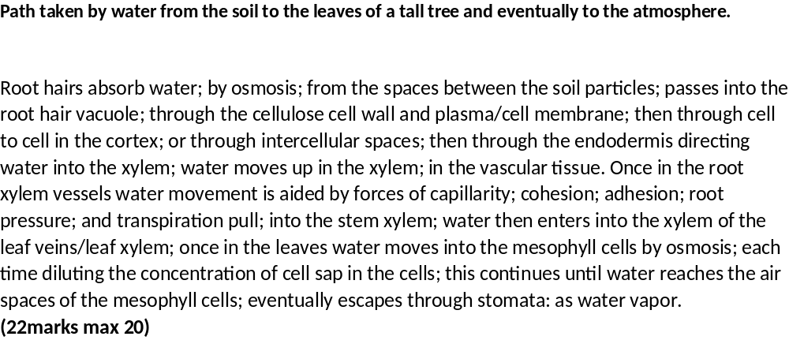
8.– The mouth has different types of teeth; that chew food increasing surface area for enzyme action;.
-The mouth has salivary glands; that secrete saliva which lubricates and softens food; Salivary amylase breaks down starch into maltose;
-The tongue rolls food into boluses; and pushes them to the back of the mouth for swallowing.
-The esophagus is hollow for easy swallowing of food; it has muscles that contract and relax; to move food boluses through peristalsis
-The alimentary canal is long; to provide a large surface area for digestion and absorption of food;
- Small intestine is highly coiled; offering a large surface area for digestion and absorption of food;
-the inner lining of the ileum has villi and micro-villi which increase surface area for absorption
-Doudenum has openings of duct; through which pancreatic juice and bile get into the lumen;
-The alimentary canal has goblet cells that secrets mucus; for lubrication of food; and protection of the wall from digestive enzymes;
-The Brunner’s glands also secretes an alkaline fluid ;which provide an optimum pH for action of intestinal enzymes;
-Small intestines has intestinal glands; that secrete digestive enzymes;
-the ileum has a rich network of blood capillaries that supply oxygen and remove metabolic waste from the intestinal tissues; and transports digested food and other nutrients
-The walls have circular and longitudinal muscles; whose peristaltic contractions causes movement of food in the gut; and mixing of food with digestive enzymes;
-The ileum has a thin epithelium; that allows soluble food materials to pass through rapidly into the bloodstream;
The villi has lacteal; to transport absorbed lipids;
The colon has a wide lumen; to increase surface area for absorption of water and mineral salts;
The anus has anal sphincter muscles; that relax and contract to eliminate the indigestible and undigestible materials; max 20mks

