Name…………………………………………………………………class……………………….…Adm. No…….................
231/1
BIOLOGY
FORM 1
Time: 2 $\frac{1}{2}$ hours
Answer all the questions in the spaces provided.

- State four ways in which study of biology is useful. (4mks)
- Solving environmental problems;
- Entry into some careers;
- One gains scientific skills;
- Creates international cooperation.;

- Name the characteristic of living organisms illustrated by dressing heavily in human beings. (1mk)
Irritability;
- Name the most appropriate apparatus that could be used to collect the following organisms.
(2mks)
- Grasshoppers in the school field.
Sweep net;
- Aphids from leaves.
Pooter;
- Outline four precautions during collection and observation of specimens. (4mks)
- Collect only number needed to avoid wastage;
- Do not harm specimen during capture/collection;
- Do not destroy the natural habitat;
- Handle with care injurious/dangerous specimen;
- Immobilize highly mobile animals for easy study;
- Return live specimens to their habitat where possible.
- Name the branch of biology involved with the study of
- External structure of living organisms. (1mk)
Morphology;
- Inheritance and variation. (1mk)
Genetics;
- Study of chemical reactions in the body of living organisms. (1mk)
Biochemistry;
- a) What is Classification. (1mk)
It’s the grouping of living organism based on their similarities and differences;
b) Who is a taxonomist? (1mk)
Is a biologist who study taxonomy/ classification;
c)State three importance of Classification (3mks)
Grouping brings together living organism with similar characteristics but separates those with different features
Helps in placing living organisms into their correct groups for reference
Helps us arrange the information about living organisms in an orderly manner to avoid chaos and confusion that would arise if this is done arbitrary
Helps us to understand the evolutionary relationship between different organisms
- To which kingdom do the following organism belong? (5mks)
a) Human beings Animalia;
b) Mango tree Plantae;
c)Mushroom Fungi;
d)Algae Protoctista;
e) Bacteria Monera;

- Zendok is an offspring of Zebra and Donkeys. Explain why it is infertile. (1mk)
Because Zebra & Donkey belongs to different species
- Below are abbreviations of some of research institutes used by biologist for research. Write their names in full.
- ICIPE (1mk)
International Centre for Insect Physiology and Ecology
- KARI (1mk)
Kenya Agricultural Research Institute
- KEMRI (1mk)
Kenya Medical Research Institute
- A form one student examined a specimen whose length was 5cm, then she drew the diagram whose length was 15cm. Calculate the Magnification of the diagram. (3mks)
Magnification==$\frac{drawing length}{actual length}$;
= $\frac{15}{5}$;
= X3;
- The scientific name of human being is Homo Sapiens.
- Identify the mistake done when writing it. (1mk)
The two names should be underlined separately
Sapiens have started with a capital letter;
- What does each of the two words stand for? (2mks)
Homo- Genus name
Sapiens- Specific name
- Name the Smallest and the Largest Taxonomic units (2mks)
Smallest- Species
Largest-Kingdom
- Outline three external features of animals used in Classification (3mks)
Tentacles in hydra
Shell in snails
Feathers and Wings in birds
Scales and fins in Fish
Body pigmentation; AVP
- The diagram below represents an instrument common in biology laboratory
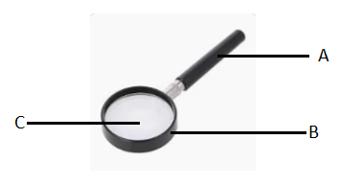

a) Identify the Instrument (1mk)
Hand lens / Magnifying lens
b) State the use of the Instrument named in 1 a above (1mk)
Enlarging / Magnifying small Objects
c)Name the parts labeled A, B & C (3mks)
- Handle
- Frame
- Convex lens

- Which organelles in a cell that synthesis of carbohydrates (1mk)
Chloroplasts;

- a) Define the term cell. (1mk)
Basic structural and functional unit of an organisms;
b. When onion epidermal cells were placed and focused along the diameter of the field of view, 10 cells were viewed and counted. Calculate the length of each epidermal cell in micrometers (1mm =1000micrometers). Assume the diameter of field of view= 3mm. (2mks)
3mm = 3000 micrometers;
= 3000 = 300 micrometers;
10
- The diagram below shows a specialized plant cell

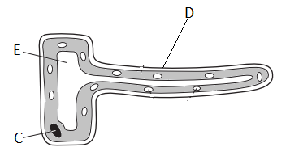

(a) i) Name the cell. (1mk)
Root hair(cell);
ii) Name the cell parts labeled E. (1mks)
E – Sap vacuole; acc cell sap;
b) State the functions of the part labelled C. (1mks)
Controls the functioning of the cell/ controls cell activity;
c) How is the above cell adapted to perform its functions (1mks)
it’s elongated to increase surface area for absorption of water and mineral salts;
it has thin cell wall to reduce distance moved by absorbed substances; ONE CORRECT
d) from which plant tissue and organ is the above cell obtained? (2mks)
Tissue-Epidermis/piliferous layer;
Organ- root;
- a) Give reasons for carrying out the following during preparation of temporary slides. (2mks)
i) Cutting thin sections
For easy passage of light /For easy absorption of stain/ dye;
ii) Staining
For the parts of the object to appear more clear/ distinct;
- The diagram below represents a common laboratory equipment.

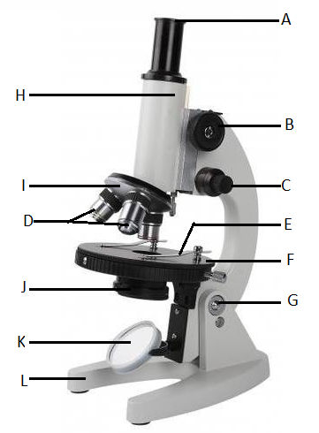
a. Identify the equipment. (1mk)
Light microscope;
b. Name the parts labelled E and H (2mks)
E- Clips/clip;
H- body tube;
c. Identify the letters that represent the part;
i) used in changing the parts labeled D from one to the other. (1mk)
I / revolving nose piece;
ii) used to incline the equipment to an appropriate position. (1mk)
G/ hinge screw;
iii) To make the image clearer when observing a specimen using a higher power objective lens? (1mk)
C/fine adjustment knob;
c) A specimen was magnified 800 times using the above instrument whose magnification at part A was X20. What was the magnification of the objective lens? (2mks)
Magnification = $\frac{800}{20}$;
=X40;
- The diagram below shows a certain cell. Use it to answer the questions that follow.

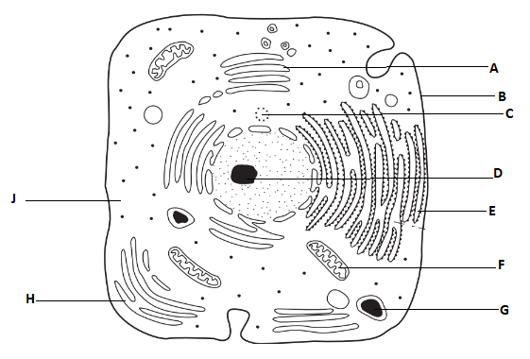
a) Give two reasons why the above cell is not a plant cell. (2mks)
Has no cell wall; has central nucleus; Has centrioles; lacks large central vacuole;
First two points
b) Name the parts labeled A, C, E and J. (4mks)
A Golgi apparatus/body
C centriole
E rough endoplasmic reticulum
J cytoplasm
c) Identify the letters that represent the part;
i) That produces ribosomes. (1mks)
D
ii) Produces lysosomes. (1mks)
A
iii) Synthesizes and transport lipids and steroids. (1mks)
H
d) State the function of the part labeled B. (1mks)
B-Bounds cell content/allows selective movement of materials in and out of the cell

- (a) What is osmosis. (1mk)
Process by which water molecules move from where they are highly concentrated to where they are lowly concentrated/ Process by which water molecules move from a hypotonic solution to a hypertonic medium across a semipermeable membrane; OWTTE.
(b) Study the figure below and answer the questions that follows. 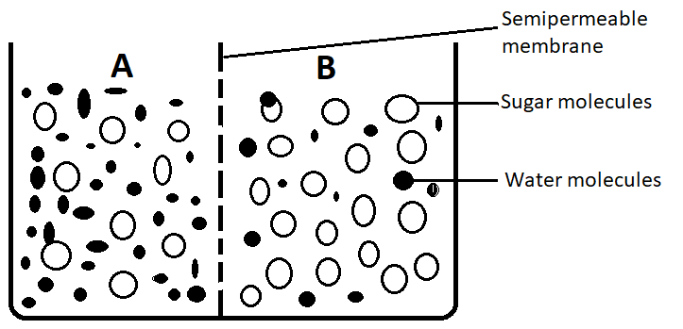

- Which solution is hypotonic. (1mk)
Solution A;
- In which direction will osmosis occur. (1mk)
Solution A to solution B
- What does the semipermeable membrane correspond to in an animal cell. (1mk)
Cell membrane;

- Distinguish between the following terms Turgor pressure and wall pressure. (2mks)
Turgor pressure | Wall pressure
Outward pressure exerted by sap vacuole against the cell wall when a plant cell gains water by osmosis (when placed in a hypotonic solution /distilled water); | Inward pressure exerted by cell wall against sap vacuole, when a plant cell gains water by osmosis/ inward pressure exerted by cell wall that is equal and opposite turgor pressure;

- a) Describe seven factors that affect the rate of diffusion. (14mks)
- Concentration Gradient;
An increase in the concentration of molecules at one region results in a steeper concentration gradient which in turn increases the rate of diffusion;
- Temperature;
High temperature increases kinetic energy of molecules. They move faster hence resulting in an increase in rate of diffusion, and vice versa;
- Size of Molecules or Ions;
The smaller the size of molecules or ions, the faster their movement hence higher rate of diffusion;
- Density;
The denser the molecules or ions diffusing, the slower the rate of diffusion, and vice versa;
- Medium;
The medium through which diffusion occurs also affects diffusion of molecules or ions. For example, diffusion of molecules through gas and liquid media is faster than through a solid medium;
- Thickness of membrane/Distance;
Rate of diffusion is faster when the distance is small i.e., thin surface;
- Surface Area to Volume Ratio;
The larger the surface area to volume ratio, the faster the rate of diffusion; For example, in small organisms such as Amoeba the surface area to volume ratio, is greater hence faster diffusion than in larger organisms.
b) State the role of osmosis to living organisms. (6mks)
Absorption of water from the soil and into the roots of plants;
Support in plants especially herbaceous plants;
Opening and closing stomata;
Absorption of water from the alimentary canal in mammals;
Re-absorption of water in the kidney tubules;
Movement of water into cells from the surrounding tissue fluid and also from cell to cell.

