Name: ………………………………………Registration Number: …………… Class: …….

231/1
BIOLOGY
2 hours
CHUGU BOYS SECONDARY SCHOOL
Kenya certificate of secondary education (K.C.S.E)
Instructions to Candidates
- Write your name, registration number and class in the spaces provided above.
- Answer all the questions in this paper.
- Answers must be written in the space provided.
- Additional pages must not be inserted.
- This paper consists of 9 Printed pages.
- Candidates should check the question paper to ascertain that all the pages are printed as indicated and that no questions are missing.
- Candidates should answer the questions in English.

For Examiner’s Use Only

Question  Number | Maximum  Score | Candidate’s  Score
1-23 | 80

- a) Distinguish between respiration and gaseous exchange. (2Marks)
………………………………………………………………………………………………………………………………………………………………………………………………………………………………………………………………………………………………………………………………………………
b) What precaution should be taken when collecting injurious specimens? (1Marks)
………………………………………………………………………………………………………………………………………………………………………………………………………………………………
c) Identify the carbohydrate food reserve stored in animal cells. (1Mark)
………………………………………………………………………………………………………………
- A student observed a water animal and noted the following features
- Had about eight pairs of jointed appendages
- Had two pairs of antennae
- Had two body parts
- Had a pair of compound eyes
Identify
- The phylum to which the organism belong. (1Mark)
………………………………………………………………………………………………………………
- The class to which the organism belong. (1Mark)
………………………………………………………………………………………………………………
- Name the largest class in the phylum named in a) above. (1Mark)
………………………………………………………………………………………………………………
- The diagram below shows a bread mould. Use it to answer questions that follow.
A
B
C
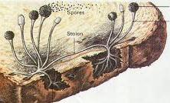
- Name parts A, B and C (3Marks)
A ...……………………………………………………
B ……………………………………………………...
C ……………………………………………………...

- Name the kingdom in which the above organism belong (1Mark)
………………………………………………………………………………………………………………
- Complete the table below showing difference between a light and an electron microscope. (3Marks)
Light Microscope | Electron microscope
Uses glass lenses

 | Specimen in illuminated with a beam of electrons
Specimen is placed on a glass slide mounted on the stage.

- The diagram below shows a highly magnified portion of an animal cell. Use it to answer questions that follow.
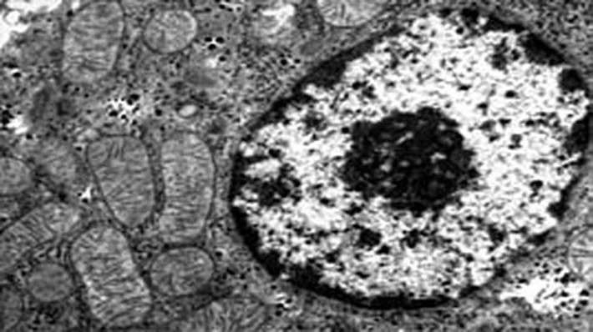
N
M
Name the parts labeled M and N and state their roles. (4Marks)
M ……………………………………………………………………………………………………..
Role………………………………………………………………………………………………………………………………………………………………………………………………………………
N……………………………………………………………………………………………………….
Role………………………………………………………………………………………………………………………………………………………………………………………………………………
- Distinguish between the following
- Haemolysis and plasmolysis. (2Marks)
……………………………………………………………………………………………………………………………………………………………………………………………………………………………………………………………………………………………………………………………………………………………………………………………………………………………………………………................

- Osmotic pressure and osmotic potential (2Marks)
……………………………………………………………………………………………………………………………………………………………………………………………………………………………………………………………………………………………………………………………………………………………………………………………………………………………………………………................
- A student noted when vegetables in their kitchen garden were irrigated with salty water, they withered and died. Explain this observation (3Marks)
……………………………………………………………………………………………………………………………………………………………………………………………………………………………………………………………………………………………………………………………………………………………………………………………………………………………………………………........................................................................................................................................................................................
- The diagram below shows an experimental setup to investigate a biological process. The setup was placed under the sun for several hours.
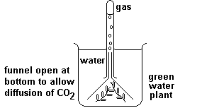
- What can be done to the water in order to increase the rate of gas production? (1 Mark)
………………………………………………………………………………………………………………………………………………………………………………………………………………………………………………………………………………………………………………………………………………
- Describe how the gas is produced by in the green water plant (3Marks)
………………………………………………………………………………………………………………………………………………………………………………………………………………………………………………………………………………………………………………………………………………………………………………………………………………………………………………………………………………………………………………………………………………………………………………………………………………………………………………………………………………………………………………………………………………………………………………………………………………………………………………………………………………………………………………………………
- The diagram below shows the jaws of a given mammal.
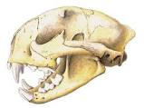
P
- With a reason give the diet fed on by the above organism. (2Marks)
Diet……………………………………………………………………………………………………... Reason…………………………………………………………………………………………………..……………………………………………………………………………………....................................................................................................................................................................................................
- Name the special tooth P and state its adaptation to its function. (2Marks)
Name…………………………………………………………………………………………………… Adaptation…………………………………………………………………………………………………………………………………………………………………………………………………………………………………………………………………………………………………………………….
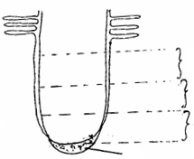
- The diagram below shows a longitudinal section of a root. Use it to answer questions that follow.
A
B
C
K

- Name part K and region B (2Marks)
K…………………………………………………………………………………………………….
B…………………………………………………………………………………………………….
- Describe the changes taking place in region C. (2Marks)
………………………………………………………………………………………….…………………………..……………………………………………………...……….……………………………………………………………………………...…………….………………………………………………………
- Describe the role of prothrombin in blood clotting process. (3Marks)
………………………………………………………………………………………….………………………………………………………………………………………….………………………………………………………………………………………….………………………………………………………………………………………….…………………………………………………………………………
- The diagram below shows a gaseous exchange structure in plants.
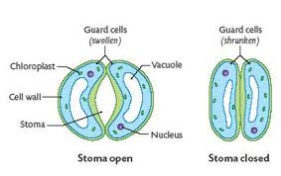
H
F

G

- Name parts F and G. (2Marks)
F ……………………………………………………………………………
G ……………………………………………………………………………
- State two adaptations of the cells labeled H to their function (2Marks)
………………………………………………………………………………………………………………………………………………………………………………………………………………………………………………………………………………………………………………………………………………
- Describe the counter current flow system in fish. (3Marks)
………………………………………………………………………………………………………………………………………………………………………………………………………………………………………………………………………………………………………………………………………………………………………………………………………………………………………………………………………………………………………………………………………………………………………………
- The flow chart below illustrates a process that occurs in living organisms.
Glucose
Two molecules of P
Water
Carbon (IV) oxide
Process M
Cycle Y in presence of oxygen
38 ATP Molecules

- Name process M, Molecule P and cycle Y (3Marks)
M ………………………………………………………………………………………….
P …………………………………………………………………………………………..
Y ………………………………………………………………………………………….
- Identify the type of respiration illustrated above (1Mark)
………………………………………………………………………………………………
- Write a balanced chemical equation for the type of respiration named in b) above. (1Mark)

- What is the source of the following plant excretory products? (2Marks)
- Cannabis. ………………………………………………………………………………………….
- Khat. …………………………………………………………………………………………..…
- List two reasons why plants do not have specialized excretory organs. (2Marks)
………………………………………………………………………………………………………………………………………………………………………………………………………………………………………………………………………………………………………………………………………………………………………………………………………………………………………………………………
- Explain what happens to excess amino acids in the liver. (3Marks)
…………………………………………………………………………………………………………………………………………………………………………………………………………………………………………………………………………………………………………………………………………………………………………..…………………………………………………………………………………………………………………..……………………………………………………………………………
- Name the instrument used to measure the following abiotic factors. (2Marks)
- Atmospheric pressure. ……………………………………………………………...........................
- Light penetration in water. …………………………………………………………………………
- In an experiment to estimate the population of grasshoppers in a school football field, form three students captured and marked 400 grasshoppers. After one day, they captured 600 grasshoppers in which 150 had been marked.
- State three assumptions that were made during the experiment. (3Marks)
……………………………………………………………………………………………………………………………………………………………………………………………………………………………………………………………………………………………………………………………………………………………………………………………………………………………………………………………………………………………………………………………………………....................................................
- Calculate the population of grasshoppers in the football field. (2Marks)
………………………………………………………………………………………………………………………………………………………………………………………………………………………………………………………………………………………………………………………………………………
- State and explain three methods by which plants ensure cross pollination occurs as opposed to self-pollination. (3Marks)
……………………………………………………………………………………………………………………………………………………………………………………………………………………………………………………………………………………………………………………………………………………………………………………………………………………………………………………………………………………………………………………………………………....................................................
- a) Name the hormone responsible for ovulation in the female reproductive system. (1Marks)
………………………………………………………………………………………………………………………………………………………………………………………………………………………………………………………………………………………………………………………………………………
b) State three other roles of the hormone named in a) above in the female reproductive system. (3Marks)
………………………………………………………………………………………………………………………………………………………………………………………………………………………………………………………………………………………………………………………………………………………………………………………………………………………………………………………………………………………………………………………………………………………………………………
- The diagram below shows a maize fruit. Use it to answer the questions that follow.
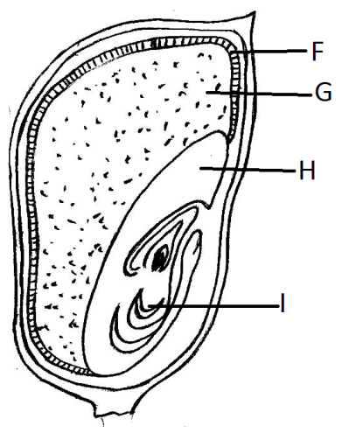

- Name parts labeled I and H. (2Marks)
I …………………………………………………………………………………….
H ……………………………………………………………………………………
- What is the function of part marked G. (1Mark)
………………………………………………………………………………………………………………………………………………………………………………………………………………………………
- What type of germination is shown by the maize plant? (1Mark)
………………………………………………………………………………………………………………………………………………………………………………………………………………………………
- A cockroach is an example of an insect that undergoes incomplete metamorphosis.
- Name
- The structure that encloses a cockroach egg. (1Mark)
………………………………………………………………………………………………………………………………………………………………………………………………………………………………
- The young one that hatches from the cockroach egg. (1Mark)
………………………………………………………………………………………………………………………………………………………………………………………………………………………………
- What hormone leads to laying of the adult cuticle in a cockroach. (1Mark)
……………………………………………………………………………………………………………………………………………………………………………............................................................................

