PAVEMENT FORM 4 TRIAL 1 EXAMINATION 2022
Kenya certificate of secondary education (K.C.S.E)
231/2 BIOLOGY PAPER 2
MARKING SCHEME
- a) K – Uterus; acc myometrium, F – Placenta; I – Amnion;
b) H - Acts as a shock absorber and protects the foetus against mechanical damage; Also lubricates the birth canal during delivery;
J is a plug of mucus that prevents entry of disease causing microorganisms into the uterus during pregnancy;
c) Umbilical artery; Umbilical vein;
d) Umbilical artery carry blood with a high concentration of carbon (IV) oxide and metabolic wastes while the umbilical vein carry blood with a high concentration of oxygen and nutrients;

- a) B – Chloroplast; C – Nucleus;
- Plant;
Presence of a cellulose cell wall; Presence of a large centralized vacuole; presence of chloroplasts;
- Well drawn plasmolysed cell; well labeled;
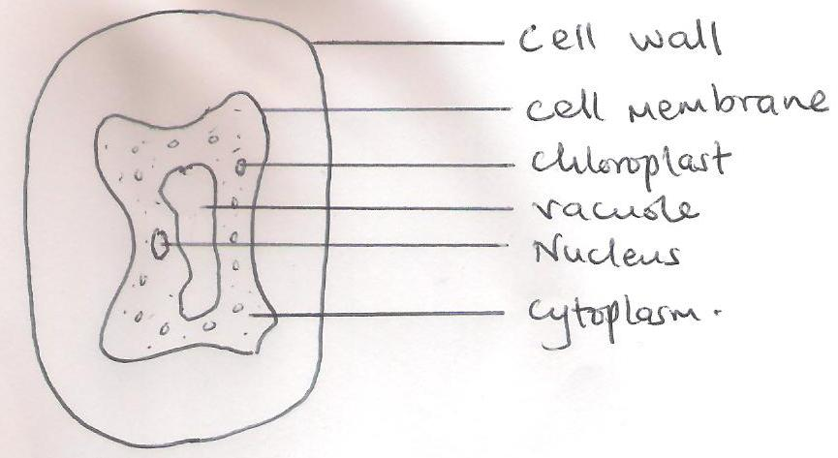
- Provides support in herbaceous plants when cells are turgid;
Used in absorption of water from the soil by root hair cells;
Feeding in insectivorous plants;
Opening and closing of stomata; Any 2

- a) N – Vascular bundles; M – Cortex
b) Class Monocotyledonae
c) In the above section, vascular bundles are scattered while in a root, they are arranged in a circular manner with xylem and phloem alternating with each other;
The above section lacks a pith which is present in a root section;
The above section lacks root hairs which are present in a root section;
d)A stem offers support to the plant exposing leaves to sunlight for photosynthesis, flowers to agents of pollination, fruits and seeds to agents of dispersal;
Some stems are storage organs for food;
- a) Root nodule;
b) Rhizobium bacteria;
c) Symbiotic relationship. The Rhizobium bacteria fix atmospheric nitrogen into nitrates for the plant while the plant provides it with organic nutrients and shelter;
d) Nitrogen fixation by free living bacteria such as Nostoc, and Anabaena;
Nitrogen fixation through lightening;
- i. Salmonella typhi;
ii. Entamoeba histolytica;
iii. Trichomonas vaginalis; rej if not underlined separately or if genus name does not start with a capital letter.

- a) Homodonts are vertebrates with teeth of the same size and shape; while heterodonts are vertebrates whose teeth are differentiated into incisors, canines, premolars and molars;
b) Premolar;
c) Has a flat broad crown; Has two roots;
d) Its long to provide a large surface area for maximum digestion and absorption;
It is highly coiled to slow down movement of food allowing more time for digestion and absorption;
Has a dense capillary network to create a steep concentration gradient for maximum absorption of digested food;
Has a thin epithelium to enable digested food substances to diffuse across a short distance into the blood stream;
It has villi and microvilli to increase surface area for absorption of digested food;
It has lacteal for absorption of fatty acids and glycerol;
The epithelium has goblet cells which produce mucus that line the epithelium protecting it from digestion by protein digesting enzymes and lubricate food during movement in the alimentary canal; Any 3

- a) labeling the axes with correct units – 2 marks,
Continuous scale where the plots cover ¾ of the grid – 2mks
Plotting all points with a distinct cross (x) – 1 mark
Drawing a smooth curve joining all the points – 1mk

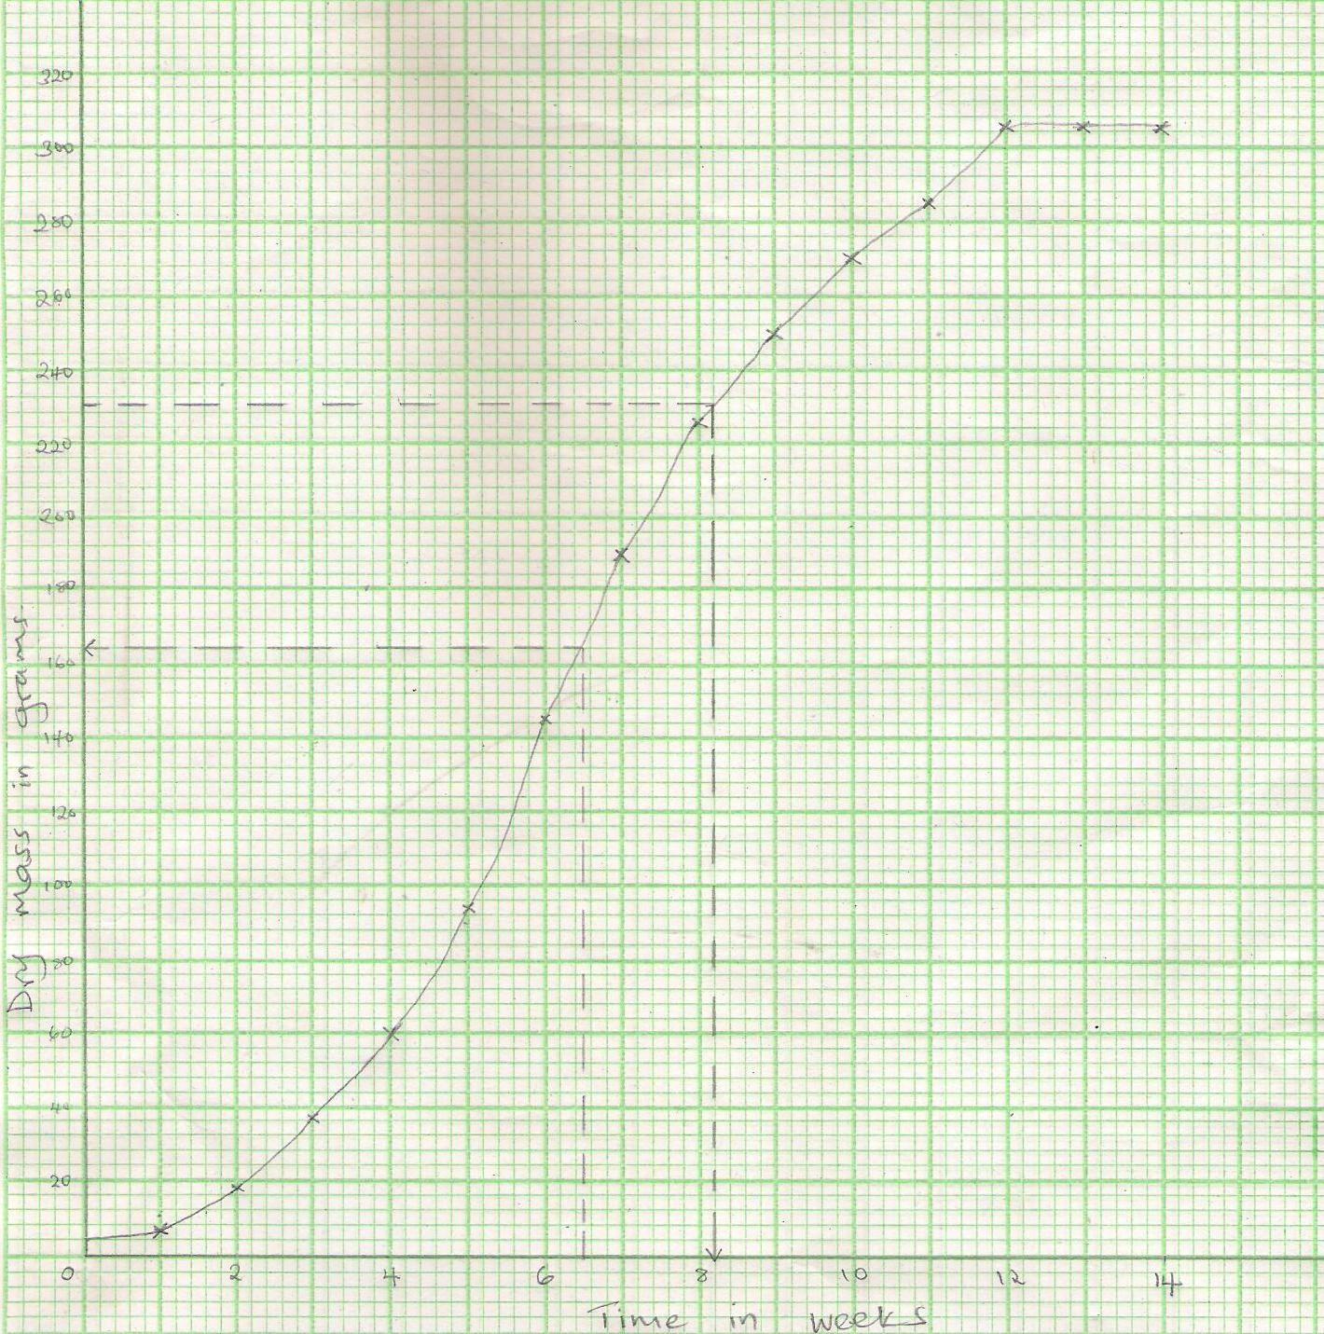
b) i. 164 g ± 2
ii. 8.2 weeks ± 0.2
c) The growth rate is slow; This is because the number of cells dividing are few; the cells have not yet adapted to the new environment;
ii. Growth rate is rapid; This is because the number of cells dividing has increased exponentially; the cells have fully adjusted to the new environment; environmental factors such as food, space, oxygen among others are not limiting; The rate of cell division is higher than the rate of cell death; any 2 reasons
iii. Growth rate is constant; This is because the rate of cell division is equal to the rate of cell death; The cells have fully differentiated and attained maximum size;
d) i. Decelerating stage;
ii. Exponential stage or log stage;
e) Sigmoid curve

- Water exists as a thin film in the soil between soil particles; The concentration of cell sap is greater than that of the surrounding solution in the soil; Thus drawing water molecules across the cell wall and cell membrane into the root hair cells by osmosis; water drawn into the root hair cell dilutes the cell sap/makes it less concentrated than that in the adjacent cortex cell; water moves into the cortex cell by osmosis; water moves from on cortex cell to another by osmosis; until it gets to the casparian strip; where it move across the endodermis by active transport; into the xylem vessels of the root; then conducted up into the xylem (vessels) of the stem into xylem of leaves; water is pushed/rises up the stem by root pressure; (in the xylem vessels) water rises by capillarity; cohesion; and adhesion forces; water moves as a continuous uninterrupted water column in the xylem vessels up the tree to the leaves; As water vaporizes from the spongy mesophyll cells; their cell sap becomes more concentrated than that of the adjacent cells; This increases the osmotic pressure of the spongy mesophyll cells; As a result water flows into the cells from other surrounding cells by osmosis; which in turn takes in water from xylem vessels within the leaf veins; This creates a pull/sunction force called transpiration pull; that pulls a stream of water from xylem vessels in the stem and roots; The transpiration pull maintains a continuous column of water from the roots into the leaves called transpiration stream;

- a) INSECT POLLINATED FLOWERS (ENTOMOPHILUS)
- are scented to attract insects;
- have stick stigma for pollen grains to stick on;
- are brightly coloured to attract insects;
- presence of nectar to attract insects;
- have nectar guides to guide insects to the nectarines;
- have nectarines to secrete nectar;
- stigma/ anthers located inside the flower/tubal/funnel shaped corolla to increase chances of contact by insects;
- sticky/spiny pollen grains which stick on the body of insects and on stigma;
- large conspicuous flowers easily seen by/attract insects;
- anthers firmly attached to the filament for insects to brush against them;
- some have a landing platform for the insect to ensure contact with anthers and stigma;
- mimicry to attract (male) insects;

- WIND DISPERSED FRUITS AND SEEDS
- Some seeds and fruits are small and light; in order to float in air currents and be blown away from the mother plant e.g. cotton seeds;
- Some seeds have hairy extensions; which enable them to float in air currents; and are blown away from the mother plant e.g. cotton seed;
- Some seeds have papery extensions or seed coat; to enable them float in air currents and be moved away from mother plant e.g. Jacaranda and Nandi flame seeds;
- Some fruits have extensions on the pericarp; to enable them float in air currents and be moved away from mother plant e.g. jacaranda;
- Some fruits like the simsim have sensor mechanism; where a capsule is borne on a long flexible stalk and upon being swayed by the wind the seeds break off from the placenta; beat against walls of capsule which splits open scattering seeds away from the mother plant;

