Name: ……………………………………………… Index Number: ………………...... / …….
Candidate’s signature: …………………...
Date: ……………………………………….
231/2
BIOLOGY
2 hours
CHUGU BOYS SECONDARY SCHOOL
Kenya certificate of secondary education (K.C.S.E)
Instructions to Candidates
- Write your name and index number in the spaces provided above.
- Sign and write the date of examination in the space provided above.
- This paper has two sections: A and B
- Answer all the questions in section A in this paper.
- In section B, answer question 6 (compulsory) and either question 7 or 8 in the space provided after question 8.
- This paper consists of 8 Printed pages.
- Candidates should check the question paper to ascertain that all the pages are printed as indicated and that no questions are missing.
- Candidates should answer the questions in English.

For Examiner’s Use Only
Section | Questions | Maximum Score | Candidate’s Score
 | 1 | 8
 | 2 | 8
 | 3 | 8
 | 4 | 8
 | 5 | 8
 | 6 | 20
 | 7 | 20
 | 8 | 20
Total Score |  | 80

- Study the diagram below and use it to answer questions that follow.
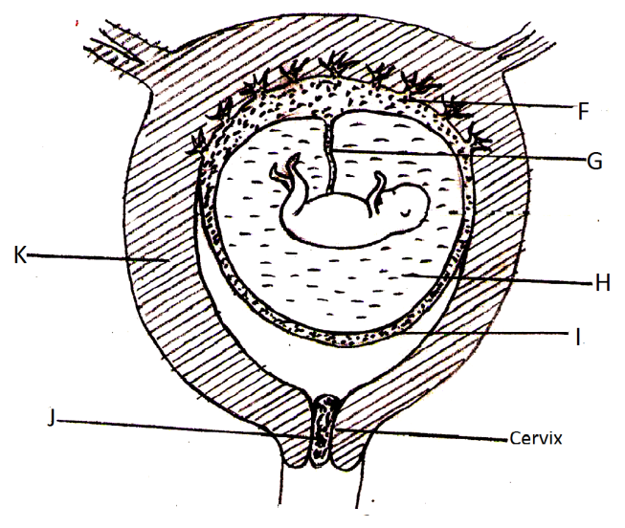
- Name parts J and F and I. (3Marks)
K ……………………………………………………………………………………………
F. …………………………………………………………………………………………….
I. ……………………………………………………………………………………………..
- State one function of parts labeled H and J. (2Marks)
H……………………………………………………………………………………………..………………………………………………………………………………………………. J……………………………………………………………………………………………...……………………………………………………………………………………………….
- Identify two blood vessels present in the structure labeled G (2Marks)
……………………………………………………………………………………………………………………………………………………………………………………………….
- State one difference in the composition of blood vessels named in c) above. (1Mark)
……………………………………………………………………………………………………………………………………………………………………………………………….
- The figure below shows a cell obtained from an organism.
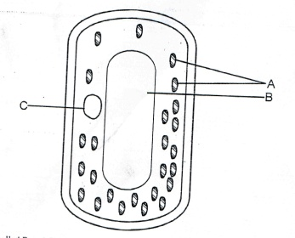
- Identify parts B and C (2Marks)
B …………………………………………………………………………………………….
C …………………………………………………………………………………………….
- Name the organism from which the cell was obtained. Give a reason. (2Marks)
Organism ……………………………………………………………………………………
Reason ………………………………………………………………………………………
- Draw a well labeled diagram to show how the above cell would appear after being placed in a concentrated salt solution for 10 minutes. (2Marks)

- State Two roles of osmosis in plants. (2Marks)
……………………………………………………………………………………………………………………………………………………………………………………………………………………………………………………………………………………………………..
- The diagram below shows a cross section of a plant stem. Use it to answer questions that follow.
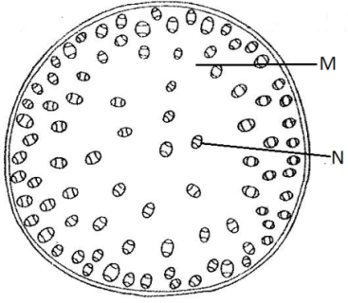
- Name part N and M. (2Marks)
N ………………………………………………………………………………………
M ………………………………………………………………………………………
- Identify the class of plant from which the cross section was obtained. (1Mark)
…………………………………………………………………………………………
- Highlight Three differences between the above section and the one obtained from the root of the same plant. (3Marks)
……………………………………………………………………………………………………………………………………………………………………………………………………………………………………………………………………………………………………………………………………………………………………………………………………………………………………………………………………………………………………………
- What is the role of a stem in a plant? (2Marks)
………………………………………………………………………………………………………………………………………………………………………………………………………………………………………………………………………………………………………
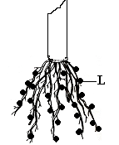
- The diagram below shows the roots of a leguminous plant. Use it to answer questions that follow.

- Name the structure labeled L. (1Mark)
…………………………………………………………………………………………………...
- Name the organism that lives in the structure labeled L (1Mark)
…………………………………………………………………………………………
- What is the relationship between the organism named in b) above and the leguminous plant. (1Mark)
……………………………………………………………………………………………………………………………………………………………………………………………………
- Apart from the organism named in b) above, state two other methods of nitrogen fixation. (2Marks)
………………………………………………………………………………………………………………………………………………………………………………………………………………………………………………………………………………………………………..
- Name the causative agent of the following diseases. (3Marks)
- Typhoid
………………………………………………………………………………………………….
- Amoebic dysentery
…………………………………………………………………………………………………
- Trichomoniasis
……………………………………………………………………………………………….
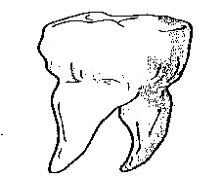
- The diagram below shows a mammalian tooth.

- Distinguish between homodonts and heterodonts. (2mks)
……………………………………………………………………………………………………………………………………………………………………………………………………
- Identify the tooth above. (1mk)
………………………………………………………………………………………….
- Give two reasons for your answer in b) above. (2mks)
……………………………………………………………………………………………………………………………………………………………………………………

- State three adaptations of the ileum to its functions. (3mks)
……………………………………………………………………………………………………………………………………………………………………………………………………………………………………………………………………………………………………………………………………………………………………………………………………………………………………………………………………………………………………………………………………………………………
Answer question 6 (compulsory) and either question 7 or 8 in the space provided after question 8.
- The data below shows the change in dry mass of the stem of an annual leguminous plant over time after germination.
Time in weeks | 0 | 1 | 2 | 3 | 4 | 5 | 6 | 7 | 8 | 9 | 10 | 11 | 12 | 13 | 14
Dry mass in grams | 4 | 7 | 18 | 37 | 60 | 94 | 145 | 190 | 225 | 250 | 270 | 285 | 305 | 305 | 305

- Using a suitable scale, plot a graph of dry mass against time. (6Mark

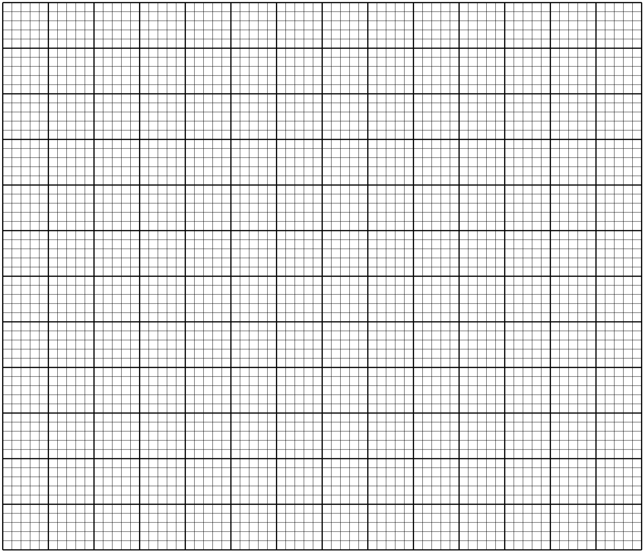

- From the graph determine
- The dry mass after 6.5 weeks. (1Mark)
…………………………………………………………………………………
- The time when the dry mass was 230g. (1Mark)
…………………………………………………………………………………
- Using the graph, explain the relationship between the dry mass and time between.
- 0 – 2nd weeks (3Marks)
- 4th -9th week. (3Marks)
………………………………………………………………………………………………………………………………………………………………………………………………………………………………………………………………………………………………………………………………………………………………………………………………………………………………………………………………………………………………
- 12th -14th week. (3Marks)
………………………………………………………………………………………………………………………………………………………………………………………………………………………………………………………………………………………………………………………………………………………………………………………………………………………………………………………………………………………………
- What is the name given to the stages between (2Marks)
- 9th – 12th week
…………………………………………………………………………………..
- 4th – 8th week
………………………………………………………………………………….
- What name is given to the growth curve plotted above? (1Mark)
………………………………………………………………………………………….……………………………………………………………………………………………………
- Describe the process undergone by water molecules in the soil until they are lost in the leaves. (20Marks)
- a) Describe the adaptations of insect pollinated flowers to the agents of pollination.(10Marks)
b) Describe the adaptations of wind dispersed fruits and seeds to their agents of dispersal. (10Marks)
………………………………………………………………………………………………………………………………………………………………………………………………………………………………………………………………………………………………………………………………………………………………………………………………………………………………………………………………………………………………………………………………………………………………………………………………………………………………………………………………………………………………………………………………………………………………………………………………………………………………………………………………………………………………………………………………………………………………………………………………………………………………………………………………………………………………………………………………………………………………………………………………………………………………………………………………………………………………………………………………………………………………………………………………………………………………………………………………………………………………………………………………………………………………………………………………………………………………………………………………………………………………………………………………………………………………………………………………………………………………………………………………………………………………………………………………………………………………………………………………………………………………………………………………………………………………………………………………………………………………………………………………………………………………………………………………………………………………………………………………………………………………………………………………………………………………………………………………………………………………………………………………………………………………………………………………………………………………………………………………………………………………………………………………………………………………………………………………………………………………………………………………………………………………………………………………………………………………………………………………………………………………………………………………………………………………………………………………………………………………………………………………………………………………………………………………………………………………………………………………………………………………………………………………………………………………………………………………………………………………………………………………………………………………………………………………………………………………………………………………………………………………………………………………………………………………………………………………………………………………………………………………………………………………………………………………………………………………………………………………………………………………………………………………………………………………………………………………………………………………………………………………………………………………………………………………………………………………………………………………………………………………………………………………………………………………………………………………………………………………………………………………………………………………………………………………………………………………………………………………………………………………………………………………………………………………………………………………………………………………………………………………………………………………………………………………………………………………………………………………………………………………………………………………………………………………………………………………………………………………………………………………………………………………………………………………………………………………………………………………………………………………………………………………………………………………………………………………………………………………………………………………………………………………………………………………………………………………………………………………………………………………………………………………………………………………………………………………………………………………………………………………………………………………………………………………………………………………………………………………………………………………………………………………………………………………………………………………………………………………………………………………………………………………………………………………………………………………………………………………………………………………………………………………………………………………………………………………………………………………………………………………………………………………………………………………………………………………………………………………………………………………………………………………………………………………………………………………………………………………………………………………………………………………………………………………………………………………………………………………………………………………………………………………………………………………………………………………………………………………………………………………………………………………………………………………………………………………………………………………………………………………………………………………………………………………………………………………………………………………………………………………………………………………………………………………………………………………………………………………………………………………………………………………………………………………………………………………………………………………………………………………………………….…………………………………………………………………………………………………………………………………………………………………………………………………………………………………………………………………………………………………………………………………………………………………………………………………………………………………………………………………………………………………………………………………………………………………………………………………………………………………………………………………………………………………………………………………………………………………………………………………………………………………………………………………………………………………………………………………………………………………………………………………………………………………………………………………………………………………………………………………………………………………………………………………………………………………………………………………………………………………………………………………………………………………………………………………………………………………………………………………………………………………………………………………………………………………………………………………………………………………………………………………………………………………………………………………………………………………………………………………………………………………………………………………………………………………………………………………………………………………………………………………………………………………………………………………………………………………………………………………………………………………………………………………………………………………………………………………………………………………………………………………………………………………………………………………………………………………………………………………………………………………………………………………………………………………………………………………………………………………………………………………………………………………………………………………………………………………………………………………………………………………………………………………………………………………………………………………………………………………………………………………………………………………………………………………………………………………………………………………………………………………………………………………………………………………………………………………………………………………………………………………………………………………………………………………………………………………………….

