Name: ……………………………………………… Index Number: ………………...... / …….
Candidate’s signature: …………………...
Date: ……………………………………….
231/3
BIOLOGY
1¾ hours
CHUGU BOYS SECONDARY SCHOOL
Kenya certificate of secondary education (K.C.S.E)
Instructions to Candidates
- Write your name and index number in the spaces provided above.
- Sign and write the date of examination in the space provided above.
- You are required to spend the first 15 minutes of the 1¾hours allowed for this paper reading the whole paper carefully before commencing your work.
- Additional pages must not be inserted.
- This paper consists of 4 Printed pages.
- Candidates should check the question paper to ascertain that all the pages are printed as indicated and that no questions are missing.

For Examiner’s Use Only
Questions | Maximum Score | Candidate’s Score
1 | 15
2 | 13
3 | 12
Total Score | 40

- You are provided with specimens labeled M.
- Identify the specimen (1Marks)
………………………………………………………………………………………………………………………………………………………………………………………………………………………………
- Using a hand lens, observe one of specimen M. Is the above specimen a fruit or a seed? Give a reason for your answer. (2Marks)
………………………………………………………………………………………………………………………………………………………………………………………………………………………………………………………………………………………………………………………………………………
- Take the remaining specimen M and using a pestle and mortar, crash the grains to make a paste. Add water and obtain an extract of specimen M. Using the reagents provided, carry out food tests on the extract of specimen M. (12Marks)
Food Substance | Procedure | Observations | Conclusion

- You are provided with specimen Q and R which are germinating seedlings of two different pants.
- Identify the type of germination exhibited by specimens Q and R (2Marks)
Specimen Q ………………………………………………………………………………………….
Specimen R ………………………………………………………..………………………………..
- Using observable features only state the class to which specimen Q and R belong.
Specimen Q (1Mark) …………………………………………………………………………………………………………..
Reasons (2Marks)
……………………………………………………………………………………………………………………………………………………………………………………………………………………………………………..…………………………………………………………………………………
Specimen R (1 Mark) …………………………………………………………………………………………………………..
Reasons (2Marks) ……………………………………………………………………………………………………………………………………………………………………………………………………………………………………………..…………………………………………………………………………………
- Describe how germination in specimen R occurs. (3Marks)
…………………………………………………………………………………………………………………………………………………..………………………………………………………………………………………………………………………………………………………………………………………………………………………………………………………………………………..………………………………………………………………………………………………………………………………………………………………………………………………………………………………………………………………………………..………………………………………………………………………………………………………………
- State the role of cotyledons in specimen Q before and after germination. (2Marks)
…………………………………………………………………………………………………………………………………………………..……………………………………………………………………………………………………………………………………………………………………………………………………..…………………………………………………………………………..………………………………………
- Use the photographs below to answer questions that follow. Photograph A shows internal organs in a dissected mice while photograph B shows a longitudinal section of organ M.
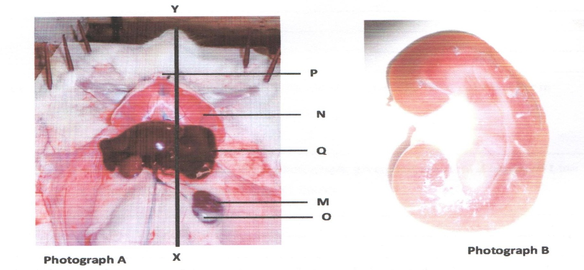
A
B
C
- Name parts A,B and C (3mks)
A ……………………………………………………………………………………
B ……………………………………………………………………………………
C ……………………………………………………………………………………
- Name the hormone produced by gland O and state its role in homeostasis. (3Marks)
…………………………………………………………………………………………………………………………………………………………………………………………………………………………………………………………………………………………………………………………………………………………………………………………………………………………………………………………………………..
- Identify part N and state its role in gaseous exchange during inhalation. (2Marks)
……………………………………………………………………………………………………………………………………………………………………………………………………………………………………………………………………………………………………………………………………………………….
- Name the basic structural and functional unit of the organ shown by photogram B. (1Mark)
……………………………………………………………………………………………………………………………………………………………………………………………………………………………………
- State two adaptations of the loop of Henle to its functions. (2Marks)
………………………………………………………………………………………………………………………………………………………………………………………………………………………………………………………………………………………………………………………………………………………
- Name one excretory substance produced by organ Q and eliminated by the organ shown in photograph B in man. (1Mark)
……………………………………………………………………………………………………………………………………………………………………………………………………………………………………

