NAME:……………………………… ……………………………..ADM NO…………………

231/1
BIOLOGY PAPER 1
(THEORY)
.
TIME:2 HOURS

.

INSTRUCTIONS TO STUDENTS:
- Write your name and admission number in the spaces provided.
- Answer all the questions in this paper in the spaces provided.
- Additional pages must not be inserted.

FOR EXAMINER'S USE ONLY

QUESTION | MAXIMUM SCORE | STUDENT'S SCORE
1-27 | 80

- Name the organelle which:
- Forms ribosomes(1mk)

- Synthesises energy(1mk)

- Contains enzymes that destroy worn – out organelles and cells.(1mk)

- Name the process by which amoeba and white blood cells obtain food.(1mk)

- State how blood volume may be brought back to normal.(3mks)

- A freshly obtained dandelion stem measuring 5cm long was split length – wise to obtain two similar pieces.
The pieces were placed in solutions of different concentrations in Petri dishes for 20 minutes.
The appearance after 20 minutes is as follows:
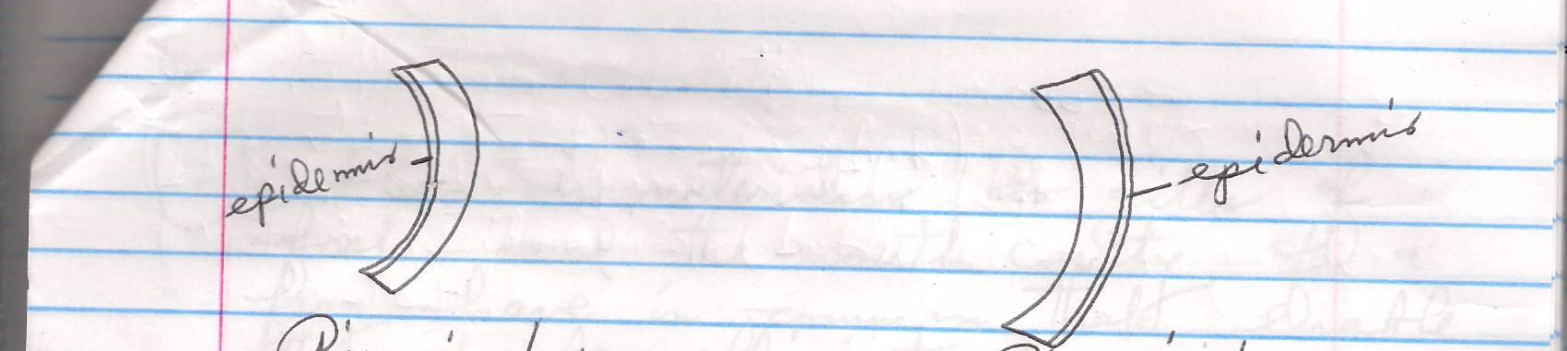Account for the appearance of the pieces in solutions L₁ and L₂. 6mks

- Explain how plants that grow below the surface of water in a lake are adapted for photosynthesis.(2mks)

- Give a reason why two species in an ecosystem cannot occupy the same niche.(2mks)

- (a) What characteristics do gills of a fish and the mouth cavity of a frog have in common that enable them to be efficient in gaseous exchange.(3mks)

(b) Describe the changes that occurs in the rib-cage and diaphragm during inspiration.(3mks)

- (a) explain what would happen if blood from a person who is A+ was transfused into a person who is A-.(2mks)

(b)Name the chemical substance that helps blood to naturally remain fluid in the blood vessels.(1mk)

- The figure below represents a plant
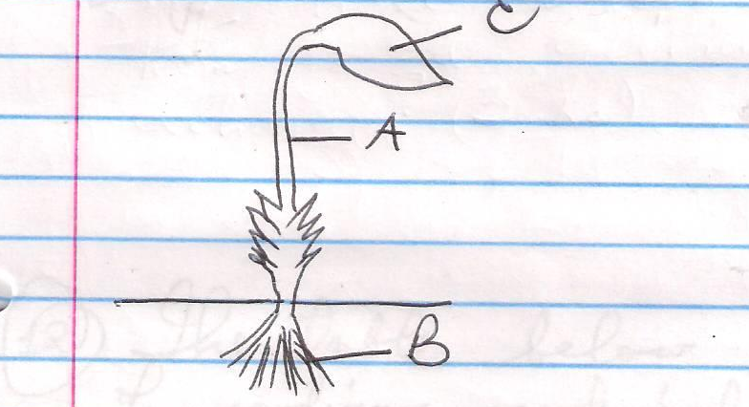
- State the division it belongs to(1mk)

- Label the parts A,B and C.(3mks)
A-
B-
C-
- State the function of the part labeled C(1mk)

- Name the hormones involved in blood sugar regulation.(2mks)

- Mammals cannot digest cellulose because they do not secrete enzyme cellulase and yet herbivores depend mainly on grass for carbohydrates. Explain.(2mks)

- The table below shows the concentrations of sodium and iodine ions in sea water and cell sap of a plant.
 | Sodium ion concentration | Iodine ion concentration
Sea Water | 250 | 35
Cell sap | 100 | 550

- (i) Name the process through which plant cells take up sodium ions(1mk)

(ii) Give a reason for your answer in (a) (i) above.(1mk)

- If the plant was sprayed with a chemical that inhibits respiration:
- Which of the two ions uptake will be affected? 1mk

- Give a reason for your answer in (b) (i) above. 1mk

- The diagram below represents a mature embryo sac. Study it carefully and answer the questions that follow
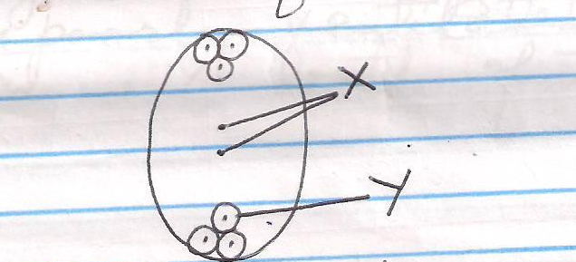
- Identify the structures labeled x and y.
x-
y-
- State what is formed when x and y are fertilized.(2mks)
x-
y-
- Why is cross- pollination more advantageous than self-pollination?(2mks)

- (a) Give two reasons why fats are not a preferred respiratory substrate in organelles.(2mks)

(b) State two reasons why respiratory quotient (RQ) is important in organisms.(2mks)

- Why is a burning charcoal stove in a poorly ventilated room likely to cause death of the inhabitants.(3mks)

- Below is an illustration of a cross section of a plant root showing the transportation of substances in the plant.
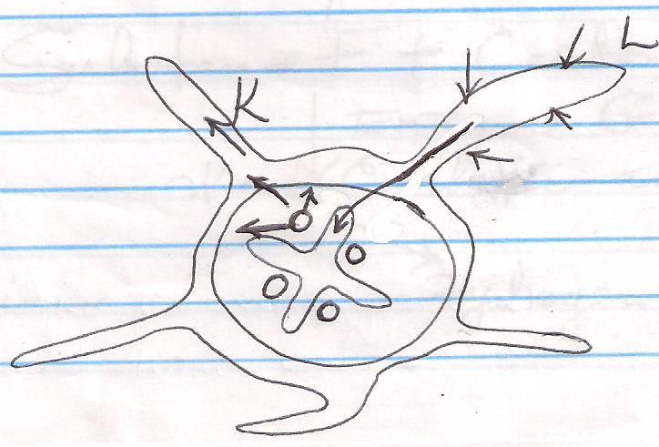
- Name the substances transported along the paths labeled k and L.
K-
L-
- Give a reason for your answer in L above.(1mk)

- (a) name the process in which water molecules are split by light during photosynthesis.(1mk)

(b) Explain why the process you named in (a) above is important to plants.(1mk)

- The diagram below illustrates the role played by red blood cells in transportation of carbon (IV) oxide.

Substance F+ Carbon (iv) oxide
Enzyme G
Weak carbonic acid

H⁺ ions Hydrogen carbonate ion.

- Other than carbon (IV) oxide transportation in the red blood cells, name the other form of carbon (IV) oxide in humans.(1mk)

- (i) Name substances F(1mk)

(ii) Name the enzyme marked G and state its role in the reaction.(2mks)
Enzyme:

Role:

- explain the role of calcium ions in blood clotting.(1mk)

- The set – up below represents an experiment to investigate the process of photosynthesis. The set-up was placed in light for six hours.
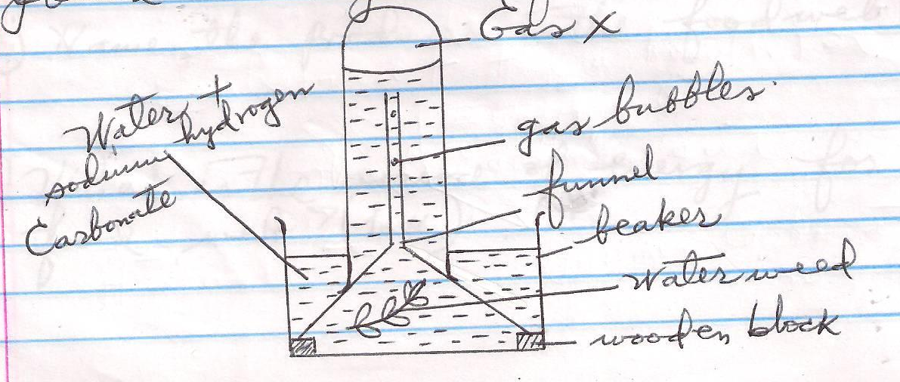

- Why was sodium hydrogen carbonate added to water in this experiment?(1mk)

- Explain why the number of bubbles reduced in the evening.(1mk)

- explain why water was used in this experiment.(1mk)

- Study the food web below and answer the questions that follow.
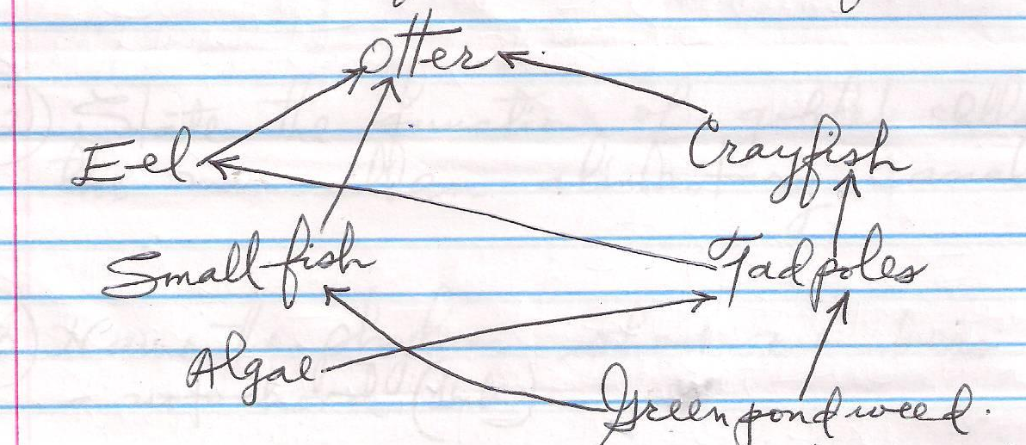

(a)(i) Name the producer in the food web. (1mk)

(ii) What is the source of energy for the food web? (1mk)

(iii) Not all the energy trapped by the producer reached the otter
Give two reasons for this energy loss.(2mks)

(b) Extract two possible food chains with the otter as the secondary consumer.(2mks)

- Name the causative agent of tuberculosis.(1mk)

- State the function of goblet cells in the mammalian alimentary canal.(1mk)

- Name the phylum whose members posses a notochord.(1mk)

- What name is given to the structure formed when the head and thorax are fused in members of Arachinda?(1mk)

- State two economic importance of fungi.(2mks)

- Under what condition is antidiuretic hormone released in the body?(1mk)

- Define the following terms:-
- Protandry 1mk

- Heterostyly (1mk)

