FORM 3 BIOLOGY PAPER 2 MARKING SCHEME

Q1. (a) Hawk; water snake (2mks)

(b) Decrease of phytoplankton; increase of small fish. (2mks)

(c) Hawk; top predator hence receives least energy since it is lost in successive tropic levels
Due to respiration/ indigestion. (2mks)

(d) Residue may be toxic/ poisonous to human; kill non – targeted organisms/ beneficial organisms; remain for long time in ecosystem/ food chains/ pollute environment. (2mks)

Q2. (a) An invagination develops at the area of contact with bacteria; cell membrane fold and flow around the bacteria forming a food vacuole/ phagocytic vesicle (2mks).

(b) Enzymes secreted by lysosomes into the food vacuole; digestion occurs; undigested materials are expelled when the vacuole moves to the edge and fuses with plasma membrane; soluble substances diffuse into the cell. (2mks).

(c) (i) Protoctista (1mk)

(ii) Produce antibodies; produce anti – toxins; produce lytic substances. (2mks).

(iii) Lymph nodes (1mk)

Q3. (a) Osmosis (1mk)

(b) Sugar solution in cavity is hypertonic to water in the beaker; water drawn into cavity by osmosis (3mks)

(c) Boiling destroys cells/ cell membrane/ semi permeable membrane osmosis does not occur (4mks).

Q4. (a) Animal A; has largest surface area to volume ratio hence cells closer to organisms body surface/ materials exchanged directly on body surface. (2mks).

(b) Total surface area
___________________ (1mk)
Organism volume
(c) Slow heat loss hence rise of body temperature; need specialized/ complex transport system/ gaseous exchange system; heat gain slow once may remain inactive for a long period. (2mks)
(d) S/A Volume S/A to volume ratio
X 6cm2 1 cm3 6:1 (1 ½mks)
Y 24cm2 8cm3 24:8 = 3:1 (1 ½mks)
Q5.(a) Cellulose (1mk)
(b) (i) Store sugars/ salts/ food; create osmotic gradient for osmosis; cause cell turgidity. (2mks)
(ii) Rate of photosynthesis would reduce/ inadequate food produced. (1mk)
(c) Cell wall; chloroplast (2mks)
(d) X 50 (1mk)
X 15 (1mk)

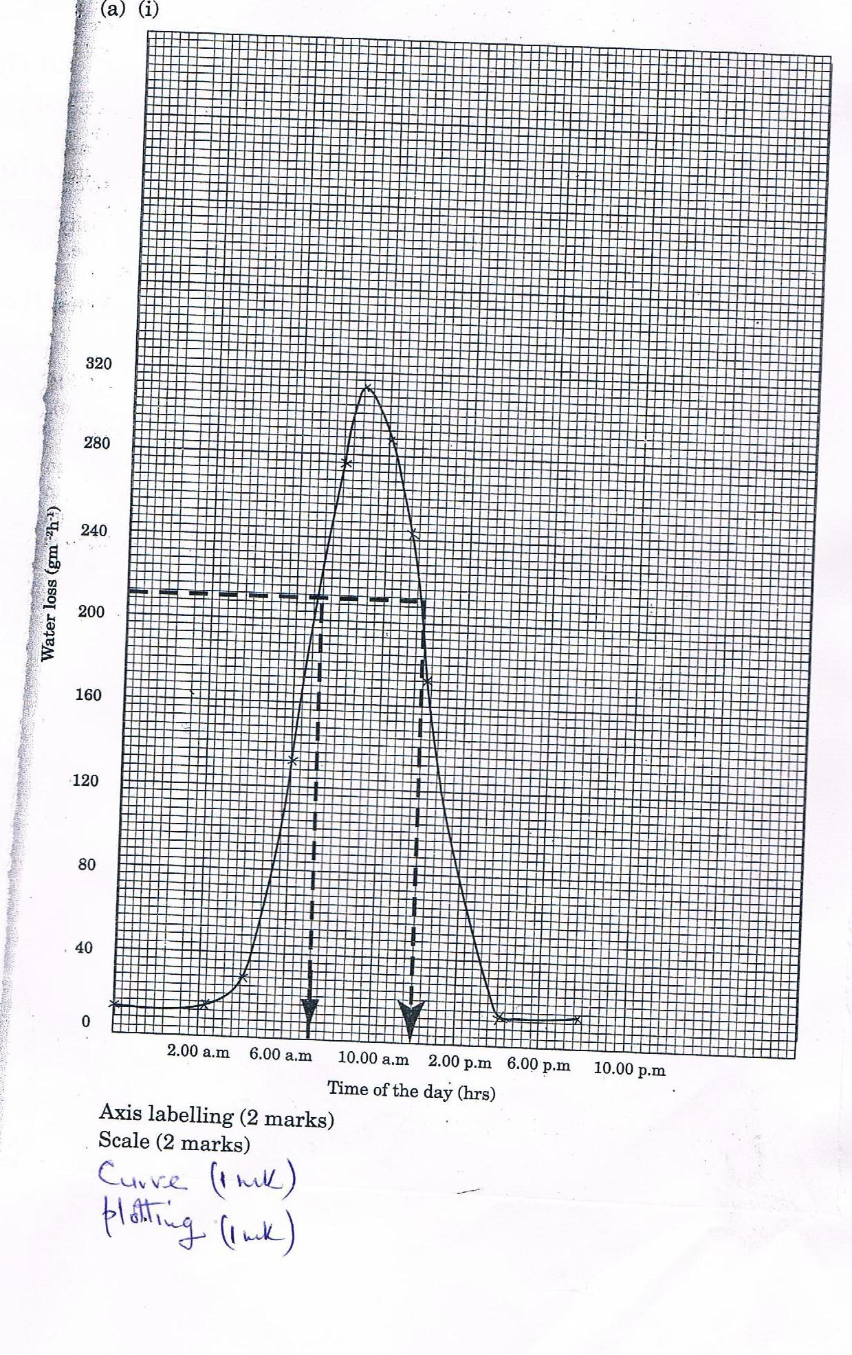
(ii) 7.00am and 12.36pm; range + 5 minutes (2mks)
(b) (i) Water loss low and constant; stomata are closed at night and temperature is low. (2mks)
(ii) Water loss increase steadily; sun rises; light intensity increase making stomata open and temperature increase; water evaporates from the stomata faster. (2mks)
(c) (i) Potometer (1mk)
(ii) More water loss; water vapour would be swept away from leaves; saturation deficit becomes high/rate of evaporation increases. (2mks)
(d) In habitat B stomata on leaves increases surface area over which water is lost; water is lost by transpiration and evaporation; (evapotranspiration). In A water is lost by evaporation only. (2mks)

Q7. (a) Animal dispersed: presence of hooks/ spines; to attach/ stick on fur/hair/clothes; e.g. Bidens pilosa. Succulent /fleshy/juicy; to attract animals; brightly coloured/scented/aroma; to attract animals; e.g. berries, drupe/mangoes; hard seed coat/mucoid seed coat/secrete anti enzymes; to prevent digestion/ inactive digestive enzymes; e.g. tomatoes, passion fruit, mangoes (7 max – atleast one example).
Water dispersed: Air spaces to make them bouyant/ light to float; e.g. water lilies/coconut; water (3 max – one example).
Wind dispersed: winged/hairy/parachutes/large extensions; to make them light/bouyant; e.g. sparthodea/cotton/jacaranda/ Nandi flame; presence of loosely attached capsule/long stalks to swing in winds; seeds small in size to be light; (4 max – one example).
Self-dispersal: presence of lines of weakness/sutures/lines of dehiscence; to split and release seeds from placenta; e.g. legumes like beans, peas (3 max – one example) (one example must be considered in each method).
(b)
Seed | Fruit
Has one scar | Has two scars
Has seed coat/testa | Has pericarp
Formed from ovule | Formed from ovary

Q8. Presence of lumen; for passage of food; long; to increase surface for digestion; and absorption; coiled; to delay/slow movement of food digestion and absorption; presence of villi/microvilli; to increase surface area for absorption; villi have thin epithelium; to allow fast diffusion of food; villi with many blood capillaries; for rapid transportation of absorbed food; presence of glands to secrete mucus; to lubricate; gland secrete juice containing digestive enzymes; mucus prevent digestion of organ by enzymes; presence of longitudinal and circular muscles; for peristalsis; presence of lacteal; for transport of fatty acids and glycerol; have duct openings; to allow bile/pancreatic juice into lumen; (23.20 max)

